WaveFEM Documentation

# Introduction

WaveFEM is a 3D electromagnetic FEM simulator. It is targeted towards microwave/RF engineering applications such as the design of filters, waveguides, and antennas. It aims to be general purpose and standalone while being simple to operate. Below is an example of a simulation performed of a horn antenna:

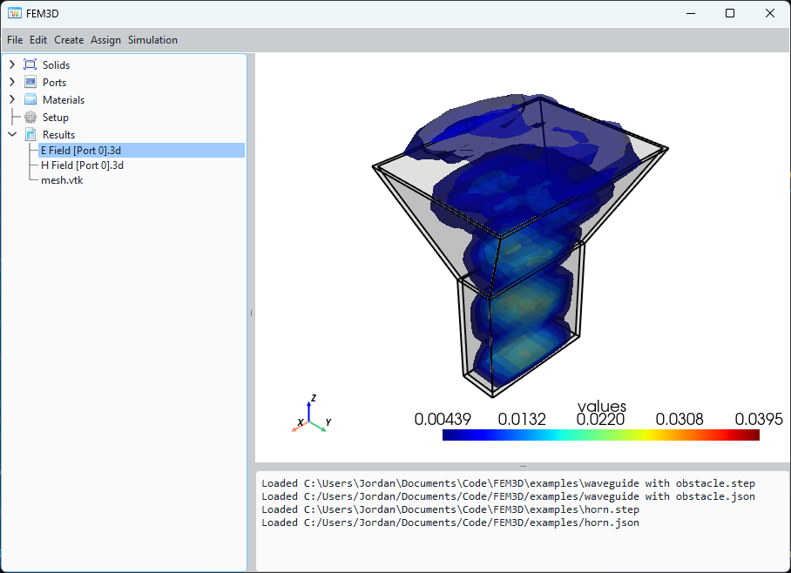

This document aims to describe the theory and code architecture in detail.

Contents

1 Introduction 1

3 Theory 3

3.1 Simplex Coordinates 3

3.1.1 2D 3

3.1.2 3D 3

3.2 Basis Functions 4

3.2.1 Edge Basis Functions 4

3.2.2 Nodal Basis Functions 4

3.3 3D Wave Propagation Analysis 5

3.3.1 Formulation 5

3.3.2 Discretization 5

3.4 2D Waveguide Port Analysis 6

3.4.1 Formulation 6

3.4.2 Discretization 6

3.5 Evaluation of Matrices 7

3.5.1 Quadrature Tables 7

3.5.2 Precomputation 8

3.6 Radiation Boundary Implementation 8

3.7 S-Parameter Evaluation 8

3.8 Far Field Computation 9

4 Code Architecture 10

5 References 10

# Theory

## Simplex Coordinates

The formulas for basis functions are expressed in simplex coordinates. We require a method of converting global coordinates to simplex coordinates to perform calculations.

### 2D

In 2d there are 3 simplex coordinates to define a point in a triangle: for . Cartesian coordinates can be converted to simplex coordinates using the equation:

Where coefficients are calculated by inverting a matrix of the tetrahedron coordinates:

The gradient of a simplex coordinate is given by:

To ensure consistency, the following numbering scheme is used.

|  |  |  |
| --- | --- | --- |
| Edge | Local Nodes | |
| 1 | 1 | 2 |
| 2 | 1 | 3 |
| 3 | 2 | 3 |

### 3D

In 3d there are 4 simplex coordinates to define a point in a tetrahedron: for . Cartesian coordinates can be converted to simplex coordinates using the equation:

Where coefficients are calculated by inverting a matrix of the tetrahedron coordinates:

The gradient of a simplex coordinate is given by:

To ensure consistency, the following numbering scheme is used.

|  |  |  |  |  |  |  |
| --- | --- | --- | --- | --- | --- | --- |
| Edge | Local Nodes | | Face | Local Nodes | | |
| 1 | 1 | 2 | 1 | 1 | 2 | 3 |
| 2 | 1 | 3 | 2 | 1 | 2 | 4 |
| 3 | 1 | 4 | 3 | 1 | 3 | 4 |
| 4 | 2 | 3 | 4 | 2 | 3 | 4 |
| 5 | 2 | 4 |  |  |  |  |
| 6 | 3 | 4 |  |  |  |  |

## Basis Functions

The solution to the electromagnetic field within each element (tetrahedron for 3d and triangle for 2d) is expressed as the weighted summation of a set of basis functions. The finite element method solves for the unknown weighting coefficients of these basis functions.

### Edge Basis Functions

Vector field solutions are expressed using the first 20 of Webb’s hierarchal functions [1]. These functions are vector basis functions which will be used to express the solution field. These formulas apply for both 3D and 2D basis functions.

|  |  |  |
| --- | --- | --- |
| Type | Number | Equation |
| Edge, | 1 per Edge |  |
| Edge, | 1 per Edge |  |
| Face, | 2 per Face | for {i; j; k}={1; 2; 3} and {2; 3; 1} |

The field in each element is then expressed as the sum of each of these 20 degrees of freedom (or 8 for the 2d case):

Where contains , and and are the weighting coefficients.

### Nodal Basis Functions

Scalar field solutions are expressed using first or second order nodal basis functions.

#### 1st Order

#### 2nd Order

Corner Nodes ():

Edge Nodes:

## 3D Wave Propagation Analysis

### Formulation

We aim to find a solution to the source-free vector Helmholtz equation given by:

The formulation based on [2] involves finding the function which minimizes the functional given by:

Where the excitation is a wave incident on with the form:

Where is the direction of propagation of the wave, and is the transverse mode of interest (in parametric coordinates). For this excitation, and are:

### Discretization

The variational form can be written in matrix form:

The matrices are defined as:

Where are the 2d vector basis functions across the surface (equivalent to .

The solution is the function which minimizes . This corresponds to the stationary point of the derivative with respect to the weighting coefficients:

This can be reduced to the standard linear form where and solved using standard techniques.

## 2D Waveguide Port Analysis

### Formulation

Before running the 3D simulation, we need to know the excitation . This aims to solve the same wave equation given previously in 2-dimensions assuming a spatial harmonic dependence in the other dimension.

The variational form becomes:

Where is the transverse del operator, is the transverse E field and is the axial E field. As described by [3], to solve this problem without needing a complex eigen solver the following substitution can be made:

This changes the variational form to look like this:

### Discretization

The variational form can be discretized as:

Where:

After minimizing the functional the equation reduces into the following eigenproblem:

## Evaluation of Matrices

### Quadrature Tables

The matrices can be evaluated using an appropriate quadrature rule. For volume integrals an 11-point rule with degree of precision 4 is used [4]:

|  |  |  |  |  |
| --- | --- | --- | --- | --- |
|  |  |  |  |  |
| 0.078933333333333 | 0.250000000000000 | 0.250000000000000 | 0.250000000000000 | 0.250000000000000 |
| 0.045733333333333 | 0.071428571428571 | 0.071428571428571 | 0.071428571428571 | 0.785714285714286 |
| 0.045733333333333 | 0.071428571428571 | 0.071428571428571 | 0.785714285714286 | 0.071428571428571 |
| 0.045733333333333 | 0.071428571428571 | 0.785714285714286 | 0.071428571428571 | 0.071428571428571 |
| 0.045733333333333 | 0.785714285714286 | 0.071428571428571 | 0.071428571428571 | 0.071428571428571 |
| 0.149333333333333 | 0.399403576166799 | 0.399403576166799 | 0.100596423833201 | 0.100596423833201 |
| 0.149333333333333 | 0.399403576166799 | 0.100596423833201 | 0.399403576166799 | 0.100596423833201 |
| 0.149333333333333 | 0.399403576166799 | 0.100596423833201 | 0.100596423833201 | 0.399403576166799 |
| 0.149333333333333 | 0.100596423833201 | 0.100596423833201 | 0.399403576166799 | 0.399403576166799 |
| 0.149333333333333 | 0.100596423833201 | 0.399403576166799 | 0.100596423833201 | 0.399403576166799 |
| 0.149333333333333 | 0.100596423833201 | 0.399403576166799 | 0.399403576166799 | 0.100596423833201 |

For surface integrals a 6-point rule with degree of precision 4 is used [5]:

|  |  |  |  |
| --- | --- | --- | --- |
|  |  |  |  |
| 0.223381589678011 | 0.108103018168070 | 0.445948490915965 | 0.445948490915965 |
| 0.223381589678011 | 0.445948490915965 | 0.108103018168070 | 0.445948490915965 |
| 0.223381589678011 | 0.445948490915965 | 0.445948490915965 | 0.108103018168070 |
| 0.109951743655322 | 0.816847572980459 | 0.091576213509771 | 0.091576213509771 |
| 0.109951743655322 | 0.091576213509771 | 0.816847572980459 | 0.091576213509771 |
| 0.109951743655322 | 0.091576213509771 | 0.091576213509771 | 0.816847572980459 |

Both these rules evaluate the integrals exactly and thus do not contribute any error into the solution (except floating point precision error). The rules are applied for surface integrals as:

And for volume integrals as:

### Precomputation

To evaluate the integrals involving the terms, the curl can be precomputed using the formulas:

Where:

To evaluate the integrals with the terms the formulas can be used:

Corner nodes:

Edge nodes:

## Radiation Boundary Implementation

The radiation boundary can be implemented using a PML. This is fictitious material which can be engineered to have the same impedance as free space while also being lossy. To modify a material to be a PML, the magnetic permeability and electric permittivity are multiplied by the following tensor [6]:

Where the must be placed on the dimension normal to the surface. This can be included simply in the above formulation by simply multiplying one of the vectors inside each of the nested dot products by this tensor [7].

## S-Parameter Evaluation

Using the above formulation, the S-parameters can be solved by taking the inner product of the computed field to the mode of interest:

Where is the resultant field when port is excited and is the mode of interest on port . For the case where , the source field contribution must be first subtracted:

## Far Field Computation

The field outside of a close surface radiating into open space can be found using the Stratton-Chu integral [8]:

This can be evaluated numerically using the quadrature rule introduced previously. For far-field computation, the approximation that can be made which simplifies the equation considerably:

is the free space Green’s function defined as:

# Code Architecture

# References

|  |  |
| --- | --- |
| [1] | J. Webb, “Hierarchal Vector Basis Functions of Arbitrary Order for Triangular and Tetrahedral Finite Elements,” *IEEE Transactions On Antennas And Propagation,* vol. 47, no. 8, 1999. |
| [2] | D. B. Davidson, “An Evaluation of Mixed-Order Versus Full-Order Vector Finite Elements,” *IEEE Transactions On Antennas And Propagation,* vol. 51, no. 9, 2003. |
| [3] | J.-F. Lee, D.-K. Sun and Z. J. Cendes, “Full-Wave Analysis of Dielectric Waveguides Using Tangential Vector Finite Elements,” *IEEE Transactions on Microwave Theory and Techniques,* vol. 39, no. 8, 1991. |
| [4] | “Moderate-degree tetrahedral quadrature formulas,” *Computer Methods in Applied Mechanics and Engineering,* vol. 55, no. 3, p. 339–348, 1986. |
| [5] | D. A. Dunavant, “High Degree Efficient Symmetrical Gaussian Quadrature Rules For The Triangle,” *International Journal For Numerical Methods In Engineering,* vol. 21, pp. 1129-1 148, 1985. |
| [6] | Z. S. Sacks, D. M. Kingsland, R. Lee and J.-F. Lee, “A Perfectly Matched Anisotropic Absorber for Use as an Absorbing Boundary Condition,” *IEEE Transactions On Antennas And Propagation,* vol. 43, no. 12, pp. 1460-1463, 1995. |
| [7] | D. B. Davidson, “Comments on and Extensions of “A Note on the Application of Edge-Elements for Modeling Three-Dimensional Inhomogeneously Filled Cavities”,” *IEEE Transactions ON Microwave Theory And Techniques,* vol. 46, no. 9, pp. 1344-1346, 1998. |
| [8] | P. Török, P. R. T. Munro and E. E. Kriezis, “Rigorous near- to far-field transformation for vectorial diffraction calculations and its numerical implementation,” *Journal of the Optical Society of America,* vol. 23, no. 3, pp. 713-722, 2006. |