**Readme**

**Compile Environment**

AVD Name: Nexus 5 API 29

Android SDK: Android 10 (Q)

CPU: x86

Size on disk: 12G

Resolution: 1080*1920

Emulator: Android studio

Max Memory: 1280MB

**How to execute the application / Functionality of APP**

1. Hide text in image. The motivation of this function is the shortcoming of the first App. When you want to send some secret information, the most important point is that do not let other knows you are sending secret information. So, this function can let users hide text in an image, other will not notice users are sending some secret things.

Click Encode and tick the <text> option. Input the text you want to hide in image in the <Edit text field>.

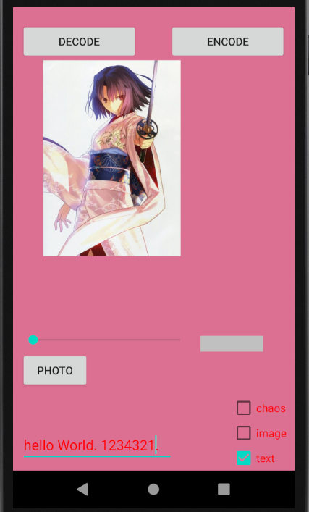

Then, it generates a new image.



Choose this image and click <decode>, it will show you the information hidden in the image.

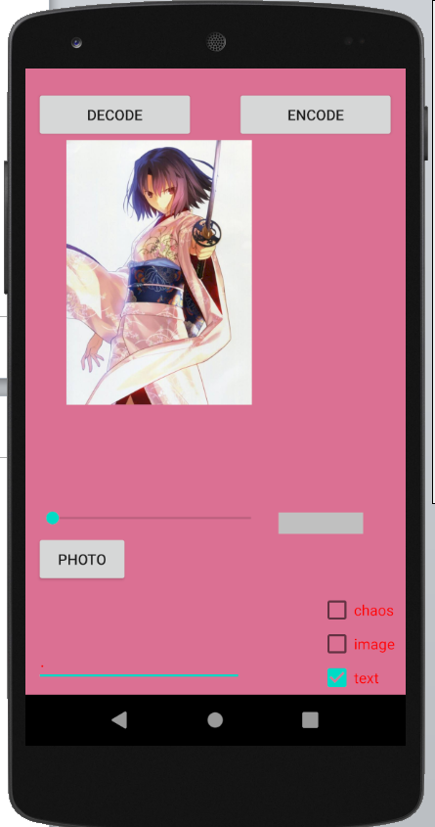 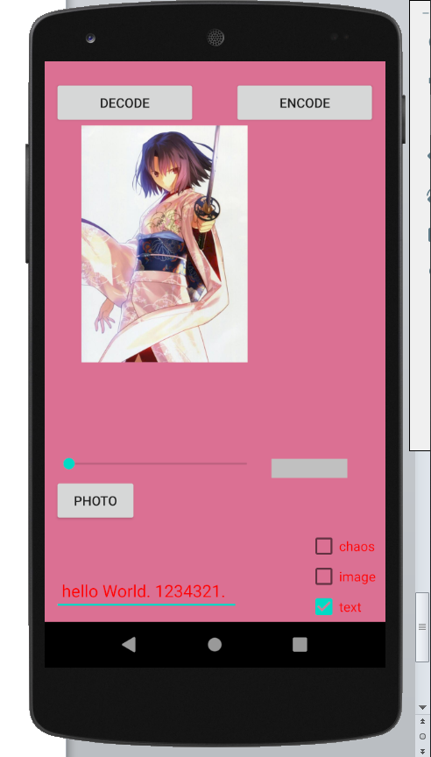

1. Use Chaos Sequence to encrypt image.

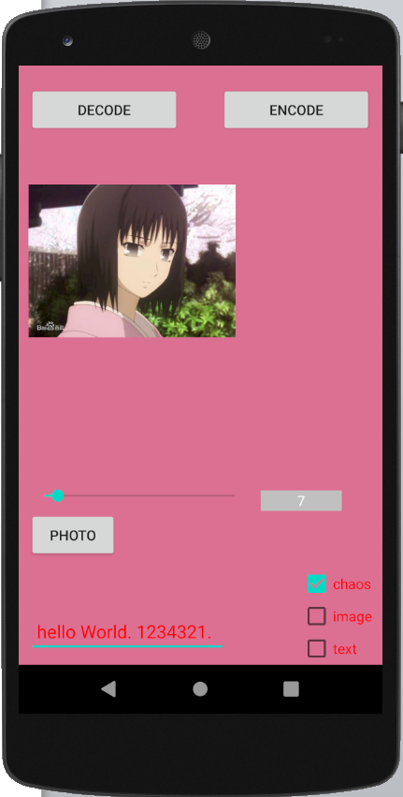

Choose an image first. Choose an initial value via the slider and then click the <encode>. It will generate a new image

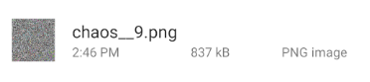

Then, the user can decode the encrypted image by clicking the <decode>. User need to set the correct value to decode successfully.

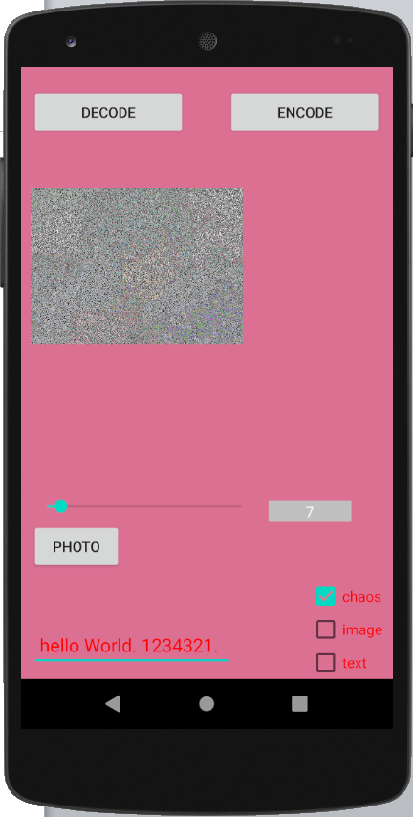 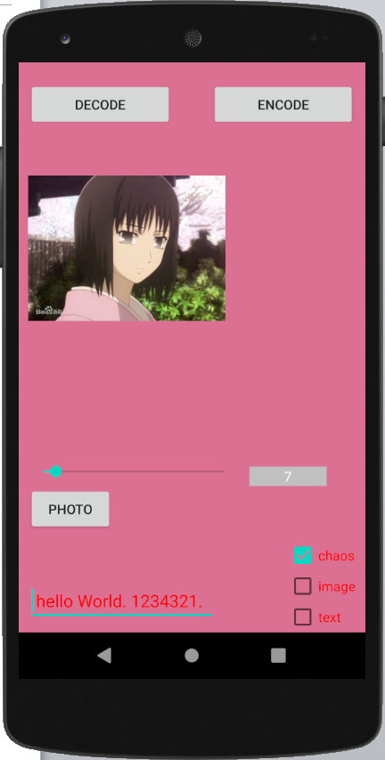

If user set a wrong chaos value, it won’t output the original image. (the right value is 7. The chaos value in second image is 40)

 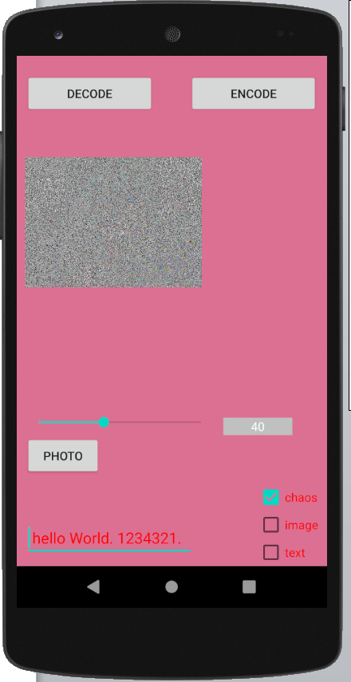

1. Enquiry the key of encrypted image

You can slide your finger to go to the second page. Then, click the <find>



The correct password is 123456

The image is named as chaos_9. So, input 9 in the number and input the key. Then, it will show the chaos value in the screen. If you input the wrong password, it will not show the value.

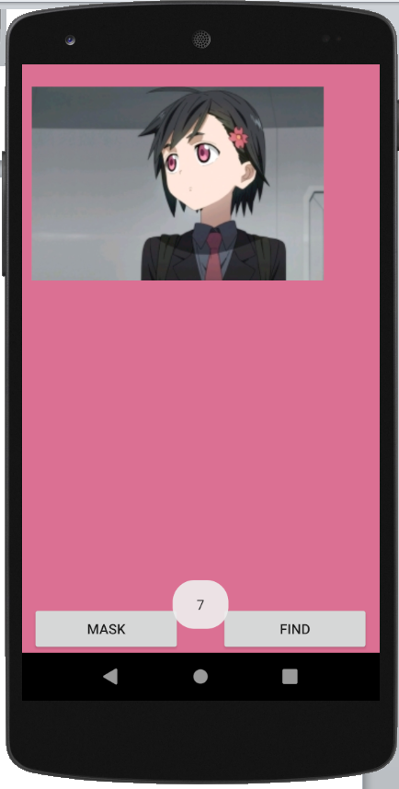 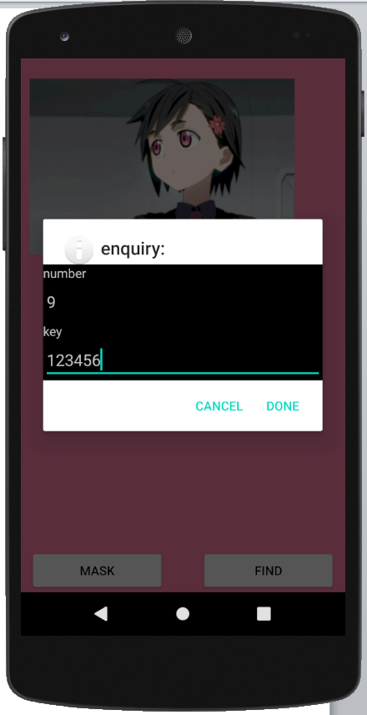

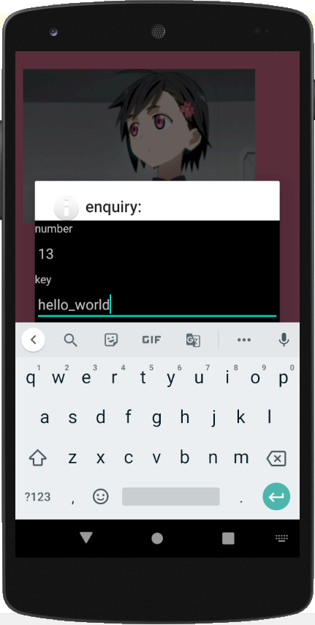 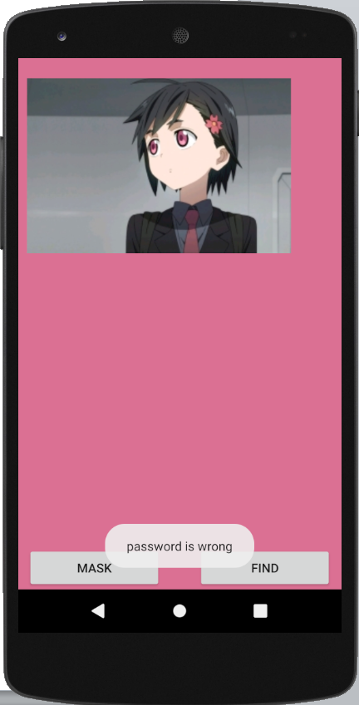

When you first time use this app, it will also let you to set your initial password first.

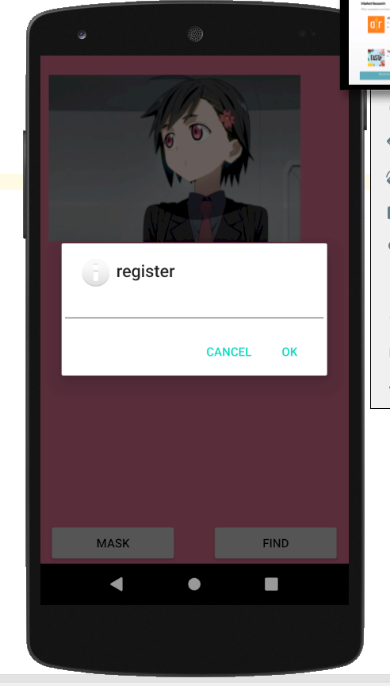

1. Encrypt image with mask

Choose a photo and then tick the image option and click <encode>

Then, it will generate two images.

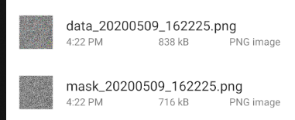

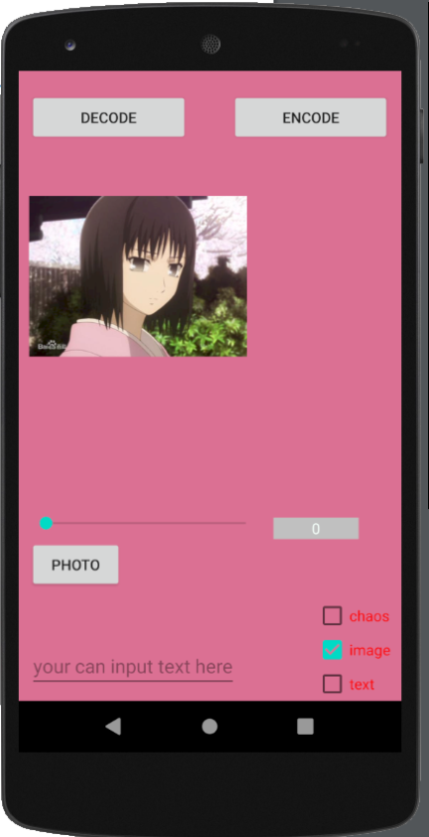

Then set mask and photo on corresponding area.

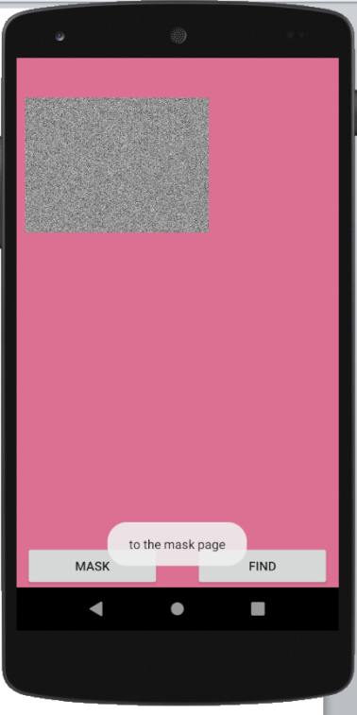 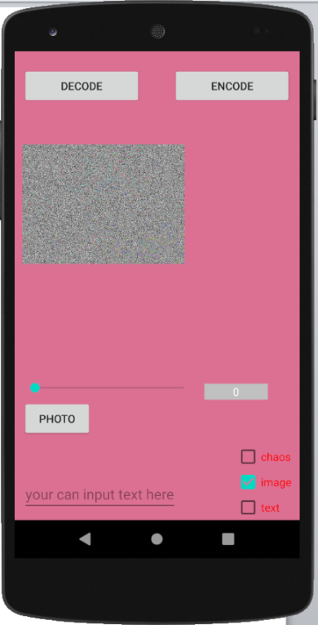

Then, click decode to see the original image.

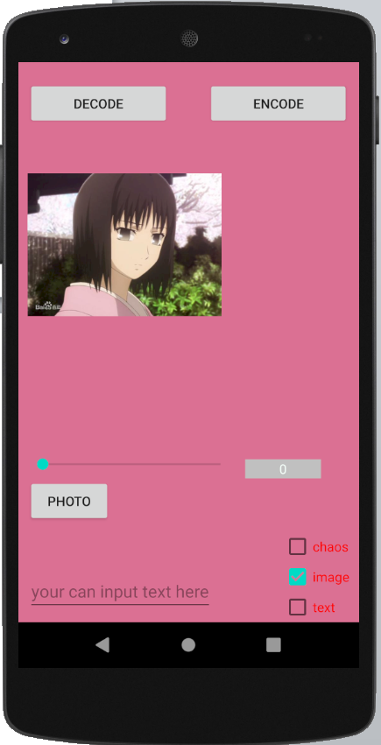

1. Change the page

This App has two pages. You can use your finger to slide right and left to go to different page of this App.