**Assignment 3b**

3a) Critical path prep of 6th pizza to delivery:

b) After the saucing there is an almost 2.5 min wait before cheese is applied and then after the cheese there is another almost 2 min wait before there is a free oven.

However, even if we would improve the wait due to cheese application we would still have to wait (even longer) for an oven to be free. So by far the biggest problem is the amount of ovens or the time they take to be ready for the next pizza. This makes sense, because the baking process takes far longer than any of the other steps so it quickly becomes a bottleneck.

c)

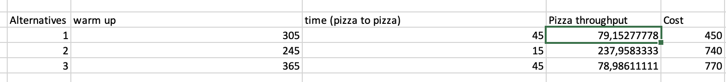

The first and second options are on the Pareto-front line. The first option saves the most money, while still being as efficient as the third option. The second option is by far the most efficient in terms of throughput, but this comes at a bit of a higher price (although it costs less than the third option). This gives the scatter plot below, with the Pareto-front coloured in green through both good alternatives (1 and 2).