**Curriculum vitae Jorrit van Gils**

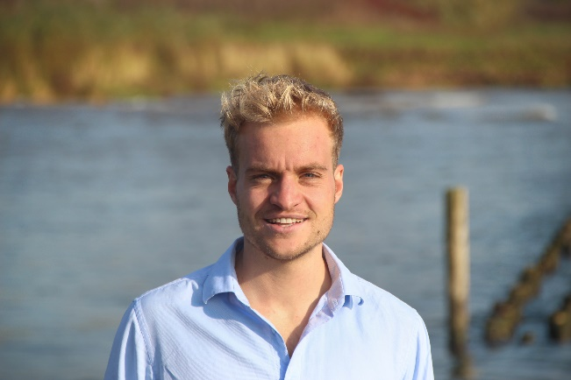

|  |
| --- |
| **Personal information** |

Name: Jorrit van Gils

Address: Hoogstraat 47, 6701BM Wageningen, The Netherlands

Phone: +31627572261

Date of Birth: 27/08/1992

Nationality: Dutch

**[](https://twitter.com/jorritvangils)[](https://github.com/JorritvanGils)**[](mailto:vangilsjorrit@gmail.com)[](https://www.linkedin.com/in/jorritvangils/)

Summary: Skilled in machine- and deep learning models, pose estimation, GIS and networking. Internationally oriented with a strong interest in technology-based solutions for conservation. Experienced Python and R programmer with a demonstrated history of working as teacher biology. Chair of youth board State Forestry involving youth in decision making.

|  |
| --- |
| **Work experience** |

01/2022-present **PiVa AI**

*Pilsen, Czech Republic*

Detection of Varroa Destruction mites on bees.

Skills: Python, FastAPI

11/2021-present **BOX21 AI website developer**

Implementing DeepLabCut pose estimation functionality to website

Skills: Docker, Python, key point implementation, website deployment

07/2016-02/2019 **Teacher Secondary school Biology**

*De Nassau, Breda*

Teaching Biology for students in their first 3 years of the lower- and higher general secondary education

Extra activities: Content developer and interactive digital lessons

|  |
| --- |
| **Education** |

02/2019-Present **Master Forest and Nature Conservation**

*Wageningen University & Research*

Specialisation: Data science management

* Thesis: *Computer vision for wildlife: Classification of wildlife behaviour from camera-trap imagery using pose estimation and deep-learning algorithms.*
* Computer science minor: Mathematics I & II, Statistics I & II, Programming in Python, Geo Scripting, Machine Learning, Deep learning, Remote sensing, Introduction Geo-information Science, Geo-information Tools
* Internship: *Mapping drought resistance of floodplains with GIS*

08/2016-02/2019 **Bachelor** **Secondary School Teacher Biology**

Fontys Hogeschool Tilburg

08/2010-02/2015 **Bachelor** **Primary School Teacher**

Avans Hogeschool Breda

|  |
| --- |
| **Invited talks** |

09/12/2021 **Thesis experience for new master students**

*Wageningen University & Research*

Physical open day. Presented thesis workflow: methodology, data-collection in R, usage of DeepLabCut, GIS integration, DL-networks.

25/11/2021 **Sharing experiences master student**

*Wageningen University & Research*

Online open day: Explaining new students master program experiences.

|  |
| --- |
| **Extra-curricular activities and side jobs** |

02/2022-05-2022 **iWildCam competition 2022**

Partitioning in yearly classification challenge hosted by Kaggle

05/2021-present **AI for Conservation Slack channel**

Active member of SLACK platform for information exchange. International contacts with researchers, PhD students, companies and volunteers.

09/2021-present **WILDLABS community member**

Latest developments in conservation technology. Tech Tutors episodes about wildlife camera traps.

02/2020-present **Youth board state forestry Netherlands**

Stand up for the involvement of Dutch youth in forest decision making

* Activities: weekly meetings, tours with forest managers, groupwork
* Communication manager social media group

02/2019-present **Volunteer nest box monitoring in spring**

Arboretum, *KNNV, Wageningen*

Stimulate bird abundance as biological pest control for caterpillar plagues

* Measure fledglings, and note nest properties

03/2015-07/2015 **Volunteer coast Care Worker**

*Perth, Australia*

Project: ‘Friends of Sorrento Beach & Marmion Foreshore’.

Coastal restoration project. Integration of refugees and education.

03/2015-07/2015 **Living with English family**

*Perth, Australia*

Looked after two children, Alex (11) and Tobi (9).

Improved English by living in English family and by taking English lessons

|  |
| --- |
| **Skills** |

**Languages:** Dutch C2, English C1, German A2, French A1, Spanish B1

**IT skills:**, Machine learning, TensorFlow, PyTorch, Python, RStudio, SPSS, Docker, GitHub, Jupyter, Linux, Shiny, Google Earth Engine, Maxent, Zonation