Portfolio Project: Liar's Dice

Liar's dice is a dice game wherein the players bid on the amount of certain dice faces in play. Players lose or gain dice as they challenge or call bids and have their own bids challenged or called.

Features

Upon starting the program, the user sees a main menu with four different options:

- 1) Play a Game
  - Begins a game of Liar's Dice.

- 2) Read Rules
  - Displays the rules for Liar's Dice

- 3) View Scores
  - Displays a leaderboard with number of wins for each player

- 4) Exit Game
  - Exits the program

When selecting 'Play a Game', the user is then asked to enter a number of players. Then a game of Liar's Dice is begun.

Game Play

Up to 5 players can play. Each player is given 5 dice. The dice values are hidden from other players. As the game begins, the dice for all of the players are rolled.

For the first turn, the player makes a starting bid. The bid represents an amount of a certain dice face in play (i.e. 2 'fours', 6 'ones', 3 'fives', etc.). A bid is correct as long as it does not exceed the number of that dice face currently in play.

After the first turn, players have 3 different options:

- Make a New Bid
- Challenge the Last Bid
- Declare the Last Bid 'Spot On'

Make a New Bid – The player must make a greater bid than the previous bid. The bid can be a higher number of the same face or any number of a higher face.

Challenge the Last Bid – The player challenges the previous bid. If the previous bid was not correct (exceeded the amount of the dice face in play), the player that made that bid loses a die. If the bid was correct, then the challenger loses a die. Dice are rerolled and a new round begins.

Declare Last Bid 'Spot On' – The player (the 'caller') declares that the last bid was 'spot on', that is, that it was the exactly right. If the last bid was exactly right ('spot on'), the caller gains a die. If it was not exactly right, the caller loses a die. Dice are rerolled and a new round begins.

As play continues, players are eliminated when they lose all of their dice. The last player with dice remaining is the winner.

Implementation

Initial Planning

In the initial stage, I made a general overview of the program. I tried to make note of the types of data I would need to keep track of and program flow. I anticipated that I would need to store variables for players, dice for each player, faces that have been rolled, and current bid. And I also planned on creating functions for rolling dice, making a bid, challenging the last bid, declaring last bid 'spot on', and for other operations that the program needed. Obviously, as I began considering the project, I imagined it from a Procedural programming standpoint, as that was what we had first been introduced to in this Python course. However, I did not do any coding at this point.

After I learned about OOP, I realized that I could create a class for the players with attributes for data like the player's number and the amount of dice that player hold and methods for doing things like rolling dice and governing turns.

Beginning Coding

I began coding during week 5. So, I began already having been introduced to OOP. I started by creating a class called Player. I gave it attributes: an empty list to store its dice values and a variable for its number of dice. I then created methods for rolling dice, making a bid, challenging the last bid, and declaring a bid spot on.

I then created a main_menu() function to display the main menu. This created a 'frame' to build code around and allowed me to break the program into smaller 'chunks', which was helpful for deciding what to do next. I created several if statements to handle the different options.
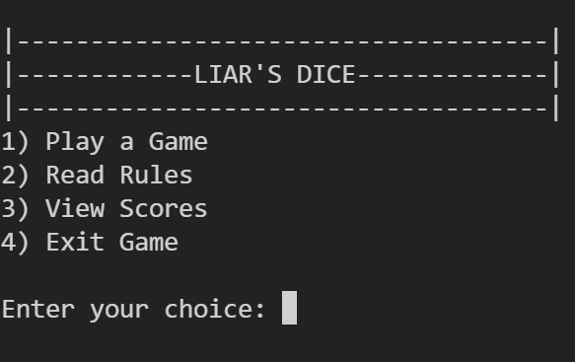

I began working on implementing the code for option 1 (Play a Game), and left options 2 and 3 for later, simply placing some placeholder code within their code blocks. All I needed for option 4 was the exit() function.

For option 1, I created code to allow a user to choose a number of players. I used a for loop to add the number of Player class instances to a dictionary. Using a dictionary allowed me to associate a number 'key' to the Player instance 'value' {player_number: player_class}. This would be helpful for referencing the players dynamically.

I made a turn_menu() function that would provide the player with the options to 'make a bid', 'challenge last bid', and 'declare last bid spot on' . I created a variable for the current player, because I knew it was vital that I have a way to increment the player. I also later added code for it to print the current player's number turn, current bid, total dice in play, and the dice values for the current player.

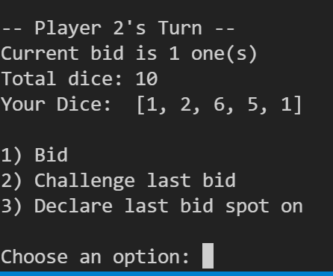

Next, I moved on to fleshing out the make_bid() function. It became apparent that I would need variables, current_bet_dice_face and current_bet_num_dice, to store the bid for the dice face and number of those dice, so I made global variables for those, as they would be useful in various functions.

As I was working on the make_bid() function, I also saw that I would need a function to increment the turn. So I made a next_turn() function to control player_number, a first_turn flag (since players have more options after the first turn) and to check whether a player has won (only one player remaining).

I made progress on the make_bid() function, while I also started to tackle the challenge_last_bid() and declare_spot_on() functions as well. There was a lot of functionality shared between the latter two functions. This included counting total bid dice faces to compare the bid to and adding and subtracting dice from players.

I decided that, when a player challenged a bid, or declared last bid spot on, that I would have the program display the previous dice values of all players, how many of the face dice were in play, the result of the challenge, and then print out the current dice values. This information helps the player, and it helped me test the program as well, since I could narrow down the problems my functions were encountering.
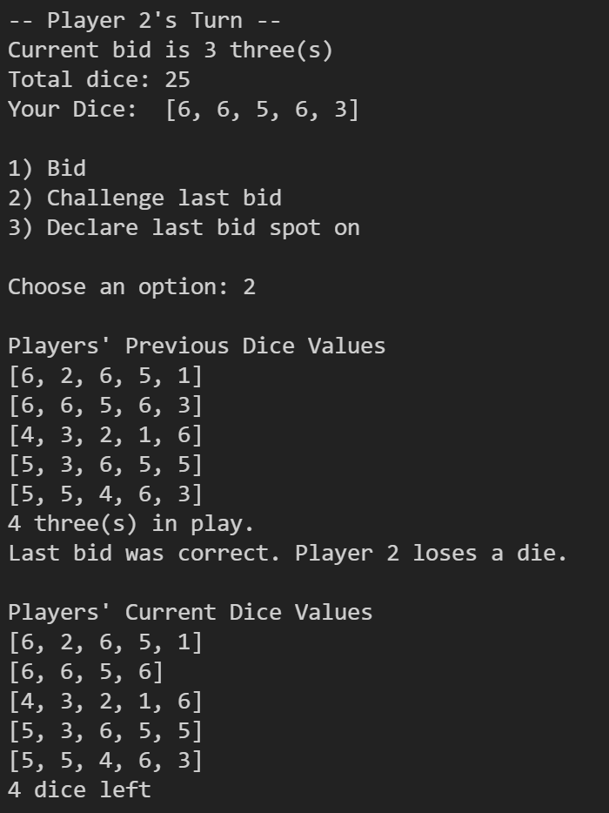

These 3 functions were the hardest part of the program to build, since I ran into many issues in referring correctly to the data I needed. I would get value errors. A print statement would print out the memory address of the player class instead of the number I meant to refer to. I realized that I needed more variables to store data that at first I hadn't noticed the functions needed to access. I hit several roadblocks at this stage, but it eventually came together, as I solved one problem then another.

At this point, I had finished the core of the program, and I spent the rest of the time fixing small problems and adding more minor pieces, including adding the explanation of the rules and the leaderboard to the main menu and making different formatting changes to try to make the program look better.

Conclusions

Looking back at my approach to the project, I believe I should have spent more time thinking through the structure of the program and its flow. I felt somewhat aimless at the beginning, which I think would have been helped by a more concrete plan.

I also think the code may be a bit sloppy in regards to how I assigned different parts to the player class. I don't really have a rationale for making the make_bid(), challenge_last_bid(), and declare_spot_on() methods of the Player class as opposed to functions outside of the class. I think I could learn more about how best to organize that functionality.

I do think the program has a good number of features and is fairly complete. The feature that I believe would most improve it, would be code to handle unexpected user input. I did not include any code to handle any unexpected values. But, overall, I'm pleased with the program for the amount of time it took. I expect to be able to work faster in the future, of course.

