Exploring the Ecological Interactions of the Common Mycorrhizal Networks through Robotics

  - Pervasive Media Exploration Group Project 2024-2025
By Coco Cai, Jocelyn Eddy and Omar Yussuf

Table of Contents
Git Repository 4
Project Proposal 4
Research and inspirations 7
Human-Computer Interaction: 7
Bionics: 9
Networks: 10
Design Inspiration: 11
Flowchart: 11
Sensor Research and Design 11
Design iteration and testing 15
Structural Design for the Robotic Flowers: 15
Sign Design: 19
Initial Prototypes: 20
User Testing / Play Testing: 22
Crit Session Feedback: 22
Group management records: 22
Meeting 1 22
Meeting 2 23
Meeting 3 23
Meeting 4 24
Meeting 5 25
Meeting 6 25
Meeting 7 26
Meeting 8 27
Meeting 9 27
Meeting 10 27
Final Outcome: 28
Video Demo 28
Showcase (12.5.25 – 26.5.25) 28
Visual Aids 28
References 28
i. Articles, books, or papers. 28
ii. Code libraries or frameworks. 28
iii. Websites and tutorials. 28

Git Repository

https://git.soton.ac.uk/jje1g24/semester-2-group-project

Project Proposal

Topic: (Robotics, AI, Ecological Interactions or Wearable Technology)

We have decided to choose ‘Ecological Interactions’ as our chosen track for this project. We are also incorporating components of robotic technology, enabling us to create a dynamic and interactive installation.

Project concept:

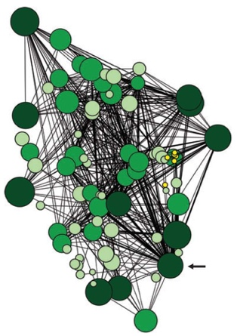
Study showing individual Douglas fir were linked to other individuals, 2009

As stated in the brief, our objective is to create a ‘non-screen-based experience’; therefore, we decided to create an interactive installation. Our initial inspiration came from the proposed concept of the ‘Wood Wide Web’, a term devised by the scientist Suzanne Simard in her 1997 PhD thesis. The idea is that a mycorrhizal network, which is ‘created by the hyphae of mycorrhizal fungi joining with plant roots’, is present and actively creates a sense of community as it allows communication between the plants. However, in 2023 aspects of this theory were argued against by Justine Karst and a team at the University of Alberta. As seen through the title of their paper, ‘Positive citation bias and overinterpreted results lead to misinformation on common mycorrhizal networks in forests’. Although they didn’t entirely dismiss the idea, they still claim that aspects are not necessarily statistically backed up. For example, they claim Simard utilised anthropomorphism as a tool to evoke feelings in the user and create a connection between them and the tree. But this idea still holds value. This organic form of a network, naturally appealed to us because of the parallels with modern computing, particularly mesh network topologies.

To create our outcome, we will be combining aspects of bionic technology, robotics and Human Centred Interaction theories. The idea of natural communication is at the forefront of our project, and we want to visually demonstrate this to the user in the form of an immersive experience. Enabling the user to actively participate in the ‘communication’ being shown. Bionics is defined as the ‘science of constructing artificial systems that have some of the characteristics of living systems’. This is important as we want to simulate the ideology behind the common mycorrhizal network (CMN), mimicking the way the ‘messages’ are passed between the roots of the plants, indicating whether they need more water, minerals, nutrients, etc. However, instead of demonstrating this with trees, we have chosen flowers. This is because they create a better visual interest due to the variety of appearance, whereas trees all follow a similar structure regardless of species.

Additionally, it will be easier to model the environmental impacts on the flowers. We can scale up the flowers to ensure the movements are demonstrated, but if we used trees, they would have to be scaled down. Theoretically, we want to create a table like areas, where the robotic plants are placed on top in a seemingly natural environment. Underneath you can see their roots and the connections between them just like with the CMN. It would be optimal to demonstrate our outcome in a darker space, as we will be incorporating LED elements on the roots of the plants to light up and show the journey the messages go on when they are sent. Around the room there will be strategically placed sensors. This is where the user can interact with the plants. For example, one sensor could be a moisture sensor, the user could either dry it or add more water, and then they can see in real time the impact this has on our environmental simulation. In a sense, this allows the user to take on ‘God like’ capabilities, they are given full control over the plant’s environment, which they can interact with at any point.

Goals:
The project aims to develop a functional, interactive simulation of mycelium-based communication, blending technology, art, and biomimicry. The technical outcome focuses on creating a modular system where users can send signals through an app or physical interface, triggering plant responses. These responses will be visualized through LED pathways, motorized movement, and potentially other sensory outputs. The network simulation will mimic organic information flow, taking inspiration from decentralized computing models and fungal communication pathways.
The impact of the project extends beyond the technical realm into educational, artistic, and scientific fields. By making hidden fungal communication systems visible and interactive, the installation aims to foster greater appreciation for ecological intelligence and biomimetic design. The immersive experience encourages participants to consider the parallels between natural and artificial networks, inspiring discussions on sustainability, technology, and interconnectedness in biological systems. Additionally, the project provides an opportunity to explore new forms of human-computer interaction that integrate living and synthetic components, contributing to emerging fields such as bio-HCI and biohybrid robotics.
Use Cases:

- Educational Tool:
  - To demonstrate how plants react to different environmental conditions in a non-digitally simulated experience.
- Artistic Installation:

Target Audience Research and Psychology Behind Mycelium Communication & HCI:
The project targets a diverse audience, including academics and researchers studying biomimicry, biohybrid systems, and communication networks. Artists and designers working with interactive installations and kinetic sculptures will find value in the project’s aesthetic and conceptual dimensions. STEM students and educators can utilize the installation as a learning tool to explore artificial ecosystems and bioinspired computing. Museum and exhibit visitors, particularly those interested in immersive experiences, will engage with the project on a sensory and conceptual level. Environmental enthusiasts and technologists will appreciate the exploration of ecological intelligence and sustainable design principles.
From a psychological perspective, the project capitalizes on humans’ natural inclination to relate to organic systems and decentralized intelligence models. The visualization of networked plant responses enhances user engagement by making abstract biological processes more tangible and emotionally resonant. Allowing participants to directly influence the system through interaction fosters a sense of agency and curiosity, reinforcing the educational impact. Additionally, the project explores the cognitive and affective dimensions of bio-HCI, investigating how people perceive and respond to artificial organisms that exhibit lifelike behaviors.
The philosophy of mind plays a crucial role in how users interpret and engage with biohybrid systems. Concepts such as extended cognition, as discussed by Clark and Chalmers (1998), suggest that technology can serve as an extension of human cognitive processes. This aligns with the idea that interacting with the artificial mycelium network allows users to externalize and manipulate an otherwise hidden biological communication process. Additionally, theories of embodied cognition (Varela, Thompson, & Rosch, 1991) propose that intelligence is not confined to the brain but emerges through interactions between the body and environment. This perspective reinforces the importance of tactile and visual engagement in our installation, making the experience more immersive and intuitively understood.
The project also draws from the philosophical debates on artificial life and non-human intelligence. Scholars such as Dennett (1991) argue that intentionality can emerge from complex systems, even if they do not possess consciousness. This notion suggests that users may ascribe agency to the artificial fungi and plants, experiencing the system as a form of emergent intelligence. By leveraging these psychological and philosophical insights, the project not only enhances human-computer interaction but also encourages users to reconsider the boundaries between organic and synthetic life.
Timeline of milestones and deliverables:

https://lucid.app/lucidspark/d2b2ae89-9b54-4a1c-b91a-fb94e85b2a50/edit?page=0_0&invitationId=inv_93f6ec4b-d5a9-422e-8b9a-a918d5a6ca89#

Research and inspirations

Human-Computer Interaction:
Whilst the concept of HCI has been around since the 1980s, it is only within the last 20 years that plants have been utilised as an ‘object’; much like a keyboard or mouse. Through this project, we will be exploring how HCI and plants can be incorporated to create interactive exhibitions.

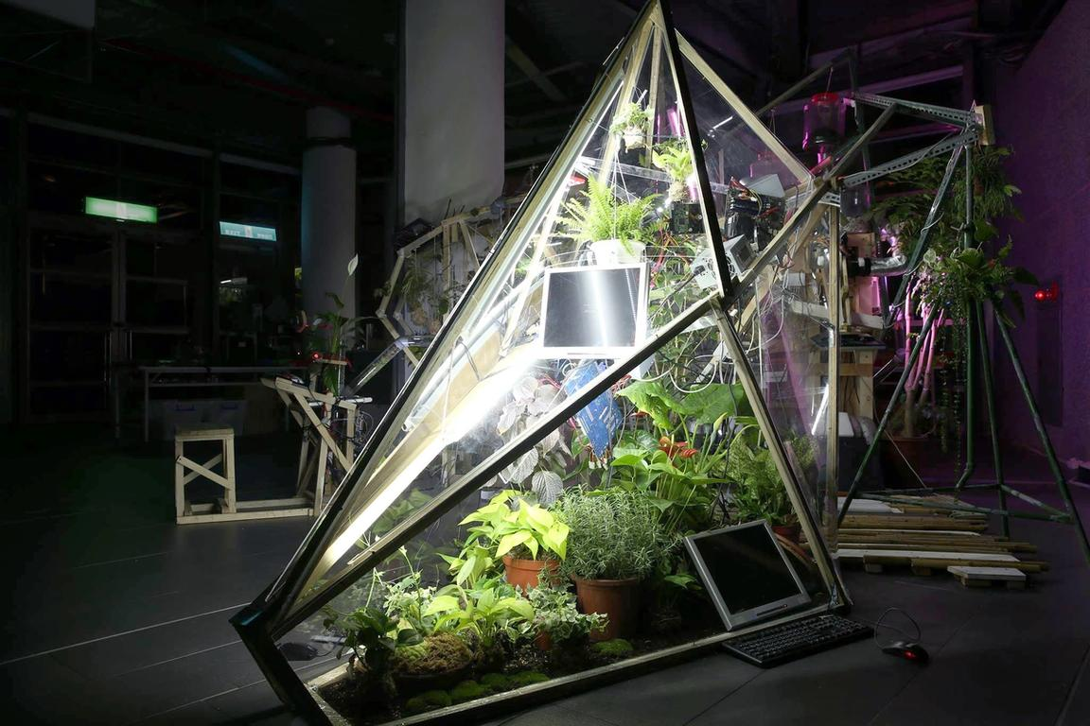

Biomodd Installation at Regeneration Movement, 2016 by The National Taiwan Museum of Fine Arts

For the first example I am looking at Biomodd, a project that has been running since 2007. It began during Angelo Vermeulen’s residency at Ohio University's College of Fine Arts. Since then, it has travelled the world reaching 5 continents so far (Europe, Asia, North America, South America and Oceania).

One interesting feature is the element of collaboration,

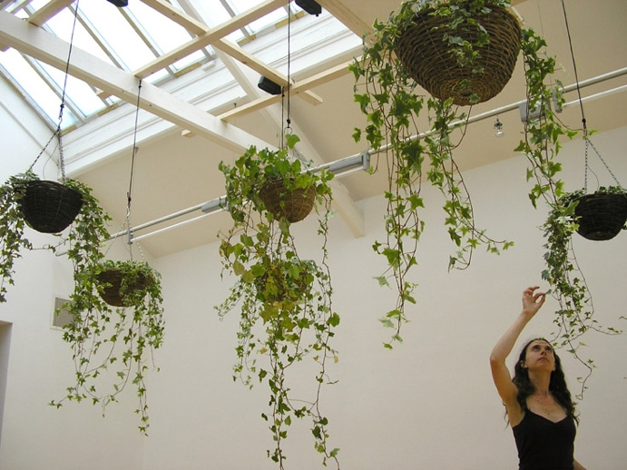
Akousmaflore, ISEA 2009 / Ormeau Baths Gallery - Belfast (Ireland)

This installation was created by the artist team Scenocosme (Grégory Lasserre & Anaïs met den Act), it has travelled all over the world, but unlike the example above, nothing fundamental to it changes between the visits. Only the location it is being hosted at and the conditions of that environment. Due to the electrostatic energy produced by the user’s body, every time they touch the plant, a sound is produced. Resulting in a unique combination of sounds creating an experience completely dependent on the user being there at that moment.

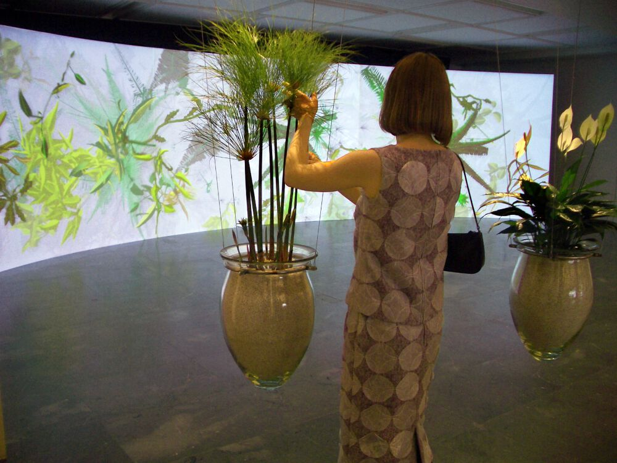
Christa Sommerer and Laurent Mignonneau, Eau de Jardin. Interactive installation. 2004

- Biomodd - https://seads.network/hyperproject/biomodd / https://www.muse.it/en/events/biomodd-tt015-2024/
- Akousmaflore https://www.scenocosme.com/akousmaflore_en.htm
- Eau de Jardin" https://www.kunstuni-linz.at/en/university/organisational-structure-1/institutes/media/interface-cultures/news/news-detail/biennale-art-and-technology-2024
- RESEARCH

Bionics:
This project draws inspiration from natural fungal communication networks, biomimicry, and interactive installations. The goal is to simulate how plants and fungi exchange information through an artificial root system, allowing users to visualize and interact with these hidden biological processes.
Cyborg Botany, developed by the MIT Media Lab, explores how plants can function as interactive interfaces by embedding sensors and electronic circuits into living organisms. This project demonstrates how plants can act as biohybrid systems that respond to environmental changes and human interaction. Cyborg Botany informs our project by showcasing the potential for plants to serve as organic input and output devices, reinforcing the idea that fungi and plants could transmit messages visually and kinetically in an interactive installation. The integration of sensors and actuators aligns with our goal of enabling user-driven plant responses, bridging biological and technological interactions.
Plantoid, a robotic project funded by the European Research Council, draws inspiration from plant root structures to develop artificial growth and exploration mechanisms. The project focuses on decentralized intelligence, where robotic roots expand and navigate their surroundings independently. This concept parallels our use of mycelium as a natural network that transmits information among interconnected organisms. Plantoid influences the project’s approach to movement and responsiveness, suggesting that artificial roots could react dynamically based on user input, enhancing the simulation of plant-fungal communication.
Flora Robotica investigates plant-robot symbiosis, where living plants and robotic structures co-evolve by influencing each other’s growth patterns. This research is relevant to our project because it highlights the potential for biological systems to integrate with artificial elements, forming a hybrid organism that exhibits emergent behaviors. The concept of responsive, self-organizing networks aligns with the mycelium-based signaling system we aim to simulate. Additionally, Flora Robotica emphasizes long-term adaptability, which could inspire iterative improvements in our project’s networked responses. (Source: https://www.florarobotica.eu)
The IIT’s biohybrid robot, constructed from biodegradable materials like flour and oat bran, demonstrates an environmentally sustainable approach to robotics. This project influences our material selection by encouraging the use of organic and biodegradable elements where possible. The integration of soft robotics with natural materials
reinforces the idea that artificial plants and fungi should not only simulate biological functions but also embody principles of sustainability. (Source: https://opentalk.iit.it/en/flour-and-oats-for-the-biohybrid-robot-useful-for-reforestation/)
DARPA’s Engineered Adaptation (EA) research explores biohybrid and bioengineered organisms for adaptive environmental response. The principles behind adaptive biohybrid intelligence, as studied in this project, relate to how our installation simulates the intelligent, decentralized decision-making processes of mycelial networks. Understanding how living systems process and react to information informs our approach to creating an interactive, responsive installation.
Biohybrid Futures, a UK research initiative, investigates the intersection of synthetic biology, robotics, and human interaction. This initiative aligns with our project’s goal of exploring human engagement with organic and artificial intelligence. By studying how users interact with biohybrid entities, we can refine the user experience of our installation, ensuring intuitive and meaningful interactions.

Networks:
https://pmc.ncbi.nlm.nih.gov/articles/PMC4497361/?utm.com
https://en.wikipedia.org/wiki/Mycorrhizal_network?utm.com
https://en.wikipedia.org/wiki/Plant_communication?utm.com

Here are network inspirations related to how plants have been incorporated into networks, and Mycorrhizal Networks.
- MIT’s “Cyborg Botany”- https://www.media.mit.edu/projects/cyborg-botany/overview/
- “Plantoid” - https://plantoidproject.eu/
- Mycorrhizal Networks & “Wood Wide Web” - https://www.scielo.sa.cr/pdf/tem/v33n4/0379-3982-tem-33-04-114.pdf
- RESEARCH

- MIT Media Lab researchers have embedded electronic sensors into living plants, turning them into interactive interfaces.
- Plantoid is a robotic system inspired by plant roots, using distributed sensors and neural networks to mimic how plants search for resources in the soil.
- The idea of the “Wood Wide Web”—that trees communicate through fungal networks—has gained popularity. However, some recent research questions whether mycorrhizal fungi actually “share information” like an internet or if they are merely facilitating nutrient transport.

https://pubmed.ncbi.nlm.nih.gov/24129903/
https://pubmed.ncbi.nlm.nih.gov/36626804/
https://www.urbangardensweb.com/2015/09/24/hybrid-art-project-creates-symbiosis-between-plants-and-computers/

Design Inspiration:

Flowchart:

Sensor Research:
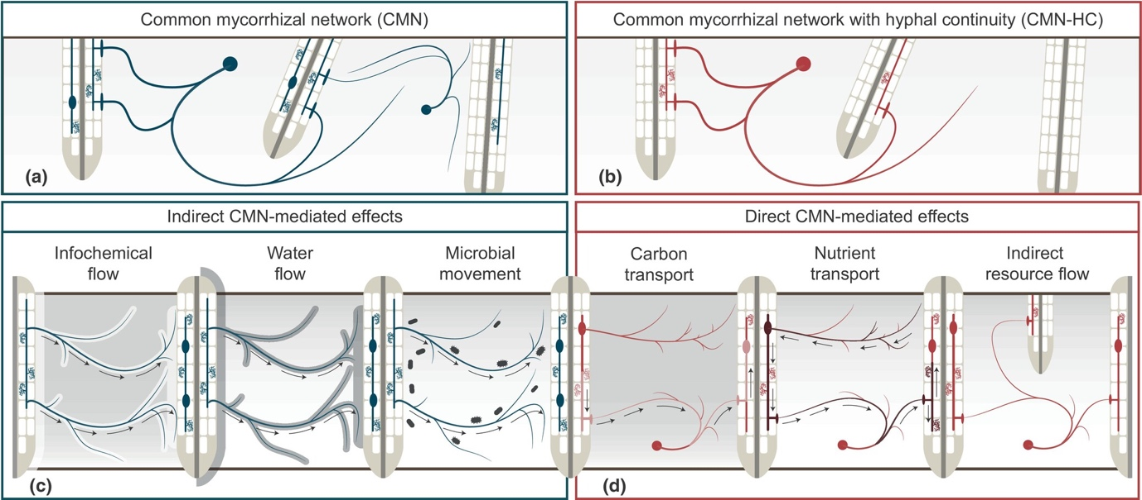
‘FUNCTIONAL DIFFERENCES BETWEEN HYPHAL CYTOPLASMIC CONTINUITY AND NON-CONTINUITY— DIRECT AND INDIRECT CMN-MEDIATED EFFECTS’
As seen in the diagram above, there are six types of activity occurring through the common mycorrhizal network. However, we cannot represent all of these in an interactive installation, for example, there currently aren’t Info chemical sensors on the market that are compatible with an Arduino. Therefore, we will be considering other factors which affect the behaviour of the plants, that we can represent through robotic movements to create visual interest. Therefore, we will also be considering other aspects that affect the appearance of the plants to create visual interest in our installation. Another factor that we need to take into consideration is how the resources interact with each other. They aren’t independent, for example, when air flow increases, the water levels decrease. This makes it necessary to research each resource and all the impact it has on the environment around it, whether that resource has been depleted or is in excess.
Resource | Sound
Sensor | Microphone Sound Sensor Module
How does it relate to the Common Mycorrhizal Networks | Unfortunately, there is no direct correlation between sound and
How does this resource impact the plant and its local environment. | Scientific studies have confirmed that ‘Sound stimuli can influence germination rates and increase plant growth and development’, ‘improve plant immunity against pathogens and can also increase their tolerance to drought’, and ‘increases the absorption efficiency of the light energy which translates into greater photosynthetic’.  This promotes growth  It promotes growth  https://pmc.ncbi.nlm.nih.gov/articles/PMC7671032/#:~:text=Sound%20stimuli%20can%20influence%20germination,the%20yield%20of%20some%20crops.&text=Furthermore%2C%20sound%20waves%20can%20improve,increase%20their%20tolerance%20to%20drought.  https://pmc.ncbi.nlm.nih.gov/articles/PMC11020090/#sec8  https://nph.onlinelibrary.wiley.com/doi/10.1111/nph.17866  https://www.google.com/search?client=safari&rls=en&q=effects+of+silence+on+plants&ie=UTF-8&oe=UTF-8  https://www.sciencedirect.com/science/article/abs/pii/S0048969724054615  https://pmc.ncbi.nlm.nih.gov/articles/PMC7671032/#:~:text=Sound%20stimuli%20can%20influence%20germination,the%20yield%20of%20some%20crops.&text=Furthermore%2C%20sound%20waves%20can%20impr【【ove,increase%20their%20tolerance%20to%20drought.  https://dl.acm.org/doi/10.1145/3512887  https://dl.acm.org/doi/10.1145/3544548.3581534
Visible observations | Lack of Sound | Excess Sound

Resource | Air Flow
Sensor | Metal Pitot Tube, Acrylic 2.5mm ID Tubing, XGMP3v3 Differential Pressure Sensor
How does it relate to the Common Mycorrhizal Networks
How does this resource impact the plant and its local environment. | When there are high amounts of air movement, it has a drying effect on the plants. Therefore they require more water at shorter intervals. Without any air movement occurring the leaves become ‘saturated with water vapour’. This increases the risk of pathogen attacks as a warm and moist environment is the perfect place for bacteria to grow. Overall this weakens the plant and can make it more susceptible to catching diseases which increases the likelihood of it spreading to the neighbouring plants.
Visible observations | Lack of Air Flow | Excess Air Flow
 | - Mildew and mould growth.  - Leaves curling in.  - Discolouration or yellowing of the leaves.  - Limited growth. | - Dried out, becoming shrivelled and brittle.  - Change in colour, going from vibrant to dull.

Resource | Moisture
Sensor | DHT11 or DHT22 humidity sensor
How does it relate to the Common Mycorrhizal Networks | Water flows through the MCN, therefore if the amount of water in a plant has decreased, it will then increase the amount it takes from the flow, reducing the amount that the other plants will be able to receive.
How does this resource impact the plant and its local environment. | Water makes up 80-95% of plants weight and is necessary for transporting nutrients and maintaining turgor pressure, this is what helps the plant stand up without drooping. With reduced amounts of water, the processes of respiration, transpiration and photosynthesis are decreased. Water aids in maintaining the temperature of plants and acts as a buffer.
Visible Observations | Lack of Water | Excess Water
 | - Wilting  - Yellow Leaves  - Brown & Crispy leaves  - Leaf Drop | - Roots become brittle and damaged  - Root rot  - Leaf Mold

Resource | Light
Sensor | Grove Light Sensor
How does it relate to the Common Mycorrhizal Networks
How does this resource impact the plant and its local environment. | Light is used to regulate many of the physiological processes within plants. It is the main source of energy which is gained through the process of photosynthesis. Therefore when the light decreases, so does photosynthesis. It is also a factor in ‘germination, leaf proliferation and expansion’, so without it the growth is slowed and stunted.
Visible Observations | Lack of Light | Excess Light
 | - Dropped Leaves  - Longer & thinner stems.  - Turn from green to yellow to white.  - Fail to produce flower buds. | - Scorched & Bleached leaves  - Brittle

Resource | Nutrients
Sensor | ZE08CH20 Electrochemical Sensor
How does it relate to the Common Mycorrhizal Networks | Transfers “water, carbon, nitrogen, and other nutrients and minerals”
How does this resource impact the plant and its local environment.
Visible observations

Resource | Temperature
Sensor | DHT11 sensor
How does it relate to the Common Mycorrhizal Networks | ‘Both mycorrhizal colonization levels and length of extraradical hyphae (ERH)’ increased as the temperatures got warmer. Additionally, every time the temperature drops by 10 degrees, the mycelium’s ability to do chemical processes halves. This affects how effective the communication between the plants is, it is necessary that the temperature remains optimum.
How does this resource impact the plant and its local environment. | Whilst the temperature from day to night fluctuates, it is recommended that it only decrease by 10 to 15°C. Any extreme temperature change can lead to stress which can hinder the plants growth. This increases their risk of disease. Warmer temperatures lead to more photosynthesis and respiration. Additionally warmer soil temperature boosts the amount of water and nutrients absorbed.
Visible observations | Excessive Low Temperature | Excessive High Temperature
 | - Wilting  - Red or purple discoloration  - Plant turns mushy / black  - Death of leaves, stems, or entire plants | - The leaves change angles and roll in on themselves.  - Wilting  - Discolouration  - Scorching  - Leaf and branch burn

Sensor Experiments:

Design iteration and testing

Structural Design for the Robotic Flowers:

Diagram | Flower Name | Characteristics | Reasons for Choice
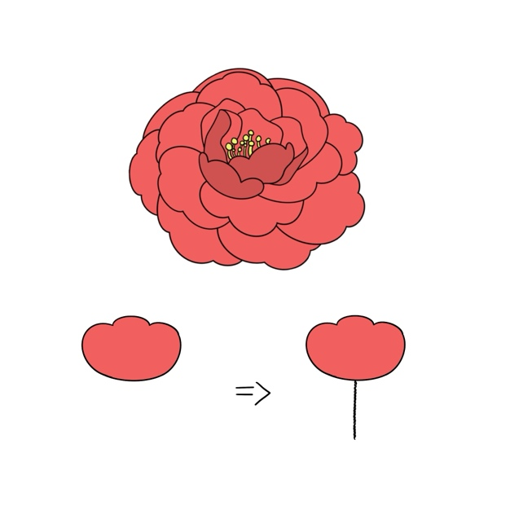 | Peony | Layer 1 = 3  Layer 2 = 5  Layer 3 = 7 | The stacked petals of the peony create a rich three-dimensional impression, making it an excellent choice for mechanical building design. Through a programmable mechanical system, it is possible to replicate a peony slowly flowering and responding dynamically to environmental changes, perfectly merging the beauty of nature with robotics.
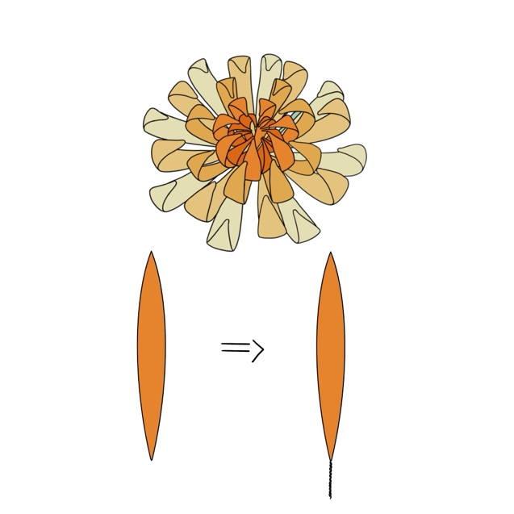 | Chrysanthemum | Layer 1 = 5  Layer 2 = 6  Layer 3 = 7 | Chrysanthemums feature a radial petal arrangement, which allows for a dynamic look with several layers. Mechanical devices can replicate the natural movements of petals unfolding layer by layer, slowly rotating, or gently swaying in the wind, increasing interactivity and viewing experience.
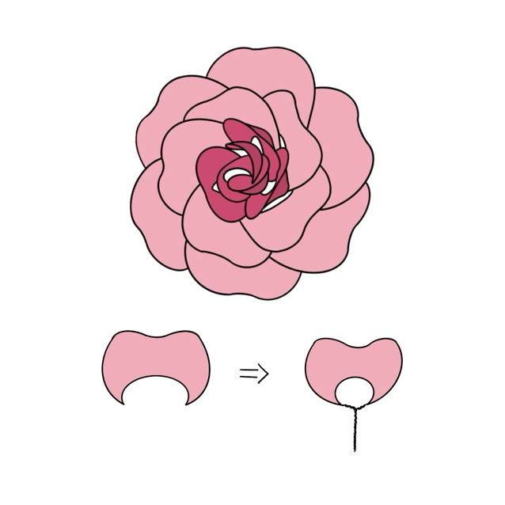 | Rose | Layer 1 = 3  Layer 2 = 5  Layer 3 = 7 | The Chinese rose has the distinct feature of flowering once a month. It can endlessly bloom, wither, and bloom again. This process can be simulated using a mechanical device. For example, it can cause flowers to gradually close and then blossom again, showing the theme of vitality and cyclical rebirth. The mechanical structure enhances the characteristic of the Chinese rose's frequent blooming, resulting in an artistic piece with a stronger sensation of life.
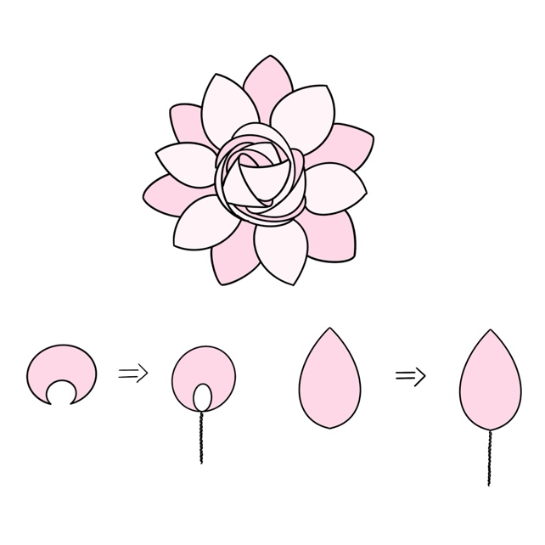 | Gardenia (Cape Jasmine Flower) | Layer 1 = 3  Layer 2 = 3  Layer 3 = 6  Layer 4 = 6 | Gardenia petals are organized uniformly and closely, with a structure that unfolds in a spiral pattern, making them ideal for opening and shutting mechanical flowers. Mechanical devices can be used to slowly rotate, unfold, or close the petals, replicating the process of gardenias from bud to full bloom, making it more vibrant and natural.
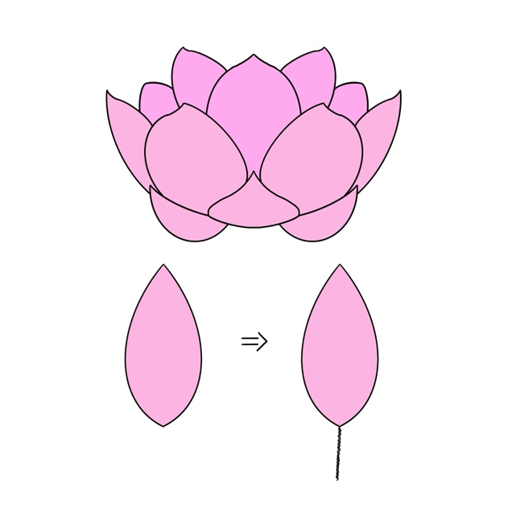 | Lotus | Layer 1 = 3  Layer 2 = 6  Layer 3 = 5 | The petals of a lotus flower open sequentially from the outside in. A multi-layered mechanical construction can be utilized to manage the petals' slow blooming, replicating natural growth and giving it a more vibrant appearance. The lotus flower blooms gently in the early morning before going close up in the evening. This type of change can be performed with servo motors, giving the mechanical flower a bionic rhythm.

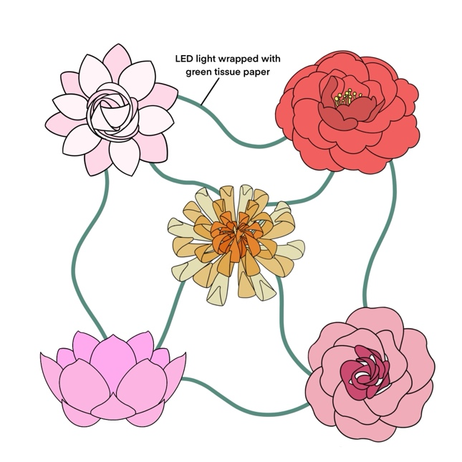

For our outcome we want to create a microcosm, simulating how the five flowers will react to different resource levels. We want to clearly show that the CMN regulates this through transporting signals and resources. Therefore, we want to add roots that go between the plants, and we will create these by embroidering them on water-soluble material. This will work effectively as we can create a wispy texture that is easy to manipulate. Additionally, this allows us to sew the LEDs into the roots rather than using full LED strips. To the side of the environment, there is a rectangle, this is representative of the sign. Through it, the user will be able to interact with the resources in the environment. Initially we wanted the users to directly interact with sensors so that the experience was pervasive, however this posed several health and safety concerns. Especially as water and electronics don’t mix. Therefore, we will use a screen where the user can select which resource they want to manipulate. Then there will be physical objects, such as buttons or potentiometers, where the user can control the resource value.

Sign Design:
https://wiki.dfrobot.com/7%27%27%20TFT_Display_with_Touchscreen_V1.0_SKU_DFR0678
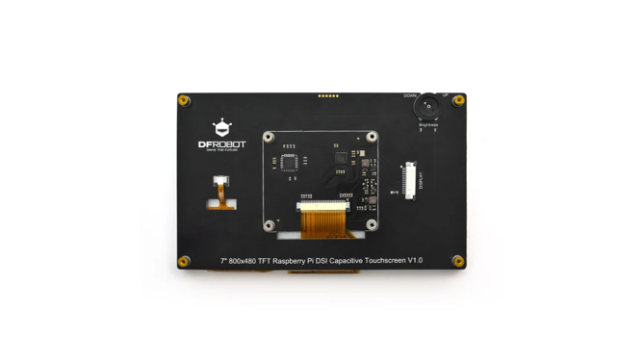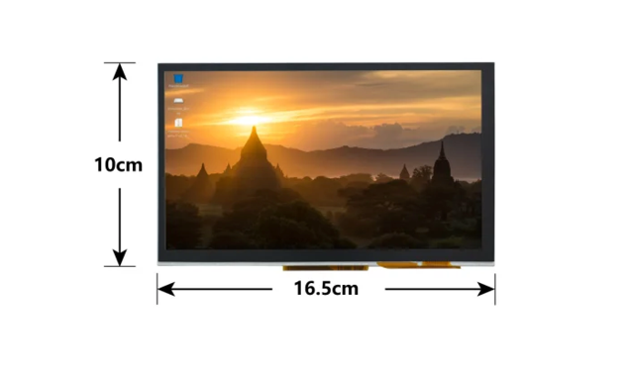
For the graphical user interface in the sign, we will be using a DFRobot 7" Raspberry Pi LCD touchscreen V1.0. This means we will be coding the interface with Python, aside from the Scientific Computing with python course we will be completing, we don’t have much prior experience using it to create interactive interfaces.
Luckily, some libraries make creating the GUI easier to program. Such as Guizero
https://lawsie.github.io/guizero/
https://pypi.org/project/guizero/
https://medium.com/women-make/7-tools-for-gui-development-on-raspberry-pi-67fd7cd9226e
ADD GANDMIFICATION THEORY AND REFERECES TO THE NOSTALGIA AND GENERAL UNDERSTANFING OF PIXEL GAMES FROM THE 1980S.
Gamification, Empathic Design, and Theories of Play in the Installation:
Gamification deepens engagement by integrating interactive storytelling and empathic design principles. The installation creates an emotionally resonant experience by allowing users to “nurture” the system, fostering a sense of care and responsibility. Empathic design, which centers on the user's emotional connection to the system, ensures that the feedback loops from robotic plants and fungi feel intuitive and meaningful. For example, if users neglect a section of the network, plants could dim their lights or physically wilt, triggering a subconscious response to intervene. Incorporating game mechanics, the installation could feature challenges requiring users to balance resource distribution (e.g., water, nutrients, and warnings) to sustain the network. Real-time feedback in the form of light pathways, sound cues, and plant responses reinforces the cause-and-effect dynamics of mycelial interactions. By using cooperative gameplay elements, users must work together to maintain the fungal network, enhancing collective learning.

Example of a dialogue box in Stardew Valley | The sign object in Minecraft
Therefore, we will draw inspiration from the graphics design styles of the popular games Stardew Valley and Minecraft.
This pixilated aesthetic
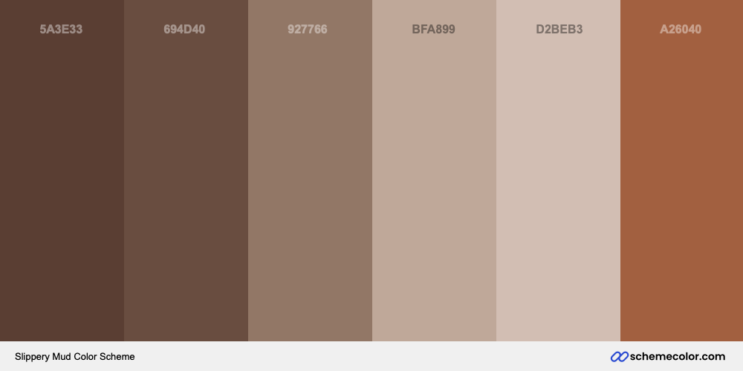
F
This is the colour palette we will be using for the user interface.

Wireframe:

https://www.figma.com/proto/b3TYG9PI3CrwJM41BB03CA/UI-for-Plant-Simulation?node-id=1-75&t=r86gIGLLbwRix7tp-1
Since making the wireframe, we have had meeting No.8. We realised that the user wont be able to actively interact with the screen aside from using potentiometers to interact with the elements. Therefore, instead of interacting with each element individually, they will all have to be on the same screen.
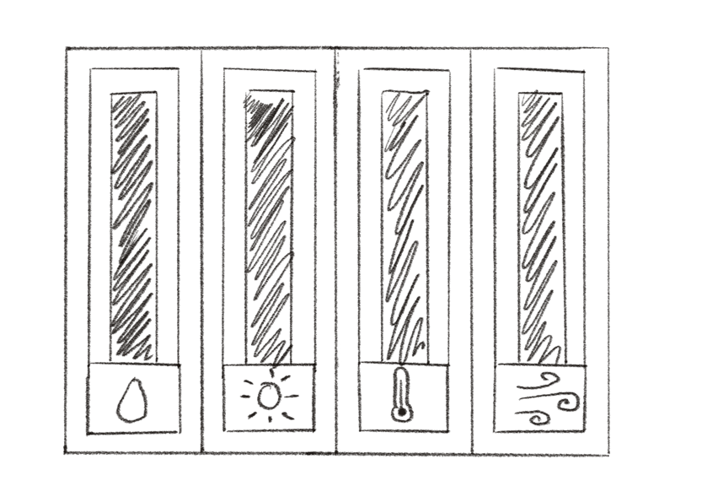

Final Sign Designs:
Element Icons:
Design | Symbol | Notes
 | Sun (Light)
 | Water Droplet (Moisture)
 | Thermometer (Temperature)
 | Wind (Air Flow)

3d Printing:
Flower joints
Potentiometers

Initial Prototypes:

Kitchen Foil:

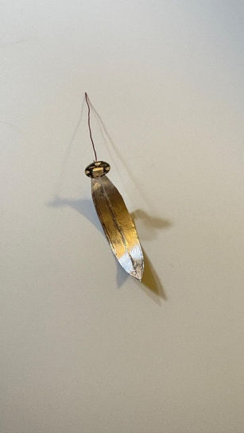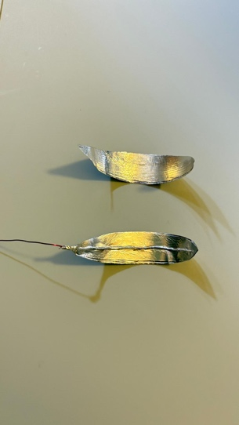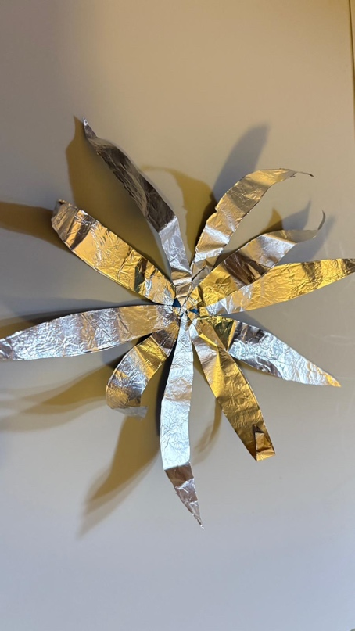
Plastic Bottles:
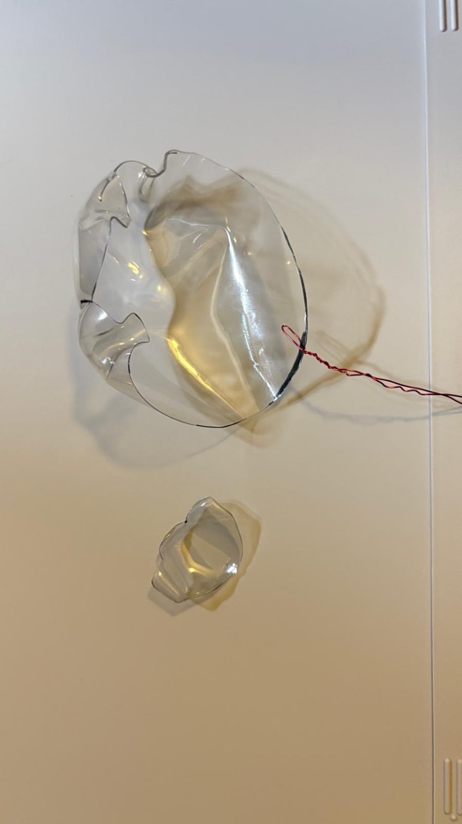
Paper:
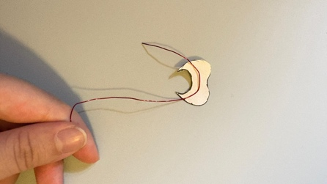

Mechanics:

3d printing:

Final Flowers:

User Testing / Play Testing:

Feedback Sessions:
Session 1:
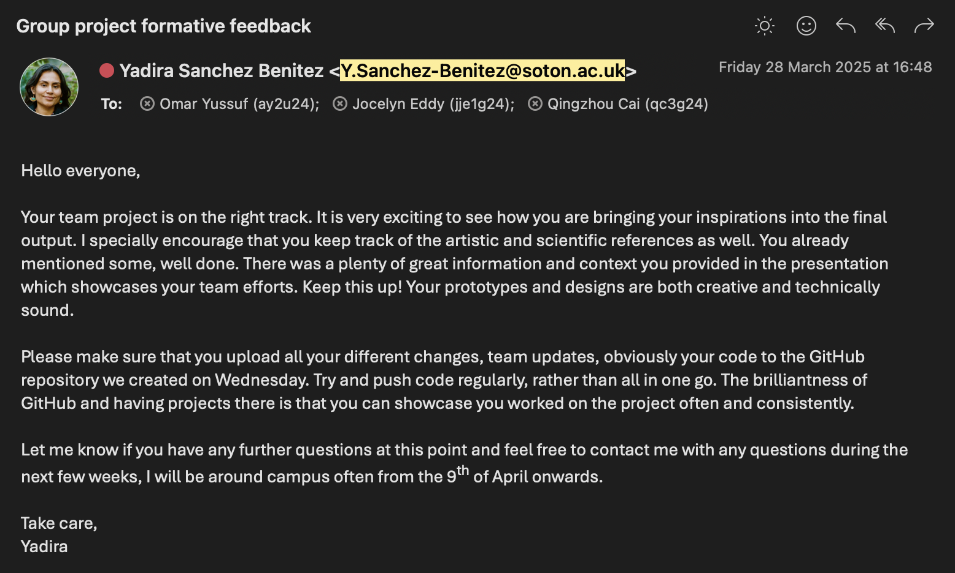

Group management records:

Meeting 1

Date | 04/02/2025 17:00
Attendance | Coco, Jocelyn and Omar (late)
Discussion | Concept ideation, simulating plant communication and the effects of the messages based on user interaction. Message examples include danger, not enough water, wind. For the outcome messages can be shown travelling through the ‘roots’ to each plant with LEDs. Then the plants can simulate the result of the message.  As evidence goes against the wood wide web, we want to look at MCN (Mycelium Connected Network) specifically in mushrooms. The parallels between mesh network topologies and these natural occurrences are a point of interest.  Want the users to directly interact by sending the messages to the plants themselves either through an app on their phone or an interface part of the installation.  Materials needed for bionic flowers, metal wire, tissue paper, clear caballing, programmable LED strips, motors. PVA Glue.  Select 5 types of fungi:  - Stinking corpse flower  Finish Flower Prototyping by week4  - Test methods and ones that aer easy can be additionally made to decorate the area
Progress Updates | N/A
Tasks assigned | Coco:  - 3 network inspirations  - Basic Design, Concept art for plants (mini animations)
Jocelyn:
- 3 plant artwork inspirations HCI
- Project concept
- Sketches for installation space layout
Omar:
- 3 bionic inspirations
- Goals (technical outcome, impact)
- Target audience research
Links | Tutorial 4 Bionics4Education – Inspiration from the plant world – The Bionic Flower  Mushrooms May Communicate With Each Other Using Electrical Impulses | Smithsonian  Fungi may not think, but they can communicate - Ars Technica  Where the ‘Wood-Wide Web’ Narrative Went Wrong  Robotic Flowers - YouTube  Swarm Garden brings robotic flowers to life - Princeton Engineering

Meeting 2

Date | 10/02/2025
Attendance | Coco and Jocelyn (Meeting with Yadira) 12:00
Discussion | Discussed feasibility of our outcome.  - Made the decision that the uses will actively participate with the sensors to control how the flowers react, rather than a graphical user interface.  - Discussed supplies that need ordering, and the list has been sent to Alice.  - Y – mentioned giant flowers made from crepe paper.  - The location for the presentation of our outcome is not yet decided but we will be updated as soon as she knows. Potentially the rotunda.

Meeting 3

Date | 17/02/24 16:00
Attendance | Coco, Jocelyn and Omar
Discussion | - Spoke to Alice about ordering craft components as the motors have already been ordered.  - Spoke to ross about 3D printing signs, buttons etc. Using PusaSicer software where files must be saved as .stl. Also must enable 3D printing toolbox on blender so that the design is watertight and solid.  - Spoke to Jacob in sculpture studio. We have organised an appointment for next Friday to look at materials. (Must bring a plan and design). Next weekask about the ceramics printer. QUESTION SECTION )  - Spoke to E-textiles, can email Gillian (galt1r23@soton.ac.uk) plan. Shes can help with domestic embroidery and conversation with textiles. They have an electrode embroidery machine.  - Alice – resin is heavy, instead use sheets of acetate (clear coloured plastic). Sheets of conductive material, conductive thread (sew led in fabric on water soluble material. For embroidery.) even sew thick wool then put the LED on top (OPEN QUESTION SECTION).  - Idea – Flower projection, showing different colours for different stages of life.
Progress Updates | - Initial Flower designs are completed.  - Initial inspiration points are selected (J & C need to finish writeup, O needs images)  - Need to send list of materials required to Alice (End of Next Week)
Tasks assigned | Coco  - Finish initial table for designs of flower.  - Animation to demonstration LED movement between plants  - Sv iii  - Research and designs for Light, Moisture (Inclusive of signs and buttons)  Jocelyn  - Writeup for UI references  - SV i  - Research and designs for Sound, Air Movement (Inclusive of signs and buttons)  Omar  - Flowcharts demonstration interaction between sensor data and robotic flowers for each resource type  - UI Flowchart for Gamified Messages  - Research into gamification theory + play  - SV iv & ii  - Research and designs for Nutrients and Motion. (Inclusive of signs and buttons)
Links | https://meredithwoolnough.com.au/blog/2021/9/28/insider-feature-how-embroidery-comes-to-life-with-water-soluble-fabric

Meeting 4

Date | 25.2.24
Attendance | Coco and Jocelyn
Discussion | Trialling different methods to make the petals.
Progress Updates
Tasks assigned | Continuation of previous research and design tasks assigned.
Links | https://learn.adafruit.com/flora-rgb-smart-pixels/add-more-pixels  https://forums.adafruit.com/viewtopic.php?t=53636

Meeting 5

Date | 28/02/24
Attendance | Coco, Jocelyn and Omar (Jacob – Sculpture Technician)
Discussion | - Could potential order stronger servo  - Have conductive thread but should keep the LEDs separate to the flowers to enable more control.  - Could 3d print and make casts but too heavy to motors, therefore more environmental decorations  - Braid the wiring for a stronger structure.  - Potential for fungi and mushrooms to link better to the MCN  - Ask for a plywood base so we can screw in the flowers, spray paint, incorporate mushrooms and moss.  - Organise a sewing machine induction and purchase materials from their online shop. (Using water soluble material with heavily embroidered thread to sew the neo pixels into)  - Ask about purchasing foam, to build structure of environment.  - To make the environment more cohesive will be including plants made from other materials, weight doesn’t matter as it isn’t motorised. Incorporate moss etc.  - Look at whether flowers are affected by the mcn.
Progress Updates | - Collected a sheet of wood from Jacob for the base of the installation. Drawn out the design for where the material needs to be cut, and the layout of the robotic flowers in order to conform to design ideas.
Tasks assigned | Continuation of previous research and design tasks assigned.

Meeting 6

Date | 13.3.25
Attendance | Coco, Jocelyn and Omar
Discussion | Organising the presentation and which elements each of us will be completed.  Completed our sewing induction and now can use the machines when required. Spoke to Jacob we will be meeting him tomorrow to figure out materials for the flower’s mechanics.
Progress Updates | - Collected an LCD screen.  - Presentation is majority done.
Tasks assigned | Coco  - Reading  - Develop paper prototype for more layers  Omar  - Reading  Jocelyn  - Reading  - Initial Graphics design for user interface.  - Design for Environment
Links

Meeting 7

Date | 28.4.25
Attendance | Coco, Jocelyn and Omar
Discussion | We need to visit Jacob and ask for 3d printing aspects and sticks. (probably Thursday in the lunch break).  For the final presentation on the 12th of May, we need to do all the theoretical work and finish making the petals so we can start motorising them next week. Additionally, it says we need visual aids/Slides so we can develop on from our formative ones. (Make posters to go with our outcome/slides that the visitor can flip through).  Need to order the materials for the board such as foam.  Change the embroidery into scraps of rolled to put the LEDS on to it. Need to get white fabric to simulate the roots, shades of cream and pale browns. We went to the fabric store in the textile department, found green weaved fabric and cream tulle. So, we will do approximately 4 layers or so.
Progress Updates | The tasks assigned are what we are going to try and complete this week. Still need to complete Task 4 for the group.
Tasks assigned | Coco  - 1 flower petals  - ½ flower petals (do prototype drawing)  - Sensor Research - for Light, Moisture  - Light sensor
Jocelyn
- 1 flower petals
- ½ flower petals
- Sensor Research - Sound, Air Movement
- Screen interface
- UI Design
- Organise Visual Aids
Omar
- Inspiration Writeup
- Sensor Research - Nutrients and Motion
- Code the LEDs
- Write up of UI + Design
- Potential for Sensor Research if completed alright.

Meeting 8

Date | 2.5.25
Attendance | Jocelyn and Coco
Discussion | Looked at how the integration of the sign will be with the environment. Originally, we wanted to 3d print a stand for the sign in the style of mindcraft however due to time limitations we don’t think this will be feasible. Therefore, we are going to embed the screen into foam on the board. In front of it there will be the four potentiometers to control each element.  Spoke to Alice and the foam has been ordered to arrive next week.  Spoke to Jacob, we reduced the size of the joints to approximately 5mm. We will test how how they work when printed and then we will print another 34 more. So that there are 7 per flower. We also requested for the disks to be made.

Meeting 9

Date | 6.5.25
Attendance | Jocelyn, Omar and Coco
Discussion
Progress Updates
Tasks assigned
Links

Meeting 10

Date
Attendance
Discussion
Progress Updates
Tasks assigned
Links

Final Outcome:

Video Demo

Showcase (12.5.25 – 26.5.25)

Visual Aids

References

i. Articles, books, or papers.

ii. Code libraries or frameworks.
LCD Bitmap Library for Arduino: https://bitbucket.org/teckel12/arduino-lcd-bitmap/wiki/Home#!index
https://pillow.readthedocs.io/en/latest/installation/basic-installation.html
https://lawsie.github.io/guizero/#additional-features-install

iii. Websites and tutorials.

The wood-wide web – mycorrhizal associations across individuals (2016) Arboriculture. Available at: https://arboriculture.wordpress.com/2016/02/24/the-wood-wide-web-mycorrhizal-associations-across-individuals/ (Accessed: February 13th, 2025).
New Scientist (1971) (no date) “Suzanne Simard interview: How I uncovered the hidden language of trees.” Available at: https://www.newscientist.com/article/mg25033320-900-suzanne-simard-interview-how-i-uncovered-the-hidden-language-of-trees/ (Accessed: February 13th, 2025).
Wikipedia contributors (2025) Mycorrhizal network, Wikipedia, The Free Encyclopedia. Available at: https://en.wikipedia.org/w/index.php?title=Mycorrhizal_network&oldid=1287598360. (Accessed: February 13th, 2025).
Yeo, S. (2024) “The ‘wood wide web’ theory charmed us all – but now it’s the subject of a bitter fight among scientists,” The guardian, 9 July. Available at: https://www.theguardian.com/commentisfree/article/2024/jul/09/wood-wide-web-theory-charmed-us-bitter-fight-scientists (Accessed: February 13th, 2025).
(No date) Nature.com. Available at: https://www.nature.com/articles/s41559-023-01986-1.epdf?sharing_token=-wxqdAiztdyvbbe2P4uWqdRgN0jAjWel9jnR3ZoTv0NhTP-fzuHqUsVVnDaJbaXlPDeSXUxYqcTbqUWYB-bJgnYwYwl2MW_UNDNQISj2SC0YL8WsBj_rqDSe8p66EzcyFqC-C_WSbzGJeSLGQUbr_acM-Qotj6FWH0tSDW46K01Y9cziqxR3aj8HH67q-h_Z2WQ5byo_OPGdyoV_2Dw0_c0gtB0A_dragZCX8-_S5fU%3D&tracking_referrer=www.theguardian.com (Accessed: February 13th, 2025).
Times of Malta (2024) Myth Debunked: Do trees communicate via a wood wide web? Maybe not, Times of Malta. Available at: https://timesofmalta.com/article/myth-debunked-do-trees-communicate-via-wood-wide-web-maybe.1100992 (Accessed: February 13th, 2025).
The Editors of Encyclopedia Britannica (2022) “bionics,” Encyclopedia Britannica. (Accessed: February 15th, 2025).
Clark, A., & Chalmers, D. (1998). The extended mind. Analysis, 58(1), 7-19.
Varela, F. J., Thompson, E., & Rosch, E. (1991). The embodied mind: Cognitive science and human experience. MIT Press.
Dennett, D. (1991). Consciousness explained. Little, Brown and Company.
Carroll, J.M. (no date) Human Computer Interaction - brief intro, The Interaction Design Foundation. Available at: https://www.interaction-design.org/literature/book/the-encyclopedia-of-human-computer-interaction-2nd-ed/human-computer-interaction-brief-intro (Accessed: February 19th, 2025).
(No date b) Sciencedirect.com. Available at: https://www.sciencedirect.com/science/article/pii/S1071581923001374#abs0002 (Accessed: February 19th, 2025).
SEADS (no date) Seads.network. Available at: https://seads.network/project/tai8 (Accessed: February 19th, 2025).
Lasserre, S.:. G. and den Ancxt, A.M. (no date) Akousmaflore Sensitive and interactive musical plants from scenocosme, scenocosme : Gregory Lasserre & Anais met den Ancxt. Available at: https://www.scenocosme.com/akousmaflore_en.htm (Accessed: March 3rd, 2025).
(No date c) Scenocosme.com. Available at: https://www.scenocosme.com/PDF/akousmaflore_en.pdf (Accessed: March 3rd, 2025).
Eau de Jardin (2021) DAM MUSEUM. Available at: https://dam.org/museum/artists_ui/artists/sommerer-mignonneau/eau-de-jardin/ (Accessed: March 3rd, 2025).
Cyborg Botany: Augmented plants as sensors, displays, and actuators (no date) MIT Media Lab. Available at: https://www.media.mit.edu/projects/cyborg-botany/overview/ (Accessed: April 28, 2025).
PLANTOID: Robotic solutions inspired by plants (no date) Shaping Europe’s digital future. Available at: https://digital-strategy.ec.europa.eu/en/news/plantoid-robotic-solutions-inspired-plants (Accessed: April 28, 2025).
(No date d) Defencescienceinstitute.com. Available at: https://defencescienceinstitute.com/wp-content/uploads/2025/01/DARPA-EA-25-02-02.pdf (Accessed: April 28, 2025).
Biohybrid futures (no date) Biohybrid-futures.ac.uk. Available at: https://biohybrid-futures.ac.uk (Accessed: April 28, 2025).
Rillig, M.C. et al. (2024) “Clarifying the definition of common mycorrhizal networks,” Functional ecology [Preprint]. Available at: https://doi.org/10.1111/1365-2435.14545.
https://makersportal.com/shop/pitot-tube-airspeed-sensor-for-arduino-and-raspberry-pi
https://www.aos.org/orchid-care/air-movement
https://www.canna-uk.com/articles/how-air-temperature-affects-plants#:~:text=When%20there%20is%20no%20air,which%20can%20attack%20the%20plant.
https://www.fdacs.gov/Consumer-Resources/Health-and-Safety/Food-Safety-FAQ/What-conditions-encourage-bacteria-to-grow#:~:text=Bacteria%20can%20live%20in%20hotter,acidic%20or%20extremely%20salty%20conditions.
https://nph.onlinelibrary.wiley.com/doi/10.1111/nph.17866
https://growace.com/blogs/learning-center/does-my-plant-have-enough-air-circulation?srsltid=AfmBOoqGLgXTW7PB9hcZyNbFn6JW44IOW0JjepFvoEYoUV_IOSaRfTvG
https://bouquetandframe.com/blog/understanding-the-colour-shifts-of-dried-floral-creations#:~:text=During%20the%20pressing%20process%2C%20flowers,or%20develop%20a%20papery%20texture
Water is Essential for Food Production (2025) Student Materials. Available at: https://serc.carleton.edu/integrate/teaching_materials/food_supply/student_materials/1090 (Accessed: May 5, 2025).
Water Deficiency in plants (no date) Myplantin.com. Available at: https://myplantin.com/diseases/water-deficiency-in-plants (Accessed: May 5, 2025).
Effect of water scarcity on plants (2020) Airowater.com. Atmospheric water Generator. Available at: https://www.airowater.com/blog/effect-of-water-scarcity-on-plants/ (Accessed: May 5, 2025).
(No date i) Researchgate.net. Available at: https://www.researchgate.net/profile/Amit-Kumar-509/publication/339715902_The_Importance_of_Water_in_Relation_to_Plant_Growth/links/63823cb6c2cb154d292d1e2c/The-Importance-of-Water-in-Relation-to-Plant-Growth.pdf (Accessed: May 5, 2025).
Bce, A.R.N. (2024) Reading the leaves: Signs of overwatering and underwatering & how to know the difference, Rockledge Gardens. Available at: https://rockledgegardens.com/reading-the-leaves-signs-of-overwatering-and-underwatering-how-to-know-the-difference/ (Accessed: May 5, 2025).
“Plants and water—A brief look at how water affects plant growth” (2022) Swan Hose, 24 March. Available at: https://swanhose.com/blogs/general-watering/how-does-water-its-amount-its-quality-affect-plant-growth (Accessed: May 5, 2025).
Wu, W. et al. (2024) “The role of light in regulating plant growth, development and sugar metabolism: a review,” Frontiers in plant science, 15, p. 1507628. Available at: https://doi.org/10.3389/fpls.2024.1507628. (Accessed: 6th May 2025)
Lighting for indoor plants and starting seeds (no date) Umn.edu. Available at: https://extension.umn.edu/planting-and-growing-guides/lighting-indoor-plants (Accessed: May 5, 2025).
Excess light on indoor plants (no date) Umd.edu. Available at: https://extension.umd.edu/resource/excess-light-indoor-plants/ (Accessed: May 5, 2025).
Bunn, R., Lekberg, Y. and Zabinski, C. (2009) “Arbuscular mycorrhizal fungi ameliorate temperature stress in thermophilic plants,” Ecology, 90(5), pp. 1378–1388. Available at: https://doi.org/10.1890/07-2080.1.
“What mushrooms do in the winter” (2021) National Trust for Scotland, 16 December. Available at: https://www.nts.org.uk/stories/what-mushrooms-do-in-the-winter (Accessed: May 5, 2025).
(No date g) Tamu.edu. Available at: https://aggie-horticulture.tamu.edu/ornamental/a-reference-guide-to-plant-care-handling-and-merchandising/light-temperature-and-humidity/#:~:text=Excessively%20low%20or%20high%20temperatures,plant%20growth%20than%20high%20temperatures. (Accessed: May 5, 2025).
CANNA Research (no date) How air temperature affects plants, Canna-uk.com. Available at: https://www.canna-uk.com/articles/how-air-temperature-affects-plants (Accessed: May 5, 2025).
Cherlinka, V. (2023) “Soil temperature for optimal crop growth and development,” EOS Data Analytics, 30 January. Available at: https://eos.com/blog/soil-temperature/ (Accessed: May 5, 2025).
(No date h) Jacksonandperkins.com. Available at: https://www.jacksonandperkins.com/signs-your-plant-is-too-cold/a/signs-your-plant-is-too-cold/ (Accessed: May 5, 2025).
Weber, H. (2023) Plant responses to heat stress, CID Bio-Science. Available at: https://cid-inc.com/blog/plant-responses-to-heat-stress/ (Accessed: May 5, 2025).
What every gardener should know about heat stress (no date) envii. Available at: https://envii.co.uk/blogs/news/what-every-gardener-should-know-about-heat-stress (Accessed: May 5, 2025)
https://wiki.dfrobot.com/7%27%27%20TFT_Display_with_Touchscreen_V1.0_SKU_DFR0678
https://medium.com/women-make/7-tools-for-gui-development-on-raspberry-pi-67fd7cd9226e
https://www.thegamer.com/stardew-valley-best-story-mods/ 3.3.25
https://minecraft.wiki/w/Sign 3.3.25
Slippery Mud color scheme (no date) SchemeColor. Available at: https://www.schemecolor.com/slippery-mud.php (Accessed: April 28, 2025).

