INTERNSHIP REPORT

NAME | : | ZENITH JOSHUA J
BRANCH & DEPARTMENT | : | B.TECH INFORMATION TECHNOLOGY
YEAR | : | IV Year
REGISTER NUMBER | : | 311123205064
ROLL NUMBER | : | 23IT074
COLLEGE NAME AND TECHNOLOGY | : | LOYOLA - ICAM COLLEGE OF ENGINEERING AND TECHNOLOGY
ORGANIZING BODIES | : | AICTE, IBM SKILLSBUILD & EDUNET FOUNDATION
BATCH | : | AICTE B2_(AI) - 2025-26
LOCATION | : | VIRTUAL (REMOTE INTERNSHIP)
INTERNSHIP START DATE | : | 18/06/2025
INTERNSHIP END DATE | : | 31/07/2025
TYPE OF INTERNSHIP | : | ARTIFICIAL INTELLIGENCE & MACHINE LEARNING INTERNSHIP (IBM SKILLSBUILD)
UNIVERSITY NAME | : | AFFILIATED TO ANNA UNIVERSITY.

ACKNOWLEDGEMENT
I would like to sincerely thank AICTE, IBM, and Edunet Foundation for giving me the opportunity to undergo this internship under the IBM SkillsBuild program, in the Artificial Intelligence & Machine Learning track. This experience allowed me to apply the theoretical knowledge gained in my academics to a real, industry-relevant machine learning project.
I am especially grateful to the program coordinators and mentors at AICTE, IBM SkillsBuild, and Edunet Foundation for their guidance, structured curriculum, and continuous support throughout the internship period. Their feedback and the well-designed learning modules helped me overcome technical challenges and improved both my technical and professional skills.
My heartfelt thanks also go to the IBM SkillsBuild program team for creating a positive and supportive virtual learning environment during my internship.
Finally, I am deeply thankful to the Department of Information Technology, Loyola-ICAM College of Engineering and Technology, and my faculty in-charge for giving me this opportunity and for their continuous encouragement throughout my academic journey.

STATEMENT OF ENDORSEMENT
I hereby solemnly declare that the work presented in this internship report entitled "SalaryPredict AI – Explainable Machine Learning for Employee Salary Prediction, under the AICTE – IBM SkillsBuild – Edunet Foundation Program" is my own original effort and has been carried out by me during the internship period from 18-06-2025 to 31-07-2025, as part of the IBM SkillsBuild (AI & Machine Learning) virtual internship organized by AICTE, IBM, and Edunet Foundation.
This report has been prepared in accordance with the guidelines provided by my institution and it has not been previously submitted, either wholly or in part, for any academic credit or degree at this or any other institution.

Date : 25/08/2026
Place : Chennai

Signature of the Student
ZENITH JOSHUA J

EXECUTIVE SUMMARY
I had the opportunity to complete a 6-week virtual internship under the IBM SkillsBuild program, organized by AICTE, IBM, and Edunet Foundation, in the Artificial Intelligence & Machine Learning track. As part of this internship, I took over and substantially rebuilt SalaryPredict AI — a machine-learning-powered web application that predicts employee salary from five inputs (age, gender, education level, job title, and years of experience) and explains, feature by feature, why it produced that number. The objective of the project was to move beyond a black-box salary predictor and build a data-driven decision-support tool whose reasoning is transparent enough to actually be useful in a negotiation.
During the course of the internship, I gained practical experience with Python, Pandas, and Scikit-learn for data handling and modelling, SHAP for model explainability, and Flask, Jinja2, and fpdf2 for building and serving the web application, all developed using Jupyter Notebook and a Flask development environment. I was responsible for auditing and cleaning an inherited codebase, redesigning the entire user interface and workflow, integrating exact per-prediction explainability using SHAP's TreeExplainer, and — critically — identifying and correcting a methodological flaw in how the application's predictions were being presented to users.
This project gave me exposure to real-world applied data-science practices that go beyond model accuracy: auditing legacy code for correctness, verifying that a deployed model's claims actually match its training data, and building an interface that explains a prediction rather than just stating it. More importantly, it helped me understand that a data science solution is only as trustworthy as its weakest assumption — in this case, an unexamined currency conversion that had been silently misrepresenting US salary data as an Indian salary estimate.
Beyond technical skills, the internship strengthened my debugging discipline, attention to detail, and willingness to question a system's existing behaviour rather than accept it at face value. The experience under the IBM SkillsBuild program has been genuinely rewarding and has given me confidence in applying my knowledge to practical, industry-relevant data science and software engineering challenges.

TABLE OF CONTENTS
1. PROGRAM & ORGANIZATION OVERVIEW 5
2. INTERNSHIP 6
2.1 Project 6
2.1.1 Context of the Project 6
2.1.2 Tasks Assigned 6
2.1.3 Schedule of the Project 7
2.1.4 Solutions Proposed 8
2.2 Observations 9
2.2.1 Presentation of the Project 9
2.2.2 Presentation of the Process 9
SalaryPredict AI – Workflow / Work Samples 9
3. ANALYSIS OF MY EXPERIENCE 12
3.1 Technical Observations 12
3.2 Presentation of the Differences 12
3.3 Difficulties Encountered 12
3.4 Satisfaction 12
4. CONCLUSION 13
4.1 What I Learnt 13
4.2 Opportunities and Scope 13
4.3 Future Enhancements 13
5. REFERENCES 14

1. PROGRAM & ORGANIZATION OVERVIEW
IBM SkillsBuild Program
IBM SkillsBuild is IBM's free, global education program, delivered in India in partnership with AICTE (All India Council for Technical Education) and Edunet Foundation, that provides students with practical, project-based learning in emerging technologies such as Artificial Intelligence, Data Analytics, and Cloud Computing. The program addresses the gap between traditional curricula and industry-relevant skills by combining structured online coursework with a self-directed, milestone-based internship project.
AICTE – All India Council for Technical Education
Name of the Organization: All India Council for Technical Education (AICTE)
Type: Statutory national-level body under the Department of Higher Education, Ministry of Education, Government of India
Date of Creation: Established in November 1945 as an advisory body; given statutory status by an Act of Parliament in 1987
Headquarters Location: New Delhi, India
Role: AICTE is responsible for the planning, coordination, and quality regulation of technical and management education in India, and coordinates the IBM SkillsBuild internship on the academic side, connecting participating colleges and students to the program.
IBM
Name of the Organization: IBM (International Business Machines Corporation)
Type: Multinational technology and consulting company
Sector of Activity: Enterprise software, cloud computing, artificial intelligence, and IT consulting; IBM SkillsBuild is run as part of IBM's corporate social responsibility and skills-for-jobs initiatives, providing free digital learning in AI and emerging technologies to students, educators, and jobseekers worldwide.
Role in this Program: Provides the AI & Machine Learning learning journeys, structured courses, and technical curriculum completed during the internship's orientation and technical-session weeks.
Edunet Foundation
Name of the Organization: Edunet Foundation
Type: Non-profit social enterprise focused on digital skilling, employability, and entrepreneurship
Date of Creation: Founded in 2015
Role: Edunet Foundation delivers the virtual internship platform, mentorship, structured curriculum, and project milestones for the IBM SkillsBuild program, bridging the academia-industry gap for participating students across India.
Strengths of the Program
- A structured, milestone-based virtual internship model combining self-paced learning with mentor guidance.
- Backing from AICTE, connecting the program directly to participating engineering colleges across India.
- Industry-grade curriculum from IBM, aligning student projects with real-world AI & Machine Learning practices.
- A dedicated e-learning and project platform operated by Edunet Foundation, supporting thousands of learners nationally.

2. INTERNSHIP

2.1 Project
2.1.1 Context of the Project
The internship was structured as a self-driven, milestone-based Artificial Intelligence & Machine Learning program. Starting from a single raw dataset, I independently designed and built SalaryPredict AI end-to-end — cleaning and exploring the data, engineering features, comparing regression algorithms, training the final model, and developing the Flask web application that serves it — with periodic guidance from the program's mentors and structured learning modules. The later weeks of the internship were then spent taking that self-built application from an early, cosmetically-styled prototype to a genuinely production-quality, explainable machine learning product.
The main goal of the internship project was to take SalaryPredict AI from an early, cosmetically-styled prototype to a professional application that would:
- Predict an employee's likely annual salary from five inputs: age, gender, education level, job title, and years of experience.
- Explain every prediction with an exact, per-feature contribution breakdown, rather than returning an unexplained number.
- Present only the fields the underlying model actually uses — not a longer form collecting data the model ignores.
- Generate a downloadable PDF report reproducing the same prediction and explanation shown on screen.
- Be visually and structurally consistent with a professional, production-grade web application.
This was a meaningful task, as it required integrating multiple layers of a real data-science product — model auditing, explainability engineering, backend cleanup, and front-end redesign — into a single, coherent, working application.
2.1.2 Tasks Assigned
The following tasks were assigned and completed during the internship project:
- Data Preparation & Model Training – Cleaned and explored the raw Salary Data.csv dataset (373 records), engineered features, and compared multiple regression algorithms (Linear Regression, Random Forest, and gradient-boosted trees) using GridSearchCV and k-fold cross-validation before selecting and training the final Random Forest Regressor.
- Application Development – Built the Flask web application end-to-end (main.py) to serve the trained model, including the prediction form, results page, and a downloadable PDF report generator.
- Codebase Audit & Refinement – Revisited my own earlier prototype, identifying dead code, duplicated logic, and unhandled error paths accumulated as the project grew.
- UI/UX Redesign – Replaced an early, overly decorative theme (animated particle background, 3D card tilts, cookie banner) with a clean, professional, single shared stylesheet used consistently across all pages.
- Workflow Correction – Reduced the prediction form from 13 collected fields down to the 5 fields the trained model actually consumes, removing inputs that were collected but silently ignored.
- Backend Cleanup – Removed roughly 250 lines of dead, duplicated PDF-report code and fixed an exception-handling bug where invalid category input was not being caught by the correct error type.
- Explainability Integration – Implemented SHAP's TreeExplainer against the trained Random Forest model to compute an exact, per-feature contribution for every prediction.
- Critical Bug Discovery & Fix – Identified that an earlier version of the application was multiplying the model's USD prediction by a fixed exchange rate and presenting it as an Indian salary estimate, despite the training data having no country or currency field at all; corrected the application to present honest USD predictions with a clear, visible disclosure of this limitation.
- PDF Report Rebuild – Rebuilt the PDF report generator to recompute predictions and explanations server-side rather than trusting values passed back from the browser, and fixed a Unicode/encoding bug that could crash report generation.
- Testing & Verification – Ran the full application end-to-end with the real trained model, verified that SHAP contributions sum exactly to each displayed prediction, and captured screenshots to confirm the redesigned interface.
- Documentation – Wrote the project README and in-app methodology page, and prepared this internship report.
2.1.3 Schedule of the Project
The internship project was completed within a 6-week duration (18 June 2025 – 31 July 2025), with each week focused on specific milestones. The schedule progressed from orientation and technical sessions, through data understanding, model and explainability work, to full application redesign, correctness fixes, and final documentation.
Week 1 – Orientation & Basic Concepts
- Completed the SkillsBuild Orientation – Edunet course.
- Completed the Edunet – Artificial Intelligence – IBM SkillsBuild course.
- Understood the AI & Machine Learning domain and the SalaryPredict AI project brief.
Week 2 – Technical Session
- Attended technical sessions covering machine learning fundamentals, including regression models, feature engineering, and model evaluation metrics.
- Studied preprocessing techniques used in the project: label encoding of categorical features and min-max feature scaling.
- Set up the Python, Flask, and Jupyter Notebook development environment used for the rest of the internship.
Week 3 – Dataset Shared & Exploratory Data Analysis
- Received Salary Data.csv (373 records: Age, Gender, Education Level, Job Title, Years of Experience, Salary) and carried out exploratory data analysis and preprocessing — label encoding of categorical features and min-max feature scaling.
- Identified that the dataset carries no country, location, or currency field, and that its salary values ($350–$250,000, mean ~$100,577) reflect a general US compensation distribution.
- Began building the Flask application scaffold (main.py) to eventually serve the model once trained.
Week 4 – Model Training & Explainability
- Trained and compared multiple regression algorithms — Linear Regression, Random Forest, and gradient-boosted trees — using GridSearchCV for hyperparameter tuning and k-fold cross-validation, and selected the Random Forest Regressor as the final model based on R², RMSE, and MAE.
- Integrated SHAP's TreeExplainer against the trained Random Forest model to compute exact, per-feature contributions for every prediction.
- Verified programmatically that the baseline value plus the five SHAP contributions always sum precisely to the model's predicted output.
Week 5 – Application Build-Out, Backend Cleanup & UI/UX Redesign
- Completed the Flask application serving the trained model, then reduced the prediction form from 13 fields to the 5 fields (age, gender, education level, job title, years of experience) the model actually uses, removing collected-but-unused fields and a distracting name/location entry modal.
- Removed approximately 250 lines of dead, duplicated PDF-generation code from the backend, and rebuilt the PDF report generator to recompute predictions and explanations server-side rather than trusting client-supplied values.
- Redesigned the entire front end — landing page, prediction form, and methodology page — into a single, consistent, professional design system, replacing an earlier decorative theme, and added a “Why this number” explanation panel visualising each SHAP contribution as a labelled, signed bar.
Week 6 – Correctness Fix, Testing & Documentation
- Discovered and corrected a critical methodological issue in an earlier version of the application: predictions were being multiplied by a fixed USD-to-INR exchange rate and presented as an Indian salary estimate, despite the training data being US-only — corrected the app to display honest USD figures with a clear, visible limitation notice.
- Fixed a Unicode/PDF-encoding bug that could crash the report download, and added a defensive text-sanitising safeguard against similar future issues.
- Ran end-to-end tests against the live Flask application and the trained model, confirmed every route and error path behaved correctly, and visually verified the redesigned interface.
- Finalised the project README, in-app methodology page, and this internship report.
2.1.4 Solutions Proposed
- Exact, Verifiable Explainability – Used SHAP's TreeExplainer, which produces exact rather than approximated feature contributions for tree-based models, and verified this programmatically rather than assuming correctness.
- Workflow-Model Alignment – Trimmed the prediction form so that every field a user fills in genuinely affects the prediction, rather than collecting data the model silently discards.
- Rigorous Model Selection – Compared multiple regression algorithms against the raw dataset with cross-validation and hyperparameter tuning before committing to the final Random Forest model, rather than assuming a single approach would generalise best.
- Honest Unit Presentation – Removed an unjustified currency conversion and replaced it with a transparent, clearly-labelled disclosure of what the model was actually trained on.
- Defensive Report Generation – Rebuilt PDF generation to recompute results server-side and added a text-sanitisation safeguard, so the report can never drift from, or crash because of, what the model actually produced.
- Consistent, Professional Interface – Replaced a fragmented, decorative front end with one shared design system applied uniformly across every page of the application.

2.2 Observations
2.2.1 Presentation of the Project
The resulting product is a fully functioning, explainable Smart Salary Prediction application. A user enters five details — age, gender, education level, job title, and years of experience — through a clean web interface, and instantly receives a predicted annual salary alongside an exact breakdown of how each of those five inputs pushed the number up or down.
What differentiates this system from a typical prediction tool is that it does not simply return a number. Because the underlying model is a Random Forest — a tree ensemble — SHAP's TreeExplainer can compute an exact, not approximated, contribution for every feature, and those contributions always sum precisely to the displayed prediction. The same breakdown is recomputed on the server for the downloadable PDF report, so the report can never disagree with what the user saw on screen.
2.2.2 Presentation of the Process
The development process followed an iterative, milestone-driven cycle, with each stage — model training, explainability integration, backend cleanup, interface redesign, correctness fixes, and testing — completed, verified, and refined before moving to the next.
At a technical level, the raw dataset was cleaned and preprocessed, several regression algorithms were trained and compared using cross-validation and hyperparameter tuning, and the resulting Random Forest model, its MinMaxScaler, and its label encoders were serialised and loaded into the Flask application. SHAP's TreeExplainer was then integrated against the unwrapped estimator to compute exact per-feature contributions, verified programmatically against the model's raw prediction. On the backend side, dead and duplicated PDF-generation code accumulated in earlier iterations was removed, error handling was corrected, and the report generator was rebuilt to recompute results server-side. On the front end, a single shared stylesheet and script replaced a fragmented, decorative theme across the landing page, prediction form, and methodology page.
This structured, verify-before-trusting process — auditing my own earlier work rather than assuming it was correct — closely mirrors how applied machine learning systems are maintained in real production environments.
SalaryPredict AI – Workflow
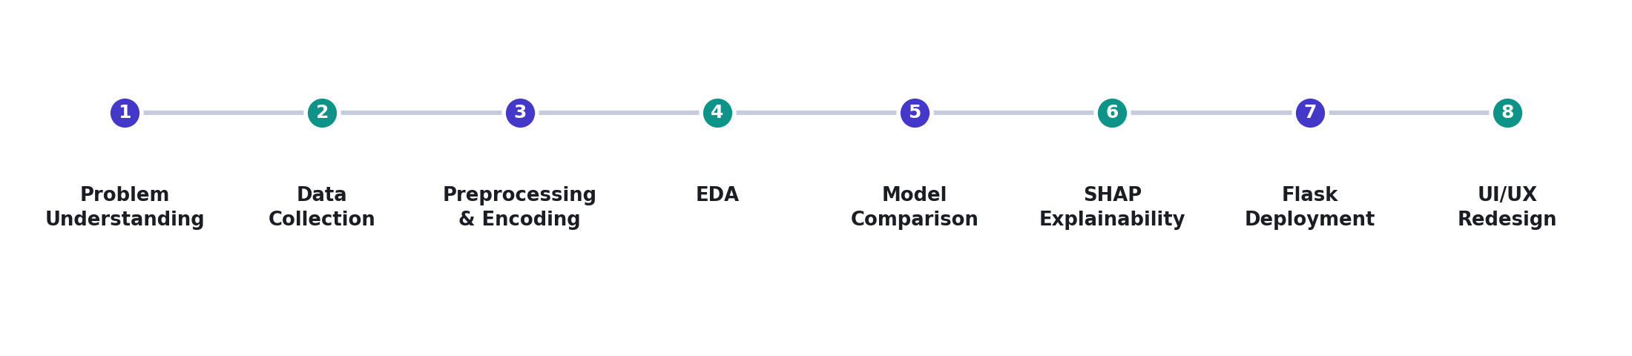
Figure 1: End-to-end workflow of the SalaryPredict AI redesign, from problem understanding to UI/UX redesign.
Work Samples
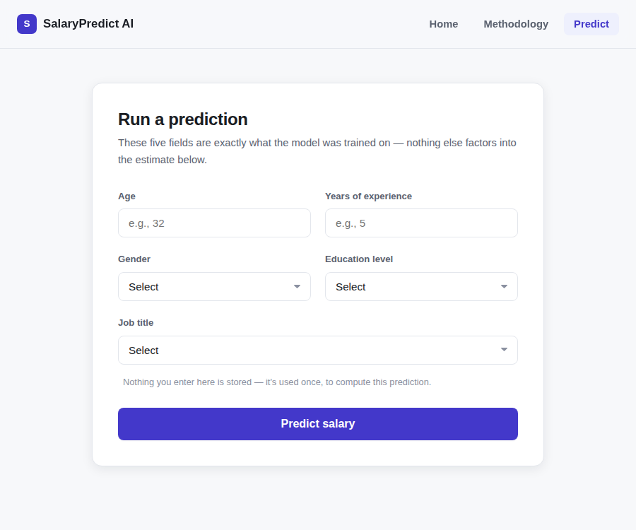
Figure 2: The redesigned prediction form — trimmed to the 5 fields the model actually uses.
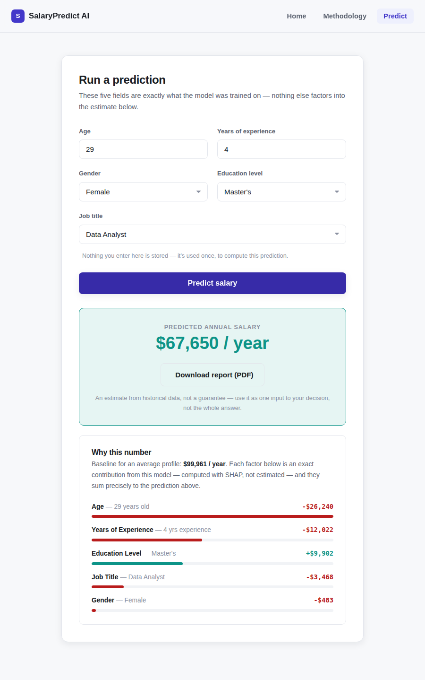
Figure 3: Predicted salary with its exact, per-feature “Why this number” SHAP explanation.

3. ANALYSIS OF MY EXPERIENCE

3.1 Technical Observations
During the internship, I gained practical exposure to the end-to-end lifecycle of building and maintaining an applied machine-learning system — from a raw CSV file to a deployed, explainable web application. I observed how Scikit-learn pipelines can obscure the true structure of a trained model until it is inspected directly, and how SHAP's TreeExplainer makes it possible to compute exact, not approximated, per-feature explanations for tree-based models such as Random Forests. I also understood the importance of keeping preprocessing consistent between training and inference, and how a clean separation between the trained model artifact (.pkl files) and the serving application (Flask) keeps a system maintainable. Another key observation was how easily an unexamined assumption — in this case, a currency conversion — can silently misrepresent what a model is actually capable of predicting.

3.2 Presentation of the Differences
This project highlighted the difference between theoretical, classroom-based learning and real-world applied data science. While academic coursework tends to focus on isolated concepts — training a single model on a clean dataset — building and maturing SalaryPredict AI required carrying a project through its full lifecycle: cleaning raw data, comparing and training models, developing and later revisiting my own codebase, and correcting both engineering bugs and a methodological error that had nothing to do with model accuracy at all. I also learned that a model with strong accuracy metrics is not the same as a trustworthy application; considerations such as data provenance, honest unit presentation, and defensive error handling — rarely emphasised in classroom exercises — turned out to be essential in practice.

3.3 Difficulties Encountered
A few challenges were faced during the project:
- Untangling roughly 250 lines of dead, duplicated PDF-generation code in the existing backend without breaking the working prediction flow.
- Diagnosing a Unicode/encoding crash in the PDF report generator, traced to a single em-dash character unsupported by the report's core font.
- Recognising that the app's existing currency-conversion behaviour was methodologically wrong — this only became visible once exact explainability made the model's reasoning transparent enough to sanity-check against real profiles.
- Keeping the SHAP-based explanation shown on the web page and the one recomputed for the PDF report perfectly consistent with each other.
- Balancing the depth of backend and UI rework against the fixed milestone deadlines set during the 6-week internship schedule.
Despite these challenges, consistent practice, official documentation for Scikit-learn, SHAP, and Flask, and guidance from the program's learning modules helped me overcome them and complete the project successfully.

3.4 Satisfaction
Overall, the internship was a highly enriching and satisfying experience. It allowed me to practically apply concepts of model auditing, explainability, backend engineering, and interface design within a structured, milestone-driven timeline. I felt a strong sense of achievement when the SHAP-based explanations began returning contributions that summed exactly to the model's predictions, and again when I traced the salary numbers back to their training data and confirmed a real methodological flaw that had gone unnoticed. The experience boosted my technical confidence, sharpened my instinct to verify rather than assume, and gave me a much clearer understanding of how a trustworthy, applied machine-learning system is engineered and maintained.

4. CONCLUSION

4.1 What I Learnt
During this internship, I gained a comprehensive understanding of applied AI and data analytics, from model auditing to explainable deployment. I learnt how to:
- Inspect a trained Scikit-learn pipeline directly to verify what model and preprocessing steps it actually contains.
- Use SHAP's TreeExplainer to compute exact, per-feature explanations for a tree-based model's predictions.
- Recognise and correct a methodological flaw in how a model's output was being presented, not just fix code-level bugs.
- Rebuild a Flask backend and PDF report generator to be defensive, consistent, and free of dead code.
- Design and apply a single, consistent front-end design system across a multi-page web application.
Overall, I learnt how different tools and techniques — Python, Pandas, Scikit-learn, SHAP, Flask, and fpdf2 — work together to deliver a complete, trustworthy, explainable machine-learning product.

4.2 Opportunities and Scope
This project opened new opportunities for me to:
- Explore retraining the model on region-specific compensation data, rather than approximating other markets through currency conversion.
- Learn more about deploying machine-learning applications on cloud platforms for public, real-world access.
- Deepen my understanding of model interpretability, so predictions can be explained to non-technical end users in even more approachable, conversational ways.
- Apply these applied data-science and explainability practices to other domains where model trust and transparency matter as much as raw accuracy.

4.3 Future Enhancements
SalaryPredict AI can be further improved with the following enhancements:
- Retraining the model on a region-specific labour-market dataset (for example, an Indian salary dataset) instead of relying on a single, US-centric source.
- Adding confidence intervals around each prediction, rather than presenting a single point estimate.
- Building a conversational “explain this prediction” assistant on top of the existing SHAP breakdown, so users can ask follow-up questions in plain language.
- Adding an admin-style dashboard to monitor prediction patterns and model behaviour over time.
- Deploying the application on a cloud platform with automated testing for wider, public access.

This internship, and the SalaryPredict AI project in particular, gave me a genuine, hands-on introduction to what applied AI and data analytics looks like outside a classroom setting — not just building a model, but verifying it, explaining it, and being honest about its limits — and has made me considerably more confident about taking on larger and more complex machine-learning systems going forward.

5. REFERENCES
1. Python Official Documentation – https://docs.python.org
2. Pandas Documentation – https://pandas.pydata.org/docs
3. Scikit-learn Documentation – https://scikit-learn.org
4. SHAP Documentation – https://shap.readthedocs.io
5. Flask Documentation – https://flask.palletsprojects.com
6. fpdf2 Documentation – https://py-pdf.github.io/fpdf2
7. NumPy Documentation – https://numpy.org/doc
8. AICTE – Official Website – https://www.aicte-india.org
9. Edunet Foundation – Official Website – https://edunetfoundation.org
10. IBM SkillsBuild – Official Website – https://skillsbuild.org

