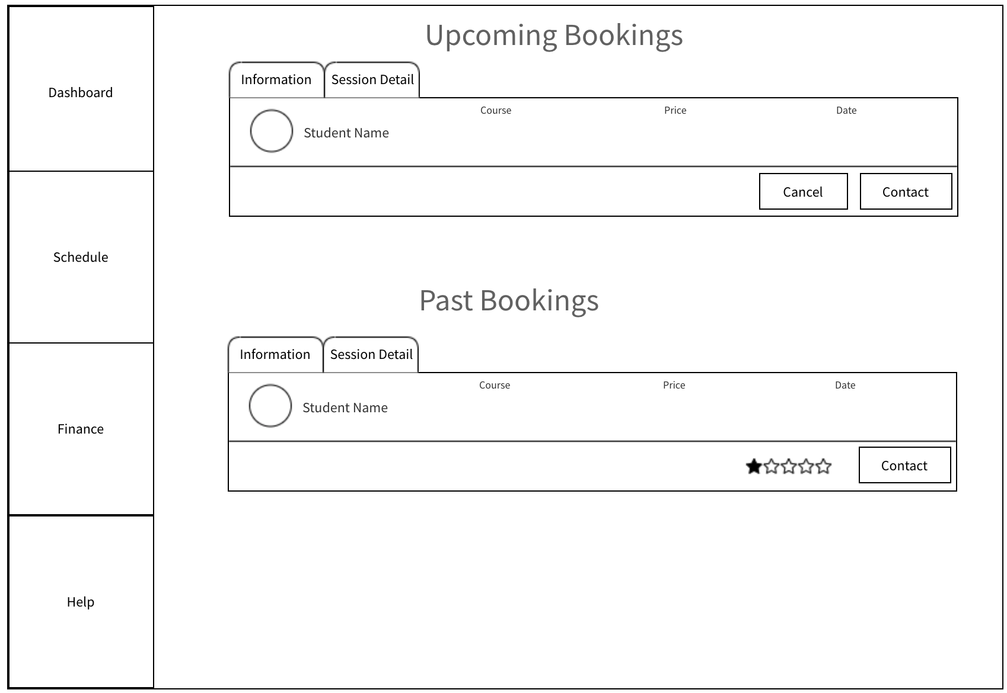

This redirects to contact page



This is the dashboard/bookings page. This page should follow this layout with distinct headers and rectangular tabs filling the webpage sufficiently. The tab to view additional details should contain the message the user may have provided alongside their booking and any further details. If there are more than one upcoming or past bookings, just place new rectangular tabs underneath. If too many, then a pagination feature should be available so we don’t have to keep scrolling down the page endlessly.

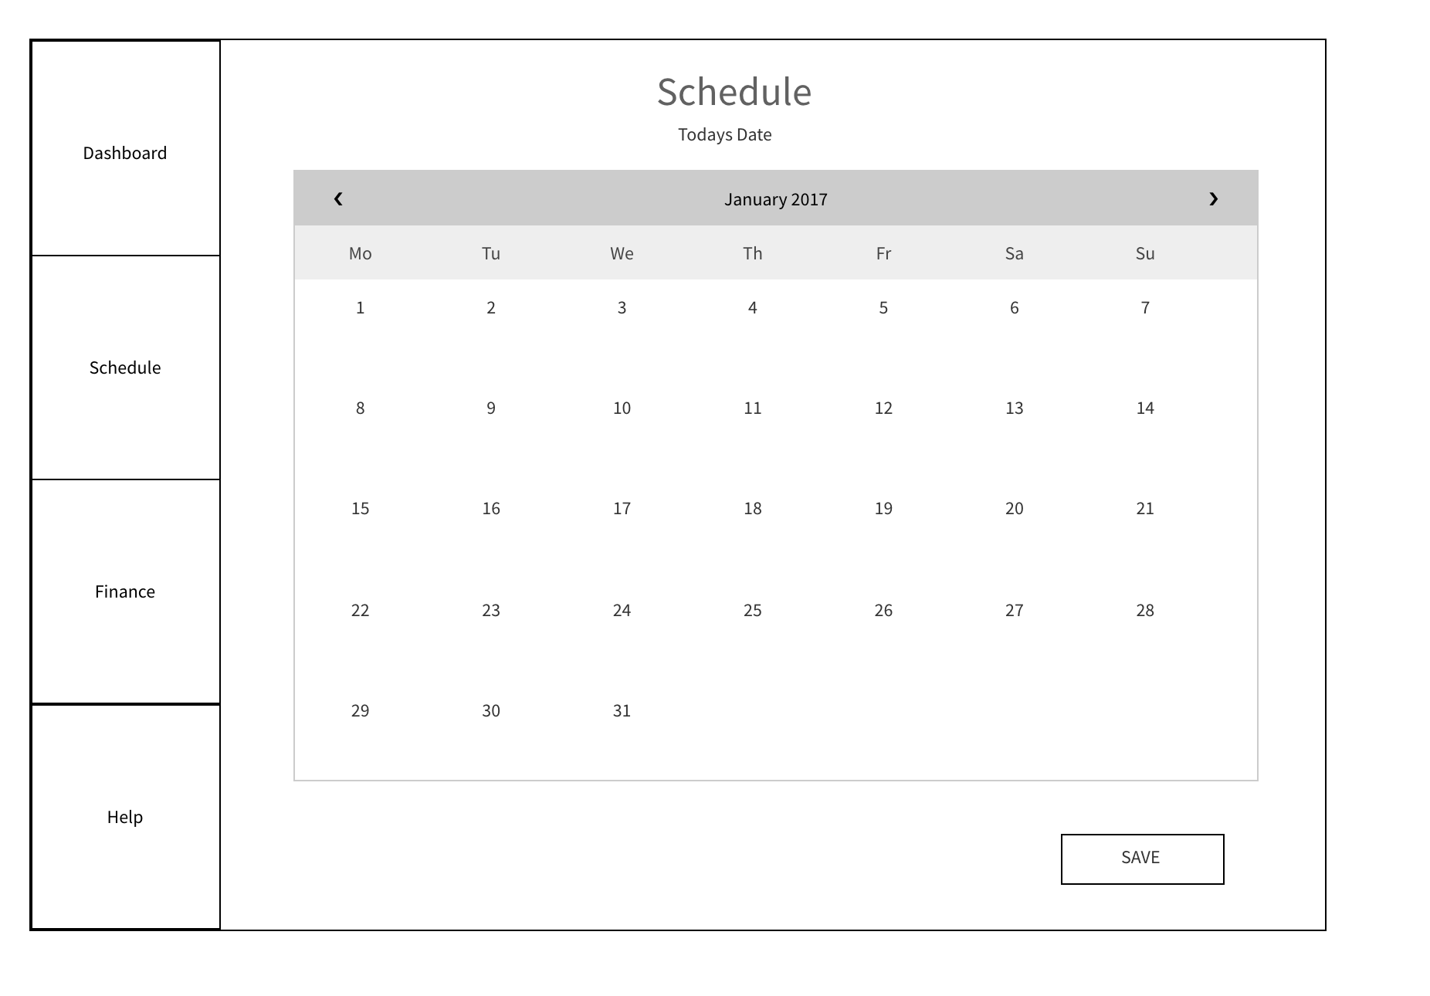

The schedule page should consist of the calendar you provided us in the skype message earlier. Note: WE DON’T WANT THIS CALENDAR, THIS IS AN EXAMPLE, WE WANT A WEEKLY CALENDAR WITH HIGHLIGHTABLE HOURS WEEKLY (like you showed in the example picture you sent). After selecting hours, there should be a save button with a further popup after confirming the times have been saved/any errors. Time slots of half an hour should be available too. This schedule should refresh weekly with the next week dates and times, so that the tutors can fill this out asap.

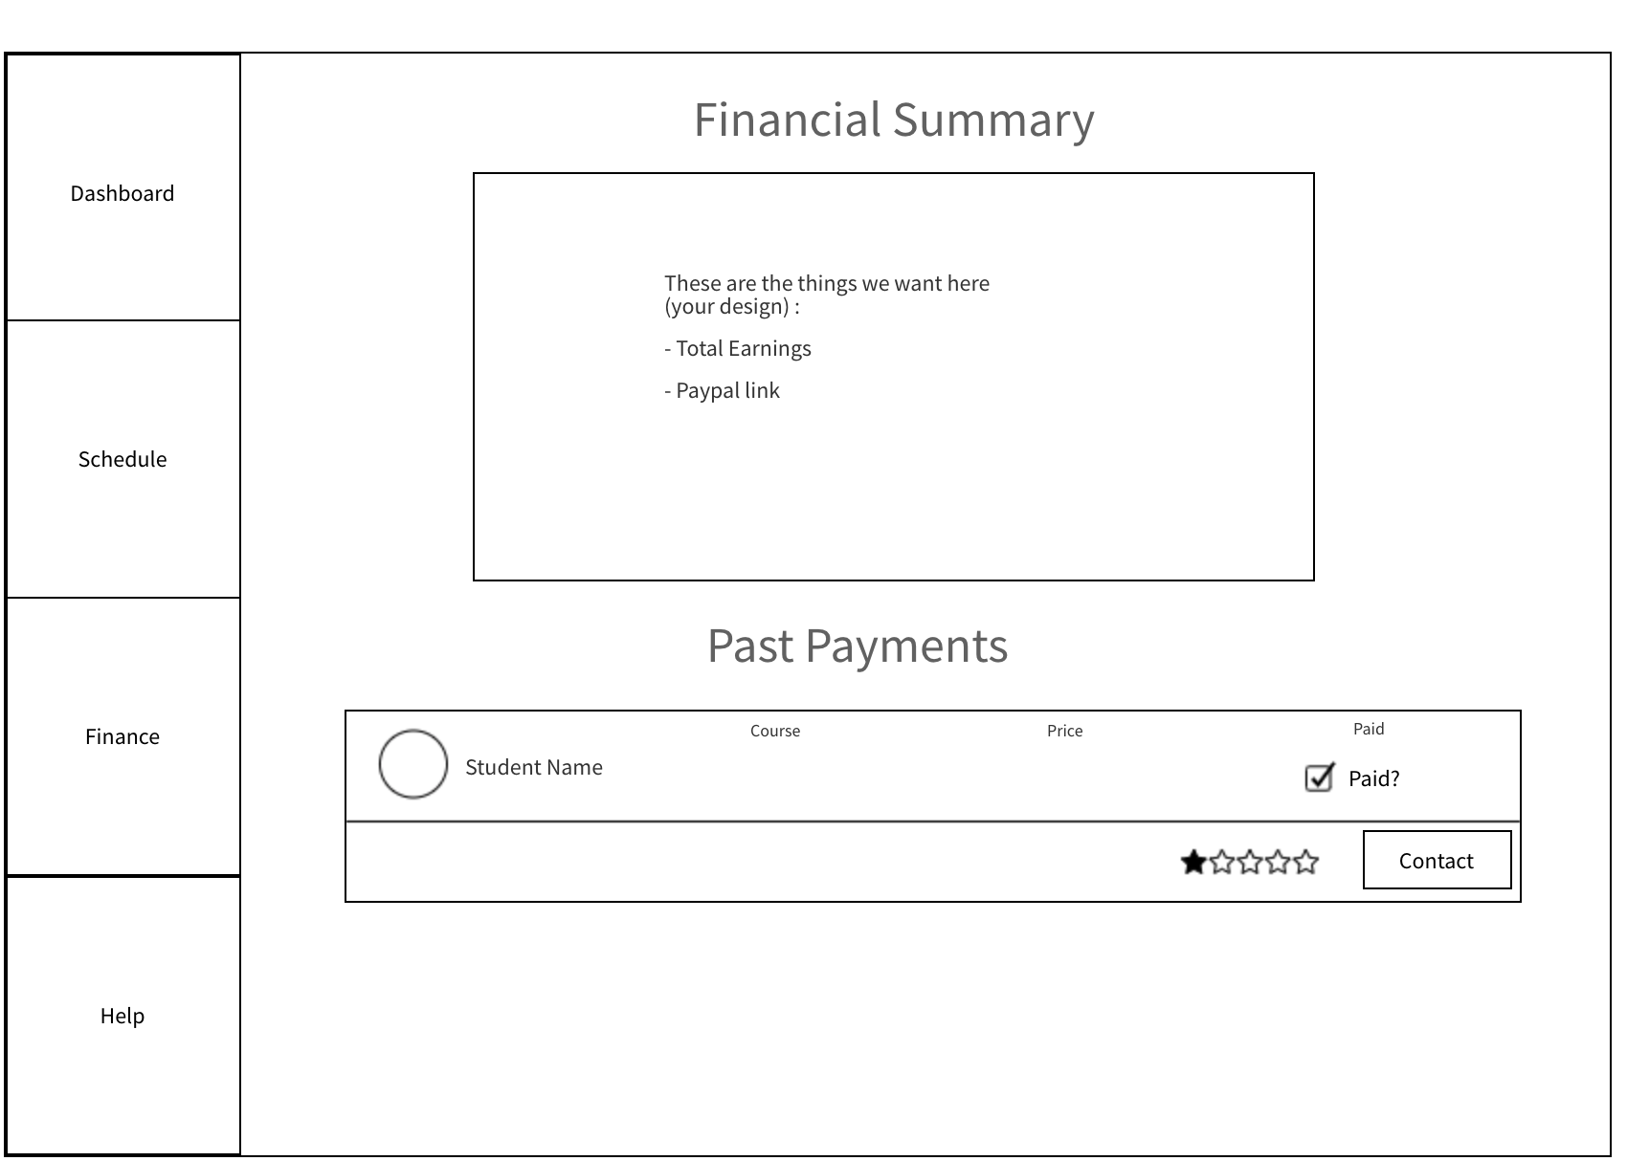

Also include date and time



The financial summary page should look somewhat like this. The top box needs to contain the items listed, but we are not sure of the best way to design and incorporate these ideas, so we would like YOU TO DESIGN THESE within the given space. We will update you if we want to add anything more. The past payments tab at the bottom should list all payments made and again should have a pagination feature incase a tutor has held a lot of classes and hence there have been a lot of payments.