CROSSOVER MEDICAL CONFERENCES PROJECT DESIGN

- Technologies: For this Project I use Eclipse Juno and API 17, to the list of conferences I prefer developed it using a ListView, the key of this project is the interaction between the activities and the use of SQLITE.
- Components: I created four classes to implement the app:
  - MedicalConferenceOpenHelper: This is the class when I define the DATABASE and the table Conference.
  - Main_Activity: This is a class that extends from ListActivity its purpose is focused in show the list of activities to the admin or doctor with different behaviors depending of the user type. These are the different behaviors:
    - For admin: Add new conferences, edit conferences pressing one of them from the ListView and Send all the conferences with the status “To Send” to the doctor.
    - For doctor: Accept or reject all the conferences from the ListView with the status “To Send” and choose an indidual conference by pressing one of them from the ListView and accept it or reject it.
  - Select_User: This is the class that implement the activity responsible of the select the user type which is going to use the app.
  - Conference_Edit: This is the class that implement the activity responsible to edit a conference, it has different behaviors depending of the user type. These are the different behaviors:
    - For admin: Save new conferences, edit conferences, send it to the doctor, and cancel it.
    - For doctor: Accept or reject a conference invitation. In case of accept it I create an event in the calendar of the emulator, but here exist a fail of the emulator because of a problem with Exchange.
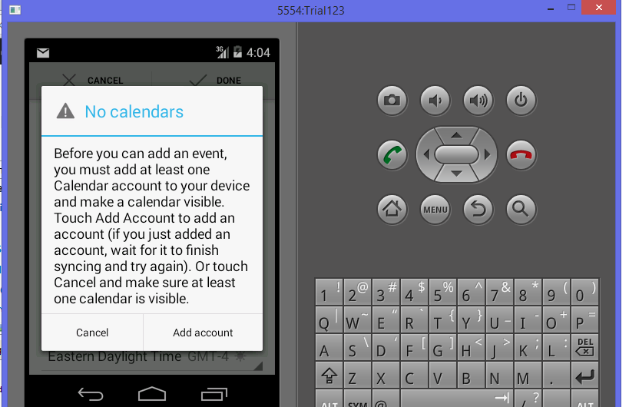

- Diagrams. I show the actual diagram class and more realistic diagram for future work.
  - Actual
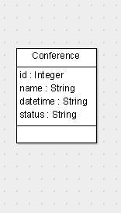

  - Future
