**Background:**

Customers use real time streaming frameworks handing large volumes of streaming data from multiple channels. This usually needs to maintain, set up and administer stream layer and processing layer which is time consuming.

**Purpose:**

This guide helps to implement real streaming processing framework with MSK cluster on AWS using spark on EMR with minimal and seamless setup.

**Introduction:**

Using MSK which is the AWS Managed Service for Kafka and AWS EMR which is the AWS Managed Hadoop Framework, we can build a stream processing framework.

MSK and EMR handle the setup and administration and we can focus on the processing logic to get handled.

**Architecture**:

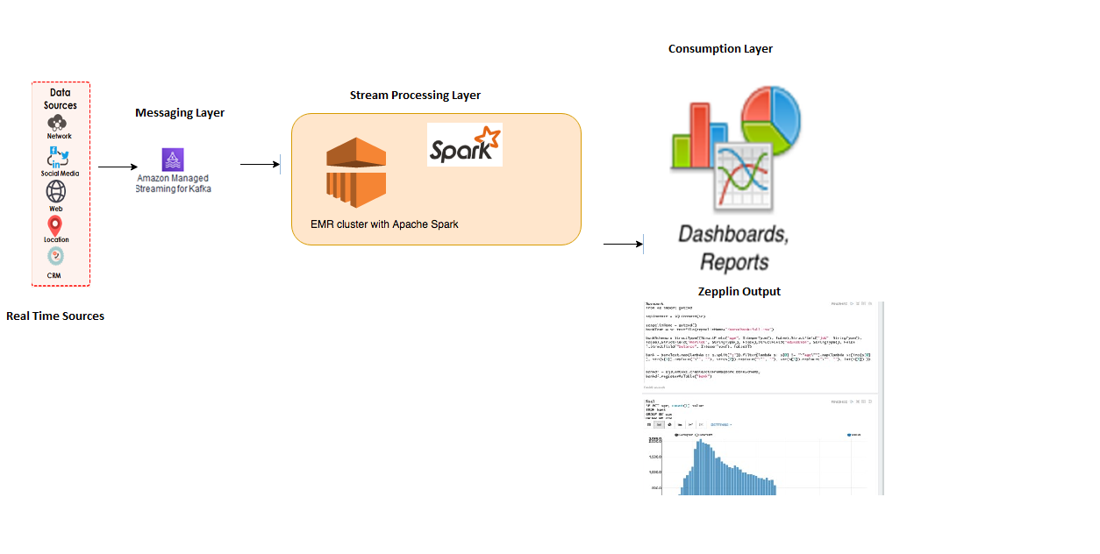

The typical architecture which captures data from various real time sources and is sent to the Messaging layer which is served by MSK. And further processed by Spark on EMR.

The first layer is the Data Source layer where the real time sources capture the information.

The intermediate block is the MSK which helps to send data between sources to the Real time processing platform.

* Data Producer sends records to the MSK using Kafka library using producer API.
* The intermediate layer is the MSK Layer which pushed these events to the further downstream systems. Kafka Topic partition replication/leader selection are automatically handled by the AWS MSK cluster. MSK is also responsible to retain the cluster and data in case of the broker failure and automatically recover from it and ensure the partition is still available to be read by consumers.
* Then the last layer is the data processing layer, which is Spark on the EMR cluster which could process the data in real time and send to the visualization layer.

**Use case:**

To demonstrate connectivity between MSK with EMR Spark, a simple example setting up EMR cluster with spark streaming and MSK cluster is show cased. Existing Spark word count example is used to consume the data from MSK topics. The final output is showcased on spark console and zeppelin.

**Activities**

Now let’s see how to set up this kind of framework on AWS. Main steps to implement a streaming application on AWS on EMR spark and MSK are as below

1. Messaging Platform :- We will leverage MSK for this.
2. Producer framework:- We will stub this using console Kafka Producer to send streaming data.
3. Processing Framework:- We would leverage EMR spark and try to make some config changes to connect to MSK cluster and run a simple word count example which can print real time word count.
4. Visualization:- We have showcased on the console and also on zeppelin to print real time word counts.

**Workshop Activities**

The below steps would guide in setting up and configuring the EMR and MSK cluster to communicate with each other and how to run the simple word count application.

1. Setting up the MSK cluster.
2. Create EMR cluster with spark and zeppelin.
3. Open ports and update security groups between Kafka and EMR Cluster
4. Provide access for EMR cluster to operate on MSK
5. Install kafka client on EMR cluster
6. Create topic. Doing a sample test for connectivity.
7. Download kafka libraries.
8. Open zeppelin and configure interpreter
9. Run the streaming code in zeppelin
10. Send records from Producer
11. Alternative to zeppelin submit via spark shell
12. Verify the logs for output.
13. Cloud formation template to set up EMR with spark/zeppelin and Kafka bootstrap scripts.

### **Setting up MSK Cluster**

First step is to create MSK cluster. Below steps outline how to create MSK though AWS console.

Key in the name and leave VPC as default. Use Kafka 2.1.0 version

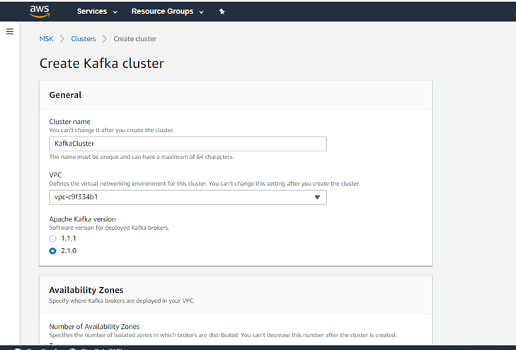

Select the subnet and AZs.

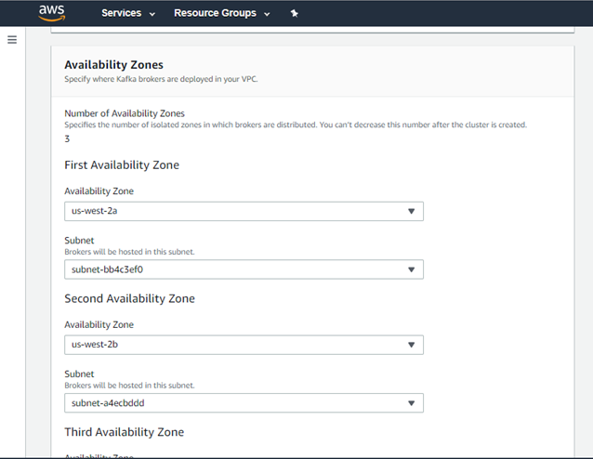

Select no of brokers per AZ .

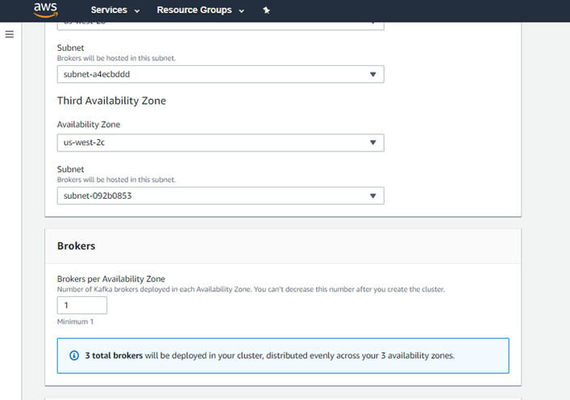

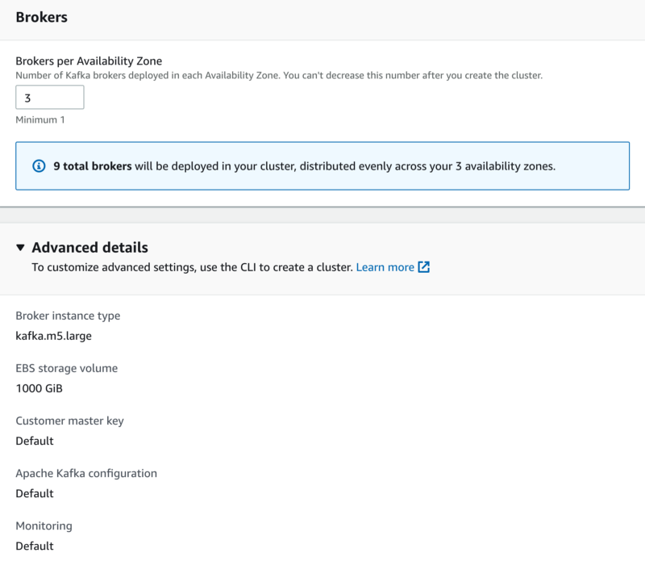

Leave the advanced details default. Click on create cluster. Wait for the MSK cluster to be created. This may take few minutes.

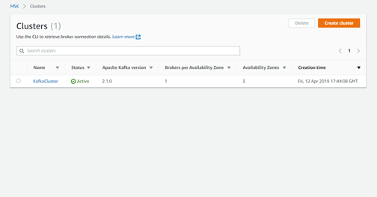

### **Setting up EMR cluster with spark/Zepplin enabled.**

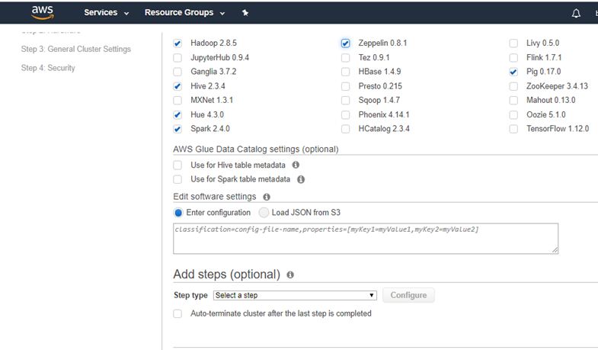

You can create it using cli or console also Ensure you select spark and zeppelin in advanced configurations while creating the cluster

Remember the security key, this would be needed in the subsequent steps while logging into the cluster.

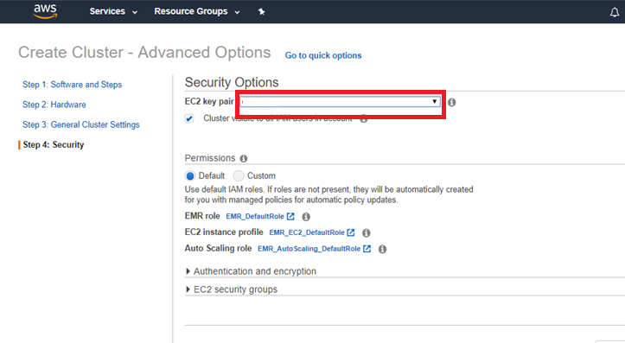

### **Open ports and update security groups**

Access the MSK cluster link and click on Security Groups

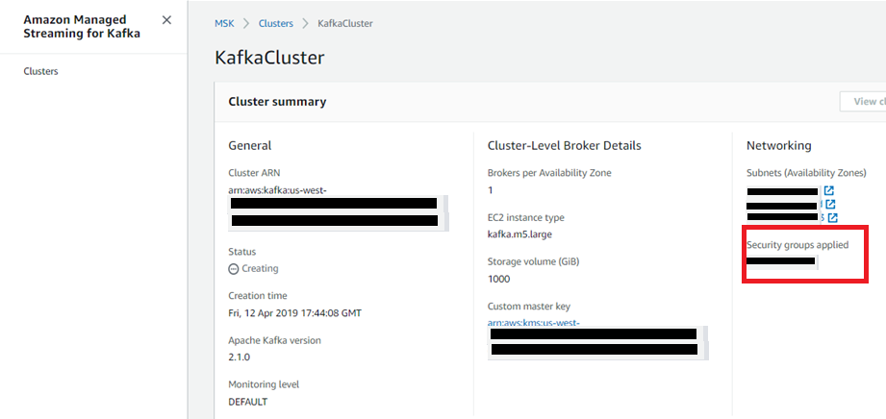

Go to EMR console and get the Security group (SG) of EMR Master.

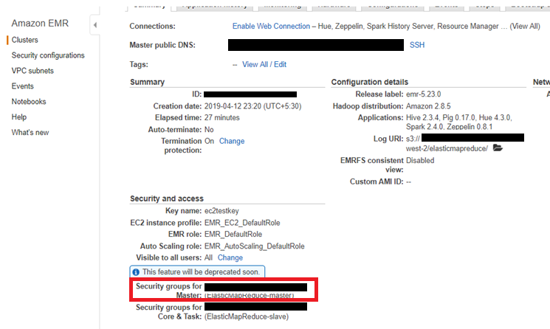

Update the Security Group as below entering all traffic from source as EMR SG name for MSK SG.

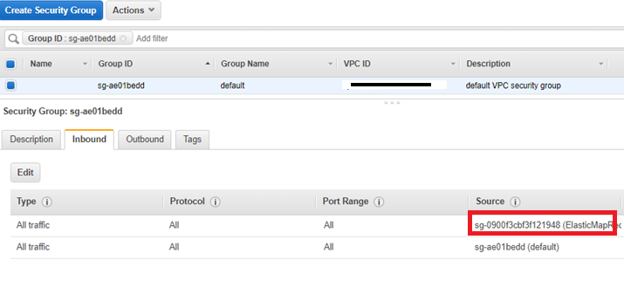

Repeat the same steps for EMR cluster.

In EMR Master Security Group add Kafka cluster Security Group name as source for all traffic.

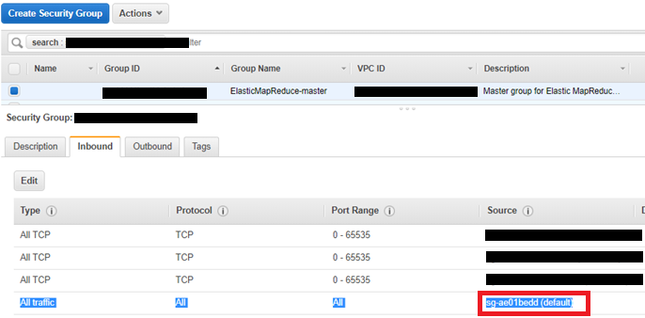

### **Provide access for EMR cluster to operate on MSK**

When launching EMR cluster, the default role EMR_EC2_DefaultRole won’t have access to describe cluster. We need to explicitly add that access and role to access MSK cluster as per the below screenshots.

Login in to the AWS console and access the IAM page link and add access to MSK. In the below screen shot, MSKFullAccess has been added. For the testing purpose full access has been provided.

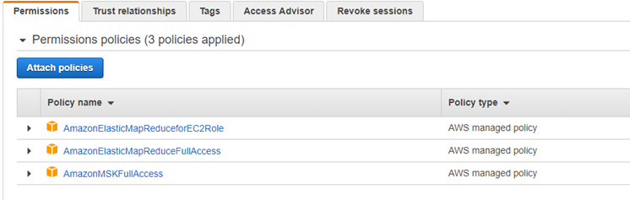

After this you can execute

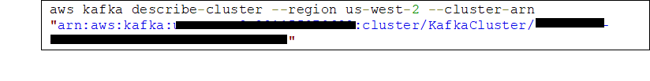

by logging into EMR cluster with secret key provided during cluster creation.

### **Install kafka client on EMR cluster**

This step allows you to setup kafka client on the EMR cluster. EMR doesn’t come with kafka client installed by default. So this step allows you to download and access kafka client.

Kafka client is needed for running kafka producer and kafka console consumer command scripts.

Download kafka based on the server version selected.

wget <http://archive.apache.org/dist/kafka/1.1.1/kafka_2.11-1.1.1.tgz>

wget <https://archive.apache.org/dist/kafka/2.1.0/kafka_2.11-2.1.0.tgz>

Extract the zip file to a folder.

tar -xzf kafka_2.11-2.1.0.tgz

### **Create topic. Doing a sample test for connectivity**

From console access the zookeeper url for creating topic.

cd /home/hadoop/kafka_2.11-2.1.0

You will get zookeeperConnectString from describe cluster command to be used while creating topic

bin/kafka-topics.sh --create --zookeeper *ZookeeperConnectString* --replication-factor 3 --partitions 1 --topic AWSKafkaTutorialTopic

Display the bootstrap brokers url from console or from cli.

aws kafka get-bootstrap-brokers --region us-west-2 --cluster-arn *ClusterArn*

Output

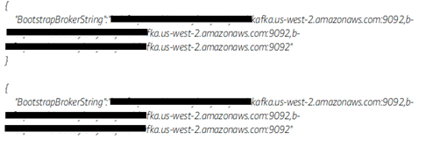

You can also get the bootstrap servers list from the client information tab on the kafka Page as well.

bin/kafka-console-producer.sh --broker-list *BootstrapBrokerString* --topic AWSKafkaTutorialTopic

In another ssh prompt open console consumer and verify messages could be produced and consumed.

bin/kafka-console-consumer.sh --bootstrap-server *BootstrapBrokerString* --topic AWSKafkaTutorialTopic --from-beginning

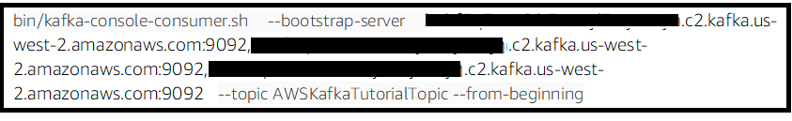

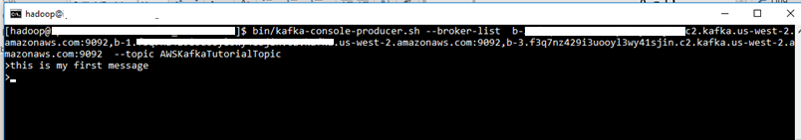

## **Download Kafka Libraries**

These libraries are needed to be installed on EMR to execute for spark shell submit command for step no 10.

wget http://central.maven.org/maven2/org/apache/kafka/kafka_2.10/0.10.0.0/kafka_2.10-0.10.0.0.jar

wget <https://archive.apache.org/dist/kafka/0.10.0.0/kafka_2.11-0.10.0.0.tgz>

wget http://central.maven.org/maven2/org/apache/spark/spark-streaming-kafka-0-10_2.11/2.4.0/spark-streaming-kafka-0-10_2.11-2.4.0.jar

## **Open zeppelin and configure interpreter**

If you are using zeppelin you can skip step 7.

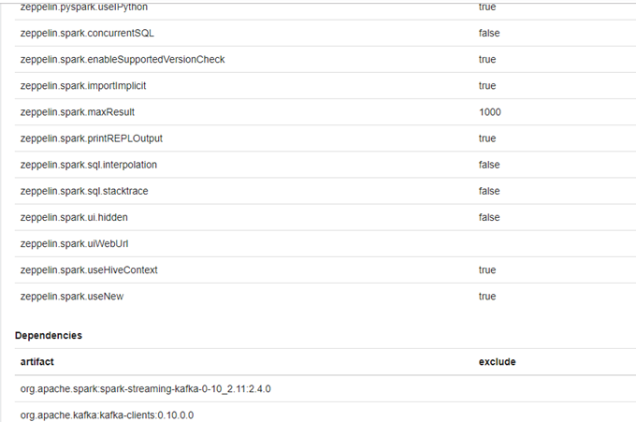

Go to Spark interpreter, under dependencies add the below entries as per image. This is needed to connect o kafka and import statements to work from zeppelin spark interpreter.

org.apache.spark:spark-streaming-kafka-0-10_2.11:2.4.0

org.apache.kafka:kafka-clients:0.10.0.0

For multiple spark sessions to run, enable multiple session to true.

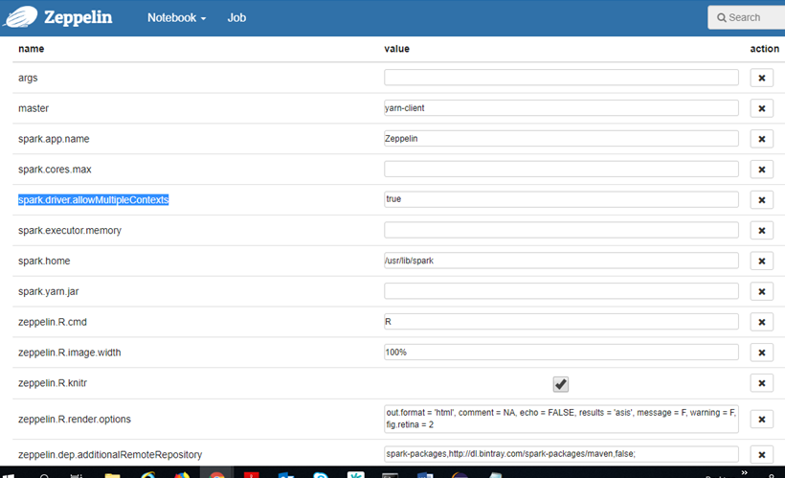

## **Run Streaming Code in Zeppelin.**

This is a sample word count program where kafka consumer is run with the spark streaming and reads the kafka messages and prints words.

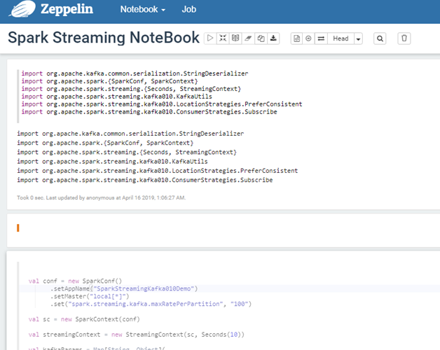

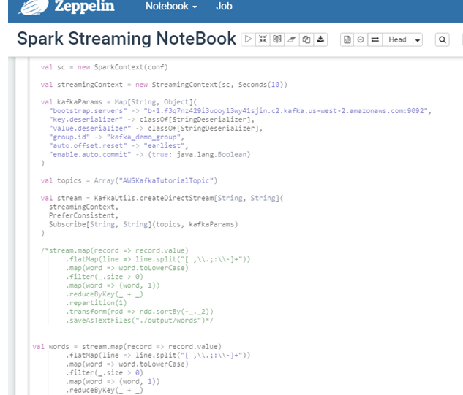

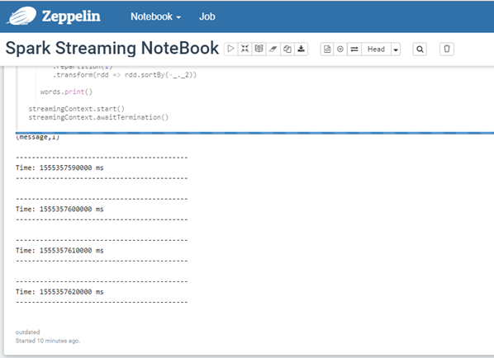

Spark context is up and running.

Lets send sample input form console producer and verify tha data in zeppelin console

For the console producer to work, kafka download in the step 5 is pre requisite.

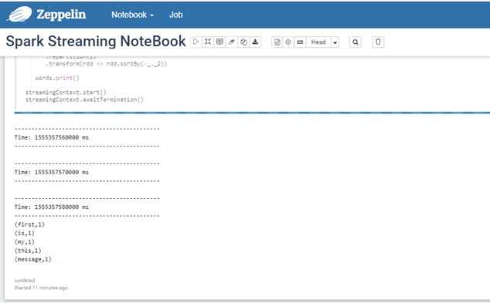

Alternative to zeppelin submit via spark shell

## **Submitting the job via Spark shell**

You can use spark examples and use sparksubmit command also to test the above

Step 7 jar files are needed to run. You can either pass jar file in command prompt or as a maven project. As we are using existing example, passing in command prompt.

spark-submit --class org.apache.spark.examples.streaming.JavaDirectKafkaWordCount --master yarn-client --jars /usr/lib/spark/examples/jars/*.jar,/home/hadoop/kafka_2.11-2.1.0/libs/*.jar,/home/hadoop/spark-streaming-kafka_2.11-2.4.0.jar --num-executors 1 --driver-memory 512m --executor-memory 512m --executor-cores 1 spark-examples*.jar b-2.f3q7nz429i3uooyl3wy41sjin.c2.kafka.us-west-2.amazonaws.com:9092,b-1.f3q7nz429i3uooyl3wy41sjin.c2.kafka.us-west-2.amazonaws.com:9092,b-3.f3q7nz429i3uooyl3wy41sjin.c2.kafka.us-west-2.amazonaws.com:9092 groupid AWSKafkaTutorialTopic

## **Output**

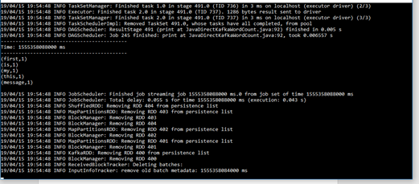

## Cloud formation template

Sample cloud formation template to create an EMR cluster and submit spark step [CF Link](https://aws-emrmsk-blog.s3-us-west-2.amazonaws.com/artifacts/EMRCFTemplate.json)

This CF has been added with additional SG. Ensure these SG for master/slave are updated with entry from MSK security group for the Kafka port.

Also it has a reference to install Kafka client and download some Kafka and spark streaming libraries in the bootstrap action which is bundled in the install script and needs to be placed in the referenced s3 location. [Install Script](https://aws-emrmsk-blog.s3-us-west-2.amazonaws.com/artifacts/install-scripts.sh)

# **Conclusion**

With Kafka offered as a Managed service on AWS, users can focus more on the consumption part instead of worrying on managing the coordination between the brokers which usually needs a detailed understanding of kafka. Features like leader selection/in synch replica brokers availability could be managed by the MSK platform. Users can then focus on processing layer to consume data from MSK and further propagate to visualization layer.