

Explore Purchase Tutorial Forum

Editor

Health_care^Sensores



Back

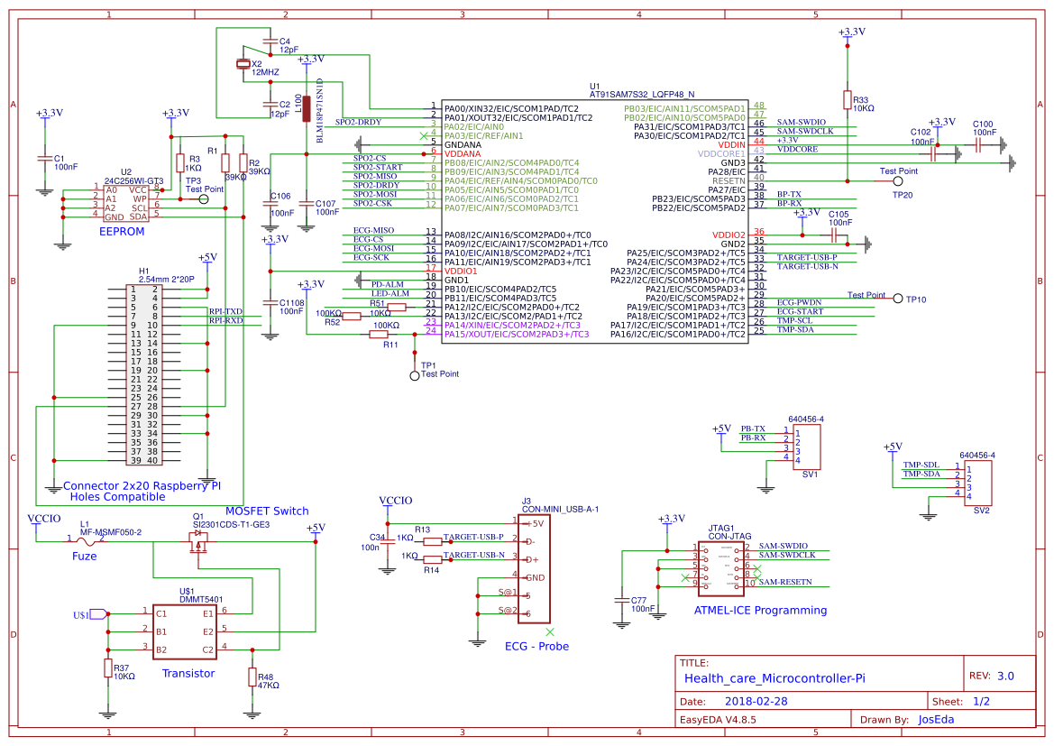

Version

Attachments

Members

Settings

Project documents Share Project Project Homepage

Schematics and Spice sub-circuit

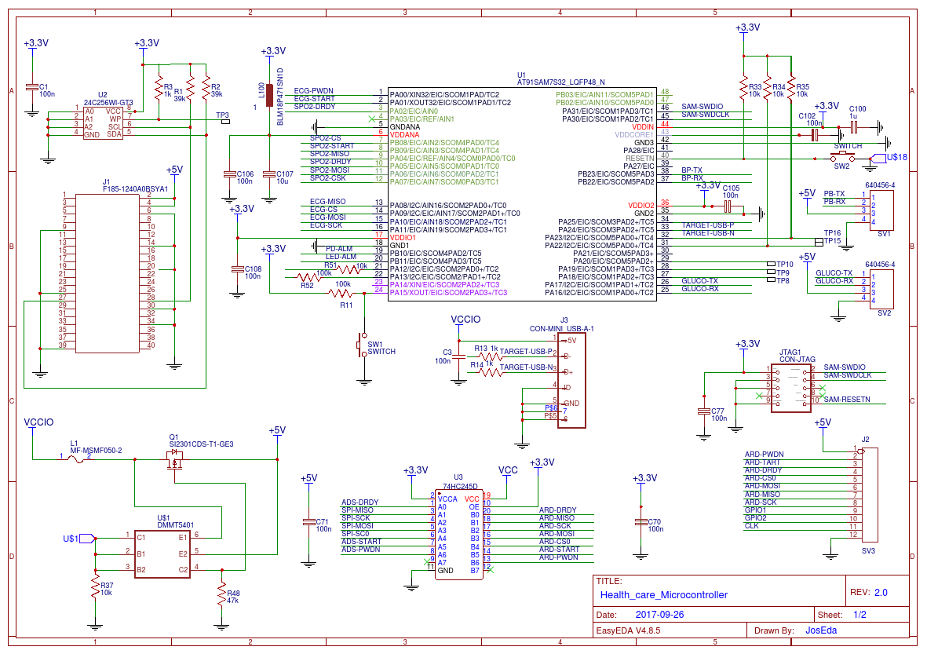

Health_care_microcontroller

Last updated :1 days ago

Edit

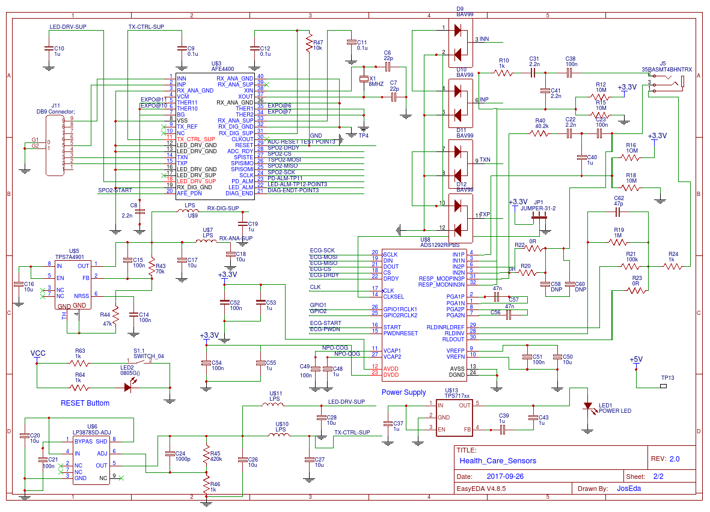

Health_care sensors

Last updated :1 days ago

Edit

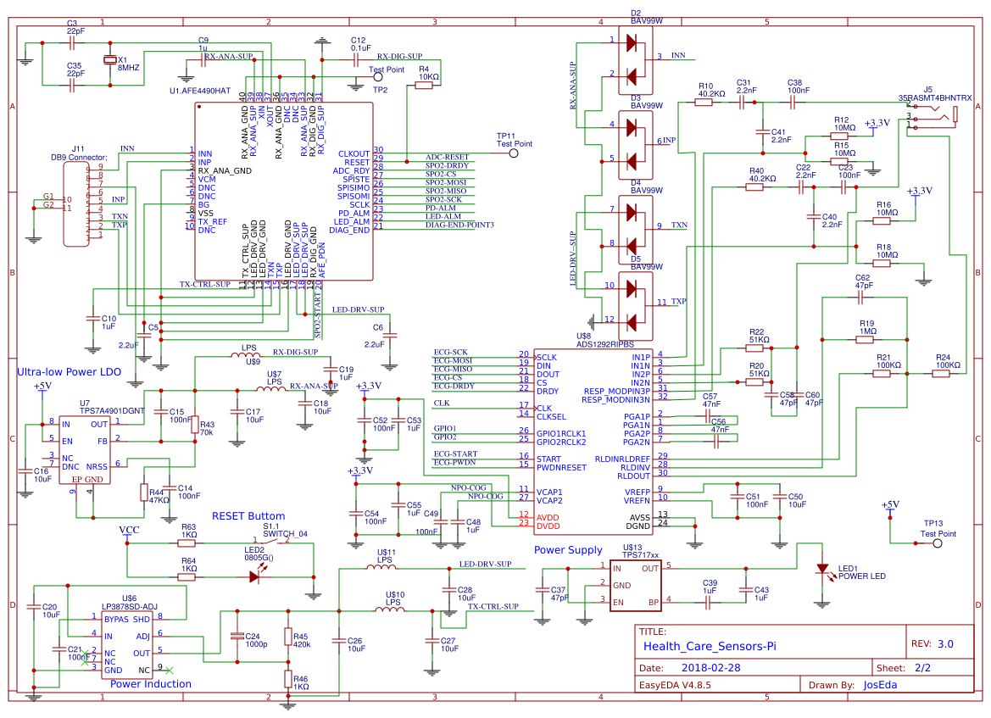

Health_care sensors copy

Last updated :-39479 seconds ago

Edit

New Schematic

PCB

New PCB

Simulation

No Simulation





Explore Purchase Tutorial Forum

Editor

Health_care^Sensores



Back



Version

Attachments

Members

Settings

Project documents Share Project Project Homepage

Schematics and Spice sub-circuit



Health_care_microcontroller

Last updated :1 days ago

Edit



Health_care sensors

Last updated :1 days ago

Edit



Health_care sensors copy





Health_Care_Microcontrollers