Building with 3 floors with 2 department in each floor.

**First floor:** Sales and Marketing Department with 120users expected.

Humans Recourses and Logistic Department 120 users expected)

**Second Floor:**  Finance and Accounts Department 120 users expected.

Administration and Public Relations Department 120 users expected.

**Third Floor:** ICT 120 users expected. Server Room 12 Devices expected.

Things we use to build this network:

* Cisco Packertracer
* hierarchical model to provide redundancy
* ISP to provide redundancy
* Wireless network to each department.
* Different Vlans for each department
* VLSM Subnetting network
* We use a PAT translation to connect to a public internet providers
* Configuration of basic setting (hostname, console password, enable password, banner messages, disable ip domain loop up)
* Communication between Vlans inter-Vlan Routing with a Multilayers Switch
* The multilayers Switches have Routing and Switching functionalities
* DHCP server connection.
* Devices in the server room are to be allocated IP address statically
* We use OSPF as routing protocol
* SSH to remote login
* Port-security for Finance and Accounts department. Sticky method to obtain mac-address and violation shut down.
* **PAT**  to use the respective outbound roouter interface ipv4 address. With its necessary ACL Rule.
* **Test Communications.**

|  |  |  |  |  |
| --- | --- | --- | --- | --- |
| **Department** | **Network**  **address** | **Subnet Mask** | **Host address**  **range** | **Broadcast**  **Address** |
| **Sales & marketing** | **172.16.1.0** | **255.255.255.128/25** | **172.16.1.1 to**  **172.16.1.126** | **172.16.1.127** |
| **HR & Logistic** | **172.16.1.128** | **255.255.255.128/25** | **172.16.1.129 to**  **172.16.1.254** | **172.16.1.255** |

|  |  |  |  |  |
| --- | --- | --- | --- | --- |
| **Department** | **Network**  **address** | **Subnet Mask** | **Host address**  **range** | **Broadcast**  **Address** |
| **Finance &**  **Accounts** | **172.16.2.0** | **255.255.255.128/25** | **172.16.2.1 to**  **172.16.2.126** | **172.16.2.127** |
| **Admin & public**  **Relations** | **172.16.2.128** | **255.255.255.128/25** | **172.16.2.129 to**  **172.16.2.254** | **172.16.2.255** |

|  |  |  |  |  |
| --- | --- | --- | --- | --- |
| **Department** | **Network**  **address** | **Subnet Mask** | **Host address**  **range** | **Broadcast**  **Address** |
| **ITC** | **172.16.3.0** | **255.255.255.128/25** | **172.16.3.1 to**  **172.16.3.126** | **172.16.3.127** |
| **Server Room** | **172.16.3.128** | **255.255.255.240/28** | **172.16.3.129 to**  **172.16.3.1142** | **172.16.3.143** |

|  |  |  |  |  |
| --- | --- | --- | --- | --- |
| **Number** | **Network**  **address** | **Subnet Mask** | **Host address**  **range** | **Broadcast**  **Address** |
| **Mlt-SW1 to R1** | **172.16.3.144** | **255.255.255.252/30** | **172.16.3.145 to**  **172.16.3.146** | **172.16.3.147** |
| **Mlt-SW2 to R1** | **172.16.3.148** | **255.255.255.252/30** | **172.16.3.149 to**  **172.16.3.150** | **172.16.3.151** |

|  |  |  |  |  |
| --- | --- | --- | --- | --- |
| **Number** | **Network**  **address** | **Subnet Mask** | **Host address**  **range** | **Broadcast**  **Address** |
|  | **172.16.3.152** | **255.255. 255.252/30** | **172.16.3.53 to**  **172.16.3.154** | **172.16.3.155** |
| **Mlt-SW2 to R2** | **172.16.3.156** | **255.255.255.252/30** | **172.16.3.157 to**  **172.16.3.158** | **172.16.3.159** |

|  |  |  |  |  |
| --- | --- | --- | --- | --- |
| **REDES Routers**  **And ISPs** | **Network**  **address** | **Subnet Mask** | **Host address**  **range** | **Broadcast**  **Address** |
|  | **192.136.17.0 /30** |  |  |  |
|  | **192.136.17.4 /30** |  |  |  |
|  | **192.136.17.8 /30** |  |  |  |
|  | **192.136.17.12 /30** |  |  |  |

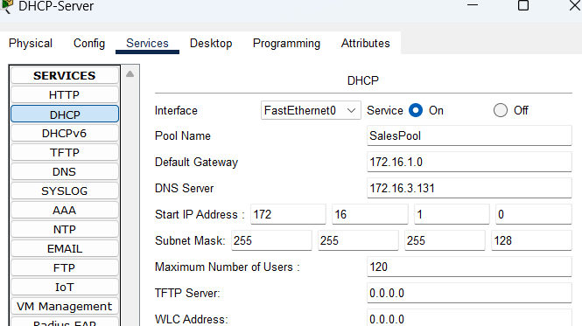

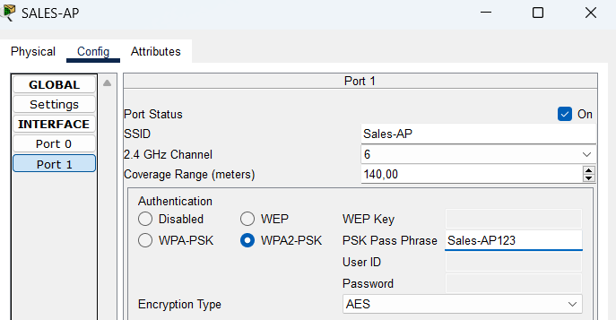

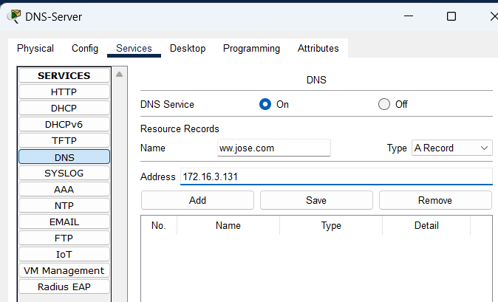

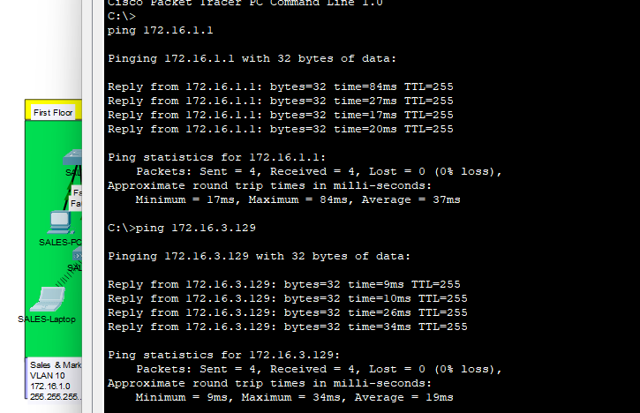

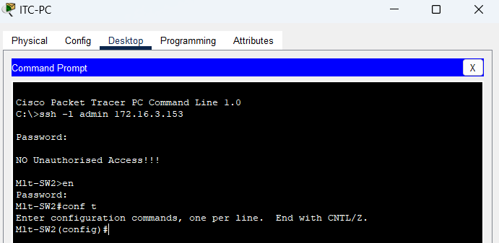

**Do show start**