MAKERERE UNIVERSITY

SCHOOL OF FOOD TECHNOLOGY, NUTRITION AND BIO-ENGINEERING
DEPARTMENT OF AGRICULTURAL AND BIOSYSTEMS ENGINEERING

DESIGN AND OPTIMIZATION OF A HYBRID SOLAR TRACKER USING AI AND SENSOR-BASED CONTROL WITH AUTONOMOUS MAINTENANCE
By
AJANAKU Jose Ozovehe
2024/HD02/27423X

A RESEARCH PROPOSAL SUBMITTED IN PARTIAL FULFILLMENT OF THE REQUIREMENTS FOR THE AWARD OF THE DEGREE OF MASTER OF
SCIENCE IN AGRICULTURAL ENGINEERING OF MAKERERE UNIVERSITY

Table of Contents
Table of Contents i
List of Figures iii
CHAPTER ONE 1
INTRODUCTION 1
1.1 Background of study 1
1.2 Problem Statement 2
1.3 Main Objective 3
1.3.1 The specific objectives are: 3
1.4 Justification of study 3
1.5 Conceptual framework 4
CHAPTER TWO 6
LITERATURE REVIEW 6
2.1 Photovoltaic System 6
2.1.2 Electrical characteristics of PV cell 6
2.2 Solar irradiance components 8
2.2.1 Direct Normal Irradiance (DNI) 9
2.2.2 Diffuse Horizontal Irradiance (DHI) 9
2.2.3 Global Horizontal Irradiance (GHI) 9
2.3 Mathematical Modelling of Solar Radiation 10
2.3.1 Transposition Modelling 10
2.3.2 The Perez Anisotropic Diffuse Model 11
2.4 Effect of temperature on PV performance 12
2.5 Effect of dust accumulation on PV performance 12
2.6 Solar Tracking Systems (STS) 12
2.6.1 Tracking model 13
2.7 AI and Machine Learning in Solar Tracking 13
2.8 Performance Metrics of AI Model 14
2.9 Dataset for the AI training 15
2.10 Review of Mechanical design 16
2.11 Related work 17
CHAPTER THREE 21
METHODOLOGY 21
3.1 Development of the AI model (Objective 1) 21
3.1.2 Simulation of optimal panel orientation. 21
3.1.3 Predictive Model Development and Training 22
3.1.4 Performance evaluation and validation 25
3.1.5 AI Model deployment 26
3.2 Design of hybrid sensor-based tracking system (Objective 2) 26
3.2.1 Mechanical design and load analysis 26
3.2.2 Actuator Sizing and Drive System Design 27
3.2.3 Intelligent Hybrid Control System Implementation 27
3.3 Design of automated cooling with self-cleaning mechanism (Objective 3) 30
3.3.1 Operational logic 30
3.3.2 Spray optimization mechanism 30
3.3.3 Water level monitoring 32
3.4 Evaluation Plan 32
3.5 Expected results 32
APPENDIX 1. 37
APPENDIX 2. 38

List of Figures
Figure 1:Global solar tracker installation 2
Figure 2:Conceptual framework 5
Figure 3:PV equivalent circuit 6
Figure 4: A PV equivalent circuit with parallel and series resistance 8
Figure 5: Dual axis solar tracking using LDR 13
Figure 6: National Solar Radiation Database (case study: Kampala) 16
Figure 7: Free Body diagram 17
Figure 8: Algorithm development block diagram 21
Figure 9: The employed MLP neural network structure 24
Figure 10 Long short-term memory 25
Figure 11: Sensor-based tracking system (Clear Sky mode) 28
Figure 12: flowchart for the hybrid tracking system 29
Figure 13: Embedded workflow 30
Figure 14:Flowchart for the cooling and cleaning mechanism 31

CHAPTER ONE

INTRODUCTION

1.1 Background of study
The need for clean and sustainable energy is growing in response to the pressing issues caused by climate change and the depletion of fossil fuels. Among the most significant clean, abundant, and renewable energy sources is solar energy (Kumba et al., 2024). The energy needs of the world are infinitesimal in comparison to the more than 173,000 TW of solar energy that the Earth receives every second. Solar PV technologies harness sunlight and convert it into electricity with the aid of semiconductor materials, which is one of the most versatile and scalable renewable energy technologies (Idris et al., 2024). PV technology is crucial for reducing greenhouse gas emissions and decreasing reliance on fossil fuels, as it harnesses the sun's energy.
The International Renewable Energy Agency (IRENA) states that, among available resources, solar energy is seen as the most cost-effective when compared to fossil fuels. From 2009 to 2023, solar energy generation increased at an incredible rate of about 243.6%. Projections show that PV technology will control 99% of the market share by 2030 (Kumba et al., 2024).
One of the biggest problems with solar energy systems is that, when they are installed as fixed or static structures, they can't keep the panels in the best position all day. The angle at which sunlight hits solar panels changes throughout the day because of the movement of the Earth towards the sun. This has a big effect on how well they work (Sarkar et al., 2021). Solar irradiance, which varies with these positional changes, directly affects how much energy solar panels can generate (Gokkus, 2024).
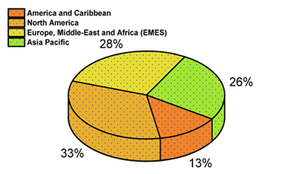
The PV system needs to be at a right angle to the light beam to generate maximum energy. So, designing a solar tracking system that keeps the PV panels perpendicular to the light beam greatly boosts energy production. Solar trackers, especially dual-axis, keep the panels in the best position in relation to the sun, which can boost production by 30–40% compared to fixed systems (Allamehzadeh, 2019). Implementation of solar trackers around the world rise by 40% from the previous year to 95 GW in 2023, which shows how important this technology is becoming (Kumba et al., 2024). The figure below shows the global solar tracker installation.
Figure 1:Global solar tracker installation
As STS are now very familiar, it's important to remember how much they can help solar energy systems work better and more efficiently. As we work toward meeting the ambitious renewable energy goals for 2030 and 2050, it will be important for solar technologies, especially STS, to keep coming up with new ideas (Kumba et al., 2024).
Various theoretical studies and research have been conducted over the past few decades to verify the efficiency and effectiveness of solar tracking systems in promoting photovoltaic electricity production (Hafez et al., 2018). With the ability to track in both azimuth and altitude directions to follow the path of the sun, dual-axis solar trackers have been proven to offer a significant advantage over single-axis trackers. These two-directional movements allow dual-axis trackers to get the most sunlight possible both daily and seasonally.
The modern dual-axis solar tracker is now designed using a hybrid system to make it more efficient than the conventional trackers. Hybrid solar trackers use two or more tracking techniques to maximize energy production while keeping costs, efficiency, and energy consumption under control (Sadeghi et al., 2025). Control systems that are based on artificial intelligence (AI) are the most current breakthrough in modern solar tracking. In order to make adjustments to the positions of sunlight intensity in real time, especially on cloudy days, AI makes use of sophisticated data-driven techniques such as machine learning (ML) and deep learning (DL) (Phiri et al., 2023).

1.2 Problem Statement
The demand for clean and renewable energy sources has necessitated the adoption of photovoltaic (PV) systems across the globe. In the various methods of optimizing solar energy, dual-axis solar tracking systems have proven efficient in providing optimum panel orientation to the sun (Vichare et al as cited by (Azad et al., 2025). However, these systems face significant limitations under cloudy conditions, where the absence of direct beam irradiance reduces tracking accuracy and overall energy yield. Studies have shown that conventional dual tracking system tends to fail when they operate under low irradiance or diffuse irradiance (Antonanzas et al., 2018).
This leads to energy consumption of the system as it continues to track the sunlight using the pre-programmed algorithm or sensor-based in the absence of direct normal irradiance (DNI). But positioning the PV system at an optimal angle where the tracker will have access to the available irradiance, which is the global horizontal irradiance (GHI) and Diffuse horizontal irradiance (DHI), will perform better than the conventional tracking system.
However, on a clear sky day where this dual-axis solar tracking performs better, it experiences high temperatures as the tracker continues to maintain a perpendicular angle with the sun as required for maximum irradiance capture. This thermal buildup negatively affects the photovoltaic conversion efficiency due to the temperature sensitivity of solar cells (Pradeep et al., 2023).
Additionally, accumulated dust and dirt on the panel surface can further decrease efficiency, especially in regions with high dust concentration or infrequent rainfall. This research seeks to address these challenges by developing a hybrid artificial intelligence (AI) and sensor-based dual-axis solar tracking system to maximize energy efficiency.

1.3 Main Objective
To develop a system that continuously optimizes photovoltaic energy collection and mitigates environmental effects on solar panels, such as cloud cover, high temperature, and dust accumulation, to maximize energy.

1.3.1 The specific objectives are:
- To develop an AI model for solar tracking.
- To design a hybrid dual-axis solar tracking mechanism
- To design an automated cooling system with a self-cleaning mechanism for higher efficiency of the solar panel

1.4 Justification of study
This study is justified by the urgent need to make solar energy more efficient by addressing the limitations of current photovoltaic (PV) systems. The academic contribution is the development of a novel, climate-adaptive control strategy for solar tracking systems. It will provide an integrated system where an AI model will be trained on comprehensive solar and weather data, which will act as an intelligent supervisor.
Beyond energy access, the research will contribute to SDG 2 (Zero Hunger) by powering sustainable agriculture, boosting productivity, and enhancing food security through solar-powered irrigation and greenhouse systems. this will enable farmers to achieve multiple harvests per year, mitigating the effects of drought and increasing crop yields. The final design will serve as a validated open-source blueprint for developing high-efficiency solar trackers in Africa.

1.5 Conceptual framework
To guide this research, a conceptual framework was developed to illustrate the core components and interactions within the proposed hybrid solar tracking system. The framework comprises four main sections: independent variables, mediating variables, moderating variables, and dependent variables.
The independent variables include the predictive inputs for the AI model and the real-time inputs for the sensor mode. The predictive inputs consist of historical and environmental parameters such as Global Horizontal Irradiance (GHI), Direct Normal Irradiance (DNI), and Diffuse Horizontal Irradiance (DHI), alongside temporal and geographic factors (time of day, day of year, latitude, and longitude). The real-time sensor inputs represent direct sunlight intensity data collected from the Light Dependent Resistor (LDR) sensor array.
At the core of the framework are the mediating variables, which convert the inputs into processing for the system response. The hybrid control decision serves as the first mediator, determining whether the AI-predicted angles or sensor data should guide the tracking operation. This control decision subsequently informs the second mediator, the physical panel orientation which adjusts the solar panel to the optimal position.
The relationship between panel orientation and energy yield is influenced by two moderating variables: panel overheating and dust accumulation. These external factors can degrade energy conversion efficiency. To mitigate their adverse effects, the automated cooling and self-cleaning subsystems are incorporated within the framework to maintain system performance and reliability as shown in Figure 2.
Finally, the dependent variables represent the desired research outcomes: maximized daily energy yield (kWh) and high system reliability. These variables serve as the key performance indicators for evaluating the overall effectiveness of the proposed hybrid solar tracking system.

Figure 2:Conceptual framework
Predictive inputs (for AI)
-Environmental factors (GHI, DNI, DHI)
-Temporal & Geographic factors

Real-time inputs (for sensor mode)
LDR Sensor array data
(Direct sunlight intensity)
-Simulation of optimal angles
Hybrid control decision
(Selects AI prediction or Sensor)

Physical panel orientation

-Automated cooling
-Self-cleaning mechanism
-AI Model

Panel overheating
Dust accumulation
-Maximized daily energy yield (kWh)
-High system reliability

CHAPTER TWO

LITERATURE REVIEW

2.1 Photovoltaic System
The sun delivers its energy to us in the form of heat and light, which leads to two main types of solar power systems: solar thermal systems that trap heat from the sun for useful energy, and solar PV systems that convert sunlight directly into electricity (Kazem et al., 2022). Photovoltaic is derived from the Greek word “phos” meaning light and from “volt”, a unit of electrical potential.
The basic unit of a photovoltaic system is the solar cells, which are made of at least two layers of semiconductor, usually silicon. A photovoltaic (PV) array consists of solar cells that are coupled together to convert sunlight into energy. A single solar cell normally produces a modest voltage, which ranges from 0.5 to 1 V, and these cells are linked in series to achieve the desired voltage. They are rated at the maximum power output under standard test conditions (STC): 25˚C, 1 kW/m², Air Mass (AM) 1.5 global spectrum. Silicon is the most common material used in solar cells because it is readily available and has high electrical characteristics (Husain et al., 2024).

2.1.2 Electrical characteristics of PV cell
A solar cell can be considered as a two-terminal device that conducts like a diode in the dark and generates a photovoltage when illuminated. The current–voltage (I–V) characteristic of the solar cell describes its electrical performance. These I–V characteristics are determined by parameters such as diode saturation current, diode ideality photo-generated current, and the presence of parasitic resistances (series and shunt resistance). These parameters depend, in turn, on the solar cell structure, material properties, and operating conditions.

2.1.2.1 PV idealized equivalent circuit
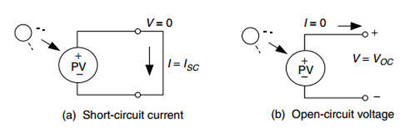
A simple equivalent circuit, which consists of a current source driven by sunlight in parallel with a real diode, as shown in figure 3 is used to represent a typical photovoltaic cell.
Figure 3:PV equivalent circuit
This circuit shows the flow of current when the two output terminals are short-circuited (I_{SC}) and the voltage across the terminals when they are left open (V_{OC}).
In a short circuit condition, there is no current flow in the diode due to the value of V_{d} that is zero. This makes all the current from the ideal source flow through the shortened terminals.
The overall current equation in the above circuit of the PV cell is given as:
$I=I_{SC}-I_{d}$ | (1)
In the absence of solar irradiation, the cell behaves as a simple PN junction diode. This characteristic is governed by the well-known Shockley diode equation expresses diode current as (Chin et al., 2015).
$$I_{d}= I_{0}\left(e^{\frac{qv}{kT}}-1\right)$$ | ($SEQ Equation \backslash * ARABIC$$2$)
In the diode equation $I_{0}$ is known as the reverse saturation current (A), a is the ideality (or quality) factor of the diode. T is the junction temperature (K), k is Boltzmann’s constant (1.381 $×{10}^{-23}$ J/K) and q is the electron charge (1.602 $×{10}^{-19}C$).
This makes the overall current to be:
$I=I_{SC}-I_{0}(e^{\frac{qv}{kT}}-1)$. (3)

From figure 1b where the PV cell terminals are left open, $I=0$, therefore the V_{OC} is given by the equation below:
$V_{OC}=\frac{kT}{q}In(\frac{I_{SC}}{I_{0}}+1)$ (4)
At standard conditions where the temperature is 25$℃$, then equation 3 and 4 become:
$I=I_{SC}-I_{0}(e^{38.9V}-1)$ and $V_{OC}=0.0257In(\frac{I_{SC}}{I_{0}}+1)$

2.1.2.2 Accurate equivalent circuit for a PV cell
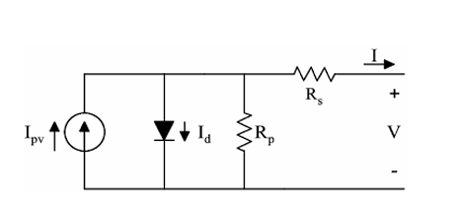
To achieve an accurate circuit, an idealized PV equivalent circuit will be modified by adding parallel and series resistance, as shown in figure 4
Figure 4: A PV equivalent circuit with parallel and series resistance
from the circuit in figure 3, the new equation for current and voltage becomes:
$I=I_{SC}-I_{d}-I_{p}$ (5)
Where $I_{p}=\frac{V_{d}}{R_{p}}=\frac{V+IR_{s}}{R_{p}}$ and $I_{d}=I_{0}(e^{\frac{q(V+IR_{S})}{kT}}-1)$
Therefore,
$I=I_{SC}-\{I_{0}(e^{\frac{q\left(V+IR_{S}\right)}{kT}}-1)\}-(\frac{V+IR_{s}}{R_{p}})$ (6)

At standard conditions where the temperature is 25$℃$, then I and V_{OC} become:
$I=I_{SC}-I_{0}\left(e^{38.9\left(V+IR_{S}\right)}-1\right)-\frac{1}{R_{p}}(V+IR_{s})$ (7)
From the circuit, the diode voltage can be calculated using the Kirchhoff voltage drop.
$V_{d}=V+IR_{s}$ (8)
The voltage across an individual cell is; $V=V_{d}-IR_{s}$
Therefore, the overall module voltage which is known as $V_{module}$ can be obtained by multiplying equation 5 by the number of cells in the module (n) which will give the follow equation.
$V_{module}=n(V_{d}-IR_{s})$ (9)

2.2 Solar irradiance components
It is fundamental in solar resource assessment (SRA) to distinguish between solar irradiance and solar irradiation. Irradiance quantifies the instantaneous power density received from the sun typically expressed in watts per square meter (W/m²). However, solar irradiation represents the cumulative energy received over a specific period of time, measured in joules per square meter or kilowatt-hours per square meter (kWh/m²). The electrical output power of a PV module is directly related to the magnitude of the incident irradiance and the geometric of how that radiation strikes the panel surface. The three main components of terrestrial irradiance are DNI, DHI and GHI, which serve as the foundational inputs for nearly all PV performance models.

2.2.1 Direct Normal Irradiance (DNI)
This is the solar radiation received directly from the sun, measured on a plane that is positioned directly perpendicular (normal) to the sun’s rays. DNI is intensely sensitive to atmospheric conditions such as clouds, aerosols, and water vapour. However, tracking systems designed to maximize DNI will yield their maximum performance exclusively in clear sky conditions and poorly in cloudy days (Al-Othman et al., 2023).

2.2.2 Diffuse Horizontal Irradiance (DHI)
DHI is a measure of the portion of sunlight that has been scattered by molecules, aerosols, clouds, and particles within the atmosphere before reaching the Earth’s surface, which is measured on a horizontal plane. DHI is the dominant energy source under overcast or highly turbid atmospheric conditions. The distinguishing feature of DHI is that its radiation is inherently non-directional, or near-isotropic, meaning it originates from the entire sky dome rather than a single point.
The ratio of DHI to GHI $(k_{d}=\frac{DHI}{GHI})$ serves as a crucial metric for characterizing the atmospheric condition. A high k_{d} value closer to 1 indicates strong scattering and thus a high diffuse light (cloudy or hazy sky). While a low ratio signifies clear, sunny conditions where DNI is the overwhelmingly dominant component (Andriamahefa et al., 2023). This ratio is fundamental to atmospheric modelling and is used explicitly in advanced tracking algorithms, to dictate when the system should switch from tracking the physical sun position to optimizing for diffuse radiation.

2.2.3 Global Horizontal Irradiance (GHI)
This is the total solar radiation incident upon a horizontal surface. GHI is the summation of the direct component of the sunlight that reaches the horizontal surface (Direct horizontal irradiance DHI_{h}, and the diffuse component).

2.3 Mathematical Modelling of Solar Radiation
The three primary irradiance components are linked by a foundational geometric identity known as the closure equation. This relationship is based on the principle of conservation of energy and establishes the connection between the direct beam measured normally and the components measured horizontally. The key is the transformation of DNI into the Direct Horizontal Irradiance (${DHI}_{h}$)which is determined by solar geometry.
${DHI}_{h}=DNI.cos⁡(θ_{z})$ (10)
Where $θ_{z}$ is the solar zenith angle, which is the angle between the sun’s apparent center and the local vertical (zenith).
The standard closure equation then defines GHI as the sum of this projected direct horizontal component and the diffuse horizontal component (DHI):
$GHI=DNI.\cos\left(θ_{z}\right)+DHI$ (11)
The term $\cos\left(θ_{z}\right)$ operates as a projection factor, geometrically converting the high intensity energy measured perpendicular to the beam (DNI) into the magnitude that falls on a flat horizontal plane (${DHI}_{h}$). When $θ_{z}$ is approaching 90⁰ (which occurs when the sun is near the horizon during morning and evening hours), the value of $\cos\left(θ_{z}\right)$ approaches zero. This results in a significant of the direct beam component that reaches a horizontal surface, often causing DHI to become the dominant fraction of GHI, even if the sky is clear. However, when $θ_{z}$ approaches 0⁰ (sun directly overhead at solar noon), $\cos\left(θ_{z}\right)$ approaches one, contributing to highest value of GHI

2.3.1 Transposition Modelling
Since PV modules are typically deployed at a fixed or variable tilt angle ($β$) and orientation (azimuth $γ$), the standard horizontal irradiance components (GHI, DHI, DNI) must be mathematically transposed to determine the energy incident on the module surface. The critical performance metric for PV system is the Global Tilted Irradiance (GTI) or Plane-of-Array Irradiance ($E_{POA}$) . $E_{POA}$ represents the sum of the three distinct components of radiation incident on the tilted surface which is shown in equation 12.
$E_{POA}= E_{b}+E_{d}+E_{g}$ (12)
Where $E_{b}$ is the beam component, $E_{d}$ is the sky diffuse component and $E_{g}$ is the ground reflected component.
$POA Beam Component, E_{b}=DNI×cos⁡(AOI)$ (13)
where AOI is the angle of incidence
POA ground reflected component ($E_{g}$) is assumed to be isotropically reflected from the ground surrounding the array. It is calculated using the GHI, the surface tilt ($β$) and the ground albedo ($ρ$) (Goli et al., 2025). The ground albedo factor, which represents reflectivity must be carefully chosen based on the ground cover
$E_{g}=GHI×ρ×\frac{1-cos⁡(β)}{2}$ (14)
The most significant complexity in transposition modelling arises from accurately predicting the sky diffuse component ($E_{d}$). This is because scattered radiation is intrinsically anisotropic, meaning its intensity is not uniform across the sky dome. Simpler models, such as the Isotopic Model, assume diffuse radiation is distributed uniformly. While computationally is simple, the isotropic model consistently under-predicts the total radiation on a tilted surface and is generally not recommended for precise general use (Tian et al., 2018).
However, Anisotropic Models such as the Hay/Davies or Perez models explicitly account for the non-uniform distribution of diffuse radiation. The model enhanced brightness in two primary regions: the circumsolar area (near the sun’s disk) and the horizon area (near the ground) (Perez et al., 1987). The accuracy of these anisotropic models is necessary for high-quality PV performance simulation.

2.3.2 The Perez Anisotropic Diffuse Model
The perez model (specifically the 1990 version) has become the prevalent choice in the PV industry for accurately estimating global tilted irradiance due to its proven performance across a variety of atmospheric conditions. Its theoretical framework divides the sky diffuse radiation into three physical components:
- Isotropic background: uniform diffuse light covering the entire sky vault.
- Circumsolar zone: the high-intensity, forward-scattered radiation clustered immediately around the position of the sun.
- Horizon zone: enhanced brightness occurring near the horizon, a factor that is particularly important when considering panels with large tilt angles.
The total shy diffuse irradiance ($E_{d}$) calculated by the Perez model is the weighted sum of the contributions from these three zones:
$E_{d}=DHI×[\left(1-F_{1}\right)\left(\frac{1+\cos\left(β\right)}{2}\right)+F_{1}\left(\frac{a}{b}\right)+F_{2}sin⁡(β)]$ (15)
Where:
DHI is the Diffuse Horizontal Irradiance (W/m²), $β$ is the array tilt angle from horizontal, F₁ is the Circumsolar brightness function, which quantifies the degree of forward anisotropic scattering, F₂ is the Horizontal brightness function, which quantifies the enhanced brightness near the horizon, $a = max(0, cos(AOI)$) and $b = max(cos(850), cos(θ_{z}))$

2.4 Effect of temperature on PV performance
Most of the PV module can only convert 6-20% of the solar radiation that hits the panel into useful power known as electricity. This efficiency varies with different climate conditions and the type of solar cell used. However, the remains of the solar radiation are transformed into heat, thereby causing the temperature of the PV module to rise and reducing the overall efficiency of the module (Dubey et al., 2013). In a PV system, high temperature increases the cell resistance, which lowers the open circuit potential (V_{oc}) (Keream et al., 2025), thereby reducing the PV power output. The efficiency of solar cells decreases by approximately 0.5 % for every 1 ◦C increase in temperature (Sepúlveda-Oviedo, 2025). This led to a strong relationship between module temperature and the bandgap energy of the PV cell material. Bandgap energy generally reduces at high operating temperature conditions (Hasan et al., 2022).

2.5 Effect of dust accumulation on PV performance
The effectiveness of the PV modules is decreased when debris, water vapor, air molecules, and other pollutants in the atmosphere prevent sunlight from penetrating the PV panel (Shaik et al., 2023). Solar irradiance can be refracted by airborne dust particles, which are bigger than the wavelength beam which leads to soiling on the module and causing a reduction in solar irradiance (Sepúlveda-Oviedo, 2025).

2.6 Solar Tracking Systems (STS)
Solar tracking systems are electromechanical devices that maximize solar energy collection by following the sun's apparent journey (Okwu et al., 2025). These trackers are classified into single and dual axis tracking, which uses passive and active control techniques to alter PV panel orientation. Passive solar trackers use thermal expansion of fluids to create movement; they are simple but less precise (Kumar et al as cited by (Sadeghi et al., 2025)). However, active trackers employ motors and control systems to improve panel alignment, resulting in much higher energy collection.
Single-axis solar tracking was developed to move PV panels in certain directions, such as azimuth or tilt. The azimuth line of a solar panel or collection is just the angle it makes when looking at it from true north (Kazem et al., 2024). However, the output from single-axis sun tracking was significantly low, especially when solar variation increased throughout the day and seasons. To overcome these challenges, researchers and engineers developed DATs, which allow PV panels to tilt in both the horizontal and vertical planes. This capacity allows for the monitoring of the sun's position throughout the day and even seasons, resulting in up to 30-40% more energy captured than fixed panel systems (Kazem et al., 2024).
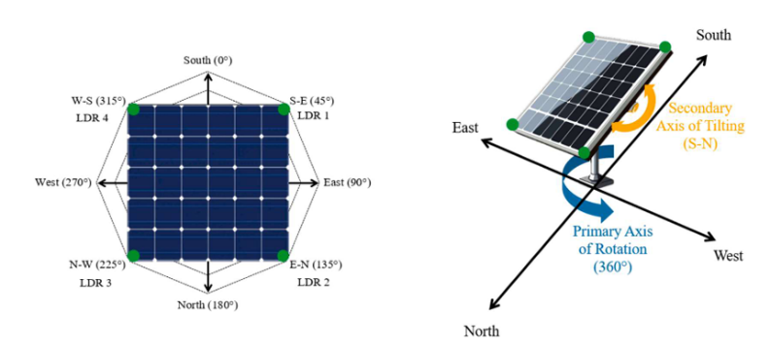
One unique aspect of solar tracking systems is their ability to follow the sun's path throughout the day. Allowing the system to adjust to the changing angles of the sun as it moves across the sky, taking into account factors such as sunrise, sunset, and variations in cloud cover (Okwu et al., 2025). The figure below shows the working principle of dual axis solar tracking.
Figure 5: Dual axis solar tracking using LDR
The distribution of publications during the previous five years shows a considerable rise in research effort, especially from 2022 forward. This trend indicates an increasing focus on enhancing tracking methods, sensor integration, and automation strategies to improve solar energy efficiency(Sadeghi et al., 2025).

2.6.1 Tracking model
Solar tracking models are mathematical techniques or algorithms used to determine the optimal orientation of solar panels towards the sun at any particular moment. The control strategies used in solar tracking systems can be divided into two main categories: traditional and modern control methods. Among the traditional strategies, there are open-loop and closed-loop systems (Awasthi et al., 2020). Open-loop systems use pre-programmed astronomical data to move panels into place without getting real-time feedback from sensors. This makes them easier to use and less expensive, but they are not as flexible when weather conditions change. Closed-loop systems, on the other hand, use sensors (like photodiodes, UV, LDRs, or pyranometers) to constantly send feedback to the controller. This makes them more accurate, but they usually need more maintenance and use more energy (Sadeghi et al., 2025).

2.7 AI and Machine Learning in Solar Tracking
AI is changing the solar energy industry and starting a new era of progress and innovation.
This new approach improved the way solar energy is made, managed, and optimized by using machine learning algorithms and data analysis (Mohammad et al. 2023). Many researchers have looked into the many ways AI can improve solar energy and how it could help shape a bright future for renewable energy. Recent advancements in artificial intelligence (AI) have enabled the creation of intelligent tracking models that aim to overcome the limitations of conventional sensor-based and astronomical trackers. These systems use prediction algorithms to optimize tracking decisions under varying weather and environmental circumstances.
Artificial intelligence (AI) techniques like as fuzzy logic, artificial neural networks (ANN) (Sahin et al., 2023), genetic algorithms, and reinforcement learning are used in intelligent tracking to determine optimal panel orientation based on historical and current data. The AI controller predicts optimal elevation and azimuth angles for peak power generation, using inputs such as sun irradiation, temperature, humidity, latitude, longitude, date, and time (Sadeghi et al., 2025).

2.8 Performance Metrics of AI Model
Several assessment measures can be used to evaluate the performance of AI models. The choice of these measures depends on the specific type of model and the task it is designed to accomplish in machine learning (Phiri et al., 2023). This section presents several evaluation metrics, including Mean Squared Error (MSE), Mean Absolute Error (MAE), Root Mean Square Error (RMSE), and Coefficient of Determination (R²). These error criteria were used to assess the accuracy of a model in predicting an observed output variable (Bilgili et al., 2021). Their calculation methods are provided as follows.
The Mean Squared Error (MSE) is the loss function used to compute the average squared difference between the actual values, denoted as ki, and the predicted values ${k'}_{i}$. This relationship is illustrated in equation 16 (Mulenga et al., 2023)
$MSE=\frac{1}{n}\sum_{i=1}^{n}{{(k_{i}-{k'}_{i})}^{2}}$ (16)
Similarly, MAE is used to calculate the average absolute variation between the actual and predicted values as defined by the equation below. MAE is given by the following formula, where $k_{i}$ denotes the actual optimal angles, which are tilt and azimuth angles, ${k'}_{i}$ denotes the predicted optimal angles, and n denotes the sample size. A low MAE value is always desirable for a model
$MAE=\frac{1}{n}\sum_{i=1}^{n}{|k_{i}-{k'}_{i}|}$ (17)
RMSE calculates the square root of the mean squared differences between the actual and predicted values as computed by equation 18. Smaller index values of the RMSE indicate a high model performance.
$RMSE=\sqrt{\frac{1}{n}\sum_{i=1}^{n}{{(k_{i}-{k'}_{i})}^{2}}}$ (18)
The R² is the total variation in the target variable that is explained by the independent variables in the regression model. The following equation is used to calculate the coefficient of determination:
$R^{2}=1-\frac{\sum_{i=1}^{N}{{(k_{i}-{k'}_{i})}^{2}}}{\sum_{i=1}^{N}{{(k_{i}-{\overline{k}}_{i})}^{2}}}$ (19)
Where ${k'}_{i}$ represents the estimation of $k_{i}$ and ${\overline{k}}_{i}$ represents the average of the observations. Sometimes R² is referred to as the prediction rate, which calculates the ratio of data samples that can be estimated by the chosen predictor value. Given that ${\overline{k}}_{i}$ is the mean of the output value, the prediction rate can be found using the following formula:
$Prediction Rate=\left(1-\frac{\sum_{i=1}^{N}{{\left(k_{i}-{k^{'}}_{i}\right)}^{2}}}{\sum_{i=1}^{N}{{\left(k_{i}-{\overline{k}}_{i}\right)}^{2}}}\right)×100\%$ (20)
The suitability of the selected performance metric lies in the experiment’s overall purpose, which is to predict the optimal angles. The MSE provides an essential model training, validation, and verification benchmark. It provides an ideal performance measure for models that predict continuous variables because of its concept of cross-entropy (Hodson et al., 2021).
Likewise, MAE is the most natural measure of average error size, and in contrast to RMSE, it provides an unambiguous measure of the average error magnitude.

2.9 Dataset for the AI training
The National Solar Radiation Database (NSRDB) is one of the most widely used public datasets, featuring a comprehensive collection of solar energy and meteorological data. The primary measures of solar radiation provided by the NSRDB are Global Horizontal Irradiance (GHI), Direct Normal Irradiance (DNI), and Diffuse Horizontal Irradiance (DHI). This data has been collected across the United States and an increasing number of international locations, ensuring high temporal and spatial resolution to accurately represent both global and regional solar radiation conditions. The NSRDB supports the SunShot Initiative goals of the U.S. Department of Energy (DOE), which aim to eliminate barriers to the widespread adoption of solar energy technologies. It offers easy access to high-quality, essential data necessary for the development of new products and downstream modeling tools (Sengupta et al., 2018).
With the improvement of satellite technology, the information accessible from precisely recovered atmospheric parameters is constantly expanding. This, along with rapid advances in computer power, has resulted in major improvements to solar radiation models. Improved retrievals of water vapor, aerosol, and cloud characteristics allow for more accurate direct calculation of DNI (Arrubla et al., 2025). NREL employed this technology to produce the latest NRSDB, which contains long-term high-resolution solar radiation from geostationary satellites.
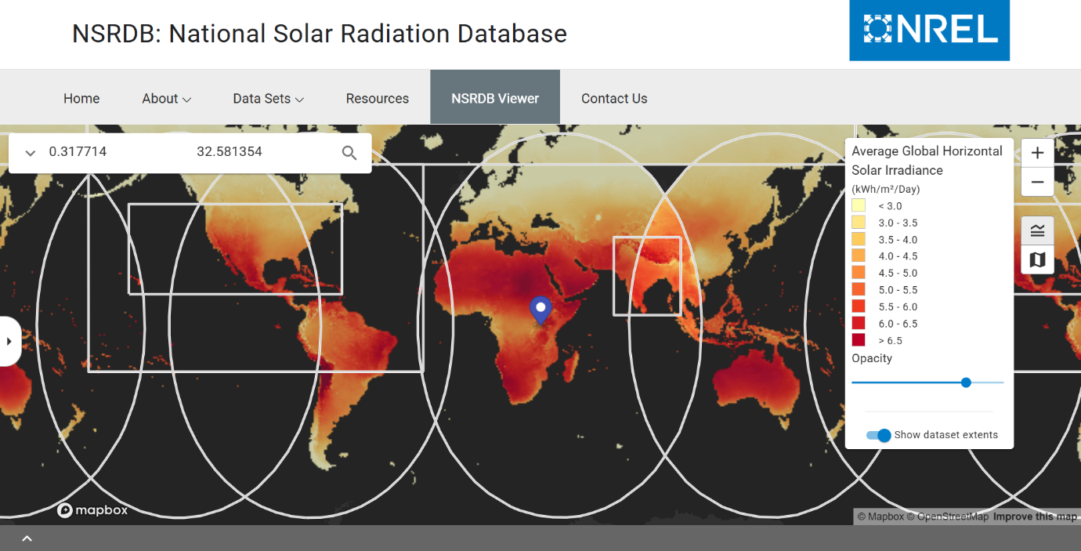
The NREL database is a free-access database where data availability for the study region (Kampala) is accessible. NREL climate data coverage can be seen in the figure below, which shows that, depending on the region, data have been available since 1998 with ten-, fiftheen-, thirty-, and sixty-minute sampling intervals (Santos de Araújo et al., 2024).
Figure 6: National Solar Radiation Database (case study: Kampala)

2.10 Review of Mechanical design
The experimental setup for dual-axis solar tracking necessitates a frame that is sufficiently sized and strong enough to support a conventional solar panel (Pramono, 2020). The rigid mechanical model consists of two fundamental components: the base and the body. The base remains fixed, while the body of the frame moves with the panel, allowing for the necessary degrees of freedom. By applying the standard equation of motion (EOM), the required torques can be determined based on a specified set of input parameters, such as the mass of the object and external wind forces, as illustrated in the figure below. The equation governing the required starting torque for the machine is as follows (Talal et al., 2023):
$τ_{start}=μ×R_{l}×B_{b}×n$ (21)
Where $μ$ is the coefficient of friction, $R_{l}$ is the radial load, $B_{b}$ is the bearing bore and n is the number of bearings.
From which required torque for sample angular acceleration, based on value of moment of inertia can be calculated for rectangular surface using:
$I=\frac{1}{12}×mass×{width}^{2}$ (22)
And required torque can be calculated by:
$τ=I×α$ (23)
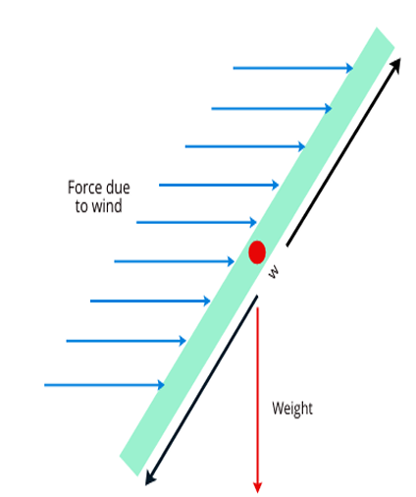
Where I is the moment of inertia and $α$ is the angular acceleration.
Figure 7: Free Body diagram
The torque required to orient a solar panel toward incoming sunlight can vary based on the size of the panel and the configuration of the tracker. For smaller trackers, torque calculations are often unnecessary because the weight is low, allowing the actuators to manage it easily. In contrast, for larger solar panels, such as those installed on rooftops, torque calculations are crucial for ensuring the system's stability and performance. This importance arises primarily from the considerable weight of the panel and the wind resistance it may encounter (Talal et al., 2023). A number of mechanical designs are available for actuation of a solar tracking system using electric motors or linear actuators or a combination of them both (Kumar et al. As cited by (Talal et al., 2023)).

2.11 Related work
(Lu & Ajay, 2024) proposed a novel sensor-based solar tracking system utilizing numerical optimization to enhance the energy output of photovoltaic systems. In this research, the tracker detects sunlight intensity using ultraviolet and microelectromechanical systems (MEMS) sensors. One sensor predicts the sun’s position in the East-West direction, while the other predicts it in the North-South direction. The study developed a control system featuring a proportional-integral-derivative (PID) controller and arithmetic optimization (AO) to adjust the panel’s position in relation to the sun's movement. The system uses clear skies for the real-time tracking experiments during cloudy days. The developed model was designed using MATLAB software, and the outcomes were analyzed. Both manual and automated modes of operation are available for this solar tracking device. But in both cases, the system must be in the absolute encoder value and reset by going back to the home position (HP) at least once.
(Jamroen et al., 2020) designed a dual-axis solar tracking model that boost the power output of PV systems. The tracker makes use of a Light Dependent Resistor (LDR) sensor as a closed-loop control system for the active tracking model. The results of the implementation are compared to the old fixed flat-plate model. The experiment's results show that the designed model was 44.89% more efficient than the fixed flat-plate model. The model that was made, on the other hand, does not take into account the weather and other environmental factors.
(Santos de Araújo et al., 2024) proposes an artificial intelligence-based algorithm for solar trackers that takes into account the following main factors: weather variations and the distance between solar panels. Its effectiveness has been validated in a real solar plant with bifacial panels located in northeastern Brazil. The algorithm achieved gains up to 7.83% on a cloudy day and obtained an average energy gain of approximately 1.2 % when compared to a commercial solar tracking algorithm. However, the system does not account for the effect of high temperature on the solar PV, which has a negative effect on the overall efficiency
A study by (Azad et al., 2025) explored several techniques to optimize the energy efficiency of dual-axis tracking systems. They designed a SIMULINK-based dual-axis solar tracking system, incorporating both electrical and mechanical components. Their theoretical and experimental findings in Jaipur, India, indicated that dual-axis tracking greatly boosts current production compared to stationary PV systems. Additionally, they studied the influence of wind pressure on tracker stability, highlighting the necessity for optimal structural designs. Their results imply that incorporating real-time sun monitoring, automation, and problem detection might further boost system efficiency and dependability, decreasing total solar power costs
(Kabir et al., 2025) investigated the performance of fixed, single-axis, and dual-axis solar tracking systems controlled by an Arduino UNO. The tracking system uses four LDR sensors and two servo motors to improve panel orientation based on real-time sunlight detection. Experimental findings indicated that dual-axis tracking greatly enhanced energy efficiency, obtaining up to 35.5% greater power production, while the single-axis system achieved 33.23% relative to a fixed panel. These results reaffirm the usefulness of active tracking systems, especially dual-axis setups, in optimizing solar radiation collection and total energy output.
(Merie & Ahmed, 2024) evaluated the influence of overcast weather on the efficiency of a PV/solar chimney system, revealing that cloud cover considerably affects solar radiation intensity, resulting to poorer energy production. Their experimental investigation examined system performance on two consecutive days, one clear and one overcast, indicating that on a cloudy day, electrical power output reduced from 341.92 W to 187.88 W at midday, while thermal efficiency decreased from 56.08% to 42%. Additionally, the system’s total efficiency was lowered from 69.65% under clear circumstances to 54.12% under cloud cover, indicating the major influence of dispersed radiation. Their results underline the necessity for adaptive tracking systems that may improve energy collection under various weather circumstances, especially for hybrid solar technologies, where both electrical and thermal performance are impacted by sun availability.
(Al-Othman et al., 2023) developed an advanced hybrid solar tracking system which is designed to enhance photovoltaic (PV) power generation under various weather conditions, particularly in cloudy or overcast skies. The study introduced a hybrid controller that merges an open-loop sun monitoring system with a dynamic feedback controller utilizing an active search algorithm. This enables the system to adjust in real time based on the current irradiance levels. The research addresses the limitations of traditional tracking methods, which rely on direct sunlight to determine optimal panel positioning and often underperform in diffuse irradiance conditions. When instantaneous irradiance levels drop below a specified threshold (DNI irradiance), the system transitions to a recently proposed circular pathfinding method to identify the Maximum Power Point Tracking (MPPT). The solar panel's generated power increased by approximately 35%, demonstrating the effectiveness of the newly proposed hybrid control system for sun tracking.
(Pradeep et al., 2023) Propose a design that improves the efficiency of a solar PV panel's power generation by using a Dual-Axis tracker with a Cooling system. The system utilizes 4 LDR sensors for the detection of the sun in both East-West and North-South directions. For the tracking mechanism, two servo motors were utilized for horizontal movement and vertical movement. In order to reduce the effect of heat as the solar panel continues to face the sun's rays, they implemented a cooling system with the dual-axis tracking device, which will help improve the efficiency of the solar energy generated.
(Sharaby et al., 2025) come up with a system that combines two methods: a tracking system to get the most energy possible and a method for cooling the surface. They looked at different PV setups, such as conventional fixed, fixed with cooling, single-axis tracking (SAT) with cooling, and double-axis tracking (DAT) with cooling. For cooled PVs, spray cooling was used on the surface of the upper panel. When SAT and DAT systems were compared to fixed panels, the input power increased by 15.18% and 16.2%, respectively. The surface temperatures of tracking systems were almost the same as those of cooled fixed panels, but they absorbed more solar energy. Tracking systems, especially DAT, which showed a 26.1% increase in power output, were also the best at increasing power generation. The DAT-based PV had the highest peak efficiency, which was about 14%.
Therefore, according to all the works analysed, the three main elements that can be optimized refer to the positioning of the photovoltaic panels during cloudy days, and also focusing on the cooling and cleaning of the solar panel in order to maximize solar energy.
This now justify the proposed hybrid system for the dual-axis solar tracker based on closed-loop control (sensor-based) and artificial intelligence to address all the cited deficiencies in solar tracker systems, such as harnessing diffuse irradiance on cloudy days and improving the efficiency of the system by cooling and cleaning the solar PV.

CHAPTER THREE

METHODOLOGY
The methodology is structured into three major phases, which are aligned with the research objectives:

3.1 Development of the AI model (Objective 1)
The block diagram below shows the three stages for the algorithm development. One of the prerequisites for developing the intelligent algorithm is the simulation of the optimal behaviour according to the current weather situation. Thus, the first step of the methodology is to download the weather data from the NREL (National Renewable Energy Laboratory) website. The NREL is an open-source website that is hosted by the U.S. Energy Department. It was chosen after analytical research on the other available climate databases, taking into account some criteria: Availability of climate data, mainly the GHI (global horizontal irradiance), DNI (direct normal irradiance), and DHI (diffuse horizontal irradiance) variables for the simulation of optimal angles.
Data sourcing & Feature engineering
Simulation optimal angle (PVLib and python)
Model development & training
First step
Second step
Performance evaluation and validation
Third step
Fourth step
Figure 8: Algorithm development block diagram
3.1.1 Data sourcing and feature engineering
It is desired that the algorithm operate in accordance with weather changes and the positioning of the sun. The intervals of the training data must be as short as possible (Santos de Araújo et al., 2024). So, data will be obtained at intervals spaced every fifteen minutes. A five-year historical meteorological dataset for Kampala, Uganda (Latitude 0.33⁰N, Longitude 32.5825⁰E) will be sourced.
The raw data will undergo a rigorous preprocessing and feature engineering pipeline to construct a feature set optimized for the predictive task.

3.1.2 Simulation of optimal panel orientation.
The simulation establishes an accurate baseline for the optimal orientation of a dual-axis tracker, which serves as the target output for the supervised machine learning models. The optimal orientation is defined as the combination of tilt and azimuth angles that maximizes the total Plane of Array (POA) irradiance for any given set of atmospheric conditions and solar position.
For this research, the perez anisotropic sky model will be selected (perez et al., 1990). This model is widely recognized in the solar energy community for its high fidelity in transposing horizontal irradiance components to a tilted plane across a comprehensive range of sky conditions, from clear to fully overcast. Its ability to account for circumsolar brightening and horizon brightening makes it superior to simpler isotropic models, a conclusion supported by numerous validation studies (Al-Qaisi et al.,2022). The model will be implemented using the open-source PVlib in Python library, which is a standard tool in photovoltaic system modelling.

3.1.2.1 Numerical optimization of panel angles
With a robust model for $I_{POA}$ established, the optimal tilt ($β$) and azimuth ($γ$) angles will be determined by solving a numerical optimization problem for each timestamp in the dataset. The objective function is to maximize the total POA irradiance:
($β_{opt}, γ_{opt}$) = $arg \max_{β,γ} I_{POA}(β, γ, θ_{z},γ_{s}, GHI,DNI,DHI)$ (24)
This optimization will be performed using the L-BFGS-B algorithm (Limited-memory Broyden Fletcher Goldfarb Shanno with Bounded-constraints), a quasi-Newton method designed for bound-constrained as bounds: $0°<β<90°$ for the tilt angle and $0°<γ<360°$ for the azimuth angle. The resulting time series of $β$ and $γ$ represents the ideal, physically-derived orientation of the solar panel at each moment.

3.1.3 Predictive Model Development and Training
Following the generation of the optimal orientation dataset, the next stage of the research will focus on the development and training of predictive models. This is to create a model that can accurately predict the optimal tilt and azimuth angles using real-time meteorological data as inputs. To ensure a comprehensive and comparative analysis, this research will implement and evaluate three distinct machine learning architectures:
1. Random Forest
2. Multi-Layer Perceptron
3. Long Short-Term Memory network.
The complete dataset will be split chronologically to simulate a real-world forecasting scenario. Data from the years 2017-2021 will be designated as the training set, which will be used for the model learning and validation. Data from the year 2022 will be reserved as the test set for final model evaluation on unseen data.

3.1.3.1 Model 1: Random Forest (RF)
The Random Forest algorithm is an ensemble learning approach invented by Breiman (2001), and will be implemented using the scikit-learn library. The model will be developed as an ensemble of independent decision trees. It will combine the predictions of many decision trees, boosting predictive accuracy in order to reduce overfitting. This strategy, which is also known as bagging, creates several subsets of the original training data, enabling each tree in the forest to learn from a distinct fraction of the data. Each tree picks distinct attributes to create randomization and guarantee variety in the model (Rafi & Sohan, 2024).
$f^{'}\frac{z}{rf}\left(p\right)=\frac{1}{z}\sum_{z=1}^{z}{T{(p)}^{k}}$ (25)
Here, in equation 25, p is the training set’s input, and rf creates z number of regression trees. Therefore, a z number of trees build $T{(p)}^{k}$.
To ensure the model is both accurate and efficient for deployment, its complexity will be controlled by pruning the trees. This will be achieved by setting a maximum tree depth and a minimum number of samples required at each leaf node. The model will be trained by fitting it to the training feature set (x_train) and the corresponding optimal angle target variables (y_train).

3.1.3.2 Model 2: Multi-Layer Perceptron (MLP)
The MLP is considered as a static network, thus for the modelling of a dynamic system with this network, it is necessary to introduce the past data (input and output data of the system) as the inputs to the MLP network (Mekki et al., 2016). This allows the static network to learn the dynamic behaviour of the system (Yildirim et al., 2023) in order to predict the optimal angles.
MLP consists of multiple layers of nodes, commonly organized into an input layer, one or more hidden layers and an output layer. Each node in a layer is connected to every node in the subsequent layer, and each connection is associated with a weight that adjusts during the training process (Mouaad et al., 2024). The nodes, neurons in the hidden layers apply an activation function such as Rectified Linear Unit (ReLU) to the weight sum of their inputs, introducing non-linearity to the model. The input features will be normalized using the standard-scaler from scikit learn in order to prevent data leakage from the test set. The final output layers will consist of two neurons with a linear activation function to provide the continuous regression outputs for tilt and azimuth.
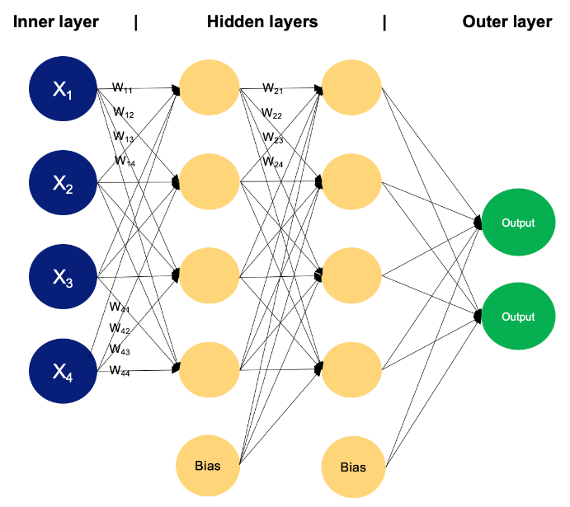
Training an MLP involves adjusting the weights through backpropagation and optimization algorithms to minimize the difference between predicted and actual outputs (Mouaad et al., 2024). For this study an Adam optimizer will be used as the optimization algorithm to compile the model through the use of TensorFlow/Keras framework for a certain number of epochs. Figure 9 illustrates the MLP architecture
Figure 9: The employed MLP neural network structure

3.1.3.3 Model 3: Long Short-Term Memory (LSTM) Network.
LSTMs are a type of Recurrent Neural Network (RNN) specifically good at learning long-term dependencies. LSTM cells have a special cell structure that allows information to be stored for longer periods of time without being lost (Olcay et al., 2024). LSTM comprises three main gates: the input gate, forget gate and the output gate (Zhu et al., 2020). The primary function of the three gates is to control the flow of information in and out of the LSTM cell. More specifically, the input gate determines how much data enters the memory cell. The forget gate handles the retention of information and regulates which information is eliminated from the cell. The output gate determines which part of the information is passed on to the subsequent unit. LSTM cell mainly uses the tangent and sigmoid activation functions. The following equations outline the recursive computations of the LSTM cell (Mulenga et al., 2023).
$f_{s}=σ(l_{xf}^{w}x_{(s)}+l_{hf}^{w}h_{(s-1)}+b_{f})$ (26)
$i_{s}=σ(l_{xi}^{w}x_{(s)}+l_{hi}^{w}h_{(s-1)}+b_{i})$ (27)
$o_{s}=σ(l_{xo}^{w}x_{(s)}+l_{ho}^{w}h_{(s-1)}+b_{o})$ (28)
${g'}_{s}=tanh(l_{xg}^{w}x_{(s)}+l_{hg}^{w}h_{(s-1)}+b_{g'})$ (29)
$z_{s}= f_{s} ⨂ z_{(s-1)}+i_{s} ⨂ {g'}_{s}$ (30)
$h_{s}=o_{s} ⨂ tanhz_{(s)}$ (31)
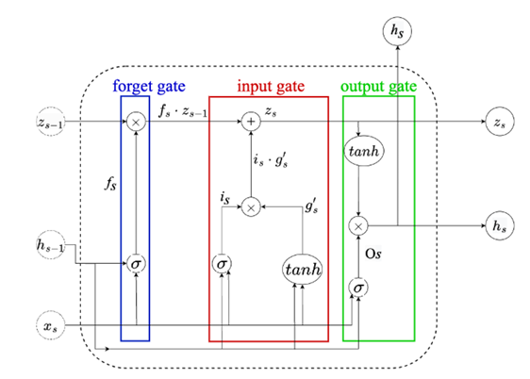
Where tanh and $σ$ denote the tangent and sigmoid activation functions, respectively. f, i, o, g, z, and h represent the forget gate, input gate, output gate, temporary memory, new memory cell, and memory block at time step s, respectively. $⨂$ represents an element-wise multiplication between two matrices. S represents the time step, and w denotes the magnitude of the window. l denotes the layer weights representing input x, and b represents the bias term. The cell structure of the LSTM module is shown below
Figure 10 Long short-term memory
The core of the LSTM methodology for this study will be the transformation of the flat time-series data into supervised learning sequences of a defined “sliding window” approach. This will be used to create input sequences of a defined lookback period.
The LSTM network will be built in Keras, with a primary LSTM layer containing a certain number of memory units to process the input sequences. This will be followed by Dense layers to map the learned sequence representation to the final two-neuron output. Dropout layers will be included to provide regularization and prevent overfitting. The process of hyperparameter tuning focusing on the lookback period and network complexity will be undertaken to optimize the model.

3.1.4 Performance evaluation and validation
The dataset of 2022, which was not used in the training and testing process, will be tested to validate the applicability of the proposed models in terms of their Mean Absolute Error (MAE), Root Mean Squared Error (RMSE), and Coefficient of Determination (R²). Any of these models RF, MLP and LSTM neural networks that perform best in terms of the error metrics, will be deployed for the hybrid solar tracking.

3.1.5 AI Model deployment
This research will implement a cloud-based deployment architecture, where the AI model will be hosted on a remote server. This Internet of Things (IoT) approach separates the system’s brain (AI) from its body (“the physical tracker”), allowing for greater model complexity and easier updates. The deployment will be structured into three key components:
- Cloud service
- Device-side (ESP32 client)
- Communication protocol

3.2 Design of hybrid sensor-based tracking system (Objective 2)

3.2.1 Mechanical design and load analysis
This phase forms the foundational engineering of the system. A CAD model (SolidWorks) will be developed to visualize the structure, identify the center of mass, and design the pivot points using ball bearings to minimize friction. The key parameters for torque calculation are defined as follows:
Gravitational torque: the torque required to hold the panel at any angle is given as
$τ_{grav}=m_{panel}×g×d×cos⁡(θ)$ (32)
Where:
$m_{panel}=5 kg$ (mass of the panel), g = 9.81 m/s² (acceleration due to gravity), d = perpendicular distance from the CAD model and $θ$ = tilt angle from horizontal.
Wind load torque: the system will be design to withstand a maximum wind speed of 80 km/h (22.22m/s). The resulting torque is calculated as:
$F_{wind}=\frac{1}{2}ρv^{2}c_{d}A_{panel}$ (33)
$ρ=1.225\frac{kg}{m^{3}}(air density)$, $c_{d}=1.2$ (drag coefficient for a flat plate), $A_{panel}=surface area of the panel (m^{2})$
Therefore wind torque, $τ_{wind}=F_{wind}×h$, where h is the moment arm from the pivot to the center of pressure.
Total torque requirement: the drive system will be sized to handle the combine worst case load:
$τ_{total} = τ_{grav} + τ_{wind}$ (34)

3.2.2 Actuator Sizing and Drive System Design
Given the high torque requirement, a NEMA 17 stepper motor (typical holding torque, $τ_{wind}=0.5 Nm$) will be used in conjunction with a timing belt pulley system to achieve the necessary mechanical advantage. The design will be governed by the gear reduction equation:
Gear reduction ration,
$i=\frac{D_{driven}}{D_{driver}}$ (35)
Output torque ($τ_{out}$):$τ_{out}= τ_{motor}×i×η$ (36)
where D is the pitch diameter of the pulleys.

The required reduction ratio will be calculated as $i=\frac{τ_{total}}{τ_{motor}×η}$ (37)

3.2.3 Intelligent Hybrid Control System Implementation
An advanced intelligent control architecture will be implemented on an ESP32 microcontroller, integrating three distinct positioning strategies to ensure optimal performance across all weather conditions. The system will operate through the following hierarchical framework.

3.2.3.1 Primary tracking mode (Clear sky conditions)
1. LDR-Based active tracking: under clear sky conditions, four Light Dependent Resistors (LDRs), housed in a cross formation with precision shading fins, will serve as the primary sensors.
2. A proportional integral derivative (PID) controller will process the differential voltage signals between opposing LDR pairs to generate precise correction.
The flowchart for the LDR based solar tracking is shown in the figure below.
Figure 11: Sensor-based tracking system (Clear Sky mode)
Start
Is L1 = L2?
Yes
Is L1 > L2?
Horizontal motor move panel towards L2
Yes
No
LDR tracking method
Horizontal motor stop running
Horizontal motor move panel towards L1
No
Vertical motor move panel towards L4
Yes
Vertical motor stop running
loop
Yes
Is L3 = L4?
Yes
Is L3 > L4?
Vertical motor move panel towards L3
No
No

3.2.3.2 Secondary Tracking mode (Cloudy/overcast conditions)
AI predictive positioning: during periods of diffuse irradiance where LDR performance degrades (cloudy days, overcast conditions), the system will automatically transition to the pre-developed Artificial intelligence model in objective 1. This mode requires stable internet connectivity to access the cloud-based AI computation resources.

3.2.3.3 Safety mode (Network failure protocol on cloudy conditions)
In scenarios where poor network connectivity prevents access to the cloud-based AI model during cloudy conditions (rendering both LDR and AI tracking inaccessible), the system will automatically execute a safety protocol.
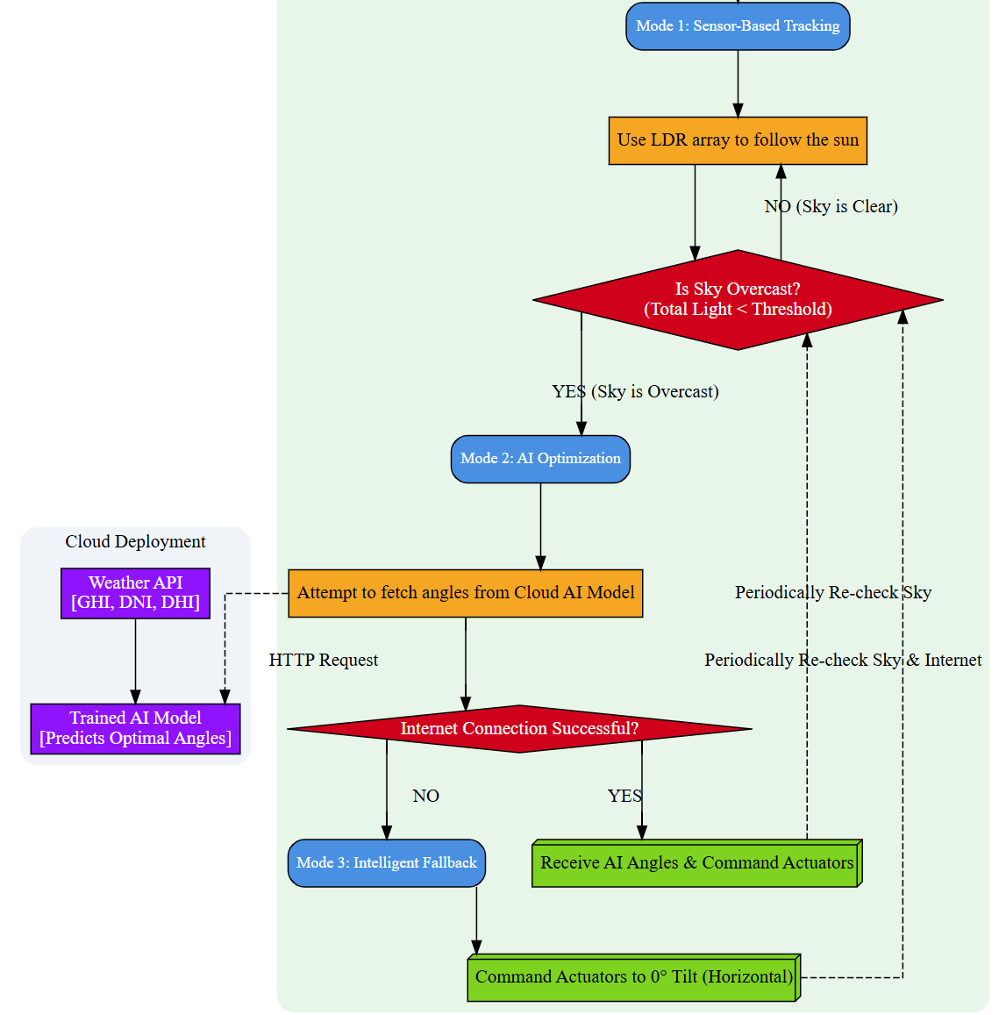
The tracker will move the panel to a predefined horizontal position. This orientation minimizes wind load stress on the mechanical structure, reduces the risk of damage from unexpected weather events and provides a reasonable effective angle for capturing Global horizontal irradiance under overcast conditions. The system will continuously monitor network connectivity and will resume AI based tracking once cloud services are accessible or revert to LDR tracking if the clear sky conditions is normal. The figure 7 and 8 shows the flowchart of the hybrid solar tracking and Sensor based respectively.
Figure 12: flowchart for the hybrid tracking system
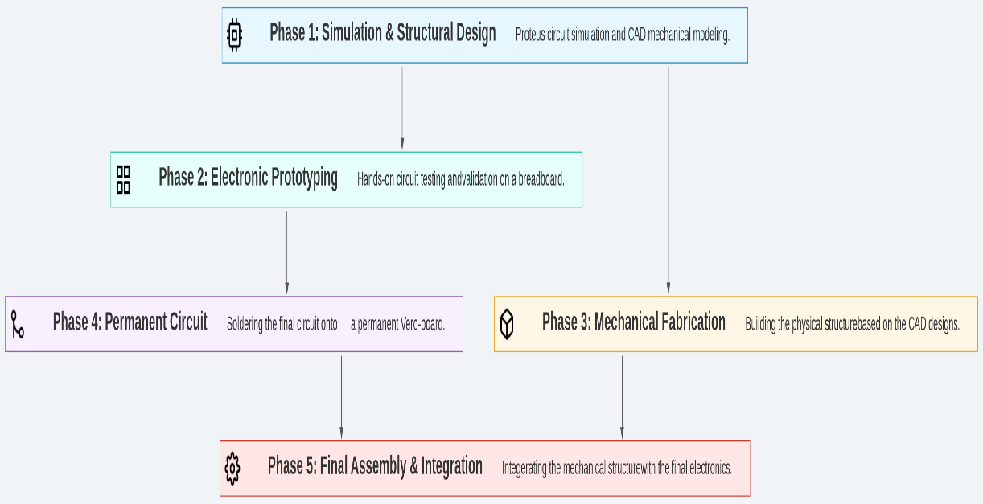
The embedded workflow for this hybrid solar tracking is shown in the figure 11
Figure 13: Embedded workflow

3.3 Design of automated cooling with self-cleaning mechanism (Objective 3)
To enhance the efficiency and longevity of the photovoltaic (PV) panel, the system will integrates an automated cooling and self-cleaning mechanism that will be trigger base on the surface temperature of the panel. This mechanism uses a fixed temperature threshold approach.

3.3.1 Operational logic
The system will be designed to activate the cooling process when the panel surface temperature exceeds 30⁰C. This temperature will be detected using a temperature sensor (DHT11 sensor), which will be attached to the back of the solar panel to accurately capture its operational temperature. It will trigger a 12 DC submersible pump from the water reservoir when it exceeds the threshold value, and the water pump will be activated via the microcontroller ESP32 and run for a fixed duration of 20 seconds. During this period, water will be pumped through a mist nozzle system to spray over the surface of the solar panel.

3.3.2 Spray optimization mechanism
To ensure full surface coverage and effective cooling and cleaning, a servo motor will be integrated to control the direction of the mist spray. The servo motor will be programmed to sweep the spray arm in a smooth arc across the panel width during the 20 seconds of operation, ensuring that water reaches the entire surface of the panel. The cooling effect is achieved through the evaporation of the mist, which rapidly absorbs heat from the panel surface. This water helps remove dust and other pollutants that may accumulate on the surface, thereby improving light absorption and overall system output. Figure 12 shows the flowchart for the cooling and cleaning system
Start
Read panel temperature (T_{p})
Is T_{p} > 30⁰C
Wait and retry after 3 mins
No
Yes
Activate DC pump (for 20 secs)
Activate servo motor to Spread the water across the panel
Stop pump and reset servo motor after 20 secs
Loop
Yes
Check water availability
Skip cooling and log water shortage
Wait for 10 mins
No
Figure 14:Flowchart for the cooling and cleaning mechanism

3.3.3 Water level monitoring
To prevent dry operation of the pump and ensure the availability of water, there will be a water level sensor within the reservoir. If the water level drops below the minimum threshold, the system will disconnect the pump and send an alert signal via the IoT dashboard. The figure below shows the flowchart for the cooling and cleaning mechanism.

3.4 Evaluation Plan
To validate the performance of the proposed hybrid AI solar tracker and quantify its advantages, various evaluation plan will be implemented. This will help test each component of the system and compare its overall performance. The evaluation is structured around four key activities
- To calibrate the sensors and optimize the energy consumption of the system. The system will be run through a series of movements to measure the energy consumed during active tracking.
- To test the switching mode AI and sensor-based tracking and evaluate the corresponding actuator response.
- To analyze the conventional tracking systems with the proposed hybrid AI tracking system, with a focus on solar energy generated & efficiency improvements.
- To analyze how elevated panel temperatures and dust accumulation affect photovoltaic performance, quantifying the associated efficiency losses.

3.5 Expected results
The primary outcome of this research will be the development of a fully functional prototype of a hybrid dual axis solar tracking system. This system will integrate artificial intelligence (AI) with real time sensor-based control to optimize photovoltaic (PV) panel orientation. The hybrid strategy aims to fill the existing research gap in performance optimization under diffuse and partially cloudy irradiance conditions, where conventional sensor based or astronomical tracking methods often fail to perform efficiently.
In addition, the study will deliver a validated cooling and self-cleaning mechanism designed to address two critical environmental challenges affecting PV efficiency such as panel overheating and dust accumulation. The mechanism will autonomously regulate panel temperature and maintain surface cleanliness, ensuring high energy output.

References
- Allamehzadeh, H. (2019). An Update on Solar Energy and Sun Tracker Technology with a Dual Axis Sun Tracker Application. 2019 IEEE 46th Photovoltaic Specialists Conference (PVSC), 2037–2044. https://doi.org/10.1109/PVSC40753.2019.8981360
- Al-Othman, A., Younes, T., Al-Adwan, I., Al Khawaldah, M., Alauthman, H., Alkhedher, M., & Ramadan, M. (2023). An experimental study on hybrid control of a solar tracking system to maximize energy harvesting in Jordan. Solar Energy, 263. https://doi.org/10.1016/j.solener.2023.111931
- Andriamahefa, M. H., Bourdin, V., Mininger, X., Badosa, J., Parra, J., & Migan-Dubois, A. (2023). Control strategy for a dual-axis sun tracker based on a radiometric cube to maximize the power output of the PV system. EPJ Photovoltaics, 14. https://doi.org/10.1051/epjpv/2023022
- Antonanzas, J., Urraca, R., Martinez-de-Pison, F. J., & Antonanzas, F. (2018). Optimal solar tracking strategy to increase irradiance in the plane of array under cloudy conditions: A study across Europe. Solar Energy, 163, 122–130. https://doi.org/10.1016/j.solener.2018.01.080
- Arrubla, M., García, M., Marroyo, L., & García, I. (2025). The Importance of Diffuse Irradiance Data on the Designing and Evaluation of PV Tracking Strategies Developed for Any Sky Conditions. Conference Record of the IEEE Photovoltaic Specialists Conference, 612–616. https://doi.org/10.1109/PVSC59419.2025.11133008
- Awasthi, A., Shukla, A. K., Murali Manohar, S. R., Dondariya, C., Shukla, K. N., Porwal, D., & Richhariya, G. (2020). Review on sun tracking technology in solar PV system. In Energy Reports (Vol. 6, pp. 392–405). Elsevier Ltd. https://doi.org/10.1016/j.egyr.2020.02.004
- Azad, A. M. A. S., Bhuiya, K. M. S., Shoshi, S. R., Jamal, J. R., Udoy, S. A., Zilani, S., Hawlather, A., Hasan, M., & Azad, T. R. (2025). Harnessing the sun: Framework for development and performance evaluation of AI-driven solar tracker for optimal energy harvesting. Energy Conversion and Management: X, 26. https://doi.org/10.1016/j.ecmx.2025.100990
- Bilgili, M., Yildirim, A., Ozbek, A., Celebi, K., & Ekinci, F. (2021). Long short-term memory (LSTM) neural network and adaptive neuro-fuzzy inference system (ANFIS) approach in modeling renewable electricity generation forecasting. International Journal of Green Energy, 18(6), 578–594. https://doi.org/10.1080/15435075.2020.1865375
- Chin, V. J., Salam, Z., & Ishaque, K. (2015). Cell modelling and model parameters estimation techniques for photovoltaic simulator application: A review. In Applied Energy (Vol. 154, pp. 500–519). Elsevier Ltd. https://doi.org/10.1016/j.apenergy.2015.05.035
- Dubey, S., Sarvaiya, J. N., & Seshadri, B. (2013). Temperature dependent photovoltaic (PV) efficiency and its effect on PV production in the world - A review. Energy Procedia, 33, 311–321. https://doi.org/10.1016/j.egypro.2013.05.072
- Gokkus, G. (2024). ANFIS-based improved GWO: Rapid prototyping of low-power solar energy system under fast-changing solar radiation conditions. Journal of Radiation Research and Applied Sciences, 17(2), 100920. https://doi.org/10.1016/j.jrras.2024.100920
- Goli, P., Gampa, S. R., Alluri, A., Gutta, B., Jasthi, K., & Das, D. (2025). Optimum Sizing of Solar Photovoltaic Panels at Optimum Tilt and Azimuth Angles Using Grey Wolf Optimization Algorithm for Distribution Systems. Inventions, 10(5), 79. https://doi.org/10.3390/inventions10050079
- Hafez, A. Z., Yousef, A. M., & Harag, N. M. (2018). Solar tracking systems: Technologies and trackers drive types – A review. In Renewable and Sustainable Energy Reviews (Vol. 91, pp. 754–782). Elsevier Ltd. https://doi.org/10.1016/j.rser.2018.03.094
- Hasan, K., Yousuf, S. B., Tushar, M. S. H. K., Das, B. K., Das, P., & Islam, M. S. (2022). Effects of different environmental and operational factors on the PV performance: A comprehensive review. In Energy Science and Engineering (Vol. 10, Issue 2, pp. 656–675). John Wiley and Sons Ltd. https://doi.org/10.1002/ese3.1043
- Hodson, T. O., Over, T. M., & Foks, S. S. (2021). Mean Squared Error, Deconstructed. Journal of Advances in Modeling Earth Systems, 13(12). https://doi.org/10.1029/2021MS002681
- Husain, M. A., Ahmad, M. W., Bakhsh, F. I., Padmanaban, S., & Malik, H. (2024). Photovoltaic Systems Technology. Wiley. https://books.google.co.ug/books?id=23MKEQAAQBAJ
- Idris, R. M., Ataalah, M., & Mohammed, A. A. (2024). INNOVATIVE APPROACHES TO DUAL AXIS SOLAR TRACKING SYSTEMS. https://jest.utm.my/index.php/jest
- Jamroen, C., Komkum, P., Kohsri, S., Himananto, W., Panupintu, S., & Unkat, S. (2020). A low-cost dual-axis solar tracking system based on digital logic design: Design and implementation. Sustainable Energy Technologies and Assessments, 37. https://doi.org/10.1016/j.seta.2019.100618
- Kabir, M. H., Abu Jihad, M. H., & Chowdhury, S. (2025). Analysis of Solar Panel Power Investigation using Fixed Axis, Single Axis and Dual Axis Solar Tracker. Procedia Computer Science, 252, 708–714. https://doi.org/10.1016/j.procs.2025.01.031
- Kazem, H. A., Chaichan, M. T., Al-Waeli, A. H. A., & Gholami, A. (2022). A systematic review of solar photovoltaic energy systems design modelling, algorithms, and software. In Energy Sources, Part A: Recovery, Utilization and Environmental Effects (Vol. 44, Issue 3, pp. 6709–6736). Taylor and Francis Ltd. https://doi.org/10.1080/15567036.2022.2100517
- Kazem, H. A., Chaichan, M. T., Al-Waeli, A. H. A. H., & Sopian, K. (2024). Dual axis solar photovoltaic trackers: An in-depth review. In Energy Sources, Part A: Recovery, Utilization and Environmental Effects (Vol. 46, Issue 1, pp. 15331–15356). Taylor and Francis Ltd. https://doi.org/10.1080/15567036.2024.2420781
- Keream, S. S., Al Mashhadany, Y., Ahmed Alrawi, A. A., & Algburi, S. (2025). High Performance for PV Panel System Based on Optimal Cooling Techniques. 22nd IEEE International Multi-Conference on Systems, Signals and Devices, SSD 2025, 1049–1054. https://doi.org/10.1109/SSD64182.2025.10989899
- Kumba, K., Upender, P., Buduma, P., Sarkar, M., Simon, S. P., & Gundu, V. (2024). Solar tracking systems: Advancements, challenges, and future directions: A review. In Energy Reports (Vol. 12, pp. 3566–3583). Elsevier Ltd. https://doi.org/10.1016/j.egyr.2024.09.038
- Lu, W., & Ajay, P. (2024). Solar PV tracking system using arithmetic optimization with dual axis and sensor. Measurement: Sensors, 33, 101089. https://doi.org/10.1016/j.measen.2024.101089
- Mekki, H., Mellit, A., & Salhi, H. (2016). Artificial neural network-based modelling and fault detection of partial shaded photovoltaic modules. Simulation Modelling Practice and Theory, 67, 1–13. https://doi.org/10.1016/j.simpat.2016.05.005
- Merie, F. H., & Ahmed, O. K. (2024). Experimental assessment of the performance of the PV/solar chimney under the cloudy weather. Results in Engineering, 23. https://doi.org/10.1016/j.rineng.2024.102605
- Mohammad, A., & Mahjabeen, F. (2023). International Journal of Multidisciplinary Sciences and Arts Revolutionizing Solar Energy: The Impact of Artificial Intelligence on Photovoltaic Systems. 2(1). https://doi.org/10.47709/ijmdsa.vxix.xxxx
- Mouaad, B., Samir, B., Mohand, D., BOUGOFFA Mouaad, st, & BENMOUSSA Samir, nd. (2024a). Dynamic Modeling for Fault Diagnosis in PV Systems Utilizing AI Technique) 1 st BOUGOFFA Mouaad. 1032–1036. https://doi.org/10.1109/ICETSIS61505.2024.10459490ï
- Mouaad, B., Samir, B., Mohand, D., BOUGOFFA Mouaad, st, & BENMOUSSA Samir, nd. (2024b). Dynamic Modeling for Fault Diagnosis in PV Systems Utilizing AI Technique) 1 st BOUGOFFA Mouaad. 1032–1036. https://doi.org/10.1109/ICETSIS61505.2024.10459490ï
- Mulenga, M., Phiri, M., Simukonda, L., & Alaba, F. A. (2023). A Multistage Hybrid Deep Learning Model for Enhanced Solar Tracking. IEEE Access, 11, 129449–129466. https://doi.org/10.1109/ACCESS.2023.3333895
- Okwu, M. O., Eruero, O. P., Abubakar, N., Edward, B. A., Oreko, B. U., Otanocha, O. B., Orikpete, O. F., Maware, C., Ezekiel, K. C., Ori, C., & Tartibu, L. (2025). Single-Axis Solar Tracking Systems: A Comprehensive Design and Performance Study. Procedia Computer Science, 253, 2740–2752. https://doi.org/10.1016/j.procs.2025.01.334
- Olcay, K., Giray Tunca, S., & Arif Ozgur, M. (2024). Forecasting and Performance Analysis of Energy Production in Solar Power Plants Using Long Short-Term Memory (LSTM) and Random Forest Models. IEEE Access, 12, 103299–103312. https://doi.org/10.1109/ACCESS.2024.3432574
- Perez, R., Seals, R., Ineichen, P., Stewart, R., & Menicucci, D. (1987). A new simplified version of the perez diffuse irradiance model for tilted surfaces. Solar Energy, 39(3), 221–231. https://doi.org/10.1016/S0038-092X(87)80031-2
- Phiri, M., Mulenga, M., Zimba, A., & Eke, C. I. (2023a). Deep Learning Techniques for Photovoltaic Solar Tracking Systems: A Systematic Literature Review. https://doi.org/10.21203/rs.3.rs-2539961/v1
- Phiri, M., Mulenga, M., Zimba, A., & Eke, C. I. (2023b). Deep learning techniques for solar tracking systems: A systematic literature review, research challenges, and open research directions. In Solar Energy (Vol. 262). Elsevier Ltd. https://doi.org/10.1016/j.solener.2023.111803
- Pradeep, D., Akash, N. V., Deeksha, B. N., Jay, M., & Shetty, S. C. N. (2023). Improving the efficiency of a solar PV panel’s power generation by using a Dual-Axis tracker with a Cooling system. 2023 IEEE International Conference on Distributed Computing, VLSI, Electrical Circuits and Robotics, DISCOVER 2023, 101–104. https://doi.org/10.1109/DISCOVER58830.2023.10316713
- Pramono Faculty Advisor, E., Dolan Senior Project, D., & Luis Obispo, S. (2020). Single Axis Solar Panel Tracking Mount Using Stepper Motor and Accelerometer Positional Control.
- Rafi, M. A. I., & Sohan, M. R. (2024). Enhanced Solar Radiation Prediction with Machine Learning: A Comprehensive Analysis of Meteorological Data Using Random Forest. 2024 15th International Conference on Computing Communication and Networking Technologies, ICCCNT 2024. https://doi.org/10.1109/ICCCNT61001.2024.10725976
- Sadeghi, R., Parenti, M., Memme, S., Fossa, M., & Morchio, S. (2025). A Review and Comparative Analysis of Solar Tracking Systems. In Energies (Vol. 18, Issue 10). Multidisciplinary Digital Publishing Institute (MDPI). https://doi.org/10.3390/en18102553
- Sahin, G., Isik, G., & van Sark, W. G. J. H. M. (2023). Predictive modeling of PV solar power plant efficiency considering weather conditions: A comparative analysis of artificial neural networks and multiple linear regression. Energy Reports, 10, 2837–2849. https://doi.org/10.1016/j.egyr.2023.09.097
- Santos de Araújo, J. V., de Lucena, M. P., da Silva Netto, A. V., Gomes, F. da S. V., Oliveira, K. C. de, de Souza Neto, J. M. R., Cavalcante, S. L., Morales, L. R. V., Villanueva, J. M. M., & Macedo, E. C. T. de. (2024). Solar Tracking Control Algorithm Based on Artificial Intelligence Applied to Large-Scale Bifacial Photovoltaic Power Plants. Sensors, 24(12). https://doi.org/10.3390/s24123890
- Sarkar, R., Kumar, J. R., Sridhar, R., & Vidyasagar, S. (2021). A New Hybrid BAT-ANFIS-Based Power Tracking Technique for Partial Shaded Photovoltaic Systems. International Journal of Fuzzy Systems, 23(5), 1313–1325. https://doi.org/10.1007/s40815-020-01037-y
- Sengupta, M., Xie, Y., Lopez, A., Habte, A., Maclaurin, G., & Shelby, J. (2018). The National Solar Radiation Data Base (NSRDB). In Renewable and Sustainable Energy Reviews (Vol. 89, pp. 51–60). Elsevier Ltd. https://doi.org/10.1016/j.rser.2018.03.003
- Sepúlveda-Oviedo, E. H. (2025). Impact of environmental factors on photovoltaic system performance degradation. In Energy Strategy Reviews (Vol. 59). Elsevier Ltd. https://doi.org/10.1016/j.esr.2025.101682
- Shaik, F., Lingala, S. S., & Veeraboina, P. (2023). Effect of various parameters on the performance of solar PV power plant: a review and the experimental study. Sustainable Energy Research, 10(1). https://doi.org/10.1186/s40807-023-00076-x
- Sharaby, M. R., Sharshir, S. W., ElBahloul, A. A., Kandeal, A. W., & Rashad, M. (2025). Performance evaluation of fixed and sun-tracking photovoltaic systems integrated with spray cooling. Solar Energy, 288. https://doi.org/10.1016/j.solener.2025.113310
- Talal, M., Pirzada, A. A., Qasim, M., Rehman, H. Z. U., & Khan, Z. H. (2023). Mechatronic Design of a Two Axis Solar Tracker System for Improved Efficiency. 2023 25th International Multi Topic Conference, INMIC 2023 - Proceedings. https://doi.org/10.1109/INMIC60434.2023.10465984
- Tian, Z., Perers, B., Furbo, S., Fan, J., Deng, J., & Dragsted, J. (2018). A comprehensive approach for modelling horizontal diffuse radiation, direct normal irradiance and total tilted solar radiation based on global radiation under Danish climate conditions. Energies, 11(5). https://doi.org/10.3390/en11051315
- Yildirim, A., Bilgili, M., & Ozbek, A. (2023). One-hour-ahead solar radiation forecasting by MLP, LSTM, and ANFIS approaches. Meteorology and Atmospheric Physics, 135(1). https://doi.org/10.1007/s00703-022-00946-x
- Zhu, Q., Chen, J., Shi, D., Zhu, L., Bai, X., Duan, X., & Liu, Y. (2020). Learning Temporal and Spatial Correlations Jointly: A Unified Framework for Wind Speed Prediction. IEEE Transactions on Sustainable Energy, 11(1), 509–523. https://doi.org/10.1109/TSTE.2019.2897136

APPENDICES

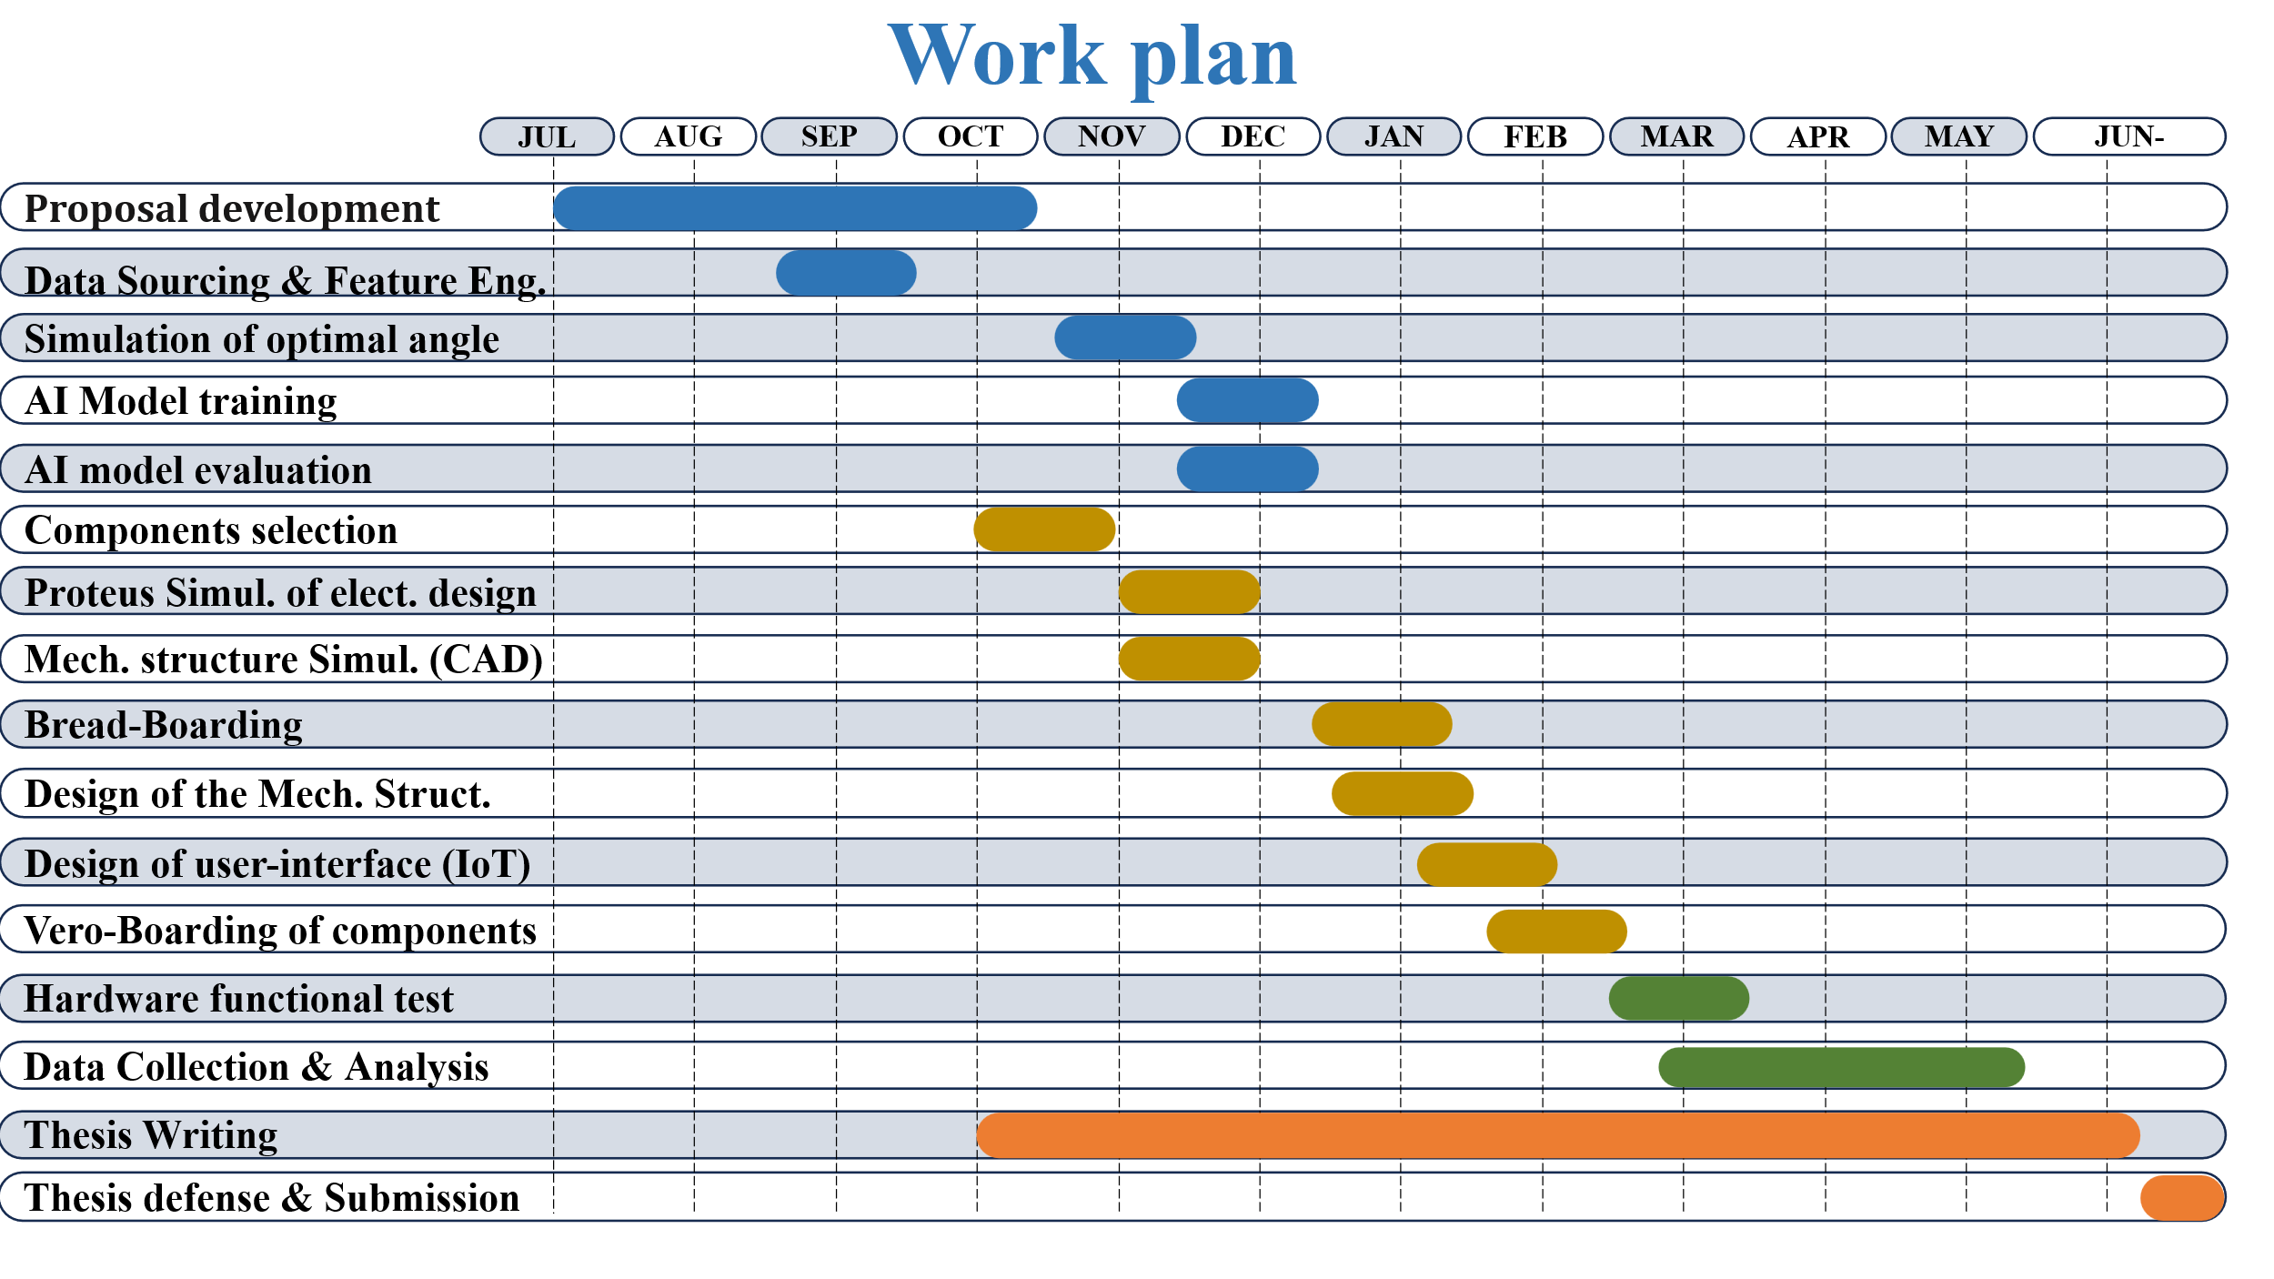
APPENDIX 1.

APPENDIX 2.
BUDGET
S/N | Components | Quantity | Price per Quantity (UGX) | Amount (UGX)
1 | Stepper motors | 3 | 100,000 | 300,000
2 | Drivers | 3 | 65,000 | 195,000
3 | ESP32 | 1 | 70,000 | 70,000
4 | LDR | 4 | 15,000 | 60,000
5 | Timing Belt | 2 meter | 25,000 | 50,000
6 | Pulley | 4 | 20,000 | 80,000
7 | Voltage sensor | 1 | 70,000 | 70,000
8 | Vero-board | 2 | 30,000 | 60,000
9 | Breadboard | 2 | 30,000 | 60,000
10 | Bulk converter | 1 | 50,000 | 50,000
11 | Solder wire | 1 coil | 35,000 | 35,000
12 | Soldering iron | 1 | 60,000 | 60,000
13 | Glue gun | 1 | 50,000 | 50,000
14 | Multimeter | 1 | 100,000 | 100,000
15 | DC Adapter | 1 | 60,000 | 60,000
16 | Resistors | 10 | 500 | 5,000
17 | Cables | 1 coil | 60,000 | 60,000
18 | Current sensor | 1 | 70,000 | 70,000
19 | Solar pane | 1 | 200,000 | 200,000
20 | Battery | 1 | 150,000 | 150,000
21 | Charge controller | 1 | 100,000 | 100,000
22 | Submersible pump | 1 | 80,000 | 80,000
23 | Water pipe | 5 meter | 2,000 | 10,000
24 | Mechanical frame and workmanship |  | 600,000 | 600,000
25 | Casing of electronic components | 1 | 100,000 | 100,000
26 | Cable connectors |  | 20,000 | 20,000
27 | AI Model & Simulation (Data bundle, software, Deployment) |  |  | 1,300,000
28 | Stationary (printing and binding) |  | 300,000 | 300,000
Total |  |  |  | 4,295,000

