RPI ZERO PORTABLE CONSOLE

This is the documentation for a DIY portable game console inspired by the Nintendo Gameboy Advance, based on a SBC, the Raspberry Pi Zero WH, or compatible SBCs.

- Introduction
- General schematic
- Power
- Controls
- Screen
- Audio
- RPI Hardware
- Software
- Case
10. PCB

1 – Introduction

dgbsrtbertb

2 – General Schematic

dgbsrtbertb
3 – Power

Premade powerbank
https://www.amazon.es/gp/product/B082PMBWRZ?ref=ppx_pt2_dt_b_prod_image

This is a charging and boost pcb
https://es.aliexpress.com/item/4001194744356.html?spm=a2g0o.productlist.0.0.744c2ed3YnLXDd&algo_pvid=f7005a09-a705-484a-a3a4-04645a911ded&algo_exp_id=f7005a09-a705-484a-a3a4-04645a911ded-0&pdp_ext_f=%7B%22sku_id%22%3A%2210000015264717864%22%7D

LiPo battery 3.7V parece correcta en cuanto a tamaño y output ~400mah la 104050
https://www.youtube.com/watch?v=6LxRnf6sQNQ

cargadr e lipo y booster salida de la bbateria 2 en 1 https://es.aliexpress.com/item/33034500618.html?spm=a2g0o.productlist.0.0.613e3fbeJwJzij&algo_pvid=e654ae90-a788-4a56-a17d-26b618c302e7&algo_exp_id=e654ae90-a788-4a56-a17d-26b618c302e7-6&pdp_ext_f=%7B%22sku_id%22%3A%2212000025775278794%22%7D&pdp_pi=-1%3B3.95%3B-1%3B-1%40salePrice%3BEUR%3Bsearch-mainSearch

otra opcion es tp5410 pero parece no estar en aliexpress
4 – Controls

dgbsrtbertb
5 – Screen

ili9488 3.5 inch 480x320 tft lcd SPI
https://es.aliexpress.com/item/32985467436.html?spm=a2g0s.9042311.0.0.501563c0ew2XB1
6 – Audio

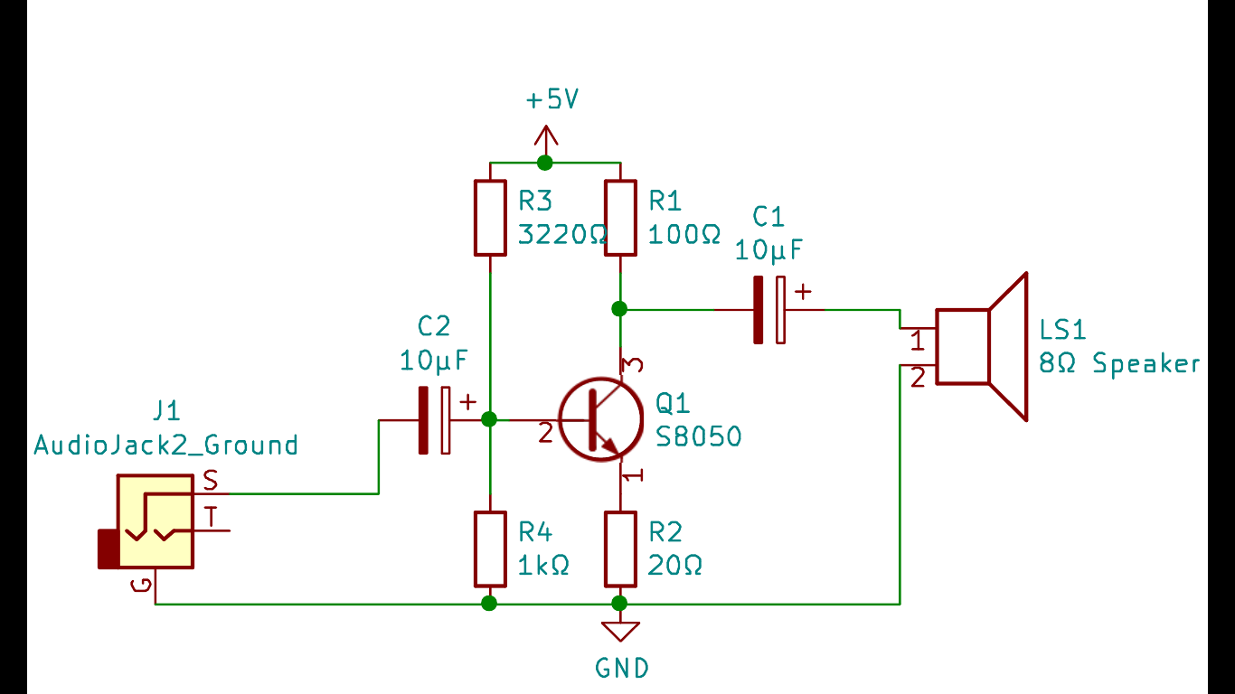
7 – RPI Hardware

dgbsrtbertb
8 – Software

dgbsrtbertb
9 – Case

dgbsrtbertb
10 – PCB
dgbsrtbertb

