MCounterPart
  - Not so fast AI - reduce Claude's tokens by inserting cheaper agents in front of him
Architecture v4 - 2026-05-23
v4 changes vs v3: (a) rename ContextLocalAgent -> LocalContextAgent and CModel -> LocalContextModel (the model that the LocalContextAgent uses); (b) rename CloudServerAgents -> CloudAgents and introduce CloudModels as a distinct concept (CloudAgents are AGENT IDENTITIES instantiated from CloudModels); (c) introduce MimicClaude - a specific CloudAgent that mimics Claude and that Claude ASKS FIRST for everything; (d) formalize the principle Not so fast AI: Claude is the most expensive tier and acts directly only when the human asks directly, otherwise delegates.

1. Mission and principle
Mission. Build Claude's counterpart and any other agent needed to run our work, so that Claude (the expensive top-tier Augment Agent) spends progressively fewer tokens over time. Trainings, learnings, history, and the shared rule set live in the workspace and are owned by LocalContextAgent on the Desktop.
Principle - Not so fast AI. Slow Claude down on purpose. Insert cheaper agents (LocalContextAgent, MimicClaude, scheduled tasks, clone-queue, other CloudAgents) between the human and Claude so that Claude only runs when the human asks him directly or when MimicClaude reports a real ceiling. The cost curve trends downward as the lower tiers absorb more of the work.

2. Glossary - naming conventions
Two layers exist on purpose. User-facing names (Claude, MimicClaude, LocalContextAgent, LocalContextModel, CloudAgents, CloudModels) are stable concepts used in docs and conversation. Internal short IDs (chost, laptop, K1, K2) are stable filesystem / env-var identifiers and never change - renaming them would break scripts, scheduled tasks, queue files, and done.jsonl history.
Term | Meaning
Claude | The Augment Agent - the top-tier model the humans talk to in VS Code. The most expensive tier. Acts directly ONLY when the human asks directly; otherwise asks MimicClaude first.
MimicClaude | A specific CloudAgent (today: airouter Qwen3.6) that mimics Claude and follows the SAME rule set. Claude asks MimicClaude first for any non-trivial work. MimicClaude can in turn delegate to LocalContextAgent or spawn subagents.
LocalContextModel | The local model fleet kept loaded in the Desktop's memory by Ollama: qwen2.5-coder:7b-instruct-q4_K_M (writer) + nomic-embed-text (retriever). Free, slow, always-ready.
LocalContextAgent | The agent IDENTITY that uses LocalContextModel. Owns the workspace memory tree, runs scheduled tasks (cold-path, clone-worker, bake-off, notifier, auto-checkpoint), and saves trainings/learnings/history. Internal id: 'chost'. A second LocalContextAgent lives on the Laptop (internal id: 'laptop') and reaches the Desktop's LocalContextModel over Tailscale.
CloudModels | The actual models hosted by airouter (today: Qwen3.6 plus whatever the weekly bake-off identifies for fastCheap / longContext / multimodal). New CloudModels can be added at any time.
CloudAgents | Agent IDENTITIES instantiated from CloudModels via airouter. Each slot (concurrent request capacity) on an API key is one CloudAgent. Today: 2 keys x 3 slots = 6 CloudAgents. MimicClaude occupies slot 1.
Pair | 1 human architect + 1 dedicated communication endpoint (a VS Code session). Today: Jose has 2 endpoints (Desktop + his laptop), Juan has 1 (his laptop). All endpoints talk to the same Claude.
Subagent | Short-lived single-purpose worker spawned by a CloudAgent (typically via the clone-agent queue) to fan out a unit of work. Reports back through the inbox / done.jsonl.
Routing ladder R3 (v4) | 1. Claude (only when asked directly). 2. MimicClaude (first delegation). 3. LocalContextAgent (free local). 4. Scheduled task / clone-queue (zero in-session cost). 5. Other CloudAgents (above MimicClaude's ceiling).
Not so fast AI | The architectural principle: insert cheaper agents in front of Claude so Claude's token use trends downward over time.
Bake-off | Scheduled weekly multi-model smoke test on slot 5, off-hours. Zero in-session token cost.
Hot path | Live conversation. Writes raw memory entries to disk. No model load.
Cold path | Nightly distill + embed pipeline (02:00 daily). Uses LocalContextModel via LocalContextAgent.
Internal IDs | Short lowercase identifiers used in env vars, file paths, queue names, scheduled-task names: 'chost' (Desktop LocalContextAgent), 'laptop' (Laptop LocalContextAgent), 'K1' / 'K2' (airouter API keys). Stable - never renamed.

3. Architecture diagram
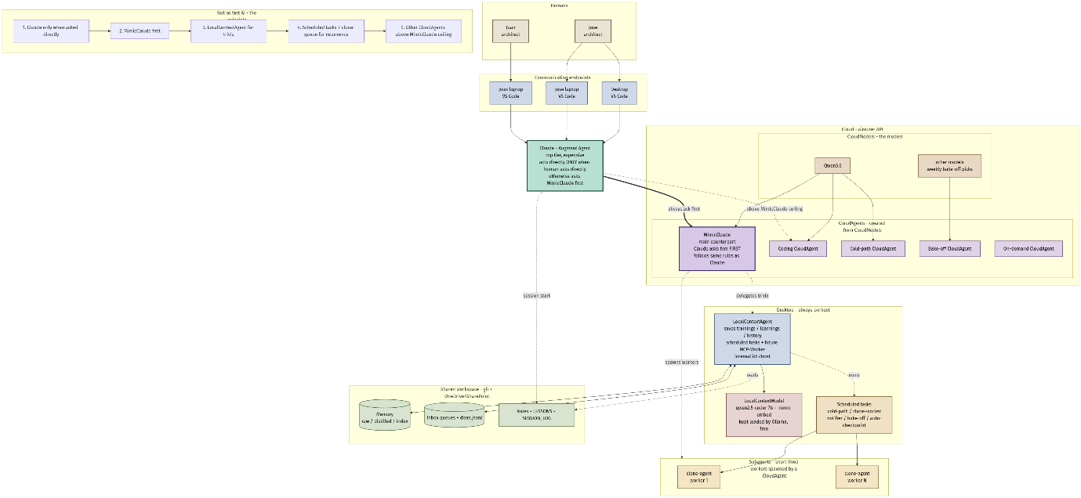
Notation: green outlined block = Claude (top tier); tan blocks = humans; light blue = VS Code endpoints and LocalContextAgent; rose = LocalContextModel; sand = CloudModels; purple = CloudAgents (MimicClaude darker); cream = subagents / scheduled tasks; cylinders = shared persistent state. Bold double-line arrow = mandatory ask. Dashed arrows = optional / on-demand.

4. Communication topology
Humans never talk to MimicClaude, LocalContextAgent, or any CloudAgent directly. They talk to Claude through a VS Code session on one of three endpoints: Desktop, Jose laptop, or Juan laptop. All three endpoints route into the same Claude. Claude is then responsible for delegating downward.
Pair model. Jose has two endpoints (Desktop + his laptop) but one pair contract; Juan has one endpoint (his laptop). Adding more humans or endpoints does not multiply Claude - it multiplies the inbox queue and the demand for delegation.

5. Shared brain
Memory: .augment/memory/{raw,distilled,index}/YYYY-MM-DD.<architect>.jsonl. Append-only daily files per architect. Owned and maintained by LocalContextAgent on the Desktop.
Inbox queues: .augment/agent-tasks/inbox-{chost,laptop}.jsonl plus done.jsonl. Read by agent-task-list.ps1; mutated by agent-task-assign.ps1 / agent-task-complete.ps1. Used for cross-endpoint and cross-agent coordination.
Rules + LESSONS: AGENTS.md, .augment/rules/agent-operating-rules.md, .augment/agent-tasks/LESSONS.md. Loaded at every Claude session start. The same rule set governs MimicClaude (he is told to follow it explicitly in his system prompt).
Sync: git is the source of truth (Tier 2); OneDrive / SharePoint mirrors the whole tree continuously (Tier 3) so the Laptop LocalContextAgent sees Desktop-written state without a git pull on every change.

6. LocalContextModel and LocalContextAgent (Desktop)
Definition. LocalContextModel is the local model fleet kept loaded in Desktop memory by Ollama and always ready. Composition: writer = qwen2.5-coder:7b-instruct-q4_K_M; retriever = nomic-embed-text. Served at 127.0.0.1:11434 on the Desktop; the Laptop reaches the same endpoint via Tailscale at 100.83.6.49:11434.
LocalContextAgent is the AGENT IDENTITY that uses LocalContextModel. It owns the memory tree, runs every scheduled task (cold-path distill at 02:00, clone-agent worker every 10 min, weekly bake-off Sundays 04:00, inbox-notifier every 2 min, auto-checkpoint every 30 min), and is the keeper of trainings, learnings, and history for the whole mission. Internal id: chost. A second LocalContextAgent lives on the Laptop (internal id: laptop) for parity and reaches the Desktop's LocalContextModel over Tailscale.
Operating discipline. OLLAMA_MAX_LOADED_MODELS=2, OLLAMA_NUM_PARALLEL=1, keep_alive=24h. Batching is mandatory: all writer calls together, then all retriever calls together, to avoid the ~10-15s evict-reload cost when switching members.
Role in the ladder. LocalContextAgent is tier 3. MimicClaude and Claude both DELEGATE TO it whenever the work is summary / extract / classify / embed / draft / small refactor / lesson digestion.

7. CloudModels and CloudAgents (airouter)
CloudModels are the actual model checkpoints hosted by airouter (today: Qwen3.6 plus whatever the weekly bake-off promotes for fastCheap / longContext / multimodal). New CloudModels can be added at any time by adding API keys or by swapping the byPurpose entries in airouter.config.json.
CloudAgents are the AGENT IDENTITIES instantiated from those CloudModels. Each concurrent slot on an API key is one CloudAgent. Today: 2 keys x 3 slots = 6 CloudAgents. Each CloudAgent has a stable purpose and is invoked from a stable caller.
Slot | Key | CloudAgent | Caller | Backing CloudModel
1 | K1 | MimicClaude (master) | Claude in-session - asked FIRST | Qwen3.6
2 | K1 | Coding CloudAgent | Claude / MimicClaude in-session | Qwen3.6
3 | K1 | Clone-agent drain (subagent host) | Desktop background queue, every 10 min | Qwen3.6
4 | K2 | Cold-path assist CloudAgent | Scheduled, 02:00 nightly | TBD fast/cheap
5 | K2 | Bake-off CloudAgent | Scheduled, Sun 04:00 | rotates per category
6 | K2 | On-demand CloudAgent | Either architect ad-hoc | whatever fits

8. MimicClaude - Claude's main counterpart
MimicClaude is the single CloudAgent that Claude asks BEFORE doing any non-trivial work himself. He runs on slot 1 (K1, Qwen3.6 today). He is given the SAME rule set as Claude (AGENTS.md + agent-operating-rules.md) in his system prompt so his behavior matches: counterpart-first delegation, token discipline, no unsolicited file creation, etc.
How Claude uses him. For every non-trivial human request: (1) Claude forwards the request verbatim to MimicClaude with the question stated understanding; (2) Claude reviews MimicClaude's plan; (3) if the plan is right -> Claude lets MimicClaude execute (typically via the clone-agent queue or via inline remote-master-call.ps1); (4) if the plan is wrong -> Claude asks for stated understanding; (5) only if understanding is still wrong does Claude take over himself, do the work, and append a LESSONS.md entry so MimicClaude does not repeat the mistake.
Subagents. MimicClaude can spawn subagents (short-lived workers drained from the clone-agent queue) to parallelize work. Subagents do not share context across runs - by design, to bound cost and contain failure.

9. Token discipline and telemetry
Routing ladder R3 (v4 ordering, cheapest tier first for Claude's POV): (1) Claude only when the human asks directly. (2) MimicClaude first. (3) LocalContextAgent for trivia, summarize, classify, embed, draft. (4) Scheduled task / clone-queue for recurring or batchable work (zero in-session cost). (5) Other CloudAgents above MimicClaude's ceiling.
Telemetry: .airouter-budget.jsonl (per remote-master-call cost log), .remote-master-reviews.jsonl (weekly bake-off), agent-spend-digest.ps1 planned (weekly per-agent per-tier summary). Commander-in-chief rule: Claude measures his own in-session token cost on non-trivial responses and reports it inline so the human sees the spend in real time.

10. Implementation status and roadmap
Done: counterpart-first review-loop, JSONL inboxes, toast notifier, LocalContextModel fleet on the Desktop, scheduled cold-path / clone-worker / auto-checkpoint, OneDrive + git two-tier persistence, session-briefing single-read, architecture docs v1 / v2 / v3.
Pending (gated on user confirmation): wire MimicClaude as the explicit slot-1 CloudAgent with Claude's rule set in its system prompt; add a Claude-only rule 'act directly only when the human asks directly' to agent-operating-rules.md (R8 amendment); AIROUTER_API_KEY_2; byPurpose block in airouter.config.json; airouter-pick.ps1 helper; multi-purpose bake-off extension; agent-spend-digest.ps1; MCP-Worker daemon (Desktop-local executor of file-dropped jobs); rename existing R2 Counterpart references to align with the v4 naming.

