Jose Corona

Home Work 2

K theta is 13x13, for a leg chain is

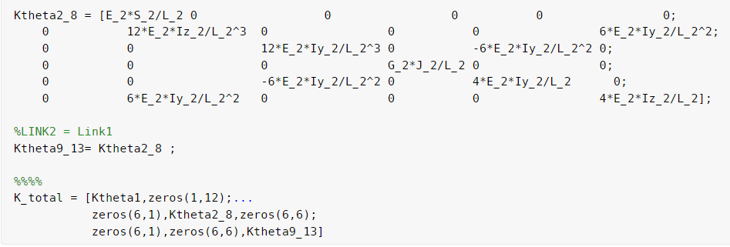

The FK of the robot was implemented

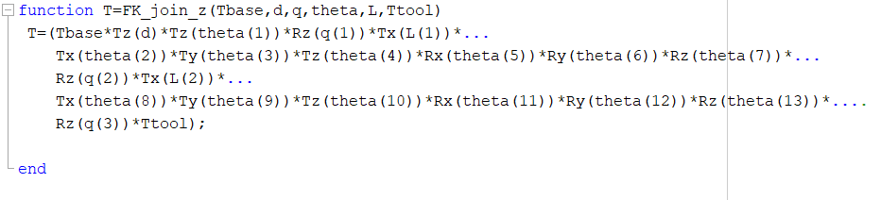

Where for each leg chain just have to enter the correspond Tbase, transform of the axis from global axis to the local leg chain axis.

The jacobian for the passive joints was calculated, for each chain leg is need to calculate the righ Tbase transform.

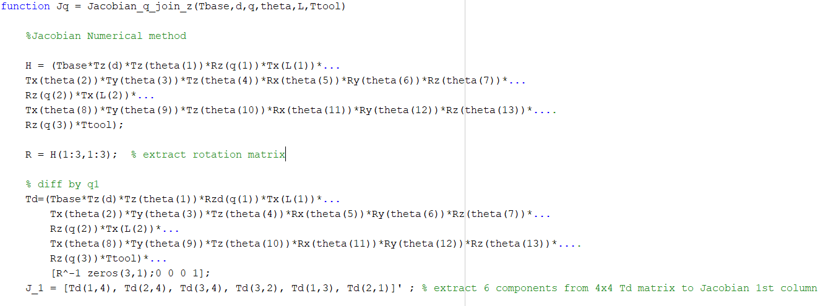

There where 3 passive joints. So the jacobian was 6*3



The jacobian for the virtual joints it was of 6*13

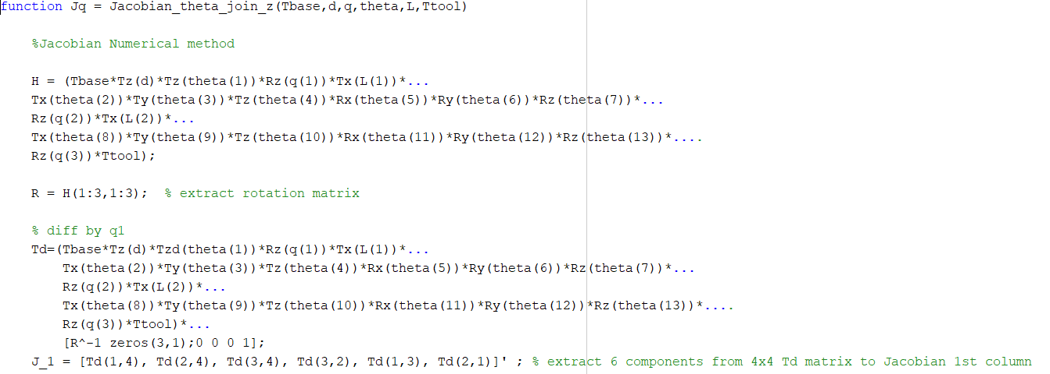



Also the IK was calculated.

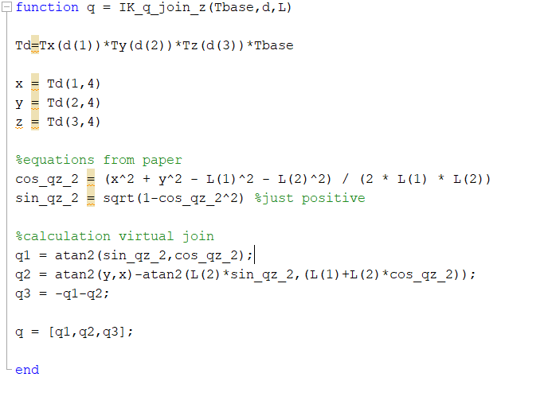

And the Cartesian stiffness matrices of the serial chains z

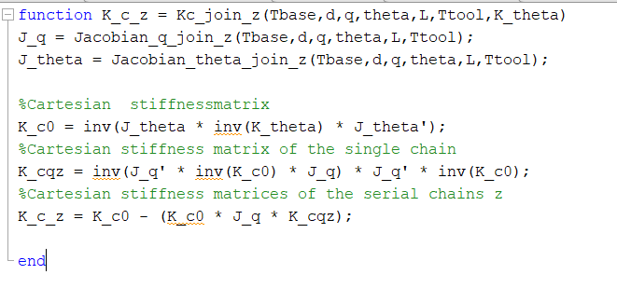

**Git Hub File:**

https://github.com/Jose-R-Corona/AR-HomeTask2