Jose Corona

Home Work 4

**Implement function for calculating the robot Jacobian**

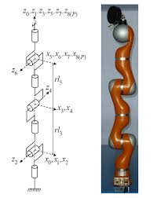



FK: Implemented using rotation in z, x and translation in z matrices.

T=(Rz(q(1))*Tz(L(1))*Rx(q(2))*Tz(L(2))*Rz(q(3))*Tz(L(3))

*Rx(-q(4))*Tz(L(4))*Rz(q(5))*Tz(L(5))*Rx(q(6))*Tz(L(6))

*Rz(q(7))*Tz(L(7)))

Jacobian: Numerical method

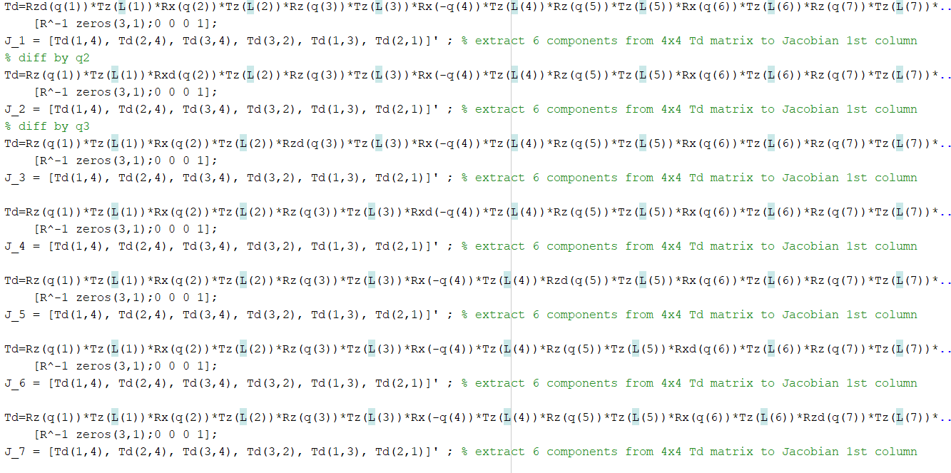



Test of the Jacobian function

%Jacobian test

L_test1 = [340 200 200 200 200 126 4];

q_test1 = [pi/2 0 0 0 0 0 0];

Jq1=Jacobian(q_test1,L_test1)

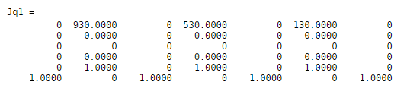

**Implement simple robot motion visualization**

Draw the robot



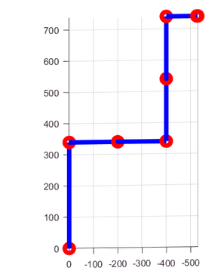

Draw the robot trajectory position, 3D visualiation

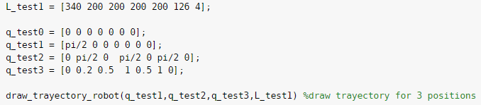

The first position is the robot arm of color blue, the second position is the robot of color green and the last position is the robot of color red. The trajectory is the line of color green.

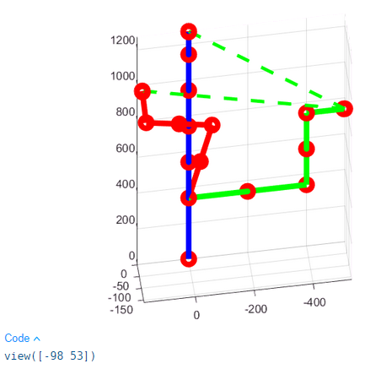

**3. Implement IK function for the robot based on**

1. Weighted pseudoinverse: I implement just pseudoinverse and Weighted pseudoinverse methods in one function. In the weighted pseudoinverse I increase the weighted of the first and second joints so they take priority.

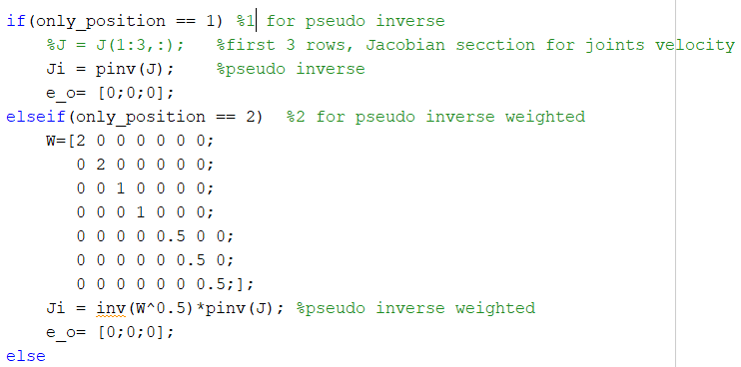

And calculated de joint position

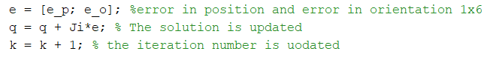

Then I visualize the arm position.

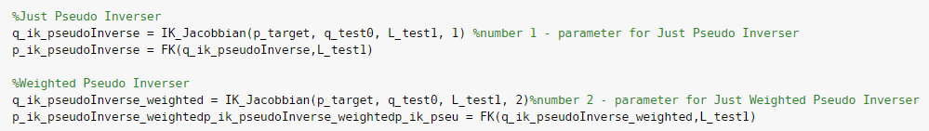

In the next figures, are presented different views of one target position of the arm. The arm of color blue is the target joint position, in green is the pseudo inverse solution and in color red is the solution using the weighted pseudo inverse Jacobian.

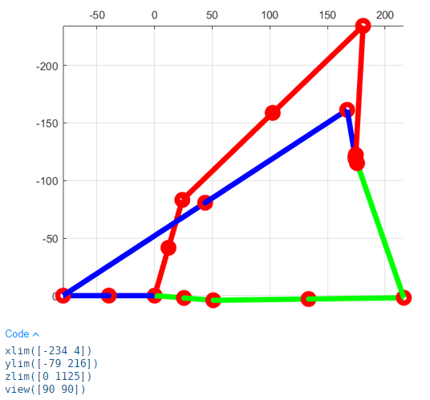

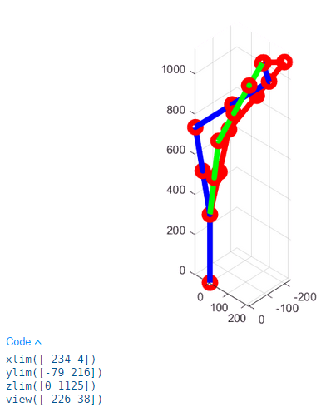 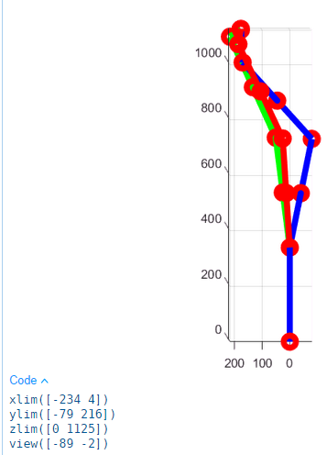 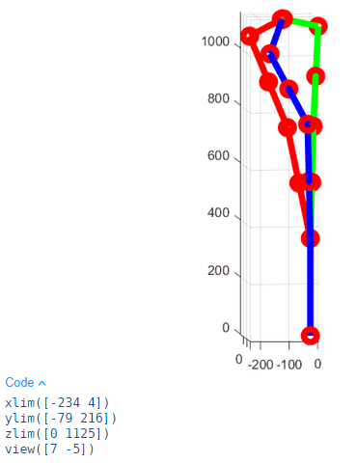

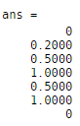 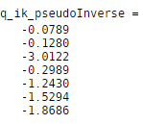 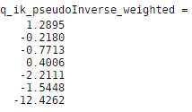

I try other positions, and in some of them the weighted and pseudoinverse version diverges, so we have to take into account singularities in the workspace.

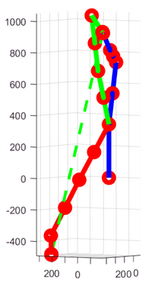 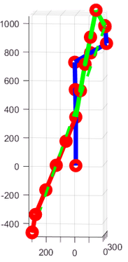

In the next figure we could the robot fallowing a trayectoy, where the final effector is in color cyan, the trayectory line is color yellow and the green dotted line follows the final effector trayectory. The trayectory to follows was a stright line in Y from 500 to 620, X=400 and Z=400

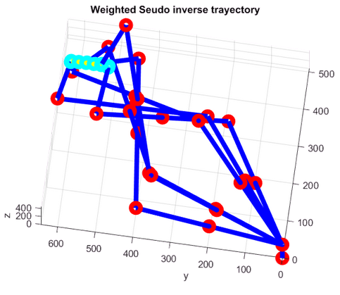 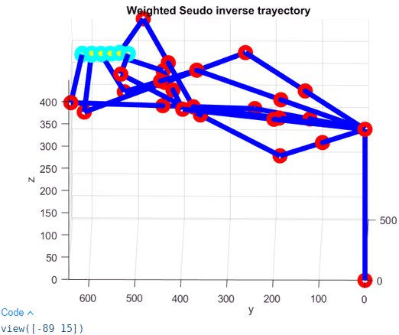

b. Damped Least Squares : I implemented this method in the same function.

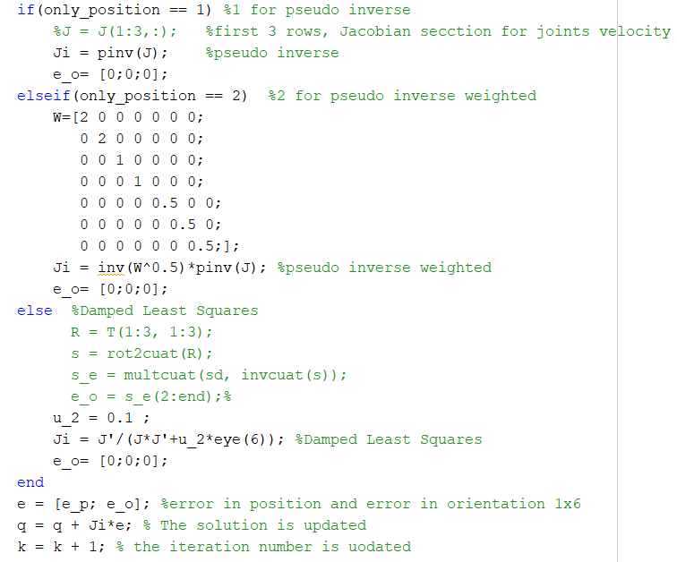

And visualize a targe position

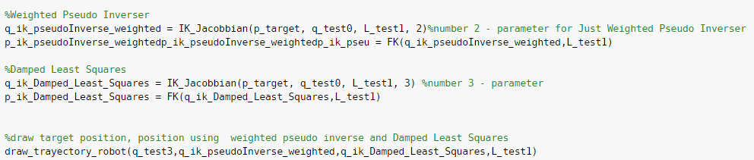

In the next figures, are presented different views of one target position of the arm. The arm of color blue is the target joint position, in green is the weighted pseudo inverse Jacobian and in color red is the solution using the Damped Least Squares.

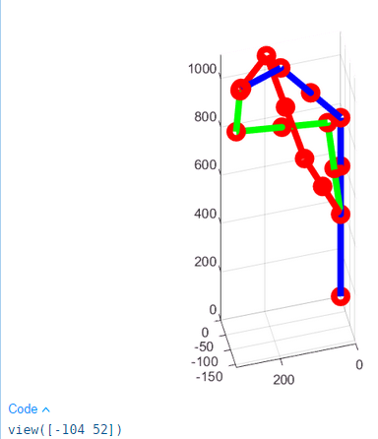 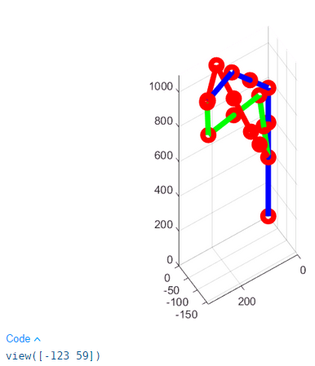 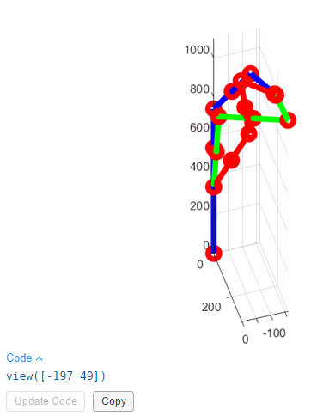

I try other positions, and in some of diverges, so for Jacobian based methods we have to take into account singularities in the workspace.

In the next figure we could the robot fallowing a trayectoy, where the final effector is in color cyan, the trayectory line is color yellow and the green dotted line follows the final effector trayectory. The trayectory to follows was a stright line in Y from 500 to 620, X=400 and Z=400

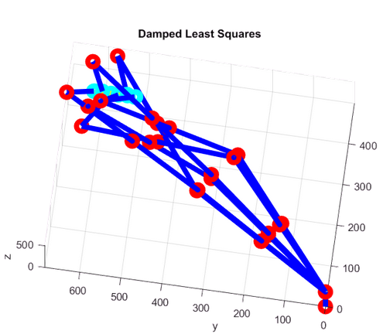 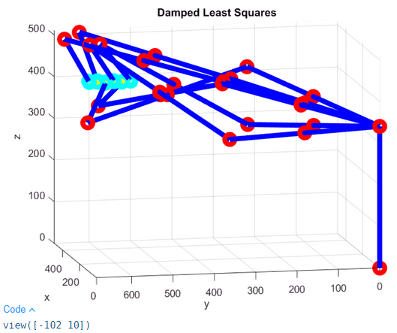

C. Null space method :

I implemented Null space in other file. I calculated the jacobian for each joint, not all the joint at the same time to get a differentiation for each join for dq0 . Since the determinat of everything is just one value, was always cero if I use the jacaobian of all joints.

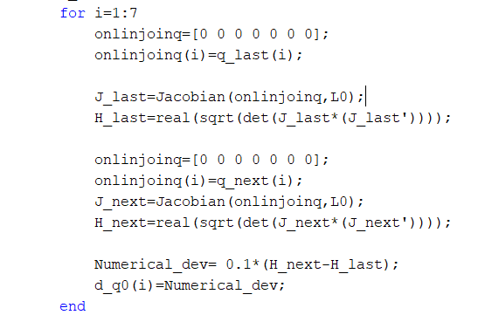

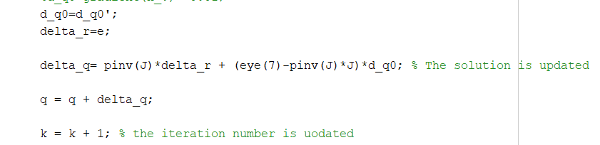

In the next figures, are presented different views of one target position of the arm. The arm of color blue is the target joint position, in green is the null space solution with joint initial position zero and in color red is the solution using other initial position.

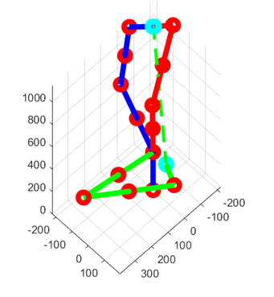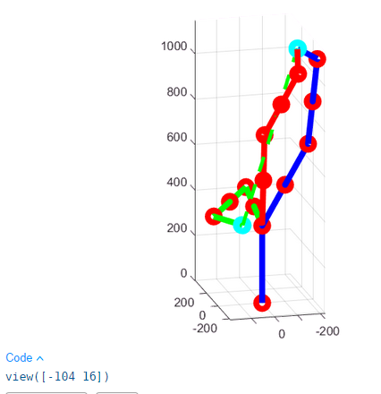

In the next figure we could the robot fallowing a trayectoy, where the final effector is in color cyan, the trayectory line is color yellow and the green dotted line follows the final effector trayectory. The trayectory to follows was a stright line in Y from 500 to 620, X=400 and Z=400

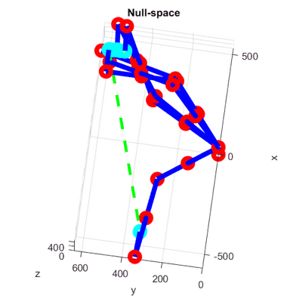 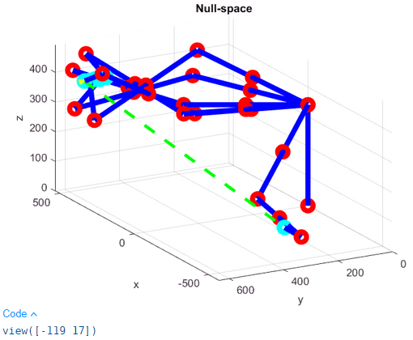

**The Augmented Task:**

Refer to only use some columms of the Jacobian to calculate the Ik. For the first example of the line

**Link Git hub:**

<https://github.com/Jose-R-Corona/AR-HomeTask4>