Jose Corona

Home Task 2

FANUC R-2000iC/165F

Description of the robot.

Robot with 6 rotations and 7 links. Use a spherical wrist.

Kinematic scheme with description of the parameters.

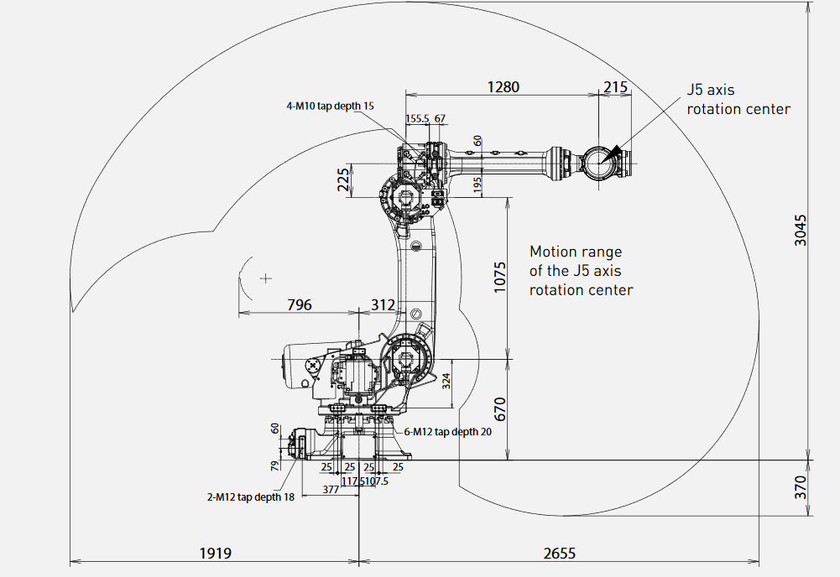

DOF: 6

d1=670-324=346

d2=324

d3=312

d4=1075

d5=225

d6=1280

d7=215

Formulas of forward kinematics solution.

T=T_z(d1)*R_z(q1)*T_z(d2)*T_x(d3)*R_y(q2)*T_x(d4)*R_y(q3)*T_z(d5)*

T_x(d6)*R_x(q4)*R_y(q5)*R_z(q6)*T_x(d7)



Step by step explanation of inverse kinematics solution.

For the numerical implementation, we use the Jacobian, evaluated in the previous instant time, for the joint variables.

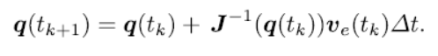

To overcome the problem of the end-effector pose is different than the corresponding, we could use an operational space error formula.





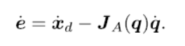

And to get the final position in the coordinate system we could use the next formula where delta_q refers to a small increment in the joints. q_0 refers to the initial position in the joints.

T(q_0+ delta_q)=T(q_0)+Jacobian*delta_q

A singularity happens when the effector try to reach a point that it is in the self-robot links or is out of the space tasks.

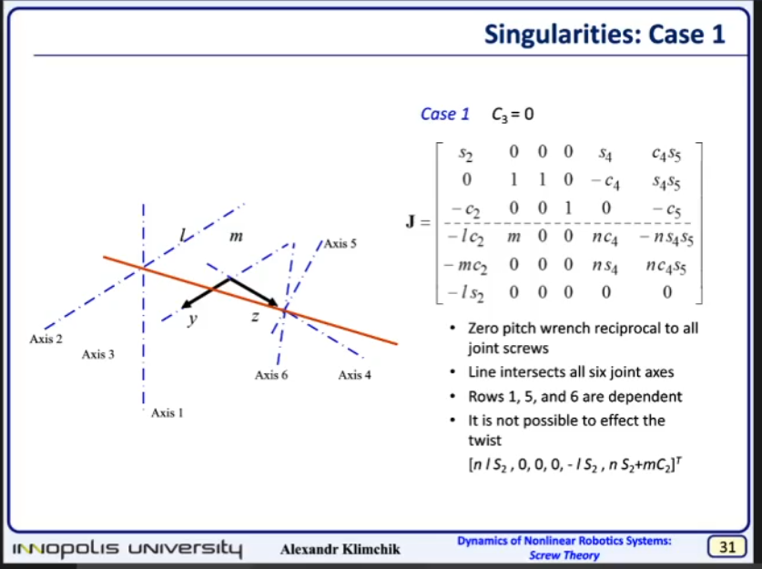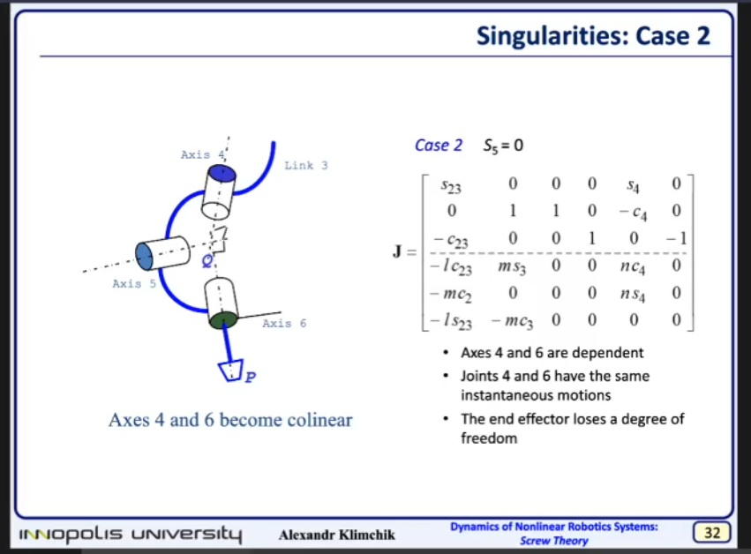

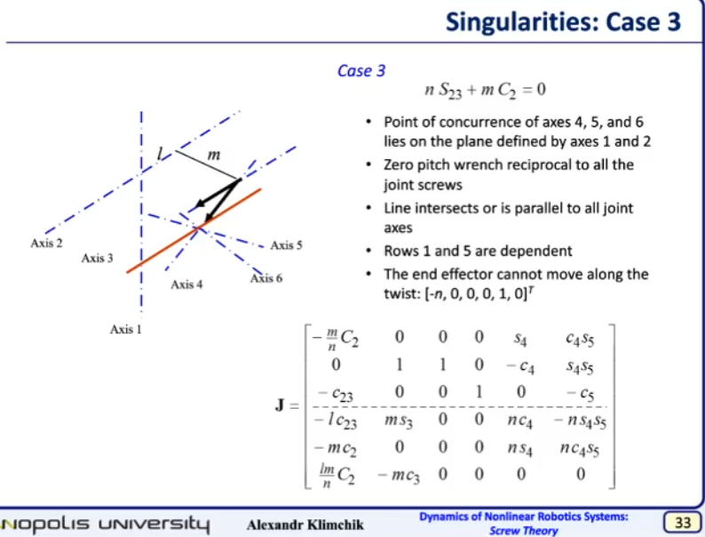

To run the program we have to introduce the initial value



Choose a point to get with the ik.



The we could calculate de IK.



We get the a column vector q = [q1 q2 q3 q4 q5 q6]' with the joints position. So we cold calculate again the FK and compare that are the same.



KUKA KR 10 R1100-2

Description of the robot.

Robot with 6 rotations and 8 links. The origin is in the base of the robot, and for the forward kinematics we take the pose when the robot is completely open in the ground.

Kinematic scheme with description of the parameters

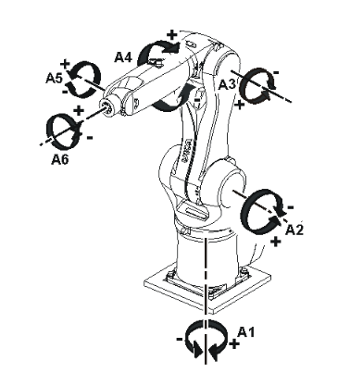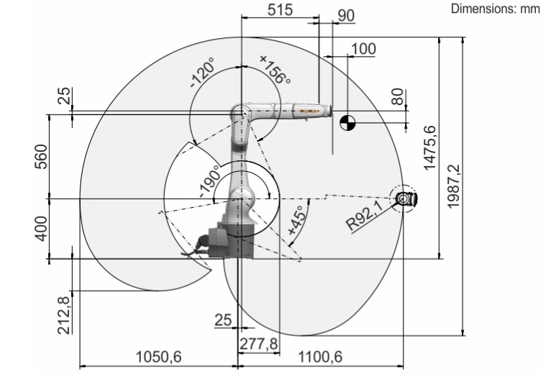

DOF: 6

d1=400/2=200

d2=200

d3=25

d4=560

d5=25

d6=277.8

d7=515-277.8 =237.2

d8=90

Formulas of forward kinematics solution.

T=T_z(d1)*R_z(q1)*T_z(d2)*T_x(d3)*R_y(q2)*T_x(d4)*R_y(q3)*T_z(d5)*

T_x(d6)*R_x(q4)*T_x(d7)*R_y(q5)*T_x(d8)*R_x(q6)

Step by step explanation of inverse kinematics solution.

KUKA LBR iiwa 14 R820 (fix third joint for simplification)

Description of the robot.

Robot with 6 rotations and 6 links.

Kinematic scheme with description of the parameters

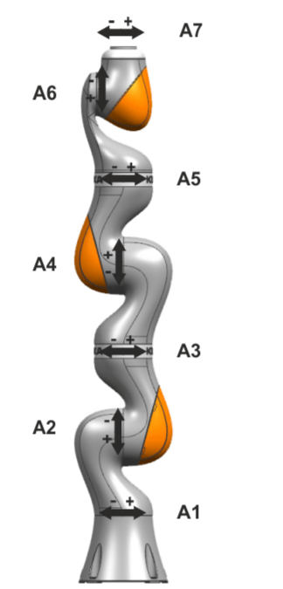 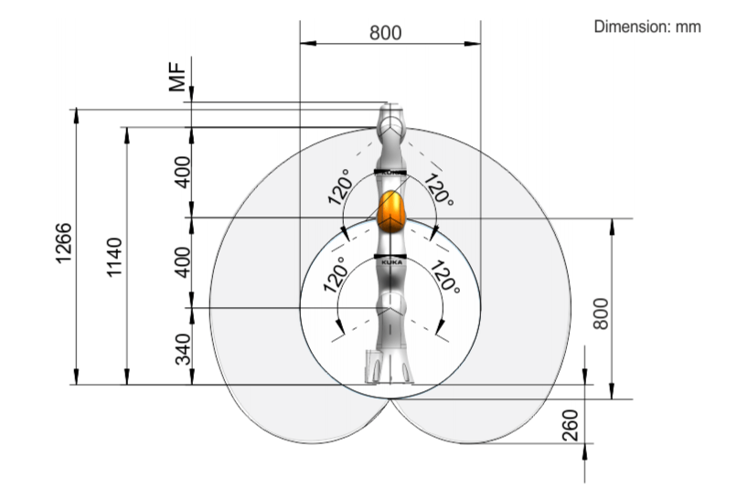

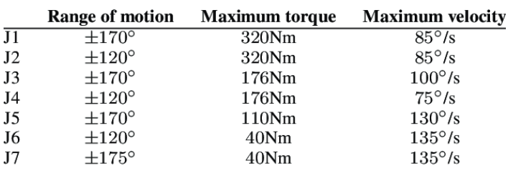

DOF: 6

d1=360/2=180

d2=360-d1=180

d3=400

d4=200

d5=200

d6=126

Formulas of forward kinematics solution.

T=T_z(d1)*R_z(q1)*T_z(d2)*R_y(q2)*T_x(d3)*R_y(q3)*T_x(d4)*

R_x(q4) *T_x(d5)*R_y(q5)*T_x(d6)*R_x(q6)

Step by step explanation of inverse kinematics solution.

AR601 arm

Description of the robot.

Robot with 5 rotations and 3 links.

Kinematic scheme with description of the parameters

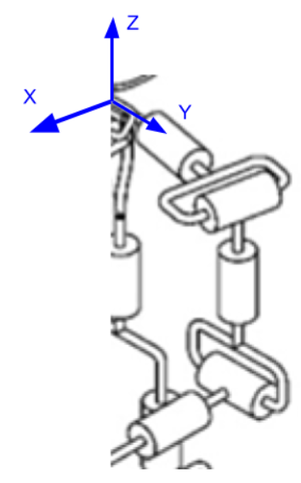 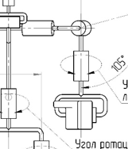

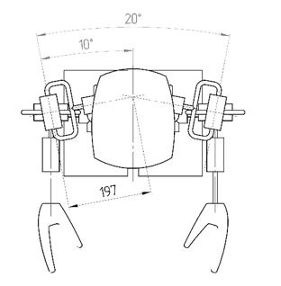 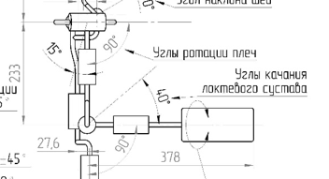

DOF: 5

d1=387/2=193.5

d2=223

d3=378

alpha1=10 degrees

Formulas of forward kinematics solution.

T=R_y(q1)*T_y(d1)*Rz(alpha1)*R_x(q2)*R_z(q3)*T_z(-d2)*R_y(q4)*T_x(d3)*R_x(q5)

Step by step explanation of inverse kinematics solution.

AR601 leg

Description of the robot.

Robot with 6 rotations and 6 links.

Kinematic scheme with description of the parameters

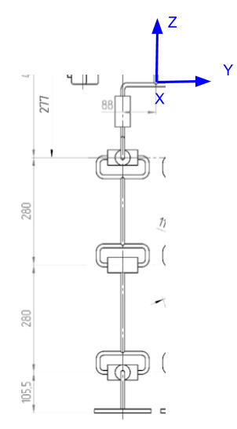 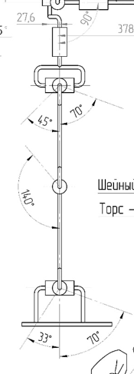

DOF: 6

d1=88

d2=27.6

d3=462-233=229

d4=280

d5=280

d6=105.5

Formulas of forward kinematics solution.

T=T_y(-d1)* T_x(d2)*R_z(q1)*T_z(-d3)*R_y(q2)*R_x(q3)*T_z(-d4)*R_y(q4)*T_z(-d5)*

R_y(q5)*R_x(q6)*T_z(-d6)

Step by step explanation of inverse kinematics solution.

Link to the project on git hub.

https://github.com/Jose-R-Corona/Home-Task2