Jose Corona

Home Task 4

1. Calculate Jacobian (numeric method)





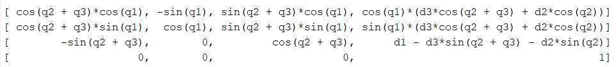

I used the numeric method to get the jacobian.

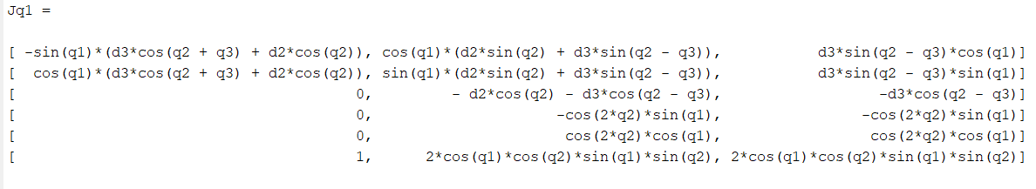

2. Joint trajectory q(t) from q(0) = (0, 0, 0) to q(2) = (2, 3, 4) with null initial and final velocities and accelerations. (polynomial)

A polynomial solution for each joint is solved as like in presentation, since it has 6 constrains, is needed a polynomial of fifth solution.

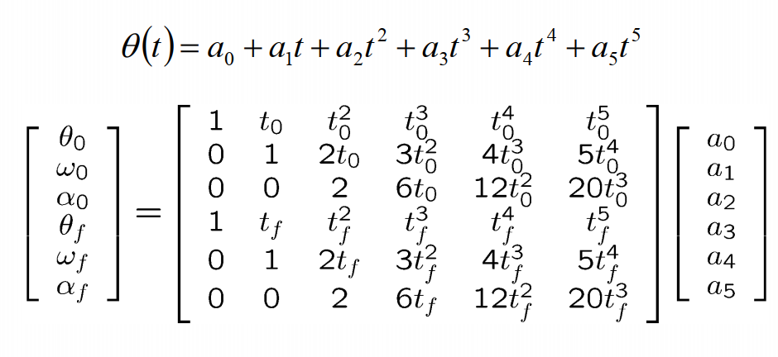

For the joint 1:

So the coefficients for the polynomial are:

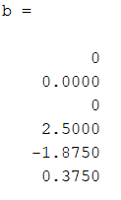

q1= (3\*t^5)/8 - (15\*t^4)/8 + (5\*t^3)/2 + t/562949953421312





For the joint 2:

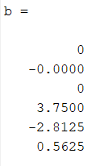

q2= (9\*t^5)/16 - (45\*t^4)/16 + (15\*t^3)/4 - t/562949953421312

 



For the joint 3:

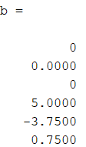

q3= (3\*t^5)/4 - (15\*t^4)/4 + 5\*t^3 + t/281474976710656





3. Joint trajectory for the following commands: PTP – q1 = (0, 0, 0) to q2 = (2, 3, 4) (trapezoidal)

Fist we have to calculate the times “ta” and “tf” for all trapezoidal velocity for each joints, taking into account the controller command interpretation frequency of 10hz.

So, the values of ta and tf for all the joins is :

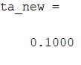 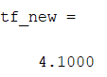

And the new values of max velocity and acceleration for each joint are:

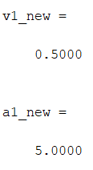 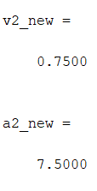 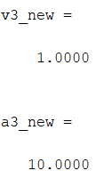

And the plot of the position, velocity and aceleration are:







4. Joint trajectory for the following commands: LIN – p1 = (1, 0, 1) to p2 = (√2/2, √2/2, 1.2) (trapezoidal)