Jose Corona

Home Task 3

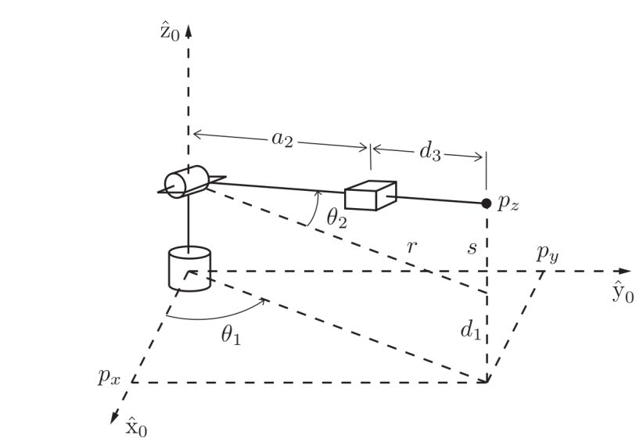

1. FK



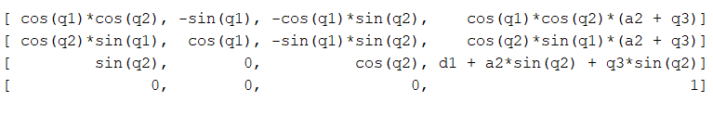

For the FK, I used “-q2” because I used the homogeneous Rotation Y. So to match the correct the coordinate system as in the diagram, is necessary to used “-q2”.

2. IK

There is two solutions one for q1 and the other for PI+q1.

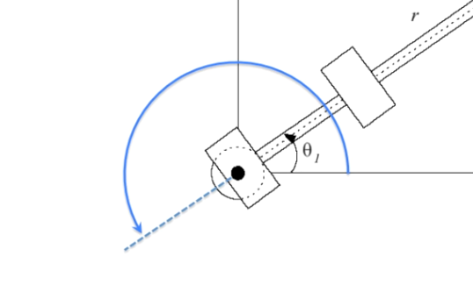

For q1:

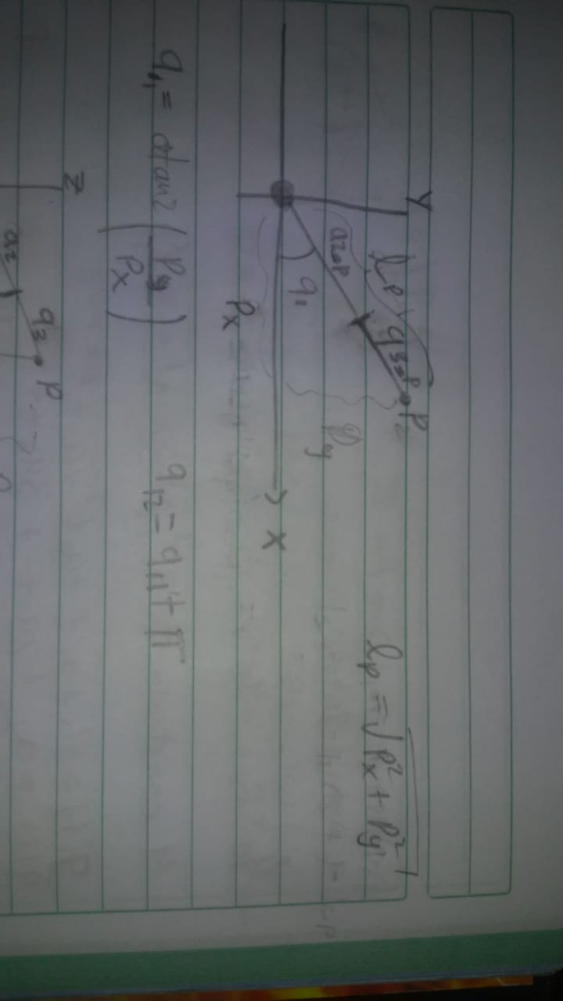

For q2:

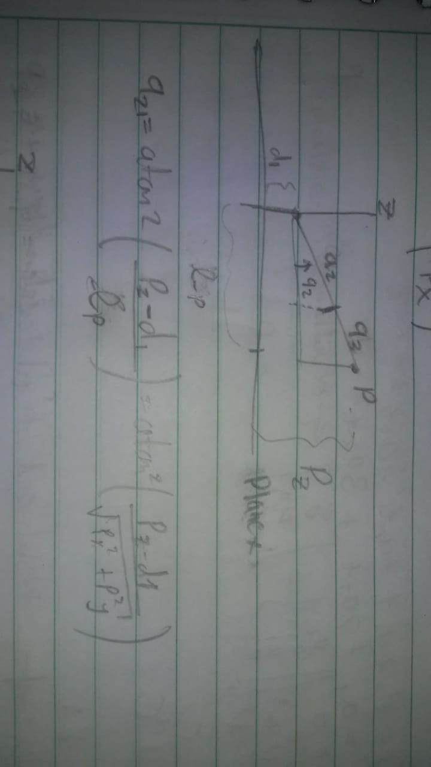

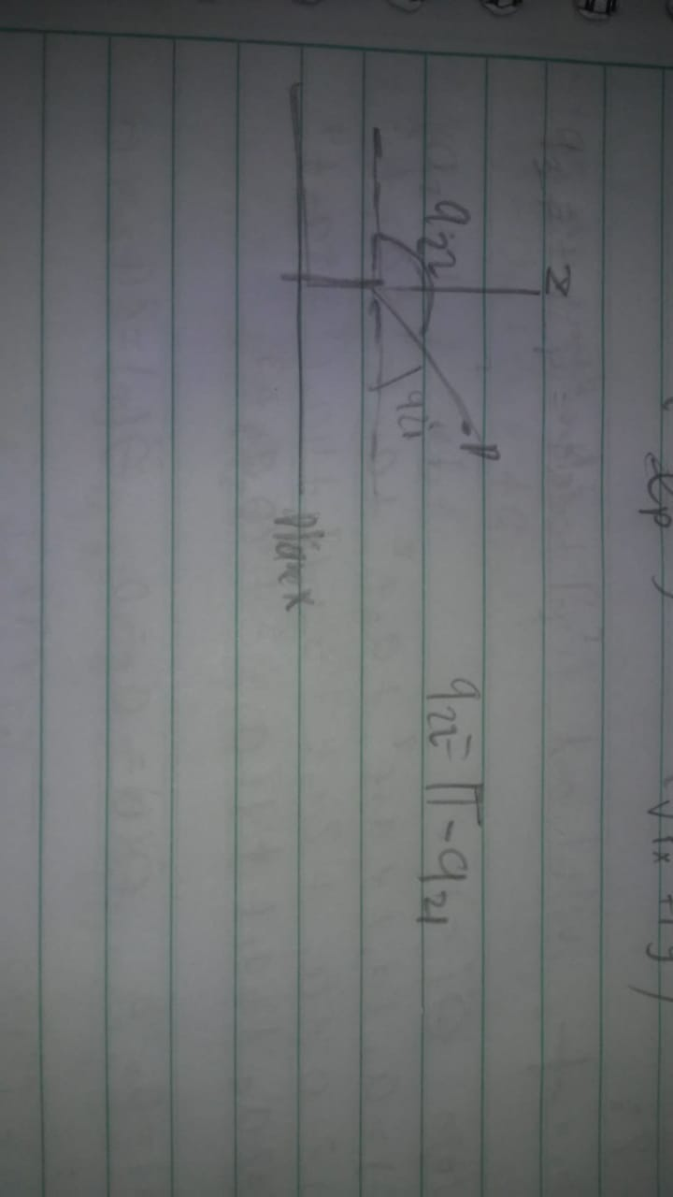

For q3:

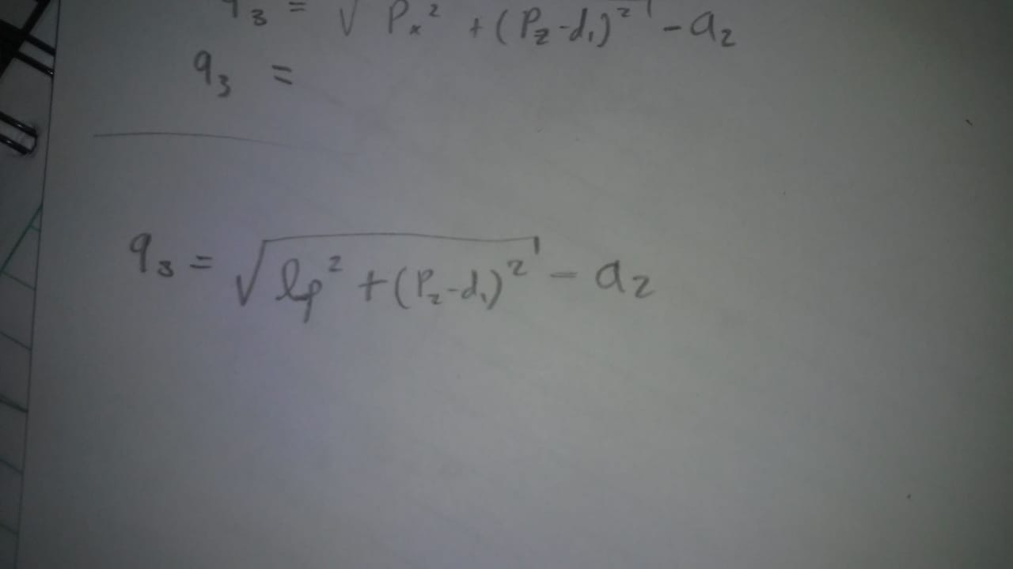

In MATLAB:

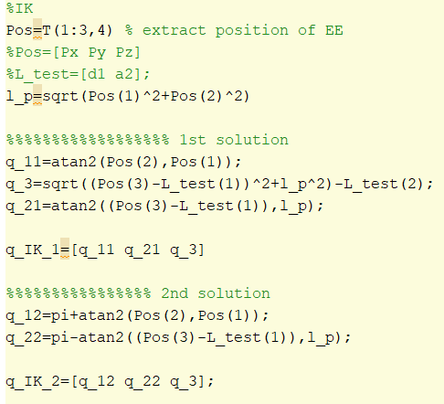

3. Jacobian

A. Derivations

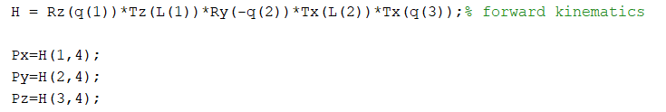

J_1 = [J_1 contribution to linear velocity ; J_1 contribution to angular velocity]

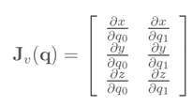 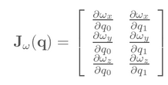

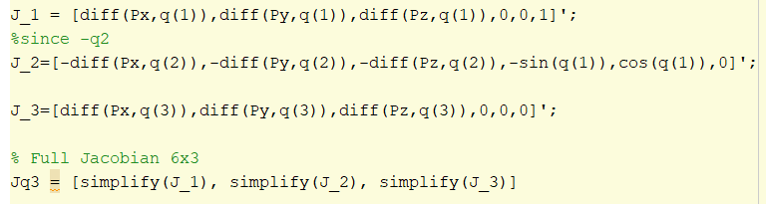

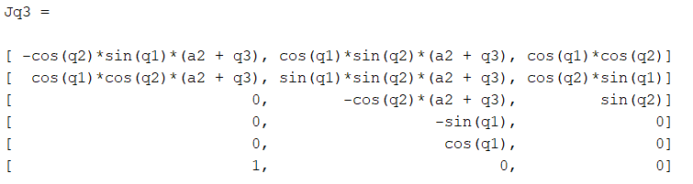

B. Screw Matrix

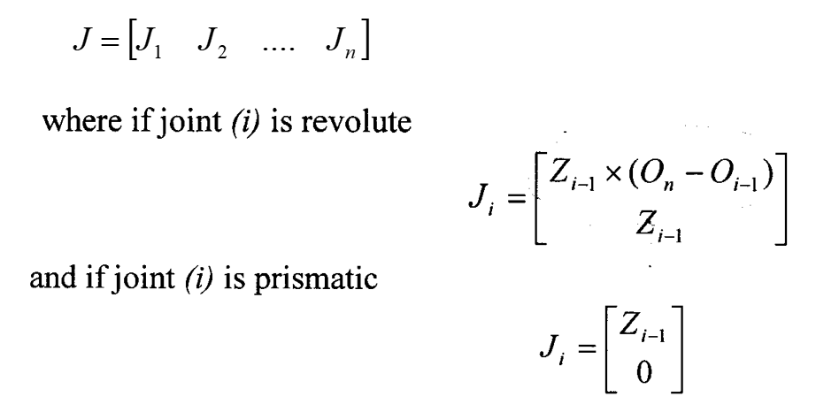

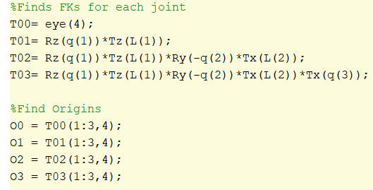

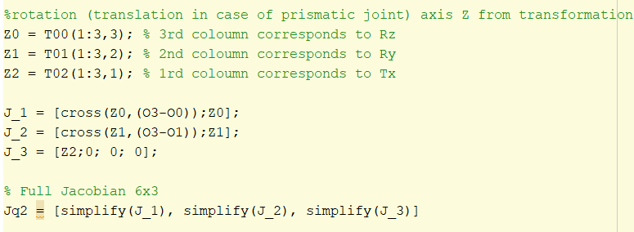

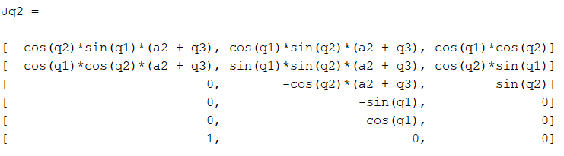

C. Numerical method

For J1

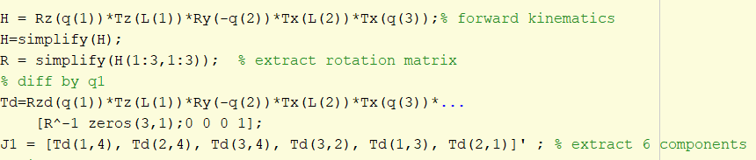

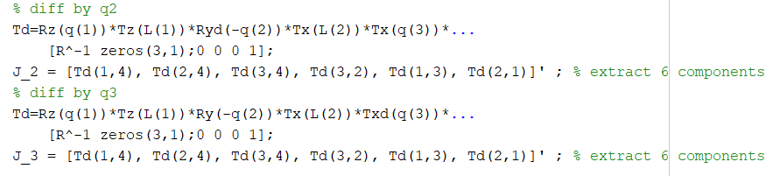

Full Jacobian



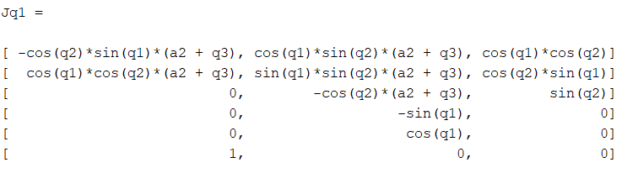

4. Singularities:

A singularity happened when in a determinate position we lose a degree of freedom; the determinant of the Jacobian (for square matrix), is zero at singular configurations. Also, the rank decreases it number.

Using Jq2, I tried to find a singular position. I tried Gauss-Jordan elimination, but I couldn’t find any singular position.

 = 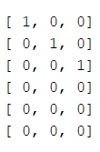

If a 3-by-3 square matrix is full rank, rank equal 3, the reduced row echelon form is an identity matrix.

If we define a specific real length for q3, we also are defining the workspace of the robot, so any point out of it, would be a singularity, since the robot could not reach it.

5. Velocities

θ1(t) = sin(t), θ2(t) = cos(2t), d3(t) = sin(3t)





Each function has a different frequency. At the beginning the prismatic joint is inside then it goes out.



Since q2 and q3 has a bigger frequency at the beginning Px_tool is going to -x axes, with high negative magnitude velocity, and continue until reach negative max magnitude Vx_tool. The negative magnitude of Vx_tool decrease when q3, that is completely out, start to turn inside.

V_y reaches it maximum point when the robot is pointing to + y_axis, q1 is near pi/5 and q3 is almost completely out.



Git_hub:

https://github.com/Jose-R-Corona/HomeTask_3.git