José Corona

HomeTask5

Task1

q2 goes from “B” to ”S”. And B is the center of mass.

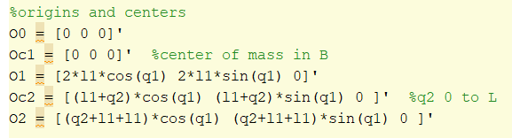

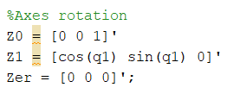

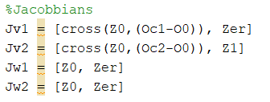

We could try to calculate K



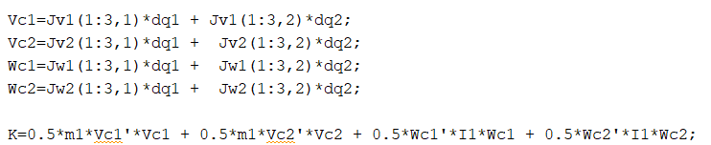



And matrix D is:

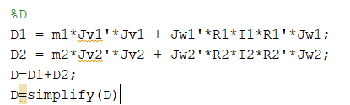

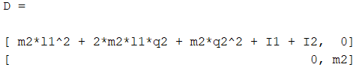

And P

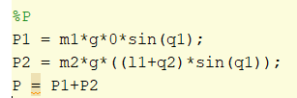

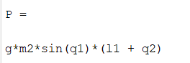

So the torques are

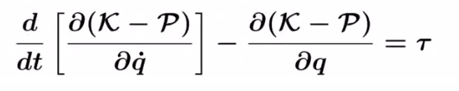

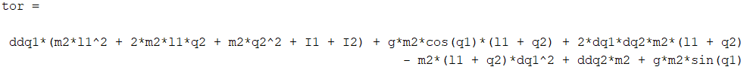

Task2



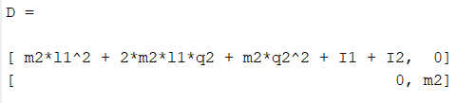

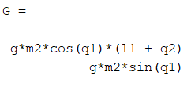

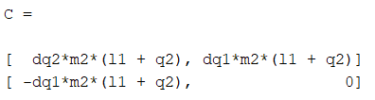



Task3

First we substitute the values

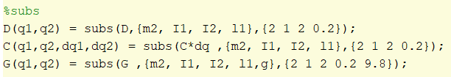

Select initial condition. In this case the position is down

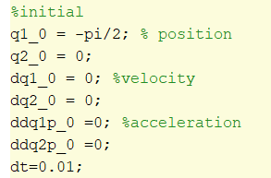

Select a torque to apply.

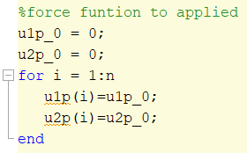

Solve the inverse dynamics to get the positions, velocities and accelerations functions of the joints

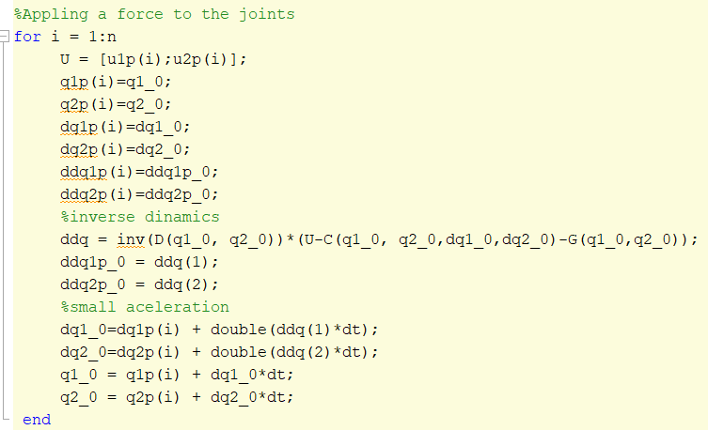

So Appling no force, and in down position we get this graphic. Since is no restriction in q2, not define q2 max, the mass pointing down falls in the plane vertically; the acceleration of q2 is positive since the axis of this link is pointing down.





So if we put the robot in “up” position, q1=pi/2 , the acceleration of q2 is negative since the axis of this link is pointing up.

 

 

Appling a constant force in q1 of 10N.

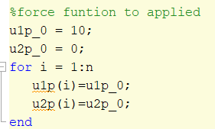

Link:

<https://github.com/Jose-R-Corona/Hometask5>