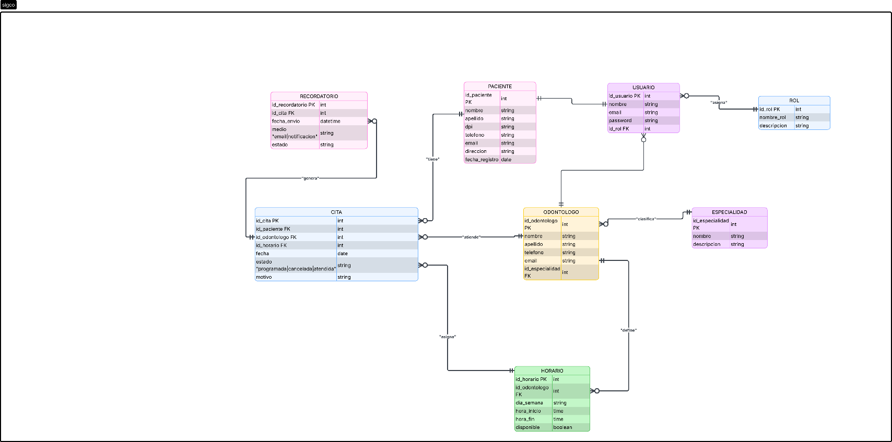
José Pablo

https://lucid.app/lucidchart/79359aae-fba9-4ec1-9899-5d61e69d5a92/edit?viewport_loc=-2747%2C619%2C6552%2C2487%2CrCBQaNbQq.-k&invitationId=inv_241e4756-c76e-4989-b95d-086b8dda1e6a

