**Jose Flores, Laura Makokha**

**Milestone # 3: Bacchus Case Study**

**5/10/2025**

**Report 1: Late Supply Deliveries**

Report: 1 checks if any supplies like bottles or corks have arrived late. It compares the planned delivery date to the actual delivery date. If the delivery was late, it shows how many days late it was. This helps Stan and Davis know which suppliers are not delivering on time so they can fix the problem.

*Report 1: Late Supply Deliveries*

*query1 = """*

*SELECT sd.Delivery_ID, s.Supply_Name, sup.Supplier_Name,*

*sd.Planned_Delivery_Date, sd.Actual_Delivery_Date,*

*DATEDIFF(sd.Actual_Delivery_Date, sd.Planned_Delivery_Date) AS Days_Late*

*FROM Supply_Deliveries sd*

*JOIN Supplies s ON sd.Supply_ID = s.Supply_ID*

*JOIN Suppliers sup ON sd.Supplier_ID = sup.Supplier_ID*

*WHERE DATEDIFF(sd.Actual_Delivery_Date, sd.Planned_Delivery_Date) > 0;*

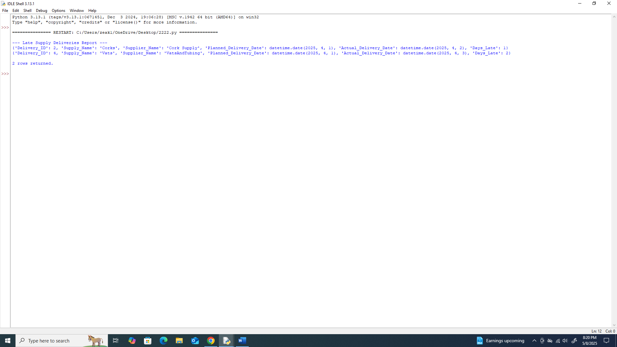

**Report 2: Wine Sales by Distributor**

This report shows how much of each wine, Merlot, Cabernet, etc., was sold by each distributor. It also shows the date each sale happened. It finds out which wines are selling the most and which ones are not. Also shows which distributors are selling each wine.

*Report 2: Wine Sales by Distributor*

*query2 = """*

*SELECT d.Distributor_Name, w.Wine_Name, wd.Quantity_Sold, wd.Sales_Date*

*FROM Wine_Distribution wd*

*JOIN Wine w ON wd.Wine_ID = w.Wine_ID*

*JOIN Distributors d ON wd.Distributor_ID = d.Distributor_ID*

*ORDER BY w.Wine_Name, wd.Sales_Date;*

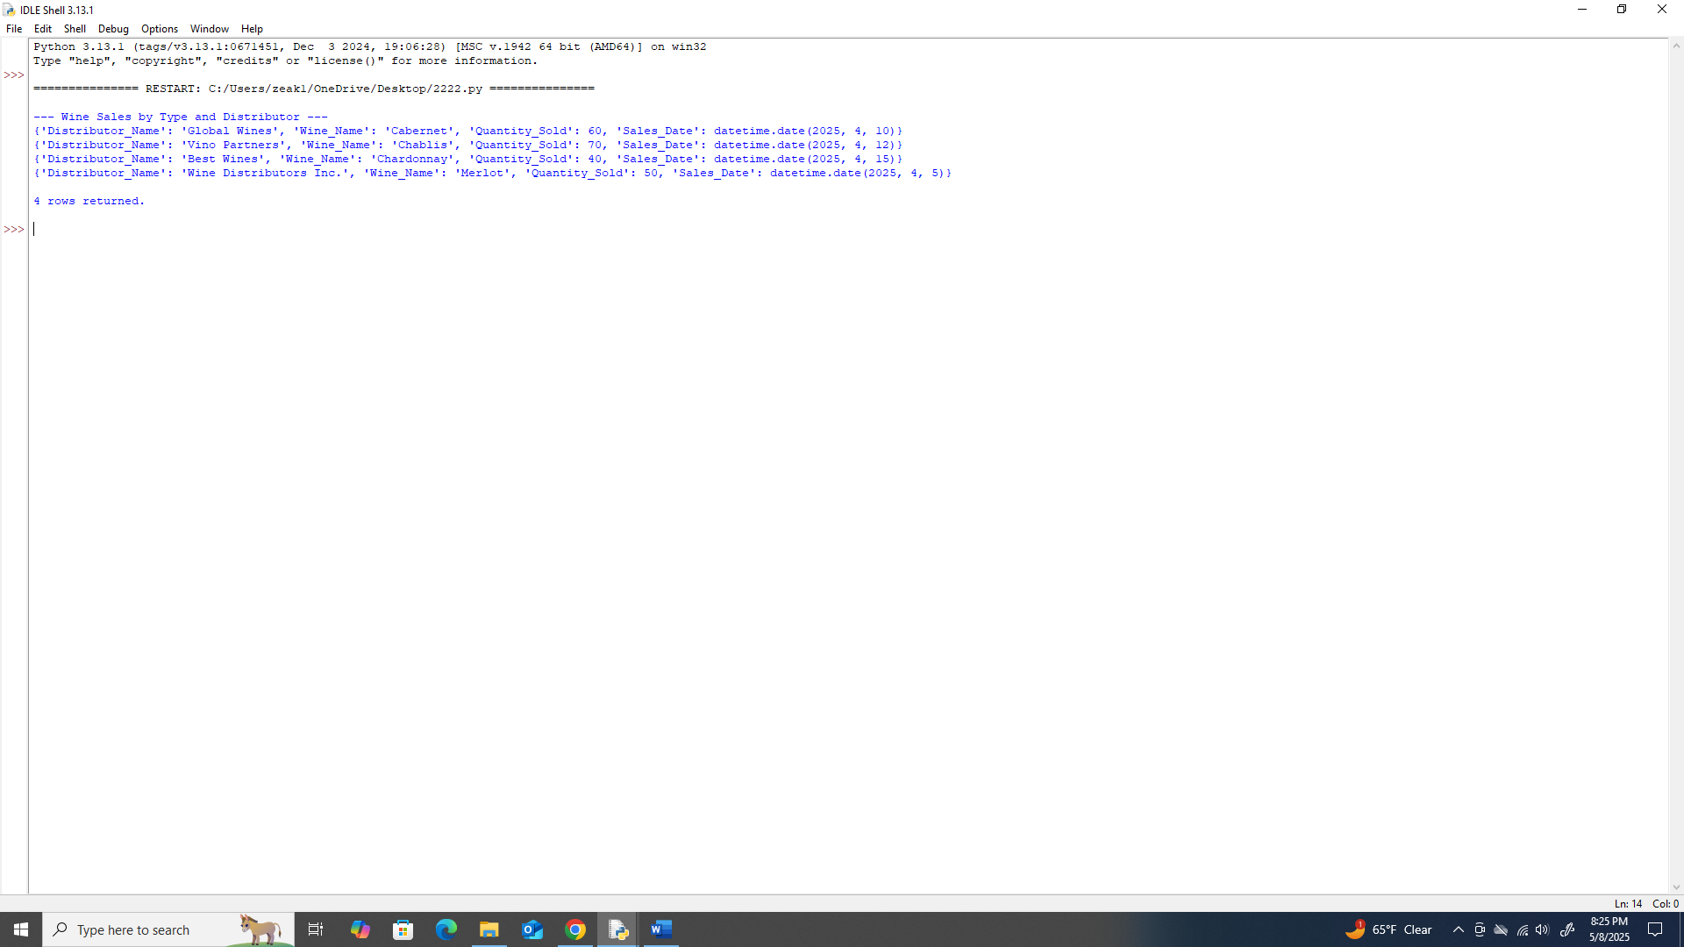

**Report 3: Employee Work Hours**

This report shows how many hours each employee worked in each quarter. It also shows what department they work in. It helps the owners see if employees are working enough or too much and if any department needs more help.

*Report 3: Employee Hours by Quarter*

*query3 = """*

*SELECT e.Employee_Name, e.Department, eh.Quarter, eh.Hours_Worked*

*FROM Employee_Hours eh*

*JOIN Employee e ON eh.Employee_ID = e.Employee_ID*

*ORDER BY e.Employee_Name, eh.Quarter;*

*"""*

