Jose Flores & Laura Makokha

5/10/2025

Assignment: Milestone 4

**Bacchus Winery Case Study**

**Presentation**

Laura and I worked together to help Bacchus Winery solve some business problems using a database. Our project focused on solving inventory, distribution, and employee tracking challenges at Bacchus Winery.

**What the Winery Needed Help With:**

Bacchus Winery is run by two brothers, Stan and Davis.

They make four types of wine.

They needed help with:

* Tracking supplies and see if they arrive late.
* Know which wines are selling well.
* Keep track of how many hours their employees work.
* Make it easier for distributors to place orders online.

**Key Assumptions:**

* Supplies come every month.
* The inventory updates when supplies arrive.
* Distributors use a website to place and track orders.
* Each employee works in just one department.
* Employee hours are tracked every 3 months.

**Database Design (ERD):**

This diagram shows how all the tables in our database are connected.

It includes:

* Wine, Supplies, Suppliers
* Deliveries, Distributors, Orders
* Employees and their work hours

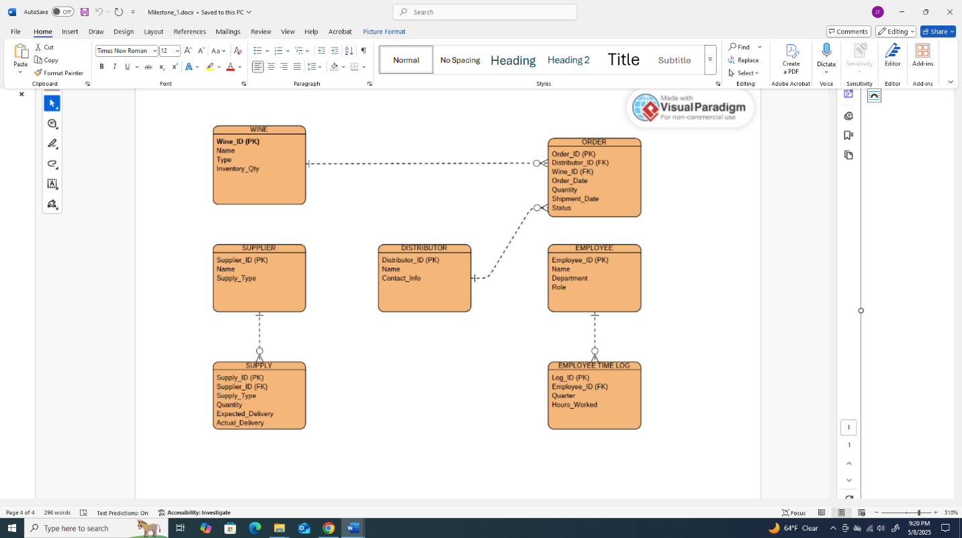

**Report Results**

**Report 1: Late Supply Deliveries**

* This report checks if deliveries were late.
* It shows how many days late and which supplier sent them.

**Report 2: Wine Sales by Distributor**

* This report shows how much wine each distributor sold.
* It helps us see which wines are popular and which ones are not.

**Report 3: Employee Work Hours**

* This report shows how many hours each employee worked.
* It also shows which department they work in.

**Assumptions:**

* We made a working database.
* We wrote reports to help the winery make smart choices.
* We used Python to show real data from the database.