Jose Flores & Laura Makokha

5/18/2025

Assignment: Milestone 5

**Bacchus Winery Case Study**

**Presentation**

Laura and I worked together to help Bacchus Winery solve some business problems using a database. Our project focused on solving inventory, distribution, and employee tracking challenges at Bacchus Winery.

**What the Winery Needed Help With:**

Bacchus Winery is run by two brothers, Stan and Davis.

They make four types of wine.

They needed help with:

* Tracking supplies and see if they arrive late.
* Know which wines are selling well.
* Keep track of how many hours their employees work.
* Make it easier for distributors to place orders online.

**Key Assumptions:**

* Supplies come every month.
* The inventory updates when supplies arrive.
* Distributors use a website to place and track orders.
* Each employee works in just one department.
* Employee hours are tracked every 3 months.

**Database Design (ERD):**

The diagram shows how all the tables in our database are connected.

It includes:

* Wine, Supplies, Suppliers
* Deliveries, Distributors, Orders
* Employees and their work hours

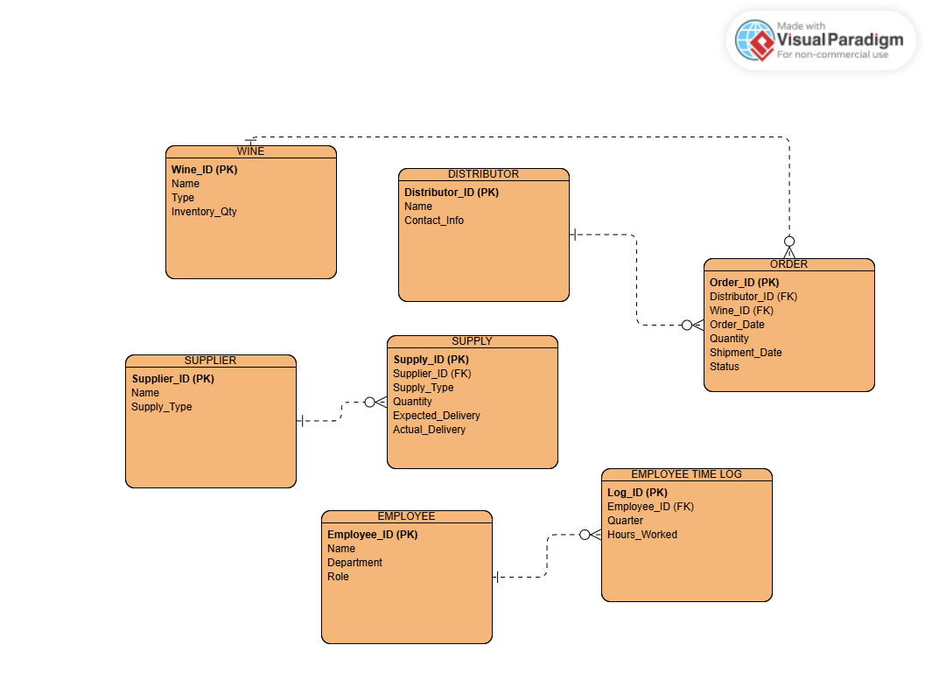

Each Delivery is connected to one Supplier and includes different Supplies like bottles, corks, or labels. It displays the contact information and quantities they have received.

Each Order shows which Distributor bought which kind of Wine (Merlot, Cabernet, Chablis, or Chardonnay) and how much they bought.

The Employee table shows who works at the winery, and the Employee time log table keeps track of how many hours each person worked every 3 months. Each employee works in one Department, like Marketing, Production, or Finance.

The Inventory keeps track of supplies and wine, so the winery table always knows what they have in stock.

**Report Results**

**Report 1: Late Supply Deliveries**

We used Visual Studio Code to find the difference between when supplies were supposed to arrive and when they actually did. Then we used Python to figure out the average number of days each supplier was late.

* The report checks if deliveries were late.
* It shows how many days late and which supplier sent them.

**Report 2: Wine Sales by Distributor**

Using Visual Studio Code, we first put together sales information from the orders, distributors, and wine tables. Then we used Python to make a chart that shows which wines are selling the most.

* The report shows how much wine each distributor sold.
* It helps us see which wines are popular and which ones are not.

**Report 3: Employee Work Hours**

To gather the necessary information we used Visual Studio Code to get the hours for each employee that worked every 3 months from the workhours table. Then we used Python to add up the hours and sort them by department.”

* The report shows how many hours each employee worked.
* It also shows which department they work in.

