**Jose Flores**

**Assignment 5.3: Movies!**

**4/11/2025**

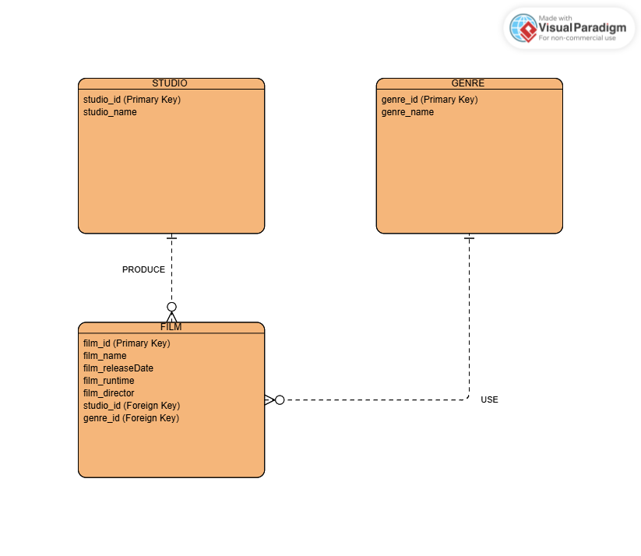

|  |  |  |  |  |  |  |  |  |  |  |  |  |  |
| --- | --- | --- | --- | --- | --- | --- | --- | --- | --- | --- | --- | --- | --- |
| Studio Table: | |  |  |  |  |  |  |  |  |  |  |  |  |
| studio_id (PK) | | studio_name | |  |  |  |  |  |  |  |  |  |  |
| 1 |  | Sony Pictures | |  |  |  |  |  |  |  |  |  |  |
| 2 |  | Warner Bros. Pictures | | |  |  |  |  |  |  |  |  |  |
|  |  |  |  |  |  |  |  |  |  |  |  |  |  |
|  |  |  |  |  |  |  |  |  |  |  |  |  |  |
| Genre Table: | |  |  |  |  |  |  |  |  |  |  |  |  |
| genre_id (PK) | | genre_name | |  |  |  |  |  |  |  |  |  |  |
| 1 |  | Action |  |  |  |  |  |  |  |  |  |  |  |
| 2 |  | Comedy |  |  |  |  |  |  |  |  |  |  |  |
|  |  |  |  |  |  |  |  |  |  |  |  |  |  |
|  |  |  |  |  |  |  |  |  |  |  |  |  |  |
| Film Table: | |  |  |  |  |  |  |  |  |  |  |  |  |
| film_id (PK) | | film_name | | film_releaseDate | | film_runtime | | film_director | | studio_id (FK) | | genre_id (FK) | |
| 1 |  | Bay Boys 2 | | 7/18/2003 |  | 147 |  | Michael Bay | | 1 |  | 1 |  |
| 2 |  | Dumb & Dumber | | 12/16/1994 |  | 106 |  | Peter Farrelly | | 2 |  | 2 |  |
|  |  |  |  |  |  |  |  |  |  |  |  |  |  |
|  |  |  |  |  |  |  |  |  |  |  |  |  |  |
|  |  |  |  |  |  |  |  |  |  |  |  |  |  |
|  |  |  |  |  |  |  |  |  |  |  |  |  |  |