**Jose Flores**

**Assignment #4: High/Low Temperatures**

**4/5/2025**

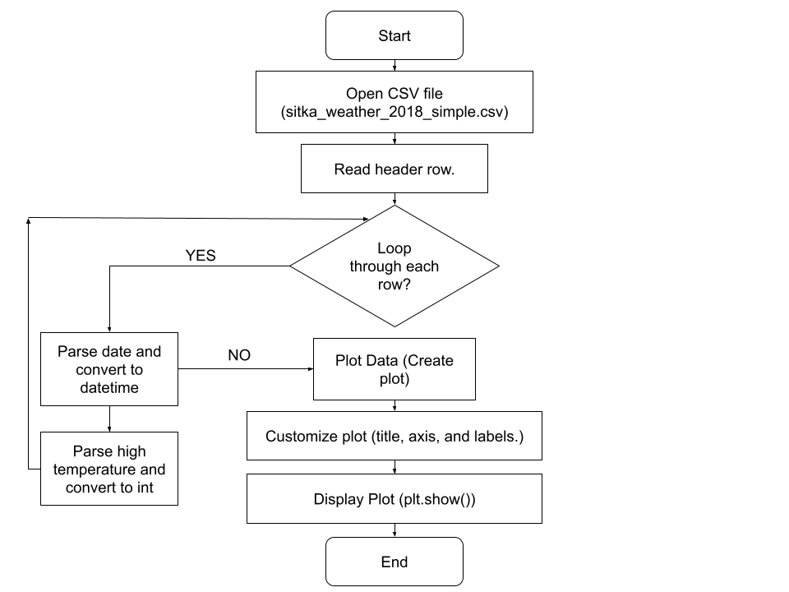

**Revised:**

