**Jose Flores**

**Assignment_8: JSON Practice**

**4/18/2025**

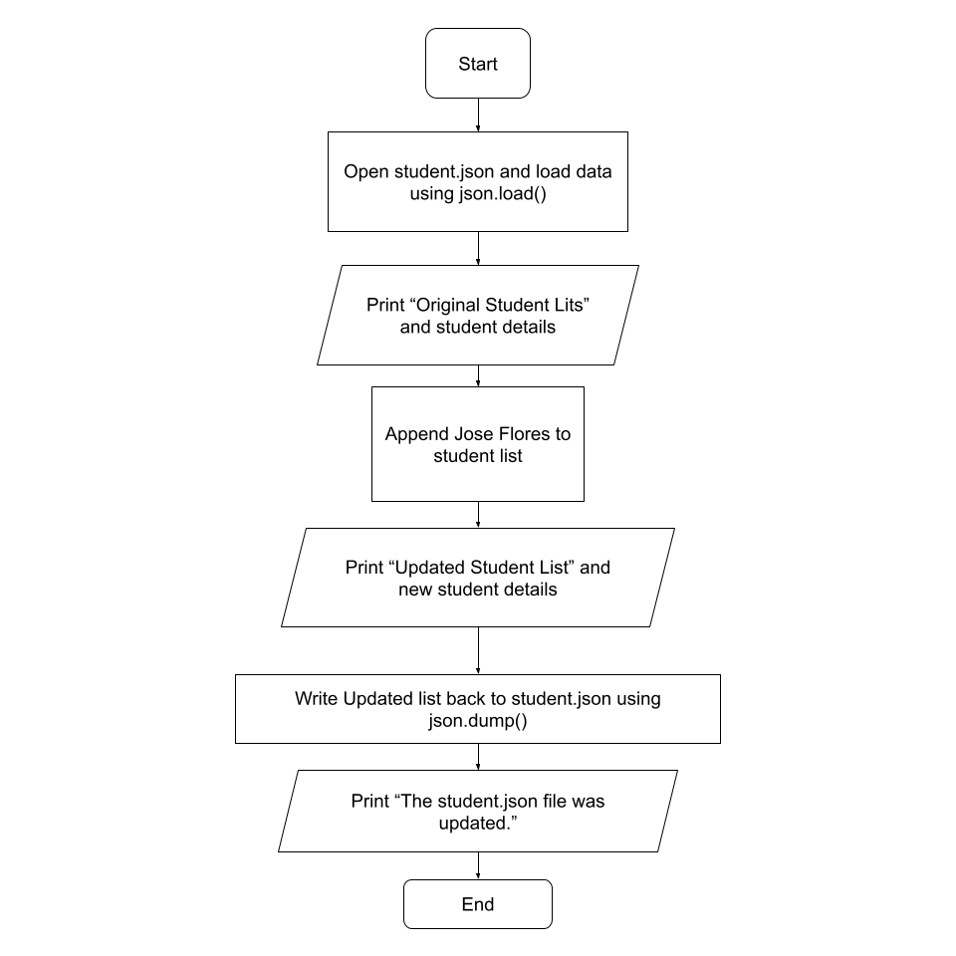

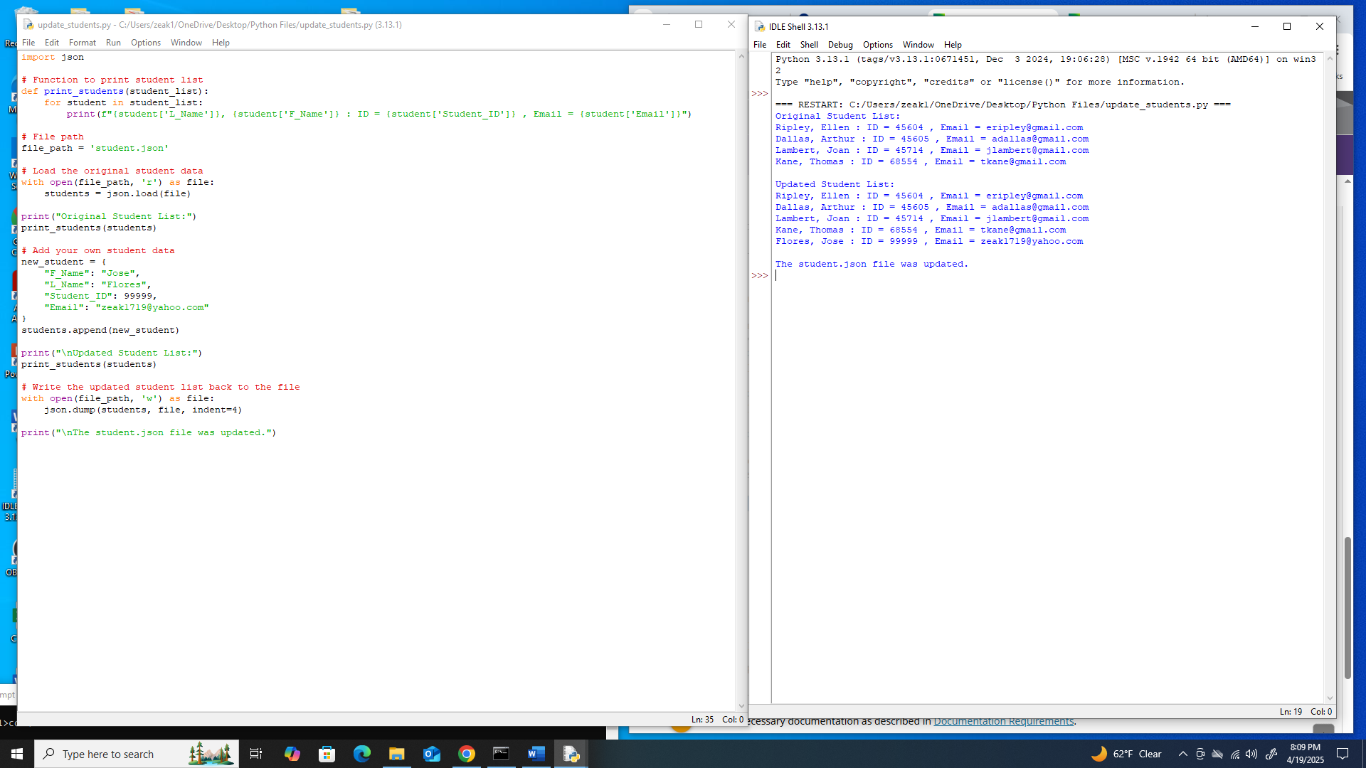

**After running the script, the student.json file updates automatically and displays the new data, VS Code does not show a pop-up or prompt to save.**

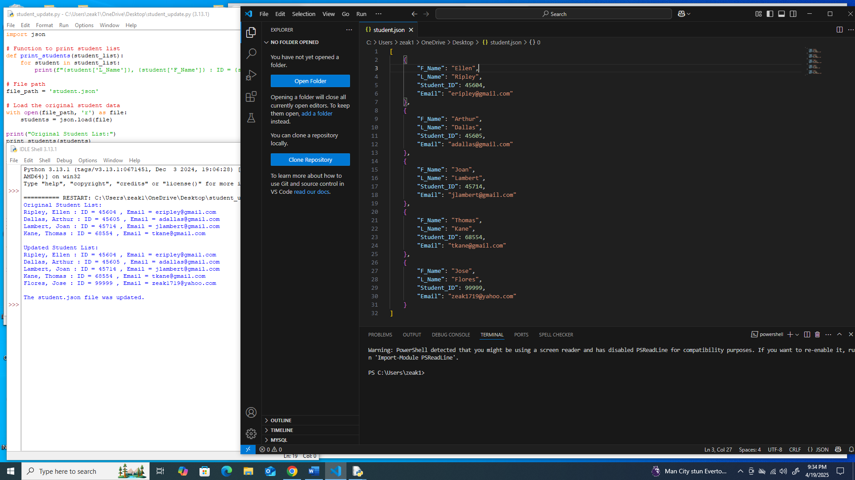

**The same thing happens when I run the program and use a different file like Notepad.**

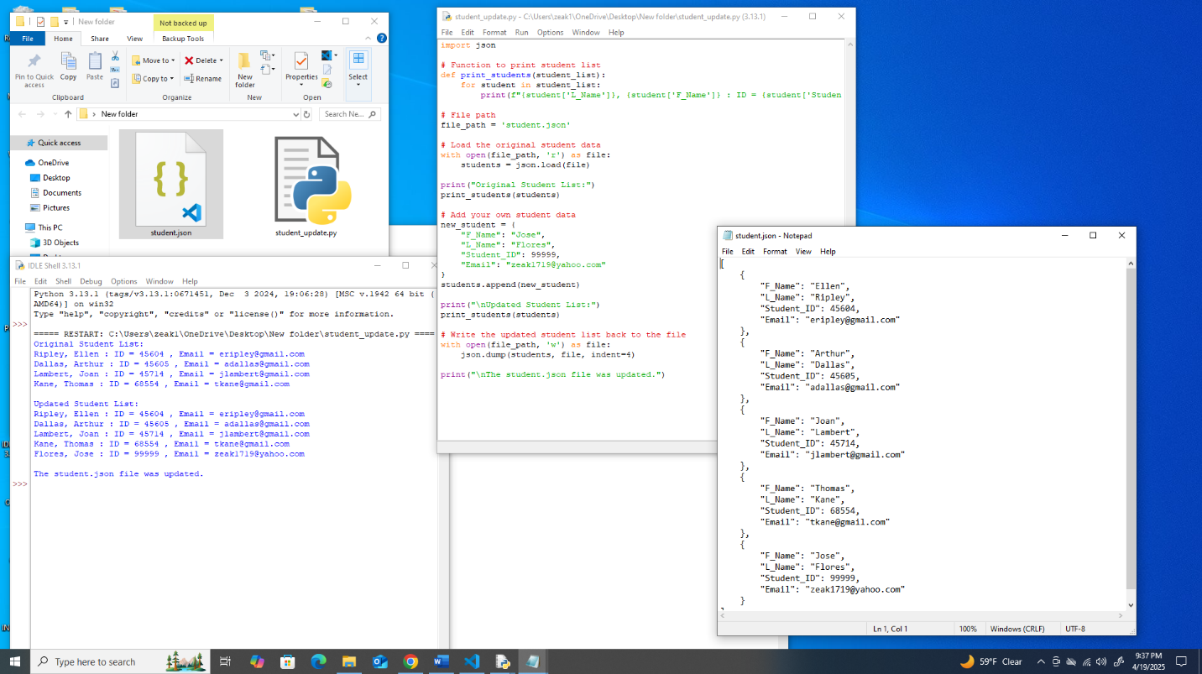

[

{

"F_Name": "Ellen",

"L_Name": "Ripley",

"Student_ID": 45604,

"Email": "eripley@gmail.com"

},

{

"F_Name": "Arthur",

"L_Name": "Dallas",

"Student_ID": 45605,

"Email": "adallas@gmail.com"

},

{

"F_Name": "Joan",

"L_Name": "Lambert",

"Student_ID": 45714,

"Email": "jlambert@gmail.com"

},

{

"F_Name": "Thomas",

"L_Name": "Kane",

"Student_ID": 68554,

"Email": "tkane@gmail.com"

},

{

"F_Name": "Jose",

"L_Name": "Flores",

"Student_ID": 99999,

"Email": "zeak1719@yahoo.com"

}

]