Project: Todo Application Test Case
Course: CSD 380 DevOps
Description: Functional test cases for Todo Application
Date: 2025/11/15
To complete the test case plan, fill out the information for Project, Course, Description and Date in the header below.

Contents
Test 1: Verify standard URL access 2
Test 2: Create new task item 3
Test 3: Block empty task submission 3
Test 4: Edit existing task 4
Test 5: Invalid URL 404 page 4

For each test, the developer should: provide a test description, a test objective, the developer name and date tested. For each step, fill out the actions to be taken and describe the expected results, and indicate yes or no for each step depending upon the result. The peer tester should provide their name, date tested, indicate yes or no for each step depending upon the result, and a screenshot (thumbnail) of the result.

Test 1 | Test 1: Verify standard URL access
 | Test Objective: Confirm that the site loads correctly through the official URL. | Developer: Clint Scott  Date tested: 2025/11/15 | Peer tester: Jose Flores  Date tested: 2025/11/15
Step | Action | Expected results: | Developer pass/fail | Tester pass/fail  + Screenshot
1 | Navigate to https://buwebdev.github.io/todo/ | Landing page loads without errors. | Yes, pass. | Yes, pass.  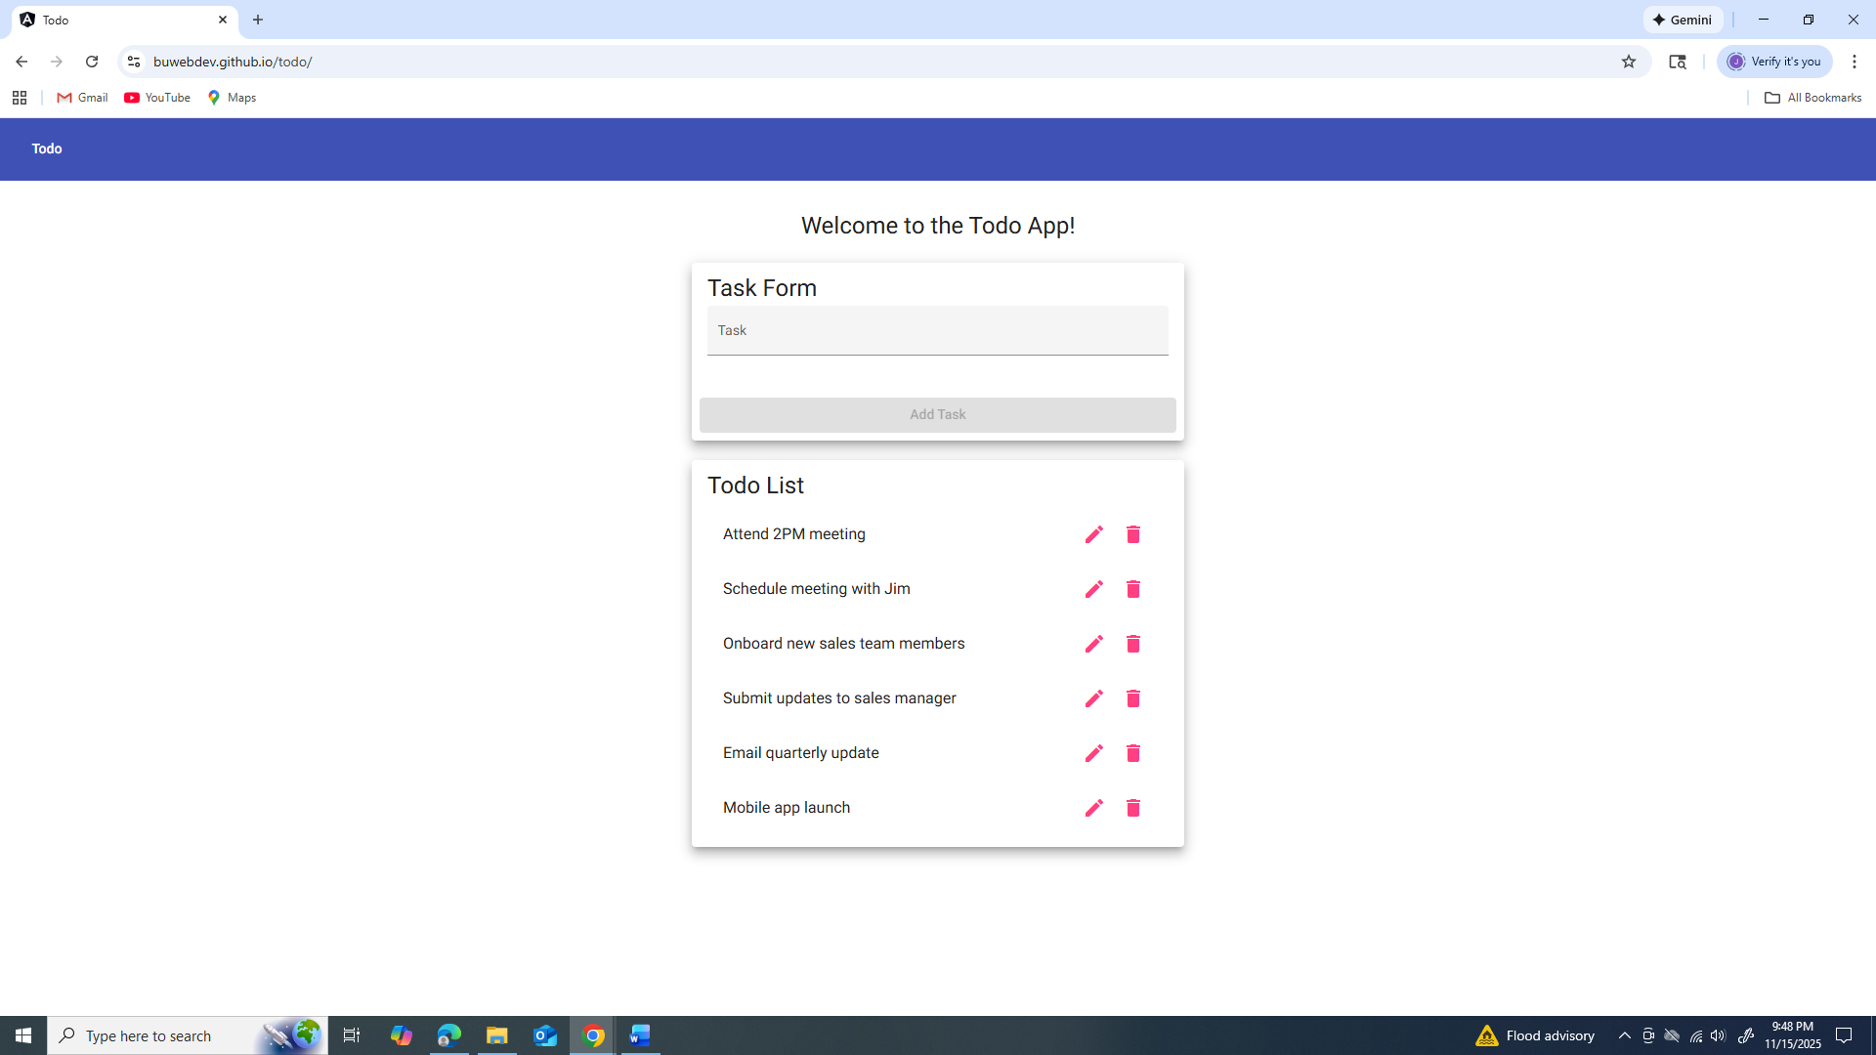
2 | Refresh the browser. | Page reloads successfully. | Yes, pass. | Yes, pass.  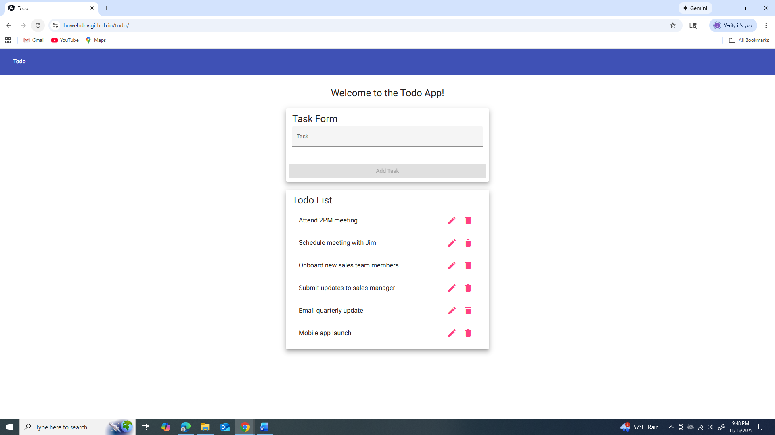
3 | Navigate to http://buwebdev.github.io/todo/ | Browser automatically redirects to https://buwebdev.github.io/todo/ and page loads without errors. | Yes, pass. | Yes, pass.  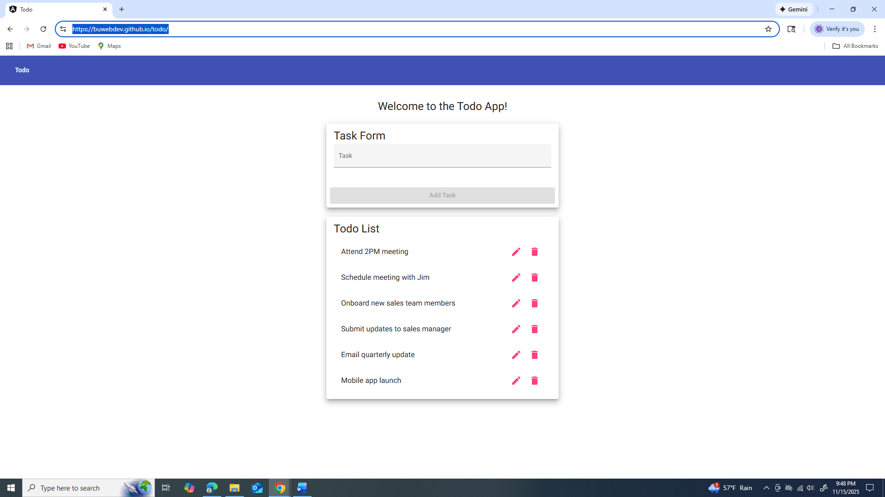
4 | Check page title. | Title displays 'ToDo'. | Yes, pass. | Yes, pass.  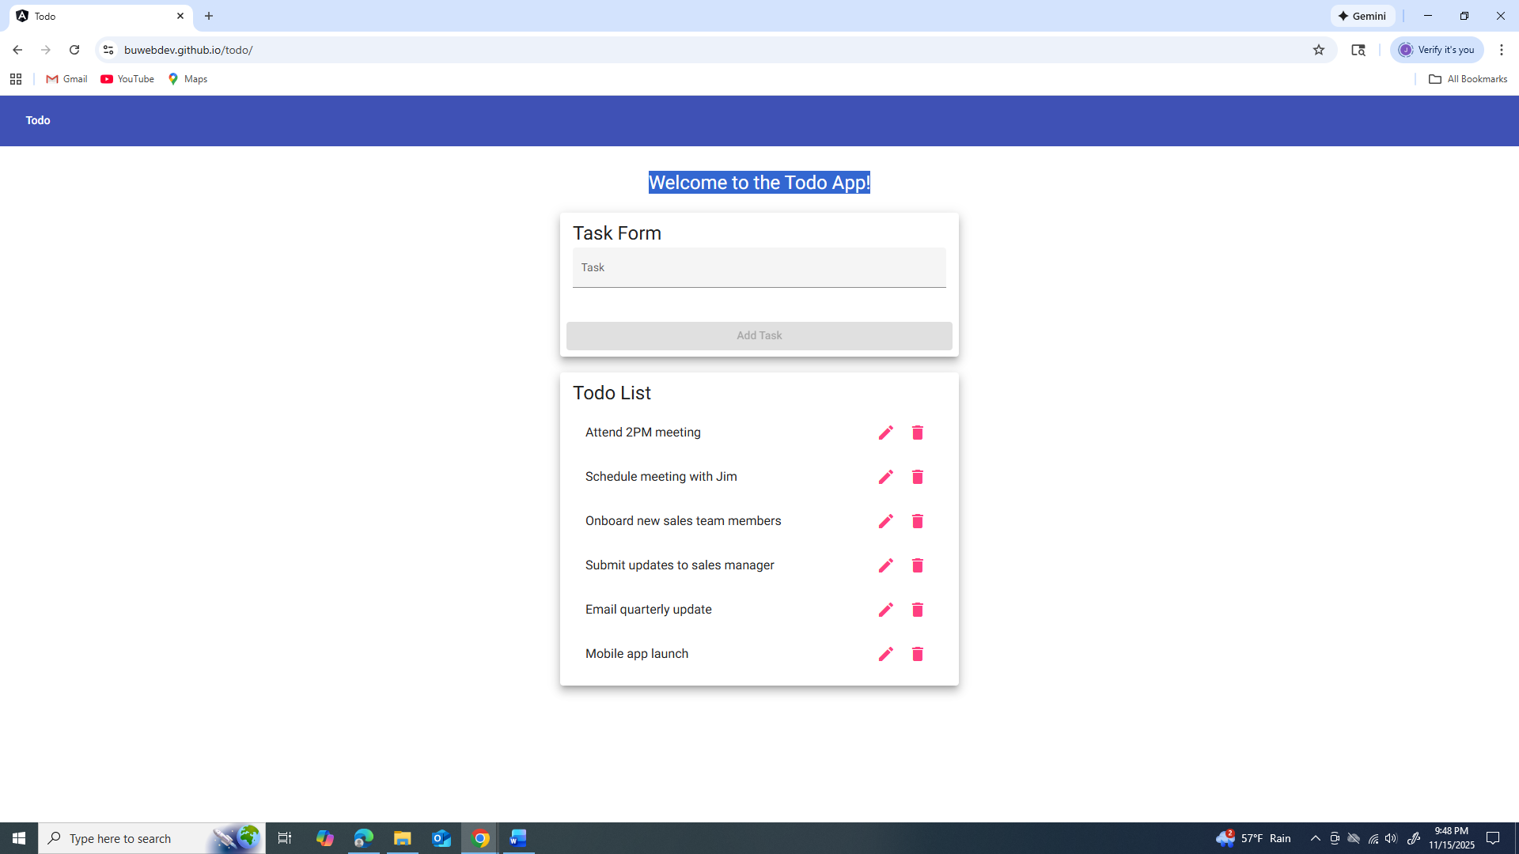
5 | Inspect console. | No errors appear. | Yes, pass. | Yes, pass.  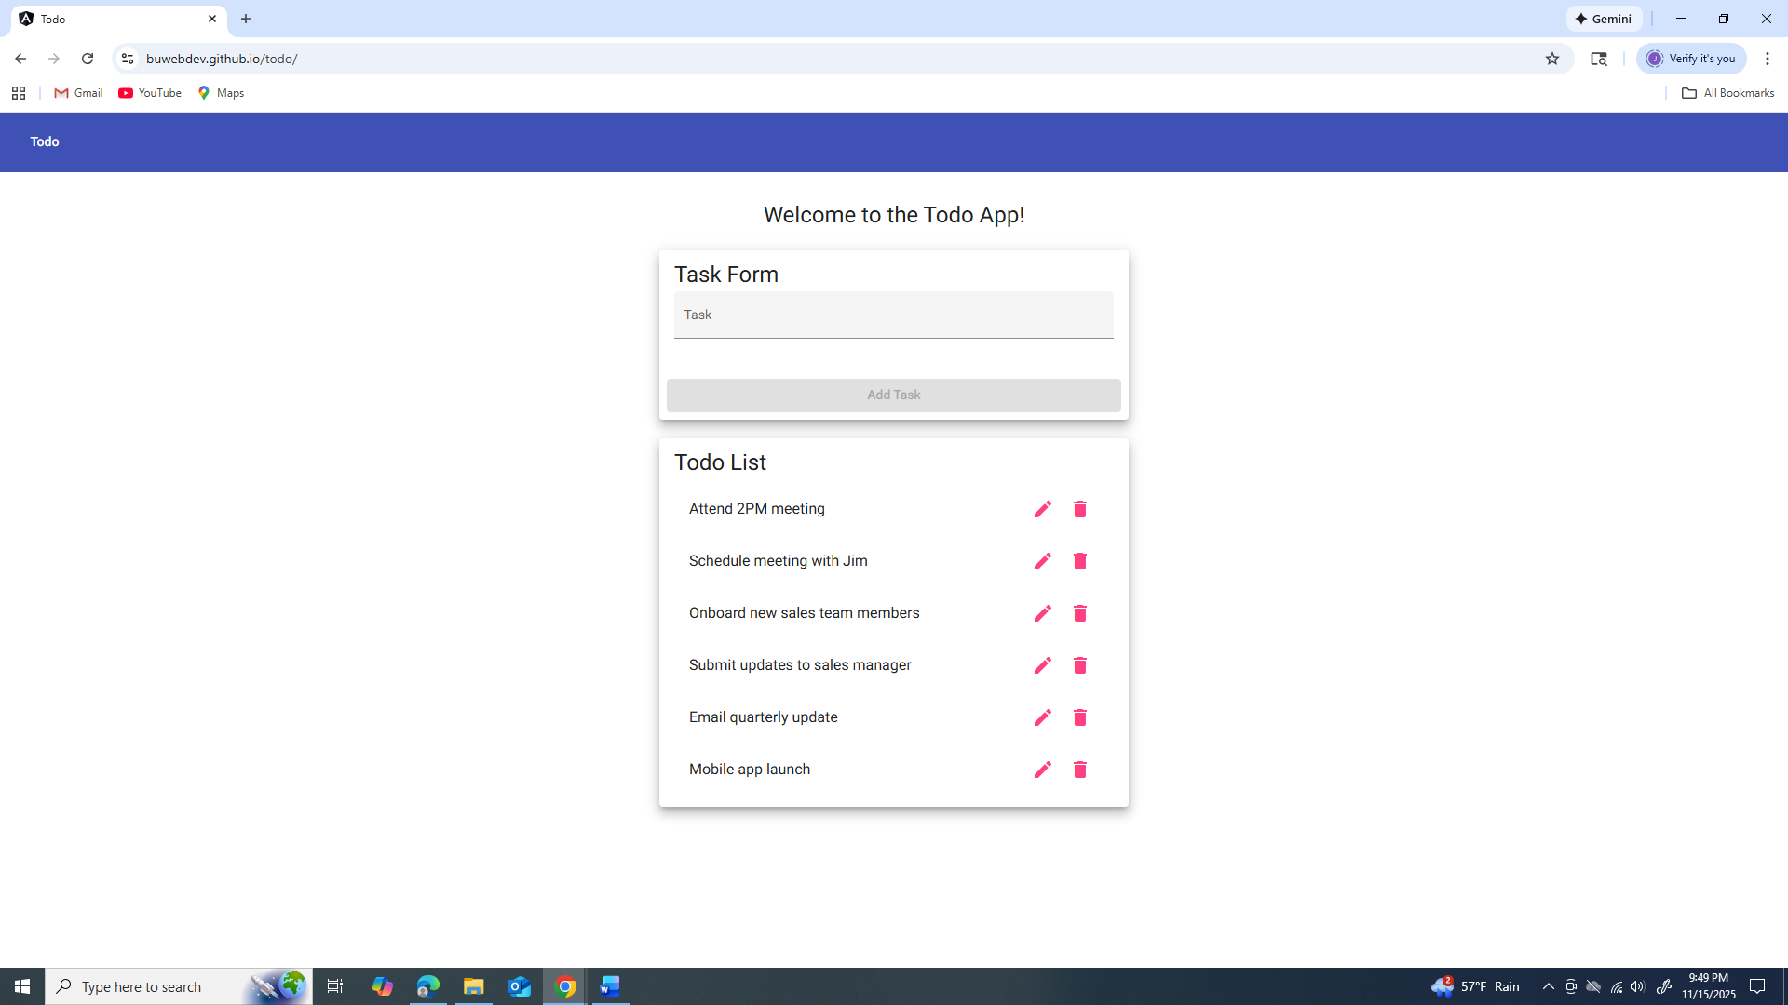
Comments | Comments should be substantive; this means there should be at least 2-3 well-structured sentences with constructive feedback.

Test 2 | Test 2: Create new task item
 | Test Objective: Ensure the Add Item form accepts valid input and displays the new task. | Developer: Clint Scott  Date tested: 2025/11/15 | Peer tester: Jose Flores  Date tested: 2025/11/15
Step | Action | Expected results: | Developer pass/fail | Tester pass/fail
1 | Open Todo application. | Page loads properly. | Yes, pass. | Yes, pass.  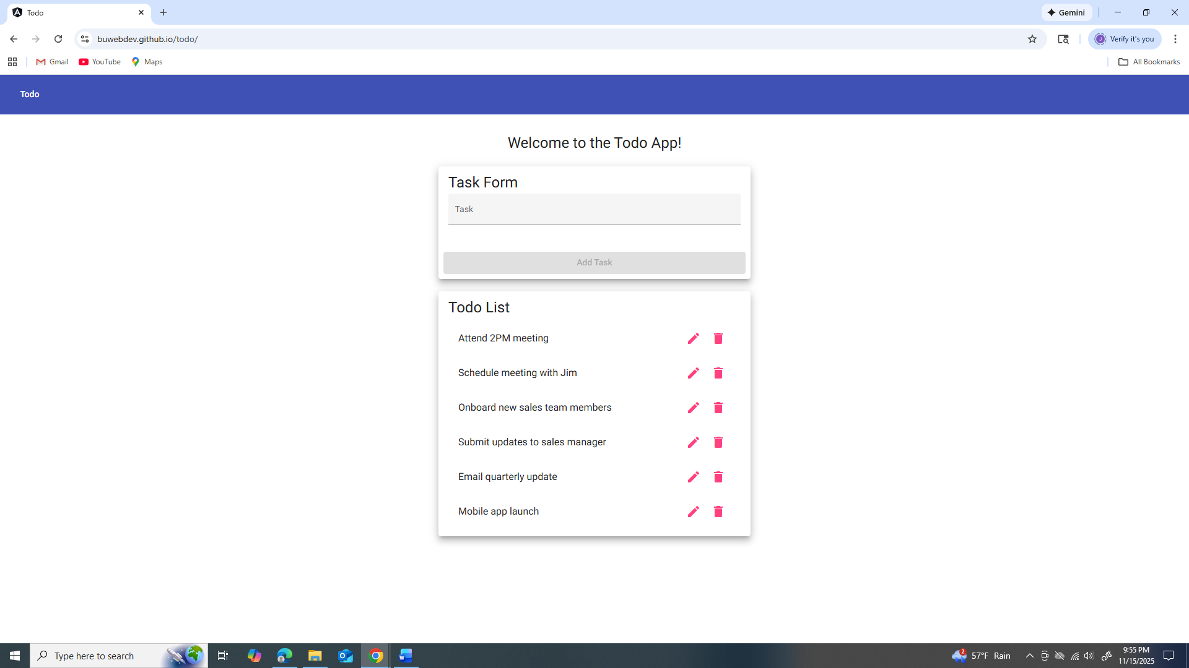
2 | Enter valid task text. | Input accepted. | Yes, pass. | Yes, pass.  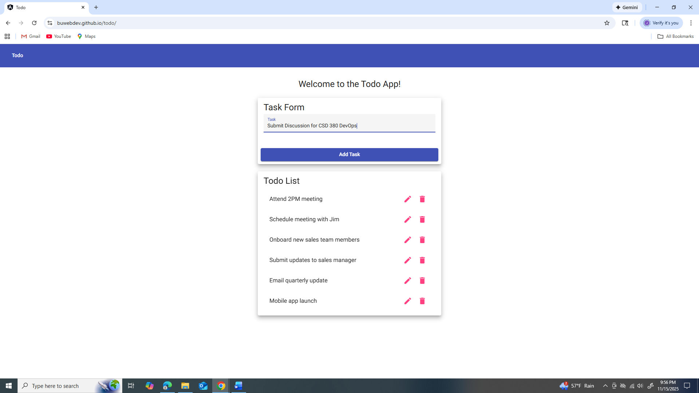
3 | Click Add button. | Task appears in list. | Yes, pass. | Yes, pass.  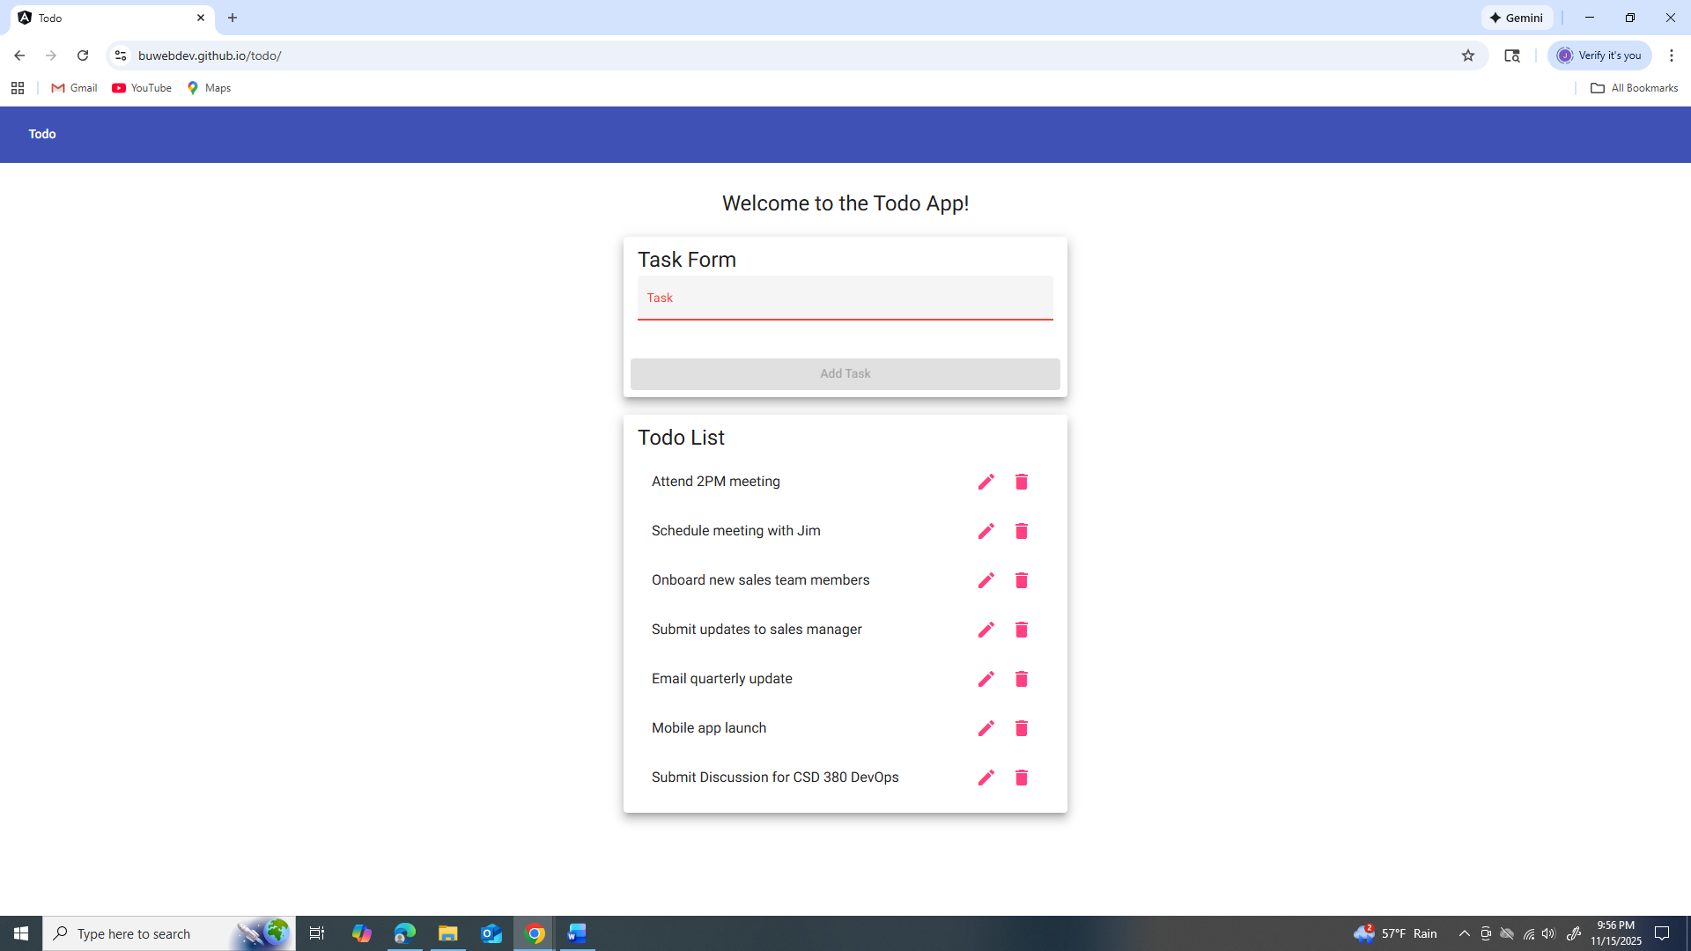
4 | Verify text matches. | Displayed text matches’ input. | Yes, pass. | Yes, pass.
5 | Check for errors. | No visible errors. | Yes, pass. | Yes, pass.
Comments | Comments should be substantive; this means there should be at least 2-3 well-structured sentences with constructive feedback.

Test 3 | Test 3: Block empty task submission
 | Test Objective: Prevent creation of empty tasks. | Developer: Clint Scott  Date tested: 2025/11/15 | Peer tester: Jose Flores  Date tested: 2025/11/15
Step | Action | Expected results: | Developer pass/fail | Tester pass/fail
1 | Open Todo app. | Page loads. | Yes, pass. | Yes, pass.  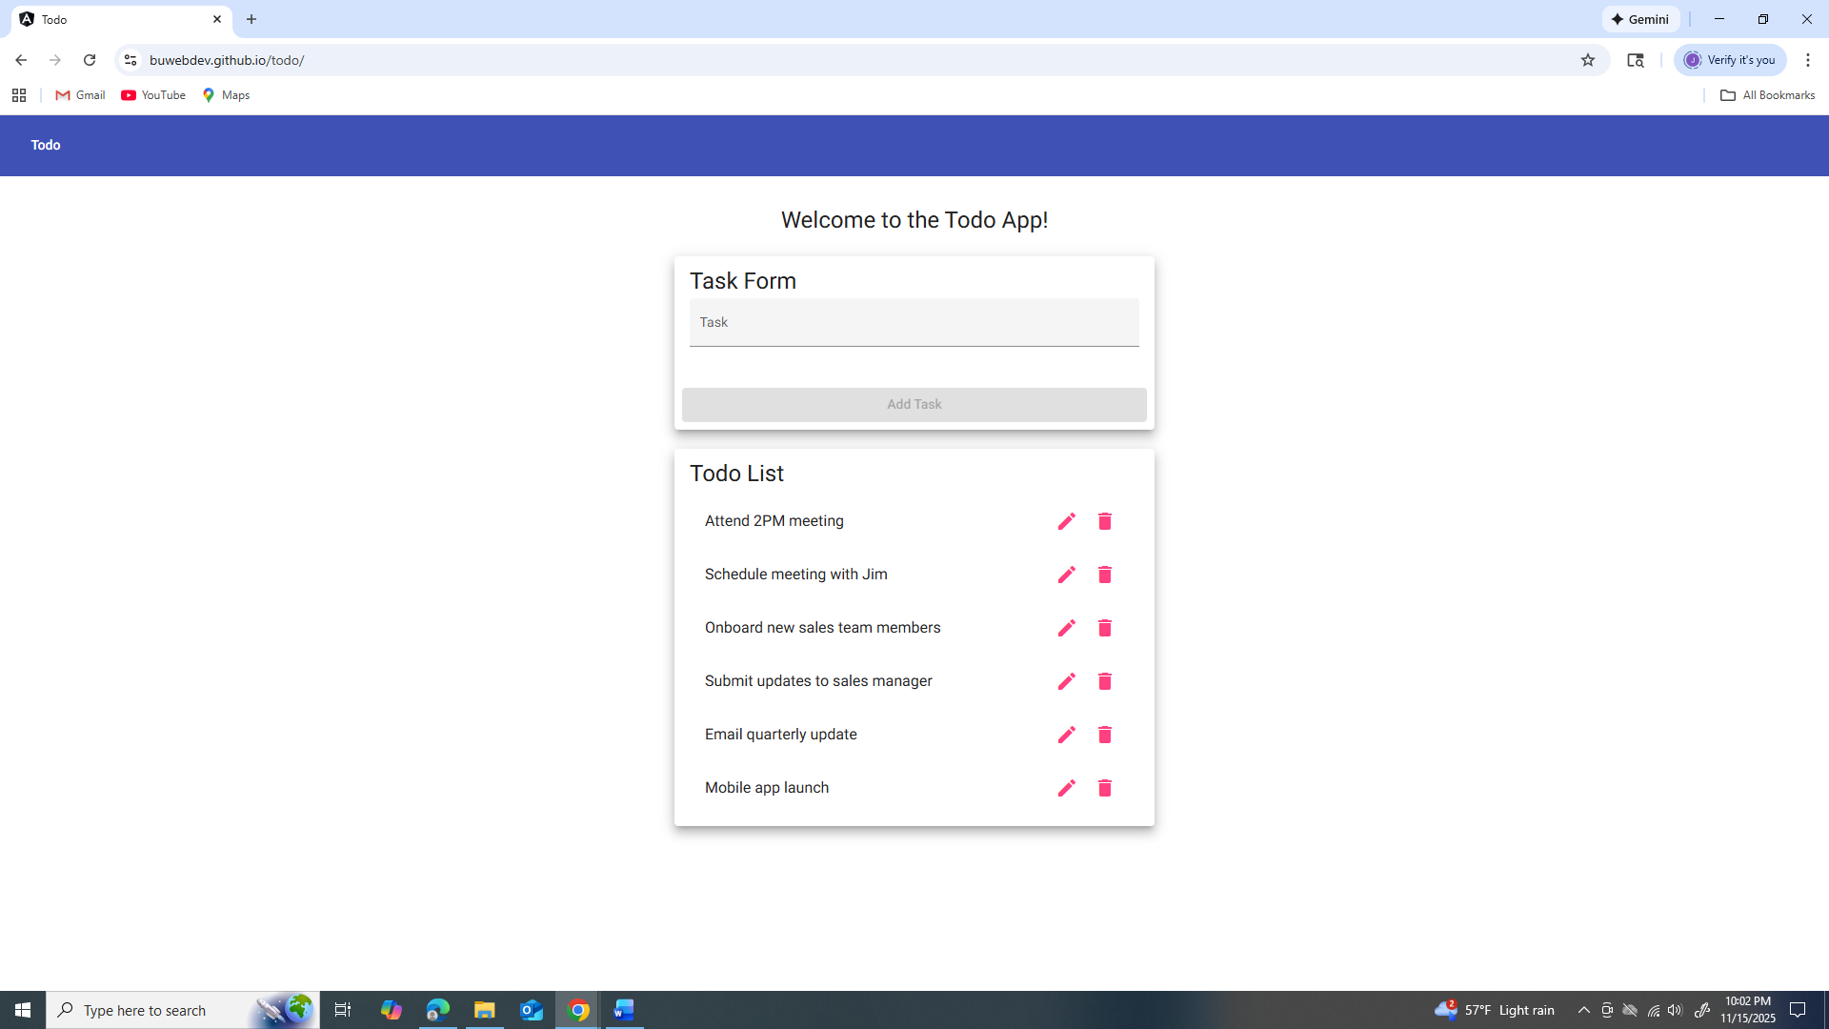
2 | Leave input blank. | Blank input remains unchanged. | Yes, pass. | Yes, pass.
3 | Click Add button. | Task is not added. | Yes, pass. | Yes, pass.  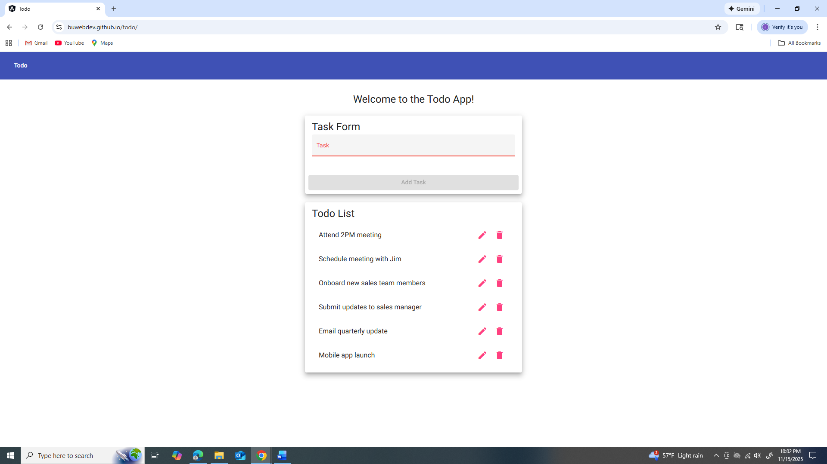
4 | Check validation. | UI blocks submission. | Yes, pass. | Yes, pass.
5 | Verify list unchanged. | Existing tasks unaffected. | Yes, pass. | Yes, pass.
Comments | Comments should be substantive; this means there should be at least 2-3 well-structured sentences with constructive feedback.

Test 4 | Test 4: Edit existing task
 | Test Objective: Confirm task editing works with valid input. | Developer: Clint Scott  Date tested: 2025/11/15 | Peer tester: Jose Flores  Date tested: 2025/11/15
Step | Action | Expected results: | Developer pass/fail | Tester pass/fail
1 | Open Todo app. | Page loads. | Yes, pass. | Yes, pass.  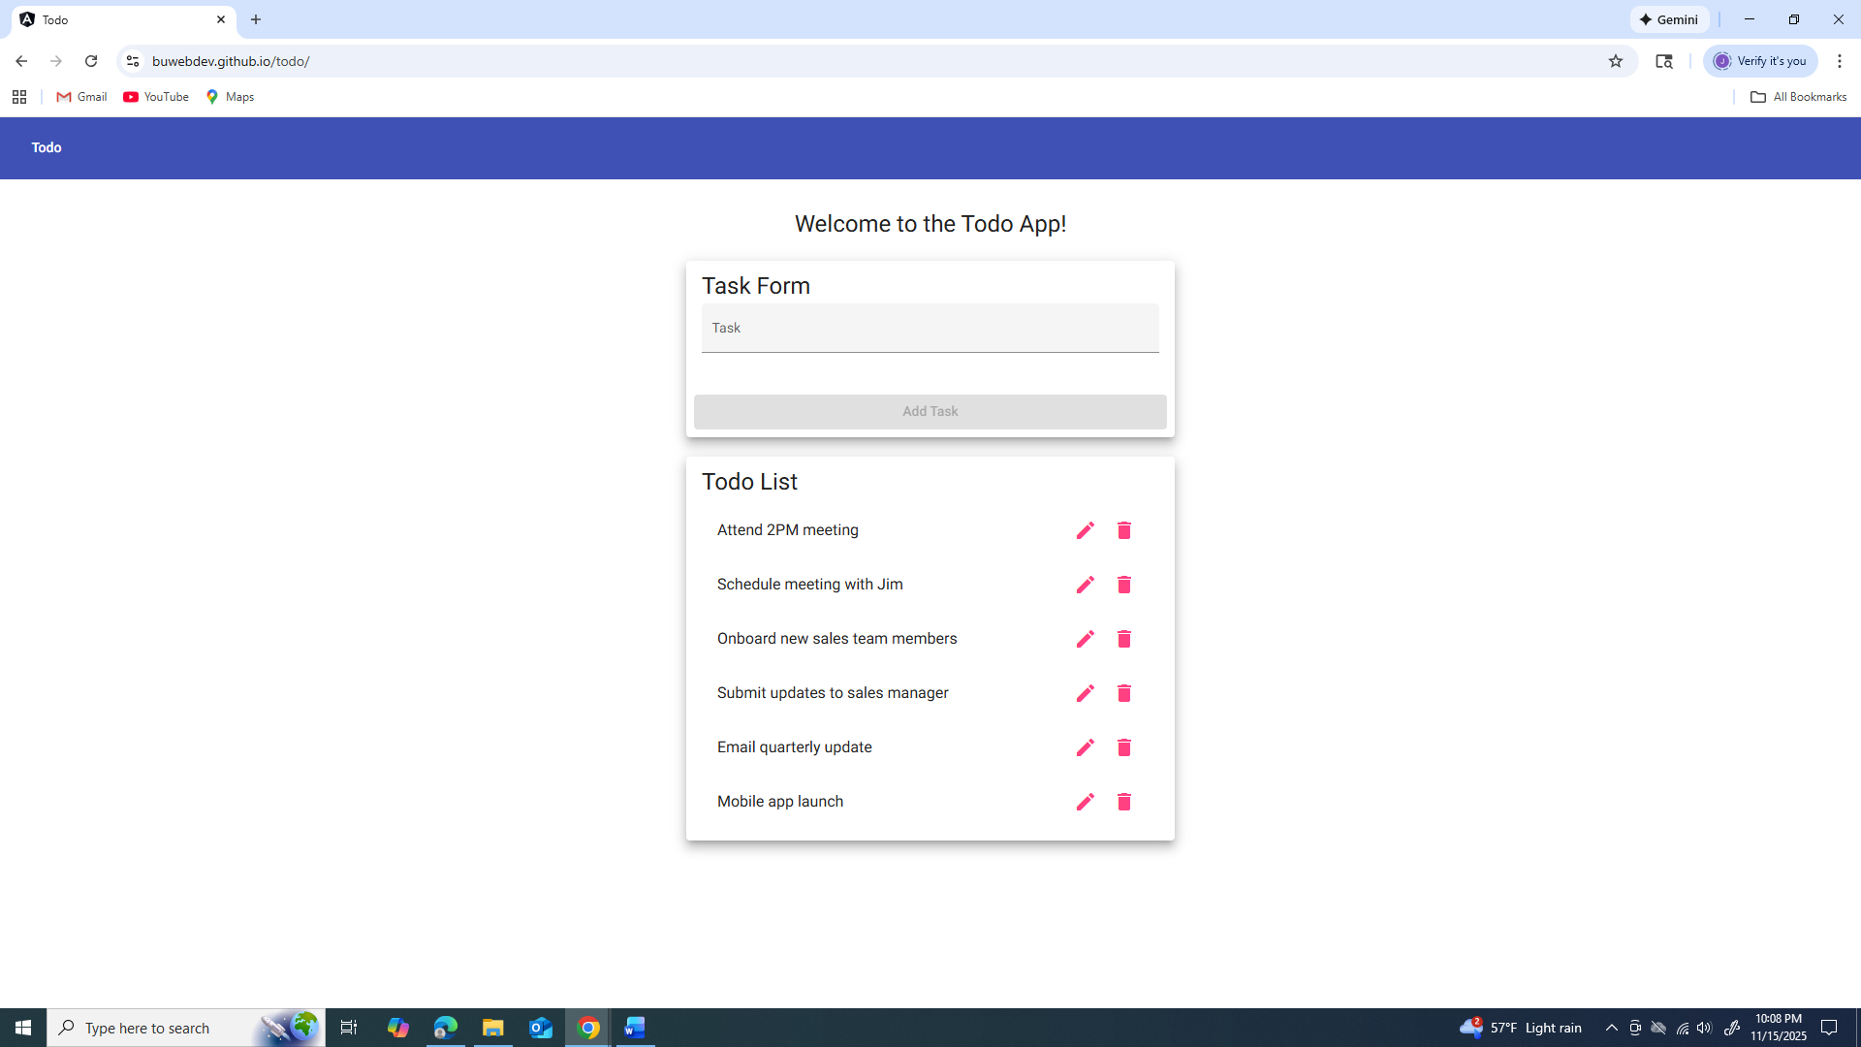
2 | Click Edit icon. | Edit form appears. | Yes, pass. | Yes, pass.  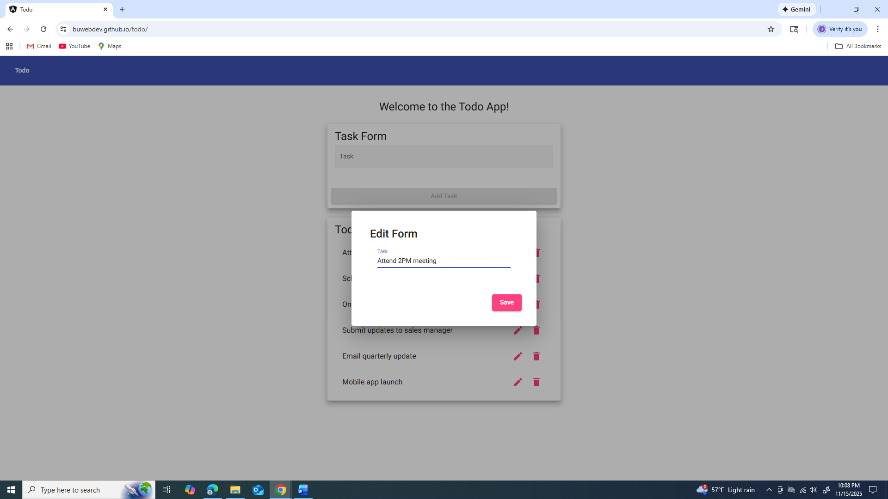
3 | Modify task text. | Input accepted. | Yes, pass. | Yes, pass.  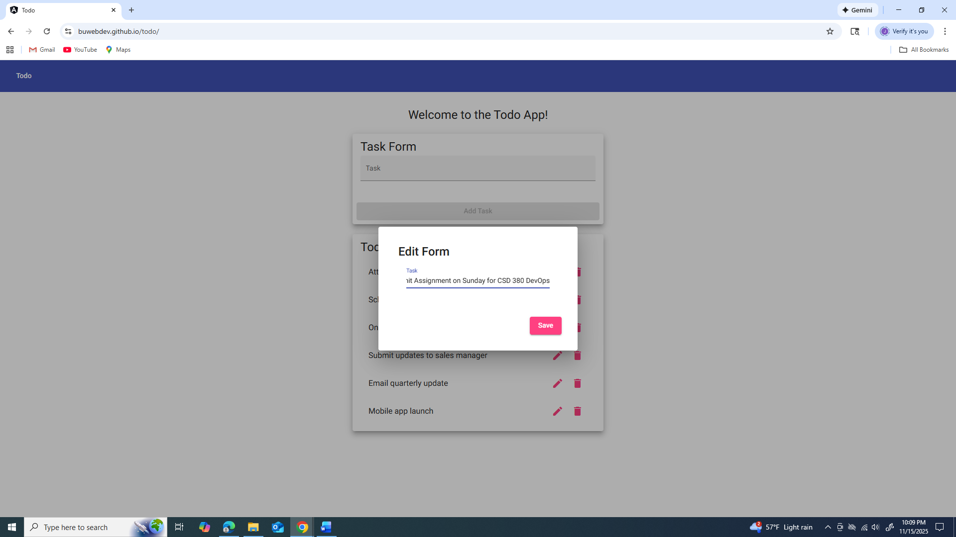
4 | Click Save. | Task updates on list. | Yes, pass. | Yes, pass.  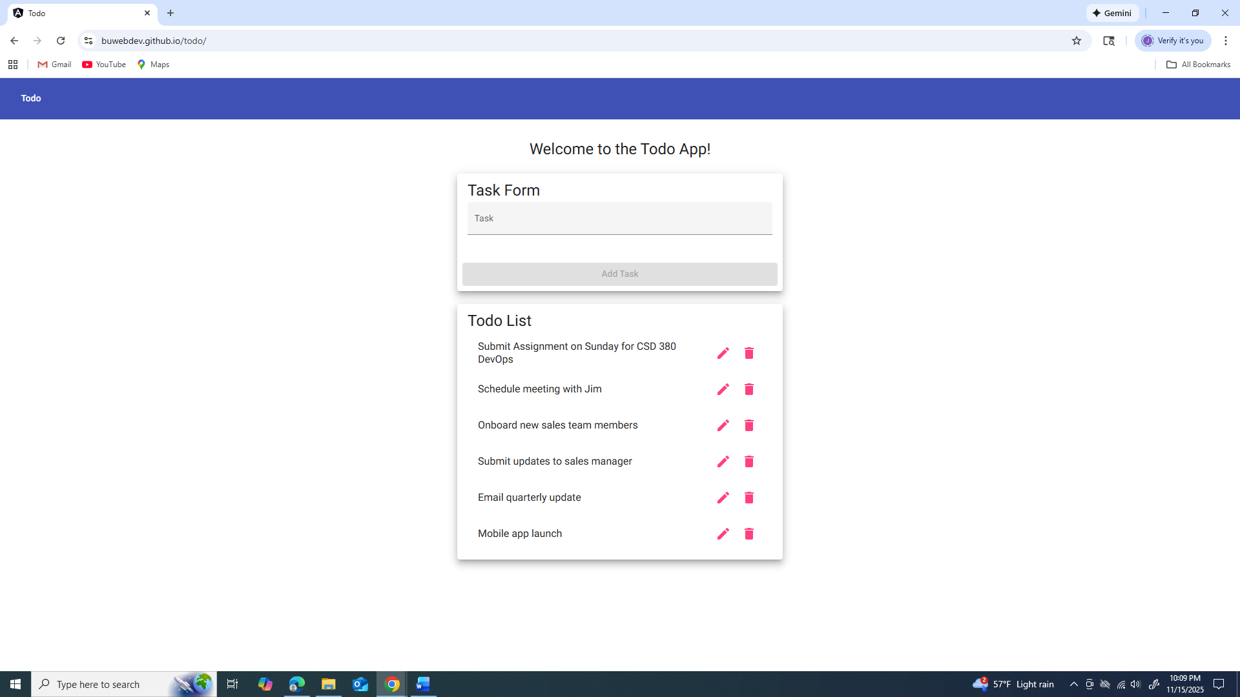
5 | Verify replacement. | New text appears. | Yes, pass. | Yes, pass.
Comments | Comments should be substantive; this means there should be at least 2-3 well-structured sentences with constructive feedback.

Test 5 | Test 5: Invalid URL 404 page
 | Test Objective: Confirm users receive a custom 404 page. | Developer: Clint Scott  Date tested: 2025/11/15 | Peer tester: Jose Flores  Date tested: 2025/11/15
Step | Action | Expected results: | Developer pass/fail | Tester pass/fail
1 | Go to /invalid-page. | Custom 404 page appears. | Yes, pass. | Yes, pass.  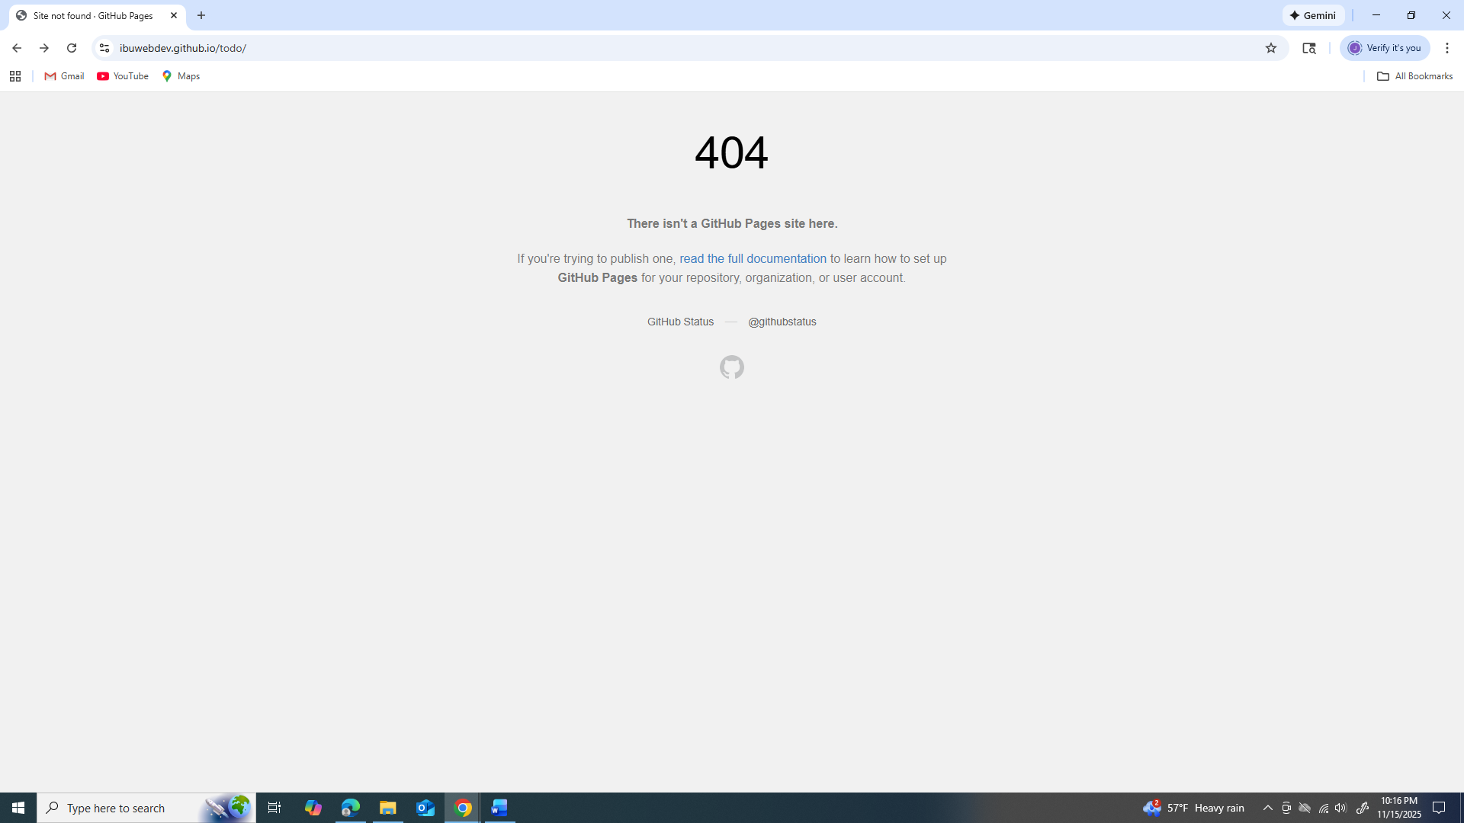
2 | Check message. | Readable 404 text displays. | Yes, pass. | Yes, pass.
3 | Check layout. | Page loads cleanly. | Yes, pass. | Yes, pass.
4 | Click return link. | User returns to homepage. | No, fail. Missing return link. | No, fail. Missing return link.
5 | Inspect console. | No critical errors. | Yes, pass. | Yes, pass.
Comments | Comments should be substantive; this means there should be at least 2-3 well-structured sentences with constructive feedback.

