Jose Flores
10/25/2025
Assignment: 1

Project Setup

Java Installed
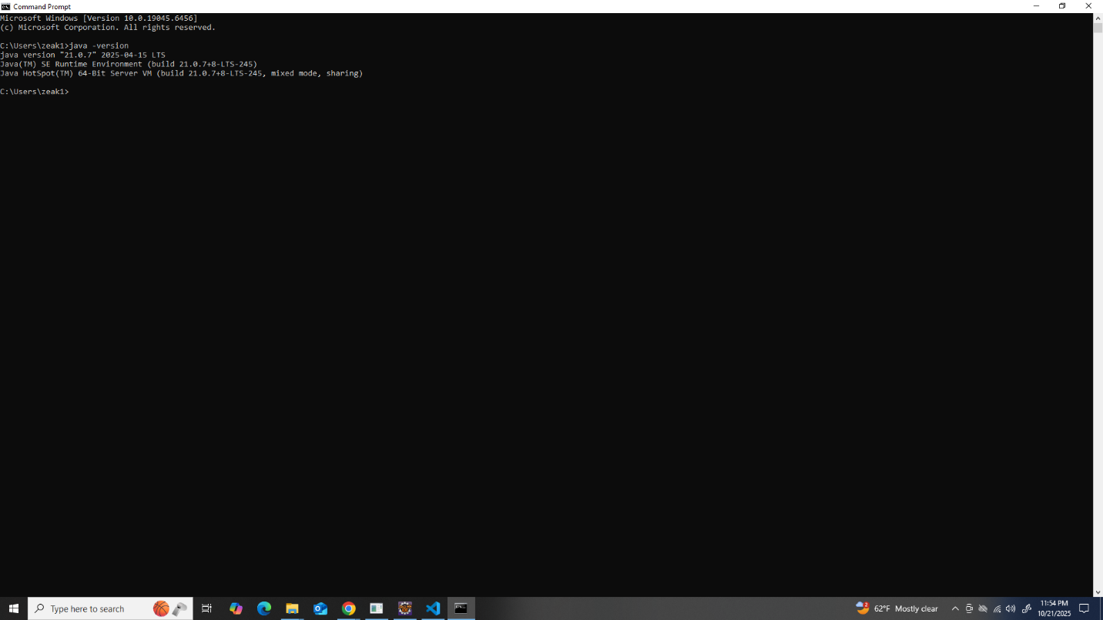

Tomcat Installed
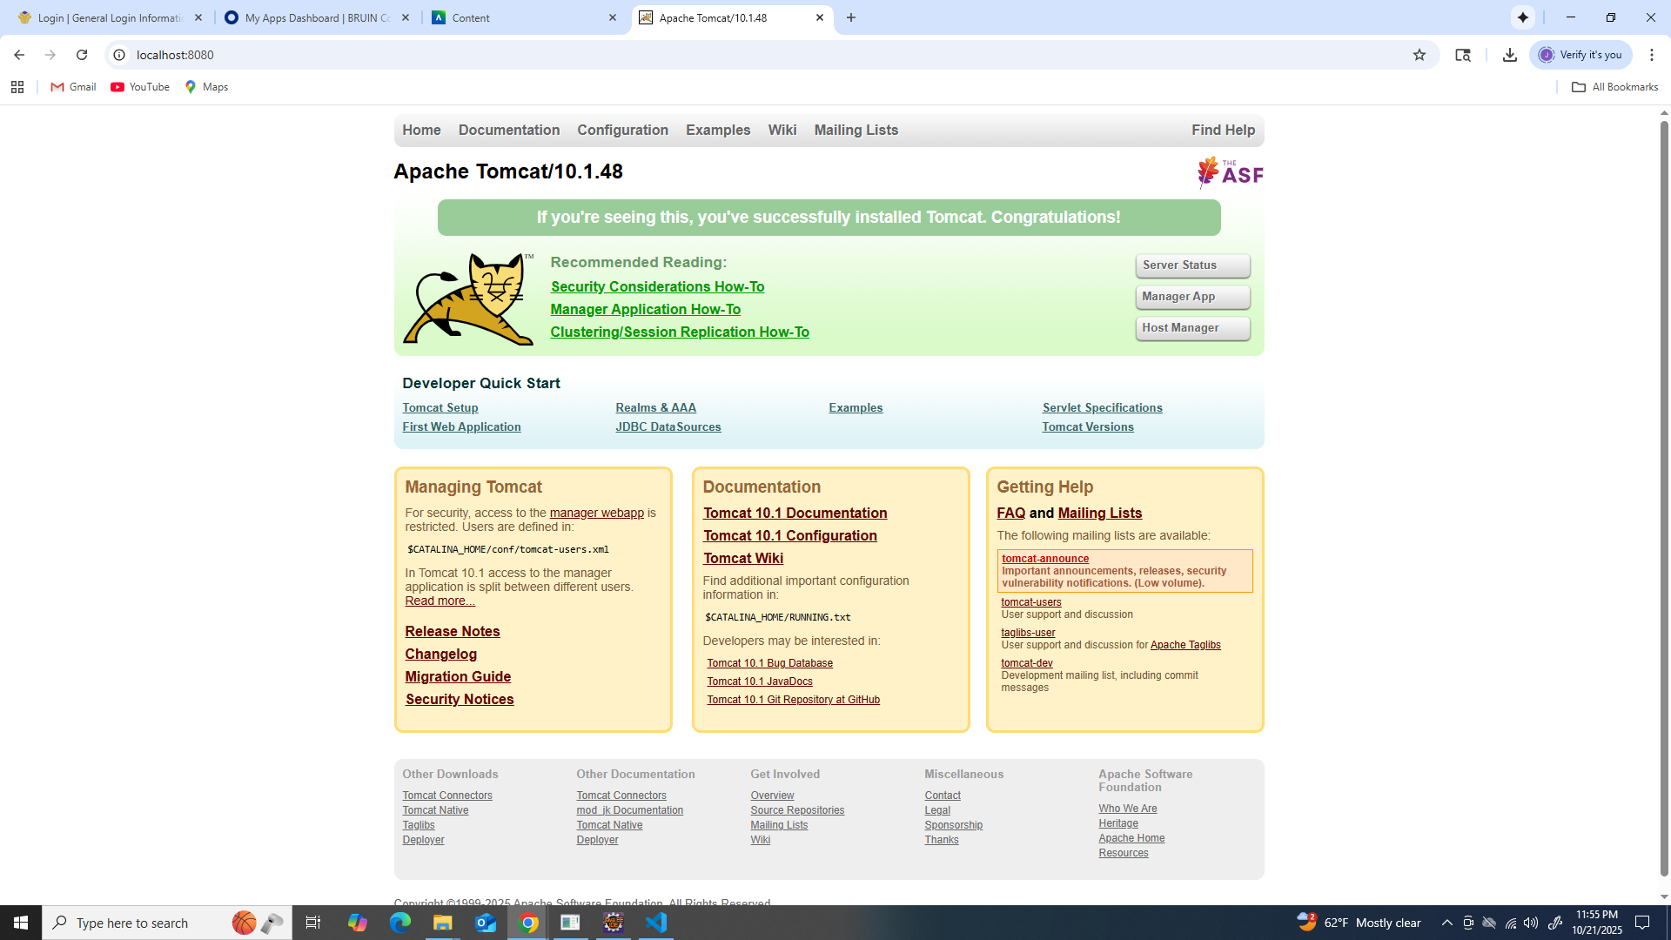

JSP File - Java + HTML
