In Situ Spectral Analysis for Soil Carbon Measurement

a

a

b

Jose A. Cortes

, Andrzej Korzeniowski

, Galina Yakubova

, Aleksandr

b

b

Kavetskiy

, H. Allen Torbert

*a*

*University of Texas at Arlington, Arlington, 76019, TX, USA*

*b*

*USDA ARS Auburn Lab, Auburn, AL, USA*

**Abstract**

Soil

carbon is a key component of

soil

health and plays a crucial

role in the

global

carbon cycle.

Accurate measurement of carbon is essential

for measur-

ing soil

quality and its impact on the environment.

Traditional

methods for

measuring carbon are often time-consuming, expensive, and require laboratory

analysis.

In situ Neutron-Gamma spectral analysis (NGSA) offers an alternative

for rapid and non-destructive measurement of soil carbon.

This paper explores

the use of NGSA techniques to measure carbon levels in various soil types.

We

simulate in MCNP6.2 common soil

types and apply different NGSA methods,

including peak fitting,

component fitting,

singular value decomposition,

and

deep learning,

to evaluate their effectiveness in measuring of soil

carbon.

The

results demonstrate that peak fitting with exponential

falloff baseline achieves

*−*5

the lowest mean squared error (7*.*66 *×* 10

),

followed by component analy-

sis methods.

The study shows that NGSA methods can provide accurate soil

carbon measurements,

with convolution techniques improving overall accuracy

across all methods.

*Keywords:*

soil carbon, spectral analysis, gamma-ray spectroscopy, MCNP

simulation, peak fitting, component analysis, deep learning

*Email*

*addresses:*

jose.cortes@uta.edu (Jose A. Cortes), korzeniowski@uta.edu

(Andrzej Korzeniowski), galina.yakubova@usda.gov (Galina Yakubova),

aleksandr.kavetskiy@usda.gov (Aleksandr Kavetskiy), allen.torbert@usda.gov (H. Allen

Torbert)

*Preprint submitted to Radiation Physics and Chemistry*

*August 18, 2025*

**1.**

**Introduction**

Soil carbon is a key component of soil health and plays a crucial role in the

global carbon cycle.

Accurate measurement of carbon is essential for measuring

soil

quality,

and its impact on the environment [1]

Traditional

methods for

measuring carbon are often time-consuming, expensive, and require laboratory

analysis [**?** ].

In situ spectral

analysis offers an alternative for rapid and non-

destructive measurement of

soil

carbon [2].

This paper explores the use of

NGSA techniques to measure carbon levels in various soil

types.

We simulate

in MCNP6.2 common soil types and apply different NGSA methods, including

peak fitting, component fitting, singular value decomposition, and deep learning,

to evaluate their effectiveness in measuring soil carbon.

**2.**

**Data Generation**

*2.1.*

*Common Soil*

*Types*

To investigate the effectiveness of NGSA methods for soil

carbon measure-

ment,

we simulate a range of common soil types.

The simulated data includes

spectral readings across different wavelengths, capturing the unique spectral sig-

natures of each soil type.

This data serves as a foundation for applying various

NGSA techniques.

Table 1:

Material compositions for soil simulation

Material

C %

H %

O %

Si %

Na %

Al %

K %

Carbon

100.0

0.0

0.0

0.0

0.0

0.0

0.0

Water

0.0

11.2

88.8

0.0

0.0

0.0

0.0

Quartz

0.0

0.0

53.3

46.7

0.0

0.0

0.0

Feldspar

0.0

0.0

48.8

32.1

8.8

10.3

0.0

Mica

0.0

0.5

48.2

21.2

0.0

20.3

9.8

Table 1 presents the elemental

composition of common soil

materials used

in the simulations.

Mechanical

mixing is used to combine materials based on

2

their weight proportions,

such that a 50% carbon and 50% water mix would

have a composition of 50% carbon, 5.6% hydrogen, and 44.4% oxygen.

To mea-

sure the effectiveness of NGSA methods for carbon measurement,

we simulate

combinations of

soil

materials with varying carbon (C) and moisture (Water)

content.

*2.2.*

*Simulation in MCNP*

MCNP6 [3] was used to simulate gamma-ray spectra resulting from neutron

activation of soil

samples.

Each simulation modeled a soil

sample undergoing

neutron activation with varying concentrations of carbon and other common soil

constituents.

The geometry was set up to mimic in situ measurement conditions,

with a neutron source placed above a soil

slab and a detector positioned to

capture emitted gamma rays [4].

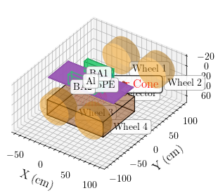

Figure 1:

Geometry of MCNP simulation setup showing neutron source, soil slab, and detector

configuration

Key simulation parameters included:

3

• **Neutron source energy:**

API120 portable neutron (D-T generator)

generator [5]

• **Soil slab dimensions:**

112 cm × 90 cm × 30 cm

• **Detector type:**

NaI detector [6]

• **Tally:**

F8 (pulse height tally) for gamma spectra

This approach enables the generation of realistic spectral data for a variety

of soil compositions, forming the basis for evaluating different NGSA techniques.

Table 2 lists the MCNP chemical identifiers for the elements considered in the

simulations.

Table 2:

MCNP Chemical Identifiers

Element

C

H

O

Si

Na

Al

K

MCNP Identifier

6000

1001

8016

14000

11023

13027

19000

*2.3.*

*Spectral*

*Readings*

The spectral

readings obtained from the MCNP simulations provide a de-

tailed distribution of the gamma-ray emissions from the soil

samples per neu-

tron, similar to what would be measured in a real-world scenario.

4

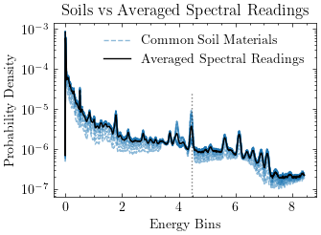

Figure 2:

Example MCNP spectral reading showing gamma-ray energy distribution

*2.4.*

*Training and Testing Data*

The training data for the NGSA methods is picked from the edge cases of

the simulated data.

This includes the highest and lowest carbon levels both as

would be found in simulation as well

as natural

soils.

The testing data is all

cases of the simulated data, excluding the training data.

The data also ranges

from 0% to 80% moisture content.

Table 3:

Carbon level classifications

Carbon Level

Associated Amount

Natural

0%-15% Carbon

High

15%-80% Carbon

5

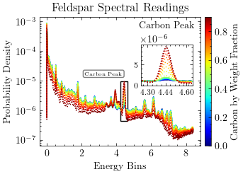

Figure 3:

Feldspar spectral reading by carbon level showing the variation in spectral signatures

with different carbon concentrations

*2.5.*

*Data Convolution*

In the context of NGSA, MCNP can be used to simulate the interaction of ra-

diation with soil materials, providing spectrums to analyze.

Linear Convolution

is used to quickly predict spectral readings for material mixtures by combining

the spectral signatures of individual components.

This does not account for the

complex interactions between materials,

but it provides a simplified approach

to generate spectral

data for analysis.

The error metric for this convolution

method is based on the difference between the simulated spectral readings and

the readings obtained from MCNP simulations.

The effects of

convolution as

training data on the analysis results will be investigated in the results section.

6

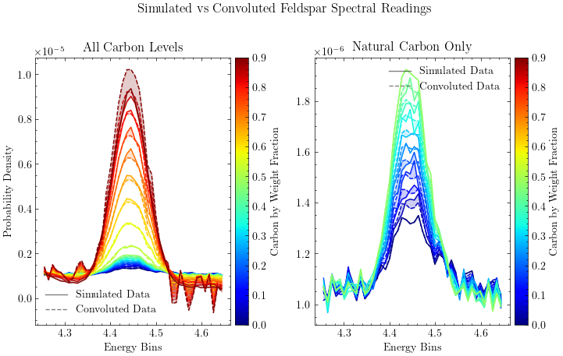

Figure 4:

Comparison of simulated vs convoluted data for Feldspar spectral readings

**3.**

**Analysis Methods of Spectral Readings**

This section explores various spectral analysis methods applied to the simu-

lated spectral readings.

Each method is evaluated for its effectiveness in measur-

ing Carbon levels.

Error is calculated using mean squared error (MSE) between

the predicted and actual carbon levels in the test data.

*3.1.*

*Calibration Layer*

All models undergo a calibration process to align their predictions with the

carbon measurements.

This involves a regression model

between a key char-

acteristic and the predicted values.

A linear regression model

is used for this

purpose.

The Scipy python package is used for the fitting process[7],

leveraging its

curve fitting capabilities to refine the initial

parameter estimates.

All

fitting

problems are taken as fitting a curve f(x,

p0) where p0 are the initial

param-

eters.

The fitting process iteratively adjusts these parameters to minimize the

difference between the predicted and actual

values,

using a least-squares ap-

proach.

The Levenberg-Marquardt algorithm is employed to optimize the fitting

7

process[8].

When the fitting is bounded,

Trust Region Reflective optimization

[9] is used.

*3.2.*

*Peak Baseline Fitting*

Peak fitting involves using the least-squares method in identifying and quan-

tifying the baseline and peaks in the spectral

data that correspond to specific

soil

components [10].

This method is useful

for extracting information about

the concentration of individual elements or compounds in the soil.

For effective

peak fitting, the data is filtered to focus on the peak area.

The fitting function is defined as:

*F*

= *F*

+ *F*

(1)

*f*

*p*

*b*

where *F*

is the peak function (e.g., Gaussian) and *F*

is the baseline function

*p*

*b*

(e.g., linear or exponential falloff).

Table 4:

Function parameterizations for peak fitting

Function Type

Example Expression

Linear

*ax* + *b*

Exp Falloff

*a ·* exp(*−b · x*) + *c*

2

2

Gaussian

*a ·* exp(*−*((*x − b*)

)*/c*

) + *d*

The SciPy Python package is used for the fitting process [7],

leveraging its

curve fitting capabilities to refine the initial parameter estimates.

The baseline

function is subtracted from the fitted function to isolate the peak, and the area

under the peak is calculated to quantify the concentration of the corresponding

element or compound in the soil.

8

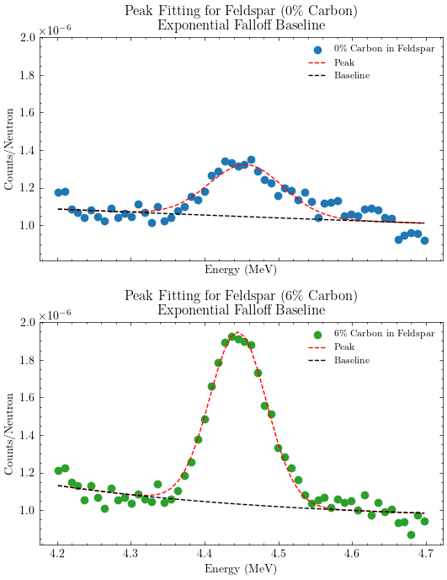

Figure 5:

Peak fitting example showing fitted peak and baseline for feldspar spectrum

An activation layer of

linear regression is used to compare the peak areas

to known soil carbon concentrations, allowing for the calibration of the model’s

predictions.

9

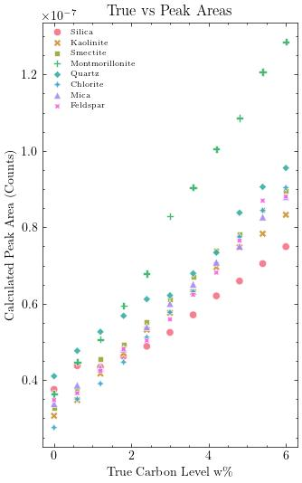

Figure 6:

Peak fitting prediction results showing carbon level vs predicted values

*3.3.*

*Component Fitting*

Component fitting involves modeling the spectral

data as a combination

of

known spectral

signatures of

soil

components.

This method allows for the

estimation of the concentration of multiple components in the soil based on their

10

spectral contributions.

The combined spectral function is defined as:

X

*F*

=

*A*

*· F*

(2)

*c*

*i*

*i*

*i*

where *F*

is the combined spectral function, *A*

are the coefficients represent-

*c*

*i*

ing the concentration of each component,

and *F*

are the spectral

functions of

*i*

individual components.

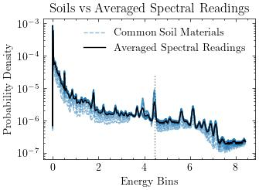

Figure 7:

Common soil

spectra vs average soil

spectrum showing the spectral

signatures of

different soil components

Components can be any known spectral signature, either from pure elemental

samples [11]

or from the average of

a set of

soil

samples.

The fitting process

involves adjusting the coefficients *A*

to minimize the difference between the

*i*

combined spectral

function *F*

and the observed spectral

data.

This method

*c*

also benefits from filtering of low energy signals which are generally more likely

to be caused by noise.

11

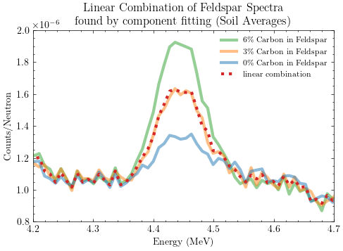

Figure 8:

Component fitting process showing linear combination of spectral

components for

feldspar analysis

The carbon coefficient *A*

is then used to estimate the Carbon level in the

*C*

soil.

This method is particularly useful

for analyzing complex soil

mixtures

where multiple known components contribute to the spectral

signature.

This

method is also generalizable to study other elements or compounds.

12

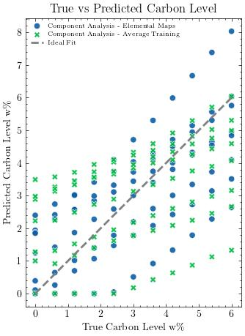

Figure 9:

Component fitting prediction results showing carbon level vs predicted values

*3.4.*

*Convex Optimization*

Convex optimization techniques can be applied to the spectral data to iden-

tify and quantify the contributions of different soil components.

By formulating

the problem as a convex optimization task,

it is possible to find the optimal

coefficients for the spectral

components that minimize the difference between

the observed and modeled spectra.

13

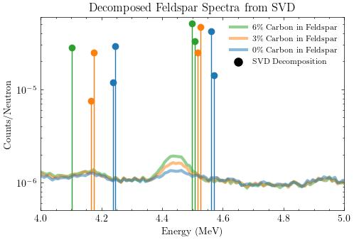

Figure 10:

Convex optimization process showing SVD decomposition of feldspar spectral data

14

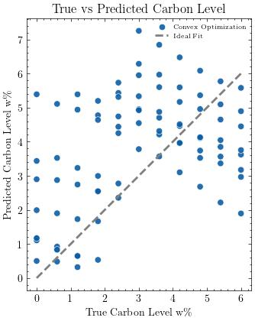

Figure 11:

Convex optimization predictions showing carbon level

vs predicted values using

SVD

*3.5.*

*Deep Learning*

Deep learning techniques,

such as convolutional

neural

networks (CNNs),

can be applied to spectral data for feature extraction and classification.

These

methods can learn complex relationships in the data and provide robust predic-

tions of

carbon levels based on spectral

readings.

The most important differ-

ence between deep learning and the previous methods is that it requires a large

amount of training data to be effective.

One method by Kim et al.

[12] uses a

deep learning model to predict existence, concentration and carbon peak areas.

15

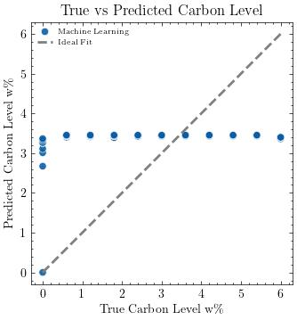

Figure 12:

Deep learning prediction results showing carbon level

vs predicted values using

machine learning optimization

**4.**

**Results**

The effectiveness of

each method in measuring carbon levels is evaluated

based on accuracy using mean squared error (MSE) as the metric.

The results

are summarized in Table 5.

16

Table 5:

Performance comparison of spectral analysis methods

Method Group

Method

MSE

*−*5

Peak Fitting

Exponential Falloff Baseline

7*.*66 *×* 10

*−*4

Component Analysis

Elemental Maps

2*.*10 *×* 10

*−*4

Component Analysis

Average Training

3*.*43 *×* 10

*−*4

Peak Fitting

Linear Baseline

3*.*52 *×* 10

*−*4

Machine Learning

Deep Learning

3*.*67 *×* 10

*−*4

Convex Optimization

SVD

4*.*27 *×* 10

*4.1.*

*Comparing Analysis Methods*

Peak fitting with exponential

falloff baseline is the most effective method

*−*5

for measuring carbon levels in soil,

achieving the lowest MSE (7*.*66 *×* 10

).

Component analysis methods also perform well, with elemental maps achieving

the second-best performance.

The deep learning method shows promise but

requires further optimization to improve its performance.

*4.2.*

*Effects of Carbon Levels on Results*

Table 6:

Method performance by carbon level

Carbon Level

MSE Values

Peak Fitting

Peak Fitting

Component

Component

Convex

Filtered ML

Machine

(Exp Falloff)

(Linear)

(Average)

(Elemental)

Optimization

Learning

*−*5

*−*4

*−*4

*−*4

*−*4

*−*3

*−*4

Agricultural

7*.*66 *×* 10

3*.*52 *×* 10

3*.*43 *×* 10

2*.*10 *×* 10

4*.*27 *×* 10

3*.*70 *×* 10

3*.*67 *×* 10

*−*2

*−*2

*−*2

*−*2

*−*2

*−*1

*−*1

All

1*.*42 *×* 10

3*.*48 *×* 10

1*.*92 *×* 10

1*.*92 *×* 10

2*.*64 *×* 10

1*.*33 *×* 10

1*.*01 *×* 10

Lower carbon levels tend to result in higher MSE values across all

meth-

ods, indicating that the spectral signatures of low-carbon soils are less distinct

and more challenging to analyze accurately.

The methods generally perform

better with higher carbon concentrations, where the spectral features are more

pronounced.

17

*4.3.*

*Effects of Convolution on Results*

Table 7:

Method performance by training dataset type

Dataset

MSE Values

Peak Fitting

Peak Fitting

Component

Component

Convex

Filtered ML

Machine

(Exp Falloff)

(Linear)

(Average)

(Elemental)

Optimization

Learning

*−*5

*−*4

*−*4

*−*4

*−*4

*−*4

*−*4

Convolution Training

7*.*26 *×* 10

3*.*50 *×* 10

2*.*95 *×* 10

1*.*91 *×* 10

2*.*93 *×* 10

3*.*65 *×* 10

3*.*61 *×* 10

*−*5

*−*4

*−*7

*−*7

*−*3

*−*2

*−*4

Feldspar

3*.*43 *×* 10

3*.*60 *×* 10

7*.*48 *×* 10

7*.*92 *×* 10

2*.*14 *×* 10

1*.*10 *×* 10

9*.*30 *×* 10

*−*5

*−*4

*−*4

*−*4

*−*4

*−*3

*−*4

Material Mixes

7*.*66 *×* 10

3*.*52 *×* 10

3*.*43 *×* 10

2*.*10 *×* 10

4*.*27 *×* 10

3*.*70 *×* 10

3*.*67 *×* 10

Convolution generally improves the accuracy of spectral analysis methods by

smoothing out noise and enhancing the signal-to-noise ratio.

The results show

that convolution leads to lower MSE values across all methods, indicating that

it is beneficial for spectral analysis in soil carbon measurement.

**5.**

**Discussion**

*5.1.*

*Conclusions*

The study demonstrates the potential of spectral analysis methods for mea-

suring soil carbon levels.

Peak fitting and component fitting methods show the

best performance,

while deep learning techniques require further refinement.

Convolution is beneficial for improving the accuracy of spectral analysis.

The peak fitting method with exponential falloff baseline achieved the high-

est accuracy,

suggesting that proper baseline correction is crucial

for effective

spectral analysis.

Component analysis methods provide a good balance between

accuracy and interpretability, making them suitable for practical applications.

*5.2.*

*Future Work*

Future work will focus on:

• Optimization of deep learning architectures for spectral analysis

18

• Investigation of hybrid methods combining multiple analysis techniques

• Field validation of the proposed methods

• Extension to other soil properties beyond carbon content

**6.**

**Acknowledgments**

We acknowledge the contributions of the USDA scientists for their guidance

and support in this research.

The spectral

data generated in this study is

available for further research and validation.

**References**

[1]

R.

Lal,

J.

M.

Kimble,

R.

F.

Follett,

B.

A.

Stewart (Eds.),

Soil

Processes

and the Carbon Cycle,

CRC Press,

Boca Raton,

2018.

doi:10.1201/

9780203739273.

[2]

G.

Yakubova,

A.

Kavetskiy,

S.

A.

Prior,

H.

A.

Torbert,

Tagged neutron

method for carbon analysis of

large soil

samples,

Applied Radiation and

Isotopes 150 (2019) 127–134.

doi:10.1016/j.apradiso.2019.05.028.

URL

https://www.sciencedirect.com/science/article/pii/

S0969804319301381

[3]

C. J. Werner, J. C. Armstrong, F. B. Brown, J. S. Bull, L. Casswell, L. J.

Cox, D. A. Dixon, R. A. Forster, III, J. T. Goorley, H. G. Hughes, III, J. A.

Favorite,

R.

L.

Martz,

S.

G.

Mashnik,

M.

E.

Rising,

C.

J.

Solomon,

Jr.,

A.

Sood,

J.

E.

Sweezy,

A.

J.

Zukaitis,

C.

A.

Anderson,

J.

S.

Elson,

J.

W.

Durkee, Jr., R. C. Johns, G. W. McKinney, G. E. McMath, J. S. Hendricks,

D. B. Pelowitz, R. E. Prael, T. E. Booth, M. R. James, M. L. Fensin, T. A.

Wilcox,

B.

C.

Kiedrowski,

MCNP User’s Manual

Code Version 6.2,

Tech.

Rep. LA-UR-17-29981, Los Alamos National Laboratory, Los Alamos, NM,

USA (Oct. 2017).

URL

http://permalink.lanl.gov/object/tr?what=info:lanl-repo/

lareport/LA-UR-17-29981

19

[4]

A.

Kavetskiy,

G.

Yakubova,

S.

A.

Prior,

H.

A.

Torbert,

A.

Kavetskiy,

G. Yakubova, S. A. Prior, H. A. Torbert, Neutron-Stimulated Gamma Ray

Analysis of

Soil,

in:

New Insights on Gamma Rays,

IntechOpen,

2017.

doi:10.5772/68014.

URL https://www.intechopen.com/chapters/54779

[5]

A. Kavetskiy, G. Yakubova, S. A. Prior, H. A. Torbert, Energy correlated

timing spectra in target

neutron techniques,

Nuclear

Instruments

and

Methods in Physics Research Section B: Beam Interactions with Materials

and Atoms 433 (2018) 80–86.

doi:10.1016/j.nimb.2018.07.028.

URL

https://www.sciencedirect.com/science/article/pii/

S0168583X18304476

[6]

G.

Yakubova,

A.

Kavetskiy,

S.

A.

Prior,

H.

A.

Torbert,

Measuring

and

mapping

moisture

content

in

agricultural

fields

by

neutron-

gamma

analysis,

Soil

and

Tillage

Research

248

(2025)

106444.

doi:10.1016/j.still.2024.106444.

URL

https://www.sciencedirect.com/science/article/pii/

S0167198724004458

[7]

P.

Virtanen,

R.

Gommers,

T.

E.

Oliphant,

M.

Haberland,

T.

Reddy,

D.

Cournapeau,

E.

Burovski,

P.

Peterson,

W.

Weckesser,

J.

Bright,

S.

J.

van der Walt,

M.

Brett,

J.

Wilson,

K.

J.

Millman,

N.

Mayorov,

A.

R.

J.

Nelson, E. Jones, R. Kern, E. Larson, C. J. Carey, I. Polat, Y. Feng, E. W.

Moore, J. VanderPlas, D. Laxalde, J. Perktold, R. Cimrman, I. Henriksen,

E. A. Quintero, C. R. Harris, A. M. Archibald, A. H. Ribeiro, F. Pedregosa,

P. van Mulbregt, SciPy 1.0:

fundamental algorithms for scientific comput-

ing in Python,

Nature Methods 17 (3) (2020) 261–272,

publisher:

Nature

Publishing Group.

doi:10.1038/s41592-019-0686-2.

URL https://www.nature.com/articles/s41592-019-0686-2

[8]

J. J. Moré, The Levenberg-Marquardt algorithm:

Implementation and the-

ory,

in:

Numerical

Analysis,

Springer,

Berlin,

Heidelberg,

1978,

pp.

105–

20

116, iSSN: 1617-9692.

doi:10.1007/BFb0067700.

URL https://link.springer.com/chapter/10.1007/BFb0067700

[9]

M.

A.

Branch,

T.

F.

Coleman,

Y.

Li,

A Subspace,

Interior,

and Con-

jugate Gradient

Method for

Large-Scale Bound-Constrained Minimiza-

tion Problems,

SIAM Journal

on Scientific Computing 21 (1) (1999) 1–

23,

publisher:

Society for

Industrial

and Applied Mathematics.

doi:

10.1137/S1064827595289108.

URL https://epubs.siam.org/doi/10.1137/S1064827595289108

[10]

R.

P.

Gardner,

X.

Ai,

C.

R.

Peeples,

J.

Wang,

K.

Lee,

J.

L.

Peeples,

A.

Calderon,

Use of an iterative convolution approach for qualitative and

quantitative peak analysis in low resolution gamma-ray spectra,

Nuclear

Instruments and Methods in Physics Research Section A:

Accelerators,

Spectrometers,

Detectors

and

Associated

Equipment

652

(1)

(2011)

544–549.

doi:10.1016/j.nima.2010.12.224.

URL

https://www.sciencedirect.com/science/article/pii/

S0168900210030500

[11]

A.

Kavetskiy,

G.

Yakubova,

S.

A.

Prior,

H.

A.

Torbert,

Neutron

gamma

analysis

of

soil

carbon:

Post-irradiation physicochemical

ef-

fects,

Environmental

Technology

& Innovation

31

(2023)

103219.

doi:10.1016/j.eti.2023.103219.

URL

https://www.sciencedirect.com/science/article/pii/

S2352186423002158

[12]

W.

Kim,

K.

Ko,

J.

Park,

S.

Lee,

H.

Yun,

G.

Cho,

Deep learning-based

gamma spectroscopic analysis

considering multiple variables

for

in situ

applications,

Radiation

Physics

and

Chemistry

226

(2025)

112261.

doi:10.1016/j.radphyschem.2024.112261.

URL

https://www.sciencedirect.com/science/article/pii/

S0969806X24007539

21