University of Niagara Falls

Data Analytics MSc

Assignment 1
“Healthcare encounter
Power BI Analysis.”
Data Warehousing/Visualization (CPSC-510-3)
Instructor: Prof. Milad Rezamand

Student:

Jose Alberto Martinez Morales

Date Submitted: August 16, 2026

Table of Contents
Table of Contents 2
1. Dataset Description and ETL Summary 3
2. Data Model 3
3. DAX Measures 4
4. Visualization and Key Insights 5
5. Limitations and Optimization 5
Appendix A Visualizations 7

1. Dataset Description and ETL Summary
The dataset is a healthcare encounters warehouse with one fact table (Fact Encounter, 1,500 records) and seven-dimension tables (Calendar, Diagnosis, Facility, Patient, Payer, Procedure, Provider), supporting analysis of utilization, cost, and readmissions across facilities, specialties, and time.
All tables were imported, renamed for readability, and profiled using Power Query's Column Quality/Distribution/Profile tools. Two issues were found and corrected:
- Calendar Table: Quarter column mixed Year and Quarter text (for example, "2019Q1"). It was spitted into a numeric Quarter Number column.
- Fact Encounter: Discharge Date ID used digit-based addition, producing invalid dates (for instance, "Oct 40"). We recalculated with proper Date.AddDays() logic so all discharge dates are valid.
All other tables (Diagnosis, Facility, Patient, Payer, Procedure, Provider) were clean. No missing values or duplicate keys were detected. We applied some additional required transformations: Calendar Table gained Start of Year/Quarter/Month, Month Name, and Week of Year fields; Patient Table gained a Patient Profile column (Gender, Age Group, State); Fact Encounter gained a Readmission Category column (Yes/No). All steps are logged in Power Query's Applied Steps pane.

2. Data Model
A star schema was built with Fact Encounter Table at the center, related to all seven-dimension tables via one-to-many relationships on their primary keys. Since Fact Encounter Table has two date keys (Admission/Discharge) both linking to Calendar Table, only the Admission relationship is active; Discharge is inactive and can be invoked with USERELATIONSHIP() when needed. See Appendix A Visualizations for the model diagram A1.
A Matrix visual combining five tables (Facility, Provider, Diagnosis, Calendar, Fact Encounter) confirmed the model resolves correctly. All subtotals reconciled to the grand total of 1,500 encounters and $36,294,228 in charges, with no blank values.

3. DAX Measures
Thirteen measures were created, covering Math/Stat, Counting, Logical/Conditional, CALCULATE, and Time Intelligence. The following table explain with detail each measure:
Measure | Category | DAX Logic | Purpose
Average Length of Stay | Math & Stat | AVERAGE(LengthOfStay) | Avg. days per encounter.
Total Billed Charges | Math & Stat | SUM(TotalCharges) | Sum of billed charges.
Total Cost | Math & Stat | SUM(TotalCost) | Sum of actual cost incurred.
Total Encounters | Counting | COUNT(EncounterID) | Total number of encounters.
Distinct Patients | Counting | DISTINCTCOUNT(PatientID) | Unique patient count.
High Cost Encounters | Logical/Conditional | COUNTROWS(FILTER(FactEncounter, TotalCharges>20000)) | Counts high-cost encounters.
Readmission Rate % | Logical/Conditional | DIVIDE(SUM(ReadmissionFlag), COUNT(EncounterID), 0) | % of encounters readmitted.
Total Charges Hospital | CALCULATE | CALCULATE(SUM(TotalCharges), FacilityType="Hospital") | Charges filtered to Hospitals.
Avg Cost Readmitted | CALCULATE | CALCULATE(AVERAGE(TotalCost), ReadmissionFlag=1) | Avg. cost, readmitted only.
Average Total Cost | Math & Stat | AVERAGE(TotalCost) | General avg. cost/encounter.
Encounters YTD | Time Intelligence | TOTALYTD(COUNT(EncounterID), Calendar[FullDate]) | Running total, year to date.
Charges PY | Time Intelligence | CALCULATE(SUM(TotalCharges), SAMEPERIODLASTYEAR(Calendar[FullDate])) | Charges vs. same period last yr.
Profit Margin | Math & Stat/Logical | DIVIDE([Charges]-[Cost], [Charges], 0) | Profitability % of charges.
Note: Calendar Table was marked as a Date Table (FullDate column) to support the Time Intelligence measures.

4. Visualization and Key Insights
Three report pages explore different relationships using bar, pie, and line charts, a matrix, a table, and interactive slicers: Financial & Operational Overview, Patient Demographics & Diagnosis Patterns, and Readmissions & Quality Insights. Full-page screenshots of each are provided in Appendix A Visualizations A2, A3 and A4.
Key insights:
- Orthopedics drives the highest patient volume and billed charges among specialties ($9.30M of $36.29M total), a priority area for cost review.
- Average cost per encounter is nearly identical between Clinics and Hospitals (~$24,250 vs ~$24,140) despite different encounter volumes, suggesting facility type is not a strong cost driver.
- Overall readmission rate is ~15%; high-cost encounters (it is greater than $130,000) occur in both Clinic and Hospital settings, showing extreme-cost cases are not confined to inpatient care.
- Average total cost is similar for readmitted vs non-readmitted encounters (~$13K vs ~$14K). Readmission alone does not appear to be the main cost driver.
- Payer mix is well diversified (18.7%–21.4% each across 5 payer types), limiting dependency risk on any single payer.

5. Limitations and Optimization
Limitations: the dataset covers a short period (2019–2021) with modest volume (1,500 encounters/500 patients), limiting the robustness of trend analysis; the source system behind the two identified data-quality issues was not available for root-cause review.
Optimization applied: kept only one active Calendar-to-FactEncounter relationship (Admission Date) rather than duplicating the Calendar Table for Discharge Date, avoiding ambiguous filter propagation while still allowing discharge-based analysis via USERELATIONSHIP() when needed.

Appendix A Visualizations
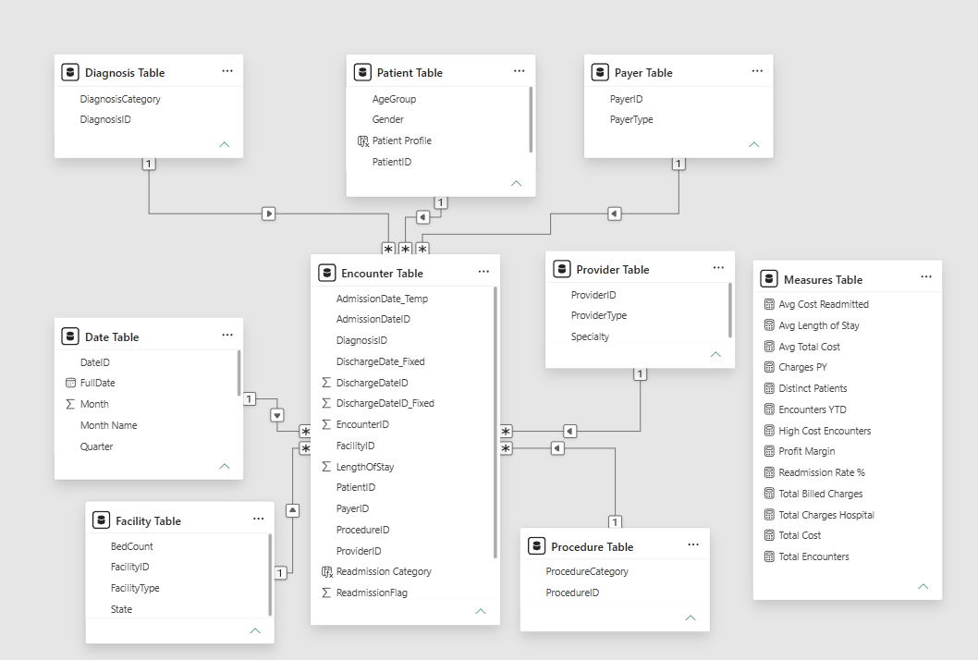
A1Start Diagram

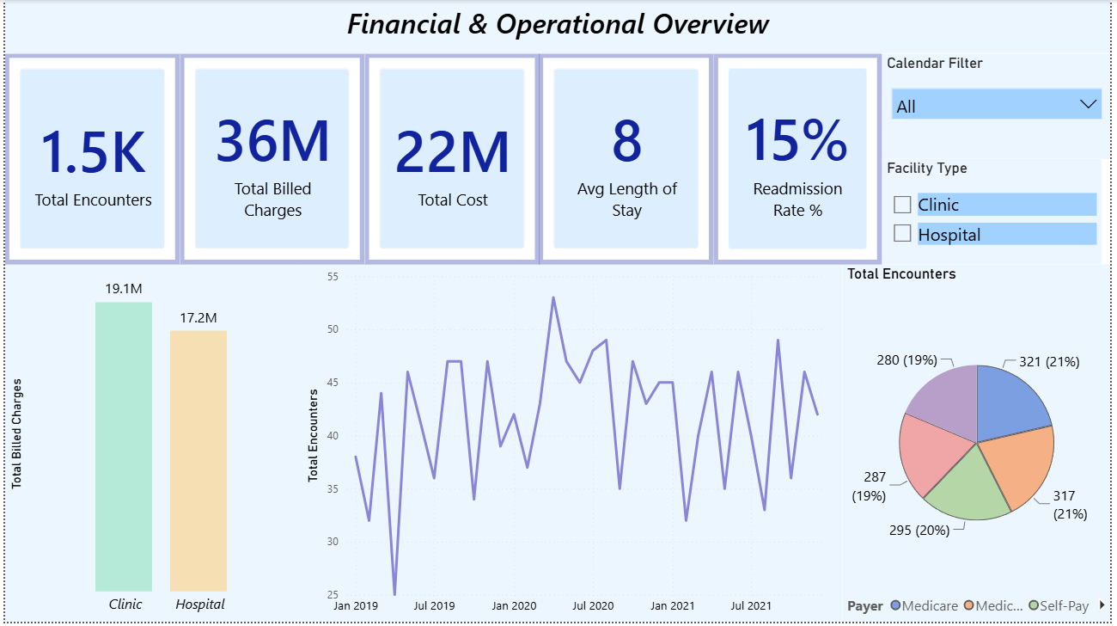
A2 Financial & Operational Overview

A3 Patient Demographics & Diagnosis Patterns
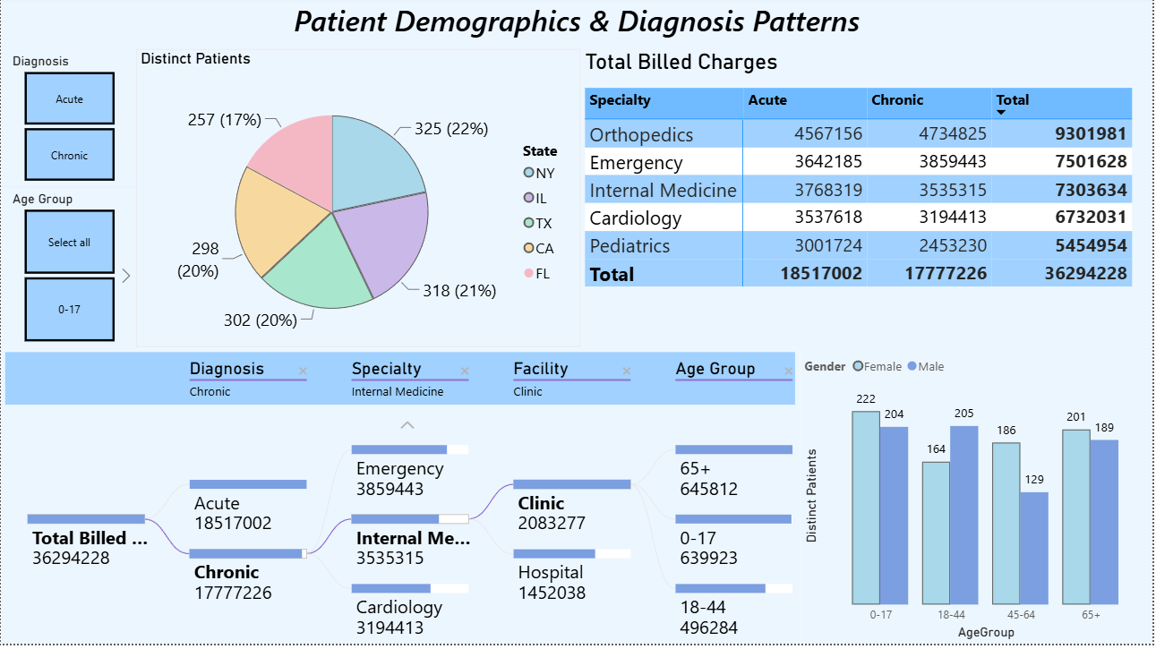
A4 Readmissions & Quality Insights
