Predictive Maintenance
Machine Failure Prediction
Jose Alberto Martinez Morales
Data Analytics MSc, University of Niagara Falls
DAMO-510-8: Predictive Analytics
Prof. Payman Janbakhsh
September 6, 2026

Table of Contents
1. Problem Definition 4
2. Data Investigation 4
Data audit. 4
Exploratory findings. 5
3. Modelling Decisions 5
Preprocessing. 5
Feature engineering. 5
Baseline and model tuning. 6
Class-imbalance investigation. 6
4. Model Comparison 6
5. Error Analysis 7
Threshold investigation. 7
Misclassification analysis. 7
6. Interpretation 7
7. Final Recommendation 8
Random Forest. 8
Robustness. 8
8. Limitations and Future Improvements 8
Limitations. 8
Improvements. 9
Appendix A. Supporting Tables 10
Table A1. Variable roles and audit decisions (Task 2; supports Section 2). 10
Table A2.Preprocessing steps: common vs. model-dependent (Task 4; supports Section 3). 10
Table A3. Engineered feature evaluation summary (Task 5; supports Section 3). 11
Table A4. Baseline model performance (Task 6; supports Sections 1 and 3). 11
Table A5. Cross-model comparison, initial vs. final configuration (Task 7; supports Section 3). 11
Table A6. Class-imbalance strategy comparison (Task 8; supports Section 3). 12
Table A8. Strongest / weakest model by criterion (Task 9; supports Section 4). 13
Table A9. Threshold comparison, Random Forest (Task 10; supports Section 5). 13
Table A10. Feature importance and rank comparison across models (Task 12; supports Section 6). 14
Table A11. Robustness check: model ranking, original (seed 666) vs. new split (seed 42) (Task 14; supports Section 7). 15
Table A12. Robustness check: threshold comparison, new split (Task 14; supports Section 7). 15
Appendix B. Supporting Visuals 16
Figure B1 (Fig. 3.1).Target class distribution 16
Figure B2 (Fig. 3.2). Tool wear by failure status. 17
Figure B3 (Fig. 3.3). Failure rate by product Type 17
Figure B4 (Fig. 3.4). Correlation matrix, numeric predictors. 18
Figure B5 (Fig. 3.4b). Rotational speed vs. Torque, by failure status. 18
Figure B6 (Fig. 3.5). Temperature differential vs. Rotational speed, by failure status. 19
Figure B7 (Fig. 3.6). Torque × Tool wear interaction, by product Type. 19
Figure B8 (Figs. 6.1–6.3). Baseline confusion matrices and ROC curves 20
Figure B9 (Fig. 9.1). ROC curves, four final models. 21
Figure B10 (Fig. 9.2). Confusion matrices, four final models. 21
Figure B11 (Fig. 10.1). Precision, Recall, and F1 vs. threshold. 22
Figure B12 (Fig. 10.2). False negatives and false positives vs. threshold. 22
Figure B13 (Fig. 11.1). Misclassified observations in speed/torque space. 23
Figure B14 (Fig. 12.1). Feature importance comparison across models. 24
Figure B15 (Fig. 14.1). Robustness comparison, original vs. new split. 25
Appendix C. Analytical Decision Record 26

1. Problem Definition
The AI4I 2020 dataset frames a binary classification problem centered on Machine failure, which is 1 when a machine has experienced at least one of five recorded failure modes (tool wear, heat dissipation, power, overstrain, or random failure) during an operating cycle and 0 otherwise. Of the 10,000 recorded observations, only 339 (3.39%) are failures, a rare-event detection problem, not a balanced discrimination task, and that asymmetry shapes every later decision in this report.
The purpose of predicting machine failure is to move maintenance away from purely reactive repair (which guarantees unplanned downtime) and fixed-schedule preventive maintenance (which wastes labour on healthy machines while still missing failures between visits), toward condition-based maintenance triggered by a machine's actual operating state. The natural users are maintenance and reliability engineers who priorities inspection queues, production planners who need advance warning to schedule downtime, shop-floor technicians who receive operational alerts, and, indirectly, safety personnel, since several underlying failure modes are also safety-relevant. In practice the model's output would be consumed through a maintenance dashboard or CMMS (Computerized Maintenance Management System) rather than as raw probabilities.
The two error types are not interchangeable. A false positive (predicting failure on a healthy machine) triggers an unnecessary inspection, a bounded cost, but one that risks alarm fatigue if frequent, eroding trust in the system. A false negative (missing a real failure) is materially more costly: it means the failure is discovered only when it occurs, with the same unplanned downtime and safety exposure predictive maintenance exists to avoid. Because failures are also rare, a model that defaults toward the majority "no failure" class can look accurate while providing essentially no protection.
This asymmetry argues against overall accuracy as the primary yardstick. A trivial always-negative model already scores highly on accuracy while being operationally useless (Section 3; Appendix A, Table A4). The metric that should receive the greatest emphasis is recall on the failure class, since missing a failure is more expensive than an avoidable inspection. Recall should not be optimized alone, however: a model that flags almost every case as high-risk generates so many false alarms that staff cannot act on them, so precision, a balancing metric (F1/F-beta), and a threshold-independent ranking measure (ROC-AUC) are tracked alongside it throughout this report.

2. Data Investigation

Data audit.
The dataset contains 10,000 observations and 14 variables, with no missing values and no duplicated rows. Two identifier columns (UDI, Product ID) were excluded, both are unique per row, and Product ID's first character duplicates Type in 100% of rows, so it carries no non-redundant information. Five binary failure-mode flags (TWF, HDF, PWF, OSF, RNF) were also excluded: four of the five agree with Machine failure in 100% of the rows where they are set, a near-tautological encoding of the label itself, not an independently observable predictor, while RNF carries almost no signal (1 of 19 RNF=1 rows is a real failure) and, like the other four, would not be knowable in advance of the outcome it flags. The 27 rows (0.27%) where Machine failure disagrees with the logical or of the five flags were deliberately left unlabeled: forcing agreement would be circular and would perturb an already scarce positive class. The retained predictor set, Type plus five continuous sensor variables, and the full exclusion rationale are summarized in Appendix A, Table A1. An IQR check flagged Rotational speed (4.2%) and Torque (0.7%) as containing outliers, but these were retained as genuine extreme operating points, a decision the exploratory findings below directly support.

Exploratory findings.
Six findings, three single-variable and three multi-variables, tie directly into later decisions (figures in Appendix B). The target is heavily imbalanced at 96.61%/3.39% (28.5:1, Figure B1), ruling out accuracy as a usable metric and mandating a stratified split. Tool wear is both higher and more dispersed for failures (mean 143.78 vs. 106.69 minutes, Figure B2), favoring tree-based models that can split on wear thresholds. Failure rate varies by product Type non-monotonically (L = 3.92%, M = 2.77%, H = 2.09%, Figure B3), ruling out an ordinal encoding of Type. Rotational speed and Torque correlate strongly (r = −0.875, Figure B4), and failures concentrate in the low-speed/high-torque corner of that relationship (Figure B5) rather than spreading evenly along it, evidence that pushed the linear model toward regularization and motivated engineered interaction features for the tree-based models. Most strikingly, a temperature-differential/rotational-speed risk zone containing just 1.5% of the data (150 rows, Figure B6) carries a 77.33% failure rate against 2.26% outside it, a 22.81× lift, directly justifying the temperature-differential feature engineered next. Finally, the product of Torque and Tool wear correlate with the target at r = 0.190 overall, strongest for Type L (r = 0.226, Figure B7), evidence of a Type-moderated risk pattern not acted on directly by any model here (Section 8).

3. Modelling Decisions

Preprocessing.
The data was split 80/20, stratified on Machine failure (seed 666), before any encoder or scaler was fit, so every preprocessing statistic is learned from the training partition only. Type was one-hot encoded (not ordinal, per the non-monotonic failure rate above). Scaling was model-dependent, applied for Logistic Regression, left unscaled for the three tree-based models, both because trees are scale-invariant and to preserve interpretable units for later analysis. Class-imbalance intervention was deliberately deferred out of this baseline preprocessing so the baseline (below) and the later imbalance comparison would each start from a clean footing. The full common-vs-model-dependent breakdown is in Appendix A, Table A2.

Feature engineering.
Three candidate engineered features were evaluated against a Logistic Regression baseline (Type plus 5 raw predictors, test AUC 0.927) using an incremental-AUC test. Does the feature add information the model could not already extract from its raw components (full results in Appendix A, Table A3)? Temperature differential (Process, Air) showed essentially no incremental gain (a difference of +0.000) but was retained anyway on the strength of its documented interaction with Rotational speed (the 22.81× risk zone above), which this additive-only test cannot detect. Torque × Tool wear showed a small negative delta (−0.001) and was not retained, applying the assignment's explicit allowance to drop a feature that does not survive testing despite a plausible interaction argument. Mechanical power (Torque × angular velocity) was the one genuine surprise: expected to be near-redundant given the −0.875 speed/torque correlation, it produced the largest incremental gain of the three (a difference of +0.007) and was retained.

Baseline and model tuning.
Two no-information baselines made the accuracy trap concrete (Appendix A, Table A4): the majority-class rule reaches 96.60% accuracy and ROC-AUC 0.500 while missing all 68 test-set failures. All four required models were tuned using mean 5-fold cross-validated ROC-AUC as the single selection criterion, chosen over accuracy and over threshold-specific metrics (model selection and threshold placement are different decisions, addressed in Section 5). This produced a recurring pattern (Appendix A, Table A5): for three of the four models, the ROC-AUC-optimal configuration was not the configuration with the best recall at the default 0.5 threshold, since reweighting for imbalance never won the ROC-AUC search for those three. Logistic Regression was the exception, where class_weight='balanced' was itself the single strongest lever.

Class-imbalance investigation.
Holding each model's architecture fixed, three imbalance conditions were compared directly: none, algorithm-level reweighting, and SMOTE, fit on the training partition only (Appendix A, Table A6). Reweighting improved recall substantially for every model (e.g. Random Forest 66.18% to 80.88%, XGBoost 45.59% to 82.35%) while leaving ROC-AUC largely unchanged, confirming reweighting mostly shifts where an already-good ranking gets cut into a decision. Reweighting matched or beat SMOTE for every model tested and was retained as the general strategy. Random Forest with class_weight='balanced' emerged as the standout, 80.88% recall at 63.22% precision, the best post-intervention precision of any model that meaningfully improved its recall.

4. Model Comparison
All four models, in fully-final form (tuned architecture plus retained reweighting), were compared on the identical seed-666 test set (Appendix A, Table A7; ROC curves and confusion matrices in Appendix B, Figures B9–B10). No single model wins on every criterion (Appendix A, Table A8), which is itself the central finding: Random Forest is strongest on accuracy (0.9775), precision (0.6322), and F1 (0.7097), and essentially tied with XGBoost on ROC-AUC (0.9783 vs. 0.9798). Decision Tree wins outright on recall, catching 65 of 68 failures (95.59%), at the cost of 118 false alarms. Logistic Regression is weakest on four of the five criteria; its 83.82% recall bought at 15.70% precision (306 false alarms).
Which model is "best" therefore depends on deployment context. If maintenance capacity is not the binding constraint and a missed failure is far costlier than an unnecessary inspection, Decision Tree is strongest, missing only 3 of 68 failures. If inspection capacity is limited and alarm fatigue is a real risk, Random Forest is strongest: it still catches over 80% of failures while cutting false alarms to a quarter of Decision Tree's count, with the best accuracy, precision, and F1 of the four. If the system is a continuously updated risk-ranking queue rather than a fixed-threshold alert, XGBoost's marginally higher ROC-AUC makes it the natural candidate. Random Forest offers the best overall balance across the largest number of criteria and is carried forward as the leading candidate below, with XGBoost as a close alternative and Decision Tree kept in view to a recall-maximizing context.

5. Error Analysis

Threshold investigation.
Random Forest's final configuration was swept across thresholds from 0.05 to 0.95 (Appendix A, Table A9; Appendix B, Figures B11–B12). The default of 0.50 is strictly dominated, not merely sub-optimal: moving to 0.57 leaves recall, true positives, and false negatives completely unchanged (55 of 68 failures caught) while cutting false positives from 32 to 13, a 59.4% reduction for zero recall cost, since no true failure in the test set has a predicted probability between 0.50 and 0.57. Beyond that free improvement, a genuine trade-off reappears lowering the threshold to 0.39 raises recall to 91.18% (62 of 68) at the cost of 79 false alarms and 43.97% precision, while raising it to 0.62 cuts false alarms to just 6 but drops recall to 75.00% (51 of 68). 0.57 is recommended on the strength of its dominance over the default; 0.39 is documented as a more conservative fallback.

Misclassification analysis.
At threshold 0.57, Random Forest produces 13 false positives and 13 false negatives; the five most borderline of each were examined in depth (Appendix B, Figure B13). The false positives are not arbitrary: all five show elevated Torque and reduced Rotational speed relative to a typical healthy machine, healthy machines that happen to resemble the low-speed/high-torque risk corner from Section 2. The false negatives show a distinct pattern: tool wear above the typical failure level in every case but combined with higher speed and lower torque than a typical failure, a wear-driven failure mode that falls outside the classic risk signature the model has organized itself around. This is a specific, diagnosable blind spot (4 of 5 selected cases) rather than random noise, and it directly motivates the targeted secondary check proposed in Section 8.

6. Interpretation
All four final models were compared on their native importance measures using rank-based comparison, mean rank and rank spread across models, since a Logistic Regression coefficient share and a tree's impurity-based importance are not the same statistical quantity (full table in Appendix A, Table A10; Appendix B, Figure B14). Four features form a clear top tier by mean rank: Rotational speed, Mechanical power, Torque, and Tool wear (mean ranks 1.50–3.25), well ahead of the next-closest feature (5.00). Rotational speed and Mechanical power are the most consistently top-ranked of all nine features, directly reaffirming the low-speed/high-torque risk corner and the Section 3 decision to retain Mechanical power. Temperature differential is the single most cross-model-consistent feature of all (rank spread of exactly 0, landing at rank 5 in all four models), a striking, model-based vindication of retaining it on interaction grounds even though the simpler additive test in Section 3 could not detect any benefit. Torque is the most divergent top-tier feature: Logistic Regression's single most important predictor (44.57% of its weight) but only fourth for Decision Tree (8.75%), a consequence of the collinearity documented in Section 2. Air temperature, Process temperature, and both Type dummies are consistently the least important across all four models, four independent feature-selection mechanisms converging on the same conclusion. One result needs an explicit caveat: Logistic Regression's signed coefficients for Rotational speed (+2.508) and Mechanical power (−5.059) run counter to the bivariate low-speed/high-torque relationship established in Section 2, a signature of multicollinearity among three highly correlated terms rather than a genuine reversal, the safe reading is the joint, descriptive one from Section 2, not the individual coefficient signs in isolation.

7. Final Recommendation

Random Forest.
The tuned architecture (139 trees, max depth 8, min_samples_leaf=10, min_samples_split=16, max_features='log2') combined with class_weight='balanced' reweighting, operated at threshold 0.57, is the recommended final model. It is not the strongest model on any single dimension in isolation (Decision Tree catches more failures, XGBoost ranks marginally better, Logistic Regression is nominally more transparent), but it is the model whose overall balance of failure-detection (80.88% recall), false-alarm control (13 false positives, 0.65% of the test set), validated threshold placement, and diagnosable error patterns (Section 5) best matches the asymmetric-cost, alarm-fatigue-aware deployment context established in Section 1. It is also the only one of the four models whose deployed operating point has been explicitly checked for dominance rather than left at an unexamined default. Against Decision Tree, Random Forest trades 10 additional missed failures for roughly a ninth of the false-alarm rate; against XGBoost, a marginal 0.0015 ROC-AUC disadvantage is outweighed by concretely fewer false alarms at their respective operating points; against Logistic Regression, a 15.70% precision makes the linear model operationally unusable as a stand-alone rule.

Robustness.
This recommendation was stress-tested on an independently drawn 80/20 split (seed 42, architectures and reweighting held fixed; full results in Appendix A, Tables A11–A12; Appendix B, Figure B15). The model ranking reproduces almost exactly on accuracy, precision, F1, and ROC-AUC, with only one minor, inconsequential reordering between Random Forest and XGBoost on recall, real evidence the model choice reflects a genuine property of these architectures rather than an artefact of the assigned seed. The specific threshold value is more fragile: on the new split, moving from 0.50 to 0.57 costs one additional missed failure rather than being free, and the new split's own F1-optimal threshold is 0.69, not 0.57. The recommendation stands as stated, with one adjustment: 0.57 should be read as a reasonable point estimate in a range of roughly 0.55–0.65, to be periodically re-derived against live outcomes in deployment rather than treated as a fixed constant.

8. Limitations and Future Improvements

Limitations.
(1) With only 339 failures in the full dataset, single-split results carry real sampling fragility, the robustness check above showed this concretely for the threshold, and other single-split results likely carry a similar, less visible fragility. (2) AI4I 2020 is a simulated dataset whose internal relationships (e.g. a −0.875 speed/torque correlation, 100% flag/target agreement for four of five failure-mode flags) are cleaner than real industrial sensor data is likely to be; reported performance (ROC-AUC approximately 0.98, 80%+ recall at a 0.65% false-alarm rate) should be read as a demonstration the approach works on this data, not a forecast for noisier real-world telemetry. (3) Multicollinearity among Torque, Rotational speed, and Mechanical power means individual Logistic Regression coefficients cannot be read as isolated, causal effects. (4) The dataset has no time dimension, so no split in this project tests genuine out-of-time generalization. (5) The misclassification analysis characterizes error patterns from 10 hand-selected borderline cases, not the full population of 13 false positives and 13 false negatives the model produces at threshold 0.57.

Improvements.
(1) Replace the F1/F2-based threshold criterion with an explicit cost-weighted threshold, derived from an actual estimated ratio between the cost of an unnecessary inspection and a missed failure. (2) Investigate Type-specific modelling: the Torque × Tool wear interaction is materially stronger for Type L (r = 0.226) than Type M (r = 0.117), suggesting a Type-specific threshold could improve detection for the highest-failure-rate product Type. (3) Source or simulate data with genuine temporal structure and evaluate with a strict time-based split, to test whether Random Forest remains stable as operating conditions drift. (4) Add a narrow secondary review rule flagging machines with tool wear above a defined percentile even when the primary model's probability falls just under threshold, directly targeting the wear-driven false-negative blind spot identified in Section 5.

Appendix A. Supporting Tables
Every table below is referenced from a specific section of the main report above. Full derivations, code, and printed output are in the accompanying Jupyter notebook.

Table A1. Variable roles and audit decisions (Task 2; supports Section 2).
Group | Variables | Type | Audit decision
Identifiers | UDI, Product ID | int / object | Excluded
Categorical predictor | Type | object (L/M/H) | Retained
Numerical predictors | Air temperature [K], Process temperature [K], Rotational speed [rpm], Torque [Nm], Tool wear [min] | float / int | Retained
Target | Machine failure | int (0/1) | Target
Failure-mode flags | TWF, HDF, PWF, OSF, RNF | int (0/1) | Excluded (data leakage)

Table A2.Preprocessing steps: common vs. model-dependent (Task 4; supports Section 3).
Preprocessing step | Common to all models, or model-dependent | Notes
Variable selection (retain Type + 5 numeric; exclude identifiers and flags) | Common | Carried forward from Task 2
Stratified 80/20 train/test split (seed = 666) | Common | Preserves the 96.61%/3.39% split in both partitions
Missing-value handling | Common | None required; verified, not assumed
One-hot encoding of Type | Common | Applied identically for all four models
Numeric feature scaling (Standard Scaler) | Model-dependent | Applied for Logistic Regression only
Numeric features left unscaled | Model-dependent | Decision Tree, Random Forest, XGBoost
Class-imbalance intervention (class_weight / SMOTE) | Model-dependent, staged for Task 8 | Not applied in baseline preprocessing; compared explicitly in Task 8

Table A3. Engineered feature evaluation summary (Task 5; supports Section 3).
Feature | Combines | Corr. w/ target (train) | Standalone test AUC | Test AUC w/ feature added to baseline (0.927) | Δ AUC vs. baseline | Decision
Temp differential [K] | Process temp, Air temp | −0.113 | 0.647 | 0.928 | +0.000 | Retained (Finding 3.5 interaction, not this test)
Torque × Tool wear | Torque, Tool wear | 0.174 | 0.783 | 0.926 | −0.001 | Not retained
Mechanical power [W] | Torque, Rotational speed | 0.175 | 0.755 | 0.934 | +0.007 | Retained

Table A4. Baseline model performance (Task 6; supports Sections 1 and 3).
Metric | Baseline A (majority-class) | Baseline B (stratified random)
Accuracy | 0.9660 | 0.9325
Precision | 0.0000 | 0.0282
Recall | 0.0000 | 0.0294
F1-score | 0.0000 | 0.0288
ROC-AUC | 0.5000 | 0.4968
Failures caught (of 68) | 0 | 2
False alarms | 0 | 69

Table A5. Cross-model comparison, initial vs. final configuration (Task 7; supports Section 3).
Model | Stage | Accuracy | Precision | Recall | F1 | ROC-AUC | Failures caught (of 68)
Logistic Regression | Initial | 0.9715 | 0.6897 | 0.2941 | 0.4124 | 0.9342 | 20
Logistic Regression | Final | 0.8415 | 0.1570 | 0.8382 | 0.2645 | 0.9274 | 57
Decision Tree | Initial | 0.9830 | 0.7500 | 0.7500 | 0.7500 | 0.8706 | 51
Decision Tree | Final | 0.9860 | 0.8333 | 0.7353 | 0.7812 | 0.9504 | 50
Random Forest | Initial | 0.9890 | 0.9600 | 0.7059 | 0.8136 | 0.9710 | 48
Random Forest | Final | 0.9865 | 0.9184 | 0.6618 | 0.7692 | 0.9786 | 45
XGBoost | Initial | 0.9845 | 0.8627 | 0.6471 | 0.7395 | 0.9753 | 44
XGBoost | Final | 0.9805 | 0.9394 | 0.4559 | 0.6139 | 0.9810 | 31

Table A6. Class-imbalance strategy comparison (Task 8; supports Section 3).
Model | Strategy | Accuracy | Precision | Recall | F1 | ROC-AUC | TP | FP | FN
Logistic Regression | None | 0.9715 | 0.6667 | 0.3235 | 0.4356 | 0.9325 | 22 | 11 | 46
Logistic Regression | Reweighted | 0.8415 | 0.1570 | 0.8382 | 0.2645 | 0.9274 | 57 | 306 | 11
Logistic Regression | SMOTE | 0.8450 | 0.1582 | 0.8235 | 0.2654 | 0.9247 | 56 | 298 | 12
Decision Tree | None | 0.9860 | 0.8333 | 0.7353 | 0.7812 | 0.9504 | 50 | 10 | 18
Decision Tree | Reweighted | 0.9395 | 0.3552 | 0.9559 | 0.5179 | 0.9686 | 65 | 118 | 3
Decision Tree | SMOTE | 0.9130 | 0.2675 | 0.8971 | 0.4122 | 0.9605 | 61 | 167 | 7
Random Forest | None | 0.9865 | 0.9184 | 0.6618 | 0.7692 | 0.9786 | 45 | 4 | 23
Random Forest | Reweighted | 0.9775 | 0.6322 | 0.8088 | 0.7097 | 0.9783 | 55 | 32 | 13
Random Forest | SMOTE | 0.9625 | 0.4711 | 0.8382 | 0.6032 | 0.9730 | 57 | 64 | 11
XGBoost | None | 0.9805 | 0.9394 | 0.4559 | 0.6139 | 0.9810 | 31 | 2 | 37
XGBoost | Reweighted (scale_pos_weight=28.52) | 0.9720 | 0.5600 | 0.8235 | 0.6667 | 0.9798 | 56 | 44 | 12
XGBoost | SMOTE | 0.9700 | 0.5408 | 0.7794 | 0.6386 | 0.9709 | 53 | 45 | 15

Table A7. Final model comparison, all four models fully tuned plus reweighted (Task 9; supports Section 4).
Model | Accuracy | Precision | Recall | F1 | ROC-AUC | TP | FP | FN | TN
Logistic Regression | 0.8415 | 0.1570 | 0.8382 | 0.2645 | 0.9274 | 57 | 306 | 11 | 1626
Decision Tree | 0.9395 | 0.3552 | 0.9559 | 0.5179 | 0.9686 | 65 | 118 | 3 | 1814
Random Forest | 0.9775 | 0.6322 | 0.8088 | 0.7097 | 0.9783 | 55 | 32 | 13 | 1900
XGBoost | 0.9720 | 0.5600 | 0.8235 | 0.6667 | 0.9798 | 56 | 44 | 12 | 1888

Table A8. Strongest / weakest model by criterion (Task 9; supports Section 4).
Criterion | Strongest | Weakest
Accuracy | Random Forest (0.9775) | Logistic Regression (0.8415)
Precision | Random Forest (0.6322) | Logistic Regression (0.1570)
Recall | Decision Tree (0.9559) | Random Forest (0.8088)
F1-score | Random Forest (0.7097) | Logistic Regression (0.2645)
ROC-AUC | XGBoost (0.9798) | Logistic Regression (0.9274)

Table A9. Threshold comparison, Random Forest (Task 10; supports Section 5).
Threshold | Precision | Recall | F1 | False Positives | False Negatives | Failures caught (of 68)
0.39 (best precision at recall ≥ 90%) | 0.4397 | 0.9118 | — | 79 | 6 | 62
0.50 (default) | 0.6322 | 0.8088 | 0.7097 | 32 | 13 | 55
0.57 (F2-maximising) | 0.8088 | 0.8088 | 0.8088¹ | 13 | 13 | 55
0.62 (F1-maximising) | 0.8947 | 0.7500 | 0.8160 | 6 | 17 | 51

¹ At t = 0.57, precision and recall happen to be numerically equal, which is why F1/F2 coincide at this row, an artefact of this particular point on the curve, not a general property of the threshold.

Table A10. Feature importance and rank comparison across models (Task 12; supports Section 6).
Feature | LogReg share | Decision Tree share | Random Forest share | XGBoost share | Mean rank | Rank spread
Rotational speed [rpm] | 0.1366 | 0.3191 | 0.2551 | 0.3067 | 1.50 | 2
Mechanical power [W] | 0.2756 | 0.2477 | 0.1887 | 0.1858 | 2.50 | 1
Torque [Nm] | 0.4457 | 0.0875 | 0.2077 | 0.1527 | 2.75 | 3
Tool wear [min] | 0.0564 | 0.2743 | 0.1884 | 0.1661 | 3.25 | 2
Temp differential [K] | 0.0376 | 0.0714 | 0.0881 | 0.0839 | 5.00 | 0
Air temperature [K] | 0.0079 | 0.0001 | 0.0394 | 0.0337 | 6.50 | 2
Type = L | 0.0305 | 0.0000 | 0.0054 | 0.0152 | 7.75 | 3
Process temperature [K] | 0.0000 | 0.0000 | 0.0236 | 0.0274 | 7.75 | 2
Type = M | 0.0097 | 0.0000 | 0.0035 | 0.0285 | 7.75 | 2

Table A11. Robustness check: model ranking, original (seed 666) vs. new split (seed 42) (Task 14; supports Section 7).
Model | Accuracy (new / orig) | Precision (new / orig) | Recall (new / orig) | F1 (new / orig) | ROC-AUC (new / orig)
Logistic Regression | 0.8570 / 0.8415 | 0.1677 / 0.1570 | 0.8088 / 0.8382 | 0.2778 / 0.2645 | 0.9059 / 0.9274
Decision Tree | 0.9385 / 0.9395 | 0.3464 / 0.3552 | 0.9118 / 0.9559 | 0.5020 / 0.5179 | 0.9468 / 0.9686
Random Forest | 0.9750 / 0.9775 | 0.6000 / 0.6322 | 0.7941 / 0.8088 | 0.6835 / 0.7097 | 0.9699 / 0.9783
XGBoost | 0.9740 / 0.9720 | 0.5909 / 0.5600 | 0.7647 / 0.8235 | 0.6667 / 0.6667 | 0.9733 / 0.9798

Table A12. Robustness check: threshold comparison, new split (Task 14; supports Section 7).
Threshold | Precision | Recall | FP | FN | TP
0.50 | 0.6000 | 0.7941 | 36 | 14 | 54
0.57 | 0.7681 | 0.7794 | 16 | 15 | 53
0.62 | 0.8226 | 0.7500 | 11 | 17 | 51

Appendix B. Supporting Visuals
Figures are produced by the Task 3/6/9/10/11/12/14 cells in the accompanying Jupyter notebook and saved as PNG files in the project's Drive visuals folder. The captions below summaries what each show and are the versions integrated into the discussion in Sections 2, 4, 5, 6, and 7 above; open the notebook or the visuals folder to view the images themselves.
Figure B1 (Fig. 3.1).Target class distribution. Bar chart of Machine failure counts (9,661 no-failure vs. 339 failure), with percentage labels. Visualizes the 96.61%/3.39% imbalance underlying Section 1's metric-choice argument and Section 2's audit.
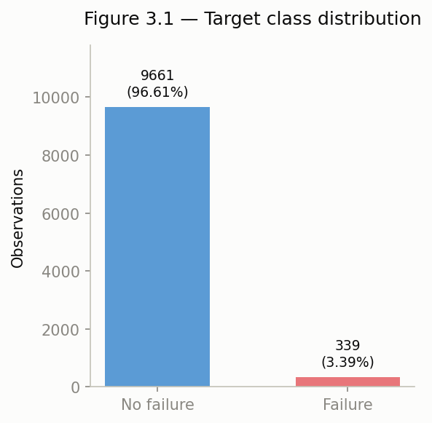

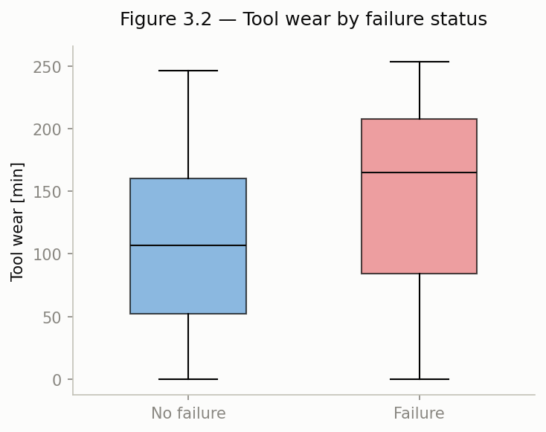
Figure B2 (Fig. 3.2). Tool wear by failure status. Boxplot of Tool wear [min] split by failure status, showing failures skew toward higher, more dispersed wear (mean 143.78 vs. 106.69 minutes).

Figure B3 (Fig. 3.3). Failure rate by product Type. Bar chart of failure rate for Type L/M/H with the overall rate as a reference line, showing the non-monotonic 3.92%/2.77%/2.09% pattern that ruled out ordinal encoding.
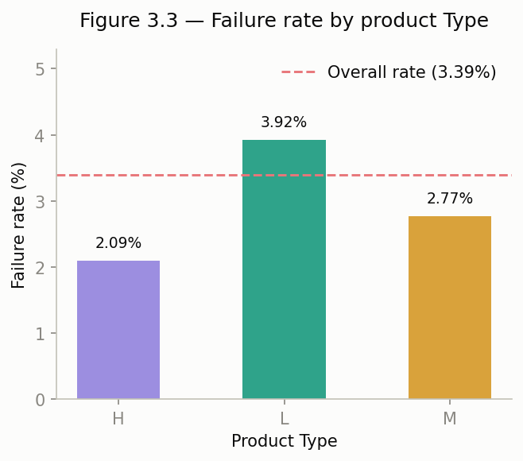

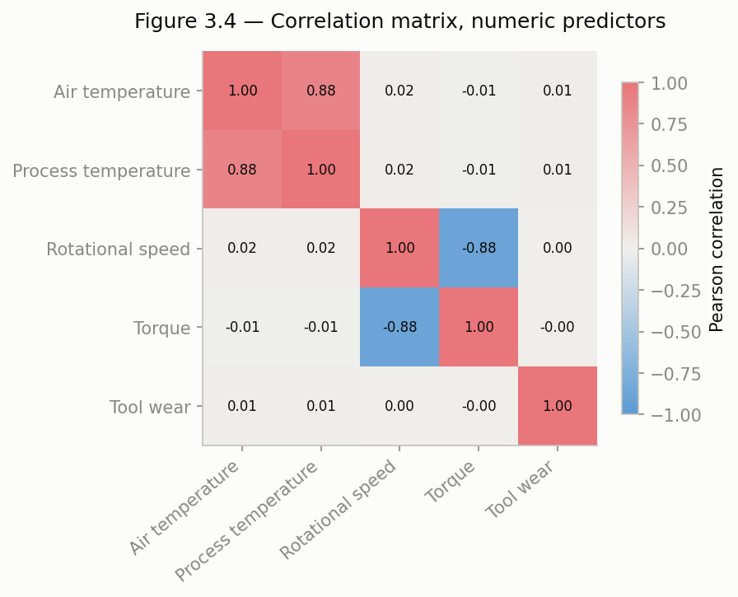
Figure B4 (Fig. 3.4). Correlation matrix, numeric predictors. Heatmap of pairwise Pearson correlations among the five numeric predictors, highlighting the 0.876 (Air/Process temperature) and −0.875 (Rotational speed/Torque) collinearities.

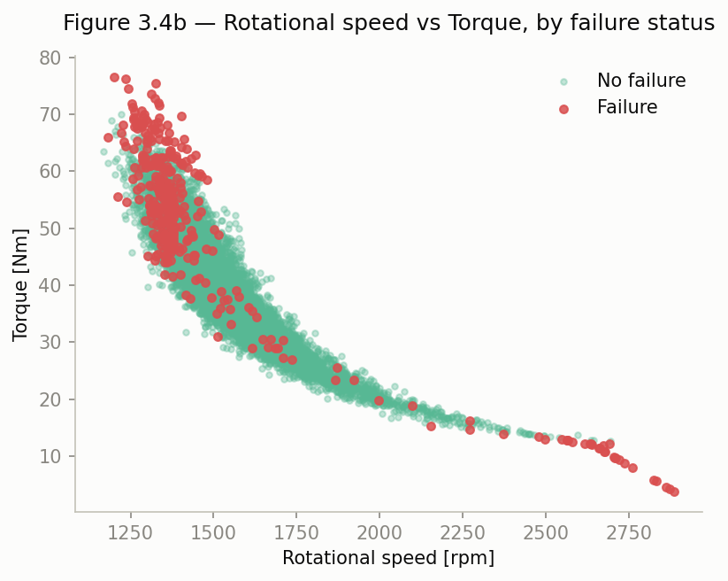
Figure B5 (Fig. 3.4b). Rotational speed vs. Torque, by failure status. Scatterplot showing failures concentrated in the low-speed/high-torque region of the near-reciprocal speed–torque relationship.

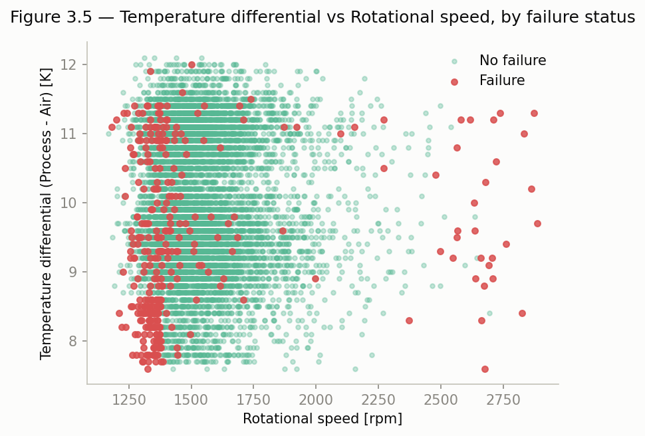
Figure B6 (Fig. 3.5). Temperature differential vs. Rotational speed, by failure status. Scatterplot revealing the low-speed/low-differential risk zone (150 rows, 77.33% failure rate, 22.81× lift) that motivated the Temp differential feature.

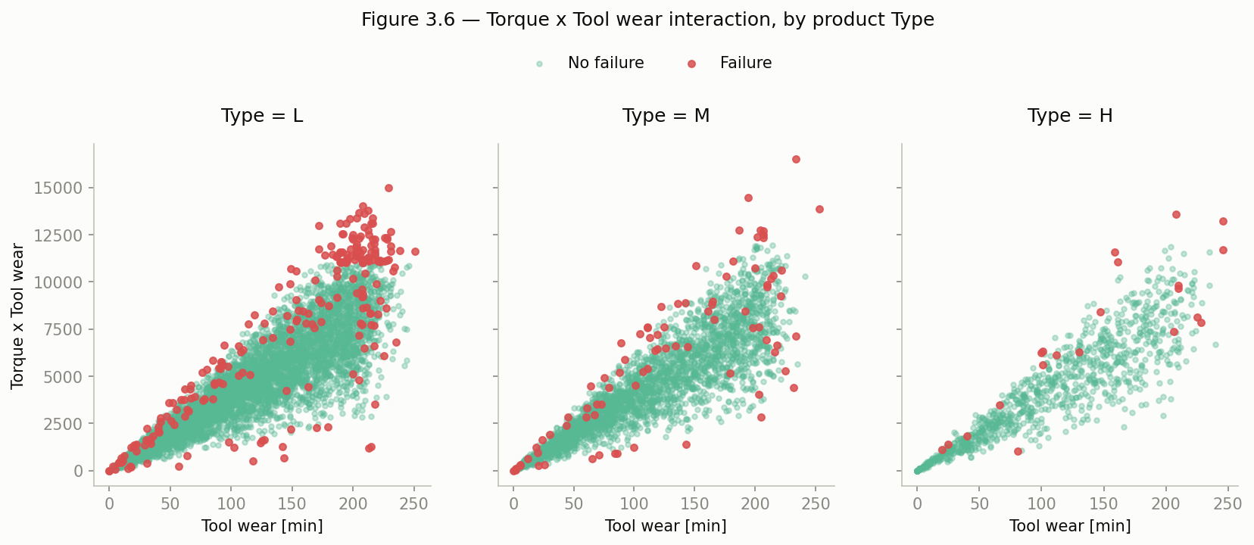
Figure B7 (Fig. 3.6). Torque × Tool wear interaction, by product Type. Three-panel scatterplot (one per Type) showing the interaction's strength is moderated by Type (L: r = 0.226; M: r = 0.117; H: r = 0.155).

Figure B8 (Figs. 6.1–6.3). Baseline confusion matrices and ROC curves. Confusion matrices for both dummy baselines and their ROC curves collapsing onto the no-skill diagonal, establishing the performance floor every Task 7 model must clear.
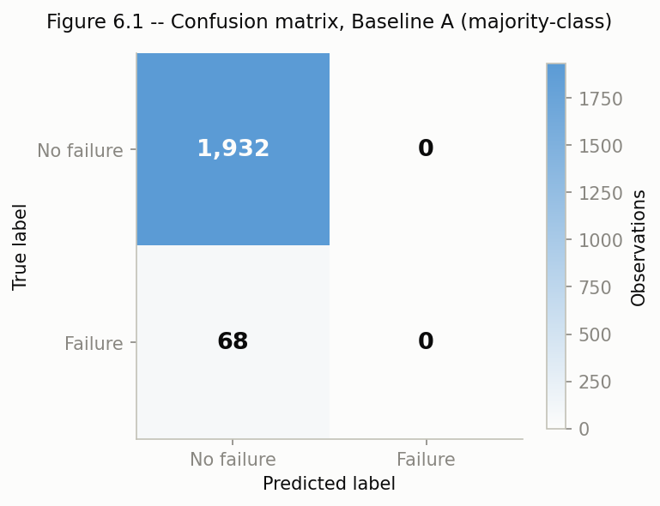
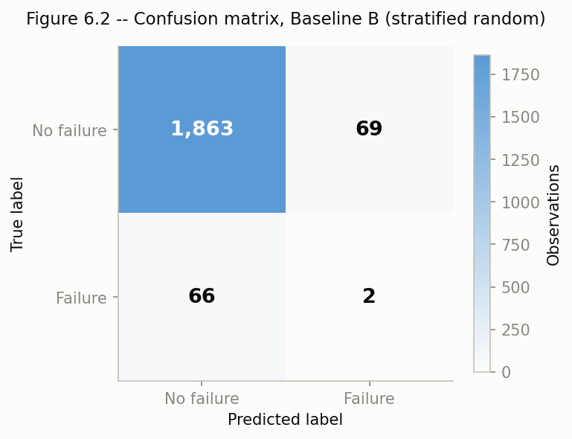

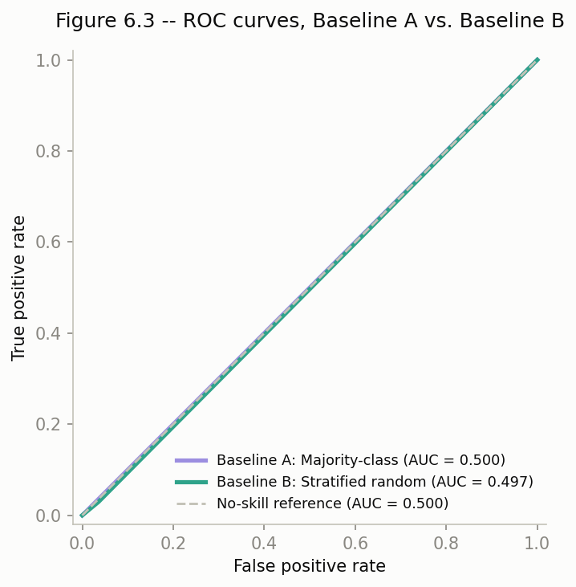

Figure B9 (Fig. 9.1). ROC curves, four final models. Overlaid ROC curves for Logistic Regression, Decision Tree, Random Forest, and XGBoost in their fully final (tuned Plut reweighted) form, supporting the ROC-AUC comparison in Table A7/Section 4.
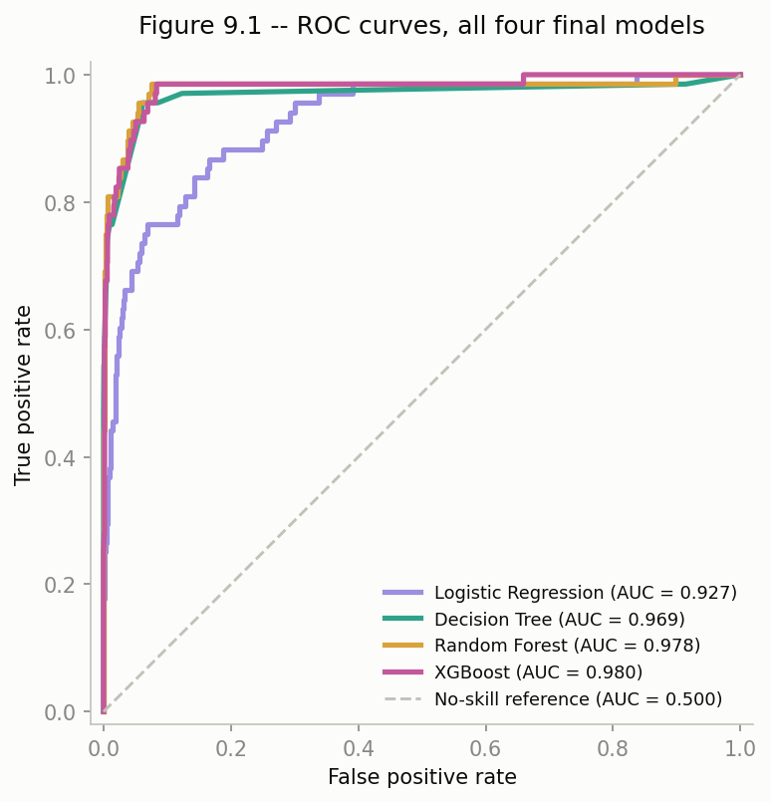

Figure B10 (Fig. 9.2). Confusion matrices, four final models. Side-by-side confusion matrices for the same four models, giving the TP/FP/FN/TN breakdown behind Table A7.
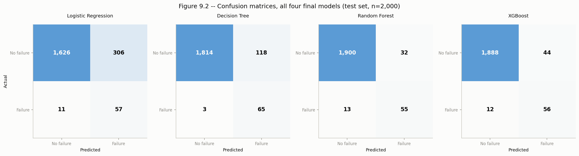

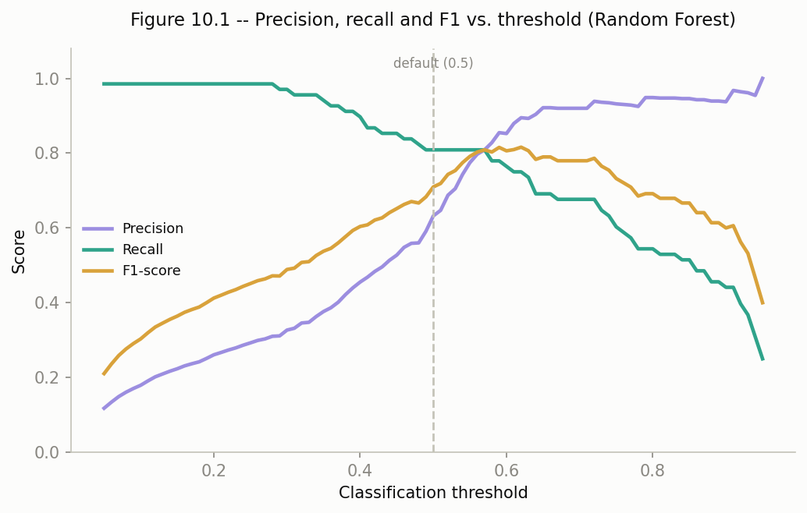
Figure B11 (Fig. 10.1). Precision, Recall, and F1 vs. threshold. Line chart across the 0.05–0.95 sweep for Random Forest, showing precision rising and recall falling as threshold increases, with the F1 peak visibly right of the 0.5 default.

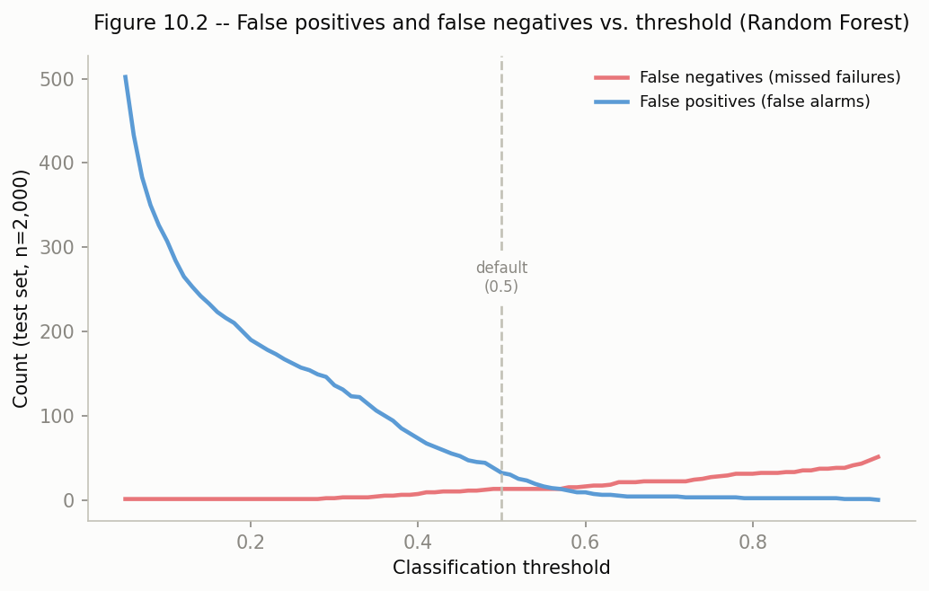
Figure B12 (Fig. 10.2). False negatives and false positives vs. threshold. Companion chart to Figure B11 showing the false-alarm count falling steeply while false negatives stay flat through the low-to-middle threshold range before climbing, the basis for the 0.57 dominance finding.

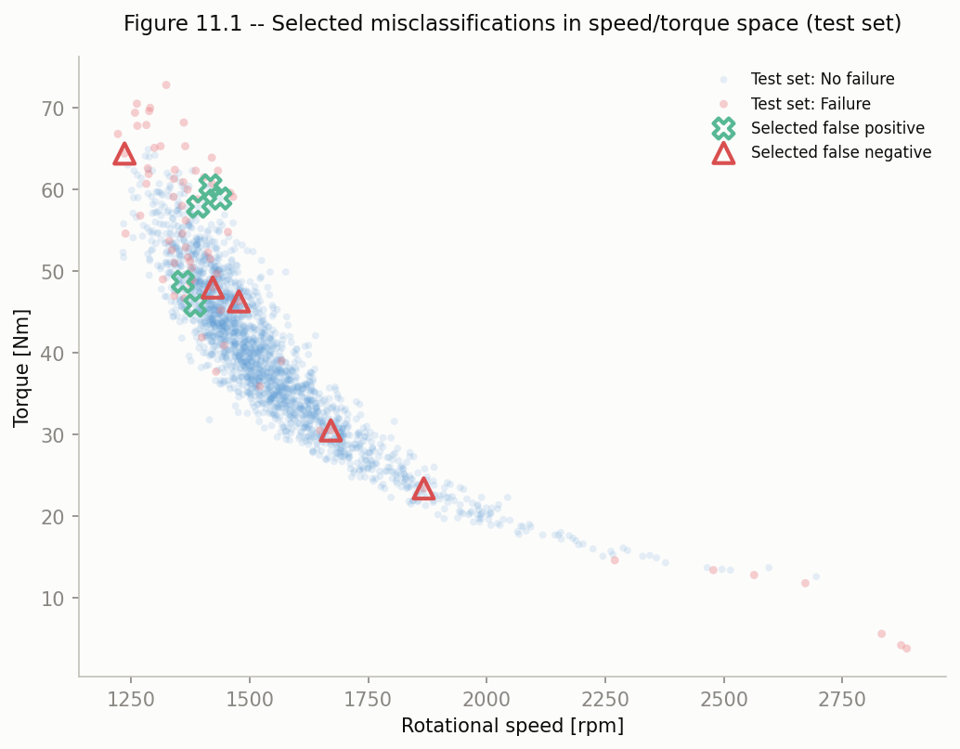
Figure B13 (Fig. 11.1). Misclassified observations in speed/torque space. Scatterplot marking the ten selected false positives and false negatives against the healthy/failure point clouds, visually confirming the false-positive cluster sits inside the known risk corner while false negatives sit outside it

Figure B14 (Fig. 12.1). Feature importance comparison across models. Grouped horizontal bar chart of each feature's importance shared for all four models, with percentage labels, underlying the rank-based comparison in Table A10.
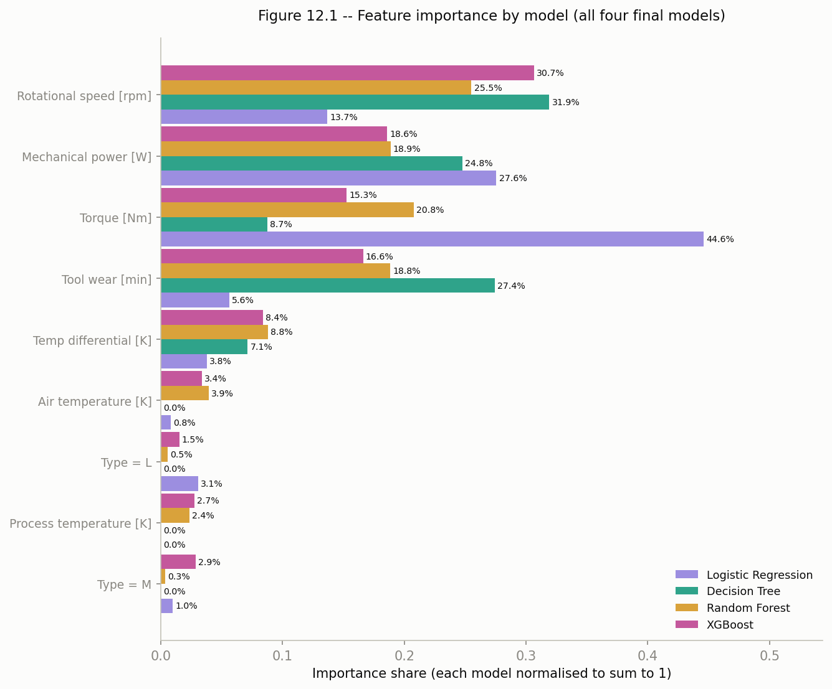

Figure B15 (Fig. 14.1). Robustness comparison, original vs. new split. Grouped bar chart comparing Recall and False Positives for all four models across the seed-666 and seed-42 splits, visualizing the ranking stability and threshold sensitivity discussed in Section 7.
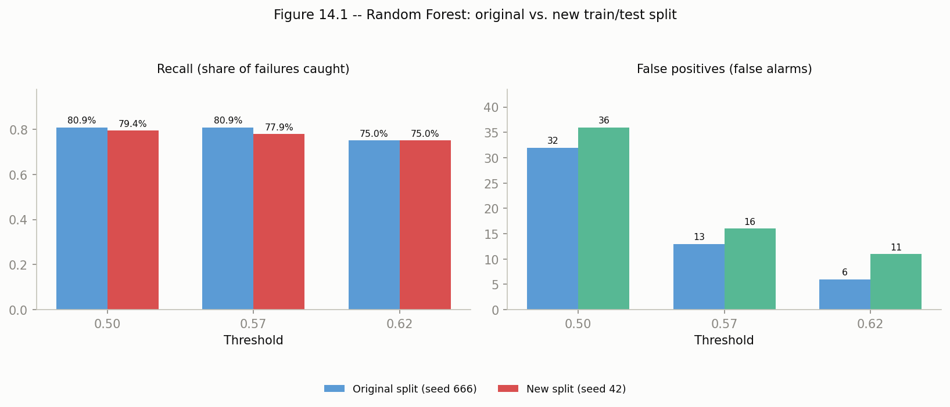

Appendix C. Analytical Decision Record
All decisions below reflect the seed-666 analysis (Tasks 2–13, 15). Task 14's robustness check deliberately uses an alternate seed (42) to test the analysis under different conditions, as documented in Section 7 above and in the notebook.
Decision | Evidence Considered | Alternatives | Final Choice | Consequence
Exclude UDI and Product ID from the predictive model | UDI is a sequential 1–10,000 row index with 0 duplicates; Product ID is 100% unique per row and its first character matches Type in 100% of rows | Retain Product ID's prefix as a re-encoded categorical feature; retain UDI as a proxy for record order | Exclude both variables entirely | Removes identifier-driven overfitting risk; the only non-redundant information Product ID carried (its type of prefix) is preserved via Type
Exclude TWF, HDF, PWF, OSF, RNF from the predictive model | 99.73% agreement between OR(flags) and Machine failure; every TWF=1, HDF=1, PWF=1 and OSF=1 row is a failure (100% each); RNF=1 corresponds to failure in only 1 of 19 rows | Retain flags as engineered "failure-mode" features; retain only RNF given its weak association | Exclude all five flags | Prevents near-total leakage from four deterministic flags and removes an uninformative, deployment-unavailable flag (RNF), forcing the model to learn from genuine operating-condition predictors
Handling of the 27 rows where Machine failure disagrees with OR(TWF..RNF) | 18 rows are RNF=1/failure=0 (consistent with RNF as a rare, independent trigger); 9 rows are failure=1 with no flag set at all | Drop the 27 rows; relabel Machine failure using the OR rule (would shift positives from 339 to 348) | Retain the original Machine failure labels unchanged; document the inconsistency | Preserves all 339 original failure cases in an already rare-event class; avoids substituting an unverified, self-derived target definition for the dataset's official label
One-hot (not ordinal) encoding of Type | Finding 3.3: failure rate by Type (L=3.92%, M=2.77%, H=2.09%) is not monotonic with an L/M/H rank order | Ordinal encoding (L=1, M=2, H=3 or reverse) | One-hot encode Type, drop first level | Avoids imposing a false linear ordering on Logistic Regression; applied uniformly across all four Task 7 models
Scale numeric features only for Logistic Regression | Predictors span very different ranges (K, rpm, Nm, min); Finding 3.4 shows strong collinearity (correlation magnitude ≈ 0.876/-0.875); tree-based splits are scale-invariant | Scale for all models uniformly; scale for none | Standard Scaler fit on training data, applied to Logistic Regression only; Decision Tree/Random Forest/XGBoost use unscaled features | Correct preprocessing for the linear model without needlessly discarding original, interpretable units for the tree-based models
Defer class-imbalance intervention out of baseline preprocessing | Task 6 requires an intervened baseline; Task 8 requires comparing intervened vs. intervened models on equal footing | Bake class_weight or SMOTE into preprocessing by default | Stratified split only in Task 4; class_weight/SMOTE staged and compared explicitly in Task 8, fit on training data/folds only | Keeps the baseline (Task 6) and the imbalance comparison (Task 8) methodologically clean and comparable
Use random seed 666 for all randomization | Assignment requires an individually assigned seed used consistently throughout | N/A (assigned value) | RANDOM_SEED = 666, used in train_test_split (Task 4) and every subsequent model/random process | Ensures all reported splits, tuned parameters, and results are reproducible and traceable to this specific run
Retain Temp differential and Mechanical power as engineered features; drop Torque × Tool wear | Incremental Logistic Regression AUC on top of the Type+5-predictor baseline (0.927): Temp differential approximately +0.000, Torque × Tool wear difference of −0.001, Mechanical power difference of = +0.007; Temp differential and Torque × Tool wear both beat their raw components standalone (AUC 0.647 and 0.783 respectively) | Retain all three engineered features regardless of incremental test; retain none and rely only on raw predictors | Retain Temp differential (justified by its Finding 3.5 interaction with Rotational speed, not by this additive test) and Mechanical power (measured incremental gain); drop Torque × Tool wear from the Task 7 model inputs | Keeps the retained feature set evidence-based rather than reasoning-only; satisfies the assignment's ≥2-retained/≥1-multivariate requirement while exercising the explicit "not required to retain" allowance on a feature that did not survive testing
Use two Dummy Classifier baselines (majority-class and stratified-random) as the Task 6 reference | Majority-class: 96.60% accuracy, 0 recall, ROC-AUC 0.500, misses all 68 test failures; stratified-random: 93.25% accuracy (lower), 2.94% recall (2/68 caught), ROC-AUC 0.4968, 69 false alarms | Use only a single "always-negative" baseline; use a more sophisticated single-feature model as the baseline instead | Report both dummy baselines side by side, evaluated on the identical Task 9 metric set | Gives a concrete, numeric demonstration of the Task 1 accuracy-trap argument (the higher-accuracy baseline is the one that catches zero failures) and sets the 0.500 ROC-AUC / near-100% test failure count as the explicit floor every Task 7 model must clear
Use mean 5-fold cross-validated ROC-AUC as the sole model-selection criterion for all four Task 7 models, and select each model's final configuration from a systematic search on that criterion | Grid/randomized search results: LogReg best CV ROC-AUC 0.9217 (C=10, L1, balanced); Decision Tree 0.9687 (depth=5, entropy); Random Forest 0.9784 (depth=8, 139 trees, unweighted); XGBoost 0.9797 (depth=8, lr approximate 0.011, scale_pos_weight=1), all four CV rankings held on the test set, but for 3 of 4 models the ROC-AUC-optimal configuration had lower recall than that model's own untouched default (RF: 4 to 45 of 68; XGBoost: 44 to 31 of 68), while only Logistic Regression's ROC-AUC-optimal config (via class_weight='balanced') improved recall (20 to 57 of 68) | Select each model's final configuration by cross-validated recall or F-beta instead; apply class-imbalance reweighting uniformly regardless of whether it improved CV ROC-AUC | Keep ROC-AUC as the selection criterion (consistent with Task 5/6/9's metric choice and appropriate for comparing ranking ability across models), but treat threshold placement as a separate, later decision rather than re-deriving it here | Produces four models whose relative ranking is trustworthy and reproducible, but explicitly leaves an open, documented gap between "best by ROC-AUC" and "best recall at threshold 0.5" for three of the four models, a gap Task 8 (imbalance strategies) and Task 10 (threshold selection) are specifically positioned to close
Retain algorithm-level reweighting (class_weight='balanced' / scale_pos_weight) over SMOTE as the imbalance strategy, with Random Forest + class_weight='balanced' as the standout configuration | Controlled comparison (architecture fixed at each model's Task 7 final config): reweighting matched or beat SMOTE on every model (e.g. Random Forest: 55 caught/32 false alarms/0.9783 ROC-AUC under reweighting vs. 57 caught/64 false alarms/0.9730 under SMOTE); RF-reweighted reached 80.88% recall (55/68) at 63.22% precision and near-unchanged ROC-AUC (0.9786 to 0.9783); Decision Tree-reweighted reached the highest recall overall (95.59%, 65/68) but at only 35.52% precision; Logistic Regression-reweighted recall rose to 83.82% but precision collapsed to 15.70% | Use SMOTE as the general strategy; use no imbalance intervention and rely on threshold movement alone (Task 10); adopt Decision Tree's higher-recall reweighted configuration instead of Random Forest's | Reweighting retained over SMOTE for all models; Random Forest plus class_weight='balanced' retained as the leading specific configuration, with Decision Tree and XGBoost's reweighted configurations kept as documented alternatives pending Task 9's full comparison | Closes the gap flagged in Task 7 between "best by ROC-AUC" and "best recall at threshold 0.5" for Random Forest specifically, while keeping the SMOTE vs. reweighting and cross-model trade-offs explicit and evidence-based rather than assumed
Evaluate all four required models in the Task 9 common-evaluation-framework table using their Task 7 architecture + Task 8 retained reweighting (not Task 7's intervened finals) | Task 7-only comparison would silently reintroduce the imbalance problem Task 8 addressed for 3 of 4 models; Task 9 results: Random Forest strongest on accuracy/precision/F1 (0.9775/0.6322/0.7097), Decision Tree strongest on recall (0.9559, 65/68), XGBoost strongest on ROC-AUC (0.9798), Logistic Regression weakest on 4 of 5 criteria | Compare Task 7's intervened final models instead; declare a single "best" model on one metric alone (e.g. accuracy or ROC-AUC) | Report all four fully final (tuned plus reweighted) models side by side on the full metric set; explicitly reject naming one "best" model, since the strongest model differs by criterion | No single winner across accuracy/precision/recall/F1/ROC-AUC, the choice of "best" model is shown to depend on intended use (recall-priority vs. precision-priority vs. ranking-quality), which directly motivates Task 10's threshold investigation and Task 13's final recommendation
Recommend threshold = 0.57 (not the default 0.5) as Random Forest's operating threshold | Fine thresholds sweep on the Task 9 final Random Forest: at t=0.57, recall/TP/FN are identical to t=0.50 (55/68 caught, 13 missed) while false positives fall from 32 to 13 (-59.4%); F1-maximising t=0.62 trades recall down to 51/68 for FP=6; best-precision-at-≥90%-recall t=0.39 raises recall to 62/68 for FP=79 | Keep the default 0.5; select the threshold that maximizes F1 (0.62) or F2 (0.57, coincides with the recommended point) without checking for dominance; select a recall-maximizing threshold (0.39) as the sole recommendation | Recommend t=0.57 as the primary operating threshold, since it strictly dominates the default (same recall, fewer false alarms) with no value trade-off required to justify it; document t=0.39 as the fallback for a more conservative, recall-maximizing deployment | Demonstrates concretely that the default classification threshold was not optimal for this model, satisfying Task 10's requirement, and hands Task 13 a specific, evidence-backed operating point rather than an unexamined 0.5 cutoff
Select the 5 most borderline (closest-to-threshold) false positives and false negatives for Task 11, rather than the most confidently wrong cases or a random sample | At threshold 0.57 (13 FP, 13 FN total): the 5 selected FP all show elevated torque and reduced speed vs. the typical healthy machine (avg -110 rpm, +14.56 Nm, matching Finding 3.4b's risk corner); the 5 selected FN show elevated wear but higher speed/lower torque than a typical failure (avg +171.6 rpm, -11.08 Nm vs. typical failure), missing Finding 3.5's risk-zone signature entirely | Select the most confidently wrong cases (highest/lowest predicted probability); select a random sample of 5 per class | Select cases with predicted probability closest to 0.57 in each direction, as the observations most literally "difficult to classify" | Surfaces two distinct, evidence-based error patterns tied to specific Task 3 findings (false positives resemble the known speed/torque risk corner; false negatives are wear-driven failures that fall outside it) rather than a generic account of misclassification
Use rank-based comparison (mean rank, rank spread across all four models) as the primary tool for judging feature-importance agreement, rather than raw importance-share values alone | LogReg's normalized |coef| share and the three tree models' feature_importances_ are not the same underlying statistical quantity; ranks showed Rotational speed/Mechanical power/Torque/Tool wear as a clear top tier (mean rank 1.50–3.25) versus Type/Process temperature/Air temperature at the bottom (mean rank 6.50–7.75), with Temp differential uniquely rank-5 in all four models (spread 0) | Compare only raw importance-share magnitudes across models; rely on a single model's importances (e.g. Random Forest) as the interpretation | Report both importance shares and rank-based mean rank/rank spread; treat rank spread of 0 (Temp differential) and 3 (Torque, Type=L) as the key consistency/divergence signals | Surfaces both a model-confirmed validation of the Task 5 feature-retention decisions (Mechanical power and Temp differential both ranks consistently high/mid) and an explicit multicollinearity caveat for reading Logistic Regression's individual coefficient signs (Rotational speed +2.508, Mechanical power −5.059) at face value
Recommend Random Forest (Task 7 architecture + Task 8 class_weight='balanced' + Task 10 threshold 0.57) as the final early-warning model | At t=0.57: 55/68 caught (80.88%), 13 FP (0.65% of test set), 13 FN, precision=recall=0.8088; vs. Decision Tree (65/68 caught, 118 FP, unvalidated default threshold), XGBoost (56/68 caught, 44 FP, ROC-AUC 0.9798 vs. RF's 0.9783, a 0.0015, threshold-independent gap), Logistic Regression (57/68 caught, 306 FP, 15.70% precision, and Task 12's multicollinearity caveat on its coefficient signs) | Recommend Decision Tree for maximum recall regardless of false-alarm cost; recommend XGBoost on its marginally higher ROC-AUC; recommend Logistic Regression for its nominal interpretability | Random Forest, reweighted, at threshold 0.57 | Only one of the four models whose deployed operating point has been explicitly validated (not just computed) as non-dominated; best balance of detection, false-alarm control, and alarm-fatigue risk given Task 1's asymmetric-cost framing, at the cost of 10 more missed failures than Decision Tree and less individual-case traceability than a single tree
Robustness-check the Task 13 recommendation with a fresh 80/20 split (seed 42) rather than recomputing on the original seed-666 split | Re-fit all four final models on the new split: model ranking on accuracy/precision/F1 reproduces exactly (RF > XGB > DT > LogReg), ROC-AUC ranking reproduces exactly (XGB > RF > DT > LogReg); only a minor RF/XGB recall reordering (79.41% vs. 76.47%, both close either way). Threshold 0.57 no longer strictly dominates 0.50 on the new split (costs 1 additional missed failure, 54 to 53 TP, for a 55.6% FP cut, 36 to 16); the new split's own F1-optimal threshold is 0.69, not 0.57 | Treat the original single-split results as sufficient without re-testing; re-tune each model's architecture on the new split as well (would test tuning-procedure robustness, not the recommendation itself) | Keep architectures/reweighting fixed at their Task 7/8 values; only the train/test partition changes; report both the reproduced ranking and the threshold discrepancy explicitly | Strengthens confidence in Random Forest as the model choice (ranking is not an artefact of one split); weakens confidence in 0.57 as an exact, zero-cost-verified constant, reframed as a reasonable estimate in a approximately 0.55–0.65 range that should be periodically re-derived in deployment rather than fixed permanently
Ground Task 15's limitations and improvements in this project's own specific findings rather than generic ML caveats | Task 14 showed the recommended threshold is sample-dependent (0.57 vs. 0.69 F1-optimal on a presplit); Task 12 showed multicollinearity compromises individual coefficient signs (Rotational speed +2.508, Mechanical power −5.059); Task 2 showed near-deterministic flag/target overlap (100% for TWF/HDF/PWF/OSF) suggesting a cleaner-than-real simulated dataset; the dataset carries no timestamp/unit ID, so no split in this project (original or robustness) tests out-of-time generalization; Task 11's error patterns were drawn from only 10 hand-selected borderline cases | Write limitations as generic ML boilerplate (e.g. "more data would help", "could overfit"); propose improvements unconnected to this project's actual findings (e.g. generic "try deep learning") | 5 limitations (3 dataset/results-specific: sample-size fragility demonstrated by Task 14, simulated-data realism gap, no temporal structure; 2 methodology-specific: multicollinearity-compromised interpretation, small hand-selected misclassification sample) and 4 improvements (cost-weighted threshold, Type-specific modelling per Finding 3.6, temporal/drift validation, a targeted secondary rule for Task 11's wear-driven blind spot) | Every limitation and improvement trace to a specific number or finding already established earlier in this report, satisfying the assignment's explicit instruction to avoid statements that could apply to any machine-learning project

