CIS 403: Final Project

Add a screenshot of the completed **Chloropleth Map Tutorial**

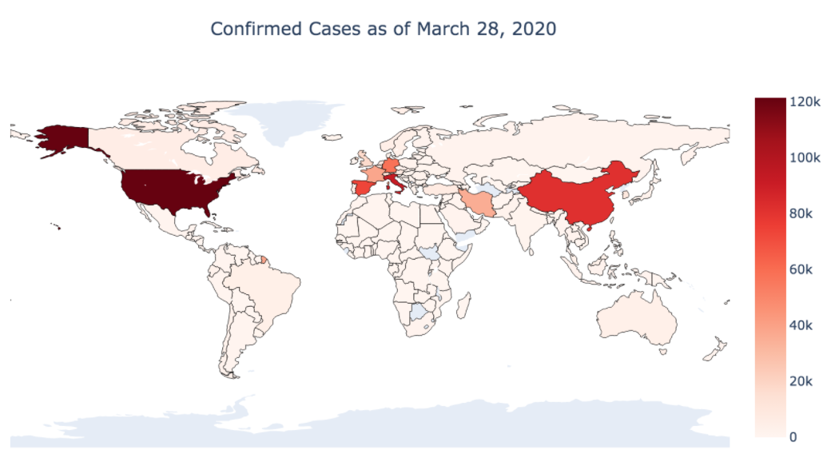

Can you change the dataset? Add a screenshot of the **updated Confirm Cases** using another dataset.



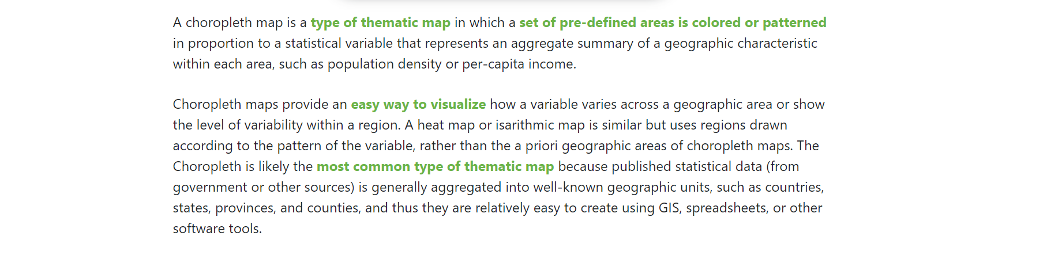

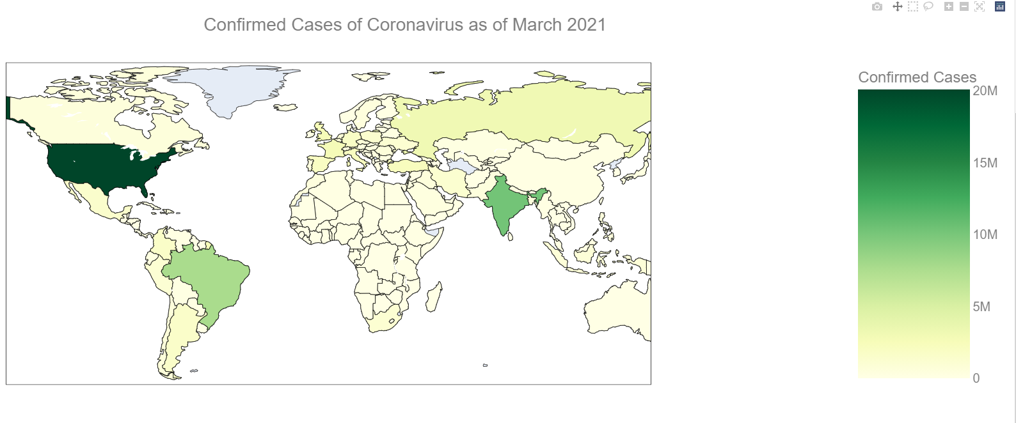

**SOURCE CODE**

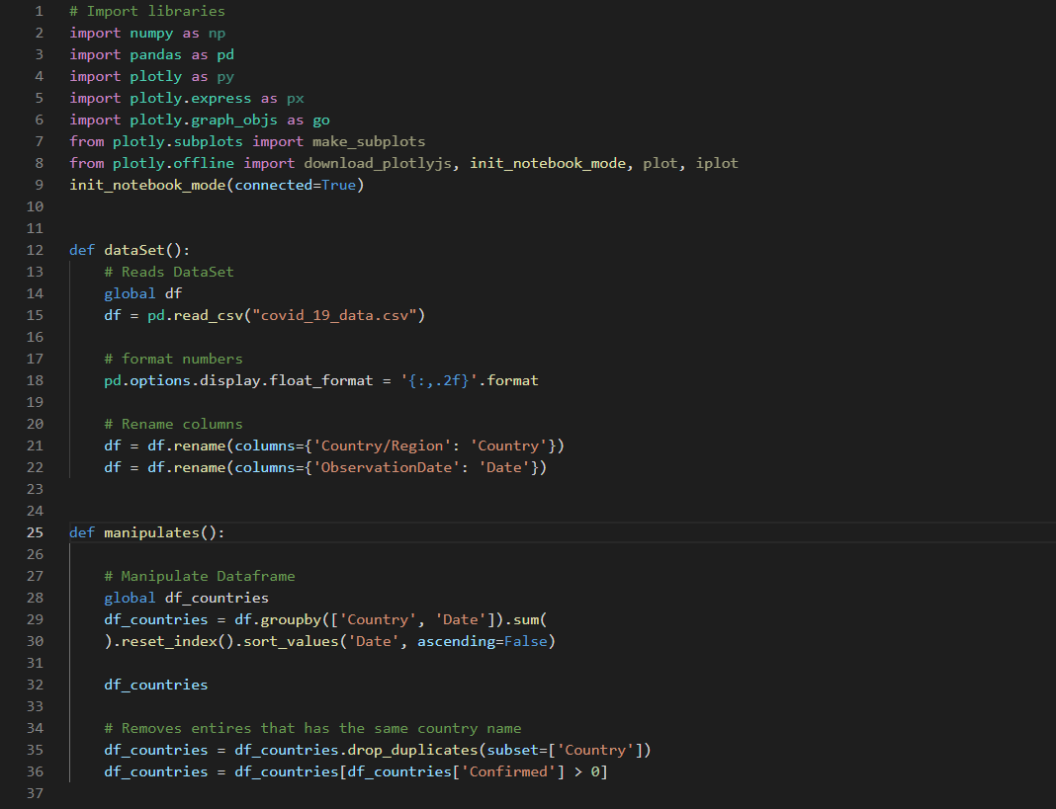

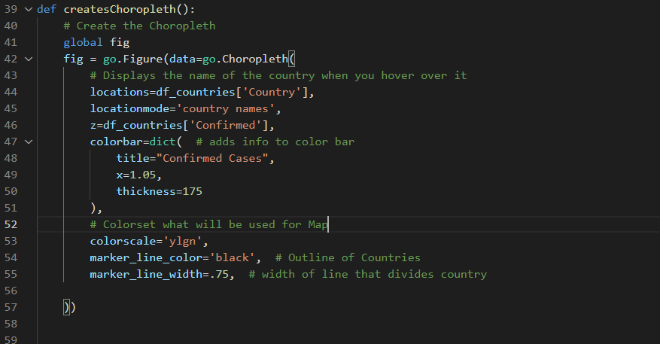

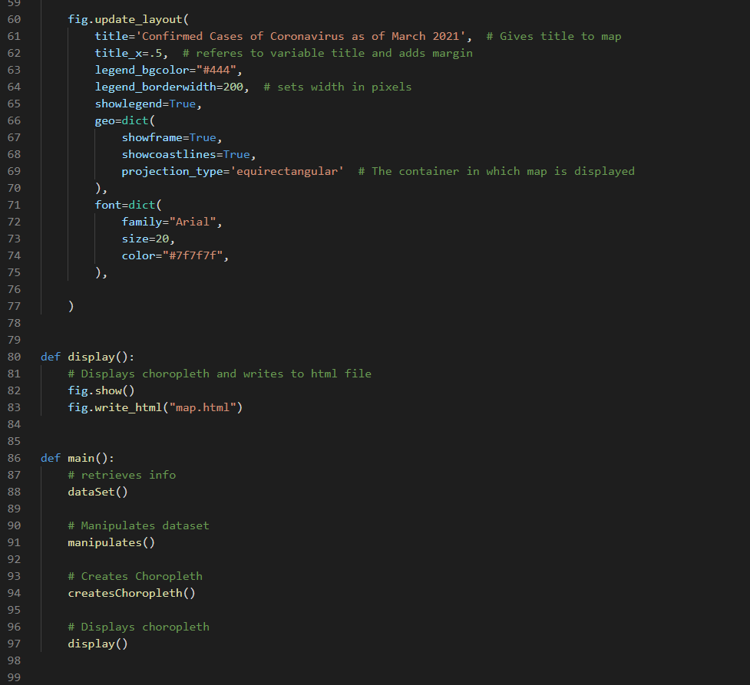

List 5 features you have worked with in this tutorial

Poltly- I worked with plotly which is a data visualization framework

Embedded Html File = In order to display the Choropleth map I wrote to a html file and embedded that into another html file in order to style it

Dataframe – I worked with dataframes in order to organize the data

Functions – I created many functions in order to modulize the code

Automatic – This map is very automated; at the click of a button, it can be updated to use a different dataset.

Describe an application you can build based on the completion of this tutorial.

I would be able to build another choropleth map or a normal graph using this tutorial. Data is a very important resource and it needs to be organized in such a way where the information is easy to comprehend.