Plant-pollintor networks worldwide are composed by the same specific building blocks

## Abstract

Ecological processes leave distinct structural imprints on species interactions shaping the topology of mutualistic networks. Detecting those relationships is not trivial since they go beyond pair-wise interactions, but may get blurred when considering full network descriptors. However, recent work has shown the network meso-scale can capture this important information. The meso-scale describes network subgraphs representing patterns of interactions between a small number of species (i.e. motifs) and those constitute the building blocks of the whole network. Here we have compiled 60 networks from 18 different studies and show that some motifs are consitently over-represented worldwide, suggesting that the building blocks of plant-pollintor networks are not random and are associated to ... Second, we show that the position of pollinator guilds and plant reproductive strategies is not random with respect to the positions occupied within each motif. ... Hence, we show that species ecology is shaping the building blocks that conform the web of life.

## INTRODUCTION

The interaction between plants and pollinators can be studied at different scales, from species level interactions (micro-scale) to the full network structure (macro-scale). Research of the plant-pollinator network structure have proven common invariant structural properties across them including a degree distribution that decays as a power law (Jordano 1987), nestedness (Bascompte et al. 2003), or the higher number of pollinator species than plant species (Blüthgen et al. 2007). In addition, species phenological overlap, morphological matching and species abundances have been shown to be determinant for the understanding of pairwise plant-pollinator interactions (Bartomeus et al. 2016; Stang, Klinkhamer, and Van Der Meijden 2006; Peralta et al. 2020). However, both species level information or an holistic view of the full network involves missing relevant information for the understanding of ecological processes (Simmons, Cirtwill, et al. 2019).

Indirect interactions (i.e., motifs), commonly referred as the building blocks that depict subsets of interactions of the network (Milo et al. 2002), are a widespread phenomenon in ecological communities (Strauss 1991). For instance, plant species can facilitate or compete for pollinator's visitation when two species are visited by the same pollinator (Ghazoul 2006). Despite the relevance of indirect interactions in ecological communities, plant-pollinator research often fails to finely capture those indirect interactions with the traditional analytical tools that condense the information either by species (e.g. interaction frequency) or in single topological indices (e.g. nestedness). Nonetheless, the emerging framework of network motifs in plant-pollinator research allows to consider both direct and indirect interactions (Simmons, Cirtwill, et al. 2019). The study of Simmons et al. (2020) have shown that the different processes that govern species interactions (e.g., species abundances versus trait-matching) can lead to different patterns of indirect interactions. However, we still ignore which are the general patterns observed in the distribution of plant-pollinator motifs worldwide.

Motifs are abstract representations often decoupled from species ecology. Hence, linking the structural properties of the meso-scale with the species ecology can help the understanding of ecological processes. For instance, different motifs can have different ecological meanings (Simmons, Cirtwill, et al. 2019) and the position within a motif can determine the species functional role (Stouffer et al. 2012; Baker et al. 2015). However, it is unclear if species ecological and life history traits strongly determines its role within the network of interactions (Coux et al. 2016). For example, large pollinators can forage larger distances (Greenleaf et al. 2007), deposit greater pollen quantities (Földesi et al. 2021) and handle complex zygomorphic flowers in comparison with small pollinators that are restricted to lower floral complexity (Gong and Huang 2009). How this different pollinator behaviors translate into their interaction topology is unknown. Similarly, recent empirical findings indicate that the meso-scale is the best descriptor of plant reproductive success (Allen-Perkins et al. 2021), but little is known on how plants reproductive strategies shape their position within the network of interactions. Although some studies have evaluated plant reproductive strategies in plant-pollinator networks (Tur, Castro-Urgal, and Traveset 2013; Lázaro et al. 2020), they are often overlooked in a community context (Devaux, Lepers, and Porcher 2014) and rarely incorporated into plant-pollinator network studies. Hence, exploring how the main plant reproductive strategies integrate with the emergent motif framework can shed light on key aspects of ecosystem functioning.

Here, we used 60 plant-pollinator networks from 18 different studies distributed worldwide, alongside a detailed grouping of plants into reproductive strategies and pollinator species into functional groups. Plants were grouped based on a comprehensive dataset that included floral, reproductive and vegetative traits compiled in Lanuza et al., (unpublished) on a larger set of plant-pollinator networks. Pollinators were grouped into the main taxonomical groups that differed in life form and behaviour. Then, we explored which motifs up to five nodes in these set of plant-pollinator networks were over and under-represented. Finally, we explore if the different plants and pollinators functional groups are over- or under-represented in certain positions.

## METHODS

**Plant-pollinator studies**

We have compiled 60 plant-pollinator networks from 18 different studies (Table S1). All studies sampled plant-pollinator interactions in natural systems and were selected based on wide geographical coverage and the presence of interaction frequency as a measure of interaction strength. In total, there were 503 plant species, 1,111 pollinator species and 6248 of pairwise interactions registered. For ease of data manipulation plant and pollinator species names were standardize with the help of the package taxize version 0.9.99 (Chamberlain et al. 2020).

**Plant and pollinator functional groups**

First, plant species were grouped into the optimal number of functional groups that summarized the main plant reproductive strategies. This was done with the help of hierarchical cluster analysis by using the trait dataset collated in Lanuza et al., (unpublished) that comprised 1,506 plant species and contained the same 60 plant-pollinator networks used in this study plus some non-weighted and weighted metawebs (see Table S1 Lanuza et al., unpublished). This dataset consisted on 8 floral, 4 reproductive and 3 vegetative traits (Table S2). We opted to calculate the plant functional groups on this larger set of species because of the higher accuracy when delimiting the functional groups with that many variables Dolnicar et al. (2014). For this, we calculated the distance of the different functional traits with the function gowdis from the package FD version 1.0-12 (Laliberté et al. 2014) with the method ward.D2 used for non-squared distances (Murtagh and Legendre 2014). All the numerical traits were previously scaled. Finally, we applied a hierarchical cluster analysis with the function hclust from the R stats package version 4.0.5 and calculated the optimal number of clusters with the function kgs from the package maptree version 1.4-7 (White and Gramacy 2009).

Second, pollinators were grouped into functional groups based on taxonomic rank. We opted to divide pollinators on the taxonomic rank level and not with functional traits because (i) they main taxonomic orders differ in form and behaviour and (ii) the lower complexity of higher taxonomic ranks (i.e., pollinators had 6 orders versus plants that had 38). Hence, we grouped pollinators into 6 functional groups: (i) Hymenoptera-Anthophila (bees), (ii) Hymenoptera-non-Anthophila (other non-bee Hymenoptera), (iii) Syrphidae-Diptera, (iv) non-Syrphidae-Diptera, (v) Lepidoptera and (vi) Coleoptera.

**Meso-scale analysis**

Following Simmons et al. (Simmons, Cirtwill, et al. 2019; Simmons et al. 2020), we broke down the plant-pollinator networks into their constituent motifs. Prior to analyses, we selected only robust links, that is, interactions whose frequency was greater than one (64.98 % interactions); and, then, we turned the quantitative networks into qualitative (or binary) ones, where interactions are present or absent. Here I would present maybe full analysis, and without singletones in sup mat, especially if they are consistent

We calculated the frequency of all motifs up to five nodes (see Figure 1) for each empirical network, by using the ‘bmotif’ package (Simmons, Sweering, et al. 2019). To control for variation in network size and for the fact that smaller motifs can be nested within larger motifs, the frequencies were normalised as a proportion of the total number of motifs within each motif class (i.e., the number of nodes a motif contains). Like (Simmons et al. 2020), we just used five-node motifs in our analyses for visualisation, interpretation and computational reasons. In addition, we also excluded two-node motifs (or links) from our analyses because their normalised frequencies would always equal one.

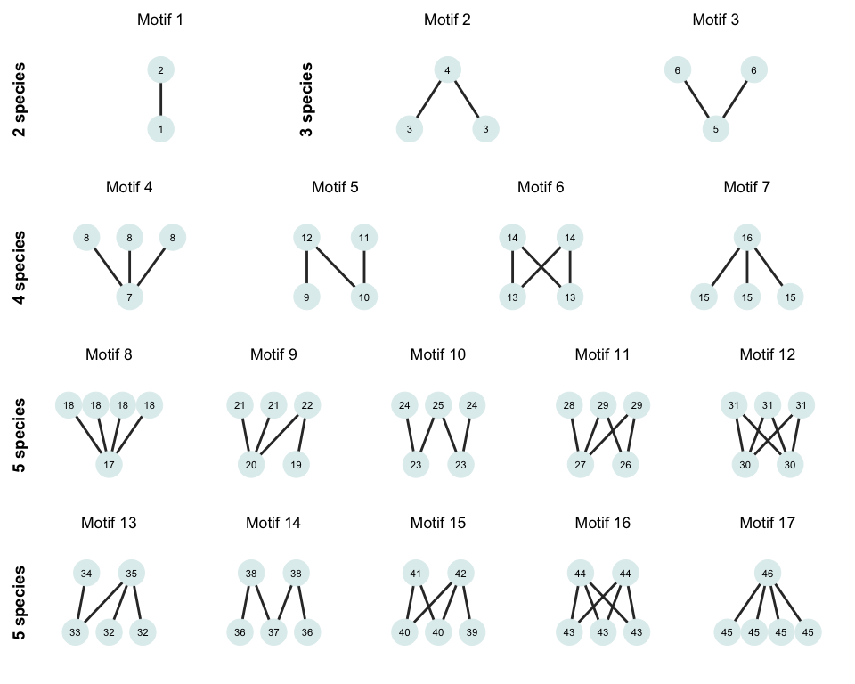

Figure 1. Adapted figure of Simmons et al., 2019 with all the possible motifs from two to five species in bipartite networks. There is a total of 17 possible motifs with 46 different positions denoted within each node.

To assess the significance of the observed frequencies, we created 1,000 simulated networks for each binary network using the ‘nullmodel’ function and the ‘vaznull’ model in the bipartite package (Dormann et al. 2009). Generated networks had the same number of plants and pollinators, as well as the same connectance of their corresponding empirical networks. After extracting the motif frequencies from the simulated networks, for each motif type and empirical network, we calculated the percentage of simulated networks whose frequencies were smaller than the ones observed, that is, we estimated the percentile of the observed motif frequencies. Motifs whose percentile is close to zero or 100 are under- or over-represented in the empirical networks, respectively, and, thus, they cannot be predicted by connectance and the number of species alone. To summarize general patterns across networks, we used an intercept-only linear mixed model (LMM) per motif, where the response variable was the observed motif percentile per network. In these models, we used the study identifiers in Table S1 as a random intercept. By doing so, we obtained estimates of the average motif frequency, in which we controlled the variation at the study level.

Next, we calculated which functional groups were over or under-represented in different motif positions by comparing position frequencies of empirical networks with those of their corresponding simulated counterparts. We extracted the position frequencies of all motifs from three to five nodes for each network and species by using the ‘bmotif’ package (Simmons, Sweering, et al. 2019). To estimate the position frequencies of each functional group in a given network, we added the frequencies of those species that belong to the group, and then, we normalised the resulting frequencies by dividing the position measure for each group by the total number of times that a group appears in any position within the same motif size class. Then, we calculated the percentile of the observed position frequencies for each group and network, just like we did motif frequencies. To outline the general patterns of position frequencies across networks and functional groups, we fit a LMM per motif position, where the response variable was the observed position percentile per network. We used the functional group identifier as an explanatory variable and the study identifiers as a random intercept. By adding the functional group estimates to the model intercept, we assessed the average motif frequency, after controlling the variation at the study level. To fit the LMMs models in our analyses, we used the ‘lmer’ package (Bates et al. 2015). Finally, we visualized with the help of the package ComplexHeatmap version 2.6.2 (Gu, Eils, and Schlesner 2016) over- and under- representation of plant and pollinator functional groups on the different motif positions.

[potential additions: Finally,for each motif, we recover the number of times a given combination of functional groups emerges ...]

## RESULTS

**Functional groups**

The hierarchical cluster analysis divided the dataset with 1506 species and 15 traits into five different clusters with different and overlapping characteristics (Figure S1 and Figure S2). The subset of plant species used in this study (N = 503) were distributed evenly across these different larger five groups (see subset of species labels within cluster in Figure S1). The first cluster was dominated by herbs with hermaphrodite flowers with high levels of autonomous selfing and we we refer to this group as "selfing herbs". The second cluster was characterized by small perennial species with a mixed of life forms (trees shrubs and herbs) with outcrossing hermaphroditic flowers and we refer to this group of species as "small outcrossing perennials". The third cluster was dominated by also perennial species with a mixed of life forms too and had large self-incompatible hermaphroditic flowers with high number of ovules and we named this group "self-incompatible perennials with large flowers". The fourth cluster had the tallest species, highest proportion of shrub and tree life forms, dioecious and monoecious breeding system with small flowers but the highest number of flowers per plant and inflorescence and we refer to this set of species as "tall plants with small unisexual flowers". Finally, the last cluster of species was dominated by small perennial and shot-lived herbs with long self-compatible zygomorphic flowers unable to self-pollinate and we refer to this group as "short-lived outcrossers with long zygomorphic flowers".

**Overall meso-scale patterns**

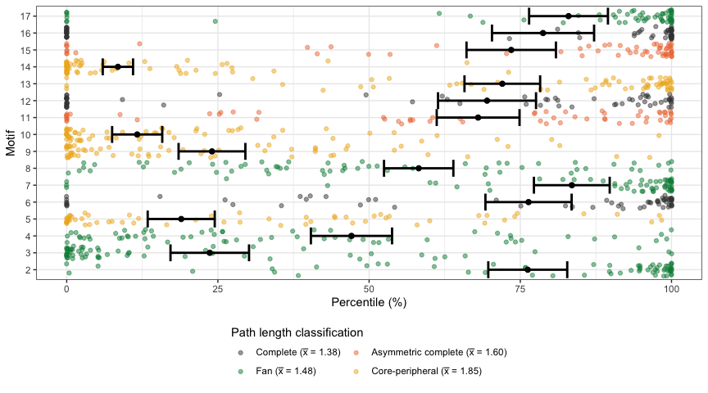

Figure 2. Comparison of the motif frequencies between empirical and simulated networks. Average percentages of motifs close to 0 and 100 indicate under- and over- representation in empirical networks. The different motifs are coloured by the mean path length as done in Simmons et al. (2020).

**Meso-scale functional groups position**

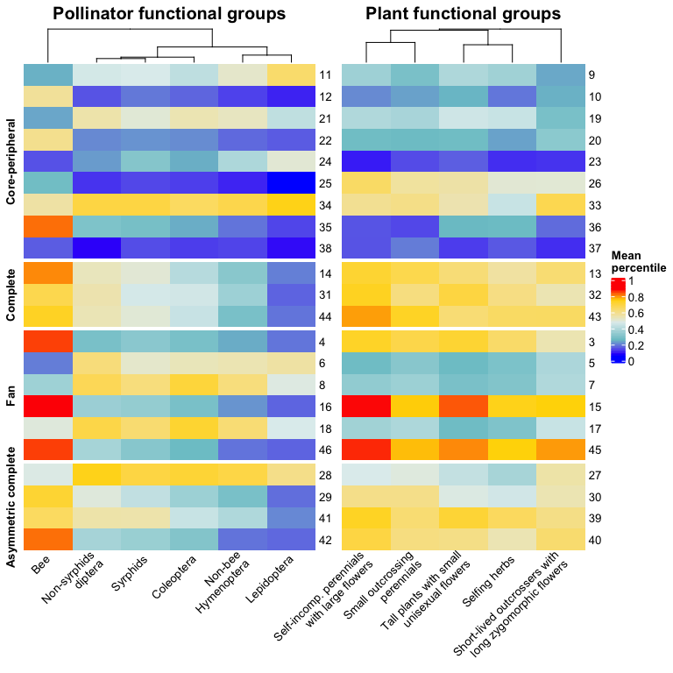

Figure 3. Heatmap indicating under- and over- representation of pollinator and plant functional groups in the different motif positions. The different motif positions are dividied by the average path length clasification by Simmons et al. (2020).

## REFERENCES

Allen-Perkins, Alfonso, Maria Hurtado, David Garcia-Callejas, Oscar Godoy, and Ignasi Bartomeus. 2021. “Community Level Individual-Based Plant-Pollinator Networks Unveil Pollen Flow Dynamics and Plant Reproductive Success.” *bioRxiv*. Cold Spring Harbor Laboratory.

Baker, Nick J, Riikka Kaartinen, Tomas Roslin, and Daniel B Stouffer. 2015. “Species’ Roles in Food Webs Show Fidelity Across a Highly Variable Oak Forest.” *Ecography* 38 (2). Wiley Online Library: 130–39.

Bartomeus, Ignasi, Dominique Gravel, Jason M Tylianakis, Marcelo A Aizen, Ian A Dickie, and Maud Bernard-Verdier. 2016. “A Common Framework for Identifying Linkage Rules Across Different Types of Interactions.” *Functional Ecology* 30 (12). Wiley Online Library: 1894–1903.

Bascompte, Jordi, Pedro Jordano, Carlos J Melián, and Jens M Olesen. 2003. “The Nested Assembly of Plant–animal Mutualistic Networks.” *Proceedings of the National Academy of Sciences* 100 (16). National Acad Sciences: 9383–7.

Bates, Douglas, Martin Mächler, Ben Bolker, and Steve Walker. 2015. “Fitting Linear Mixed-Effects Models Using lme4.” *Journal of Statistical Software* 67 (1): 1–48. doi:[10.18637/jss.v067.i01](https://doi.org/10.18637/jss.v067.i01).

Blüthgen, Nico, Florian Menzel, Thomas Hovestadt, Brigitte Fiala, and Nils Blüthgen. 2007. “Specialization, Constraints, and Conflicting Interests in Mutualistic Networks.” *Current Biology* 17 (4). Elsevier: 341–46.

Chamberlain, Scott, Eduard Szoecs, Zachary Foster, Zebulun Arendsee, Carl Boettiger, Karthik Ram, Ignasi Bartomeus, et al. 2020. *Taxize: Taxonomic Information from Around the Web*.

Coux, Camille, Romina Rader, Ignasi Bartomeus, and Jason M Tylianakis. 2016. “Linking Species Functional Roles to Their Network Roles.” *Ecology Letters* 19 (7). Wiley Online Library: 762–70.

Devaux, Celine, Clotilde Lepers, and Emmanuelle Porcher. 2014. “Constraints Imposed by Pollinator Behaviour on the Ecology and Evolution of Plant Mating Systems.” *Journal of Evolutionary Biology* 27 (7). Wiley Online Library: 1413–30.

Dolnicar, Sara, Bettina Grün, Friedrich Leisch, and Kathrin Schmidt. 2014. “Required Sample Sizes for Data-Driven Market Segmentation Analyses in Tourism.” *Journal of Travel Research* 53 (3). Sage Publications Sage CA: Los Angeles, CA: 296–306.

Dormann, C. F., J. Frueund, N. Bluethgen, and B. Gruber. 2009. “Indices, Graphs and Null Models: Analyzing Bipartite Ecological Networks.” *The Open Ecology Journal* 2: 7–24.

Földesi, Rita, Brad G Howlett, Ingo Grass, and Péter Batáry. 2021. “Larger Pollinators Deposit More Pollen on Stigmas Across Multiple Plant Species—A Meta-Analysis.” *Journal of Applied Ecology* 58 (4). Wiley Online Library: 699–707.

Ghazoul, Jaboury. 2006. “Floral Diversity and the Facilitation of Pollination.” *Journal of Ecology* 94 (2). Wiley Online Library: 295–304.

Gong, Yan-Bing, and Shuang-Quan Huang. 2009. “Floral Symmetry: Pollinator-Mediated Stabilizing Selection on Flower Size in Bilateral Species.” *Proceedings of the Royal Society B: Biological Sciences* 276 (1675). The Royal Society: 4013–20.

Greenleaf, Sarah S, Neal M Williams, Rachael Winfree, and Claire Kremen. 2007. “Bee Foraging Ranges and Their Relationship to Body Size.” *Oecologia* 153 (3). Springer: 589–96.

Gu, Zuguang, Roland Eils, and Matthias Schlesner. 2016. “Complex Heatmaps Reveal Patterns and Correlations in Multidimensional Genomic Data.” *Bioinformatics* 32 (18). Oxford University Press: 2847–9.

Jordano, Pedro. 1987. “Patterns of Mutualistic Interactions in Pollination and Seed Dispersal: Connectance, Dependence Asymmetries, and Coevolution.” *The American Naturalist* 129 (5). University of Chicago Press: 657–77.

Laliberté, Etienne, Pierre Legendre, Bill Shipley, and Maintainer Etienne Laliberté. 2014. “Package ‘Fd’.” *Measuring Functional Diversity from Multiple Traits, and Other Tools for Functional Ecology*.

Lázaro, Amparo, Carmelo Gómez-Martínez, David Alomar, Miguel A González-Estévez, and Anna Traveset. 2020. “Linking Species-Level Network Metrics to Flower Traits and Plant Fitness.” *Journal of Ecology* 108 (4). Wiley Online Library: 1287–98.

Milo, Ron, Shai Shen-Orr, Shalev Itzkovitz, Nadav Kashtan, Dmitri Chklovskii, and Uri Alon. 2002. “Network Motifs: Simple Building Blocks of Complex Networks.” *Science* 298 (5594). American Association for the Advancement of Science: 824–27.

Murtagh, Fionn, and Pierre Legendre. 2014. “Ward’s Hierarchical Agglomerative Clustering Method: Which Algorithms Implement Ward’s Criterion?” *Journal of Classification* 31 (3). Springer: 274–95.

Peralta, Guadalupe, Diego P Vázquez, Natacha P Chacoff, Silvia B Lomáscolo, George LW Perry, and Jason M Tylianakis. 2020. “Trait Matching and Phenological Overlap Increase the Spatio-Temporal Stability and Functionality of Plant–pollinator Interactions.” *Ecology Letters* 23 (7). Wiley Online Library: 1107–16.

Simmons, Benno I, Andrew P Beckerman, Katrine Hansen, Pietro K Maruyama, Constantinos Televantos, Jeferson Vizentin-Bugoni, and Bo Dalsgaard. 2020. “Niche and Neutral Processes Leave Distinct Structural Imprints on Indirect Interactions in Mutualistic Networks.” *Functional Ecology*. Wiley Online Library.

Simmons, Benno I, Alyssa R Cirtwill, Nick J Baker, Hannah S Wauchope, Lynn V Dicks, Daniel B Stouffer, and William J Sutherland. 2019. “Motifs in Bipartite Ecological Networks: Uncovering Indirect Interactions.” *Oikos* 128 (2). Wiley Online Library: 154–70.

Simmons, Benno I, Michelle JM Sweering, Maybritt Schillinger, Lynn V Dicks, William J Sutherland, and Riccardo Di Clemente. 2019. “Bmotif: A Package for Motif Analyses of Bipartite Networks.” *Methods in Ecology and Evolution* 10 (5). Wiley Online Library: 695–701.

Stang, Martina, Peter GL Klinkhamer, and Eddy Van Der Meijden. 2006. “Size Constraints and Flower Abundance Determine the Number of Interactions in a Plant–flower Visitor Web.” *Oikos* 112 (1). Wiley Online Library: 111–21.

Stouffer, Daniel B, Marta Sales-Pardo, M Irmak Sirer, and Jordi Bascompte. 2012. “Evolutionary Conservation of Species’ Roles in Food Webs.” *Science* 335 (6075). American Association for the Advancement of Science: 1489–92.

Strauss, Sharon Y. 1991. “Indirect Effects in Community Ecology: Their Definition, Study and Importance.” *Trends in Ecology & Evolution* 6 (7). Elsevier: 206–10.

Tur, Cristina, Rocío Castro-Urgal, and Anna Traveset. 2013. “Linking Plant Specialization to Dependence in Interactions for Seed Set in Pollination Networks.” *PloS One* 8 (10). Public Library of Science: e78294.

White, D, and RB Gramacy. 2009. “Maptree: Mapping, Pruning, and Graphing Tree Models. R Package Version 1.4-5.”

## SUPPLEMENTARY MATERIAL

**TABLES**

Table S1. List of studies ordered by author with the year of publication, number of contributed networks and digital object identifier

First author

Year

Number of networks

DOI

Arroyo-Correa

2019

3

<https://doi.org/10.1111/1365-2745.13332>

Bartomeus

2008

6

<https://doi.org/10.1007/s00442-007-0946-1>

Bartomeus

2008

16

<https://github.com/ibartomeus/BeeFunData>

Bundgaard

2003

1

Unpublished, Master thesis

Burkle

2013

1

<https://doi.org/10.1126/science.1232728>

Dicks

2002

2

<https://doi.org/10.1046/j.0021-8790.2001.00572.x>

Dupont

2003

3

<https://doi.org/10.1111/j.1365-2656.2008.01501.x>

Elberling

1999

1

<https://doi.org/10.1111/j.1600-0587.1999.tb00507.x>

Fang

2008

1

<https://doi.org/10.1111/1749-4877.12190>

Inouye

1988

1

<https://doi.org/10.1111/j.1442-9993.1988.tb00968.x>

Kaiser-Bunbury

2017

8

<https://doi.org/10.1038/nature21071>

Kaiser-Bunbury

2011

6

<https://doi.org/10.1111/j.1365-2745.2010.01732.x>

Kaiser-Bunbury

2010

2

<https://doi.org/10.1016/j.ppees.2009.04.001>

Lundgren

2005

1

[https://doi.org/10.1657/1523-0430(2005)037[0514:TDAHCW]2.0.CO;2](https://doi.org/10.1657/1523-0430(2005)037%5B0514:TDAHCW%5D2.0.CO;2)

Olesen

2002

2

<https://doi.org/10.1046/j.1472-4642.2002.00148.x>

Peralta

2006

4

<https://doi.org/10.1111/ele.13510>

Small

1976

1

/13960/t4km08d21

Souza

2017

1

<https://doi.org/10.1111/1365-2745.12978>

Table S2. Traits used to delimit the different plant functional groups divided in quantitative and categorical traits.

Quantitative traits

Categorical traits

Type

Traits

Type

Traits

Vegetative

Plant height (m)

Vegetative

Lifepan

Floral

Flower width (mm)

Vegetative

Life form

Floral

Flower length (mm)

Floral

Flower shape

Floral

Inflorescence width (mm)

Floral

Flower symmetry

Floral

Style length (mm)

Reproductive

Autonomous selfing

Floral

Ovules per flower

Reproductive

Compatibility system

Floral

Flowers per plant

Reproductive

Breeding system

Reproductive

Autonomous selfing (fruit set)

**FIGURES**

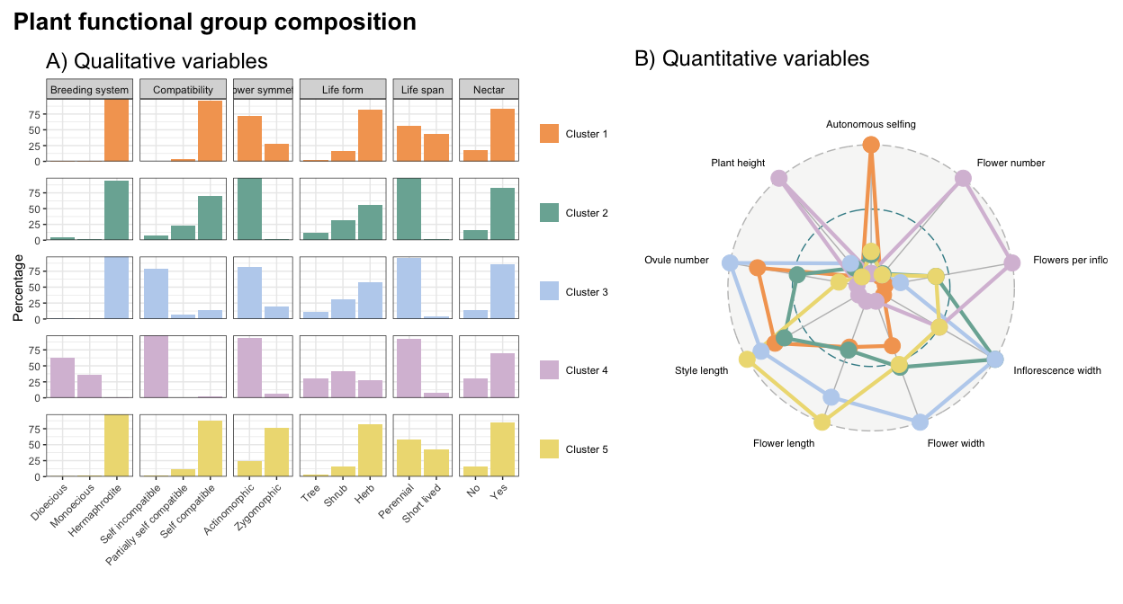

Figure S1. Plant functional group composition separated in qualitative and quantitative variables. Panel A) shows the percentage of the different categories within trait represented with different colours for each functional group. Plot B) shows the radar plot of the different quantitative variables standardize on the same scale also coloured with the same patterns of colours as qualitative variables per cluster.

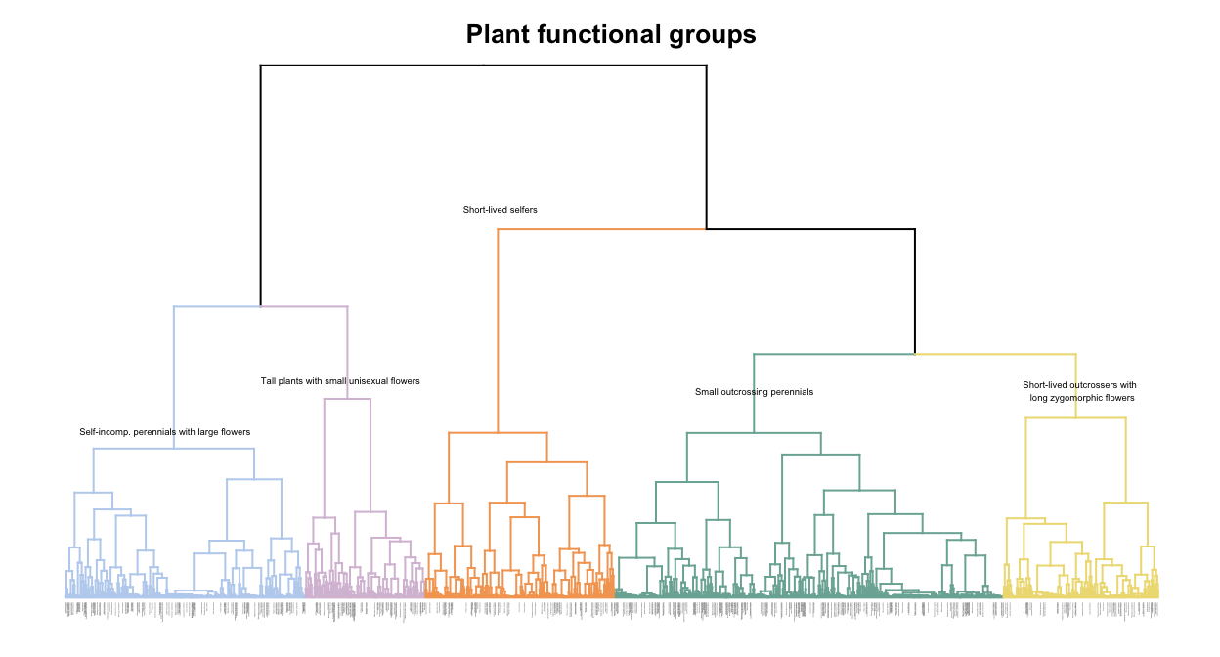

Figure S2. Hierarchical clustering dendrogram with the branches coloured by the optimal number of clusters (5). The labels of the subgroup of species (N = 524) used in this study are coloured in black in order to show the evenness of the distribution of the species across clusters. The rest of species labels are omitted for visualization purposes (N = 982).

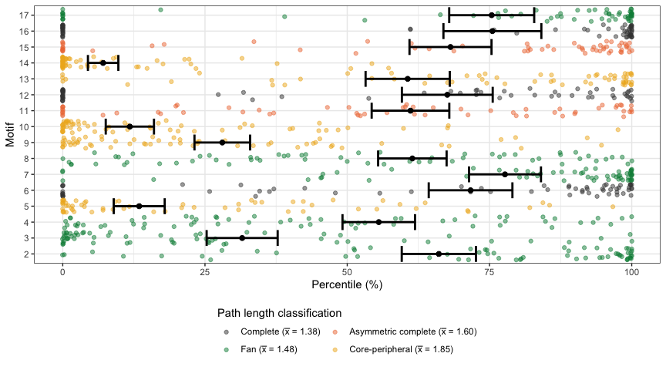

Figure S3. Comparison of the motif frequencies between empirical and simulated networks. Average percentages of motifs close to 0 and 100 indicate under- and over- representation in empirical networks, after removing non-robust links, that is, interactions whose frequency was equal to one. The different motifs are coloured by the mean path length as done in Simmons et al. (2020).

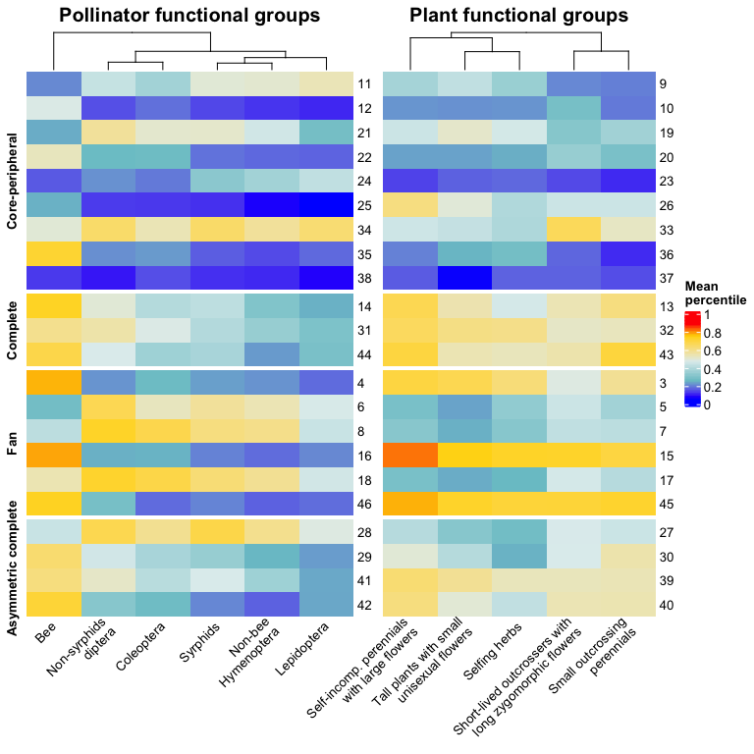

Figure S4. Heatmap indicating under- and over- representation of pollinator and plant functional groups in the different motif positions, after removing non-robust links, that is, interactions whose frequency was equal to one. The different motif positions are dividied by the average path length clasification by Simmons et al. (2020).