Honeybee dominance reshapes floral resource use of wild pollinators across Europe
Lorenzo Marini¹,* | Jose B. Lanuza²
¹ DAFNAE, University of Padova, Viale dell’Università 16, Legnaro, Padova, Italy
² Mediterranean Institute for Advanced Studies (IMEDEA, UIB-CSIC), Mallorca, Balearic Islands, Spain
E-mail: lorenzo.marini@unipd.it; tel.: +39 049 827 2807

ABSTRACT
Apis mellifera L. (the western honeybee) is one of the most abundant and frequent pollinator species worldwide. Its high abundance is often associated with the introduction of managed colonies for honey production and crop pollination, raising concerns about potential impacts on wild pollinators. Using a European-level plant-pollinator interaction dataset, we quantified resource overlap between honeybees and wild pollinators, and changes in diet specialisation along a gradient of honeybee dominance across Europe. Increasing dominance reduced resource use overlap between honeybees and wild pollinators indicating strong floral niche partitioning, yet wild pollinators became more generalist, visiting a greater diversity of floral resources. Using location-scale models, we also observed a more inconsistent and unpredictable behaviour across wild pollinators when honeybees were very abundant. High local floral diversity provided increasing foraging opportunities for wild pollinators, but it did not mitigate these effects. Our results suggest that avoidance and interference behaviours between managed and wild pollinators are common across Europe, but the importance of these resource use shifts for pollinator population dynamics, changes in community diversity, and ecosystem functioning in the long term remains an open question.

INTRODUCTION
Apis mellifera L. (the western honeybee) is one of the most abundant and frequent pollinator species occurring across both agricultural and natural landscapes (Hung et al. 2018). Its high abundance is often associated with the introduction of managed colonies for honey production and crop pollination (Gazzea et al. 2023; Visick & Ratnieks 2023), raising concerns about potential impacts on wild pollinators due to competition for floral resources (Iwasaki & Hogendoorn 2022; Thomson & Page 2020) and pathogens’ spillover (Maurer et al. 2024). Field studies manipulating colony density in the short term have shown that honeybees can often cause competitive displacement through the use of shared resources (Hudewenz & Klein 2015; Magrach et al. 2017, 2025; Pasquali et al. 2025; Valido et al. 2019), forcing other pollinators to forage on alternative plants that are less preferred by the honeybee (Page & Williams 2023; Pasquali et al. 2025; Thomson 2004; Thomson 2016; Travis et al. 2025). This finding is consistent with the low plant specialisation, opportunistic foraging behaviour, and high population density of this species (Lowe et al. 2023). Manipulative experiments involving the exclusion or supplementation of honeybees are complex due to their widespread distribution and long foraging distances. As a result, we still lack a comprehensive synthesis to evaluate how common these processes are across different biogeographical regions, climates, and habitats.
Quantifying resource overlap between the honeybee and wild pollinators and their diet specialisation across ecological networks can provide a complementary approach to detect shifting preferences along a gradient of honeybee dominance (Cappellari et al. 2022). When floral resources are limited and pollinators compete asymmetrically, low resource overlap and an altered foraging breadth should emerge, indicating potential competitive displacement in which a superior competitor forces inferior competitors to shift their niche and feed on sub-optimal floral resources (Magrach et al. 2017; Pascual Tudanca et al. 2025; Pasquali et al. 2025). Such displacement can reduce the abundance of the inferior competitor (Lindström et al. 2016; Thomson 2016), or, in the most extreme cases, lead to their local disappearance (Lázaro et al. 2021). Low plant diversity can increase resource overlap between honeybees and other pollinators due to the lack of alternative floral resources, forcing species to forage on the same plants (Bernhardsson et al. 2024; Page et al. 2024), while functional trait similarity (e.g., body size and tongue length) can also reshape resource use (Cappellari et al. 2022). Insect pollinators are highly diverse, with Hymenoptera, Diptera, Lepidoptera and Coleoptera representing the key flower-visiting orders, which differ in life histories, nesting requirements, diet preferences, and floral resource specialisation. Yet most research has focused on the relationship between honeybees and wild bees (Iwasaki & Hogendoorn 2022) with limited understanding of the responses of other key pollinator groups to increased honeybee dominance.
Using the European plant-pollinator network database (Lanuza et al. 2025), this study provides the first continental synthesis of the effect of honeybee dominance on resource overlap and diet specialisation across more than 1800 species of wild pollinators, including wild bees, hoverflies, butterflies and beetles. Based on more than 649 independent networks and 1625 sampling events, the role of the honeybee across European plant-pollinator networks was assessed in terms of visitation rate patterns and floral resource use. It was tested whether increasing dominance of the honeybee in the networks broadened the foraging breadth of co-occurring wild pollinators and reduced their resource overlap with the honeybee, indicating a potential intensification of competition for floral resources (see Fig. 1 for a conceptual summary). Using recently developed scale-location models, we also explored the variability in pollinator response. These relationships were examined across the major biogeographical, climatic, and land-use gradients in Europe.
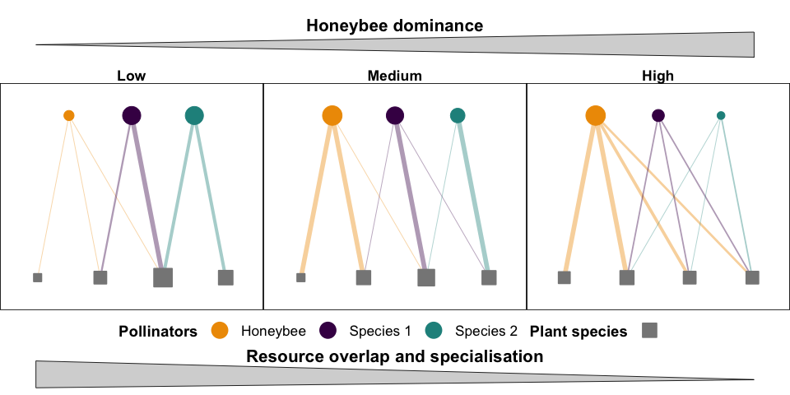
Figure 1. Conceptual graph showing how increasing honeybee dominance reshapes resource overlap and diet specialisation of wild pollinators. Three scenarios of plant-pollinator networks with low, medium, and high honeybee dominance are shown. As honeybee dominance increases, resource overlap between honeybees and wild pollinators decreases, while wild pollinators become more generalist. The variability in wild pollinator responses also increases under high honeybee dominance, indicating more inconsistent foraging behaviour across species. Three pollinator species are shown with solid points: honeybee (orange), pollinator species 1 (purple), and pollinator species 2 (green). Four plant species are displayed with filled squares, all in grey. These nodes are proportional to each species’ total interactions, and edges represent interaction strengths between plants and pollinators, with line widths proportional to interaction weights.

MATERIALS AND METHODS
Data
This work uses the recently compiled database of European plant-pollinator networks [EuPPolNet; Lanuza et al. (2025)]. The harmonised taxonomy across the different networks enabled testing for resource overlap and diet specialisation at the species level across multiple networks. Weighted networks that met the following criteria were included: i) presence of honeybees, ii) more than one plant species, and iii) more than one pollinator species. The pollinator species were pooled into six non-overlapping taxonomic groups that are expected to interact differently with the honeybee due to distinct behavioural and morphological traits: wild bees (hymenopteran families: Apidae, Halictidae, Andrenidae, Colletidae, Megachilidae, Melittidae), non-bee hymenopterans (all families excluding wild bees), lepidopterans, coleopterans, hoverflies (dipteran family: Syrphidae), and non-syrphid flies (all dipteran families excluding Syrphidae). The final filtered dataset comprised 592 independent networks from 46 studies with a total of 1634 sampling events.
Resource overlap and diet specialisation
For each sampling event per network, we used the observed interactions to compute the Morisita-Horn index (Horn 1966) to quantify resource overlap between each focal pollinator species and the honeybee:
$$\text{Morisita-Horn}=\frac{2\sum_{k}^{S}{p_{k}}h_{k}}{\left(\sum_{k}^{S}{\left(\frac{p_{k}^{2}}{P^{2}}\right)}+\sum_{k}^{S}{\left(\frac{h_{k}^{2}}{H^{2}}\right)}\right)PH}$$
Here, $p_{k}$ is the number of interactions of the focal pollinator species with each plant species k and $h_{k}$ is the number of interactions of the honeybee with each plant $k$. $S$ is the number of plant species, $P$ the total number of interactions of the focal pollinator, and $H$ is the total number of interactions of the honeybee. This symmetric index ranges from 0 (no shared use of resources) to 1 (identical resource use profile). The index normalises visits for each species by its total, using the relative distributions of resource use. Hence, it is not mathematically related to the abundance of focal pollinators or honeybees. The Müller index was not used as it is directional and mathematically related to honeybee dominance, ranging from 0 when honeybees are rare to 1 when they dominate the network, i.e. irrespective of the resource overlap, if honeybees are rare visitors overall, observed Müller index values will tend to 0, while if honeybees numerically dominate the network, Müller index values will inflate toward 1.
For each pollinator, we also estimated two complementary measures of diet specialisation, normalised degree and PDI (Poisot et al. 2012). Normalised degree is defined as $\frac{k_{i}}{N_{\text{plant}}}$, where k is the species degree (number of plant species visited by pollinator i) and $N_{\text{plant}}$ is the total number of plant species in the network. As normalised degree is mathematically constrained by the number of plant species in a network, values are not directly comparable among networks with different plant species richness.
The pair difference index (PDI) was computed using its normalised version. For a species with interaction strengths $w_{1}≥w_{2}≥…≥w_{k}$ across $k$ plants, we set $p_{i}=\frac{w_{i}}{max\left(w\right)}$ so that $p_{1}=1$. The index is defined as:
$$PDI_{\text{norm}}=\frac{\sum_{i}^{k}{\left(1-p_{i}\right)}}{k-1}$$
The index lies between 0 and 1, with 0 indicating a perfect generalist (visiting all plants equally), and 1 a perfect specialist (visiting a single plant). The Kullback-Leibler distance [d’; Blüthgen et al. (2006)] was not used, as in the absence of independent data on plant abundance, the metric d’ is sensitive to the behaviour of the other pollinator species in the network, and the metric becomes mathematically related to the abundance of any dominant species (Poisot et al. 2012).
Null models
Most node-level metrics computed across networks can be affected by overall network topology. Null models can be used effectively to compare metrics across networks, removing the effect of neutral processes (Blüthgen & Staab 2024). For each network and sampling event, we created 500 null models using the Patefield algorithm (Patefield 1981). This null model maintains the total interactions of both pollinator and plant species constant. We used this null model because the total number of interactions per pollinator reflects the local abundance of honeybees and other pollinators in the habitat, while keeping the total number of interactions per plant constant preserves the fact that some plant species are inherently more attractive to pollinators than others. While keeping these constraints, the null model randomly reshuffled pollinator visits across plants. For each species, mean and SD from the 500 null models were computed for all metrics and used to compute standardised effect sizes: $SES=\frac{\left(\text{observed}-{\text{mean}}_{\text{null}}\right)}{SD_{\text{null}}}$. Due to the generating constraints of the Patefield algorithm, in some networks, SES could not be computed because SD approximated 0. In further analyses, networks with SD = 0 or IQR = 0 were removed as SES could not be defined.
Drivers
In the EuPPollNet database, each network contains information on geographical coordinates, sampled habitat, date of the sampling, and biogeographical regions. Summer mean temperature was derived by averaging the monthly averages from May to September for each sampling site (i.e., network) using the Chelsea database (Karger et al. 2023). Since there was a strong collinearity between climate and habitats, the original habitat types were grouped in two broad categories: (i) natural habitats including forest/woodland, riparian vegetation, semi-natural grasslands, moors and heathland, sclerophyllous vegetation, montane to alpine grasslands, beaches, dunes and sands; and (ii) anthropogenic habitats including intensive grasslands, agricultural land, agricultural margins, green urban areas, and ruderal vegetation. At the network level and for each sampling event, we computed the total number of plant partners, the total number of pollinator species, and the honeybee dominance as the ln-ratio of total honeybee interactions and non-honeybee interactions. The ln-ratio is 0 when honeybee interactions are equal to the sum of the interactions of all other pollinators sampled. We could not use the total abundance of honeybees because sampling effort differed across studies. Although the database includes information on floral abundance, inconsistent sampling methodologies limited its use, and only 74% of the studies reported such data.
Data analysis
Resource overlap with the honeybee and foraging breadth of wild pollinators
The three metrics (i.e., Morisita-Horn index, normalised degree, and PDI) were transformed into standardised effect sizes (SESs) and used as response variables in generalised linear mixed models (GLMMs) with a Gaussian distribution in the glmmTMB package (McGillycuddy et al. 2025). For each response, a location-scale model was fitted. Although ecological data often exhibit non-constant variance, this pattern is commonly treated as noise that violates the assumptions of statistical models, while heteroscedasticity can sometimes reflect meaningful ecological processes (Cleasby & Nakagawa 2011). The location component (conditional in glmmTMB) tested the effect of pollinator group, honeybee dominance, number of plant partners, temperature and habitat type on the SES mean of each metric. A quadratic term for dominance was also tested, and the term was removed when linearity could not be rejected (P > 0.05). Two interactions were also tested: honeybee dominance with pollinator taxonomic groups and honeybee dominance with floral richness. The first model tested whether the six pollinator taxonomic groups responded differently to the honeybees, while the second tested whether the availability of floral partners modified the honeybee dominance effect on wild pollinators. A hierarchical random-effects structure was used, with date nested within the network ID and the network ID nested within the study ID, to account for the non-independence of sampling events within networks and within studies. In addition, a scale component (dispformula in glmmTMB) was used to test whether the number of floral partners and honeybee dominance affected the variance of the SES residuals. The same random structure was included in the scale component, but it was fitted independently from the conditional, as correlated random effects are not implemented in glmmTMB. Models with and without the scale component were compared with the likelihood ratio test using AIC. In all models, likelihood ratio tests (LRTs) always supported the inclusion of the two predictors and the random structure in the scale component. We tested for potential collinearity among predictors using a global model with no interactions using the check_collinearity() function in the performance package (Lüdecke et al. 2021). All predictors included in the modelling exhibited low variance inflation factors (VIFs < 1.5). Continuous predictors were scaled using the scale() function. Model diagnostics were performed using the DHARMa package (Hartig 2016). All models performed well except for Morisita-Horn, which presented a slight deviation. All analyses were run using R version 4.5.1.
Sensitivity analysis
As resource overlap and diet specialisation metrics could be influenced by species degree and abundance, a sensitivity analysis was conducted, where focal pollinator species were removed based on their total number of interactions per network and sampling event. Main text analyses included only pollinator species with at least five interactions and a minimum of five honeybees per network. In the Supplementary Information, we present the same models using different interaction thresholds per network and sampling event (minimum = 2 and 10 interactions). Results were qualitatively similar and showed strong consistency in the observed patterns.

RESULTS
General results
Honeybees visited approximately 50% of all plant species in the dataset. Only 3.5% of plants were visited exclusively by the honeybee. They contributed on average 36% of the interactions per network (Fig. 2 and Fig. S1), ranging from networks where they were present only sporadically and at low density (under 1% of visits) to networks where they were consistently the main visitor (up to 98% of visits). As expected, there was a positive linear association between floral richness and pollinator richness across networks (Fig. 3). Both floral and pollinator species richness showed a weak correlation with honeybee normalised degree, with a trend for higher normalised degree at low species richness values. In the sampled networks, honeybee dominance was weakly negatively correlated with floral and pollinator richness and positively with honeybee normalised degree (Fig. 3). Covariation patterns were consistent when all networks of the datatset were included (Fig. S2).
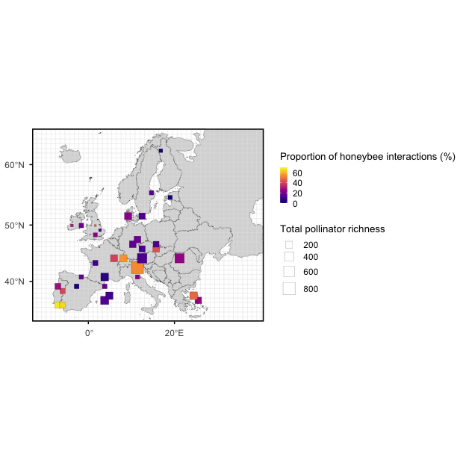
Figure 2. Approximate locations of the studies, showing the proportion of honeybee interactions weighted by the total number of pollinator species in each study.

Resource overlap
The standardised effect sizes (SESs) of Morisita-Horn were mainly negative, indicating that in most cases, wild pollinators co-occurring with the honeybee exhibited a lower resource overlap than expected from the null models. The location component on the mean SES supported an interaction between pollinator group and honeybee dominance (Table S1a), with a steeper slope for coleopterans and syrphids compared to other groups (Fig. 4a). The interaction between the number of plants and dominance was not strongly supported, while the number of plants available in the network reduced resource overlap. No effect of temperature or habitat was found. The scale component indicated an increase in the SES residual variance with dominance and a decrease with floral richness (Table S1b), meaning that pollinator resource overlap became more variable at high dominance and low floral richness.
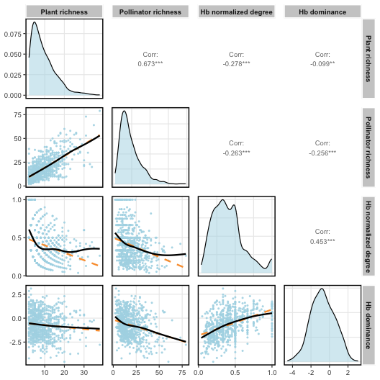
Figure 3. Scatterplots showing the relationships between the two components of network size (i.e., plant and pollinator species richness) and honeybee normalized degree and dominance (log ratio of honeybee interactions over total interactions), restricted to networks containing at least five honeybee individuals. The dashed orange line represents the linear regression, and the solid black line represents the GAM fitted with cubic regression splines. Each point corresponds to an independent sampling event within a network. Diagonal panels represent variable density distributions, while upper panels indicate Pearson correlation coefficients between metrics.
Diet specialization
The SESs for the paired difference index (PDI) were mostly positive or near 0, indicating that pollinator specialisation tended to be relatively higher than or similar to the expected values from the null models. The location-scale component indicated that mean PDI declined non-linearly with increasing honeybee dominance for all groups, except for the coleopterans, which showed an opposite pattern (Fig. 4B). Coleopterans and lepidopterans were those with higher specialisation. There was a weak interaction between dominance and floral richness on mean PDI, with a slightly steeper negative slope in networks with more flowering species. Networks sampled in warmer regions presented higher pollinator specialisation (Table S2a). The dispersion component indicated a negative effect of floral richness on the PDI residual variability, while dominance did not have an effect (Table S2b).
The SESs of normalised degree were mainly negative or near 0, indicating that the pollinator use of the available plants tended to be relatively lower than or similar to the expected values from the null models. Consistent with PDI, an interaction between taxonomic group and dominance was found (Table S3a), with normalised degree increasing with honeybee dominance in all groups except for coleopterans, which exhibited an opposite pattern (Fig. 4C). An interaction between floral richness and dominance was also observed, where mean normalised degree declined with increasing floral richness but only at low dominance values. The dispersion component indicated an increase in the SES residual variance of normalised degree with dominance and a decrease with floral richness (Table S3b).
Model performance and sensitivity
The residuals’ diagnostics for the four scale-location models were satisfactory, given the complexity of the data and the modelling. The deviations were minor, but statistically significant due to the large number of observations. The sensitivity analysis indicated that removing species with different thresholds of minimum interactions per network (n = 2, and 10) did not alter the observed patterns (Tables S4-S5-S6 and Figure S3 for a threshold of 2 interactions, and Tables S7-S8-S9 and Figure S4 for a threshold of 10 interactions).
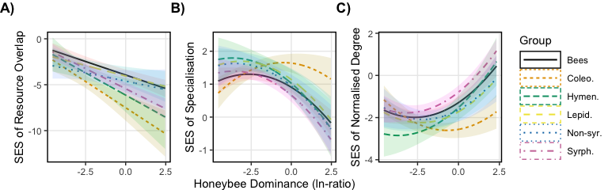
Figure 4. Effect of honeybee dominance on the standardised effect size (SES) of A) resource overlap with the honeybee (Morisita-Horn index), B) specialisation (PDI) and C) normalised degree of wild pollinators across different groups of flower-visiting insects: bees, coleopterans (Coleo.), non-bee hymenopterans (Hym.), lepidopterans (Lepid.), non-syrphid Diptera (Non-syr.), and syrphids (Syrph.). Lines represent predicted values from location-scale glmm. The analysis included networks with at least 5 honeybee individuals and wild pollinator species with at least 5 individuals per sampling event.

DISCUSSION
Honeybees were dominant visitors across European plant-pollinator networks, and their increasing dominance was associated with a systematic decline in floral resource overlap with co-occurring wild pollinators, as well as a broader and more variable foraging breadth among co-occurring species. Although the observed associations were consistent across natural and disturbed habitats and climatic gradients, the major pollinator groups did not respond equally to honeybee dominance. As honeybees are known to remove a large share of floral resources, often from the most abundant and rewarding flowering species (Hung et al. 2018), this finding suggests that honeybees can reshape the resource use of co-occurring wild pollinator species (Magrach et al. 2025). How important these diet shifts are for population dynamics, in community diversity, or ecosystem functioning remains an open question (Beaurepaire et al. 2025; Pascual Tudanca et al. 2024).
The observed low interactions of wild pollinators with the flowering species visited by the honeybee may reflect a direct response to resource depletion, but possibly also to deterrent scent cues or other indicators of honeybee presence (Stout & Goulson 2001). Although the direction and the mechanisms underlying this avoidance behaviour are still not fully understood, reduced resource use overlap between the honeybee and other wild bees has been reported in many experimental and observational studies (Cappellari et al. 2022; Magrach et al. 2025; Page & Williams 2023). Manipulative studies that have excluded honeybees have demonstrated that a reduced resource overlap is often associated with short-term foraging shifts that can be reversed when honeybees are removed from the community (Pasquali et al. 2025). This pattern might also be affected by plant diversity, where increasing plant niche space generally reduces the probability of intra-species contact, providing more foraging opportunities to co-occurring species (Gómez-Martı́nez et al. 2022). The inclusion of a large number of networks with a harmonised taxonomy allowed us to test whether this reduced overlap changed for the major European pollinator groups. On the one hand, wild bees and lepidopterans exhibited a relatively higher overlap with the honeybee than other groups, consistent with the similar nectar requirements of these taxa. On the other hand, coleopterans exhibited the lowest overlap. Observed coleopterans, such as Scarabaeidae (Cetoniinae), Oedemeridae, Nitidulidae, and Melyridae, are often florivores that, besides removing pollen and nectar, frequently damage flower parts, thereby reducing flower attractiveness for pollinators (Haas & Lortie 2020). Coleopterans usually select flower species mainly based on their greater longevity, spending a long time feeding on the same species (Camurça et al. 2024). Hence, it is likely that the observed reduced overlap was a consequence of honeybees avoiding flowers either damaged or occupied by florivores (Boaventura et al. 2022). In addition, we cannot exclude the possibility that other species can also push the honeybee away from preferred resources (Inouye 1978; Taggar et al. 2021).
The scale-location model also indicated that not only the mean resource overlap was affected by the honeybee, but also its variability. This contrasts with many ecological and behavioural studies where variability is often assumed to be constant, potentially masking informative environmental and biological patterns in the data (Nakagawa et al. 2025). An increase in behavioural variability in pollinators in the presence of a dominant pollinator is consistent with a trait-mediated shift in behaviour. Species differ in their ability to avoid honeybee-used plants (e.g. tongue length, body size, handling time, floral preferences) and under intense honeybee pressure, some species shift away (low overlap), while others are unable to avoid or even track the same rewarding resources due to their trait similarity with the honeybee (Cappellari et al. 2022).
Optimal foraging theory also suggests that when resources are abundant and diverse and species are not competing strongly, pollinators should concentrate on a few most-preferred plants and have narrow food niches, while increased competition usually forces inferior competitors to become more generalist in their resource use (MacArthur & Pianka 1966). After removing the effects of neutral processes using null models, we observed a general decrease in diet specialisation with increasing honeybee dominance for all pollinator taxonomic groups, except for florivorous coleopterans. Again, pollinator taxonomic groups showed contrasting responses likely due to trait-mediated differences in their ability to adjust their foraging behaviour under increased honeybee dominance. An interaction between floral diversity and honeybee dominance was also found, with a more pronounced specialisation with increasing floral diversity only at low dominance, while at high dominance levels, specialisation did not depend on floral diversity. Again, the location-scale model also detected an increase in the variability of responses among species, suggesting that honeybee pressures might amplify intra- and interspecific differences, likely driven by morphological and behavioural traits affecting resource use (Cappellari et al. 2022).
Although species can adjust to competition by shifting their diets, the coexistence of a superabundant pollinator such as the honeybee and native pollinators can be fragile. It is important to stress that asymmetric competition among pollinators is probably the rule across plant-pollinator networks (Sponsler & Bratman 2021), and it has been observed in many other pollinator species besides the honeybee (Inouye 1978; Taggar et al. 2021). However, several studies examining nectar and pollen landscapes have indicated that honeybee-induced diet shifts are often associated with poorer nutritional quality in wild pollinator diets (Page et al. 2024; Wignall et al. 2020). Hence, the effectiveness of conservation interventions for wild pollinators, in particular across agricultural landscapes, should always consider the potential competition with the honeybees (Bommarco et al. 2021; Raderschall et al. 2022). At the same time, maintaining honeybee populations across agricultural landscapes is crucial for delivering adequate crop pollination. Under these circumstances, it is vital to identify the minimum number of honeybee hives to balance yield and biodiversity by providing needed pollination for the crop while minimising competition with wild pollinators (Fijen et al. 2022). From a wild plant pollination perspective, the consequences of these diet shifts are difficult to predict and are expected to be strongly context-dependent (Gao et al. 2025; Magrach et al. 2017; Pascual Tudanca et al. 2024; Valido et al. 2019). Ultimately, the observed avoidance behaviours and the dominant role of honeybees suggest that interactions within pollinator communities are far from neutral and that more research is needed to understand the direction and mechanisms of potential antagonistic interactions. Although managed honey bees per se may not be a conservation priority, beekeeping is deeply rooted in the human-nature history (Sponsler & Bratman 2021) and is associated with key cultural services, highlighting the need to co-create effective, context-relevant strategies to reconcile beekeeping and the conservation of wild pollinators.

ACKNOWLEDGEMENTS
The research was supported by the European Union’s Horizon 2020 329 project “Safeguard” (Grant agreement ID: 101003476) funded under Societal Challenges - Climate 330 action, Environment, Resource Efficiency and Raw Materials to L.M.

AUTHORS’ CONTRIBUTIONS
Conceptualization: L.M., Formal analysis: L.M. & J.B.L., Resources: J.B.L., Writing - Original Draft: L.M., Writing - Review & Editing: L.M. & J.B.L., Supervision: L.M., Funding Acquisition: L.M.

REFERENCES
Beaurepaire, A.L., Hogendoorn, K., Kleijn, D., Otis, G.W., Potts, S.G., Singer, T.L., et al. (2025). Avenues towards reconciling wild and managed bee proponents. Trends in ecology & evolution, 40, 7–10.
Bernhardsson, O., Kendall, L., Olsson, O., Olsson, P. & Smith, H.G. (2024). Shared use of a mass-flowering crop drives dietary niche overlap between managed honeybees and bumblebees. Journal of Applied Ecology, 61, 2135–2145.
Blüthgen, N., Menzel, F. & Blüthgen, N. (2006). Measuring specialization in species interaction networks. BMC ecology, 6, 9.
Blüthgen, N. & Staab, M. (2024). A critical evaluation of network approaches for studying species interactions. Annual Review of Ecology, Evolution, and Systematics, 55.
Boaventura, M.G., Villamil, N., Teixido, A.L., Tito, R., Vasconcelos, H.L., Silveira, F.A., et al. (2022). Revisiting florivory: An integrative review and global patterns of a neglected interaction. New Phytologist, 233, 132–144.
Bommarco, R., Lindström, S.A., Raderschall, C.A., Gagic, V. & Lundin, O. (2021). Flower strips enhance abundance of bumble bee queens and males in landscapes with few honey bee hives. Biological Conservation, 263, 109363.
Camurça, L.M., Santos, A.M.M., Castro, C.C. & Leite, A.V. (2024). Trophic interactions between plants, pollinators, florivores and predators: A global systematic review. Biological Journal of the Linnean Society, 141, 214–222.
Cappellari, A., Bonaldi, G., Mei, M., Paniccia, D., Cerretti, P. & Marini, L. (2022). Functional traits of plants and pollinators explain resource overlap between honeybees and wild pollinators. Oecologia, 198, 1019–1029.
Cleasby, I.R. & Nakagawa, S. (2011). Neglected biological patterns in the residuals: A behavioural ecologist’s guide to co-operating with heteroscedasticity. Behavioral Ecology and Sociobiology, 65, 2361–2372.
Fijen, T.P., Bodegraven, V. van & Lucassen, F. (2022). Limited honeybee hive placement balances the trade-off between biodiversity conservation and crop yield of buckwheat cultivation. Basic and Applied Ecology, 65, 28–38.
Gao, E., Qiu, Y., Yan, X., Ma, H., Wang, Y., Bi, C., et al. (2025). Managed honey bees aggravate pollination challenges for pollen-limited species in alpine meadows. Journal of Applied Ecology, 62, 2261–2272.
Gazzea, E., Batary, P. & Marini, L. (2023). Global meta-analysis shows reduced quality of food crops under inadequate animal pollination. Nature Communications, 14, 4463.
Gómez-Martı́nez, C., González-Estévez, M.A., Cursach, J. & Lázaro, A. (2022). Pollinator richness, pollination networks, and diet adjustment along local and landscape gradients of resource diversity. Ecological Applications, 32, e2634.
Haas, S.M. & Lortie, C.J. (2020). A systematic review of the direct and indirect effects of herbivory on plant reproduction mediated by pollination. PeerJ, 8, e9049.
Hartig, F. (2016). DHARMa: Residual diagnostics for hierarchical (multi-level/mixed) regression models. CRAN: Contributed Packages.
Horn, H.S. (1966). Measurement of" overlap" in comparative ecological studies. The American Naturalist, 100, 419–424.
Hudewenz, A. & Klein, A.-M. (2015). Red mason bees cannot compete with honey bees for floral resources in a cage experiment. Ecology and Evolution, 5, 5049–5056.
Hung, K.-L.J., Kingston, J.M., Albrecht, M., Holway, D.A. & Kohn, J.R. (2018). The worldwide importance of honey bees as pollinators in natural habitats. Proceedings of the Royal Society B: Biological Sciences, 285, 20172140.
Inouye, D.W. (1978). Resource partitioning in bumblebees: Experimental studies of foraging behavior. Ecology, 59, 672–678.
Iwasaki, J.M. & Hogendoorn, K. (2022). Mounting evidence that managed and introduced bees have negative impacts on wild bees: An updated review. Current Research in Insect Science, 2, 100043.
Karger, D.N., Lange, S., Hari, C., Reyer, C.P., Conrad, O., Zimmermann, N.E., et al. (2023). CHELSA-W5E5: Daily 1 km meteorological forcing data for climate impact studies. Earth System Science Data, 15, 2445–2464.
Lanuza, J.B., Knight, T.M., Montes-Perez, N., Glenny, W., Acuña, P., Albrecht, M., et al. (2025). EuPPollNet: A european database of plant-pollinator networks. Global Ecology and Biogeography, 34, e70000.
Lázaro, A., Müller, A., Ebmer, A.W., Dathe, H.H., Scheuchl, E., Schwarz, M., et al. (2021). Impacts of beekeeping on wild bee diversity and pollination networks in the aegean archipelago. Ecography, 44, 1353–1365.
Lindström, S.A., Herbertsson, L., Rundlöf, M., Bommarco, R. & Smith, H.G. (2016). Experimental evidence that honeybees depress wild insect densities in a flowering crop. Proceedings of the Royal Society B: Biological Sciences, 283, 20161641.
Lowe, A., Jones, L., Brennan, G., Creer, S., Christie, L. & Vere, N. de. (2023). Temporal change in floral availability leads to periods of resource limitation and affects diet specificity in a generalist pollinator. Molecular Ecology, 32, 6363–6376.
Lüdecke, D., Ben-Shachar, M.S., Patil, I., Waggoner, P. & Makowski, D. (2021). Performance: An r package for assessment, comparison and testing of statistical models. Journal of open source software, 6.
MacArthur, R.H. & Pianka, E.R. (1966). On optimal use of a patchy environment. The American Naturalist, 100, 603–609.
Magrach, A., González-Varo, J.P., Boiffier, M., Vilà, M. & Bartomeus, I. (2017). Honeybee spillover reshuffles pollinator diets and affects plant reproductive success. Nature Ecology & Evolution, 1, 1299–1307.
Magrach, A., Tobajas, E. & Martin, P.A. (2025). Negative ecological impacts of honeybees begin at densities below recommended levels for crop pollination. Journal of Applied Ecology, 62, 2089–2095.
Maurer, C., Schauer, A., Yañez, O., Neumann, P., Gajda, A., Paxton, R.J., et al. (2024). Species traits, landscape quality and floral resource overlap with honeybees determine virus transmission in plant–pollinator networks. Nature Ecology & Evolution, 8, 2239–2251.
McGillycuddy, M., Popovic, G., Bolker, B.M. & Warton, D.I. (2025). Parsimoniously fitting large multivariate random effects in glmmTMB. Journal of Statistical Software, 112, 1–19.
Nakagawa, S., Mizuno, A., Morrison, K., Ricolfi, L., Williams, C., Drobniak, S.M., et al. (2025). Location-scale meta-analysis and meta-regression as a tool to capture large-scale changes in biological and methodological heterogeneity: A spotlight on heteroscedasticity. Global Change Biology, 31, e70204.
Page, M.L., Francis, J.S., Müller, U. & Williams, N.M. (2024). Wildflower plantings and honeybee competition impact nutritional quality of wild bee diets. Journal of Applied Ecology, 61, 3104–3113.
Page, M.L. & Williams, N.M. (2023). Evidence of exploitative competition between honey bees and native bees in two california landscapes. Journal of Animal Ecology, 92, 1802–1814.
Pascual Tudanca, M.P., Debandi, H. & Vázquez, D.P. (2024). Managed honeybee hives negatively affect the reproduction of native plants in a dryland nature reserve. Journal of Applied Ecology, 61, 1301–1311.
Pascual Tudanca, M.P., Medero, A.V. & Vázquez, D.P. (2025). Beekeeping in natural areas and its effects on wild bees. Biological Conservation, 305, 111097.
Pasquali, L., Bruschini, C., Benetello, F., Bonifacino, M., Giannini, F., Monterastelli, E., et al. (2025). Island-wide removal of honeybees reveals exploitative trophic competition with strongly declining wild bee populations. Current Biology, 35, 1576–1590.
Patefield, W. (1981). Efficient method of generating random r x c tables with given row and column totals: Algorithm AS 159. Applied Statistics, 30, 91–7.
Poisot, T., Canard, E., Mouquet, N. & Hochberg, M.E. (2012). A comparative study of ecological specialization estimators. Methods in Ecology and Evolution, 3, 537–544.
Raderschall, C.A., Lundin, O., Lindström, S.A. & Bommarco, R. (2022). Annual flower strips and honeybee hive supplementation differently affect arthropod guilds and ecosystem services in a mass-flowering crop. Agriculture, Ecosystems & Environment, 326, 107754.
Sponsler, D.B. & Bratman, E.Z. (2021). Beekeeping in, of or for the city? A socioecological perspective on urban apiculture. People and Nature, 3, 550–559.
Stout, J.C. & Goulson, D. (2001). The use of conspecific and interspecific scent marks by foraging bumblebees and honeybees. Animal behaviour, 62, 183–189.
Taggar, A.K., McGrath, E. & Despland, E. (2021). Competition between a native and introduced pollinator in unmanaged urban meadows. Biological Invasions, 23, 1697–1705.
Thomson, D. (2004). Competitive interactions between the invasive european honey bee and native bumble bees. Ecology, 85, 458–470.
Thomson, D.M. (2016). Local bumble bee decline linked to recovery of honey bees, drought effects on floral resources. Ecology letters, 19, 1247–1255.
Thomson, D.M. & Page, M.L. (2020). The importance of competition between insect pollinators in the anthropocene. Current Opinion in Insect Science, 38, 55–62.
Travis, D.J., Kohn, J.R., Holway, D.A. & Hung, K.-L.J. (2025). Pollen exploitation by non-native, feral honey bees: Potential consequences for interspecific competition. Insect Conservation and Diversity.
Valido, A., Rodrı́guez-Rodrı́guez, M.C. & Jordano, P. (2019). Honeybees disrupt the structure and functionality of plant-pollinator networks. Scientific reports, 9, 4711.
Visick, O.D. & Ratnieks, F.L. (2023). Density of wild honey bee, apis mellifera, colonies worldwide. Ecology and Evolution, 13, e10609.
Wignall, V.R., Brolly, M., Uthoff, C., Norton, K.E., Chipperfield, H.M., Balfour, N.J., et al. (2020). Exploitative competition and displacement mediated by eusocial bees: Experimental evidence in a wild pollinator community. Behavioral Ecology and Sociobiology, 74, 152.

SUPPLEMENTARY INFORMATION
Table 1. Scale-location model testing multiple predictors on the standardized effect size of pairwise resource overlap (Morisita-Horn) between the honeybee and wild pollinator species across European networks. The conditional component tested the effects of group, honeybee dominance (linear and quadratic terms), temperature, habitat, plant richness, and the interactions between dominance and group and between dominance and plant richness. The dispersion component tested the effects of dominance and plant richness on the residual variance. Both components included a hierarchical random-effects structure, with date nested within network ID and network ID nested within study ID. Each observation corresponded to a species with at least five individuals recorded in a sampling event that also contained at least five honeybees.
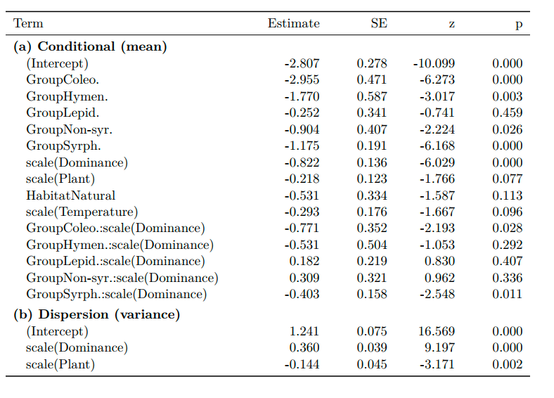

Table 2. Scale-location model testing multiple predictors on the standardized effect size of paired difference index (PDI) between the honeybee and wild pollinator species across European networks. The conditional component tested the effects of group, honeybee dominance (linear and quadratic terms), temperature, habitat, plant richness, and the interactions between dominance and group and between dominance and plant richness. The dispersion component tested the effects of dominance and plant richness on the residual variance. Both components included a hierarchical random-effects structure, with date nested within network ID and network ID nested within study ID. Each observation corresponded to a species with at least five individuals recorded in a sampling event that also contained at least five honeybees.
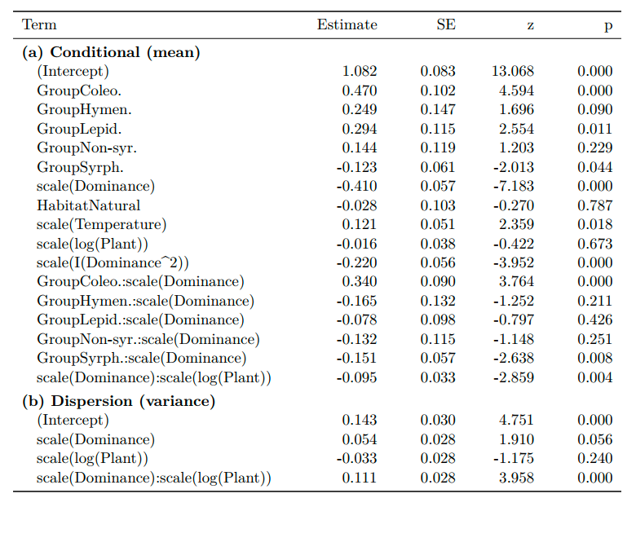

Table 3. Scale-location model testing multiple predictors on the standardized effect size of normalised degree between the honeybee and wild pollinator species across European networks. The conditional component tested the effects of group, honeybee dominance (linear and quadratic terms), temperature, habitat, plant richness, and the interactions between dominance and group and between dominance and plant richness. The dispersion component tested the effects of dominance and plant richness on the residual variance. Both components included a hierarchical random-effects structure, with date nested within network ID and network ID nested within study ID. Each observation corresponded to a species with at least five individuals recorded in a sampling event that also contained at least five honeybees.

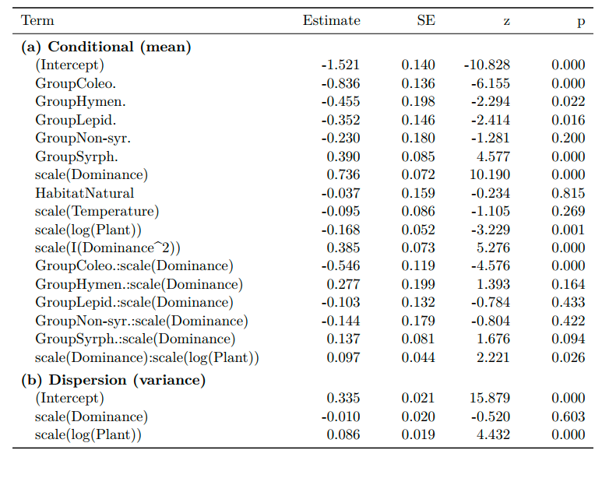

Table 4. Scale-location model from the sensitivity analysis applying a minimum interaction threshold of two species. The model tests multiple predictors on the standardized effect size of pairwise resource overlap (Morisita-Horn) between honeybees and wild pollinator species across European networks. The conditional component tested the effects of group, honeybee dominance (linear and quadratic terms), temperature, habitat, plant richness, and the interactions between dominance and group and between dominance and plant richness on mean PDI. The dispersion component tested the effects of dominance and plant richness. Both components included a hierarchical random-effects structure, with date nested within network ID and network ID nested within study ID. Each observation corresponded to a species with at least five individuals recorded in a sampling event that also contained at least five honeybees.
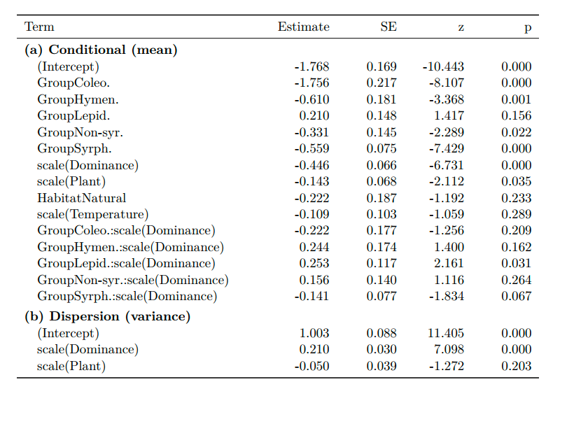

Table 5. Scale-location model from the sensitivity analysis applying a minimum interaction threshold of two species. The model tests multiple predictors on the standardized effect size of paired difference index (PDI) between honeybees and wild pollinator species across European networks. The conditional component tested the effects of group, honeybee dominance (linear and quadratic terms), temperature, habitat, plant richness, and the interactions between dominance and group and between dominance and plant richness. The dispersion component tested the effects of dominance and plant richness on the residual variance. Both components included a hierarchical random-effects structure, with date nested within network ID and network ID nested within study ID. Each observation corresponded to a species with at least five individuals recorded in a sampling event that also contained at least five honeybees.

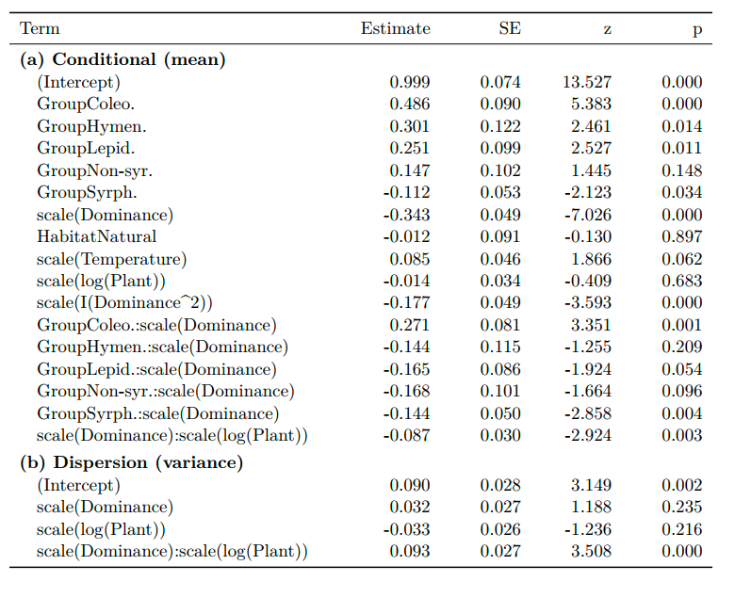
Table 6. Scale-location model from the sensitivity analysis applying a minimum interaction threshold of two species. The model tests multiple predictors on the standardized effect size of normalised degree between honeybees and wild pollinator species across European networks. The conditional component tested the effects of group, honeybee dominance (linear and quadratic terms), temperature, habitat, plant richness, and the interactions between dominance and group and between dominance and plant richness on mean PDI. The dispersion component tested the effects of dominance and plant richness. Both components included a hierarchical random-effects structure, with date nested within network ID and network ID nested within study ID. Each observation corresponded to a species with at least five individuals recorded in a sampling event that also contained at least five honeybees.
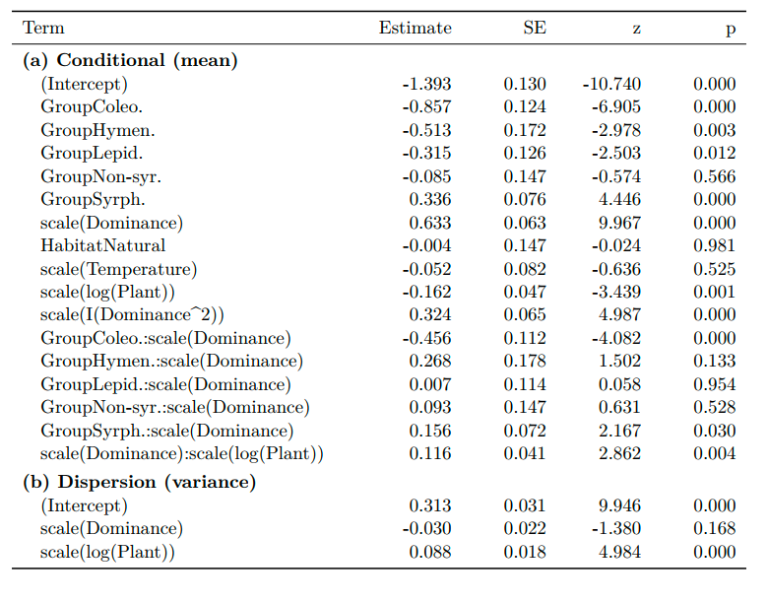
Table 7. Scale-location model from the sensitivity analysis applying a minimum interaction threshold of ten species. The model tests multiple predictors on the standardized effect size of pairwise resource overlap (Morisita-Horn) between honeybees and wild pollinator species across European networks. The conditional component tested the effects of group, honeybee dominance (linear and quadratic terms), temperature, habitat, plant richness, and the interactions between dominance and group and between dominance and plant richness on mean PDI. The dispersion component tested the effects of dominance and plant richness. Both components included a hierarchical random-effects structure, with date nested within network ID and network ID nested within study ID. Each observation corresponded to a species with at least five individuals recorded in a sampling event that also contained at least five honeybees.

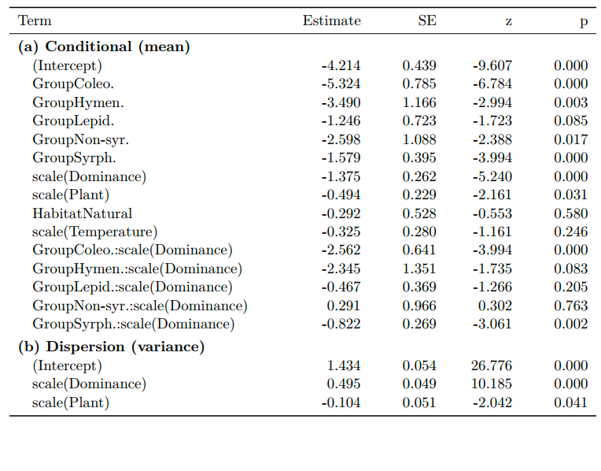

Table 8. Scale-location model from the sensitivity analysis applying a minimum interaction threshold of ten species. The model tests multiple predictors on the standardized effect size of paired difference index (PDI) between honeybees and wild pollinator species across European networks. The conditional component tested the effects of group, honeybee dominance (linear and quadratic terms), temperature, habitat, plant richness, and the interactions between dominance and group and between dominance and plant richness on mean PDI. The dispersion component tested the effects of dominance and plant richness. Both components included a hierarchical random-effects structure, with date nested within network ID and network ID nested within study ID. Each observation corresponded to a species with at least five individuals recorded in a sampling event that also contained at least five honeybees.
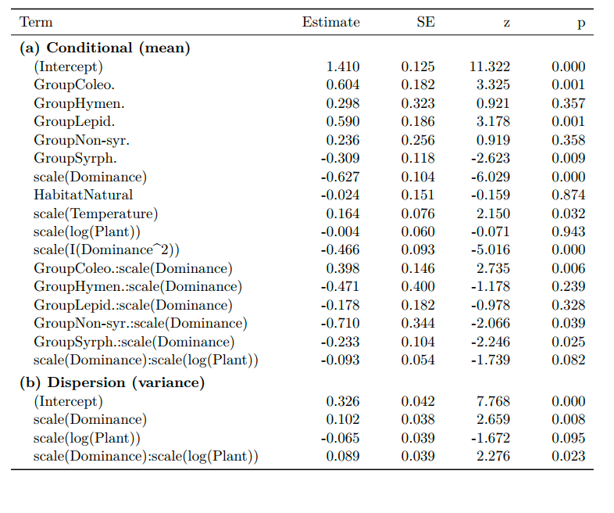
Table 9. Scale-location model from the sensitivity analysis applying a minimum interaction threshold of ten species. The model tests multiple predictors on the standardized effect size of normalised degree between honeybees and wild pollinator species across European networks. The conditional component tested the effects of group, honeybee dominance (linear and quadratic terms), temperature, habitat, plant richness, and the interactions between dominance and group and between dominance and plant richness on mean PDI. The dispersion component tested the effects of dominance and plant richness. Both components included a hierarchical random-effects structure, with date nested within network ID and network ID nested within study ID. Each observation corresponded to a species with at least five individuals recorded in a sampling event that also contained at least five honeybees.

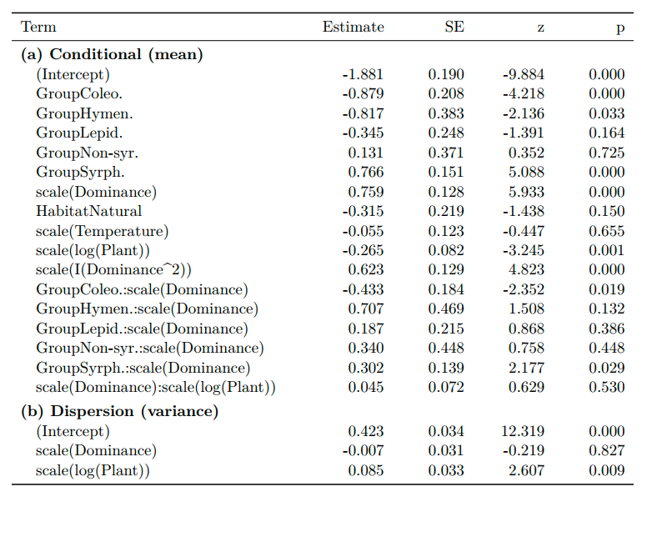

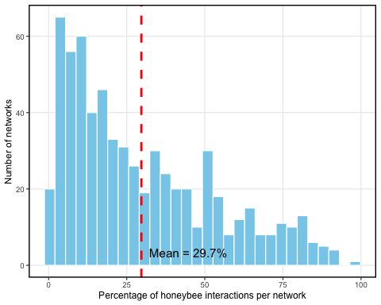
Figure S1. Histogram showing the mean proportion of interactions of honeybees per network. The average value across all networks is indicated with a vertical dashed red bar.

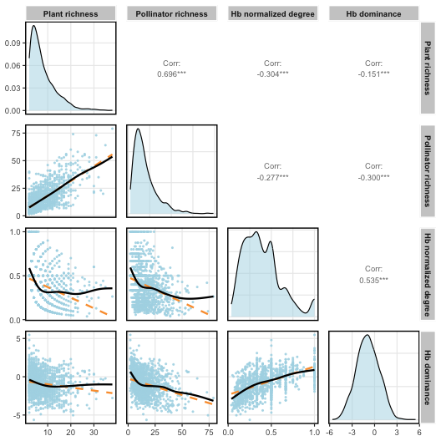
Figure S2. Scatterplots showing the relationships between the two components of network size (i.e., plant and pollinator species richness) and honeybee normalized degree and dominance (log ratio of honeybee interactions over total interactions), including all networks of the dataset. The dashed orange line represents the linear regression, and the solid black line represents the GAM fitted with cubic regression splines. Each point corresponds to an independent sampling event within a network. Diagonal panels represent variable density distributions, while upper panels indicate Pearson correlation coefficients between metrics.

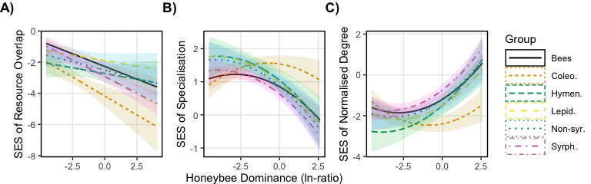
Figure S3. Effect of honeybee dominance on the standardised effect size (SES) of A) resource overlap (Morisita-Horn), B) specialisation (PDI), and C) normalised degree, shown for the sensitivity analysis applying a two-species minimum interaction threshold. The floral visitor groups are: bees, coleopterans (Coleo.), non-bee hymenopterans (Hym.), lepidopterans (Lepid.), non-syrphid Diptera (Non-syr.), and syrphids (Syrph.). Lines represent predicted values from the location-scale GLMM. The analysis included networks with at least five honeybee individuals and wild pollinator species with at least five individuals per sampling event.

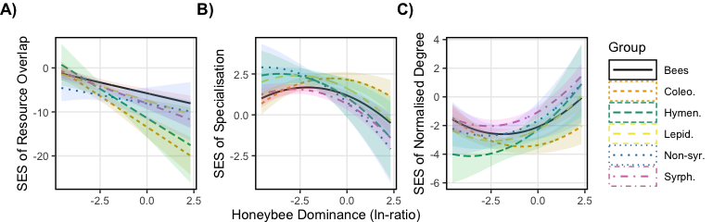
Figure S4. Effect of honeybee dominance on the standardised effect size (SES) of A) resource overlap (Morisita-Horn), B) specialisation (PDI), and C) normalised degree, shown for the sensitivity analysis applying a ten-species minimum interaction threshold. The floral visitor groups are: bees, coleopterans (Coleo.), non-bee hymenopterans (Hym.), lepidopterans (Lepid.), non-syrphid Diptera (Non-syr.), and syrphids (Syrph.). Lines represent predicted values from the location-scale GLMM. The analysis included networks with at least five honeybee individuals and wild pollinator species with at least five individuals per sampling event.

