HDFS - HADOOP

Dentro del proyecto tenemos definifos 3 capas de datalake

1ra capa

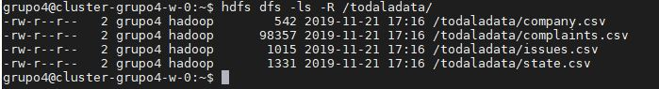

2nda capa

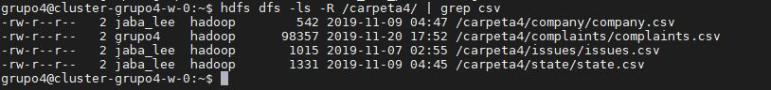

3ra capa

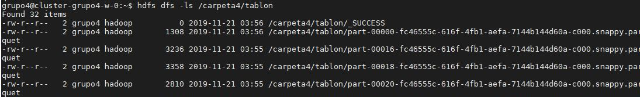

Comandos usados para la creación de las 2 primeras capas

hdfs dfs -mkdir /todaladata/

hdfs dfs -put state.csv /todaladata/

hdfs dfs -put company.csv /todaladata/

hdfs dfs -put issues.csv /todaladata/

hdfs dfs -put complaints.csv /todaladata/

hdfs dfs -cp /todaladata/state.csv /carpeta4/state/

hdfs dfs -cp /todaladata/company.csv /carpeta4/company/

hdfs dfs -cp /todaladata/issues.csv /carpeta4/issues/

hdfs dfs -cp /todaladata/complaints.csv /carpeta4/complaints/

Las carpetas de las 2nda capa fueron creados al momento de crear las tablas

HIVE- BEELINE

Procedemos a crear la base de datos

beeline -u jdbc:hive2://10.128.0.9:10000/

create database trabajo4;

Empezamos por las tablas simples

use trabajo4;

CREATE EXTERNAL TABLE IF NOT EXISTS trabajo4.issues(

id_issue string COMMENT 'Id_issue',

issues string COMMENT 'Issues'

)

COMMENT 'Tabla Issues'

ROW FORMAT DELIMITED

FIELDS TERMINATED BY ','

LINES TERMINATED BY '\n'

STORED AS TEXTFILE

LOCATION '/carpeta4/issues'

tblproperties("skip.header.line.count" = "1");

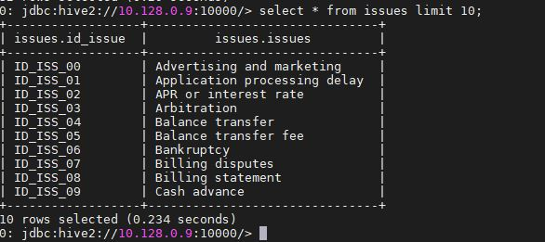

use trabajo4;

CREATE EXTERNAL TABLE IF NOT EXISTS trabajo4.complaints(

date_received date COMMENT 'Date_received',

id_issue string COMMENT 'Id_issue',

id_company string COMMENT 'Id_company',

id_state string COMMENT 'Id_state',

consumer_consent_provided string COMMENT 'Consumer_consent_provided',

submitted_via string COMMENT 'Submitted_via',

date_sent_to_company date COMMENT 'Date_sent_to_company',

company_response_to_consumer string COMMENT 'Company_response_to_consumer',

timely_response string COMMENT 'Timely_response'

)

COMMENT 'Tabla Complaints'

ROW FORMAT DELIMITED

FIELDS TERMINATED BY ','

LINES TERMINATED BY '\n'

STORED AS TEXTFILE

LOCATION '/carpeta4/complaints'

tblproperties("skip.header.line.count" = "1");

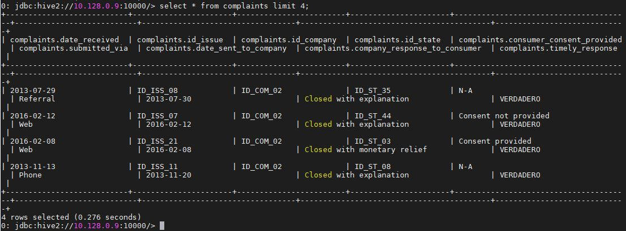

Procedemos con las tablas estructuradas

use trabajo4;

CREATE EXTERNAL TABLE IF NOT EXISTS trabajo4.company(

id_company string COMMENT 'Id_company',

company_name string COMMENT 'Company_name',

id_company_company_name struct<id_company:STRING,company_name:string> COMMENT 'Id_company_company_name'

)

COMMENT 'Tabla Company'

ROW FORMAT DELIMITED

FIELDS TERMINATED BY '|'

COLLECTION ITEMS TERMINATED BY ','

MAP KEYS TERMINATED BY ':'

LOCATION '/carpeta4/company'

tblproperties("skip.header.line.count" = "1");

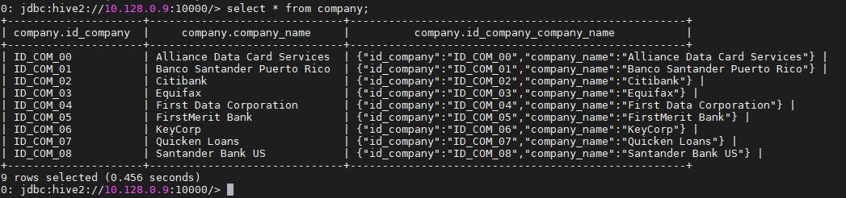

use trabajo4;

CREATE EXTERNAL TABLE IF NOT EXISTS trabajo4.state(

id_state string COMMENT 'Id_state',

state string COMMENT 'State',

id_state_state struct<id_state:STRING,state:string> COMMENT 'Id_state_state'

)

COMMENT 'Tabla State'

ROW FORMAT DELIMITED

FIELDS TERMINATED BY '|'

COLLECTION ITEMS TERMINATED BY ','

MAP KEYS TERMINATED BY ':'

LOCATION '/carpeta4/state'

tblproperties("skip.header.line.count" = "1");

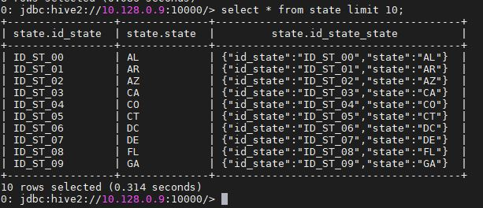

Luego toca crear una tabla estática y la función que ayudara al llenado de la misma

CREATE EXTERNAL TABLE trabajo4.tabla_particion_estatica

(

date_received date COMMENT 'Date_received',

id_issue string COMMENT 'Id_issue',

id_company string COMMENT 'Id_company',

id_state string COMMENT 'Id_state',

consumer_consent_provided string COMMENT 'Consumer_consent_provided',

submitted_via string COMMENT 'Submitted_via',

date_sent_to_company date COMMENT 'Date_sent_to_company',

company_response_to_consumer string COMMENT 'Company_response_to_consumer',

timely_response string COMMENT 'Timely_response'

)

PARTITIONED BY (mensual STRING)

STORED AS PARQUET

LOCATION '/carpeta4/complaints_part_esta/tabla_particion_estatica';

insert into trabajo4.tabla_particion_estatica partition(mensual = '201211')

select

from_unixtime (unix_timestamp(Concat(substring(date_received,1,4),SUBSTRING(date_received,5,2), SUBSTRING(date_received,7,2)), 'yyyyMMdd'), 'yyyy-MM-dd') as date_received,

id_issue,

id_company,

id_state,

consumer_consent_provided,

submitted_via,

from_unixtime (unix_timestamp(Concat(substring(date_sent_to_company,1,4),SUBSTRING(date_sent_to_company,5,2), SUBSTRING(date_sent_to_company,7,2)), 'yyyyMMdd'), 'yyyy-MM-dd') as date_sent_to_company,

company_response_to_consumer,

timely_response

from trabajo4.complaints where date_received like '2012-11-%';

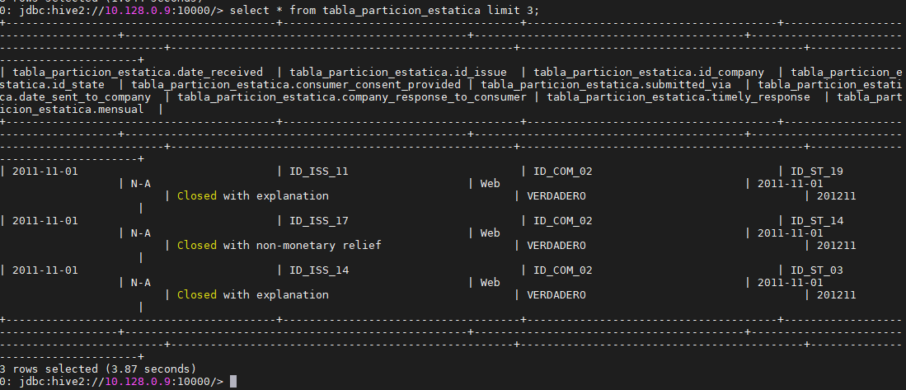



Luego toca crear una tabla dinámica y la función que ayudara al llenado de la misma

CREATE EXTERNAL TABLE trabajo4.tabla_particion_dinamica

(

id_issue string COMMENT 'Id_issue',

id_company string COMMENT 'Id_company',

id_state string COMMENT 'Id_state',

consumer_consent_provided string COMMENT 'Consumer_consent_provided',

submitted_via string COMMENT 'Submitted_via',

date_sent_to_company date COMMENT 'Date_sent_to_company',

company_response_to_consumer string COMMENT 'Company_response_to_consumer',

timely_response string COMMENT 'Timely_response'

)

PARTITIONED BY (date_received STRING)

STORED AS PARQUET

LOCATION '/carpeta4/complaints_part_dina/tabla_particion_dinamica';

set hive.exec.dynamic.partition.mode=nonstrict;

insert into trabajo4.tabla_particion_dinamica partition(date_received)

select

id_issue,

id_company,

id_state,

consumer_consent_provided,

submitted_via,

from_unixtime (unix_timestamp(Concat(substring(date_sent_to_company,1,4),SUBSTRING(date_sent_to_company,5,2), SUBSTRING(date_sent_to_company,7,2)), 'yyyyMMdd'), 'yyyy-MM-dd') as date_sent_to_company,

company_response_to_consumer,

timely_response,

from_unixtime (unix_timestamp(Concat(substring(date_received,1,4),SUBSTRING(date_received,5,2), SUBSTRING(date_received,7,2)), 'yyyyMMdd'), 'yyyy-MM-dd') as date_received

from trabajo4.complaints where date_received like '2012-0%';

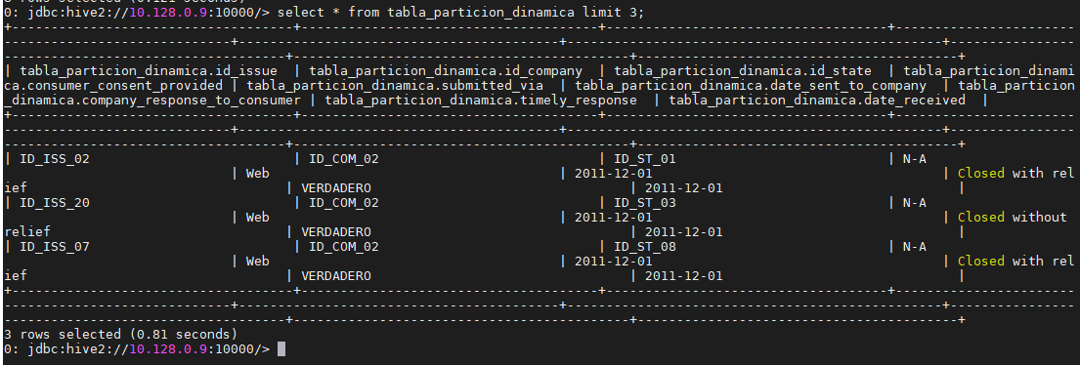

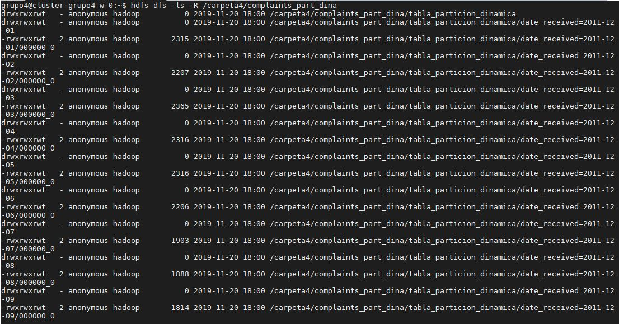

Ahora procedemos a crear el bucking

CREATE EXTERNAL TABLE IF NOT EXISTS trabajo4.company_buckets (

id_company string COMMENT 'Id_company',

company_name string COMMENT 'Company_name',

id_company_company_name struct<id_company:STRING,company_name:string> COMMENT 'Id_company_company_name'

)

CLUSTERED BY (company_name) INTO 2 BUCKETS

ROW FORMAT DELIMITED

FIELDS TERMINATED BY '|'

COLLECTION ITEMS TERMINATED BY ','

MAP KEYS TERMINATED BY ':'

LOCATION '/carpeta4/company_buck/tabla_bucketing';

set map.reduce.tasks = 2;

set hive.enforce.bucketing = true;

INSERT OVERWRITE TABLE trabajo4.company_buckets SELECT * FROM trabajo4.company;

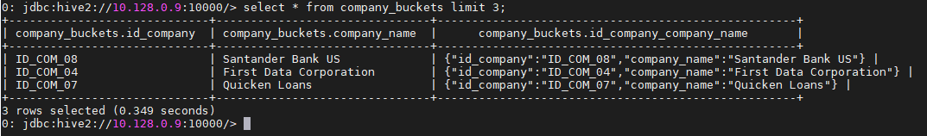



SPARK

Procedemos a pasar las tablas a data frames

val df_state = spark.read.table("trabajo4.state")

df_state.show()

df_state.printSchema()

val df_issues = spark.read.table("trabajo4.issues")

df_issues.show()

df_issues.printSchema()

val df_complaints = spark.read.table("trabajo4.complaints")

df_complaints.show()

df_complaints.printSchema()

val df_company = spark.read.table("trabajo4.company")

df_company.show()

df_company.printSchema()

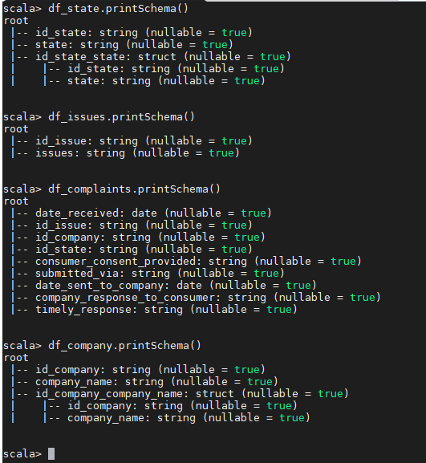

val df_tablon =df_complaints.as("cot").join(df_issues.as("iss"),"id_issue").join(df_state.as("sta"),"id_state").join(df_company.as("coy"),"id_company").select("cot.date_received","iss.issues","coy.company_name","sta.state","cot.consumer_consent_provided","cot.submitted_via","cot.date_sent_to_company","cot.company_response_to_consumer","cot.timely_response")

df_tablon.show()

df_tablon.printSchema()

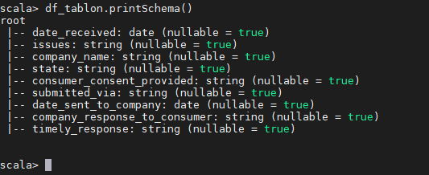

Guardamos el dataframe en parquet y creamos una tabla con la data a analizar

df_tablon.write.format("parquet").save("/carpeta4/tablon/")

df_tablon.createOrReplaceTempView("tablon");

spark.sql("create table if not exists trabajo4.tablon as select * from tablon");

La “/carpeta4/tablon/" es la tercera capa del datalake que se generará

