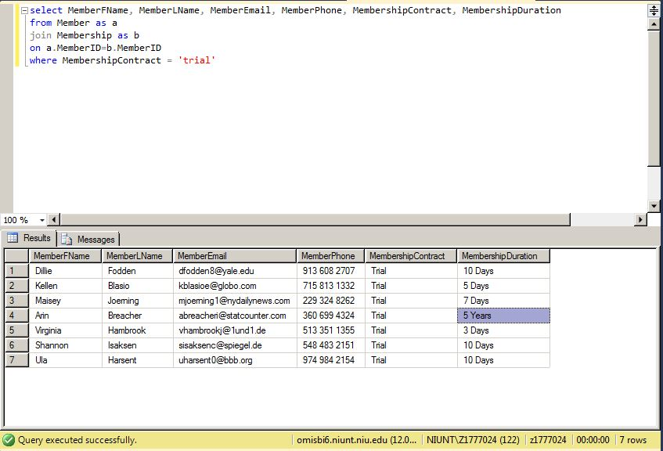

The gym is starting a promotional event where new members are able to sign up for a full membership at a discounted price. Only $1 down payment and the first month is free. Gains Gym is going through their members looking for the people who are on a trial contract and send them an email and a phone call to let them know about the promo.

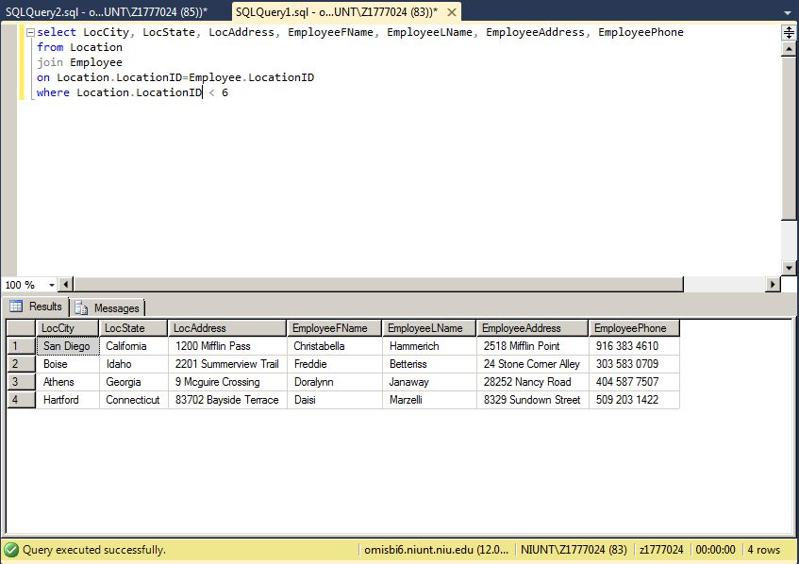

Gains Gym originally opened only four locations and started off really well with income. As the years come and go, the buildings the gyms are in are getting older and older. They have gotten so old that it is not worth spending money on refurnishing and more beneficial to close them for good. Now the gym will have to get the names and contact information of the specific locations employee/manager to inform them of the decision.

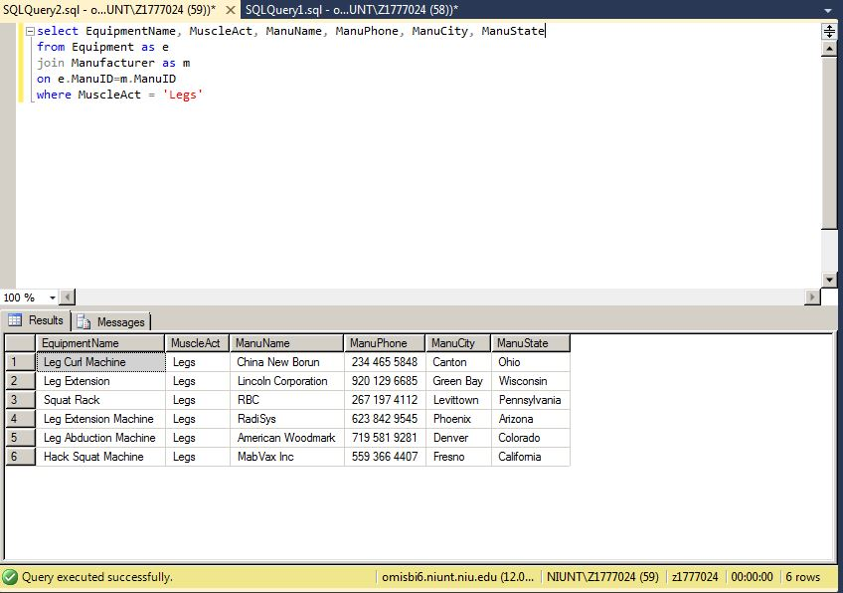

Gym employees have noticed an increase in interest in leg machines and receiving suggestions from members about there being not enough machines for everyone. Now the gym is finding all the type of leg machines that they currently have and the manufacturer for each of the machines. Gains can now call the manufacturer and order more.

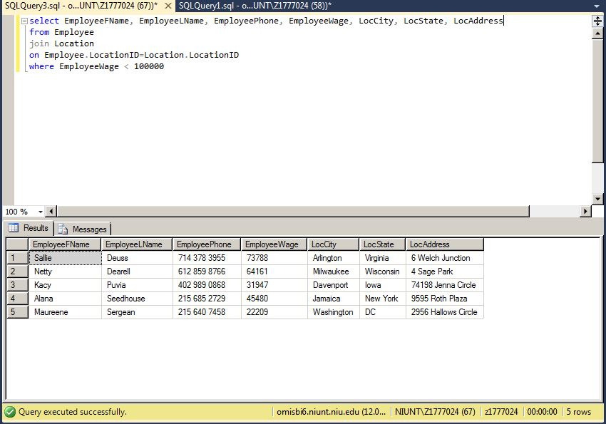

Gains gym recently received a large donation from a former member who attributes his fitness career success to the gym. With the large amount of funds now at disposal for the gym, they are deciding to give back to their employees. Employees who are making under 100K are getting a bonus at the end of the month. The owner and CEO will be going to each location and let the employees know in person.

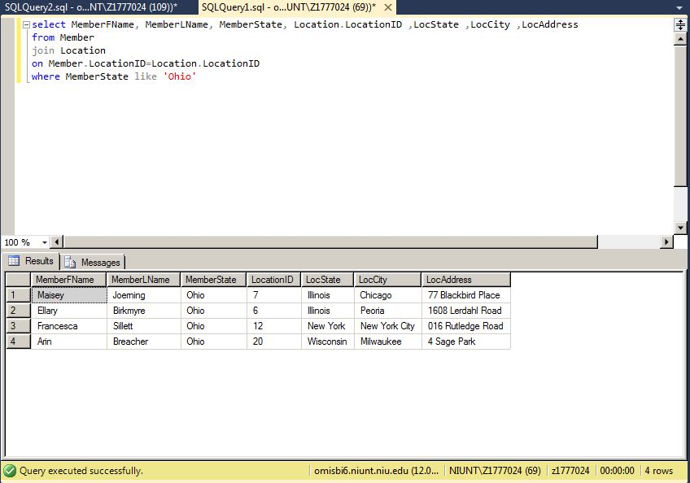

After noticing the number of members that are from Ohio and the fact that there are no gyms in the state of Ohio, Gainz is going through the motions of opening a location there. A number of meetings will take place to talk about the pros and cons of having a new location and should come to a conclusion in the next couple of months.

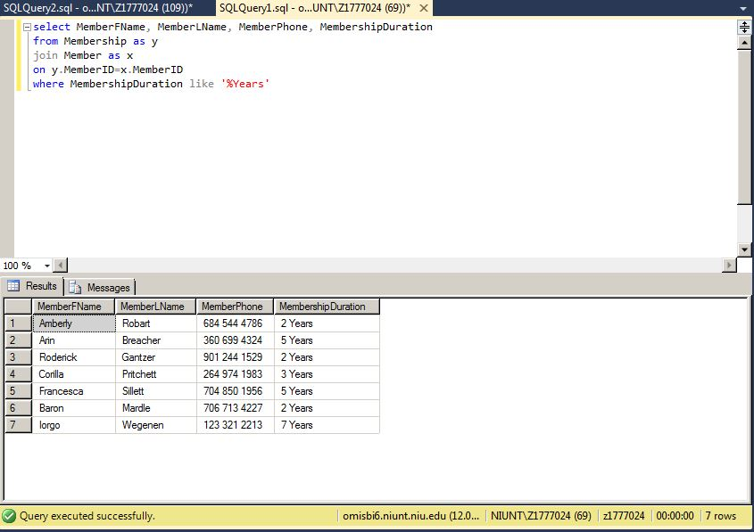

The gym wants to start a new Membership Rewards program. All members who have memberships or have been with the gym for at least two years will have their names put on a certificate and put up on the walls of the gym. The certificates will contain their first name, last name, and the length of the membership. Each year they will be updated with new members and update the current group.

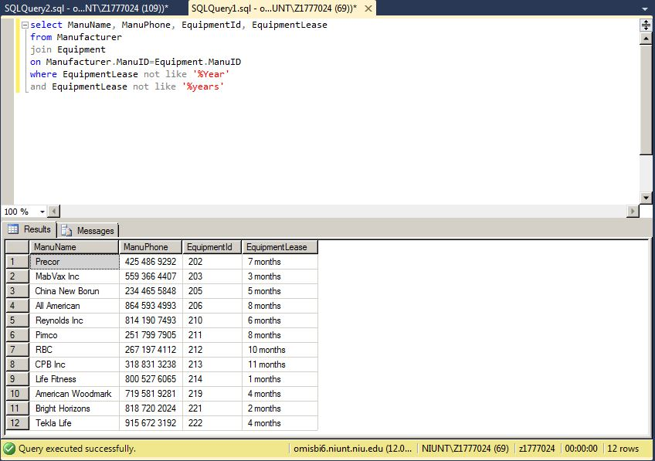

At the end of every 3 months, Gains Gym looks at the leases for each of their machines. If they have less than four months remaining then they will have to find the manufacturer for the machine and either call to renew their lease or to inform the manufacturer that they will no longer need the machine and let manufacturer take back their machine.

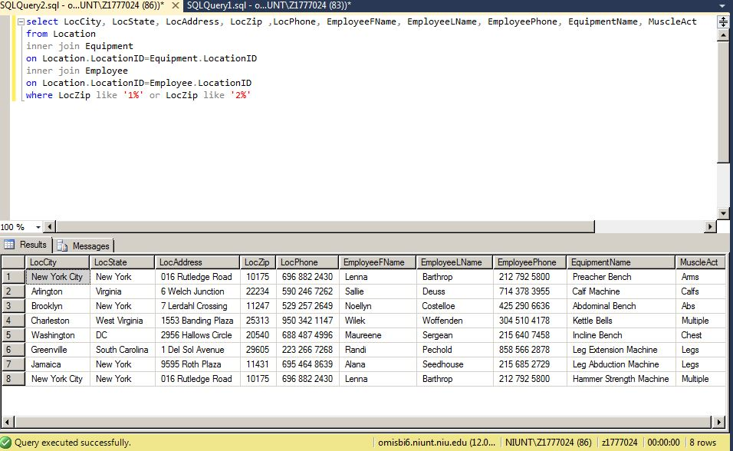

Potential new members are inquiring about if there are any locations near where they are moving. Using the first digit of their new zip code, Gains can find the locations around them. Along with locations, the new members also want to know what equipment is going to be available along with someone they can contact to ask more questions about the gym. The gym hopes that this person will get a membership and allow for Gains to continue to grow nationwide.