**Lean in the service industry**

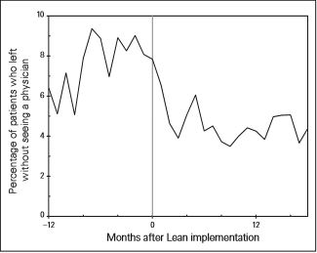Lean production plays a massive role in the manufacturing, but it is not a process that is only in the manufacturing industry. Lean production is about eliminating waste in order to better a process, regardless if in the automotive industry, warehouses, healthcare, or banks. In 2005 the Hôtel-Dieu Grace Hospital in Canada began using lean principles to reduce wait times in the emergency department and improve the quality of care in the ED. With a team that included emergency physicians, nurses, administrators, the ED director, etc. they agreed that they should focus on CTAS-2 to -5 patients, who were deemed as “dischargeable” at initial triage rather than “admit” or “uncertain” (Ng et al., 2009). CTAS is the Canadian Triage and Actuality Scale. According to the Training Triage Participants Manual, there are five CTAS levels. The Hospital focused on all but the first level. These levels were; Level 2 – Emergent, Level 3 – Urgent, Level 4 –Less Urgent, and Level 5 – Non-Urgent. Twice, the team came up with a type of visual tool called a value stream map. The first map was to figure out the current process and the second was a future map describing how they would like the process work.

Figure 1

The original map was a 19 step process with a lead time between 61 minutes to 76 hours and only 2% of patients received flawless care. The future map reduced the process to only 6 essential components with the total lead time of an average 215 minutes and 84% of patients received complete and accurate care (Ng et al., 2009). Following the value stream mapping, the team was then able to begin the implantation of the new project. With the new lean thinking at the hospital, the percentage of patients who were not seen in September 2005 was 7.1%, by March 2007 the percentage dropped to 4.3% and continued to improve, as shown in figure 1.

Lean in health care can be hit or miss, results can be what was expected or as said in the study by Young et al., (2016) the results of lean implementation in hospitals tend to be poor to fair rather than exceeding expectations. Something that should be of focus when implementing lean in not just hospitals, but everywhere, is the “5S” principles. The 5S’s are: Sort, Set in order, Shine, Standardize, and Sustain. When comparing hospitals that used little to no lean and hospitals that incorporated lean into the entire system, the second group of hospitals preformed significantly better and had more consistent results (Young et al., 2016). This can be credited to the fact that when deciding to implement lean you are not only trying to improve the process by removing errors, you are speeding up the process by eliminating unwanted waste in the process.

Aside from the success of lean at the Hôtel-Dieu Grace Hospital, it can also be incorporated in the financial sector and the marketing services as described by Simon Elias (2016) in “Why Lean Thinking is Valuable to the Service Industry”. Financial firms can be some of the most wasteful places, Elias (2016) mentions that at least of 40% of costs in the financial sectors are spent on wasteful activates that have no added value to the customer. By implementing lean business can begin to cut those wasteful activities and begin to become more productive. In marketing services many projects are time consuming and contain many unneeded tasks. Lean implementation will allow the companies to directly improve work quality and add value to the customer, giving these marketing companies and edge over their competition (Elias 2016).

**Implementing Lean and the TPS**

Lean production, also known as the Toyota Production System (TPS), can be implemented into a manufacturing facilities using four design rules. Black (2007) goes into depth on each of the steps; the first rule is to make sure that the same amount of the product is made and the end of each day by using the takt time of the final assembly line, the second step is to run the line in a MO-CO-MOO (make one, check one, and move one on) basis, the third rule is to make sure that the machines are not running longer than needed by using less than the necessary cycle time (NCT), the final rule is determining the maximum number of inventory at any specific link in the assembly line.

**Introduction**

UTC Aerospace Systems is one of the world’s largest suppliers of advanced aerospace products and systems for commercial, military, and space customers. UTAS is just one of many subsidiaries, including Otis (a manufacture of people moving products), Pratt & Whitey (design, manufacturer, and service of engines and power units), and UTC Climate, Controls & Security, of the parent company, United Technologies (UTC). The company as a whole amassed over $59 billion in net sales (“UTC Financials”, 2017).

**History**

The parent company, United Technology Corporation, was founded in 1934 and originally called “United Aircraft Corporation”. The subsidiary known as UTC Aerospace Systems was founded in 2012. UTC already owned a company called “Hamilton Sundstrand” which was a company who manufacture industrial and aerospace products. In the year 2012 UTC bought the company known as Goodrich Corporation, or, “B.F Goodrich Company” for $18.4 billion. Later that year they merged the two companies in order to create what is known today as UTC Aerospace Systems. Although still a fairly new company, it has become quite successful.

**Company Today**

Today, UTC Aerospace Systems continue their success by following two quotes on the website, “Ideas Born to Fly™” and “It takes the most brilliant thinking on the ground to put the most innovative solutions in the air”. UTC first adopted the current code of ethics in 1990. The code is described as “an expression of fundamental values, and represents a framework for decision making”. The core values of the culture of UTC are: trust, integrity, respect, innovation, and excellence.

**Financial Information**

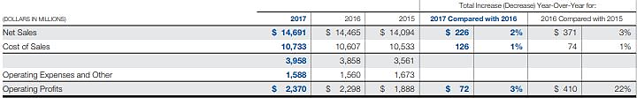

This first image is part of UTAS’ financial statement. This part allows us to see how the company has been doing sales and profit wise and compare with the past two years. Net sales was recorded at $14.6 billion, an increase of 2% since 2016 and 5% since 2015. Profits from 2015 to 2016 increased by a significant amount, 22%, mostly because operating expenses decreased due to the pay cuts that took place that year.

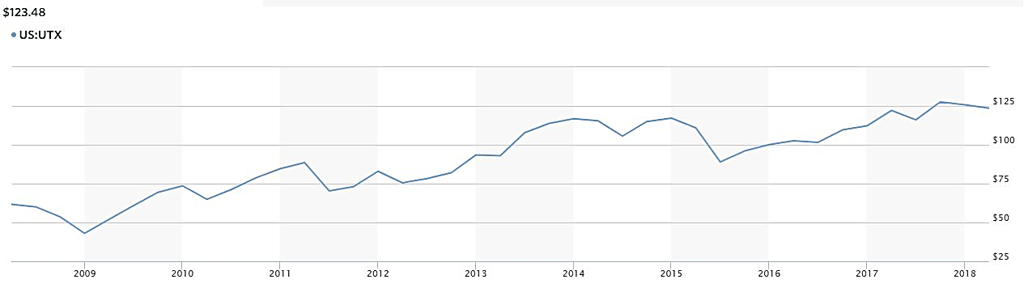

This second image is shows the market shares of UTC over the past 10 years. The current cost for a share of UTC is $123.48. The company has been on a rise, especially in the past five or so years. When Goodrich was purchased in early 2012 you can see the slight dip in price but later that year when Aerospace Systems was formed, the increase in price began.

**Products**

UTC Aerospace Systems offer a wide variety of products. Suppling parts to a many different customers including commercial and business aviation, military & defense, rotorcrafts, space, and marine. Some examples of products the company ships, which can be found on the company’s webpage, <https://www.utcaerospacesystems.com/>;

* Commercial & Business Aviation
  + Landing gear for commercial planes. UTC uses advanced designs and technologies and make the most innovative and safest landing gear.
  + Interiors for Business aircrafts, UTC makes sure that interiors of the planes they supply are of the highest quality allowing for a more comfortable experience for the passenger.
* Military & Defense
  + Ejection Seats, these new seats give pilots better neck and head protection during ejection making them some of the safest seats to eject in.
  + Laser Waring Systems, for both aircraft and ground vehicles, allows them to be able to detect when they are targeted by a laser guided weapon. This system give them the right amount of time to act and defend as needed.
* Space
  + Space Suits, working side by side with NASA, UTC was able to adapt and enhance the quality of their suits giving the astronaut everything they need to stay alive while in space.
* Marine
  + Life Rafts, UTC has supplied the market with WINSLOW Life Rafts for over 70 years. They offer unmatched quality and essential features in each raft. They continue to improve the quality and specifications each year to stay at the top when it comes to quality life rafts.

**Problem**

Being such a large manufacturer and supplier of many different aircraft parts, some process can become longer than needed making the process cost more than it should. The manufacturing line especially was behind the curve and the company needed to find a way to reduce costs and improve the processes