INTEGRATED OPTIMIZATION OF AIR TRANSPORTATION SYSTEMS (AIRCRAFT AND NETWORK)

José Alexandre Tavares Guerreiro Fregnani

Thesis Committee Composition:

|  |  |  |  |  |
| --- | --- | --- | --- | --- |
| Prof. Dr. | Nome Completo | Chairperson | - | ITA |
| Prof. Dr. | Bento Silva de Mattos | Advisor | - | ITA |
| Prof. Dr. | José Antônio Hernandes | Co-advisor | - | ITA |
| Prof. Dr. | Jorge Eduardo Leal Medeiros |  | - | Poli/USP |
| Prof. Dr. | Fernando Martini Catalano |  | - | EESC/USP |
| Prof. Dr. | Álvaro Martins Abdala |  | - | EESC/USP |

ITA

*À minha amada família*

*Luciana, Anna Carolina e Enzo*

Acknowledgments

Esta parte é dedicada aos agradecimentos aos professores, funcionários, colegas e familiares que ajudaram no seu trabalho.

Caso o aluno tenha sido bolsista, é importante agradecer à agência de fomento responsável pelo suporte financeiro (CAPES, FAPESP, CNPq, etc).

*"Esta página é opcional. Pode conter uma epígrafe,*

*ou seja, a citação de um pensamento, de uma frase ou de um provérbio”.*

(Nome do Autor da Citação)

Abstract

Assim como a pesquisa científica segue normas, regras e procedimentos definidos para gerar novos conhecimentos, os resultados obtidos também devem ser padronizados conforme as diretrizes nacionais e internacionais de normalização para serem disseminados entre os pesquisadores, facilitando a leitura e compreensão da comunidade acadêmica e científica. Aplicar corretamente as normas no planejamento e apresentação de projetos e trabalhos científicos requer algumas exigências na elaboração dos elementos pré-textuais, textuais e pós-textuais dos documentos de forma a valorizar os resultados da pesquisa realizada. O presente manual se propõe a apresentar o formato que dissertações e teses desenvolvidas no ITA devem seguir, atento às peculiaridades do Instituto e às regras de padronização da Associação Brasileira de Normas Técnicas (ABNT), adotando a estrutura desde o modelo da folha de rosto até o último elemento pós-textual, exemplificando e ampliando suas aplicações de modo mais didático para obtenção da qualidade na sua editoração.

List of Figures

Figure 1.1: Global airlines profit margin since year 2000 25

Figure 1.2: Aviation industry emissions reduction roadmap 26

Figure 1.3: Fuel efficiency improvement since the first commercial jet 28

Figure 1.4: Typical network planning process adopted by airlines 32

Figure 1.5: Conceptual design configurations study 35

Figure 1.6: Aircraft layout after the conceptual design is finished 35

Figure 2.1: Analysis block for range computation. 44

Figure 2.2: Generic MDO framework. 45

Figure 2.3: Latin hypercube sampling. 46

Figure 2.4: Example of Multidisciplinary Feasible framework (MDF) 48

Figure 2.5: Example of Individual Discipline Feasible framework (IDF) 48

Figure 2.6: Example of Collaborative Optimization framework (CO) 49

Figure 2.7: Types of Optimization Algorithms 51

Figure 2.8: GA standard flowchart 54

Figure 3.1: Proposed “Hybrid MDF-CO” MDO framework 65

Figure 3.2: Baseline Aircraft (78 passengers, single class) 65

Figure 3.3: Proposed MDO workflow elaborated with modeFrontier® 72

Figure 3.4: Flowchart of Aircraft Framework calculations 74

Figure 3.5: Single wheel nose and main landing gear configuration 78

Figure 3.6: Main landing gear design clearances considering engine, inner flaps and fuselage geometries 78

Figure 3.7 Typical fuselage cross section computation 79

Figure 3.8 Example of wing and tail placements considering the allowable CG variation (blue) for a certain design 80

Figure 3.9 Scholz method to determine the minimum horizontal tail area 81

Figure 3.10 Flight quality requirements for Dutch Roll and short period 82

Figure 3.11 Wing geometric parameters 84

Figure 3.12 Airfoil geometric parameters 84

Figure 3.13 Airfoil coordinates and polynomial fittings 85

Figure 3.14 Comparison between ANN overall drag predictions and CFD results 86

Figure 3.15 Generic compressor map 89

Figure 3.16 Noise measuring points for airplane certification 90

Figure 3.17 Design Diagram check 92

Figure 3.18 Two stop demand model and adopted shares 101

List of Tables

Table 1.1: Global strategies for reducing aviation fuel uses and emissions. 27

Table 1.2: Airframe technologies development impact on fuel efficiency. 28

Table 1.3: Engine technologies development impact on fuel efficiency. 29

Table 3.1: Baseline aircraft design requirements. 66

Table 3.2: Aircraft and Engines design parameters 66

Table 3.3: Aircraft fixed parameters. 67

Table 3.4: Aircraft operational and certification fixed parameters. 67

Table 3.5: Network fixed parameters. 67

Table 3.6: Airport and econometrics database parameters. 68

Table 3.7: Aircraft definition parameters. 69

Table 3.8: Engine weight equation exponents and coefficients. 76

Table 3.9: Engine weight equation normalization parameters 76

Table 3.10: Weight error estimation for typical turbofan/jet engines 77

Table 3.11: Inputs for the ANN computation 83

Table 3.12: Airfoil geometric parameters 85

Table 3.13: Wing characteristics of ITA107 airliner 86

Table 3.14: Predicted and calculated coefficient values by ANN and full potential code 87

List of Abbreviations

|  |  |
| --- | --- |
| *a0* | Speed of sound at sea level on standard atmosphere [m/s] |
| *ACO* | Ant colony optimization algorithm |
| *ADj* | Arrival delay at airport j [min] |
| *AED* | Airport and econometrics database |
| *AFA* | Approach and landing fuel allowance [kg] |
| *AFP* | Aircraft fixed parameters |
| *ailpos* | Aileron position on wing semi-span [%] |
| *AisleW* | Aisle width |
| *ALD* | Average landing delay [min] |
| *ANN* | Artificial neural network |
| *ANOPP* | Airplane Noise Operations Prediction Program |
| *AOCFP* | Aircraft operational/certification fixed parameters |
| *APTID* | ICAO’s four-letter code airport designator |
| *ATA* | Approach and landing time allowance [kg] |
| *ATAG* | Air Transport Action Group |
| *ATD* | Average takeoff delay [min] |
| *ATM* | Air Traffic Management |
| *AVL* | Aerodynamics Vortex Lattice |
| *B* | City pair combined buying power index |
| *Bi* | Buying power index related to the city of the i-th airport |
| *BPR* | Engine by-pass ratio |
| *b* | Passenger capacity |
| *bflap* | Flap length on semi-span [%] |
| *bk* | Passenger capacity of k-th aircraft |
| *BuffMGN* | Buffet margin (g) |
| *CARGO* | Total cargo loaded onboard [kg] |
| *C* | City pair airport catchment area product |
| *Ci* | City pair airport catchment related to the i-th airport [km2] |
| *CabHt* | Passengers cabin internal height [m] |
| *CD* | Total aircraft drag coefficient |
| *CD0* | Zero lift drag coefficient |
| *CD0 ubridge* | Zero lift drag increase due to wing-fuselage interference |
| *CDflap* | Drag increase due to takeoff flap extended |
| *CD ind* | Induced drag coefficient |
| *CDgear* | Drag increase due to landing gear extended |
| *CDMMO* | Drag coefficient evaluated at maximum operating Mach number |
| *CD wave* | Wave drag coefficient |
| *CD wing* | Total wing drag coefficient |
| *CDwindmill* | Drag increase due to wind milling of a failed engine |
| *CDrudder* | Drag increase due to ruder deflection |
| *CD0.70* | Drag coefficient evaluated at 0.7 Mach number |
| *Ceiling* | Maximum aircraft certified altitude [ft] |
| *Cflt* | Flight component of direct operational cost (crew, oil, fuel and insurance) [US$/nm] |
| *Cmaint* | Maintenance (labor and material) component of the direct operational cost [US$] |
| *Cdepr* | Depreciation (airframe, engines and avionics) component of the direct operational  cost [US$] |
| *Cfee* | Fees (Navigation, Airport and Register) component of the direct operational cost [US$] |
| *Cfin* | Financial (airframe and engine leasing) component of the direct operational cost [US$] |
| *CFD* | Computer fluid dynamics |
| *CG* | Aircraft’s center of gravity |
| *chordc* | Airfoil chord length at central fuselage [m] |
| *chordk* | Airfoil chord length at wing kink [m] |
| *chordr* | Airfoil chord length at wing root [m] |
| *chordt* | Airfoil chord length at wing tip [m] |
| *City* | City name |
| *CL* | Lift coefficient |
| *CLMAX* | Maximum lift coefficient at undeflected flap/gear up configuration |
| *CLMAX APP* | Maximum lift coefficient at approach flaps/gear up configuration |
| *CLMAX LD* | Maximum lift coefficient at landing flaps/gear down configuration |
| *CLMAX TO* | Maximum lift coefficient at takeoff flaps/gear down configuration |
| *CL 2nd seg* | Lift coefficient evaluated at the 2nd segment takeoff flight path |
| *CMA* | Wing mean aerodynamic chord length [m] |
| *CNS* | Communication, Navigation and Surveillance Technologies |
| *Cmα* | Pitch moment coefficient |
| *Cnβ* | Yawing moment coefficient |
| *CO* | Collaborative optimization framework |
| *CO2* | Carbon dioxide |
| *CORSIA* | Carbon Offsetting and Reduction for International Aviation |
| *CRAD* | Catchment area radius [km] |
| *Crew* | Number of crew members (flight attendants + pilots) |
| *ck* | Average direct operational cost [$/nm] of k-th aircraft at design range |
| *D* | Total aircraft drag [N] |
| *DATCOM* | United States Air Force Stability and Control Data Compendium |
| *DDi* | Departure delay at i-th airport [min] |
| *dij* | Distance from i-th to j-th airport [nm] |
| *DOC* | Direct operational cost [US$/nm] |
| *DOCijk* | Direct operational cost from i-th to j-th airport [US$/nm] |
| *DOE* | Design of experiments |
| *DMG* | Airport magnetic declination [o] |
| *DU* | Average daily aircraft utilization [h] |
| *eCLR* | Engine minimum clearance to ground [m] |
| *ELEV* | Airport’s reference point elevation [ft] |
| *EPNdB* | Effective perceived noise in decibels |
| *le* | Engine length [m] |
| *eDiam* | Engine fan diameter [m] |
| *eM* | Engine Design Point Mach Number |
| *ePOS* | Engine position flag |
| *epydz* | Engine pylon height [m] |
| *eSwet* | Engine wet area [m2] |
| *eTIT* | Engine turbine inlet temperature [K] |
| *F* | Frequency of sound source [Hz] |
| *FAR25* | Part 25 of the United States Code of Federal Regulations Title 14 (Airworthiness Standards: Transport Category Airplanes) |
| *fij* | Daily demand from airport i-th to j-th airport |
| *fp* | Vector of fixed parameters |
| *FF* | Engines total fuel flow [kg/s] |
| *FOB* | Total fuel on board [kg] |
| *FPR* | Engine fan pressure ratio |
| *flapLD* | Landing flap deflection [o] |
| *flapTO* | Takeoff flap deflection [o] |
| *fusd* | Fuselage diameter [m] |
| *fusdz* | Fuselage external height [m] |
| *fush* | Fuselage height [m] |
| *fush2w* | Fuselage height-to-width ratio |
| *fusw* | Fuselage width [m] |
| *fuswetS* | Fuselage wet area [m2] |
| *g* | Gravity acceleration [m/s2] |
| *g(x,fp)* | Inequality constraint function |
| *G* | Combined city pair Gross Domestic Product [US$] |
| *GA* | Genetic algorithm |
| *GAFA* | Go-around fuel allowance [kg] |
| *GATA* | Go-around time allowance [min] |
| *GDP* | Gross Domestic Product [US$] |
| *GDPi* | Gross Domestic Product related to the city of the i-th airport [US$] |
| *GSP* | Gas Turbine Simulation Program |
| *h(x,fp)* | Equality constraint function |
| *Hmaxbuffet* | Maximum pressure altitude limited by buffet margin [ft] |
| *hAR* | Horizontal tail aspect ratio |
| *hS* | Horizontal tail area [m2] |
| *hSweep* | Horizontal tail sweep angle |
| *hTR* | Horizontal tail aspect ratio |
| *HOLDT* | Regulatory holding time (min) |
| *Hp* | Pressure altitude [ft] |
| *hpos* | Horizontal tail position flag |
| *HT* | Horizontal tail |
| *hTR* | Horizontal stabilizer tapper ratio |
| *ID* | Average inflight delay cost [US$/min] |
| *IDF* | Individual Discipline Feasible framework |
| *IATA* | International Air Transport Association |
| *ICAO* | International Civil Aviation Organization |
| *inc kink* | Airfoil incidence at wing kink [o] |
| *inc root* | Airfoil incidence at wing root [o] |
| *inc tip* | Airfoil incidence at wing tip [o] |
| *J(x,fp)* | Objective function |
| *k1* | Total operational costs to direct operational costs ratio |
| *k2* | Total revenue to ticket revenue ratio |
| *KinkPos* | Wing kink semispan position [%] |
| *lco* | Forward fuselage length [m] |
| *lf* | Fuselage length [m] |
| *ltail* | Tailcone length [m] |
| *L* | Airplane lift force [N] |
| *LAT* | Airport’s reference point latitude [o] |
| *LATi* | Latitude of the origin airport [o] |
| *LAtj* | Latitude of the destination airport [o] |
| *LDA* | Landing distance available [m] |
| *lf* | Fuselage length [m] |
| *LFL* | Design Landing Field Length, @ sea level, ISA conditions [m] |
| *LFref* | Reference Load Factor |
| *LON* | Airport’s reference point longitude [o] |
| *LONi* | Longitude of the origin airport [o] |
| *LONj* | Longitude of the destination airport[o] |
| *LPM* | Linear Programming Model |
| *LRWY* | Most used landing runway |
| *LW* | Landing weight [kg] |
| *L/Dbest ROC* | Best rate of climb lift over drag ratio |
| *M* | Mach Number |
| *MaxAlt* | Maximum Certified Cruise Altitude Ceiling [ft] |
| *MAXFUEL* | Maximum Fuel Capacity @ 0.81kg/l fuel density [kg] |
| *MaxPax* | Maximum Cabin Passengers Capacity |
| *MAXRATE* | Maximum Takeoff Thrust @ sea level / ISA conditions [lbf] |
|  | Engine turbofan compressor actual mass flow [kg/s] |
| *MDA* | Multidisciplinary design analysis |
| *MDF* | Multidisciplinary Feasible |
| *MDO* | Multidisciplinary design and optimization |
| *Nc* | Turbofan engine compressor corrected rotor speed [%] |
| *NFP* | Network fixed parameters |
| *NLR* | National Aerospace Laboratory of Netherlands |
| *MILP* | Mixed Integer Linear Programing |
| *MINCRZT* | Minimum cruise time [min] |
| *MIT* | Massachusetts Institute of Technology |
| *MLW* | Maximum landing weight [kg] |
| *MMO* | Maximum certified speed (Mach number) |
| *MOGA* | Multi-objective genetic algorithm |
| *MTOW* | Maximum takeoff weight [kg] |
| *MZFW* | Maximum zero fuel weight [kg] |
| *Nacftk* | Total number of k-th aircraft |
| *Naisles* | Number of aisles in the cabin |
| *NAND* | Nested Analysis Design |
| *NDOC* | Total air transport network’s direct operational cost [US$/ nm] |
| *NASA* | United States National Aeronautics and Space Administration |
| *ne* | Number of engines installed in the aircraft |
| *Ngalleys* | Number of galley stations in the aircraft |
| *NP* | Total network profit [US$/(PAX.nm)] |
| *Npax* | Number of Passengers (single class, pitch 32”) |
| *Nseat* | Number of Seat Abreast |
| *NPV* | Total sum of manufacturer´s net present value cashflow during the aircraft development and production period |
| *NSGA* | Non-Dominated Sorting Genetic Algorithm |
| *NSGA-II* | Fast Non-Dominating Sorting Genetic Algorithm |
| *OEW* | Operational empty weight [kg] |
| *OPR* | Engine overall pressure ratio |
| *p* | Average ticket price [US$] |
| *p0* | Static air pressure at sea level on International Standard Atmosphere (102325Pa) |
| *ptin* | Engine turbofan compressor inlet total pressure [Pa] |
| *Ptout* | Engine turbofan compressor outlet total pressure [Pa] |
| *P* | City pair population product |
| *Pi* | City pair population related to the city of the i-th airport |
| *PAX* | Passenger or Passengers |
| *PAXWT* | Total passenger’s weight including baggage [kg] |
| *PAYLOAD* | Total payload carried by the aircraft [kg] |
| *POP* | City population |
| *PR* | Turbofan engine compressor pressure ratio |
| *PSO* | Particle swarm optimization algorithm |
| *qHTeff* | Dynamic pressure efficiency on horizontal tail [%] |
| *r* | Distance from the sound source to the receiver [m] |
| *r0* | Airfoil leading edge radius |
| *RANGE* | Design Range, Full passengers @ 100kg, ISA conditions [nm] |
| *RROC* | Residual rate of climb [ft/min] |
| *rsparps* | Rear spar position on mean aerodynamic chord [%] |
| *SA* | Simulated annealing optimization algorithm |
| *SAND* | Simultaneous analysis and design |
| *SeatW* | Passenger´s seat width |
| *sflap* | Flap area [m2] |
| *SlatPres* | Slat presence flag |
| *SPDLIM* | Speed Limit below 10000ft pressure altitude in terms of indicated airspeed [kt] |
| *SPL* | Sound Pressure Level [dB] |
| *T* | Engine net thrust [N] |
| *T0* | Static air temperature at sea level on International Standard Atmosphere (288,15K) |
| *TAT* | Turnaround time [min] |
| *tc* | Airfoil thickness ratio |
| *tcmax* | Airfoil maximum thickness chord-wise position |
| *tckink* | Airfoil thickness ratio at wing kink |
| *tcroot* | Airfoil thickness ratio at wing root |
| *tctip* | Airfoil thickness ratio at wing tip |
| *Tctcmax* | Camber at maximum thickness chord-wise position |
| *Tij* | Trip time spent between i-th and j-th airports [min] |
| *TBij* | Block time spent between i-th and j-th airports [min] |
| *TIT* | Taxi-in time [min] |
| *TODA* | Takeoff Distance Available [m] |
| *TOFL* | Design Takeoff Field Length @ sea level, ISA conditions [m] |
| *TOT* | Taxi-out time [min] |
| *totSwet* | Total aircraft wet area [m2] |
| *ToWreq* | Required thrust-over-weight ratio |
| *Tref* | Airport reference temperature |
| *TOF* | Takeoff fuel (fuel on board at beginning of takeoff run) [kg] |
| *TOFA* | Takeoff and climb-out fuel allowance [kg] |
| *TOTA* | Takeoff and climb-out time allowance [min] |
| *TOW* | Takeoff weight [kg] |
| *TRWY* | Most used takeoff runway |
| *T/W* | Thrust-to-weight reatio |
| *V* | True airspeed [m/s] |
| *vAR* | Vertical stabilizer aspect ratio |
| *VMO* | Maximum certified speed (indicated airspeed, kt) |
| *VT* | Vertical tail |
| *vAR* | Vertical Tail aspect ratio |
| *Vbest ROC* | Best rate of climb speed [m/s] |
| *vS* | Vertical tail area [m2] |
| *vSweep* | Vertical tail sweep angle |
| *vTR* | Vertical stabilizer aspect ratio |
| *W* | Airplane weight [kg] |
| *Wc* | Turbofan engine compressor corrected mass flow [kg/s] |
| *Wf* | Total fuel burned from origin to destination airport [kg] |
| *Wfapp* | Total fuel burned on approach phase [kg] |
| *Wfalternate* | Total fuel burned from destination to alternate airport [kg] |
| *Wfcontingency* | Contingency fuel [kg] |
| *Wfholding* | Fuel for the holding flight phase [kg] |
| *Wftaxi* | Taxi fuel [kg] |
| *wAR* | Wing aspect ratio |
| *wDih* | Wing Dihedral [o] |
| *WingletPres* | Winglet presence flag |
| *wb* | Wing semi-span [m] |
| *WoSreq* | Required wing load [N/m2] |
| *wS* | Wing reference area [m2] |
| *wSweep1/4* | Wing quarter-chord sweepback angle [o] |
| *wSweepLE* | Wing leading edge sweepback angle [o] |
| *wTR* | Wing tapper ratio |
| *wTwist* | Wing Twist Angle [o] |
| *WL\_AR* | Winglet Aspect ratio [m2] |
| *WL\_TR* | Winglet tapper ratio |
| *WL\_sweep* | Winglet sweep angle |
| *WL\_cantl* | Winglet cantlever angle [deg] |
| *WL\_twist* | Winglet twist angle [deg] |
| *W/S* | Wing loading [N/m2] |
| *x* | Vector of design parameters |
| *xle* | Wing leading edge position |
| *xLB* | Design variable lower band limit |
| *xUB* | Design variable upper band limit |
| *XDSM* | Extended Design Structure Matrix |
| *Ycmax* | Airfoil maximum camber |
| *Xiltj* | Fraction of the passenger’s demand flow fij from origin i to destination j |
| *Yijk* | Number of type-k airplane linking i-th to j-th city (route frequency) |
| *XYcmax* | Camber at maximum thickness chord-wise position |
|  |  |

List of Symbols

|  |  |  |
| --- | --- | --- |
| *α* | Angle of attack [o] | |
| *β* | Sideslip angle [o] | |
| *δ* | Atmospheric pressure ratio (s*tatic air pressure/p0*) at a given pressure altitude | |
| *δ1* | Inner wing panel dihedral [o] | |
| *δ2* | Outer wing panel dihedral [o] | |
| *ε* | Airfoil camber line angle at trailing edge [o] | |
| *φ* | Airfoil thickness line angle at trailing edge [o] | |
| *ϕ* | Acceleration factor function | |
| *γ* | Flight path angle [rad] | |
| *П* | Engines throttle position [%] | |
| *η* | Turbofan engine compressor efficiency | |
| *ρ* | Air density at a givel pressure altitude | |
| *ρ0* | Air density at sea level on International Standard Atmosphere (1,225kg/m3) | |
| *σ* | Atmospheric density ratio (*air density/ρ0*) at a given pressure altitude | |
| *θ* | Atmospheric temperature ratio (*static air temperature/T0)* at a given pressure altitude | |
| *θc* | Airfoil camber line angle at leading edge [o] | |
| *Θ* | Directivity angle of the sound source [o] | |
| *ΔISA* | Temperature deviation from the temperature predicted by ICAO’ International Standard Atmosphere at a given pressure altitude (Hp) | |
| *ΔDdiv* | | Airplane total drag percentual increase due to compressibility effects near MMO [%] | |

Sumary

[**1. Introduction** 24](#_Toc14856177)

[1.1 Aircraft Conceptual Design 32](#_Toc14856178)

[1.2 Objectives 37](#_Toc14856179)

[1.3 Research Contribution 38](#_Toc14856180)

[1.4 Chapters Structure 40](#_Toc14856181)

[**2.** **Literature Review** 41](#_Toc14856182)

[2.1 Multidisciplinary Design Optimization 41](#_Toc14856183)

[2.2 Design Optimization Techniques 49](#_Toc14856184)

[2.3 Air Transport Network Optimization 56](#_Toc14856185)

[2.4 Integrated Aircraft and Network Optimization 60](#_Toc14856186)

[**3.** **Methodology** 63](#_Toc14856187)

[3.1 The Aircraft Framework 73](#_Toc14856188)

[3.1.1 MTOW and OEW Estimation 74](#_Toc14856189)

[3.1.2 Aerodynamics 83](#_Toc14856190)

[3.1.3 Propulsion 88](#_Toc14856191)

[3.1.4 Noise 90](#_Toc14856192)

[3.1.5 Airplane Design Performance Check 92](#_Toc14856193)

[3.2 Network Framework 98](#_Toc14856194)

[3.2.1 Network Optimization 99](#_Toc14856195)

[3.2.2 Mission Performance 101](#_Toc14856196)

[3.2.3 Network Economics 101](#_Toc14856197)

[3.3 Optimization Module 101](#_Toc14856198)

[3.4 The Aircraft Database Approach 102](#_Toc14856199)

[**4.** **Simulation and Dicussions** 102](#_Toc14856200)

[**5.** **Conclusions** 102](#_Toc14856201)

[**6.** **Future Research Developments** 102](#_Toc14856202)

[**References** 104](#_Toc14856203)

[Appendix A 113](#_Toc14856204)

# **1. Introduction**

According to the International Air Transport Association (IATA) [1], in year 2018 the global airline industry comprised over 2000 airlines operating more than 23,000 aircraft, providing service to over 21,000 city pairs. The world’s airlines have flown almost 35 million scheduled flight departures and carried over 4.3 billion passengers. The growth of world air traffic has demonstrated an average growth of approximately 5% per year over the past 30 years, with substantial variations due to both changing economic conditions and differences in economic growth in different regions of the world. Historically, the annual growth in air travel has been about twice the annual growth in world’s GDP. Even with relatively conservative expectations of economic growth over the next decades, a continued 4-5% annual growth in global air travel will lead to a doubling of total air travel during this period.

Despite such developments, since the beginning of the commercial aircraft operations, the aviation industry has been characterized as a low profit margin business. Several reasons, specific to this activity, are attributed to this phenomenon. Ferocious fares competition, narrow band of product differentiation, extremely regulated industry, government policies and strong power of suppliers (manufacturers, travel agencies and fuel providers) are frequently pointed as main reasons of the marginal economic performance of airlines [2]. In fact, since the 80´s, the average world airlines profit margin has demonstrated a narrow variation, from -5% to 10%, meaning that the impact of efficient operations of the fleets in the assigned networks is crucial for the survival of the business [3]. This is observed in Fig. 1.1, which shows the global airlines profitability since the year 2000.

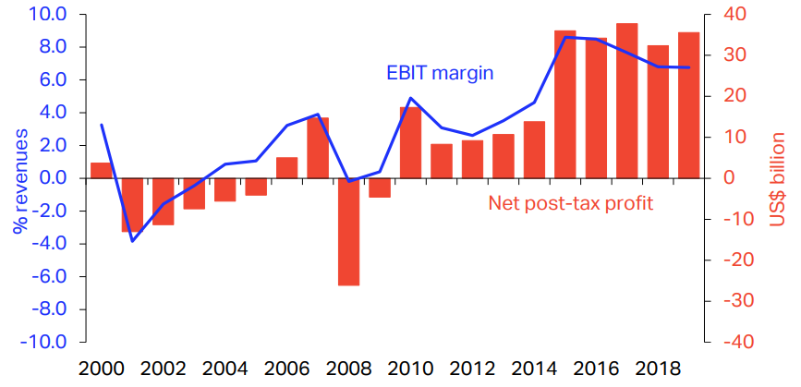

**Figure 1.1**: Global airlines profit margin since year 2000[2]

Under this context, the usual initial approach adopted by airlines, with the objective to increase the profit margin, is the adoption of methods to reduce operational costs. In the flight operations domain, this is mainly related to the reduction of the trip fuel burn and trip time.

Trip fuel reduction links with an important aspect that has been recently impacting the industry: The global commitment on mitigation of aviation greenhouse gas emissions, established at the United Nations Climate Conference held in 2009 at Copenhagen [4]. This commitment was set after findings reported by the Aviation Working Group of Intergovernmental Panel on Climate Change in 1999 where aviation was found to contribute to 2.5% on global CO2 emissions with a growing tendency in the following years [5]. In fact, a recent study conducted by Fregnani and Mattos shows that the share contribution of aviation in global emissions would increase up to 15% by the year 2050, if the other transport modals turn to electrical energy as the main source of energy and the aviation industry keeps its dependence strictly on fossil fuels [6]. Since then, discussions have evolved on the search for effective solutions with the objective of reducing the participation of aviation industry in global gas emissions. In the final report of the Copenhagen Conference, the following goals were agreed by the main aviation industry stakeholders (airlines, manufacturers, airports and air navigation service providers):

1. Improvement in fuel efficiency of 1.5% per year from 2009 to 2020 (measures under industry control, linked to operational procedures and basic infrastructure improvements).
2. Carbon-neutral growth at 2020 (when fuel CO2 emissions are neutralized).
3. Reduction in CO2 emissions to 50% of 2005 levels by 2050.

Here the term “fuel efficiency” is defined as the mass of fuel burned per passenger kilometer transported and is directly proportional to the level of greenhouse gas emissions, including CO2. Toward the improvement (reduction) of this quantity, the aviation industry has since then driven to invest hard and continuously on new technologies (aircraft design and biofuels) and infrastructure (airports and air traffic management), in addition to the improvement of operational procedures. Focus on fuel efficiency became the main goal of all industry stakeholders, not only driven by fuel prices, but also considering the environmental aspects. Fig. 1.2 shows the estimation of added contribution of each of these components on the total emissions on yearly basis, considering an average of 5% growth on world traffic demand [1].

Based on these goals, a few years later, the International Air Transport Association, representing airlines, announced the so-called “Four-pillar” Strategy [7] [8], with the objective to guide the industry stakeholders toward the 2050 emissions reduction goal, via specific areas of development as shown in Table 1.1. In this framework, the development of market-based measures, including establishment of global offset mechanisms, was also included as an alternative solution toward the 2050 target. In fact, this was recently proposed in a global level by the International Civil Aviation Organization (ICAO) in 2018, with the development of the Carbon Offsetting and Reduction Scheme for International Aviation (CORSIA) Program [9].

Figure 1.2: Aviation industry emissions reduction roadmap [8]

Table 1.1: Global strategies for reducing aviation fuel uses and emissions

|  |  |  |  |
| --- | --- | --- | --- |
| **Technology** | **Flight Operations** | **Infrastructure** | **Market Base Measures** |
| New airframe and engine technologies | Improved operational procedures | More efficient air traffic management | Global offset mechanisms |
| Retrofits | More efficient flight procedures | More efficient airports | Positive economic incentives |
| Sustainable aviation fuels | Weight reduction | Public-private initiatives |

Among the Four Pillars, the technology related initiatives are considered the main contributors for achieving the desired 2050 objectives in emission reduction [8]. Its achievement strongly depends on the development and implementation of new aircraft design methodologies using higher fidelity computational tools. In fact, aircraft and the engine manufacturers have been investing heavily to produce the airplanes as fuel efficient as possible. The main areas identified to have direct impact on fuel efficiency are airframe (aerodynamics, structures, equipment systems and new configurations) and engines technologies. It can be easily observed that each subsequent generation of airplane has better weight-to-drag ratios, improved wing performance, and the engines that use less fuel. These efficiencies can be measured and are part of the proposition airlines evaluate when deciding to acquire or lease new airplanes.

This effort may be verified along the aviation history, since new aircraft designs have always driven toward more and lower fuel efficiency values. A study conducted by the Air Transport Actions Group (ATAG) [10], considering several air transport aircraft data, concluded that over the last 50 years, since the operations of the first generation of jet transport aircraft (Comet 4), the fuel efficiency has been reduced by over 82% when compared with the current designs. Figure 1.3 shows the results of such study.

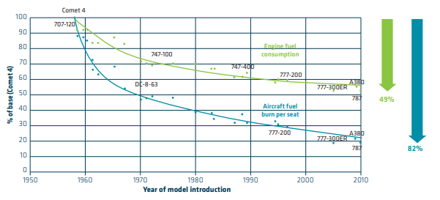

**Figure 1.3**: Fuel efficiency improvement since the first commercial jet [10]

It is worth mentioning that from 1970 onward, fuel efficiency was further enhanced with the development of flight management systems which automatically set the most efficient cruise speed and engine power settings based on fuel and other operational costs involved. Recently, airlines have developed a range of operational, maintenance and planning procedures to ensure that their current technology aircraft are flying to their optimal levels of efficiency [7] [10]. Nowadays aircraft are equipped with the 4th generation of jet engines and carbon fiber fuselages (such as the Boeing 787 and the Airbus 350), offering 20% improvement in fuel efficiency over 1990`s levels.

Tables 1.2 and 1.3 show the list of proposed technological improvements (airframe and engines related) and their associated fuel efficiency reduction related to 2005 levels. It is noticeable that up to 30% reduction on fuel efficiency may be achievable after 2020, most of them related to engines technologies [2] [7].

Table 1.2: Airframe technologies development impact on fuel efficiency

|  |  |  |  |  |  |  |
| --- | --- | --- | --- | --- | --- | --- |
| **Group** | **Concept** | **Technology** | **Applicability** | **Fuel Efficiency**  **Reduction Benefit** | **TRL in 2014** | **Expected**  **Availability** |
| Aircraft Configuration | Truss braced wing | | After 2020 | 10 to 15% | 2 | 2028 |
| Hybrid wing-body | | After 2020 | 10 to 15% | 4 | 2026 |
| Cruise efficient stall | | After 2020 | < 1% | 3 | 2027 |
| Flying without landing gear | | After 2030 | 10% to 20% | 1 | 2032 |
| Aerodynamics | Advanced  Wingtip | Wingtip fence | Retrofit | 1% to 3% | 9 | 2012 |
| Blended winglet /Sharklets | Retrofit | 3% to 6% | 9 | 2012 |
| Racked wingtip | Retrofit | 3% to 6% | 9 | 2012 |
| Split winglets (scimitar tips) | Retrofit | 2% to 6% | 7 | 2022 |
| Spiroid wingtip | After 2020 | 2% to 6% | 7 | 2022 |
| High Lift Devices | High lift / Low Noise | After 2020 | 1% to 3% | 4 | 2026 |
| Variable Camber Trailing Edge | Before 2020 | 1% to 2% | 9 | 2012 |
| Dropped spoiler | Before 2020 | 1% to 2% | 9 | 2012 |
| Hingeless flap | After 2030 | 1% to 2% | 3 | 2027 |
| Drag reduction | Drag coating | Retrofit | < 1% | 9 | 2012 |
| Turbulent flow coating (riblets) | Retrofit | 1% | 8 | 2015 |
| Graphic Films | Retrofit | 1% | 9 | 2012 |
| Natural Laminar Flow | | After 2020 | 5% to 10% | 7 | 2022 |
| Hybrid Laminar Flow | | After 2020 | 10% to 15% | 7 | 2022 |
| Variable Camber | | Before 2020 | 1% to 3% | 8 | 2015 |
| Variable Camber with new control surfaces | | After 2020 | 1% to 5% | 5 | 2024 |
| Structures | Active Load Alleviation | | Before 2020 | 1%to 5% | 9 | 2012 |
| Composite Primary Structures | | Before 2020 | 1% to 3% | 9 | 2012 |
| Smart wing/actuators | | After 2020 | < 1% | 6 | 2023 |
| Morphing wings | | After 2030 | 2% to 8% | 5 | 2024 |

Table 1.3: Engine technologies development impact on fuel efficiency

|  |  |  |  |  |  |  |  |
| --- | --- | --- | --- | --- | --- | --- | --- |
| **Group** | **Concept** | **Technology** | | **Applicability** | **Fuel Efficiency**  **Reduction Benefit** | **TRL in 2014** | **Expected**  **Availability** |
| New Engine  Architecture | Geared Turbofans | | | Before 2020 | 10%-15% | 7 | 2016 |
| Advanced Turbofans | | | Before 2020 | 10%-15% | 7 | 2016 |
| Counter rotating fan | | | After 2020 | 15%-20% | 3 | 2019 |
| Open Rotor | | | After 2020 | 15%-20% | 5 | 2019 |
| New engine core concepts | | | After 2030 | 25%-30% | 2 | 2026 |
| Embedded Distributed Fan | | | After 2030 | Less than 1% | 2 | 2026 |
| Advanced Concepts | Fan | | Component Improvements | Before 2020 | 2%-6% | 8 | 2013 |
| Zero Hub | Before 2020 | 2%-4% | 7 | 2016 |
| High BPR | Before 2020 | 2%-6% | 7 | 2016 |
| Variable Nozzle | After 2020 | 1%-2% | 7 | 2016 |
| Combustor | | Variable Flow Splits | After 2020 | 1%-2% | 5 | 2020 |
| Ultra-compact low emission | Before 2020 | 1%- 2% | 5 | 2020 |
| Advanced | Before 2020 | 5%-10% | 8 | 2013 |
| Compressor | | Bling concept | After 2030 | 1%-3% | 3 | 2023 |
| Bisk Concept | After 2020 | 1%-3% | 7 | 2016 |
| Variable Geometry Chevron | | | After 2020 | Less than 1% | 5 | 2020 |
| Nacelles and Installation | Buried engines | | | After 2020 | 1%-3% | 5 | 2020 |
| Reduced nacelle weight | | | Before 2020 | 1%-3% | 7 | 2016 |
| Engines Cycles | Adaptive Cycles | | | After 2030 | 5%-15% | 2 | 2030 |
| Pulse Detonation | | | After 2030 | 5%-15% | 2 | 2030 |
| Others | Boundary Layer Ingestion Inlet | | | After 2020 | 1%-3% | 3 | 2023 |
| Ubiquitous Composites | | | After 2020 | 10%-15% | 3 | 2023 |
| Adaptive flow control | | | After 2020 | 10%-20% | 2 | 2026 |

According to ICAO, flight operations related initiatives (the second pillar) would have potential to reduce emissions in a range of 2% to 6%, despite technology improvements [5]. Emissions are directly proportional to trip fuel burn, this means for airlines direct investments on flight path management, enhancements on flight planning methods and the adoption of fuel conservation programs should be carried out. With the oil crisis in the 70´s, such procedures and methods have been developed by aircraft manufacturers and airlines with the objective to reduce fuel burn, and nowadays, they have been enhanced by high performance computer dedicated applications. Some examples are: fuel reserves management, empty weight management, center of gravity management, optimized flight planning systems, optimized strategies for climb, cruise and descent phase on speed and altitude management, among others [11] [12].

It should be noted that although the magnitude of such reductions seems to be small, the impact of such reductions in the whole network served by a fleet throughout a year is significant, since the multiplication factors are large. For example, 1% of trip fuel burn reductions on a Boeing 737-800 fleet, considering 13 hours of daily utilization and average sector of 600 nm (typical for a large Low-Cost Carrier), represents savings about 56.9 tons of jet fuel per year per aircraft. A fleet of 100 aircraft, would represent annual savings of about 3.7 Million US$, considering an average fuel price of 0.65 US$/kg. Although the magnitude of investments in such kind of initiatives is normally lower than acquiring new aircraft quipped with leading technologies, its success is highly dependable on the implementation of company policies and staff training, which are sometimes hard to be fully effective due to cultural aspects and resistance of change [12].

The third pillar, related to aviation infrastructure initiatives (Air Traffic Management and Airport operations related), have potential to reduce aviation emissions by 12% [5]. This area, initially considered complementary on flight operations initiatives, has direct impact on the operations of aircraft which deals with the trajectories management of traffic flows evolving in a certain region. Moreover, the integration of onboard and ground systems (CNS/ATM technologies) have driven the efficient use of the airspace for the benefit of all stakeholders (airlines, airports and air navigation service providers). The main objective here is to reduce the delays associated with airspace capacity and infrastructure constraints. The more delays aircraft experience while maneuvering, the more fuel is burned and lower fuel efficiency. Therefore, the minimization of gate to gate time represents less fuel burnt and then less emissions.

In addition to the environmental aspects described above, optimization methods have been widely researched to improve airline’s network efficiency toward profit maximization. Most optimization methods are related to total operational cost minimization and therefore indirectly related to the reduction of fuel burn. Such methods are developed to be applied on airline’s network planning phase, in which three main processes blocks are considered [13], as shown in Fig. 1.4.

The first block is related to the process called Route Assignment (or Schedule Generation). The route allocation along the city pairs is determined according to the estimated or actual passenger and cargo demand, taking into consideration airport constraints, such as operational hours or infrastructure issues. At this stage, gravitational demand forecast models are frequently adopted when traffic data between cities is absent [14] [15].

It is worth mentioning that the aircraft types used in this block are selected based on preliminary studies conducted by the airline´s fleet planning departments, frequently assisted by manufacturer´s marketing teams. Usually, families of existing aircraft from one or more manufacturers are tested into the network produced at this phase, through experimental trials, in order to determine the highest potential profit configuration. In each run, once the fleets are selected, the amount of frequencies for each city pair is determined for each aircraft type based on their specific capacity, design range and a preliminary estimation of direct operational costs, as function of the sector distance. In this type of problem, the optimization models, typically falling into the Mixed Integer Linear Programming (MILP) class, are designed with the objective to exhaust a given demand for each sector, based on a specific load factor and market share for each city-pair [16]. The objective function is frequently set for revenue or yield maximization, considering a pre-determined average fare [17] [18].

The second block is related to the process called Fleet Assignment (or Aircraft Scheduling). There, the optimum time schedules of each city-par (slots) are determined and assigned to each tail number (of each aircraft type), according to the frequencies determined for each route resulting from block 1 optimization. In this process, aircraft maintenance requirements and airport specific operational limitations (such as compatibility, presence of maintenance base, handling services, fuel availability are taken into consideration on the optimization problem. In this block, the objective function is usually set to optimize the fleet size [19].

After the network is implemented, airlines frequently assign the aircrafts which present the lowest performance degradation and empty weight combination to the longest routes, where the Maximum Takeoff Weight (*MTOW*) limit is frequently reached. This practice may also be introduced as new constraint into the block 2 optimization, whenever the aircraft schedule is reviewed on a frequent basis. The third and last block is related to the process called Crew Assignment, where pilots and commercial crew members are allocated to each flight, complying with labor regulations and crew technical constraints, on a rostering/pairing scheme. In this block, the objective function is frequently set to minimum crew numbers.

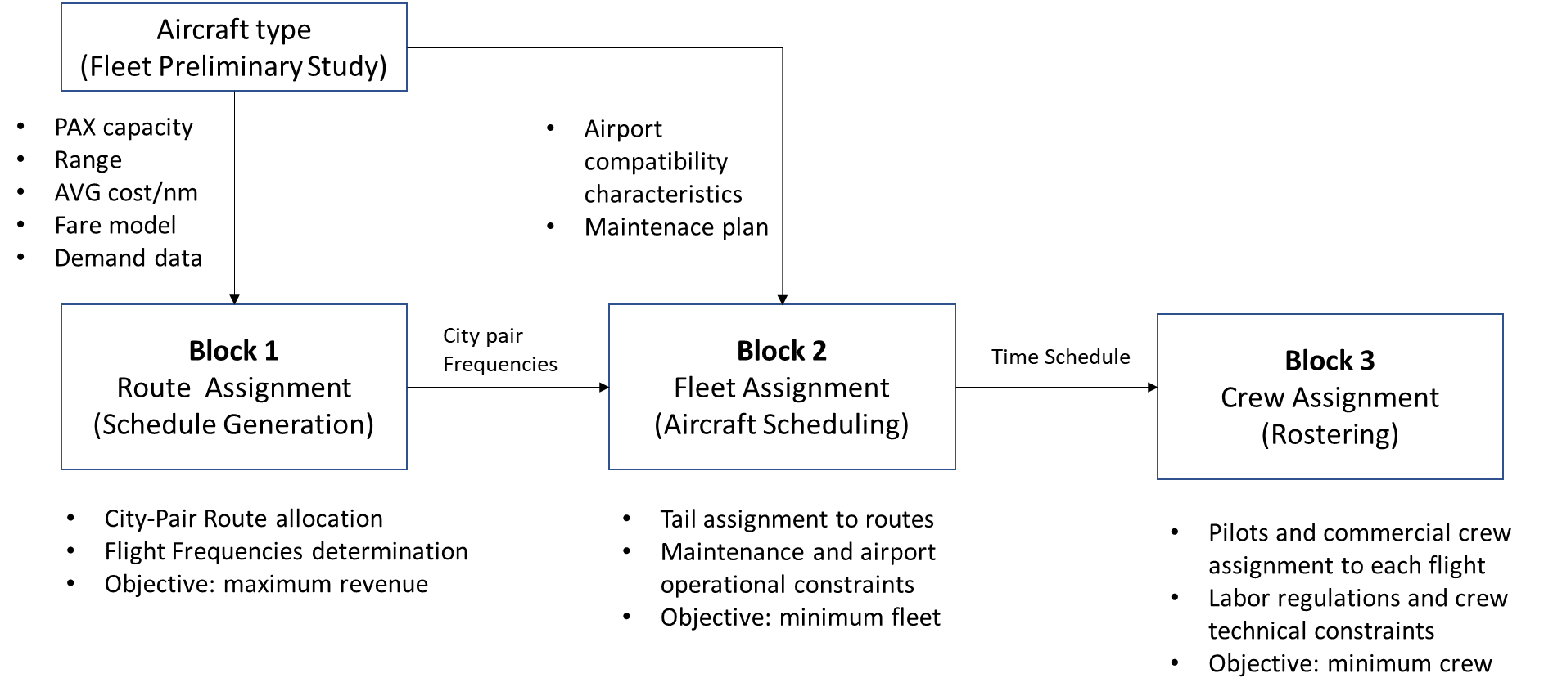

**Figure 1.4**: Typical network planning process adopted by airlines

These three blocks are interdependent, where outputs from each block are the necessary inputs for the subsequent block. However, each block has its own objective functions which impact on the total profit of the network. Because of this, some models are built to solve all blocks in a single step, where the minimization of costs or maximization of revenues are set as global objective functions [13]. However, this unified resolution method, applied to optimize the entire process, leads to large-scale problems sometimes involving non-linear programming algorithms and therefore significant computational power may be required for the complete solution [20]. Nevertheless, airlines preference is to solve each block separately in order to have faster and less complex to model solutions, even if a sub-optimum solution is reached.

As earlier mentioned, the selection of the aircraft fleet types suited to the network is most of the times performed prior to the optimization of block 1, which has strong influence on flight frequencies. The determination of the optimal flight network and associated frequencies is a key step for airlines to elaborate their strategic planning, from market determination to aircraft and crew rostering. An optimal solution for this block facilitates the solution for the others. Furthermore, if in this optimization, the optimum aircraft types could be associated with the assigned network, the goal for maximum revenue and/or minimum operational costs would even be further improved. In other words, the network optimization is normally carried out separately from the aircraft optimization in the airline planning process.

* 1. Aircraft Conceptual Design

Some aspects related to the conceptual design of commercial transport airplanes shall be mentioned at this point. In this phase, the aircraft configuration that best meets all the requirements related to market, certification and manufacturing (or others established by the aircraft manufacturer) is chosen, evaluating numerous alternative design concepts potentially satisfying an initial statement of design requirements. The conceptual design process is iterative in nature where concepts are evaluated, compared to the requirements, revised, reevaluated, and so on until convergence to one or more satisfactory concepts is achieved (Fig.1.5). Inconsistencies among the requirements are often exposed, so that the products of conceptual design frequently include a set of revised requirements. Conceptual design traditionally performs mission analysis, sizing, and configuration down-select of candidate designs via empirical or low-fidelity physics analyses. The geometry parameters at this stage can, in practice define the overall shape or even the outer mold-ling of the aircraft to a degree sufficient for aerodynamic and flight analyses, or for simple structural analyses, such as Simple Bending/Torsion Beam Theory.

According to Magalhães and Mattos [21] when selecting a group of aircraft design methodologies to automate the conceptual design, there are two basic questions that must be answered: what disciplines should be considered and to what level of detail each of them should treated. The first one shall be addressed, from the very beginning, under the airline perspective in which profit means its survival and is the major topic of interest. Once the airfare is normally determined by market laws and yield management models, the airplane best design is the one that provides minimum acquisition and operating costs, which leads to the necessity of a cost estimating module in the design framework.

A large fraction of airplane operating costs comes from its fuel consumption (according to IATA [7], between 25% to 50% of the total operational costs depending on the airline business model) , which is derived exclusively from aircraft mission performance. So, the aircraft performance module shall be the core of the optimization framework. However, in order to develop a performance module other module, it is also necessary to develop the modules related flight physics disciplines, providing key input parameters to performance computations, which are: aerodynamics (providing aerodynamic coefficients), propulsion (providing net thrust and full flow) and stability and control. These for their turn, are based on an initial geometry definition module. These are the core modules for any airplane design framework. Improvements can be made, once the initial set is complete, to incorporate a structural layout and analysis module, which would enable a more accurate calculation of airplane weight and other sophisticated elements (i.e. assessment of aeroelastic characteristics, noise, etc…).

Once the minimum set of modules is defined, the second question may be addressed: how deep the selected disciplines should be developed. This is directly related to the compromise between project development costs, time and level of accuracy required at the conceptual design phase. This is highly dependent on the available resources (human and infrastructure) and the budget allocated to the project. An interesting aspect to consider while interest in new materials and unusual configurations for future airplanes, these methodologies are being constantly revised.

Frequently based on a point mass models, performance computations rely on analytical approaches of the main flight physics disciplines (aerodynamics, propulsion, stability, control and performance) [22] [23] and in order to estimate fuel consumption, for a given mission and geometry. After some iterations, designers can determine, with a certain margin of error, the size and weight of the major aircraft components (fuselage, wing, empennage). Frequently, numerical optimization techniques are applied in this process with the objective to select engines, define the airplane layout and establish system architectures [24]. In the conceptual design phase, the engine is selected, aircraft layout containing access panels and structural shape is defined, the airplane is sized, and system architectures are established. After this phase, the aircraft configuration concept will look like the image shown in Fig. 1.6 [25].

|  |  |
| --- | --- |
| C:\Users\bxistos\Desktop\Plotairplane3D\airplane3d_e1w1.png | C:\Users\bxistos\Desktop\Plotairplane3D\airplane3d_e1w2.png |
| C:\Users\bxistos\Desktop\Plotairplane3D\airplane3d_e2w1.png | C:\Users\bxistos\Desktop\Plotairplane3D\airplane3d_e2w2.png |
| C:\Users\bxistos\Desktop\Plotairplane3D\airplane3d_e1w1h1.png  **Figure 1.5**: Conceptual design configurations study [12] | |
|  | |

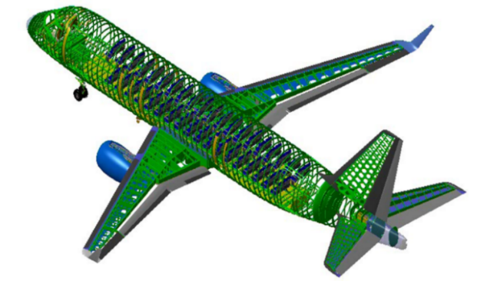

**Figure 1.6**: Aircraft layout after the conceptual design is finished [12]

Typically, the conceptual design process is carried out by aircraft manufacturers (and frequently by the academia) through optimization of averaged direct operational cost in each set of stage lengths (or ranges), carefully chosen by the project team. Considerations about the suitability of the product into a realistic airline network are usually not considered. In order to capture more realistic design scenarios, a common approach is to conduct surveys with airlines to incorporate their specific requirements into the project. Airline representatives are usually allocated into an aircraft development program council in order to provide regular feedbacks on design reviews. However, different airlines present different requirements for their fleets, highly influenced by their business model and operational profile, sometimes not explicit to this kind of committee for strategic reasons. Because of this, families of aircraft types (variants from a standard model) are offered to customers, in order to provide a range of solutions for different airline profiles and business models [12].

Until the 90’s, the tools used for the aircraft conceptual design were limited by computational power. Simplistic models were developed in the several aeronautical disciplines, and therefore lower fidelity, in the sake of computational costs. Because of that, aircraft designers most times restricted mission requirements and performed optimizations focused on subsystems, ignoring the high degree of dependency that exists between airplane and network, resulting in a sub-optimization of systems functionalities.

With the increase of the computational power, the aircraft conceptual design process is nowadays carried out by manufacturers using Multidisciplinary Design Optimization (MDO) frameworks. A great deal of computational analysis is required to obtain optimum configurations to satisfy many objectives and design constraints. Disciplines such as aerodynamics, propulsion, flight mechanics, structures and aeroelasticity, among others, are frequently considered in the optimization framework to obtain more realistic geometries of flight vehicles in addition to mission analysis into the network. Because of the increased complexity of such kind of methodology, significant efforts of computational analysis are required to obtain optimum configurations to satisfy many objectives and design constraints. Nowadays, many design variables (and types) may be employed, and advanced optimization algorithms that enable complex models of the aeronautical disciplines can be considered.

In order to produce realistic results, the airplane representation used in design framework is considerably more complex and sophisticated than that utilized by many authors. For example, Taylor [26] or Bower and Kroo [27] ran optimizations with only a single objective cost function and adopting just three aircraft design parameters (range, lift-to-drag ratio, and cruise speed), associated with simplistic frameworks with few disciplines. However, in recent studies, Mattos et. al [12] [28] proposed several design variables, constraints and features to be considered in the conceptual design framework as listed below:

* Geometric variables: front fuselage, tailcone, fuselage cross-section shape and dimensions, wing planform characteristics and wing airfoil geometries, wing structural sizing, vertical and horizontal tail characteristics, winglets, and landing gear sizing.
* Topology: engine location, wing location, number of engines, engine positioning to avoid hot exhaust gases hitting flaps and fan debris reaching fuel tanks, wing structure layout, seating abreast, number of aisles, main and nose landing gear location and sizing to comply with engine clearances from ground, and tail configuration.
* Propulsion: engine by-pass ratio, overall pressure ratio, fan pressure ratio, turbine inlet temperature, and fan diameter.
* Environmental constraints: noise footprint and engine emissions.
* Certification and performance requirements: 2nd segment climb, rate of climb, cruise speed, initial cruise altitude, time to climb, landing climb, takeoff climb, wing spanwise location where stall starts, landing and takeoff field lengths, flap settings, and fuel storage.

In addition, considering the complex network theory [29], the main indicators reflecting the statistical features of air transport network structure may be included in the framework such as degree of nodes, average degree, average path length, density and clustering coefficient [30]. Airports characteristics in the network may also be included in the mission profile computation. Information such as noise levels constraints for operating airplanes, runway length, elevation and environmental conditions could be set as fixed parameters in the framework.

In summary, there is a need for integrated design where both aircraft or family of aircraft and air transport networks are simultaneously optimized. For realistic results, a mandatory detailed representation of the airplane with accurate and concise mission performance calculations must be done, which must consider operational characteristics of airlines in their aerial network.

This should be carried out with a detailed description of the optimized configuration, not just representing the airplane with a few parameters, but with precise and concise mission performance calculations considering operational characteristics of airlines, taken into consideration fuel efficiency enhancements techniques, in the whole network. In addition, the cost of design and production of such aircraft models should be included in the optimization process, with the objective to balance the economic benefits between the airlines and the aircraft manufacturer.

* 1. Objectives

This research proposes an innovative methodology for development of a Multidisciplinary Design Optimization (MDO) framework that integrates a highly detailed airplane model simultaneously with the optimum airline network. Under this scope, the following achievements are envisioned:

1. Development of a detailed Airplane Calculator Module, incorporating typical disciplines used in the conceptual design phase;
2. Development of a Network/Mission Analysis Module with the objective to calculate trip fuel and time on each sector of an aerial network, considering a realistic airline operational scenario, selected average load factor and market share;
3. Development of the appropriate MDO framework, incorporating both modules, with the objective to run simulations considering the following cases:
4. Determination of the optimal airplane design that fits into a fixed airline network and given passenger demand, on a test set of airports;
5. Determination of optimal aerial airline network for a selected airplane type, considering an appropriate passenger demand model, on a test set of airports;
6. Determination of the optimal design of network, considering an appropriate demand model, and fleet of three airplane types (typical airline classification for fleet purchase) at the same time, on a typical domestic airline set of airports.
   1. Research Contribution

The major contributions of the present research are outlined as follows:

1. Integration of the aircraft and airline network designs in the same optimization process.
2. Several design parameters are used to represent the airplane in finest detail with accurate aerodynamic, stability and control, and propulsion characteristics, necessary for realistic mission analysis. Aircraft are generated according to the following design features:
   1. An Artificial Neural Network (ANN) system is employed to calculate the aerodynamic characteristics of the airplane configurations, based on full potential formulation with viscous correction. The use of the ANN enabled a high degree of accuracy and fidelity for the aerodynamics of the present work, allowing performance calculations in such a level never achieved in conceptual design before.
   2. Verification of regulatory performance requirements: climb rate at 2nd segment, missed approach, takeoff field length, landing field length, climb rate at service ceiling, cruise speed, and adequate fuel storage.
   3. Verification of noise signatures at ICAO Annex 16 standard certification points (sideline, approach, and takeoff).
   4. Innovative method for turbofan engine weight calculation.
   5. Realistic landing gear sizing and integration into the configuration avoiding flaps being affected by wake generated by wheels and hit by engine hot exhaust gases.
   6. Proper sizing of wheel tires selected from tables containing internal pressure, loads, speed and other parameters. Main landing gear trunnion is positioned between the rear and auxiliary spars of the inner wing.
   7. Ditching requirements are considered for fuselage cross-section sizing.
   8. Engines of underwing configurations are positioned in such a way to avoid uncontained fan debris to hit fuel tanks.
3. A database of airplanes with the most distinguished characteristics is employed in the optimization of both aircraft and network integrated. Optimal fleet is then found from the airplanes from this database, ensuring faster convergence of the optimization process in this way.
4. Realistic airline mission performance calculation, considering:
   1. Airline operational characteristics;
   2. Consideration of average ground and in-flight delay times per airport. Associated costs modeled as function of Maximum Takeoff Weight (*MTOW*);
   3. Payload-range envelope limitations;
   4. Calculation of maximum performance limit takeoff and landing weights according to regulatory requirements.
5. The determination of the optimum network considers a two-stop route model and three airplane types making up the airline fleet. This is solved in a sub-procedure for obtaining the network with maximum profit.
6. Optimal airplane fleets are obtained considering maximization of Network Profit (airline objective) and Net Present Value (aircraft manufacturer objective). A genetic algorithm is used for such multi-objective optimization context.
7. Net Present Value (*NPV*) calculations are derived from a realistic aircraft program and adapted to each aircraft generated as function of Maximum Takeoff Weight (*MTOW*), number of passengers, wing area, engine diameter and engines maximum thrust at sea level.
8. Aircraft sales price, used in the NPV calculations, modeled as function of Maximum Takeoff Weight (*MTOW*).
9. Crew salaries, used in the Direct Operational Cost (*DOC*) calculations, modeled as function of Maximum Takeoff Weight (*MTOW*).
10. The final test case considers fifty European airports extracted from Lufthansa main domestic destinations in 2017. The impact of noise constraints and stochastic characteristics of the ground and in-flight delays are explored in this evaluation.
    1. Chapters Structure

This study is organized into five chapters, bibliographical references and annexes. The chapter summaries are described as follows.

* Chapter 2 – Literature Review: presents the state-of-art of the existing Multidisciplinary Design Optimization (MDO) frameworks, airline network optimization methods and integrated aircraft and network optimization research.
* Chapter 3 – Methodology: presents the methods and procedures used for the development of: (i) a detailed aircraft calculation model considering five design disciplines (aerodynamics, propulsion, stability and control, weight estimation, tail sizing and landing gear sizing), (ii) a network calculation module considering two disciplines (network optimization and mission analysis) and (iii) the proposed MDO integration framework for simultaneous aircraft and network optimization.
* Chapter 4 – Results: presents the results of the proposed optimization framework considering three distinct scenarios: (i) Optimization of one airplane design that fits into a fixed airline network, serving six Brazilian airports). (ii) Optimization of an aerial airline network serving twenty Brazilian airports, considering a given airplane model. (iii) Simultaneous optimization fleet of three airplane types and a network at the same time, serving fifty European airports. In all cases, a comparison with the results produced by a reference aircraft is performed.
* Chapter 5 – Conclusions: presents the final considerations regarding the developed MDO framework, including the analysis of the achieved objective and model restrictions. Future developments and improvements of such framework are also proposed.

# **Literature Review**

* 1. Multidisciplinary Design Optimization

The Multidisciplinary Design Optimization (MDO) is an engineering design methodology in which the main objective is to determine numerically the optimal engineering design which involves several disciplines and/or subsystems, submitted to constraints and fixed parameters. This method allows the considering of interaction between disciplines as a synergetic driver into the best design solution. In fact, Sobieszczanski-Sobieski in 1993 defines for the first time, the term MDO as “*an emerging field of knowledge in which* *a methodology for the design of complex engineering systems are governed by mutually interacting physical phenomena and made up of distinct interacting subsystems*” with the key characteristic of “*synergism of the disciplines and subsystems*” [31].

Considering the solution of the MDO framework early in the conceptual design process, taking advantage of advanced computational analysis tools, designers can simultaneously improve the design and reduce the time and cost of the design cycle [32] [12]. According to Reymer [33], MDO techniques are capable of reducing the weight and cost of an aircraft design concept in the conceptual design phase considering minor changes to the design variables, and no additional downstream costs.

The idea of integrated engineering design frameworks was first introduced by the academia (and promptly adopted by the aeronautical industry) with the research conducted by Schmit [34] and Haftka [35] where several disciplines in wing structural optimizations were included. Some years later, the initial applications using the Multidisciplinary Design Optimization (MDO) concept, considering the integration of wing design disciplines (aerodynamics, structures and flight controls) were adopted in the work of Ashley [36] and Grossman et.al [37].

The research on multidisciplinary design architectures and optimization methods started to gain momentum during the 90´s, when computational power started to permit complex problem solvings at resonable costs. Some relevant research studies in the field are worth mentioning:

Haftka et. al [38] performed the first framework for indisciplinary analysis, considering the computational challenges for non-linear algebric equations and coupled systems. Cramer et. al [39] formalized the monolithic frameworks and necessary computational methods to find the global minima, based on gradient formulations.

Balling and Sobieski [40] studied several monolithic approaches and estimated their computational costs based on gradient methods. In their research, they have also identified that aircraft design may vary in single level and multilevel optimization. In single level approach, both disciplinary and system design variables are determined by the system optimizer, while in the second one, system and design variables have their own optimizers. In addition, this study identifies simultaneous analysis design (SAND) or nested analysis design (NAND) as suitable strategies to handle system variables in complex problems. In the SAND approach, both disciplinary design and state variables are determined by the optimizer, while in NAND, only disciplinary design variables are determined by it. In the first case, the optimum solution may be reached in less interactions, although providing a high computational cost.

Alexandrov and Hussaini [41] presented a complete research on possible monolithic and distributed architectures, optimization methodologies and convergence properties. In the same year, Sobieski and Haftka [42] also presented an extensive survey on mathematical modeling, design analysis, approximation concepts and systems sensitivities.

Kroo and Shevell [43] described several aeronautical design optimization formulations and their integration. Isikveren [44] presented, in his doctorate thesis, the first MDO framework applied for the whole aircraft design process. Recent research studies made use of such variety of frameworks developed by the above authors, on environmental- aeronautical applications. For example, Henderson [45] developed an environmental design framework to design and optimize aircraft for speciﬁc environmental metrics on engine emissions. Magalhães and Mattos [46] developed an MDO framework to consider the noise impact on aircraft conceptual design of three different mission profiles.

The core of the MDO framework is the analysis block, composed of a set of relevant disciplines most times dependent on each other. This block is responsible for integrating the inputs of outputs of each discipline, considering their specific design variables, and producing a desired output to be used as objective function in the optimization cycle. Depending on the type of the simulation architecture, the outputs from certain disciplines may be the inputs of others. Fig. 2.1 shows a classic example on how the output and input variables for each discipline may interact producing a main output in the range of an aircraft. In this analysis, four main blocks of disciplines are integrated: structures, aerodynamics, propulsion and performance.

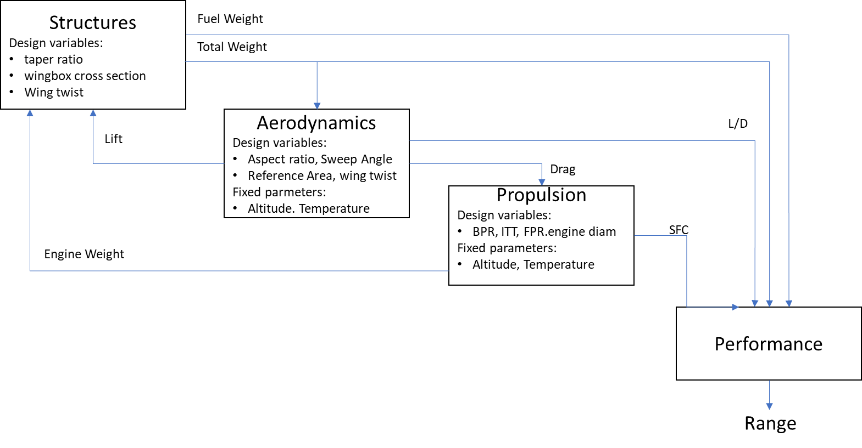

**Figure 2.1**: Block analysis for range computation

Many forms of approximation methods were developed to model disciplines in order to enhance the speed of the optimization when heavy computations are required. Empirical formula like the Class-I and -II methodologies proposed by Torenbeek [22] and Loftin [47] for drag and weight estimation are still extensively used for modeling because they provide faster results.

Surrogate techniques have been increasingly adopted in MDO frameworks to model the physics with enough precision and reducing the computational time of complex and heavy calculations [48] [32]. The aim of this technicque is to represent the original model based on sampling data. They are recommended to be used when the inner physics of a certain system is not well known (or even understood), but the input-output behavior is well defined. The surrogate is constructed based on modeling the response of the system to a limited number of intelligently chosen data points in the design space. Its accuracy depends on the number and location of samples in the design space [48]. When only a single design variable is involved, the surrogate model resumes on the statistical curve fitting [49]. Considering multivariable problems, the most used methods are polynomial response surfaces [50], Radial Basis Functions [51], Support-vector machines [52] and space mapping [53]. More recently, Kriging interpolation [54] , Bayesian Networks [55] and Artificial Neural Networks [56] have been providing satisfactory results on aerospace systems modeling. Fig. 2.2 shows the generic formulation of the MDO framework, considering its basic components: analysis, optimization and design of experiments.

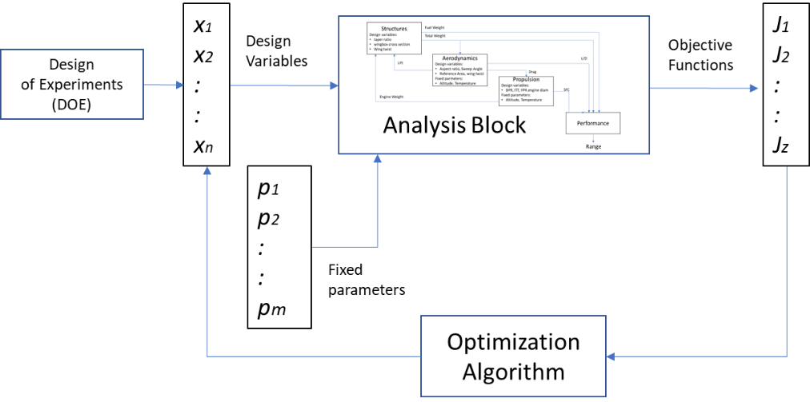

Figure 2.2: Generic MDO framework

Considering this framework, for a given *J* vector of objective functions, *x* vector of design parameters and *fp* vector of fixed parameters, the following generic mathematical formulation is applied:

(Eq. 1)

Submitted to: (Eq. 2)

(Eq. 3)

Where:

*g* and *h* are constraint functions

andare upper and lower limits of the design variables

In the MDO concept, the optimization algorithm is responsible for evaluating the value of each objective function, output from the analysis models, in each interactive cycle and adjust the values of the design variables, according to a certain algorithm, in order to seek the direction of the minimum global solution. Depending on the type of disciplines integrated into the framework, the objective functions may be conflicting, and then slowing the convergence search toward the global minima. Optimization techniques will be explored in Session 2.2.

In order to provide the design variables space of exploration in which the optimizer runs, a design of experiments (DOE) [57] shall be provided in MDO frameworks. This statistical technique is commonly used in systematic approaches, such as in Monte Carlo simulations, where there is a need to determine the relationship between factors affecting a process and the output of that process (in this case, the process is the optimization algorithm itself). Among several types, the space fillers sampling methods (such as Latin Hypercube [58], Sobol [59] and Random Sampling) are frequently used in MDO problems. The Latin Hypercube (Fig. 2.3), derived from the 2D Latin Square which provides a single random sample on each dimensional row, is very popular in complex optimization problems, since it provides fewer design points and faster convergence times in multiple design variables environments [60].

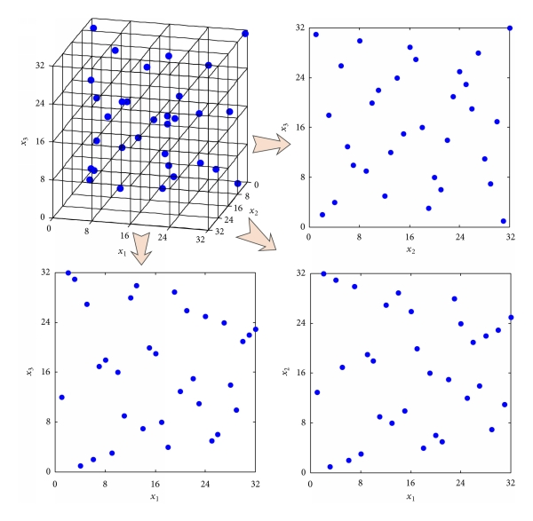

Figure 2.3: Latin Hypercube sampling [58]

According to Martins and Lambe [32], the most important considerations when implementing MDO are the description of the problem to be solved and how to organize the discipline analysis models, approximation models (if any), and optimization algorithm related to the problem formulation so that an optimal design is achieved. Such a combination of problem formulation and organizational strategy is referred to as MDO achitecture, deﬁning how the different models are coupled and the optimization problem is solved. Two kinds of MDO framework architectures are frequently used by the industry (and academy):

* Monolithic architectures – where a single optimization problem is solved at once.
* Distributed architectures – where the overall problem is discomposed into multiple sub-optimization blocks, before going through the overall optimization.

The most intuitive monolithic architecture for engineers, and one of the first to be considered in MDO frameworks, is the so called Multidisciplinary Feasible (MDF). In this architecture, several discipline analyses, wrapped together in a Multidisciplinary Analysis (MDA) block, are executed in a certain sequence from which outputs are computed and aggregated into the final objective functions. An example of MDF framework is shown in Fig. 2.4, represented in the so-called Extended Design Structure Matrix (XDSM) format [61], considering three disciplines (Analysis 1,2 and 3), four design variables (*xi*), three coupling variables between disciplines (*yi*), a constraint vector I and a single objective function (*f*).

The analysis execution sequence is numbered from zero to seven. This framework always returns a system design that satisfies the consistency constraints, what is desirable in terms of engineering [32]. However, depending on the complexity of the disciplines, the analysis procedure may be time consuming. Also, during the optimization process, gradients of the coupled systems may be challenging to compute. This may be mitigated by the agregation of the coupling variables to reduce the information transfer among the disciplines, in the so-called Individual Discipline Feasible (IDF) approach. In this case, constraints are rewritten as function of the design variables. This permits discipline analyses to be executed in parallel from which outputs are computed and aggregated into the final objective functions, as shown in Fig. 2.5.

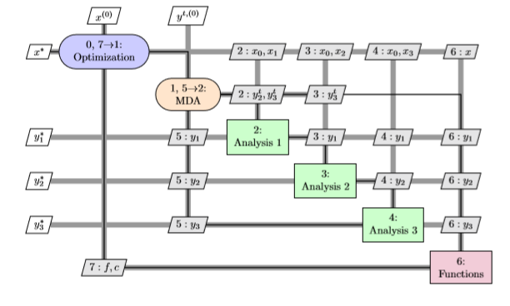

Figure 2.4: Example of Multidisciplinary Feasible Framework (MDF) [32]

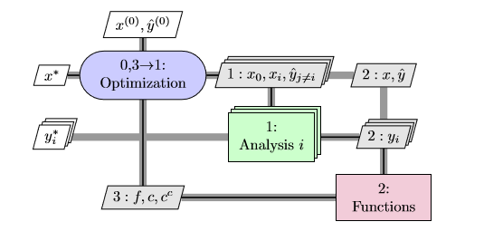

Figure 2.5: Example of Individual Discipline Feasible framework (IDF) [32]

Typical industrial practices involve breaking up the design of large and complex systems to specific engineering teams, that may be geographically distributed and have control of their own design procedures. For this reason, the distributed architectures are the most commonly used by the industry, although researchers are dedicated to investigating both [62]. An example of such framework is the Collaborative Optimization (CO) as shown in Fig 2.6, where a sub-optimization process is applied at a certain discipline analysis level. In this framework, the discipline sub-optimization problems are made independent of each other by using copies of the coupling and shared design variables. These copies are then shared with all the disciplines during every iteration of the solution procedure [32].

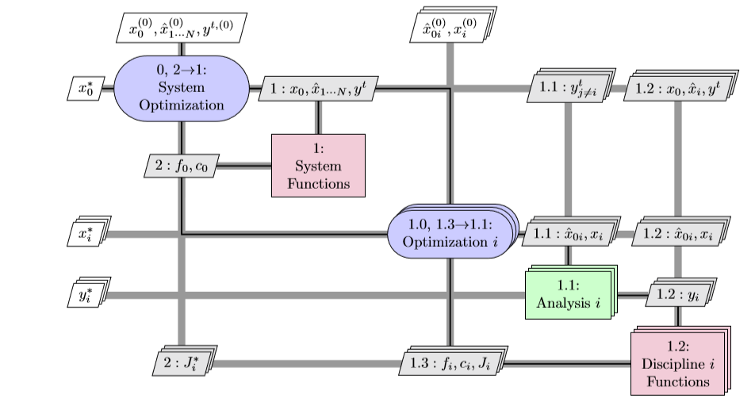

Figure 2.6: Example of Collaborative Optimization framework (CO) [32]

As extensions to the above classifications, Balling and Sobieski [40] define the concept of simultaneous analysis and design (SAND) or nested analysis design analysis (NAND) frameworks. In SAND, both design and state variables are determined by the optimization process, mostly used in distributed architectures, while in NAND, only the design variables are determined by it.

It should be noted that different architectures and optimization methods may be used to solve a given optimal design problem. However, the correct definition of the type of architecture adopted is a key factor for the effectiveness of convergence of the optimization process [63] and has a signiﬁcant inﬂuence on the ﬁnal design. For example, if the calculations permit a given architecture to be run parallel, a distributed architecture is always preferred over a monolithic architecture for the sake of increased computational expense [32].

* 1. Design Optimization Techniques

The design optimization process is a consolidated activity of any engineering branch. Optimization methods have been in use since the 50´s and have been combined with design synthesis and parametric analysis in the aerospace industry aiming to provide the best technical and/or economical solution to engineering problems. According to Sobieski [31], an optimization method is necessary whenever at least two opposing trends exist as function of the design variables during the analysis process. Optimization algorithms work under the same basic principle: in each cycle, the design parameters are adjusted, according to a certain function based on the evaluation of the objective functions, seeking the direction of a minimum (or global) global solution. In early stages, when computer power is limited, graphical methods were used to find the minimum (or maximum) of multivariate function [64].

The selection of the suitable optimization method to be used in the airplane conceptual design process requires a careful analysis of the nature of the problem. The first aspect to consider is that calculations usually rely on information from several different types of objective functions and constraints which may or may not be continuous and differentiable. This might be a showstopper for some methods, where first and second order derivatives are most of the times required. Secondly, consideration of computational costs: an automated algorithm may take from few minutes to hours on running a single case depending on the level of fidelity of the models required for the results. This might be an issue considering the timelines of the project. Finally, the optimization method must be flexible enough to tackle both single-objective and multi-optimization problems with good converging characteristics. The designer should be able to perform some level of sensitivity analysis when multiple objectives are inserted into the optimization problem, like a Pareto front analysis [21]. Several techniques and methods have been developed over the years to address this issue, classified in two major groups: gradient-based methods and gradient-free methods, as shown in Fig.2.7.

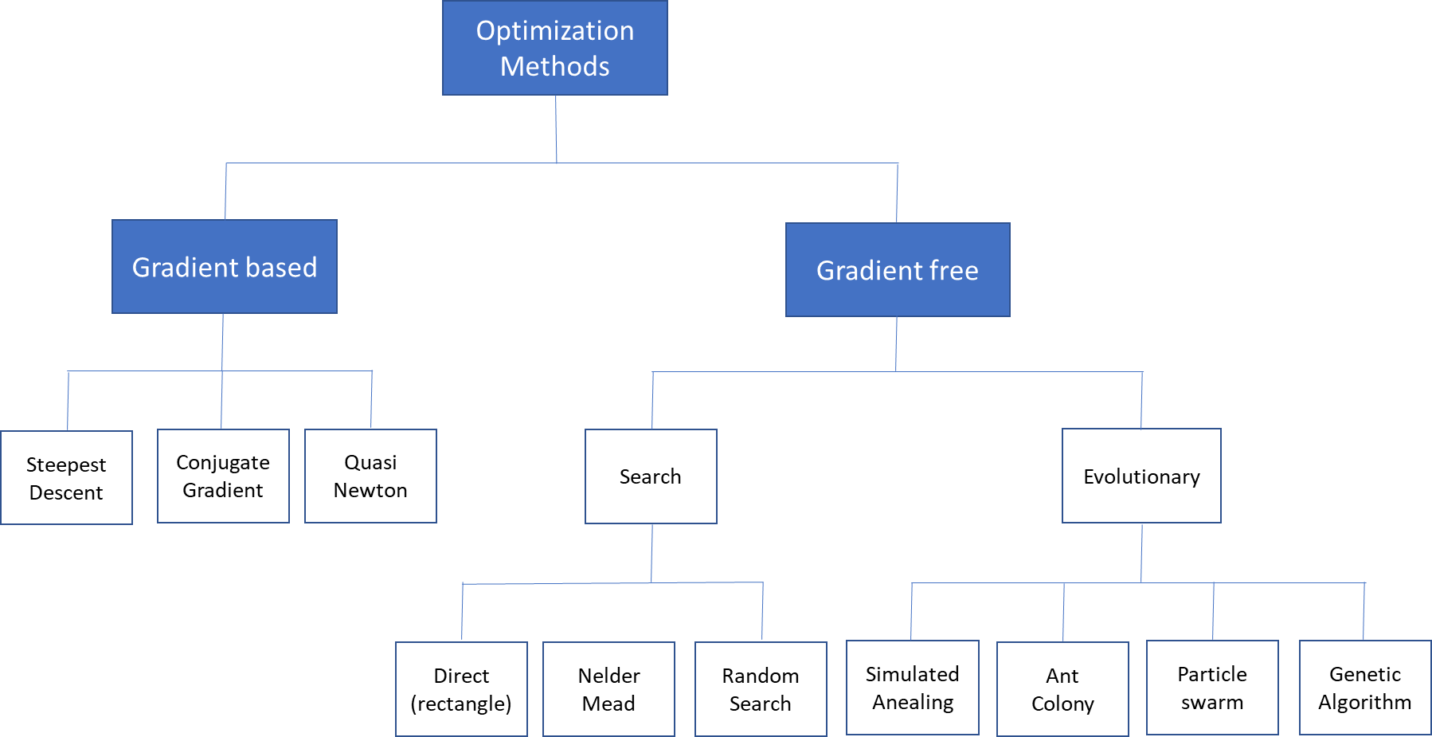

Figure 2.7: Types of Optimization Algorithms [63]

Initially, MDO problems were formulated considering single objective functions, continuous design variables and few disciplines, typical from aero-structural formulations. Under these scenarios, gradient-based and search algorithms were suitable. Since they are relatively simple to implement and capable of finding the local optima with high reliability, these methods became very popular in early 80’s when computer power started to improve.

However, in such methods, the search for the global minima may get stuck when multiple peaks and valleys are present in the design space – a common characteristic in complex multi-objective/multi-variables and non-linear problems. Depending on the setting of initial conditions of design variables, the results may be trapped into local solutions. Also, these methods require the continuous and differentiable functions for evaluation of gradients (1st and 2nd order), which is sometimes difficult or not possible to calculate (i.e. discrete or step functions) [65]. This may cause difficulties on the convergence depending on the size of calculation steps adopted. Some examples of gradient based methods are: adjoint equations [66], steepest descent [67], conjugate gradient [68] and sequential quadratic programming [65]. With the increasing complexity of the MDO frameworks (multi-objective problems and increasing number of design variables), other optimization methods started to be formulated, such as in the research conducted by Tappeta and Renauld [69] on collaborative optimization and Miettinen [70] on non-linear multi-objective methods. Also, with the increasing number of disciplines, decomposition methods were integrated into these algorithms [71].

Later in 90’s, with the increase of computational power, gradient-free search methods introduced in MDO frameworks. Among these, evolutionary algorithms have been demonstrated to be efficient for complex MDO problems involving different types of design variables. The main characteristic of such methods is the capability to evolve to better design variables at each optimization cycle, seeking the global minimum solution, based on a nature-inspired logic set to evaluate the objective (fitness) functions [72]. The most popular algorithms of this class are:

• Simulated annealing (SA);

• Particle swarm optimization (PSO);

• Ant colony optimization (ACO);

• Genetic algorithms (GA).

The Simulated Anealing (SA) algorithm is inspired on searching for lower enthropy thermal equilibrium in metallic structures, using a statistical random search logic. In this method, the acceptance of a new design worse than the previous one is occasionally and probabilistically allowed, increasing the chances to escape from local minima. Because of that, the speed of convergence might be slower than other methods, depending on the initial setting conditions of the system. This method is designed and mostly applied in single objective optimizations [73].

The Particle Swarm Optimization (PSO) algorithm iteratively improves a candidate solution with regard to a given measure of quality. In general, it presents a fast convergence and may deal with multiple objectives. It solves a problem by having a population of candidate solutions, modeled as flying particles, and moving these particles around in the search-space according to simple mathematical formula over the particle’s position and velocity. Each particle’s movement is influenced by its local best known position, but is also guided toward the best known positions in the search-space, which are updated as better positions are found by other particles. This is expected to move the swarm toward the global minimum [74]. However, some studies show that the algorithm may still lead to early convergence or particles spread, very dependent on empirical data to set up initial conditions [75] [76].

Ant colony optimization (ACO) is an algorithm based on behavior of ants in a colony. Artificial ants (simulation agents) seek optimal solutions by moving through a parameter space representing all possible solutions. Real ants lay down pheromones directing each other to resources while exploring their environment. The simulated ants record their positions and the quality of their solutions, so that in later simulation iterations, more ants locate better solutions [77]. Initially idealized for shortest path routing problems, ant colony optimization may be applied for the search of single objective optimum searches. According to recent studies [78] [76], although the convergence is mathematically proven, it is difficult to determine its time to reach the global minima.

Evolutionary optimization methods are known to handle noisy, non-smooth responses and are able to operate efficiently in large problems. Among them, Genetic Algorithms (GA) offer an alternative to the solution of complex and diverse frameworks, since they are simple to couple with the analysis modules, and do not incur the cost of computing the derivatives and can handle different types of design variables and constraints [79] [72].

GA methods are based on the natural biological evolution which operates on populations of potential solutions applying the principle of survival of the fittest to produce better approximations to a solution. It has been demonstrated to work with acceptable levels of robustness on multi-objective/multivariable problems, aiming to reduce the number of qualitative decisions required and with increase in the number of design variables [72] [80]. At each generation, a new set of approximations is created by the process of selecting individuals according to their level of fitness in the problem domain and breeding them together using operators borrowed from natural genetics. This process leads to the evolution of populations of individuals that are better suited to their environment than the individuals that they were created from (just as in natural adaptation). Individuals are encoded as strings (chromosomes) composed over some alphabet(s), so that the genotypes (chromosome values) are uniquely mapped onto the decision variable (phenotypic) domain. The genetic characteristics of an individual are stored in a chromosome, which is represented by the set of chosen design parameters. The GA algorithm standard flowchart is displayed in Fig.2.8 [81] [72].

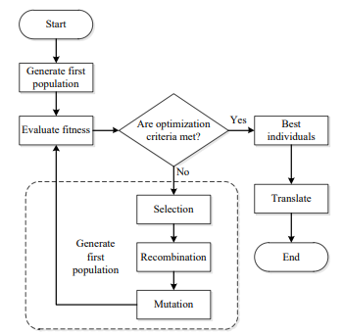

Figure 2.8: GA standard flowchart

The selection, mutation and crossover mechanisms in GA are particularly important to prevent the process from ending up in a local minimum. GA methods may be used to create new designs with features that were absent not only in the parent pairs but anywhere in the entire parent generation. This amounts to extending design space by adding new variables and is entirely beyond the capability of gradient-directed search allowing the escape from a local minima trap [42]. They differ substantially from more traditional search and optimization methods as follows:

1. Ability to generate population with parallel processing.

2. Does not require derivative information or other auxiliary knowledge. Only the objective function and corresponding fitness levels are needed.

3. Uses probabilistic transition rules, not deterministic ones.

4. Works on an encoding of the parameter set rather than the parameter set itself.

5. Allows the use of continuous, discrete, and integer design variables in the same optimization process. This feature is especially interesting in aircraft design and sizing need to be integrated with network parameters in a single optimization process.

6. Has no requirement for objective functions and constraints to be continuous (no gradient calculations involved in the optimization process).

It is important to note that GA methods provide several potential solutions to a given problem and the choice of final solution is left to the user (or decision maker). In cases where a problem does not have one individual solution, for example a family of Pareto-optimal solutions, (as is the case in multi-objective optimization), GA methods are potentially useful for identifying these alternative solutions simultaneously. Genetic algorithms are now of generalized use in optimization problems, including aircraft design and air transport networks [27] [82] [46] [83] [84]. However, one drawback is that stochastic algorithms in general can have difficulty obeying equality constraints. In addition, GA is sensitive to the initial population used. Wide diversity of feasible solutions is what is usually wanted.

The Multi-objective Genetic Algorithms (MOGA) are extensions of the standard GA [85] [86], based on controlled elitism concepts applied on multi-objective context. Its efficiency is ruled by two inherent operators (crossover and mutation) and the use of elitism, i. e., the best organism from the current generation to carry over to the next. The direction of improvement is always evaluated by comparing the fitness of the individual from generation with the fitness of its parents belonging to the previous generation. The new individuals are then created by moving in a randomly weighted direction that lies within the ones individuated by the given individuals and his parents. The crossover operator of GA may exploit structures of good solutions with respect to different objectives to create new non-dominated solutions in unexplored parts of the Pareto front. In such algorithms, the user constraints always lead to objective function penalization and allow concurrent evaluation of independent individuals [72]. The first multi-objective GA was the so-called Vector Evaluated Genetic Algorithms [87]. Afterwards, several variations of multi-objective evolutionary algorithms were developed such as Multi-objective Genetic Algorithm (MOGA) [88], Niched Pareto Genetic Algorithm [89], Random Weighted Genetic Algorithm [90], Strength Pareto Evolutionary Algorithm [91] and Multi-objective Evolutionary Algorithm [92], among others.

Kalyanmoy et. al [93] proposed the Non-Dominated Sorting Genetic Algorithm (NSGA) as an improvement of the standard GA. In this method, a non-dominated sorting procedure is used on a modified elitism rule: the solution adopts an Elitism-preserving approach, storing all non-dominated solutions discovered so far, beginning from the initial population, enhancing the convergence properties toward the true Pareto-optimal set. In addition, the constraint handling method does not use penalty parameters. Therefore, this algorithm implements a modified definition of dominance to solve constrained multi-objective problems more efficiently. The main advantage of using this method on network and aircraft multi-objective design optimization problem is a slightly faster convergence on complex modeling when compared to MOGA [88], using both continuous and discrete variables [84].

An interesting compilation of characteristics of these GA algorithms was performed by Deb [94]. In this study, comparisons considering different methods were performed in several test functions of great complexity. The results have consistently shown the Fast Dominating Non-Sorting Algorithm (NSGA-II) [95] providing faster convergence to the Pareto Front and better spread of solutions. In fact, this was also observed in the study performed by Fregnani and Mattos [84].

Notwithstanding their effectiveness, the non-gradient methods also have their drawbacks. They may generate a large number of cycles in the analysis, due to their evolutionary characteristics and exploration of the whole design space at each run, when compared with gradient methods. Therefore, their use is limited by the computational costs, which is sometimes a critical factor in the research. In addition, these methods may lead to different designs each time they are run and the convergence is not completely mathematically proven in most of the cases [64] [72] [42]. This was demonstrated by Zingg et. al [96] in study where a genetic algorithm is compared with a gradient-based (adjoint) algorithm on several single and multi-objective aerodynamic shape optimization problems. Results demonstrated that both algorithms reliably converge to the same optimum, depending on the nature of the problem, the number of design variables, and architecture chosen, the genetic algorithm requires from 5 to 200 times as many function evaluations.

Finally, Martins and Lambe [61] [32] concluded that, for complex MDO frameworks, using non-gradient methods likely lead to better ﬁnal designs than gradient optimizers, due to the last one presenting higher possibility to converge to a local minimum early in the design process. However, if gradients can be computed efﬁciently, the computational cost of the gradient-based optimization may be far less than that of the global optimization because the discipline analyses do not need to be run as many times.

* 1. Air Transport Network Optimization

The Airline Deregulation Act, released in late 1978 by the North American government, presented a set of economic and operational measures tailored to lower the level of control on airfares, routes and stimulate the entry of new airlines into the aviation market. Consequently, the power of civil aviation regulators over fares was eliminated, establishing market forces for the first time in the history of airline industry. Ever since, this model has been quickly replicated in other countries as a form to support the growing passenger demands worldwide. Because of free competition between airlines, Hub-and-Spoke networks have evolved as the minimum cost configuration for Legacy Airlines while fully connected networks have become the emerging solution for the Low-Cost Carriers in their competition for growing markets. Since the 90’s, boosted by these industry trends and the increasing computational power, a wide range of research initiatives were conducted on network optimization techniques with the objective to reduce costs or maximize profit for airlines [17].

These initiatives included initially the route assignment problems (Block 1, as defined in Chapter 1), once there was a strong interest to compare the optimum efficiency of the Hub-and-Spoke against point-to-point route systems. This was particularly helpful to support the low-cost airlines, raising worldwide in the end of 90´s, which adopted the point-to-point solution for their networks [3]. In this kind of problem, the demands between city pairs are identified and thus potential flights between airport pairs are defined. It is crucial to address airports restrictions in this process (i.e. time of operations restrictions) – to prevent the inclusion of operationally impossible flights in the solution. As previously mentioned, in this phase, the flight frequencies for each route are also determined. Some important research studies on this topic are worth mentioning:

Aykin [97] studied hub location and routing, proposing an interactive heuristic method to solve both problems separately in a simple network system. This was one of the first studies to focus on hub allocation optimization and optimum spoke routes.

Campbell [98] performed a study presenting an integer programming formulation for four types of hub-allocation problems, featuring discrete hub centers and one-stop models for that.

Akhuja et. al [99] presented a detailed study about applications for network optimization problems in several fields of operational research, including the ones related to transportation. This study was one of the first to explore the cost minimization problem in complex network route assignment problem using a Mixed Integer Linear Programming (MILP) computational method.

Jaillet et. al [100], in their innovative study, presented a flow-based linear model for designing networks based on minimum cost optimization. In this research, heuristic methods were proposed to solve a Mixed Integer Linear Problem (MILP), presenting as output the associated frequencies to the routes located for one or more types of aircraft. The proposed model was able to predict the occurrence of hubs if they reveal to be cost effective for the aircraft fleets considered.

A reference research on network types and respective key performance indicators was performed by Lederer et. al [29], where analytic expressions for passengers and airline costs were derived for several network types. Parametric studies were conducted to evaluate the effect of distances, demands and frequencies on profit with the aim of profit optimization.

Later in years 2000, with a significant increase of computational power, an investigation was started into the coupled solution of route assignment and flight scheduling.

Evans et. al [101] proposed a model for network optimization coupled to flight scheduling and constraints on airport capacity, including passenger demand via gravitational model, airline competition, flight delay, and airline cost in the optimization model and three aircraft types.

Caetano and Gualda [13] also proposed a solution for jointly route assignment and fleet scheduling using a simplified linear program model. In a subsequent study, these authors described the so-called transport momentum methodology as a proxy for operational costs that are tailored for solving fleet assignment problems encompassing scheduling [102].

Sawai [103] proposes an innovative method that creates a new type of small-world network (based on communication theory) with less average path-length and larger clustering coefficients than the ones obtained via conventional route assignment methods, inspired on an Ant-Colony Optimization (ACO) algorithm.

Pita et. al [104] presented a mixed-integer linear optimization model for integrated flight scheduling and fleet assignment considering aircraft and passenger delay costs. In this model, for the first time, the objective function was set to maximize the expected profits of an airline that faces a given origin/destination-based travel demand and operates in congested, slot-constrained airports.

Bing [30] developed key performance metrics to evaluate the efficiency of transport networks featuring any kind of topology, suggested to be used as objective functions on future route and aircraft scheduling optimization research studies.

Gurkan et. al [20] proposed a nonlinear mixed integer programming model considering fuel consumption and CO2 emission cost in terms of objective function. For the first time, cruise speed control is integrated into the three blocks of airline operations planning (Fig.1). This innovative method enabled the construction of a schedule to increase utilization of fuel-efficient aircraft and even to decrease total number of aircraft needed while satisfying the same service level and maintenance requirements for aircraft scheduling.

Dong et.al [105] proposed an integrated route scheduling and fleet assignment problem based on two coupled mixed integer programming models considering itinerary price elasticity and proposing heuristic algorithm to solve the problem.

As earlier mentioned, passenger demand is another important input to be considered in the network optimization process. In the last decades, gravitational models became popular to determine passenger demand in air transportation mainly because of their simplicity and forecast capacity using historical econometric variables related to the cities involved and time-geometric parameters. These models, analog to the gravitational law of physics, consider as ‘bodies’ the cities associated with the departure and arrival routes of the airports, the ‘mass’ equivalent to the amount of populations involved on each city, and the ‘distance’ is the geometric distance (great circle) between them. In fact, the first models considered the passenger demand as proportional to the product of populations divided by square of the distance.

Before the 50’s, gravitational models have been used in urban transport engineering, leaving its application to the analysis of long-distance mobility to geographers, on demand studies of the dominant modes of transportation (road and rail transport). However, the application of gravity models to air transport networks started with the academic work of Taaffe [106] and Taaffe & King [107] studying mobility of passengers among major cities in the United States, using a logarithmic regression analysis. This methodology was later endorsed by Kanafani [108] as a suitable option where actual demand values are unknown or missing.

Jaillet et. al [100], in their already mentioned study on route assignment using a MILP formulation, proposed the use of the basic gravitational models to estimate the demand on this kind of problem. In this approach, the authors use the basic two-variable gravitational formulation, considering city-pair populations and great circle distance, on running the network optimization for fifty US airports. Later on, Ceha and Ohta [109] used the same formulation to predict the demand for air passengers on scheduled commercial flights in US.

Wojan [15] also determined the characteristics of the optimum airline networks using a modified gravitational model, considering population product only. In his work, the demand and cost conditions of an airline have been identified as one of the main determinants of network topology.

More recently, gravity models started to include geo/socio-economic and air transport variables, besides population and distance, since research studies soon perceived the low adherence of actual demand data considering these two variables only. Geo/socio-economic factors were identified to imply social and economic, industrial/business activities, geographical features related to cities served by the air transport system and competition between airports. Several variables of such kind started to be considered in the model such as: wealth (measured by GDP), employment rate, structure of the productive sector, competitiveness index, level of deregulation of air market [110] , border effect factor [111], composition of society, proximity to airport hub, tourist factor, and catchment area of big cities. For example, Grosche et. al [14] proposed an extended gravitational model considering population, catchment area, buying power index, gross domestic income, time to travel and distance between city pairs, using data from twenty-eight European airports for calibration.

Factors related to air transport service were later included, such as: historical volumes of traffic at the airport, intensity of traffic flow between two cities, flight time, ticket cost, type of airport (flights, frequencies and chairs offered by airlines) and quality of service (offered by airlines).

Under this perspective, Bhadra and Kee [112] analyzed the demand and changes in the market for air travel passengers in the United States. Piermartini and Rousová [110] proposed a modified gravity model to explain bilateral international passenger traffic and estimated the impact of the deregulation of air transport services for passengers. In this line of research, Hazdeline [111] performs the analysis of border effects in the domestic and international air transportation of passengers in Canada. Doganis [3], however, proposed a different approach, estimating the passenger demand of airports as function of airfares, frequency and scheduled traffic.

More recently, Olariaga et.al [113] analyzed the flow of domestic passengers by air transportation between twelve airports of a Colombian air transport network, expanding Grosche’s model to specific characteristics of the arrival airports.

* 1. Integrated Aircraft and Network Optimization

Although many research studies have been conducted on airline network optimization problems, especially on route and tail assignment, few studies integrated aircraft design characteristics and performance to realistic mission analysis for each city pair considered [26] [27]. The research on integration of entire airline networks with aircraft design variables started to be developed in the last fifteen years and was enabled with the increase of computational power and development of robust optimization solvers which are capable of handling multivariable, multi-objective functions and are submitted to non-linear constraints [61] [114]. The inclusion network and mission analysis modules into the aircraft design MDO framework is a complex task which involves several operational variables and extremely dependent of aircraft performance related disciplines (such as aerodynamics, structures and propulsion) and non-linear equations.

In fact, initial studies show that the direct coupling of aircraft design and airline fleet-route allocation frequently use mixed-integer and nonlinear programming formulations and require diverse types of design variables, constraints and disciplines. This would require a decomposition approach, using disciplines sub-optimizations, in order to facilitate the resolution of such framework [115] [116]. Some key studies on this approach are mentioned in the following paragraphs.

Roth and Crossley [117] proposed the use of genetic algorithms, combined with a gradient based method, for aircraft design optimization in specific mission profiles, providing the first insight in such kind of problem. Isikveren [44] expanded this concept including range optimization and computing fuel consumption with semi-empirical formulations. Cavalcanti et. al [118] proposed a multi-objective optimization of wing planform carried out by the minimization of the block time and block fuel for a given mission. Versiani et. al [119] proposed a design framework to optimize families of aircraft for a given mission profile using genetic algorithms.

Taylor and Weck [120] [26] presented, for the first time, the benefits of optimizing an integrated air transportation network and vehicle design, concurrently defined. This study focused exclusively on the design of an air transportation network for overnight package delivery on two turn-around hub configurations connecting seven U.S. cities. By concurrently optimizing both the vehicle (simplified model base on Breguet Range equation) and network for a selected few cities with fixed demand, it was possible to obtain a minimum of a ten percent improvement in operational costs over the one obtained by optimizing the network design using a set of pre-defined aircraft. This was accomplished by embedding a linear programming solver in the perturbation step of simulated annealing algorithm to solve the substantial number of linear constraints imposed by the capacity and demand requirements of the network.

Afterwards, Mane et. al [121] conducted a research proposing to split aircraft design and airline allocation problems, on a systems-of systems approach. The aircraft design block first optimized a new aircraft for a speciﬁed design mission range and payload. The designed aircraft along with the existing set in ﬂeet were allocated to the route network via a MILP problem. This study also compared the decomposition approach with solving the coupled problem as an MINLP problem using algorithms like genetic algorithms and Branch and Bound.

Bower and Kroo [27] developed a methodology for aircraft design considering demands of a given aerial network. In their design approach, the objectives are the minimization of direct operating costs and airplane emissions (CO2 and NOx). For this purpose, a hierarchical decomposition was used with discipline-specific optimization algorithms using simplistic models. A modified version of a multi-objective genetic algorithm is implemented in the system level aircraft design subspaces. Results were presented for a test problem that involved designing a single aisle commercial aircraft for a route network consisting of four cities and eight route segments, using eighteen design variables.

Nusawardhana and Crossley [116] proposed a mathematical formulation to solve simultaneously the aircraft design and fleet allocation problem (tail assignment) using a monolithic approach and a heuristic optimization solution, for a given airline network. Siqueira et. al [122] proposed a Multi-disciplinary Design Optimization (MDO) framework to select the optimum conceptual aircraft design for an existing scheduled (fixed) airline network. Braun et. al [123] demonstrated the evaluation of future aircraft optimizing network and fleet assignment at the same time.

Davendralingam and Crossley [124] presented a joint conceptual framework on concurrently design aircraft and the operational network by incorporating established passenger demand models, using an MDF approach. A conceptual scenario involving six airports is formulated and solved to exhibit the methodology employed and showing reflexivity of demand. In preliminary studies [125], the authors investigated the impact of aircraft design choices on target market capture decisions and on demand itineraries and economic risks.

Hwang et al. [126] studied a method for simultaneous design and mission allocation optimization, using a modular approach on aerodynamics, propulsion and aircraft performance surrogates into a mission analysis tool, using a gradient-based optimization. A three-route test problem was executed with one design aircraft, showing a 200% to 400% profit increase when compared with a standard airliner. Extending this work, Hwang and Martins [127] expanded the analysis for a 128-route framework, considering a parallel computing technique.

Later, Hwang [128] et al. integrated the above methods on a concurrent optimization encompassing aircraft design, mission profiles, and the allocation of aircraft to routes in an airline network. To enable the solution of this complex approach, a gradient-based optimization approach was adopted with a parallel computational framework, which boosts the computation of derivatives in the multidisciplinary analysis. A surrogate model for the CFD analysis is retrained in each optimization iteration given the new set of shape design variables. The resulting optimization problem contains over 6,000 design variables and 23,000 constraints, and it is solved in approximately 10 hours on a machine with 128 processors.

The optimization revealed a 27% increase in airline profit when comparing the allocation-mission-design optimization to allocation only optimization. Afterwards, Roy et. al [129] [130] proposed the aircraft allocation optimization into this framework, introducing a Mixed Integer Non-Linear Problem (MINLP) to the problem, increasing the complexity of the solution search. In a preliminary study, the authors proposed a framework based on the so-called Efficient Global Optimization, a special gradient-based algorithm is applied in the design space, to solve this problem [131].

Finally, Roy et.al [132] studied the inclusion operational and revenue management variables (such as fare, booking limits, demand and aircraft count constraints), using a genetic algorithm as heuristic method combined with a Branch-and-Bond method (gradient based), in a monolithic approach for network optimization. This approach solves a 11-route problem, providing significant improvements on airlines objectives using a standard single aisle aircraft.

It is worth mentioning that all the above research studies directed the optimization frameworks considering the minimization of global network operational costs or profit, in single objective functions. No studies were conducted considering multiobjective approaches. Also, for the moment, there are no studies in the literature considering the minimization of aircraft development and production costs taken into the integrated aircraft and network optimization framework. However, in an interesting research paper, Wilcox and Wakayama [133] used a monolithic framework to design a family of aircraft in a common framework, sharing parts of selected mission requirements, where design and manufacturing costs are considered in the objective function.

# **Methodology**

In this research, the adoption of a “*hybrid MDF-CO*” MDO architecture with the objective to optimize simultaneously, the aircraft and network designs is proposed, as shown in Fig. 3.1. In fact, this model represents an improvement of the methodology proposed by Bower and Kroo [27], differing from the detailed airplane configuration and to the fidelity of some aeronautical disciplines considered in the optimization process. Two major design analysis blocks are presented:

1. The Aircraft Framework: in which the disciplines related to the aircraft design (aerodynamics, propulsion, MTOW/OEW estimation, stability and control and noise) are integrated providing the necessary coupling variables for the Network Framework disciplines calculation (such as drag, thrust and weights) in each calculation cycle;
2. The Network Framework: in which the disciplines related to network optimization, mission performance and airline economics are integrated, producing the output variables (network profit, network direct operational costs (DOC), net present value of total development/production cash flow (NPV) and estimated number of aircraft) which will be used in selected objective functions.

These frameworks are executed in series, such like in the MDF approach, and wrapped into an optimization cycle. First the Aircraft Framework is executed, determining the aircraft design to be used in the Network Framework. However, the execution of the last one is conditioned to the evaluation of an Airplane Design Check block, where the feasibility of the selected aircraft design is verified considering certification and operational requirements. If not complying with such requirements, the design in analysis is considered failed and a new one is then restarted in the optimization cycle. It is worth mentioning that a sub-optimization process is executed inside the Network Framework (Network Optimization Block) in order to determine the optimum airline network at each cycle, considering a certain passengers demand model (when the demand is not known directly) and the aircraft design under evaluation, like a CO framework.

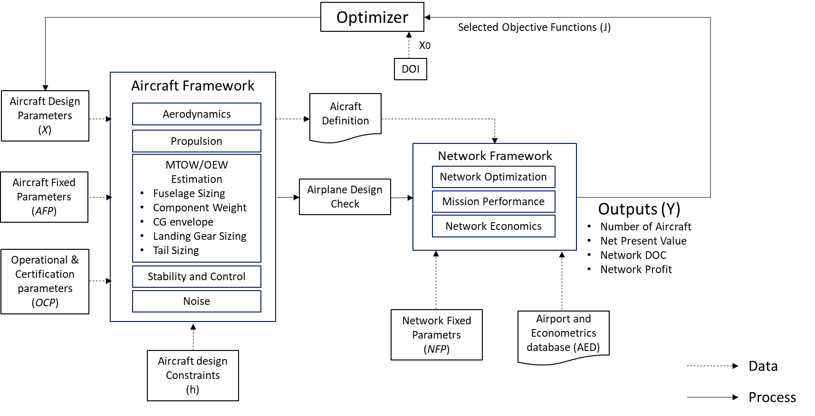

Figure 3.1: Proposed “Hybrid MDF-CO” MDO framework.

Airplanes generated in each calculation cycle are defined as a set of design and fixed parameters mostly related to airframe and engine geometric characteristics. Table 3.2 shows the selected aircraft design parameters (*xi*), and its allowed design interval (from *xlb* to *xub*), produced in each calculation cycle. This design interval is constructed taking into consideration the variation from a baseline aircraft design, which will be used in this research for comparison purposes.

The baseline aircraft corresponds to a mid-size regional jet (78 passengers in single class configuration), designed according to basic design requirements shown in Table 3.1. Figure 3.2 shows some of the aircraft views. For the sake of comparison, the design parameters values associated with the baseline aircraft are also shown in Table 3.2.



Figure 3.2: Baseline Aircraft (78 passengers, single class)

Table 3.1: Baseline aircraft design requirements

|  |  |  |
| --- | --- | --- |
| Basic Mission Requirements | Symbol | Value |
| Maximum Cabin Passengers Capacity | *MaxPax* | 78 |
| Maximum Certified Cruise Altitude Ceiling [ft] | *MaxAlt* | 41000 |
| Design Range, Full passengers @ 100kg, ISA conditions [nm] | *RANGE* | 1600 |
| Design Landing Field Length, @ sea level, ISA conditions [m] | *LFL* | 2000 |
| Design Takeoff Field Length @ sea level, ISA conditions [m] | *TOFL* | 2500 |
| Operational Empty Weight [kg] | *OEW* | 21800 |
| Maximum Zero Fuel Weight [kg] | *MZFW* | 31700 |
| Maximum Taxi Weight [kg] | *MTW* | 38890 |
| Maximum Takeoff Weight [kg] | *MTOW* | 38790 |
| Maximum Fuel Capacity @ 0.81kg/l fuel density [kg] | *MAXFUEL* | 9428 |
| Maximum lift coefficient at undeflected flap/gear up airplane configuration | *CLMAX* | 1.65 |
| Maximum lift coefficient at landing flaps/gear down configuration | *CLMAX LD* | 2.20 |
| Maximum lift coefficient at takeoff flaps/gear down configuration | *CLMAX TO* | *2.00* |
| Number of engines installed in the aircraft | *ne* | *2* |
| Maximum Takeoff Thrust @ sea level / ISA conditions [lbf] | *MAXRATE* | *14200* |

Table 3.2: Aircraft/Engine design parameters

|  |  |  |  |  |
| --- | --- | --- | --- | --- |
| *i* | Design Parameter (*Xi*) | Symbol | Allowed design interval  *(Xlb to Xub)* | Baseline Aircraft  value |
| 1 | Wing reference area [m2] | *wS* | 72 to 130 | 72.72 |
| 2 | Wing aspect ratio | *wARw* | 7.5 to 10 | 8.6 |
| 3 | Wing taper ratio | *wTR* | 0.25 to 0.50 | 0.44 |
| 4 | Wing quarter-chord sweepback angle [o] | *wSweep1/4* | 15 to 35 | 23.5 |
| 5 | Wing twist Angle [o] | *wTwist* | -5 to -2 | -3 |
| 6 | Wing kink semispan position [%] | *KinkPos* | 0.32 to 0.40 | 0.32 |
| 7 | Engine by-pass ratio | *BPR* | 4.5 to 6.5 | 5.0 |
| 8 | Engine fan diameter [m] | *eDiam* | 1.0 to 2.0 | 1.425 |
| 9 | Engine overall pressure ratio | *OPR* | 25 to 30 | 28.0 |
| 10 | Engine turbine inlet temperature [K] | *eTIT* | 1350 to1500 | 1405 |
| 11 | Engine fan pressure ratio | *FPR* | 1.4 to 2.5 | 1.6 |
| 12 | Number of passengers (single class, pitch 32”) | *Npax* | 70 to130 | 78 |
| 13 | Number of seat abreast | *Nseat* | 4 to5 | 4 |
| 14 | Design range, full pax @ 100kg, ISA conditions [nm] | *RANGE* | 1000-2500 | 1600 |
| 15 | Engine design point pressure altitude [ft] | *eHp* | 33000 to 43000 | 41000 |
| 16 | Engine design point Mach number | *eM* | 0.74 to 0.82 | 0.78 |
| 17 | Fuselage height-to-width ratio | *Fush2w* | 1.0 to1.15 | 1.1 |
| 18 | Horizontal tail aspect ratio | *hAR* | 4 to 5 | 4.4 |
| 19 | Vertical tail aspect ratio | *vAR* | 0.8 to 1.2 | 0.89 |
| 20 | Horizontal tail tapper ratio | *hTR* | 0.3 to 0.5 | 0.4 |
| 21 | Vertical tail tapper ratio | *vTR* | 0.2 to 0.5 | 0.3 |
| 22 | Horizontal tail position flag | *hpos* | 0=conventional 1 =T-tail | 0 |
| 23 | Engine position flag | *ePos* | 0= tail, 1=under wing | 1 |
| 24 | Winglet presence flag | *WingletPres* | 0= none, 1= with | 1 |
| 25 | Slat presence flag | *SlatPres* | 0=none, 1=with | 1 |

Considering the Aircraft Framework, in each calculation cycle aircraft fixed parameters (*AFP*) and operational/certification fixed parameters (*AOCFP*) are set as constant values to be used in the discipline computations, also common to the baseline aircraft design. They are listed in Tables 3.3 and 3.4.

Table 3.3: Aircraft fixed parameters

|  |  |  |  |
| --- | --- | --- | --- |
| *i* | Fixed parameter (*AFPi*) | Symbol | Adopted value |
| 1 | Number of galley stations | *Ngalleys* | *2* |
| 2 | Number of aisles in the cabin | *Naisles* | *1* |
| 3 | Aisle width [m] | *AisleW* | *0.50* |
| 4 | Passengers seat width [m] | *SeatW* | *0.46* |
| 5 | Passengers seat pitch [in] | *SeatPitch* | *32* |
| 6 | Passengers cabin internal height (m) | *CabHt* | *2.0* |
| 7 | Airfoil incidence at wing root [o] | *inc root* | *2* |
| 8 | Wing Dihedral [o] | *wDih* | *3* |
| 9 | Miscellaneous drag fcator (%) | *Dmisc* | *3.5* |
| 10 | Dynamic pressure efficiency on horizontal tail [%] | *qHTeff* | *90.0* |
| 11 | Engine minimum clearance to ground [m] | *eCLR* | *0.40* |
| 12 | Number of engines installed in the aircraft | *ne* | *2* |
| 13 | Approach flap deflection | *FlapAPP* | *15* |
| 14 | Takeoff flap deflection | *FlapTO* | *35* |
| 15 | Landing flap deflection | *FlapLD* | *45* |

Table 3.4: Aircraft operational and certification fixed parameters

|  |  |  |  |
| --- | --- | --- | --- |
| *i* | Fixed parameter (*AOCi*) | Symbol | Adopted value |
| 1 | Residual rate of climb [ft/min] | *RROC* | 300 |
| 2 | Buffet margin (g) | *BuffMGN* | 1.3 |
| 3 | Speed Limit Hp<10000ft – indicated airspeed [kt] | *SPDLIM* | 250 |
| *4* | Maximum aircraft certified altitude [ft] | *Ceiling* | 41000 |
| *5* | Maximum certified speed (Mach/indicated airspeed in kt) | *MMO/VMO* | 0.82/340 |

In the Network Framework side, network fixed parameters (*NFP*) are set as constant values representing airline´s data considered in network computations. They are listed in Table 3.5.

Table 3.5: Network fixed parameters

|  |  |  |  |
| --- | --- | --- | --- |
| *i* | Fixed parameter (*NFPi*) | Symbol | Adopted value |
| 1 | Aircraft average daily utilization [h] | *DU* | *13* |
| 2 | Average turnaround time [min] | *TAT* | *45* |
| 3 | Takeoff and climb-out fuel allowance [kg] | *TOFA* | *200* |
| *4* | Takeoff and climb-out time allowance [min] | *TOTA* | *3* |
| *5* | Approach and landing fuel allowance [kg] | *AFA* | *100* |
| *6* | Approach and landing time allowance [min] | *ATA* | *2* |
| *7* | Go-around fuel allowance [kg] | *GAFA* | *200* |
| *8* | Go-around time allowance [min] | *GATA* | *3* |
| *9* | Regulatory holding time [min] | *HOLDT* | *30* |
| *10* | Minimum cruise time [min] | *MINCRZT* | *3* |
| *11* | Taxi-out time [min] | *TOT* | *10* |
| *12* | Taxi in time [min] | *TIT* | *5* |
| *13* | Turn around tome [min] | *TAT* | *35* |
| *14* | Total Passenger’s weight, with baggage [kg] | *PAXWT* | *110* |

In addition, an airport and econometrics database (*AED*) supports the optimum network and mission performance disciplines, providing airport and city econometric related data used in their calculations. The parameters provided for each airport in this database are listed in Table 3.6:

Table 3.6: Airport and econometrics database parameters

|  |  |  |
| --- | --- | --- |
| *i* | Parameter | Symbol |
| 1 | ICAO’s four-letter code airport designator | *APTID* |
| 2 | City Name | *City* |
| 3 | Airport’s reference point latitude [o] | *LAT* |
| 4 | Airport’s reference point longitude [o] | *LON* |
| 5 | Airport’s reference point elevation [ft] | *ELEV* |
| 6 | Airport reference temperature | *Tref* |
| 7 | Airport magnetic declination [o] | *DMG* |
| 8 | Most used takeoff runway | *TRWY* |
| 9 | Most used landing runway - Takeoff Distance Available [m] | *TODA* |
| 10 | Most used landing runway | *LRWY* |
| 11 | Most used landing runway – Landing Distance Available [m] | *LDA* |
| 12 | Average takeoff delay [min] | *ATD* |
| 13 | Average landing delay [min] | *ALD* |
| 14 | City population | *POP* |
| 15 | City catchment area radius [km] | *CRAD* |
| 16 | City buying power index | *B* |
| 17 | Gross domestic product | *GDP* |

The whole MDO framework is integrated using the modeFrontier® application, produced by the Italian software company *ESTECO®*. This platform, developed in *Java* ® language, allows users to choose the optimization strategy based on the design space boundaries and on the required reliability and robustness. The platform includes advanced algorithms for direct optimization, using deterministic, stochastic and heuristic methods for both single and multiobjective problems [134]. This application is capable of handling different standalone modules, written in different languages or third part tools, allowing efficient streamlining of teamwork within multidisciplinary engineering processes. For that, input and output variables in such modules are configured to be recognized inside the application, which are used within the logic of the optimization framework.

In this research, the Aircraft and Network frameworks are coded into two distinct modules using *MATLAB*® application. These modules are integrated and called modeFrontier® in the optimization process. For convenience, the Aircraft Design Check routine is embedded in the Aircraft Design module. Fig. 3.3 displays the workflow of the framework.

Constraints (*h*), specific to the Aircraft Framework, are adopted in the optimization cycle as follows:

1. ICAO takeoff noise certification Chapter 4 compliant [135] .
2. Fuel storage – all mission fuel must be accommodated in the wing fuel tanks.
3. Airplane stall beginning in the inner wing.
4. Longitudinal modes determined and checked against certification requirements (minimum Level 3) [136].
5. Static margin considering tail sizing and wing positioning.
6. Critical angles and clearance boundaries considered on landing gear and engines design.

The constraints I and II are built into the flow constructed modeFrontier framework. Constraints III, IV, V and VI, however, are embedded into the Aircraft Module applied during the discipline’s calculations (to be explained in Session 3.1). The output of the Aircraft Framework execution is the aircraft definition vector, composed of the main geometric and operational characteristics of the aircraft design in analysis. This includes design parameters, calculated parameters (from the aircraft design process) and aircraft fixed parameters. This vector is saved in a file, to be accessed during the execution of the Network module. The list of parameters included in the aircraft definition vector is shown in Table 3.7.

Table 3.7: Aircraft definition parameters

|  |  |  |
| --- | --- | --- |
| Aircraft definition parameter | Symbol | Source |
| Maximum Operational Empty Weight [kg] | *OEW* | Aircraft Framework Module (calculated) |
| Maximum Zero Fuel Weight [kg] | *MTW* | Aircraft Framework Module (calculated) |
| Maximum Taxi Weight [kg] | *MZFW* | Aircraft Framework Module (calculated) |
| Maximum Takeoff Weight [kg] | *MTOW* | Aircraft Framework Module (calculated) |
| Maximum Fuel Capacity (kg) @ 0.81kg/l fuel density | *MAXFUEL* | Aircraft Framework Module (calculated) |
| Design Range (full capacity @ 100 kg) | *RANGE* | Design parameter |
| Maximum certified Mach | *MMO* | Fixed parameters |
| Maximum certified Indicated Airspeed [kt] | *VMO* | Aircraft Operational and Certification fixed parameters |
| Maximum certified Altitude [ft] | *Ceiling* | Aircraft Operational and Certification fixed parameters |
| Number of Passengers (single class) | *Npax* | Design parameter |
| Number of crew members (pilots + flight attendants) | *Crew* | Aircraft Framework Module (calculated) |
| Number of aisles | *Naisles* | Aircraft fixed parameters |
| Number of Seat Abreast | *Nseat* | Design parameter |
| Seat width [m] | *SeatW* | Aircraft fixed parameters |
| Fuselage length [m] | *lf* | Aircraft Framework Module (calculated) |
| Forward fuselage length [m] | *lco* | Aircraft Framework Module (calculated) |
| Tailcone length [m] | *ltail* | Aircraft Framework Module (calculated) |
| Fuselage width ratio | *fush2w* | Aircraft Framework Module (calculated) |
| Fuselage width [m] | *fusw* | Aircraft Framework Module (calculated) |
| Fuselage diameter [m] | *fusd* | Aircraft Framework Module (calculated) |
| Fuselage height [m] | *fush* | Aircraft Framework Module (calculated) |
| Fuselage external height [m] | *fusdz* | Aircraft Framework Module (calculated) |
| Fuselage wet area [m] | *fuswetS* | Aircraft Framework Module (calculated) |
| Aircraft maximum lift coefficient on clean configuration | *CLMAX* | Aircraft Framework Module (calculated) |
| Aircraft maximum lift coefficient at takeoff configuration | *CLMAX TO* | Aircraft Framework Module (calculated) |
| Aircraft maximum lift coefficient at landing configuration | *CLMAX LD* | Aircraft Framework Module (calculated) |
| Wing Reference Area [m2] | *wS* | Design parameter |
| Wing Aspect Ratio | *wAR* | Design parameter |
| Wing Taper Ratio | *wTr* | Design parameter |
| Wing semi-span [m] | *wb* | Aircraft Framework Module (calculated) |
| Wing quarter-chord sweepback angle [o] | *wSweep1/4* | Design parameter |
| Wing leading edge sweepback angle [o] | *wSweepLE* | Aircraft Framework Module (calculated) |
| Wing Twist Angle [o] | *wTwist* | Design parameter |
| Wing Wet Area [m2] | *wSwet* | Aircraft Framework Module (calculated) |
| Kink Semispan position | *KinkPos* | Design parameter |
| Airfoil Incidence @ wing root [o] | *incroot* | Aircraft fixed parameters |
| Airfoil Incidence @ wing kink [o] | *inckink* | Aircraft Framework Module (calculated) |
| Airfoil Incidence @ wing tip [o] | *in\_tip* | Aircraft Framework Module (calculated) |
| Airfoil thickness ratio @ wing root | *tcroot* | Aircraft Framework Module (calculated) |
| Airfoil thickness ratio @ wing kink | *tckink* | Aircraft Framework Module (calculated) |
| Airfoil thickness ratio @ wing tip | *tctip* | Aircraft Framework Module (calculated) |
| Airfoil chord length @ central fuselage [m] | *chordc* | Aircraft Framework Module (calculated) |
| Airfoil chord length @ wing root [m] | *chordr* | Aircraft Framework Module (calculated) |
| Airfoil chord length @ wing kink [m] | *chordk* | Aircraft Framework Module (calculated) |
| Airfoil chord length @ wing tip [m] | *chordt* | Aircraft Framework Module (calculated) |
| Wing mean aerodynamic chord length [m] | *CMA* | Aircraft Framework Module (calculated) |
| Wing leading edge position | *xle* | Aircraft Framework Module (calculated) |
| Flap length on semi-span [%] | *bflap* | Aircraft Framework Module (calculated) |
| Flap area [m2] | *sflap* | Aircraft Framework Module (calculated) |
| Takeoff flap deflection [o] | *flapTO* | Aircraft fixed parameters |
| Landing flap deflection [o] | *flapLD* | Aircraft fixed parameters |
| Aileron position on wing semi-span [%] | *ailpos* | Aircraft Framework Module |
| Fuselage length [m] | *lf* | Aircraft Framework Module (calculated) |
| Forward fuselage length [m] | *lco* | Aircraft Framework Module (calculated) |
| Tailcone length [m] | *ltail* | Aircraft Framework Module (calculated) |
| Fuselage width ratio | *fush2w* | Aircraft Framework Module (calculated) |
| Rear spar position on mean aerodynamic chord [%] | *rsparps* | Aircraft Framework Module (calculated) |
| Vertical Tail Area [m2] | *vS* | Aircraft Framework Module (calculated) |
| Vertical Tail aspect ratio | *vAR* | Design Parameter |
| Vertical Tail tapper ratio | *vTR* | Design Parameter |
| Vertical tail sweep angle [o] | *vSweep* | Aircraft Framework Module (calculated) |
| Horizontal tail Area [m2] | *hS* | Aircraft Framework Module (calculated) |
| Horizontal tail aspect ratio | *hAR* | Design Parameter |
| Horizontal tail tapper ratio | *hTR* | Design Parameter |
| Horizontal tail sweep angle[o] | *hsweep* | Aircraft Framework Module (calculated) |
| Winglet Aspect ratio [m2] | *WL\_AR* | Aircraft Framework Module (calculated) |
| Winglet tapper ratio | *WL\_TR* | Aircraft Framework Module (calculated) |
| Winglet sweep angle | *WL\_sweep* | Aircraft Framework Module (calculated) |
| Winglet cantlever angle [deg] | *WL\_cantl* | Aircraft Framework Module (calculated) |
| Winglet twist angle [deg] | *WL\_twist* | Aircraft Framework Module (calculated) |
| Maximum Takeoff Thrust @ sea level / ISA conditions [lbf] | *MAXRATE* | Aircraft Framework Module (calculated) |
| Engine by-pass ratio | *BPR* | Design Parameter |
| Engine Fan Diameter [m] | *eDiam* | Design Parameter |
| Engine Fan Pressure Ratio | *FPR* | Design Parameter |
| Engine Overall Pressure Ratio | *OPR* | Design Parameter |
| Engine Turbine Inlet Temperature [K] | *TIT* | Design Parameter |
| Engine length [m] | *le* | Aircraft Framework Module (calculated) |
| Engine minimum clearance to ground [m] | *eCLR* | Aircraft Framework Module (calculated) |
| Engine pylon height [m] | *epydz* | Aircraft Framework Module (calculated) |
| Engine wet area [m2] | *eSwet* | Aircraft Framework Module (calculated) |
| Total aircraft wet area [m2] | *totSwet* | Aircraft Framework Module (calculated) |
| Engine position flag | *ePOS* | Design Parameter |
| Horizontal tail position flag | *hpos* | Design Parameter |
| Winglet presence flag | *WingletPres* | Design Parameter |
| Slat presence flag | *SlatPres* | Design Parameter |

According to the explanations provided in Session 2.2, genetic algorithms are considered the most suitable optimizers for the multiobjective problem proposed in this research, especially due to its robustness, ability in dealing with global minima or maxima in poor-known search space and handling several types of variables. Genetic algorithms designed for multiobjective optimization frameworks (such as MOGA and NSGA-II) are available in modeFrontier® and therefore will be used as main optimizers in this research.

The design of experiments (*DOE*), used as search space by the optimization algorithm, is based on the Latin Hypercube sampling methodology. As discussed in Session 2.1, such method guarantees relatively random uniform distribution, with minimum number of samples over each of the design variable dimension [58]. This is also an embedded feature of the modeFrontier ® application.

The outputs produced by the Network Framework (Net Present Value, Network Direct Operational Cost, Number of Aircraft and Network Profit) may be selected as objective functions (*J*) to be used in the multi objective optimization process. In genetic algorithms, they represent fitness functions, which are evaluated in each by the optimizer, influencing the characteristics of each population generation. Although in Fig. 3.3, all output variables are illustrated as objective functions, some of them may be excluded from the analysis, depending on the nature of the optimization (to be explained in Session 4).

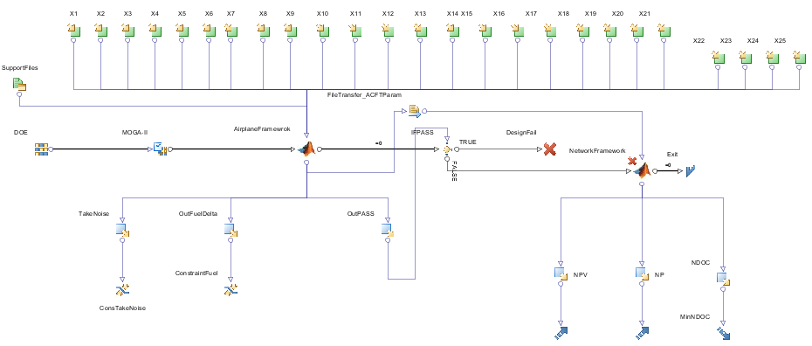

Figure 3.3: Proposed MDO workflow elaborated with *modeFrontier*®.

The following sessions describe in detail the Aircraft and Network frameworks calculation methodologies related to the disciplines involved. As mentioned previously, each framework is implemented as a single MATLAB ® code module.

* 1. The Aircraft Framework

The definition of airplane geometry is one of most important deliverables in the conceptual design phase and is the final objective of the Aircraft Framework module. Usually it consists in using a set of input parameters in order to determine the basic layout and dimensions of the passenger section of fuselage, fuselage nose and tail cone, wing, horizontal and vertical tails, engine nacelle and pylon [46].

Considering the traditional approaches developed by Roskam [23] , Torenbeek [22] , and Raymer [137] and the more recent one proposed by Isikveren [44], that proposed by Roskam was considered here as it is more straight-forward and is widely used by aircraft manufacturers. In all these methods the initial parameter to be determined is the total wetted area, which is required for aerodynamic drag coefficient and therefore for initial weight estimation. However, thanks to the improvement in computer power, higher levels of details for geometry modeling became standard procedure in the conceptual design phase.

The Aircraft Framework is implemented in a single *MATLAB*® module composed of several calculation routines in which computations related to the disciplines are executed and a final certification design check is performed. This module has the main objective to generate the aircraft definition parameters according to design techniques related to the following disciplines: Aerodynamics, Propulsion, Weight Estimation, Noise computations and Design Check.

In the conceptual design phase, a reasonable estimation of airplane´s Maximum Takeoff Weight (*MTOW*) and Operational Empty Weight (*OEW*) is fundamental to the aircraft dimensions determination process and is at the core of the Aircraft Framework module.

Figure 3.4 shows the block diagram related to the execution of this module. The main idea is to size the aircraft via an iterative loop which primary objective is to estimate the MTOW and OEW. All aircraft design related definitions parameters are derived from such process. After the weight estimation loop, noise computations are performed considering certification standards [138] and then the airplane design check is performed in order to allow the Network Framework computations or not consider the design.

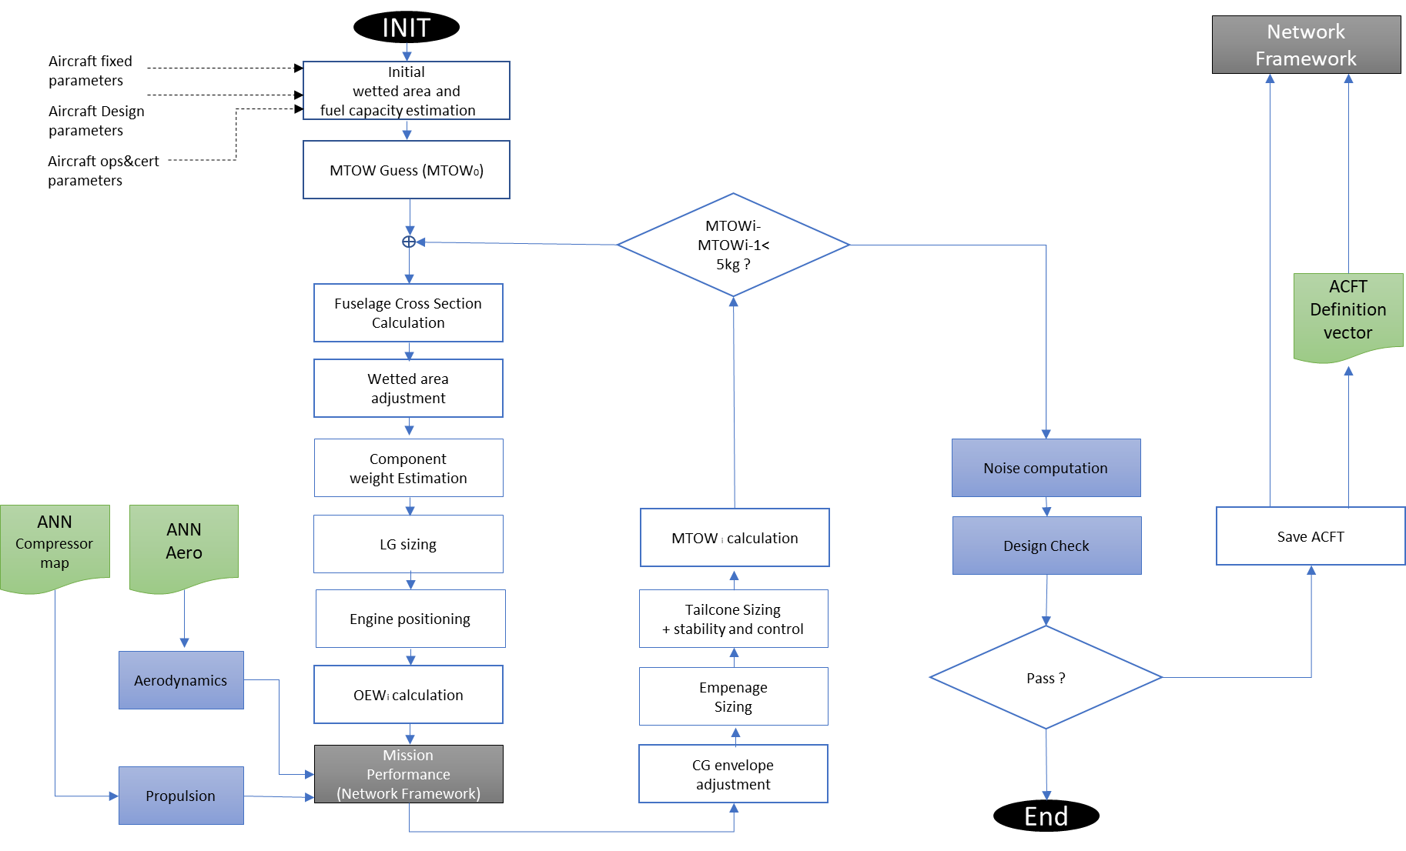

Figure 3.4: Flowchart of Aircraft Framework calculations

* + 1. MTOW and OEW Estimation

The weight estimation loop is the core of the Aircraft Framework module trough an iterative calculation process. According to Fig. 3.4, the initial airplane dimensions estimation is used to calculate an initial guess of airplane weight based on its wetted area, according to the methodology proposed by Roskam [139], in the so called Class I method. This initial guess is then used in the calculation of airplane’s component weight breakdown, according to the methodologies developed by Roskam [139] and Torenbeek [22], in the so called Class II method.

In this method, the calculation of pylons, fuselage, empennage (vertical and horizontal tails), systems, landing gear and engines are done separately and then added together to compose the Operational Empty Weight (*OEW*). These component weights are then used on the determination of the OEW´s related center of gravity (*CG*).

With the OEW determined, the MTOW and Maximum Landing Weight (*MLW*) are then calculated using the mission performance module, used in the Network Framework, where the trip fuel is determined. The following operational profile assumptions are considered in the mission performance calculations:

* Standard atmosphere.
* Takeoff and Landing airports at sea level.
* Payload related to 100% of passenger’s capacity (@100kg each).
* Mission distance equal to the design range;
* Alternate airport distance equal to 200nm
* Speed and Altitude profiles defined according to mission performance module logic.

The information derived from the above process is then used to estimate the moments of inertia of the airplane and the center of gravity shift with fuel consumption required for the stability and control analysis performed in the tail sizing refinement process. The resulting MTOW is iteratively refined until the difference between two consecutive iterations is lower than 5kg tolerance, which then defines the weight convergence. Finally, the Maximum Zero Fuel Weight (*MFW*) is assumed as 98% if the MLW, as suggested by Roskam [140] [23]. In addition to the above explanations, the following considerations are necessary related to sizing and weight estimation of some specific components:

*Wing’s Weight Estimation*

The wing weight is estimated by sizing the wingbox to withstand aerodynamic loads calculated with a full potential code in some few maneuvers in the flight envelope and the secondary structure being estimated by empirical formulae, according to the methodology proposed by Isikveren [141].

*Engine´s Weight Estimation*

Most of jet engines weight estimation methods developed in academia are derived from empirical formulae are based on geometric data from first and second generations of turbojet engines, presenting by-pass ratios. Some examples are the work developed by Reymer [33] , Loftin [47] and Boeing [142]. Such methods are most of the times not applicable to the current generation of turbofan engines, with high by-pass ratios, much different in manufacturing technologies and design (notably equipped with larger fan diameters, improved combustion cameras and complex associated accessories). It is not uncommon to observe significantly different results, using the traditional weight estimation formulae, when compared with actual engine weight data. For example, applying the classical method developed by Reymer [33] to the GE-90/77B engines (used in the Boeing 777 series) an estimated engine weight 46% larger than the actual value is found. In order to improve such kind of results, studies dedicated to turbofan engines were later conducted by Tong et. al [143] , Lolis [144] and Greizter [145], mainly focusing on single component weight modeling, producing more suitable results, within 15% error margin. In this research, we propose a new method for engine weight estimation considering the main thermodynamic parameters commonly used on high-bypass turbofan engines, as an expansion of the conventional modeling proposed by Reymer [33] and Loftin [47]. Thus, the following parametrization is proposed:

(4)

The coefficients and exponents of Eq. 4 are obtained by optimization using a genetic algorithm with the minimization of mean square error related to known engines [146]. These engines belong to a database comprised of over 25 engines with considerable thrust variation among them, covering a large variety of turbofan designs [147]. Table 3.8 shows the coefficients and parameters obtained with the optimization process. Table 3.9 shows the average parameters used for normalization. Table 3.10 contains weight estimation errors for some known turbofan engines.

Table 3.8: Engine weight equation exponents and coefficients

|  |  |
| --- | --- |
| Coefficient/exponent | Value |
| T1 | 2587.2461 |
| T2 | 50.1920 |
| T3 | 154.6179 |
| a | -0.1965 |
| b | -0.0718 |
| c | 1.0435 |
| d | 0.2493 |
| e | -0.3444 |
| f | -0.1455 |

Table 3.9: Engine weight equation normalization parameters

|  |  |
| --- | --- |
| Parameter | Value |
|  | 4.6911 |
|  | 25.4000 |
| [m] | 1.7906 |
| [m] | 3.3276 |
| [kN] | 148.1217 |
| [kg/s] | 464.7333 |

Table 3.10: Weight error estimation (typical turbofan/jet engines)

|  |  |
| --- | --- |
| Engine | Deviation [%] |
| CF6-50C | 2.55 |
| JT8D-219 | 0.74 |
| GE CF-34-10A | 6.48 |
| R&R RB211-535C | 0.97 |
| Trent 800-875 | 3.12 |
| Pratt & Whitney PW2040 | 0.44 |
| GE-90/77B | 0.31 |
| R&R Tay 620 | 2.65 |

*Landing Gear Sizing*

Although the landing gear design is not normally determined in the airplane´s conceptual design phase, in this research a detailed nose and main landing gear positioning and dimensions are developed inside the weight estimation loop in order to provide a more accurate weight value for such components. For that, the methodology developed by Roskam [140] with improvements proposed by Currey [148] is adopted.

The process consists of determining gear position based on airplane balance on the ground from airplane attitudes, *CG* limit locations (derived from the component weight estimation process) and estimations of gear static and dynamic loads. The following aspects are considered in the calculation process:

* + Engine clearance to ground (0.3m) considered in the landing gear main strut sizing.
  + Wheels of the main landing gear must be accommodated inside the wing-fuselage fairing.
  + Wake from the main landing gear wheels must avoid hitting and shadowing the inner flaps.
  + Nose and main landing gears designed with single wheel axis and mounting.
  + Nose and main landing gear wheels equipped with tires designed for 225 mph speed limit
  + Main landing gear wheels chosen by minimum weight design criteria [148].
  + Nose landing gear wheels chosen by lower radius design criteria [148].

Figure 3.5 shows the single wheel landing gear configuration used in all designs. Fig. 3.6 illustrates the main landing gear design clearances considering engine, inner flaps and fuselage geometries.

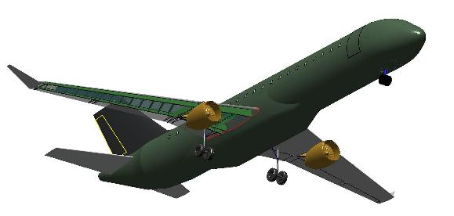

Figure 3.5: Single wheel nose and main landing gear configuration

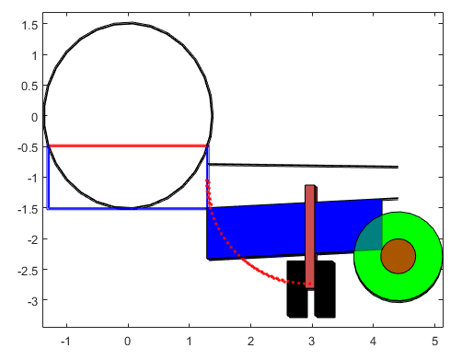

Figure 3.6: Main landing gear design clearances considering engine, inner flaps and fuselage geometries

*Fuselage and Cabin Sizing*

The code developed for fuselage and cabin sizing is based on the methodology described in the work of Sholz [149] [150] and Marckwardt [151] on aircraft preliminary design.

In such method, the fuselage is modeled as a long cylinder with constant ellipsoid cross section. The code considers as inputs the total number of passengers, seat width, aisle width, cabin height, number of aisles and number of seats abreast (maximum 6), in order to calculate the dimensions of the minor and major axis of the ellipsoid’s cross section (outer dimensions, considering fuselage thickness) and total fuselage length. These are key parameters used in the wet area computation adopted in the MTOW/OEW determination loop, using Roskam’s formulae [140] . Although cargo revenue is not considered in this research, space for cargo containers in the fuselage lower floor is also considered in the fuselage cross-section computations. Figure 3.7 shows typical layouts produced by such methodology. In all designs, the following assumptions are made during the cross-section calculations:

* + Single class configuration (economy).
  + Space for two LD3-45/AKH container (1,46m x 1,49m x 1,13m) [152] in the lower cargo compartment, mostly used in the A320 aircraft.
  + Passenger´s dimensions defined by the 95% of American male, defined by NASA [153].

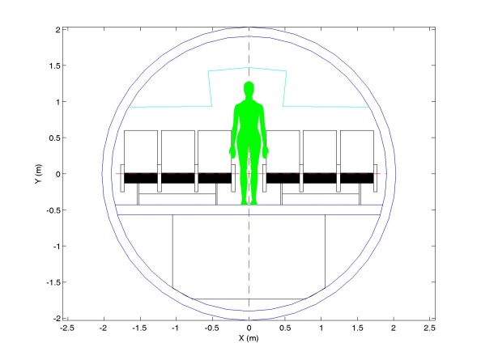

Figure 3.7: Typical fuselage cross section computation

*Horizontal and Vertical Tail Sizing*

The code developed for horizontal and vertical stabilizer areas sizing considers a higher fidelity method than that offered by the tail volume approach, as described in the classical aircraft preliminary design literature (Roskam [139], Raymer [137] and Torenbeek [22]). A methodology based on static stability and controllability criteria was developed and integrated into MTOW interactive process, based on Mattos and Secco´s work [154].

The incorporation of a more sophisticated methodology for the tail plane sizing determines a more complex task in the interactive process for MTOW calculation. The determination of the CG location, and its allowable variation along the flight envelope, is needed not only for the tail plane area calculation, but for the positioning of the wing, and the main and nose landing gears, which are also dependent on this process. The allowable center of gravity variation is calculated regarding the design mission, depending on the associated fuel consumption (as function of wings geometry) and mass distribution along the fuselage, including passengers’ uneven distributions and people movements along the cabin in cruise phase. In addition, the CG location guides the wing placement in the chosen configuration [154] [137], as shown in Fig. 3.8.

Uma imagem contendo texto, mapa

Descrição gerada com muito alta confiança

Figure 3.8: Example of wing and tail placements considering the allowable CG variation (blue) for a certain design

Two criteria are adopted for the vertical stabilizer sizing: lateral static stability and controllability. They are evaluated separately in which the geometry of the largest area is taken as solution. The lateral stability criteria is set in order to fulfill a value that incorporates a desired variation of yawing moment coefficient with yaw angle (*Cnβ*), calculated according to Roskam’s methodology [155] . The lateral controllability criteria is set in order to fulfill the one engine failure takeoff minimum control speeds certification requirements, according to FAA’s regulations for commercial transport aircraft [156].

The horizontal stabilizer area is obtained considering the evaluation of both longitudinal static stability and controllability criteria at the same time. The static longitudinal stability criteria is determined through the check of the pitch moment coefficient (*Cmα*) sign or the location of the aircraft neutral point, also according to Roskam’s methodology [155]. The longitudinal controllability criteria is determined via classical tail volume analysis, as described in the classical literature [139] [137] [22]. According to Scholz [157], the relationship between the area ratio (*hS/wS*) and the distance from the CG to the neutral point (static margin) for both criteria may be combined into a single graph, where the integrated analysis is performed, as shown in Fig. 3.9. The permitted areas of focus are settled between the limit lines of controllability and stability requirements. Between these lines, the required CG range (green dashed line) can thus be fitted in order to determine smallest horizontal tail surface area [154].

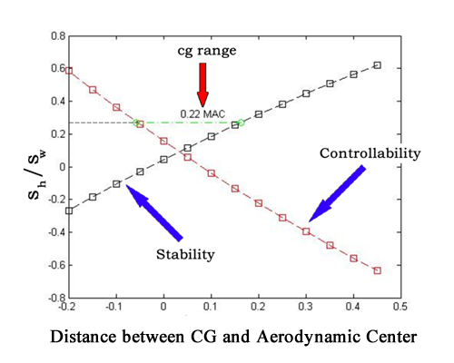

Figure 3.9: Scholz method to determine the minimum horizontal tail area

The stability derivatives needed for the above calculations (*Cmα* and *Cmα*) and the other ones necessary for the stability and control analysis, were obtained using the Aerodynamic Vortex Lattice (AVL) open application, developed by the Massachusetts Institute of Technology [158] . This application uses the aircraft’s main aircraft geometric characteristics to model a flow simulation, suing an extended vortex lattice model for the lifting surfaces, together with a slender-body model for fuselages and nacelles, in order to determine the main aerodynamic coefficients and associated stability derivatives of the aircraft. The application also has a flight dynamic analysis mode that combines a full linearization of the aerodynamic model about a steady flight state. Inertia properties, necessary inputs for AVL’s dynamic model, were estimated via Roskam´s methodology [155] also using the main geometric characteristics of the aircraft.

With AVL results, the flight quality evaluation is performed on the resulting airplane considering the longitudinal and lateral responses to small perturbations. This is done according to Stevens et. al methodology [159] where a frequency response examination if performed on the poles resulted from the eigenvector of the stability derivatives matrix. In the longitudinal movement, the short period oscillations mode is considered, while in the lateral-directional movement, Dutch-roll mode is investigated. The damping constant (*ξd*) and response frequency (*ωn*) associated to these two modes are checked against the MIL-STD-1797B flight quality requirements [159] [160] , as shown in Fig. 3.10. The design in analysis is then considered accepted if minimum Level 2 classification is achieved in both modes. This means that flight qualities are adequate to accomplish the mission flight phase, but some increase on pilot workload may be expected. If not, a new horizontal and vertical stabilizer cycle needs to be initiated until convergence.

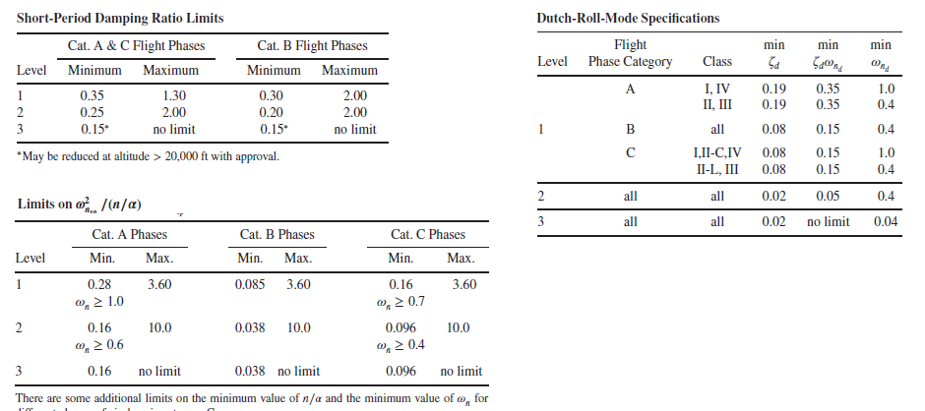

Figure 3.10: Flight quality requirements for Dutch Roll and short period [159]

* + 1. Aerodynamics

This module, developed in *MATLAB*® code, computes the total drag and lift coefficients required for performance calculations mission performance module, to be detailed in Session 3.2.1.

For that, a surrogate model based on an artificial neural network (*ANN*) is employed for the estimation of aerodynamics coefficients of the wing, according to the methodology proposed by Secco and Mattos [56]. Among many architectures evaluated, a three-layer feed-forward ANN, with hyperbolic transfer function, was found to be best suited for non-linear problems with dozens of variables as with the present case. This type of network can approximate any function to any desired degree of accuracy, provided it has enough neurons in the hidden layers.

Regarding estimation of total drag coefficient, three dedicated ANNs were designed to estimate the three drag components, zero-lift, induced, and wave drag. According to Secco and Mattos [56], this approach in considerably more accurate than employing a single ANN for the total drag estimation. Approximately, 110,000 different wing configurations were employed for training and validation purposes. For the generation of the database of this size, a full potential aerodynamic code was used. The potential module is coupled with an integral boundary layer algorithm that calculates the viscous effects at prescribed stations along wingspan.

Input for the computations of the ANN are environmental conditions, wing and airfoil parameters, as listed in Table 3.11 and Figures 3.11 and 3.12 An additional 3-4% on total CD is applied to consider miscellaneous drag. Induced drag is adjusted for the presence of winglets according to the study conducted by Mattos et. al [161].

Table 3.11: Inputs for the ANN computation

|  |  |
| --- | --- |
| ANN Input Parameters | Symbol |
| Mach number | *M* |
| Pressure Altitude (ft) | *Hp* |
| Angle of attack | *α* |
| Wing Aspect Ratio | *wAR* |
| Wing Taper Ratio | *wTR* |
| Wing semi-span (m) | *wb* |
| Wing leading edge sweepback angle (deg) | *wSweepLE* |
| Inner wing panel dihedral | *δ1* |
| Outer wing panel dihedral | *δ2* |
| Kink Semispan position | *KinkPos* |

‘

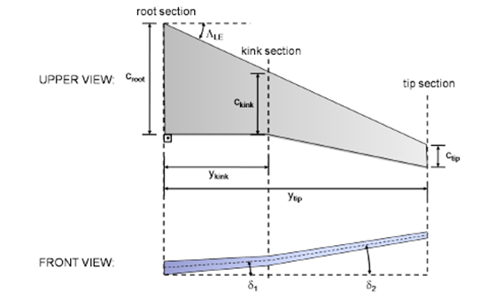

Figure 3.5a: Wing geometric parameters [56]

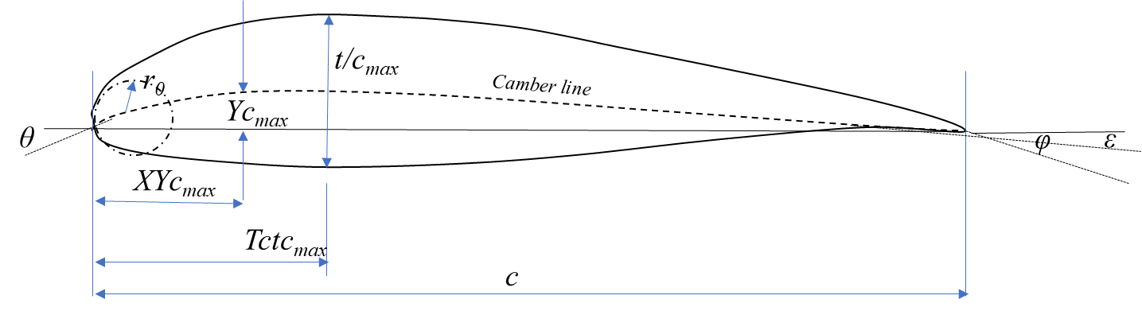

Figure 3.5b: Airfoil geometric parameters

In this research, the three fixed airfoils for the root, kink and tip stations are used in all wings of the airplanes generated in each optimization cycle. Such airfoils are optimized for Mach 0.78 cruise speed, with maximum L/D = 23. Their coordinates are read from a specific database (Aero ANN database - Fig. 3.4). Since the airfoils geometric parameters are needed as input for the ANNs, a polynomial fitting, according to Sobieski methodology [162] is applied to the provided coordinates in order to determine such parameters. Fig.3.13 shows the original airfoil coordinates and the obtained polynomial fittings. The three airfoils parametric coefficients are presented in Table 3.12.

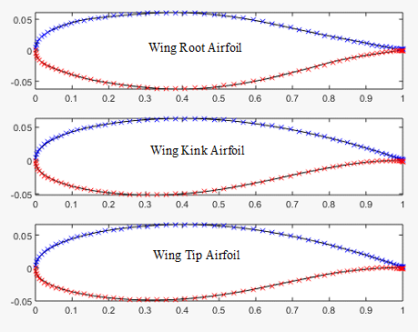

Figure 3.13: Airfoil coordinates and polynomial fittings.

Table 3.12: Airfoil geometric parameters

|  |  |  |  |  |
| --- | --- | --- | --- | --- |
| Parameters | Symbol | Root | Kink | Tip |
| Leading edge radius | *r0* | 1.5 | 1.5 | 1.5 |
| Airfoil thickness ratio [%] | *tc* | 12.3 | 11.3 | 11.3 |
| Thickness line angle at trailing edge [o] | *φ* | -0.1 | -0.1 | -0.1 |
| Maximum thickness chord-wise position | *tcmax* | 0.3738 | 0.3545 | 0.3630 |
| Camber line angle at leading edge [o] | *θc* | 0.1 | 0 | 0.1 |
| Camber line angle at trailing edge [o] | *ε* | -0.1 | -0.1 | -0.1 |
| Maximum camber | *Ycmax* | -0.0404 | 1.2095 | 1.3791 |
| Camber at maximum thickness chord-wise position | *Tctcmax* | -0.0638 | 0.5663 | 0.8571 |
| Maximum chamber chord-wise position | *XYcmax* | 0.6188 | 0.7283 | 0.7033 |

The accuracy of drag estimation by the ANN system proved to be significant, recording an average error of 3 drag counts in high-Mach regimes when compared with the results from the full potential code. This represents typically the error obtained with flight test data and those from large subsonic wind tunnels. If the flow is subsonic over the entire airplane surface, the average estimation error of the ANN lies below 0.1 drag counts. An additional 3-4% on total *CD* is applied to consider miscellaneous drag. Induced drag is adjusted for the presence of winglets as per Mattos et. al study [161].

A verification of the accuracy and capability of the ANN estimation of the drag divergence is shown in Fig. 3.7. Two airplane configurations were selected from the database for further analysis (not part of the ANN training set) presenting different drag behavior over Mach number. Fig. 3.14 also shows that the delay of the drag divergence with the increase of the wing sweep angle was correctly captured by the drag-predictor ANN for the two configurations, evaluate at a pressure altitude of 35000ft. In addition, an airliner with 93.5 m2 wing reference area, designated as ITA107, was also chosen to evaluate the accuracy of the designed ANNs in predicting drag and lift coefficients. Wing geometric characteristics and flight condition information are given in Table 3.13.

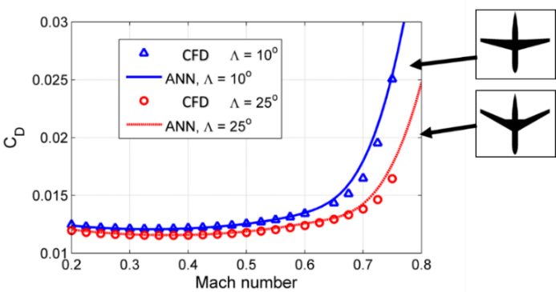

Figure 3.14: Comparison between ANN overall drag predictions and CFD results

Table 3.13: Wing characteristics of ITA107 airliner

|  |  |
| --- | --- |
| Parameter | Value |
| Incidence angle at root station [o] | 2 |
| Incidence angle at break station [o] | 0 |
| Incidence angle at tip station [o] | -2 |
| Wing reference area [m2] | 93.5 |
| Wing aspect ratio | 8.43 |
| Wing taper ratio | 0.235 |
| Quarter-chord wing sweepback angle [o] | 17.5 |
| Mach number | 0.77 |
| Angle of attack [o] | 1 |
| Cruise altitude [ft] | 34,000 |
| Break station location (fraction of semispan) | 0.39 |

Table 3.14 shows a comparison between the ANN and CFD results. The overall drag differs by one drag count only. The wave drag coefficient recorded the highest difference between the neural network and the full potential code, which was of three drag counts. The ANN drag estimation provided average error of 3 drag counts when compared with the full potential code results. At the flight condition shown in Table 3.10, the streamlines on the wing upper side as calculated by the full potential code, indicate attached flow close to the fuselage and at the wingtip. However, there is a large separation region close to the trailing edge along a great portion of semispan, caused by shock waves. It is observed that in some wing parts, the flow experiences a reattachment to wing surface and suffers another separation. This is indeed a complex flow pattern, which was well captured by the ANN prediction. This example is an excellent boost for the ANNs designed in the present work. Despite the complexity of the airflow at the cruise condition over the test case airliner, ANNs could predict the drag coefficients.

Table 3.14: Predicted and calculated coefficient values by ANN and full potential code

|  |  |  |  |
| --- | --- | --- | --- |
| Predicted coefficient (counts) | ANN | Full potential code | Deviation |
| *CD0* | 0.0065 | 0.0066 | 1.5% |
| *CD ind* | 0.0055 | 0.0056 | 1.8% |
| *CD wave* | 0.0069 | 0.0066 | 4.5% |
| *CD* | 0.0189 | 0.0188 | 0.53% |
| *CL* | 0.3670 | 0.3820 | 3.9% |

*CLmax computation*

Several analytical methods that account for both stall effects and enable the prediction of the maximum lift coefﬁcient were discussed and a trade-off between the methods was conducted by Singh [163]. In his study it was found that both the pressure difference rule and the so-called Critical Section are good options in terms of accuracy and versatility.

Therefore, the Critical Section Method was used in this module to estimate airplane´s clean maximum lift coefﬁcient (*CLmax*). For that an *XFOIL* ® panel code [164] , combined with a wing-fuselage full potential code with viscous corrections according to the methodology proposed by Mattos [165], was used to determine the maximum lift coefﬁcient on the set of wing sections of the wing design in analysis.

*High Lift Devices*

High-lift systems have a major influence on the sizing, economics, and safety of transport airplanes. Although high-lift systems are complex and costly, they are a necessity to allow airplanes to take off and landing on runways of acceptable length without penalizing the cruise efficiency significantly [166]. In this module the methodology described in the US Airforce DATCOM [167] is used to determine the *CLMAX,* for the takeoff, landing and approach flaps configurations. The basic high lift devices geometric configurations adopted in all designs are:

* One slot flap
* Slat present
* Flap length: 75% wingspan.
  + 1. Propulsion

This module, developed in *MATLAB* ® code, computes the net thrust (*T*) and fuel flow (*FF*) parameters required for performance calculations mission performance module (Session 3.2.1) and Noise Module (Session 3.1.4).

During the conceptual design phase, engine performance is usually determined based on a desired thrust and an average specific fuel consumption values [25]. However, whenever vehicle trajectory simulations need to be performed, sophisticated engine models are necessary to predict both steady state and transient engine behavior. In such models, engine performance fidelity is highly dependent on the modeling aerodynamic, thermodynamic and mechanical component behaviors. The aerothermodynamic turbofan engine model employed in this module is based on Loureiro’s work [168] , derived from the generic engine deck formulations proposed by Benson [169] and adopted by NASA in the *EngSim* Project [170]. The model uses a closed formulae approach to calculate thermodynamic input and output states on each engine’s component in a generic mounting configuration.

The input parameters used in such model correspond to the engine design parameters, listed in Table 3.2. They are by-pass ratio (*BPR*), fan pressure ratio (*FPR*), overall pressure ratio (*OPR*), inlet turbine temperature (*TIT*), fan diameter (*DFAN*) and cruise altitude design point. In addition, the operational parameters necessary for computations at each flight calculation point are pressure altitude, Mach number, ISA deviation and throttle position (*П*). The outputs from the calculation are net thrust (*T*) and fuel flow (*FF*). Two calculation steps are built in this methodology:

1. The design step: where all engine characteristics are determined at a given design point defined by a given cruise Mach number, cruise altitude and 95% of maximum throttle setting.
2. The analysis step: where it is possible to calculate the engine thrust and fuel flow from the geometric characteristics obtained in the design step.

A special consideration shall be given to the turbofan compressor efficiency computation, which is performed as an intermediate step of the net thrust determination. In this work a numerical interpolation , via multi-dimensional look-up table, is performed via generic compressor map used in the Gas Turbine Simulation Program (GSP) developed by National Aerospace Laboratory of Netherlands (NLR) [171]. This map was selected since it provides more realistic performance calculations during transitory operations, such as on climb and descent phases, rather than using fixed efficiency as stated in Benson´s model (assumed to be 80%). This last model produces, for example, throttle settings different than zero for idle thrust during the descent and therefore increasing the fuel flow at this phase, which is not realistic. In the GSP formulation, the compressor efficiency (*η*) is calculated as function of compressor pressure ratio (*PR*), corrected mass flow (*Wc* and corrected rotor speed (*Nc*), as shown in Fig.3.15.

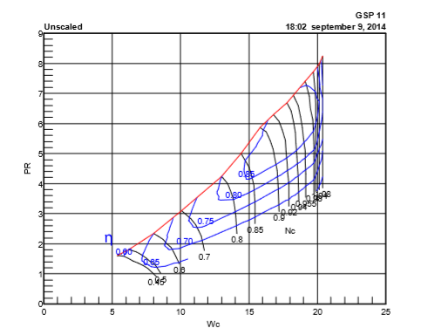

Figure 3.15: Generic compressor map [171]

Where *Wc , Nc, PR* are given by: (5) (6) (7)

* + 1. Noise

This module, developed in *MATLAB* ® code, computes the noise levels at the aircraft certification measuring points, recorded in the Aircraft Definition database.

According to Fig. 3.2, after the aircraft dimensions are defined as product of the weight estimation loop, the aircraft noise estimations are performed according to type certification regulations. For that, airplane noise shall be assessed in three defined measurement points along the flight path, according to international standards defined by Annex 16 of the Convention of the International Civil Aviation Organization [138].

These measurement points, illustrated on Fig. 3.16 as green dots where microphones are set, are determined with the objective to capture the effects of airplane performance (fly-over point), engine design (sideline point) and airframe characteristics (approach point) on the resulting noise signature. According to Annex 16, the accumulative level (sum of the measured sound level in these three performance points, measured in terms of *Equivalent Perceived Noise - EPNdB*) shall be used as baseline for the noise classification of the aircraft (the so-called “Chapters 2,3,4 and 14”). This information is essential to determine the capability of the aircraft to operate at certain airports, according to specific noise constraints.

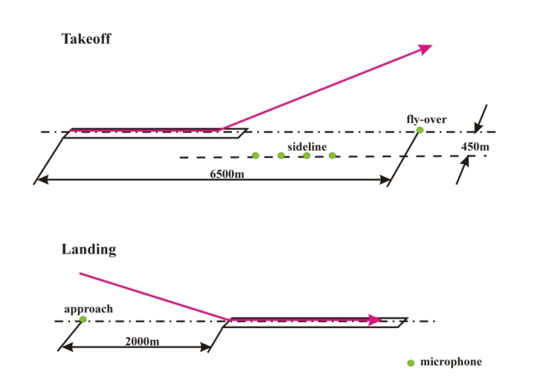

Figure 3.16: Noise measuring points for airplane certification (Source: Magalhães [172])

Airplane noise models have been used to estimate the noise level at certification points since the 70´s and vary on complexity of details [173] . The so-called type-1 models, according to classification proposed by Zaporozhets et. al [174] , are the foundation for the basic noise computations of any aircraft type, consists on a spectral analysis of the acoustic field around the aircraft due to the aggregated contributions of each of its noise source evaluated separately. These models consider the distance from the airplane to the receiver (*r*), the frequency (*F*) and directivity (Θ) of the sound source, engines throttle setting (*П*) and airplane configuration (flaps and landing gear) to measure the sound level in terms of Sound Pressure Level (*SPL*). The equation used to predict the complete airplane noise is defined below:

(8)

Where *SPLi (F)* is the basic spectrum contribution of each noise source corrected for directivity, frequency shift, relative movement of the source, interference of sources, atmospheric attenuation and absorption and ground reflection.

Semi-empirical type-1 models were the first to be developed and are based on correlations of key design parameters and measured noise from airframe and engine components. Considering this approach, the most complete model is NASA´s Airplane Noise Operations Prediction Program (ANOPP) [173] , which provides closed formulae for such computations including corrections for directivity, spectral and speed variations, besides atmospheric abortions. In this research the methodology proposed by Magalhães [172] [46] , based on the ANOPP model equations, is used to estimate noise and airframe noise levels at certification points.

In order to accomplish this calculation, complete a flight path simulation shall be performed in order to achieve the certification points. Takeoff and approach noise assessment are derived from simple flight mechanics’ modeling, according to a Roskam´s methodology [23] . The takeoff flight path consists of an integration of airplane acceleration on the ground, followed by an integration of rate of climb data up to 3000ft above the runway. No thrust reduction (cut-back) was considered in the flight path for simplicity. The approach flight path consists of calculating a standard -3deg flight path approach in the landing configuration from 1500ft down to 50ft above the runway [172].

The complete airplane noise model consists of the integration of the flight-path generation with the engine and airframe noise estimation functions. Once the SPLs for the whole trajectories were obtained, they were converted into Effective Perceived Noise Levels (*EPNL*dB) for the noise certification points.

* + 1. Airplane Design Performance Check

As mentioned previously, once the aircraft design is completed it is necessary to check if its performance is adequate according to specific certification requirements predicted in FAR25 [156], before running the mission/network calculations. The idea is to have an initial estimation about operational performance of the aircraft under evaluation, in order to avoid potentially unfeasible designs for airlines.

In this research the methodology proposed by Loftin, in his work developed to NASA [47] about the operational suitability of aircraft designs, is adopted. The method is based on the so-called Design-Diagram check, where the analysis of the influence of the wing loading (*W/S*) and thrust-to-weight ratio (*T/W*) in a set of operational characteristics of the aircraft is performed. The idea of this method is to compare the pair (MTOW/S, T/W) the aircraft in analysis with the function *W/S=f(T/W)* associated certain operational conditions. Fig. 3.17 shows a graphical example of such methodology, considering some basic performance checks.

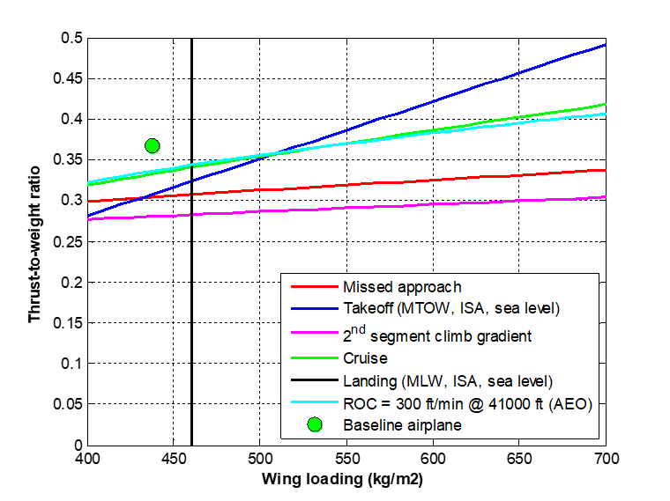

Figure 3.17: Design Diagram check

Class-I methods (direct formulae) are used to check each performance condition, based on Roskam´s [23] and Torembeek´s [22] methodologies . If the selected aircraft design does not satisfy any of the checks the aircraft is considered a fail in the MDO cycle and is not considered in the optimization process. The following checks are considered:

*Takeoff Field Length*

The balanced field length takeoff capability is verified at Maximum Takeoff Weight (*MTOW*) and Maximum Takeoff Thrust (*Tmax*) considering the design takeoff field length (*TOFL*), sea level airport and standard atmospheric conditions. The following equation, derived from Roskam’s methodology [23] , is used:

(9)

If the ration *Tmax/MTOW* is less than *ToWreq*, the aircraft design under evaluation is not selected.

*Landing Field Length*

The landing field length landing capability is verified at Maximum Landing Weight (*MLW*), considering the design landing field length (*LFL*), a sea level airport and standard atmospheric conditions. The following equation, derived from Roskam’s methodology [23] , is used:

(10)

If the ratio *MTOW/wS is less than WoSreq*, the aircraft design under evaluation is not selected.

*Second Segment Climb*

The climb capability is verified according to FAR25.121 requirements for the second segment on the gross takeoff flight path, considering the following configuration:

* One engine failed
* Maximum thrust applied in the remaining engine
* Minimum climb gradient: 2.4% (2 engines aircraft)
* Takeoff flaps applied
* Landing gear retracted
* 1.2 Stall speed at the configuration
* No ground effects
* Maximum Takeoff Weight
* Standard atmospheric conditions
* Sea level airport

The following equations, derived from Roskam’s [23] and Torembeek’s [22] methodologies, are used:

(11)

*(12)*

(13)

Where:

*CDwing* is the total wing drag coefficient, obtained from the ANN described in session 3.1.2

*CD0* is the zero lift drag coefficient [23]

*CD0ubridge* is the zero lift drag increase due to wing-fuselage interference [23]

*CDrudder* is drag increase due to ruder deflection [23]

*CDflap* is drag increase due to takeoff flap extended [23]

*CDwindmill* is the drag increase due to wind milling of the failed engine [22]

If the ratio *T/MTOW* is less than *ToWreq*, the aircraft design under evaluation is not selected.

*Landing Climb*

The climb capability is verified according to FAR25.119 requirements applied to the go-around maneuver in the final approach phase, considering the so-called “Landing Climb configuration” as follows:

* All engines operating
* Maximum thrust applied in all engines
* Minimum climb gradient: 3.2%
* Landing flaps applied
* Landing gear extended
* 1.3 Stall speed at the configuration
* No ground effects
* Maximum Landing Weight
* Standard atmospheric conditions
* Sea level airport

The following equations, derived from Roskam’s [23] methodology, are used:

(14)

(15)

(16)

Where:

*CDwing* is the total wing drag coefficient, obtained from the ANN described in session 3.1.2

*CD0* is the zero lift drag coefficient [23]

*CD0ubridge* is the zero lift drag increase due to wing-fuselage interference [23]

*CDflap* is drag increase due to takeoff flap extended [23]

*CDgear* is drag increase due to landing gear extended [23]

If the ratio *T/MTOW* is less than *ToWreq*, the aircraft design under evaluation is not selected.

*Approach Climb*

The climb capability is verified according to FAR25.121 requirements applied to the go-around maneuver in the final approach phase, considering the so-called “Approach Climb configuration” as follows:

* One Engine operating
* Maximum thrust applied in the remaining engine
* Minimum climb gradient: 2.1%
* Approach flaps applied
* Landing gear retracted
* 1.65 Stall speed at the configuration
* No ground effects
* Maximum Landing Weight
* Standard atmospheric conditions

The following equations, derived from Roskam’s [23] and Torembeek’s [22] methodologies, are used:

(17)

(18)

(19)

Where:

*CDwing* is the total wing drag coefficient, obtained from the ANN described in session 3.1.2

*CD0* is the zero lift drag coefficient [23]

*CD0ubridge* is the zero lift drag increase due to wing-fuselage interference [23]

*CDrudder* is drag increase due to ruder deflection [23]

*CDflap* is drag increase due to the approach flap extended [23]

*CDwindmill* is the drag increase due to wind milling of the failed engine [22]

If the ratio *T/MTOW* is less than *ToWreq*, the aircraft design under evaluation is not selected.

*Residual Rate of Climb*

A minimum residual rate of climb of 300ft/s (1,524 m/s) is verified at maximum certified ceiling altitude, considering the best climb speed, weight at takeoff climb equivalent to 95% MTOW and maximum thrust at this altitude at standard atmosphere. The following equations are used:

(20)

(21)

(22)

Where the zero lift drag (*CD0)* and Oswald Factor (*e*) of the airplane are estimated via Class-I formulas according to Torembeek´s methodology [22].

If the ratio *T/MTOW* is less than *ToWreq*, the aircraft design under evaluation is not selected. In this case the cruise thrust (*T*) is evaluated at maximum certified ceiling via propulsion model as described in Session 3.1.3, considering cruise speed equal to .

*Maximum Cruise Speed*

In this check it is verified if the aircraft is capable to maintain the Maximum Operational Mach (MMO) at the cruise altitude equal to the certified ceiling, standard atmosphere and associated weight at top of climb (*WTOC)* considering taking off with MTOW. The following formulas are applied:

(23)

(24)

(25)

Where:

*CDwing* is the total wing drag coefficient, obtained from the ANN described in session 3.1.2

*CD0* is the zero lift drag coefficient [23]

*CD0ubridge* is the zero lift drag increase due to wing-fuselage interference [23]

If the ratio *T/MTOC* is less than *ToWreq*, the aircraft design under evaluation is not selected. In this case *WTOC* is calculated via mission performance module (described in session 3.2.1) and the cruise thrust (*T*) is evaluated at maximum certified ceiling via propulsion model as described in Session 3.1.3, considering the cruise speed associated to *MMO*.

*Drag Divergence*

In this check the wave drag behavior is checked when the aircraft accelerates through a range of speeds towards the MMO. This would ensure smooth increase on drag raise along a selected speed range and therefore a minor impact in fuel consumption when flying at higher speeds. The test condition consists on the drag computation at Mach 0.7 and MMO, cruise altitude equal to the certified ceiling, standard atmosphere and weight at top of climb (*WTOC)* considering taking off with MTOW. In this scenario the drag rise at these two speeds should not exceed 2.5%. The following equation is therefore applicable:

(26)

The CD computation follows the same methodology applied to Maximum Cruise Speed check (Eq.23). If *∆Ddiv* is more than *2.5%*, the aircraft design under evaluation is not selected.

* 1. Network Framework

As shown in Fig. 3.1, once the aircraft geometry is defined, the calculation flow is transferred to the Network Framework module, which is responsible to calculate the optimum airline network associated to such design and the necessary outputs used in the optimization process. Three calculation sub-modules are executed in the following sequence:

1. Network Optimization:

In this sub-submodule the optimum airline network is determined considering selected airports in a given area of operations and the associated to the aircraft in analysis. In this process, a Linear Programing Model (*LPM*) is executed in a local optimization routine in order to determine the frequencies between the involved city pairs. A gravitational passenger demand model is used to estimate the daily passengers flow between the city pairs, based on the city/airports information extracted from the Airport and Econometrics Database (*AED*) and network fixed parameters.

1. Mission Performance:

Once the frequencies between city pairs are determined, this sub-module is responsible to compute the trip time, fuel burned and direct operational cost (*DOC*) for each route connection, considering the aircraft under analysis at a given load factor. In this process a realistic vertical flight path profile simulated, considering the selection of optimum speeds and optimum altitudes along the flight path. All certification performance limitations at origin and destination airports, as well as payload-range envelope constraints, are considered to determine the takeoff weight in all computations.

1. Network Economics:

In this last sub-module, the outputs necessary to feed the optimization process are computed, considering the data generated in the other sub-modules. In this process, aggregated network key performance indicators, envisioning the airline’s objective functions side, are determined. They are: Estimated Total Number of Aircraft, Network Total Direct Operational Costs (*NDOC*) and Total Network Profit (*NP*). In addition, in this sub-module the Net Present Value (*NPV*) of the aircraft design and production cashflow is also calculated, envisioning the aircraft manufacture´s objective function side.

The calculation methodologies employed in each of these three sub-modules are described below:

* + 1. Network Optimization

The optimization algorithm in this sub-module is derived from the Linear Programming Model (*LPM*) proposed by Jaillet et. all [100] for generic network determination considering passengers fractional flow. A *MATLAB*® code was developed to set up and solve this problem using the LPM solver available for this application. The mathematical formulation of the problem is presented in the next paragraphs.

Let be the fraction of the passenger’s demand flow from origin i to destination j, served by a two-stop connecting flight through cities l and t, the number of aircraft type used in the route from city i to j, p the average fare per passenger, the average operational cost ($/nm) at design range , *bk* the passenger capacity of aircraft *k*, the reference load factor *LFref* and *dij* the distance between origin and destination airports. The following integer linear programming model is proposed:

(27)

subject to:

(28)

*(*29)

, for all i*≠j*

where , are positive and integer positive for all i≠j

The average operational costs (*Ck*) for each aircraft fleet, necessary for the optimization, correspond to the Direct Operational Cost (*DOC*) related to the design range of each aircraft in analysis (explained in item 3.2.2). The objective function (27) is set to maximize the network profit, based on the difference between the average fare (p) and the average cost per passenger. Constraint (28) states that the fractional flow on route ij cannot exceed the total capacity of the aircraft assigned, while constraint (29) ensures that the passenger flow from a direct flight from i to j is non-negative.

In this research it is assumed that 50% of all passenger demand from i to j are derived from direct flights ), 30% distributed equally among all one-stop flights and 20% distributed equally among two-stop flights , as shown in Fig. 3.18. Passengers demand between origin and destination (*fij*) is estimated via gravitational model, based on city pair distance and econometric parameters, as proposed by Wojan [15]. Let *P* be the city pair population product (*P=Pi.Pj*), *C* the city pair airport catchment area product (), *B* the city pair combined Buying Power Index (), *G* the city pair GDP product (*G=GDPi..GDPj*) and dij the reference distance of the city pair. The following passenger demand model is proposed as follows:

(30)

In Equation 30, the exponents *K0, K1, K2, K3, K4 and K5* are calibration constants, determined by log-linear regression. They may be easily calculated using the public econometric data available (*Pi, Ci, Bi* and *GDPi* often published by economic agencies).

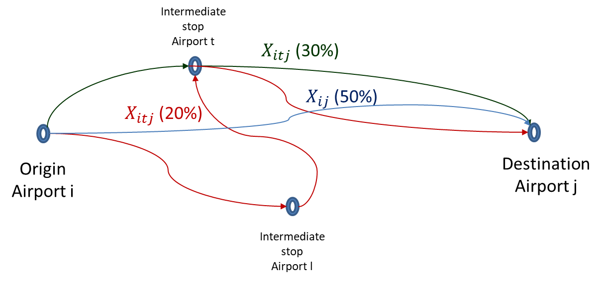

Figure 3.18: Two stop demand model and adopted shares

* + 1. Mission Performance

*DOC Modeling*

* + 1. Network Economics

*NPV Modeling*

* 1. Optimization Module
  2. The Aircraft Database Approach

# **Simulation and Dicussions**

# **Conclusions**

# **Future Research Developments**

# **References**

|  |  |
| --- | --- |
| [1] | IATA, International Air Transport Association, “Economic Performance of the Airline Industry,” International Air Transport Association, Montreal, Canada, 2018. |
| [2] | IATA, International Air Transport Association, “Profitability and the air transport value chain,” International Air Transport Association, Montreal, Canada, 2013. |
| [3] | R. Doganis, Flying Off Course IV: Airline Economics and Marketing, Routledge, 2009. |
| [4] | ICAO, International Civil Aviation Organization, “Group on International Aviation and Climate Change,” ICAO, 2009, Montreal. |
| [5] | ICAO, International Civil Aviation Association, “Intergovernamental Panel on Climate Change (IPCC). Special Report on Aviation and Global Atmosphere. Special report from groupd I and III,” ICAO, Montreal, Canada, 1999. |
| [6] | J. Fregnani e B. Mattos, “Aviation and Electrical Road Vehicles.,” em *16th AIAA Aviation Technology, Integration, and Operations Conference*, Washington D.C., United States of America, 2016. |
| [7] | IATA, International Air Transport Association, “Operational Fuel Efficiency,” International Air Transport Association, Montreal, Canada, 2015. |
| [8] | IATA, International Air Transport Association, “Technology Rodamap,” International Air Transport Association, Montreal, 2013. |
| [9] | ICAO, International Civil Aviation Organization, “Resolution A39-3: Consolidated statement of continuing ICAO policies and practices related to environmental protection – Global Market-based Measure (MBM) scheme,” ICAO, Montreal, 2018. |
| [10] | ATAG, Air Transport Action Group, “Beginner´s Guide to Aviation Efficiency,” Geneva, Switzerland, 2014. |
| [11] | The Boeing Company, “Jet Transport Perfromance Methods,” Boeing Commercial Aircraft, Seattle, 2015. |
| [12] | B. S. Mattos, J. A. Fregnani e P. C. Magalhães, Conceptual Design of Green Transport Airplane., Book Series: Frontiers in Aerospace Science ed., vol. 3, Sharjah: Bentham Books, 2018. |
| [13] | D. J. Caetano e N. D. F. Gualda, “A Flight Schedule and Fleet Assignment Model,” em *12th World Conference on Ait Transport Research*, Lisbon (Portugal), 2010. |
| [14] | T. Grosche, F. Rothlauf e A. Heinzl, “Gravity models for airlines passenger volume estimation,” *Journal of Air Transport Management,* pp. 175-183, 2007. |
| [15] | O. Wojan, “Airline Network Structure and the Gravity Model,” University of Hamburg and Lufthansa Technik AG, Hamburg, 2000. |
| [16] | W. E. O´Connor, Am introduction to airline economics, Westport, United States of America: Greenwood Publishing Group, 2001. |
| [17] | D. Klabjan, “Large-scale models in the airline industry,” *Column generation,* pp. 163-197, 2005. |
| [18] | A. Rabetanety, J. Calmet e C. Schoen, *Airline Schedule Planning Integrated Flight SChedule Design and Product Line Design,* Karlsuhe: Universty of Karlsuhe, 2006. |
| [19] | C. Hane, C. Barnhart, C. Johnson, E. Marsten, R. Nemhauser e G. Sigismondi, “The fleet assignment problem: solving a large-scale integer program,” Georgia Institute of Technology, 1995. |
| [20] | H. Gurkan, S. Gurel e M. Akturk, “An integrated approach for airline scheduling, aircraft fleeting and routing with cruise speed control,” *Transportantion research Part C- Emerging Technologies,* vol. 68, pp. 38-57, 2014. |
| [21] | P. Magalhães e B. Mattos, “Conceptual optimal design of environmentally friendly airliners: a review of available methodologies and their integration into a consistent framework for everyday use,” em *16th AIAA/ISSMO Multidisciplinary Analysis and Optimization Conference*, 2015. |
| [22] | E. Torenbeek, Advanced Aircraft Design, Wiley & Sons, 2013. |
| [23] | J. Roskam, Airplane Design Part I - Preliminary Sizing of Aircraft, DARcorporation, 1999. |
| [24] | P. Shmollgruber, Enhancement of the conceptual aircraft design process through certification constraints management and full mission simulations, Toulouse: Université Fédérale Toulouse Mid-Pyrénées, 2018. |
| [25] | B. S. Mattos, J. A. Fregnani e P. C. Magalhães, Conceptual Design of Green Transport Airplane., Book Series: Frontiers in Aerospace Science ed., vol. 3, Bentham Books, 2018. |
| [26] | C. P. Taylor, “Integrated transportation system design optimization,” Boston, United States of America, 2007. |
| [27] | G. Bower e I. Kroo, “Multiobjective Aircraft Optimization for minimum cost and emissions over specific route networks,” em *8th AIAA ATIO* , 2008. |
| [28] | B. S. Mattos and N. R. Secco, "An Airplane Calculator Featuring a High-Fidelity Methodology for Tailplane Sizing," *Journal of Aerospace Technology and Management,* vol. 5, pp. 371-386, 2013. |
| [29] | P. J. Lederer and R. S. Nambimandom, "Airline Network Design," *Operations Research,* pp. 7865-804, 1998. |
| [30] | D. Bing, “Reliability Analysis for Aviation Airline Network Based on Complex Network,” *Journal of Aerospace Technologies Management,* vol. 6, nº 2, pp. 193-201, 2014. |
| [31] | S. Sobieski, “Multidisciplinary design optimization: An emerging new engineering discipline,” NASA-TM-107761, 1993. |
| [32] | J. R. Martins e A. B. Lambe, “Multidisciplinary design optimization: a survey of architectures,” *AIAA journal,* pp. 2049-2075., 2013. |
| [33] | D. Raymer, Aircraft Design: A conceptual approach. 5th Edition and RDSWin STUDENT, Washington,D.C: American Institute of Aeronautics and Astronautics, 2012. |
| [34] | L. Schimt, “Structural Design by Systematic Synthesis. 2nd Conference on Electronic Computation,” New York, 1960. |
| [35] | R. Haftka, “Automated Procedure for Design of Wing Structures to Satisfy Strength and Flutter Requirements,” Hampton,VA, 1973. |
| [36] | H. Ashley, “On Making Things the Best — Aeronautical Uses of Optimization,” *Journal of Aircraft,* vol. 19, nº 1, pp. 5-28, 1982. |
| [37] | B. Grossman, R. Haftka, P. Kao, D. Polen e M. Rais-Rohani, “Integrated Aerodynamic-Structural Design of a Transport Wing,” *Journal of Aircraft,* vol. 27, nº 12, pp. 1050-1056, 1990. |
| [38] | R. Haftka, J. Sobieski e S. Padula, “On options for interdisciplinary analysis and design optimization,” *Structural optimization,* vol. 4.2, pp. 65-74, 1992. |
| [39] | E. Cramer, J. Dennis, P. Frank, R. Lewis e G. Shubin, “Problem Formulation for Multidisciplinary Optimization,” *SIAM Journal on Optimization,* pp. 754-776, 1994. |
| [40] | R. J. Balling and J. Sobieszczanski-Sobieski, "Optimization of coupled systems - A critical overview of approaches," *AIAA Journal,* vol. 34, 1996. |
| [41] | N. Alexandrov e M. Hussaini, Multidisciplinary design optimization: State of the art, vol. 80, SIAM, 1997. |
| [42] | J. Sobieski e R. Haftka, “Multidisciplinary aerospace design optimization: survey of recent developments,” *Structural Optimization,* vol. 14.1, pp. 1-23, 1997. |
| [43] | I. Kroo e R. Shevell, Aircraft design: Synthesis and analysis, Desktop Aeronautics Inc., 2001. |
| [44] | A. T. Isikveren, “Quasi-Analytical Modelling and Optimisation Techniques for Transport Aircraft Design,” Royal Stockholm of Technology (KTH), Stockholm, 2002. |
| [45] | R. Henderson, "Multidisciplinary Design Optimization of Airframe and Engine for Emissions Reduction," Master Thesis, Uniersity of Toronto, Toronto, 2009. |
| [46] | P. Magalhães e B. Mattos, “Conceptual optimal design of environmentally friendly airliners: a review of available methodologies and their integration into a consistent framework for everyday use,” em *16th AIAA/ISSMO Multidisciplinary Analysis and Optimization Conference, AIAA AVIATION Forum*, Dallas,TX, 2015. |
| [47] | L. K. Loftin, Subsonic aircraft: Evolution and the matching of size to performance (NASA reference publication), National Technical Information Service, 1980, p. 441. |
| [48] | N. Queipo, R. Hafka, W. Shyy, T. Goel e R. Vaidyanathan, “Surrogate-based analysis and optimization,” *Progress in Aerospace Science,* vol. 41, nº 1, pp. 1-28, January 2005. |
| [49] | S. Arlinghaus, PHB Practical Handbook of Curve Fitting, Boca Raton, United States: CRC Press, 1984. |
| [50] | G. Box e N. Draper, Response Surfaces, Mixtures, and Ridge Analyses, Second Edition ed., Willey, 2007. |
| [51] | J. Park e I. Sandberg, “Universal approximation using radial-basis-function networks,” *Neural Computation,* vol. 3(2), pp. 246-257, 1991. |
| [52] | C. Cortes e V. Vapnik, “Support-vector networks,” *Machine Learning,* vol. 20, nº 3, pp. 273-297, 1995. |
| [53] | J. Bandler, R. Biernacki, S. Chen, P. Grobelny e R. Hemmers, “Space mapping technique for electromagnetic optimization,” *Transactions on Microwave Technology,* vol. 42, nº 12, pp. 2356-2544, 1994. |
| [54] | N. V. Queipo, R. Haftka, S. Shyy, T. Goel, R. Vaidyanathan e P. K. Tucker, “Surrogated Based Analysis and Optimization,” *Progress in Aerospace Sciences,* pp. 1-28, 2005. |
| [55] | I. Cardenas, “On the use of Bayesian networks as a meta-modeling approach to analyse uncertainties in slope stability analysis,” *Georisk: Assessment and Management of Risk for Engineered Systems and Geohazards,* vol. 17, nº 4, pp. 53-65, 2019. |
| [56] | N. R. Secco e B. S. Mattos, “Airtificial Neural Networks Applied to Airplane Design,” em *53rd AIAA Aerospace Sciences Meeting, AIAA SciTech Forum*, 2015. |
| [57] | R. FIsher, The design of experiments, Edinburgh,UK: Macmillan, 1937. |
| [58] | B. Tang, “Orthogonal array-based Latin hypercubes,” *Journal of the American statistical association,* vol. 824, pp. 1392-1397, 1993. |
| [59] | I. Sobol, “Distribution of points in a cube and approximate evaluation of integrals,” *U.S.S.R Comput. Maths. Math. Phys,* vol. 7, pp. 8-112, 1967. |
| [60] | M. McKay, R. Beckman e W. Conover, “A Comparison of Three Methods for Selecting Values of Input Variables in the Analysis of Output from a Computer Code,” *Technometrics,* vol. 21, nº 2, pp. 239-245, 1979. |
| [61] | J. R. Martins e A. Lambe, “Extensions to the Design Structure Matrix for the Description of Multidisciplinary Design, Analysis, and Optimization Processes,” *Structural and Multidisciplinary Optimization,* vol. 2, nº 46, pp. 273-284, 2012. |
| [62] | N. P. Tedford e J. R. Martins, “Benchmarking multidisciplinary design optimization algorithms,” *Optimization Engineering,* pp. 159-183, 20 03 2009. |
| [63] | J. R. Martins, “A Short Course on Multidisciplinary Design Optimization - University of Michigan,” 2016. [Online]. Available: http://mdolab.engin.umich.edu/. |
| [64] | J. Arora, “Introduction to optimum design - PhD Thesis,” Standford University, Pallo Alto, United States of America, 2005. |
| [65] | J. Nocedal e S. Wright, Numerical Optimization, 2nd Edition ed., Springer, 2006. |
| [66] | K. Leoviriyakit, “Wing Planform Optimization via an Adjoint Method.PhD Dissertation,” Standford,United States, 2005. |
| [67] | Y. Nestorov, Introductory Lectures on Convex Optimization. A Basic Course, New York, United States of America: Springer, 2004. |
| [68] | M. R. Hestenes e E. Stiefel, “Methods of Conjugate Gradients for Solving Linear Systems,” *Journal of Research of the National Bureau of Standards,* December 1952. |
| [69] | R. Tappeta e J. Renauld, “Multiobjective Collaborative Optimization,” *Journal of Mechanical Design,* vol. 119, pp. 403-401, 1997. |
| [70] | K. Miettinen, Nonlinear Multiobjective Optimization, Kluwer Academic Publishers, 1998. |
| [71] | S. Sobieski, J. B. Jaroslaw e D. R. Agustine, “Structural otimization by multi-level decomposition,” *AIAA Journal,* pp. 1775-1782, 1985. |
| [72] | C. Coello, G. Lamont e D. Veldhuizen, Evolutionary Algorithms for Solving Multi-Objective Problems, Urbana, United States of America: Springer, 2007. |
| [73] | S. Kirkpatrick, C. Gelatt e M. Vecci, “Optimization by Simulated Annealing,” *Science,* vol. 220, pp. 671-680, 13 May 1983. |
| [74] | J. Kennedy e R. Eberhart, “Particle Swarm Optimization,” em *Proceedings of IEEE International Conference on Neural Networks. IV. pp. 1942–1948.* , Perth, Australia, 1995. |
| [75] | M. Boyandi e Z. Michalewitz, “A locally convergent rotationally invariant particle swarm optimization algorithm,” em *Swarm Intelligence*, vol. 8, Springer, 2014, pp. 159-198. |
| [76] | B. Mattos, *Notas de Aula do Curso AP-266 "Projeto de Otimização Multidiciplinar". Aula 3,* Sao José dos Campos, Brasil: Instituto Tecnológico de Aeronáutica, 2016. |
| [77] | M. Dorigo e M. Birattari, “Ant Colony Optimization,” em *Encyclopedia of Macine Leraning*, Boston, United States, Springer, 2010. |
| [78] | M. Zlochin, M. Birattari, N. Meuleau e M. Dorigo, “Model-based search for combinatorial optimization: A critical survey,” *Annals of Operations Research,* vol. 131, pp. 373-395, 2004. |
| [79] | J. Holland, Adaptation in natural and artificial systems, Michigan University Press, 1975. |
| [80] | M. D. McKay, R. J. Beckman e W. J. Conover, “A comparison of three methods for selecting values of input variables in the analysis of output from coputer code,” *Technometrics,* pp. 55-61, 2000. |
| [81] | J. Roberts, M. Agnello, J. SIlveira, P. Prado e J. Freire Junior, “GAtoolbox: a Matlab-based Genetic Algorithm,” em *THE 12th LATIN-AMERICAN CONGRESS ON ELECTRICITY GENERATION AND TRANSMISSION - CLAGTEE*, 2017. |
| [82] | L. V. Cabral, P. Paglione e B. S. Mattos, “Multi-Objective Design Optimization Framework for Conceptual Design of Families of Aircraft,” em *44th AIAA Aerospace Sciences Meeting and Exhibit*, Reno, 2006. |
| [83] | L. Siqueira, B. S. Mattos e V. Loureiro, “The Suited Airliner for an Existing Airline Network,” em *50th AIAA/ASME/ASCE/AHS/ASC Structures, Structural Dynamics, and Materials Conference*, California, 2009. |
| [84] | J. Fregnani e B. Mattos, “An Example of Genetic Algorithms Applied to Multidisciplinary Design Optimization,” *Journal of the Brazilian Air Transportation Society,* vol. 1, nº 1, 2018. |
| [85] | C. M. Fonseca e P. J. Fleming, “Genetic Algorithms for Multiobjective Optimization: Formulation, Discussion and Generalization,” em *Proceedings of the Fith International Conference*, San Mateo (CA), 1993. |
| [86] | A. Zalzala e P. Fleming, Genetic Algorithms in Engineering Systems, The Institute of Electric Engineers, 1997. |
| [87] | J. Shaffer, “Multiple objective optimization with vector evaluated genetic algorithms,” em *Proceedings of the First International Conference on Genetic Algorithms and Their Applications*, 1985. |
| [88] | C. Fonseca e P. Fleming, “Genetic Algorithms for Multiobjective Optimization: Formulation, Discussion and Generalization,” *Icga,* vol. 93, 1993. |
| [89] | J. Horn, N. Nafpliotis e D. Goldberg, “A niched Pareto genetic algorithm for multiiobjective optimization. Proceedings of the First IEEE Conference on,” em *IEEE World Congress on Computational Intelligence*, Orlando, United States, 1994. |
| [90] | T. Murata e H. Ishibuchi, “MOGA: multi-objective genetic algorithms,” em *Proceedingsof 1995 IEEE International Conference on Evolutionary Computation*, Perth, Australia, 1995. |
| [91] | E. Zitler e L. Thiele, “Multiobjective evolutionary algorithms: a comparative case study and the strength Pareto approach,” em *IEEE Transactions on Evolutionary Computation*, 1999. |
| [92] | R. Sarker, K. Liang e C. Newton, “A new multiobjective evolutionary algorithm,” *European Journal of Operational Research ,* vol. 140, nº 1, pp. 12-23, 2002. |
| [93] | D. Kalyanmoy, A. Patrap, S. Agarwal e T. Meyarivan, “Fast and Elitist Multiobjective Genetic Algorithm: NSGA-II,” *Transitions of Evolutionary Computation,* vol. 6, nº 2, p. IEEE, 2002. |
| [94] | K. Deb, Multi-objective optimization using evolutionary algorithms, Reston, USA: AIAA, 2009. |
| [95] | K. Deb, A. Pratap, S. Agarwal e T. Meyarivan, “A fast and elitist multiobjective genetic algorithm: NSGA-II,” em *IEEE Transactions on Evolutionary Computation*, 2002. |
| [96] | D. Zinng, M. Nemee e T. Pulliman, “A Comparative Evaluation of Genetic and Gradient-Based Algorithms Applied to Aerodynamic Optimization,” *Shape design in aerodynamics REMN,* vol. 17, pp. 103-126, 2008. |
| [97] | T. Aykin, “The hub location and routing problem,” *European Journal of Operational Research,* vol. 83, pp. 200-219, 1993. |
| [98] | J. F. Campbell, “Integer Programming formulations of discrete hub locaion programming,” *European Journal of Operational Research,* pp. 387-405, 1994. |
| [99] | R. K. Akhuja, T. L. Magnanti, J. B. Orlin e M. R. Reddy, “Aplications in Netwok Optimization,” em *Handboks of Operations Reserach and Management Science*, Kanpur (India), 1995, pp. 1-83. |
| [100] | P. Jaillet, G. Song e G. Yu, “Airline Network Design and Hub Allocation Problems,” *Location Science,* vol. 4, pp. 195-212, 1996. |
| [101] | A. D. Evans, A. Schafer e L. Dray, “Modelling Airline Network Routing and Scheduling under Airport Capacity Constraints,” em *26th Congress of International Council of the Aeronautical Science*, Anchorage, 2008. |
| [102] | D. J. Caetano and N. D. Gualda, "An exact model for airline flight network optimization based on transport momentum and load factor," *Transportes,* pp. 14-26, 2017. |
| [103] | H. Sawai, “Reorganizing a new generation airline network based on an ant-colony optimization-inspired small-world network.,” em *Congress on Evolutionary Computation*, 2012. |
| [104] | J. Pita, C. Barnhart e A. Antunes, “Integrated flight scheduling and fleet assignment under airport congestion,” *Transportation Science,* vol. 47, nº 4, pp. 477-492, 2012. |
| [105] | Z. Dong, C. Yu e H. Hyk, “An integrated flight scheduling and fleet assignment method based on a discrete choice model,” *Computers & Industrial Engineering,* vol. 98, pp. 195-210, 2016. |
| [106] | E. Taaffe, “Trends in airline passenger traffic: A geographic case study,” *Annals of the Association of American Geographers,* vol. 49, nº 4, pp. 393-408, 1959. |
| [107] | E. Taaffe e L. King, “Geography in an Urban Age: Networks of cities,” Association of American Geographers, Washington,DC, 1966. |
| [108] | A. Kanafani, Transportantion Demand Analysis, McGraw-Hill, 1983. |
| [109] | R. Ceha e H. Ohta, “Prediction of Future Origin Destination Matrix of Air Passengers by Fratar and Gravity Models,” *Computers & Industrial Engineering,* vol. 33, nº 3-4, pp. 845-848, 1997. |
| [110] | R. Piermartini e L. Rousová, “Liberalization of Air Transport Services and Passenger Traffic. Staff Working Paper ERSD-2008-06,” World Trade Organization, Economic Research and Statistics Division, Geneve, 2008. |
| [111] | T. Hazdeline, “Border effects for domestic and international Canadian passenger air travel,” *Journal of Air Transport Management,* vol. 15, pp. 7-13, 2009. |
| [112] | D. Bhadra e J. Kee, “Structure and dynamics of the core US air travel markets: a basis empirical analysis of domestic passenger demand,” *Journal of Air Transport Management,* vol. 14, pp. 27-39, 2008. |
| [113] | O. Olariaga, N. Bolívar, R. Gutiérrez e O. Galeana, “Gravitational analysis of the air transport network. Application to the case of Colombia,” *Transportation Research Procedia,* vol. 33, pp. 51-58, 2017. |
| [114] | N. Davendralingam e W. Crossley, “Robust Optimization of Aircraft Design and Airline Network Desing Incorporating Econometric Trends,” em *11th AIAA Aviation Technology*, 2010. |
| [115] | W. A. Crossley and M. Mane, "System of Systems Inspired Aircraft Sizing Applied to Commercial Aircraft / Airline Problems," in *AIAA 5th Aviation, Technology, Integration, and Operations Conference (ATIO)*, Arlington, 2005. |
| [116] | Nusawardhana and W. A. Crossley, "Concurrent Aircraft Design and Variable Resource Allocation in Large Scale Fleet Networks," in *9th AIAA Aviation Technology, Integration, and Operations Conference (ATIO)* , 2009. |
| [117] | G. Roth e W. Crossley, “Commercial transport aircraft conceptual design using a genetic algorithm based approach,” em *7th AIAA/USAF/NASA/ISSMO Symposium on Multidisciplinary Analysis and Optimization, Multidisciplinary Analysis Optimization Conferences*, St. Louis, 1998. |
| [118] | J. Cavalcanti, B. S. Mattos and P. Paglione, "Optimal Conceptual Design of Transport Aircraft," in *11th AIAA/ISSMO Multidisciplinary Analysis and Optimization Conference* , Portsmouth, 2006. |
| [119] | L. Versiani, P. Paglione e B. Silva de Matos, “Multi-Objective Design Optimization Framework for Conceptual Design of Families of Aircrafts,” em *44th AIAA Aerospace Sciences Meeting*, 2006. |
| [120] | C. Taylor e O. Week, “Integrated Transportation Network Design Optimization,” em *47th AIAA Conference*, 2006. |
| [121] | M. Mane, W. Crossley e A. Nusawardhana, “SYstems-of-sytems Inspired Aircraft Sizing and Airline Resource alocation via Decomposition,” *Journal of Aircraft,* pp. 1222-1235, 2007. |
| [122] | L. Siqueira, V. Loureiro e B. Silva de Mattos, “The Suited Airliner for an Existing Airline Network,” em *11th AIAA*, 2009. |
| [123] | M. Braun, K. WIcke e A. Koch, “Analysis of Natural Laminar Flow Aircraft based on Airline Network Design and Fleet Assignment,” em *11th AIAA Aviation Technology, Integration, and Operations (ATIO) Conference, Aviation Technology, Integration, and Operations (ATIO) Conferences*, Virginia Beach,VA, 2011. |
| [124] | N. Davendralingam e W. Crossley, “Robust Approach for concurrent aircraft desing and airline network design,” *Journal of Aircraft,* vol. 51, nº 6, pp. 1773-1783, 2014. |
| [125] | N. Davedralingam e W. Crossley, “Concurrent aicraft design and network design incorporating passenger demand models,” em *9th AIAA Aiation Technology*, 2009. |
| [126] | J. Hwang, S. Roy, J. Martis e W. Crossley, “Simultaneous aircraft allocation and mission optimization using a modular adjoint approach,” em *56th AIAA/ASCE/AHS/ASC Structures, Structural Dynamics, and Materials Conference, AIAA SciTech Forum*, Kissime,FL, 2015. |
| [127] | J. Hwang e J. Martins, “Parallel allocation-mission optimization of a 128-route network,” em *16th AIAA/ISSMO Multidisciplinary Analysis and Optimization Conference, AIAA AVIATION Forum*, Datals,TX, 2015. |
| [128] | J. T. Hwang and J. R. Martins, "Allocation-mission-design optimization of next-generation aircraft using a parallel computational framework," in *57th AIAA/ASCE/AHS/ASC Structures, Structural Dynamics, and Materials Conference, AIAA SciTech Forum,*, San Diego, 2016. |
| [129] | S. Roy, K. Moore, J. Hwang, J. Gray, W. Crossley e J. Martins, “A mixed integer efficient global optimization algorithm for the simultaneous aircraft allocation-mission-design problem,” em *58th AIAA/ASCE/AHS/ASC Structures, Structural Dynamics, and Materials Conference, AIAA SciTech Forum*, Grapevine, Texas, 2017. |
| [130] | S. Roy, “A Mixed Integer Efficient Global Optimization Framework: Applied to the Simultaneous Aircraft Design, Airline Allocation and Revenue Management Problem - Doctoral Dissertation,” Pardue University, 2017. |
| [131] | S. Roy e W. Crossley, “An EGO-like Optimization Framework for Simultaneous Aircraft Design and Airline Allocation,” em *57th AIAA/ASCE/AHS/ASC Structures, Structural Dynamics, and Materials Conference*, San Diego,CA, 2016. |
| [132] | S. Roy, W. Crossley, K. Moore, J. Gray e J. Martins, “Next generation aircraft design considering airline operations and economics,” em *2018 AIAA/ASCE/AHS/ASC Structures, Structural Dynamics, and Materials Conference, AIAA SciTech Forum, (AIAA 2018-1647)*, Kissimee,FL, 2018. |
| [133] | K. Wilcox e S. Wakayama, “Simultaneous Optimization of a Multiple-Aircraft Family,” *Journal of Aircraft,* vol. 40, nº 4, pp. 616-622, 2003. |
| [134] | ESTECO, "Optimization with modeFrontier," ESTECO, May 2017. [Online]. Available: http://www.esteco.com/modefrontier/optimization-modefrontier. [Accessed May 2017]. |
| [135] | Federal Aviation Administraion, FAA, “14CFR36 Noise Standards and Airworthiness Certification Am.29,” FAA, Washington, 2013. |
| [136] | Department of Defense, DOD, “Flying Qualities of Piloted Aircraft MIL-HDBK-797,” US Department of Defense (DOD), Washington, 1992. |
| [137] | D. Raymer, “Enhancing Aircraft Conceptual Design using Multidisciplinary Optimization - Doctoral Thesis,” Royal Institute of Technology, 2002. |
| [138] | ICAO, International Civil Aviation Organization, Annex 16 to the Convention of International Civil Aviation - Volume I. Aircraft Noise, Montreal: ICAO, 2008. |
| [139] | J. Roskam, Airplane Design Part II - Preliminary configuration, Lawrence: DAR Corporation, 2003, p. 209. |
| [140] | J. Roskam, Airpalne Design Part V - Component Weight Estimation, Lawrence, USA: DAR Corporation, 2003. |
| [141] | A. T. Isikveren, “Quasi-analytical modelling and optimisation techniques for transport aircraft design,” Stockholm, Sweden, 2002. |
| [142] | E. Onat e G. Klees, “A method to estimate weight and dimensions of large and small gas turbine engines,” Boeing Military Airplane Development, Seattle, USA, 1979. |
| [143] | M. Tong, I. Halliwell e L. Ghosn, “A computer code for gas turbine engine weight and disk life estimation,” em *ASME Turbo Expo 2002: Power for Land, Sea, and Air*, 2002. |
| [144] | P. Lolis, “Development of a preliminary weight estimation method for advanced turbofan engines - PhD Thesis,” CRANFIELD UNIVERSITY SCHOOL OF ENGINEERING, Cranfield, UK, 2004. |
| [145] | E. Greitzer, “Design methodologies for aerodynamics structures weight and thermodynamic cycles, Final\_Report, Vol. 2.,” Massachussets Intitute of Technology, Boston, USA, 2010. |
| [146] | MathWorks, "Genetic Algorithm," MathWorks, December 2017. [Online]. Available: https://www.mathworks.com/discovery/genetic-algorithm.html. [Accessed December 2017]. |
| [147] | Jane's, "Jane's Aero Engines," IHS Markit, December 2017. [Online]. Available: https://janes.ihs.com/. |
| [148] | N. Currey, Aircraft Landing Gear Design: Principles and Practices, Reston, USA: AIAA, 1988. |
| [149] | D. Sholz, “Script for aircraft design. Lecture Notes,” Hamburg University of Applied Sciences. Department of Automotive and Aeronautical Engineering,, Hamburg, Germany, 1999. |
| [150] | Bishop GmbH, “PresTo-Cabin. A preliminary sizing tool for passenger aircraf cabin - Documentation and user manual,” Aero, Hamburg, Germany, 2015. |
| [151] | K. Marckwardt, “Documents for the lecture aircraft design,” Hamburg University of Applied Sciences, Department of Automotive Engineering, Hamburg, Germany, 1998. |
| [152] | IATA, International Air Transport Association, “ATA ULD Regulations Manual (Unit Load Devices),” International Air Transport Association, Montreal, Canada., 2018. |
| [153] | National Aeronautics and Space Administration, “NASA STD 3000B (Volume I). Man Systems Integration Standards,” National Aeronautics and Space Administration, Cape Canaveral (FL), USA, 1995. |
| [154] | B. Mattos e N. Secco, “An Airplane claculator featuring a high-fidelity methodology for tailplane sizing,” *Journal of Aerospace Technology and Management,* pp. 371-386, 4 5 2013. |
| [155] | J. Roskam, Methods for estimating stability and control derivatives of conventional subsonic airplanes, Kansas: DAR, 1971. |
| [156] | Federal Aviation Administration, FAA, “14CFR25 Airworthiness Standards: Transport Cathegory Airplanes. Subpart B,” FAA, Washingtin, USA, 2017. |
| [157] | D. Scholz, “PreSTO - Aircraft Preliminary Sizing Tool - From Requirements to the Three-view Drawings,” em *EWADE 2011 - 10th Workshop on Aircraft Design Education*, Naples, Italy, 2011. |
| [158] | Massachussets Institute of Technology, MIT, “Aerodynamics Vortex Lattice Software.,” [Online]. Available: https://acdl-web.mit.edu/software. [Acesso em 10 01 2019]. |
| [159] | B. Stevens, F. Lewis e E. Johnson, Aircraft control and simulation: dynamics, controls design, and autonomous systems, John Wiley & Sons, 2015. |
| [160] | J. Hodgkinson, Aircraft Handling Qualities. AIAA Education Series, Reston, USA: AIAA, 1998. |
| [161] | B. S. Mattos, A. Puppin-Macedo and D. Silva Filho, "Considerations about Winglet Design," in *21st AIAA Applied Aerodynamics Conference*, 2003. |
| [162] | H. Sobieczki, “Parametric Airfoils and Wings,” *Notes on Numerical Fluid Mechanics,* vol. 68, pp. 71-88, 1998. |
| [163] | B. Singh, "A Medium-Fidelity Method for Rapid Maximum Lift Estimation," Delft University, Delft, 2017. |
| [164] | M. Drela, "XFOIL - Subsonic Airfoil Development System," October 2018. [Online]. Available: http://web.mit.edu/drela/Public/web/xfoil/. [Accessed October 2018]. |
| [165] | B. S. Mattos, "Numerischer Entwurf von transsonischen Flügeln und Tragflügelprofilen unter Anwendung des AF2-Algorithmus zur Lösung de vollständigen Potentialgleichung," Universität Stuttgart, Stuttgart, 1995. |
| [166] | C. P. van Dam, "The aerodynamic design of multi-element high-lift systems," *Progress in Aerospace Sciences,* vol. 38, pp. 101-144, 2002. |
| [167] | D. E. Hoak, The USAF Stability and Control DATCOM. Chapter 8 - High Lift Systems and Maximum Lift, Air Force Wright Aeronautical Laboratories, 1978. |
| [168] | V. Loureiro, “Optimum design of transport airplanes with realistic engine model. Undergraduation Thesis,” Technological Institute of Aeronautics (ITA), Sao Jose dos Campos, Brazil, 2008. |
| [169] | T. Benson, “An interactive educational tool for turbojet engines,” em *AIAA 31st Joint Propulsion Conference Exibit*, 1995. |
| [170] | National Aeronautics and Space Administration, “EngineSim Version 1.8a,” Glenn Research Center, 01 06 2016. [Online]. Available: https://www.grc.nasa.gov/WWW/K-12/airplane/ngnsim.html. [Acesso em 01 06 2016]. |
| [171] | W. Visser, “Generic Analysis Methods for Gas Turbine Engine Performance: The development of the gas turbine simulation program GSP - Doctoral Thesis,” TU Delft, Amsterdan, Netherlads, 2015. |
| [172] | P. Magalhães, “Multi-objective multi-disciplinary optimization applied to the conceptual design of airliners for minimal environmental impact. Masters Degree Thesis,” Technological Institute of Aeronautics (ITA), São José dos Campos, 2014. |
| [173] | M. Smith, Aircraft Noise, Cambridge,UK: Cambridge University Press, 1989. |
| [174] | O. Zaporozhets, V. Tokarev e K. Attenborough, Aircraft Noise:Assessment, prediction and Control, Moscow, Russia: CRC Press, 2011. |
| [175] | ICAO, International Civil Aviation Organization, “Manual of Implementation of a 300m (1000ft) vertical Separation Minimum between FL290 and FL410 - Doc 9574,” Montreal, 2002. |
| [176] | ICAO, International Civial Avation Organization, “Manual of the ICAO Standard Atmosphere - Doc.7488/3, Third Edition,” Montreal, 1993. |
| [177] | ICAO, International Civial Aviation Organization, “Annex 11 to the Convention on International Civil Aviation - Air Traffic Services,” Monteral, 2001. |
| [178] | T. Vicenty, “Direct and Inverse solutions of geodesic on the ellipsoid with application of nested equations,” *Survey Review,* vol. 23, nº 176, pp. 88-93, 1975. |
| [179] | Agência Nacional de Aviação Civil (ANAC), “Regulamento Brasileiro de Aviação Civil No.121 - Requisitos Operacionais: Operações Domésticas, Suplemetares e de Bandeira,” Brasília, 2010. |
| [180] | NASA Glenn Research Center, “EngineSim Version1.8a,” NASA, 2016. [Online]. Available: https://www.grc.nasa.gov/WWW/K-12/airplane/enginesim.html. [Acesso em 30 January 2018]. |
| [181] | G. F. Newell, "Airport Capacity and Delays," *Transportation Science,* pp. 201-241, 1979. |
| [182] | C. C. Robusto, “The cosine-harvesine formula,” *The Americal Mathematical Monthly,* vol. 64, nº 1, pp. 30-40, 1957. |
| [183] | Brazilian Airspace Control Department, “Aeronautical Information Publication (AIP) - AGA Part,” Institute of Aeronautical Cartography, Rio de Janeiro, 2016. |
| [184] | The Boeing Company, “Jet Transport Perfromance Methods,” Boeing Commercial Aircraft, Seattle, USA, 1998. |
| [185] | R. C. Quintero, "Techno-Economic and Environment Risk Assessment of Innovative Propulsion Systems for Short-Range Civil Aircraft," Cranfield, 2009. |
| [186] | H. Gurkan, S. Gureal and S. Altuk, "An integrated approach for airline scheduling, aircraft fleeting and routing with cruise speed control," *Transportation Research,* vol. Part C, pp. 38-57, 2016. |
| [187] | Y. Zang, “Solving Large-Scale Linear Programs by Interior-Point Methods under MATLAB environment,” Baltimore, 1995. |
| [188] | A. K. Kundu, Aircraft Design, Cambridge University Press, 2010. |
| [189] | J. C. Medau, *Allocation of aircraft to flights considering aircraft operational, maintenance and performance restrictions,* São Paulo: University of São Paulo, 2017. |
| [190] | MIT, *Multidisciplinary System Design Optimization,* Boston, MAssachssets , 2010. |
| [191] | J. Fregnani, C. Muller e A. Correia, “A fuel tankering model applied to a domestic airline network,” *Journal fo Advanced Transportation,* pp. 386-398, 2011. |
| [192] | ICAO, Internationa Civil Aviation Organization, “Mitigation of Climate Change - Contributions of Working Group III to the Fourth Assessment of the Intergovernamental Panel on Climate Change (IPCC),” Cambridge University Press, New York, 2007. |
| [193] | Airbus Industries, “Getting to Grips with Fuel Efficiency,” Airbus, Toulouse, France, 2003. |
| [194] | P. Nolte, “Quantitative Assessment of Technology Impact in Aviation Fuel Efficiency,” em *Air Transport Operations Symposium* , Amsterdan, 2012. |
| [195] | J. Mankins, “Technology Readiness Levels,” Office of Space Access and Technology, NASA, 1995. |
| [196] | Intergovernmental Panel on Climate Change, “Mitigation of Climate Change - Contributionof Working group III to the Fourth Assessment of the IPCC,” Cambridge University Press, New York, 2007. |
| [197] | Wikipedia, “Fuel Economy in Aircraft,” Wikipedia, the Free Encyclopedia, 11 May 2016. [Online]. Available: https://en.wikipedia.org/wiki/Fuel\_economy\_in\_aircraft. [Acesso em 28 May 2016]. |
| [198] | Y. Sun and H. Smith, "Supersonic Business Jet Conceptual Design in a Multidisciplinary Design Analysis Optimization Environment," in *2018 AIAA/ASCE/AHS/ASC Structures, Structural Dynamics, and Materials Conference*, Kissimmee, Florida, 2018. |
| [199] | ANAC, Agencia Nacional de Aviação Civil, “Anuário do Transporte Aéreo,” Agencia Nacional de Aviação Civil (ANAC), 2014, 2015 and 2016. [Online]. Available: http://www.anac.gov.br/assuntos/dados-e-estatisticas/mercado-de-transporte-aereo/anuario-do-transporte-aereo/dados-do-anuario-do-transporte-aereo. [Acesso em 30 Janeiro 2018]. |
| [200] | P. C. Magalhães e B. S. Mattos, “Conceptual optimal design of environmentally friendly airliners: a review of available methodologies and their integration into a consistent framework for everyday use,” em *16th AIAA/ISSMO Multidisciplinary Analysis and Optimization Conference*, Dallas, 2015. |

# Appendix A

|  |  |  |  |
| --- | --- | --- | --- |
| FOLHA DE REGISTRO DO DOCUMENTO | | | |
| 1. CLASSIFICAÇÃO/TIPO  TD | 2. DATA  12 de novembro de 2015 | 3. REGISTRO N°  DCTA/ITA/DM-xxx/20xx | 4. N° DE PÁGINAS  45 |
| 5. TÍTULO E SUBTÍTULO:  Modelo de Dissertação ou Tese Utilizando Microsoft Word | | | |
| 6. AUTOR(ES):  Nome Completo do Aluno | | | |
| 1. INSTITUIÇÃO(ÕES)/ÓRGÃO(S) INTERNO(S)/DIVISÃO(ÕES):   Instituto Tecnológico de Aeronáutica – ITA | | | |
| 8. PALAVRAS-CHAVE SUGERIDAS PELO AUTOR:  1. Palavra-chave sugerida. 2. Palavra-chave sugerida. 3. Palavra-chave sugerida. | | | |
| 9.PALAVRAS-CHAVE RESULTANTES DE INDEXAÇÃO:  Palavra-chave 1 padronizada; Palavra-chave 2 padronizada; Palavra-chave 3 padronizada; Palavra-chave 4 padronizada; Palavra-chave 5 padronizada. | | | |
| 10. APRESENTAÇÃO: X Nacional Internacional  ITA, São José dos Campos. Curso de Mestrado. Programa de Pós-Graduação em Nome do Programa. Área de Nome da Área. Orientador: Prof. Dr. Nome Completo Defesa em XX/XX/20XX. Publicada em 20XX. | | | |
| 11. RESUMO:  Copiar o resumo da dissertação/tese para este campo. XXXXXXX XXXXXXX XXXXXXX XXXXXXX XXXXXXX XXXXXXX XXXXXXX XXXXXXX XXXXXXX XXXXXXX XXXXXXX XXXXXXX XXXXXXX XXXXXXX XXXXXXX XXXXXXX XXXXXXX XXXXXXX XXXXXXX XXXXXXX XXXXXXX XXXXXXX XXXXXXX XXXXXXX XXXXXXX XXXXXXX XXXXXXX XXXXXXX XXXXXXX XXXXXXX XXXXXXX XXXXXXX XXXXXXX XXXXXXX XXXXXXX XXXXXXX XXXXXXX XXXXXXX XXXXXXX XXXXXXX XXXXXXX XXXXXXX XXXXXXX XXXXXXX XXXXXXX XXXXXXX XXXXXXX XXXXXXX XXXXXXX XXXXXXX XXXXXXX XXXXXXX XXXXXXX XXXXXXX XXXXXXX XXXXXXX XXXXXXX XXXXXXX XXXXXXX XXXXXXX XXXXXXX XXXXXXX XXXXXXX XXXXXXX XXXXXXX XXXXXXX XXXXXXX XXXXXXX XXXXXXX XXXXXXX XXXXXXX XXXXXXX XXXXXXX XXXXXXX XXXXXXX XXXXXXX XXXXXXX XXXXXXX | | | |
| 12. GRAU DE SIGILO:  (X ) OSTENSIVO ( ) RESERVADO ( ) SECRETO | | | |