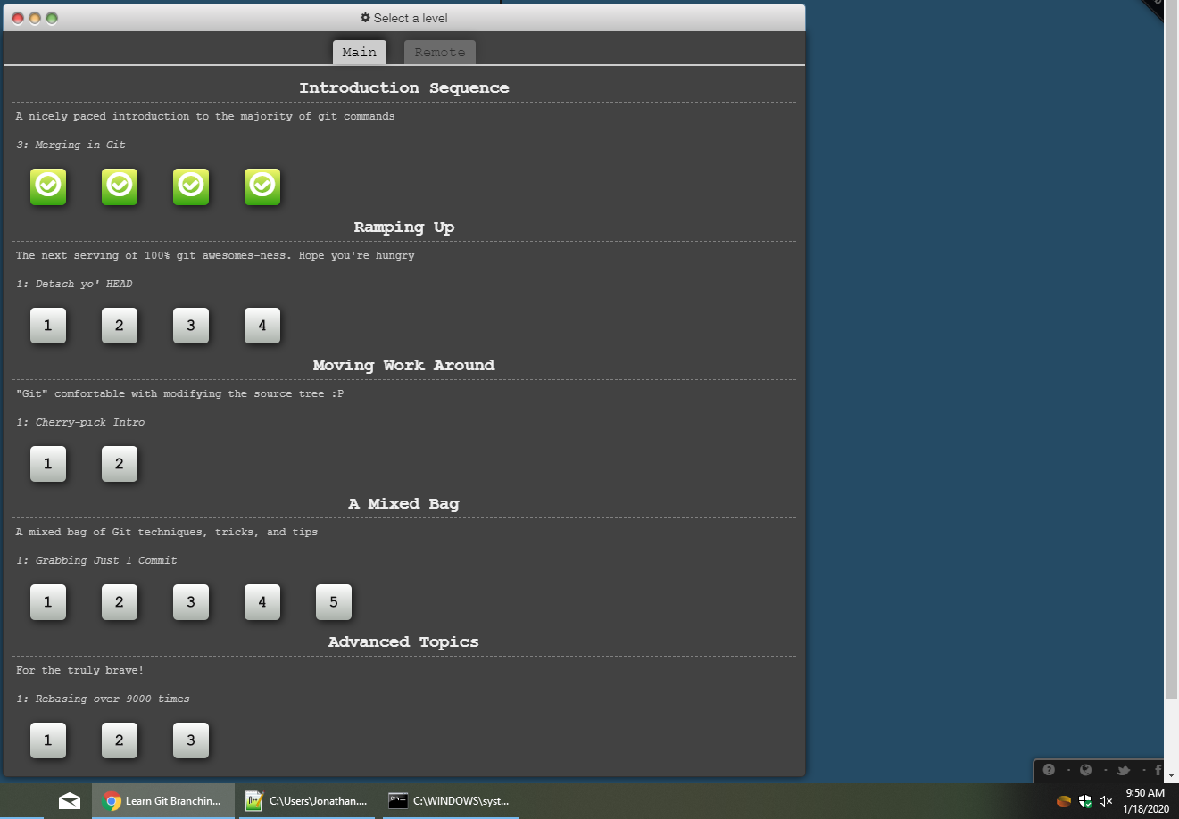

Jonathan Pulido 2133951 9:50am 18/1/2020

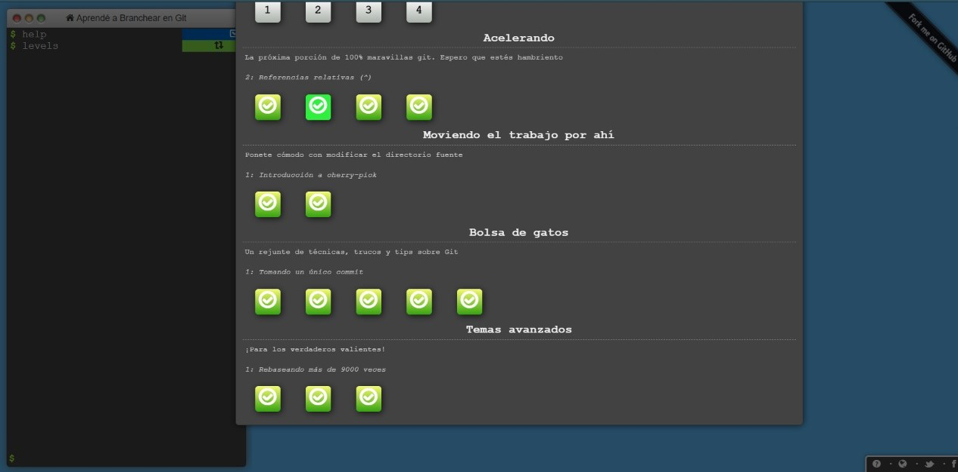

Jonathan Pulido 2133951 3:18pm 19/1/2020

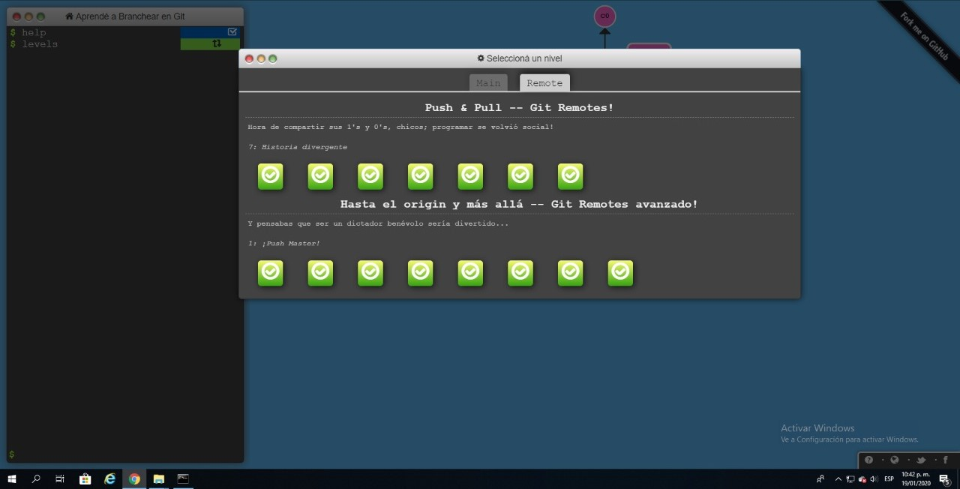

Jonathan Pulido 2133951 10:42pm 19/1/2020