Jose Luis Alvarez Pineda

19392

Laboratorio #03:

Ejercicio #01:

Tabla 01:

SOP: Y= (A´ B´ C´) + (A´ B C´) + (A B´ C´) + (A B´ C) + (A B C)

POS: Y= (A + B + C´) * (A + B´ +C´) * (A´ + B´ + C)

Tabla 02:

SOP: Y = (A´ B´ C) + (A B C´) + (A B C)

POS: Y = (A + B + C) * (A + B´+ C) * (A + B´+ C´) * (A´ + B + C) * (A´ + B + C´)

Tabla# 03:

SOP: Y = (A´ B´ C´ D´) + (A´ B´ C´ D) + (A´ B´ C D´) + (A´ B´ C D) + (A B´ C´ D´) + (A B´ C D´) + (A B C D´)

POS: Y = (A + B´ + C + D) * (A + B´ + C + D´) * (A + B´ + C´ + D) * (A + B´ + C´ + D´) * (A´ + B + C + D´) * (A´ + B + C´ + D´) * (A´ + B´ + C + D) * (A´ + B´ + C + D´) * (A´ + B´ + C´ + D´)

Tabla# 04:

SOP: Y = (A´ B´ C´ D´) + (A´ B´ C D´) + (A´ B´ C D) + (A´ B C D´) + (A´ B C D) + (A B´ C´ D´) + (A B´ C D´)

POS: Y = (A + B + C + D´) * (A + B´ + C + D) * (A + B´ + C + D´) * (A´ + B + C + D´) * (A´ + B + C´ + D´)

* (A´+ B´ + C + D) * (A´ + B´ + C + D´) * (A´ + B´ + C´ + D) * (A´ + B´ + C´ + D´)

Ejercicio #02:

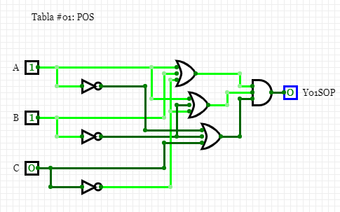

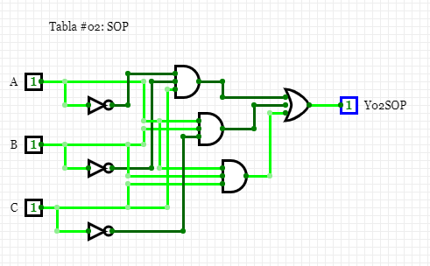

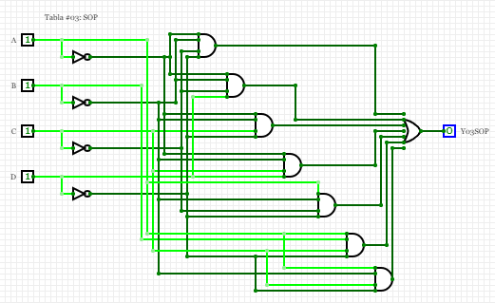

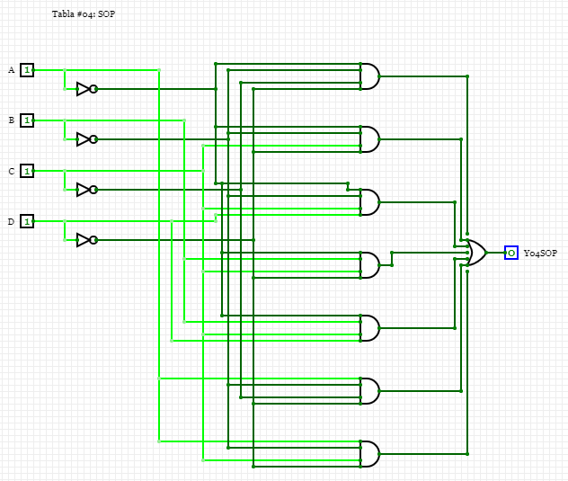

Link Ejercicio 03:

https://github.com/JoseLuisA-P/Laboratorio_03_dIgitales.git