Deber 3

Jose Luis Santillán
211496

grep MemTotal /proc/meminfo

MemTotal: 4020464 kB

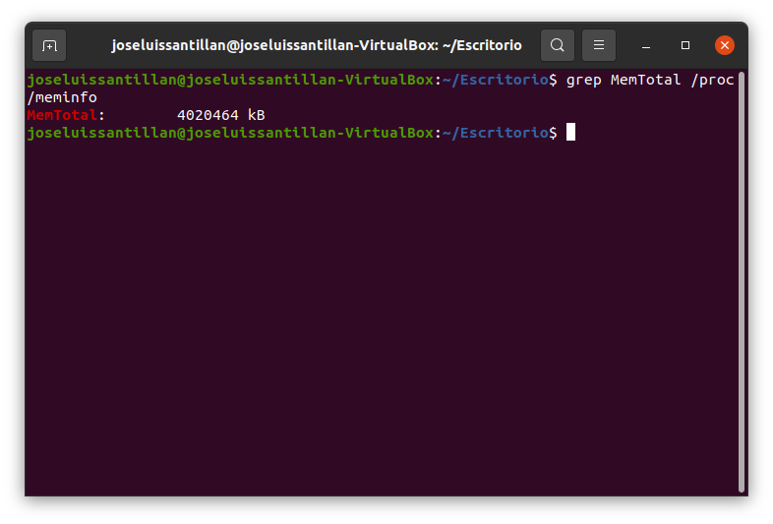

grep VmallocTotal /proc/meminfo

VmallocTotal: 34359738367 Kb

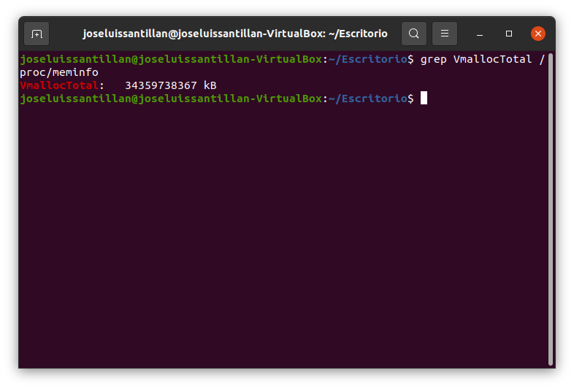

Top

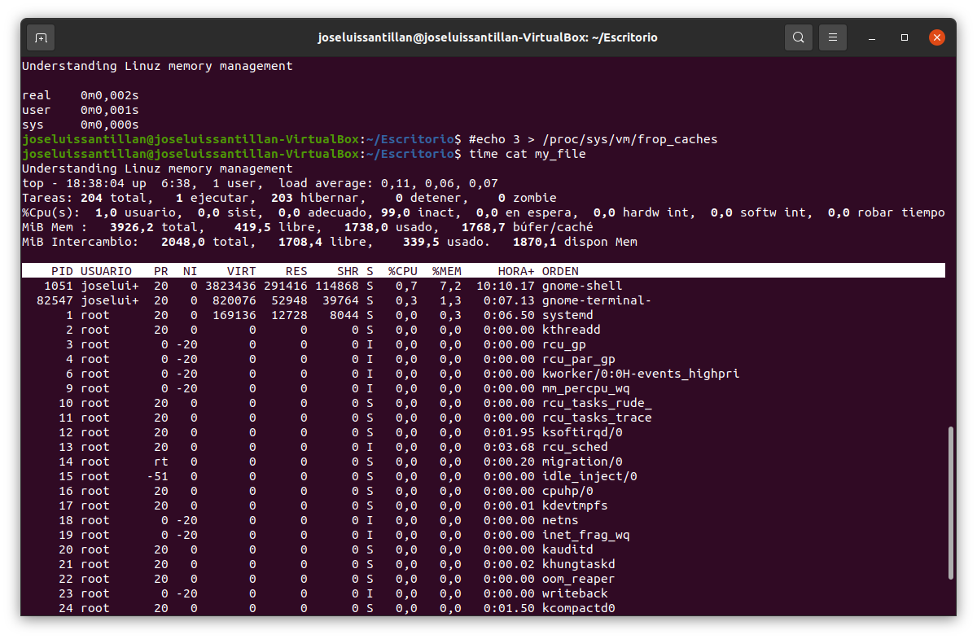

cat /proc/sys/vm/overcommit_memory
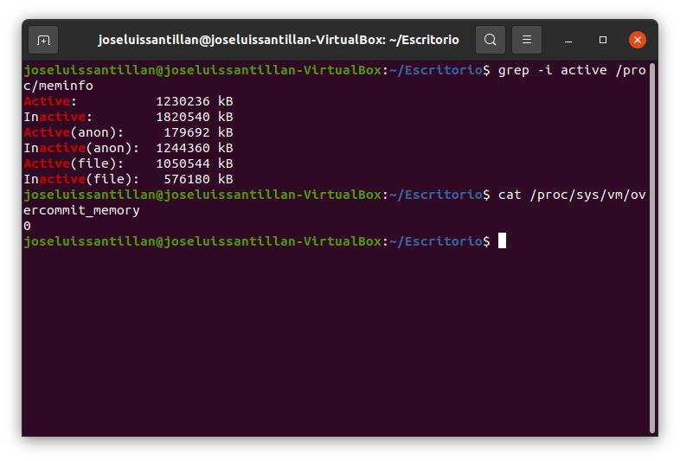

echo “Understanding Linuz memory management” > my_file

sync

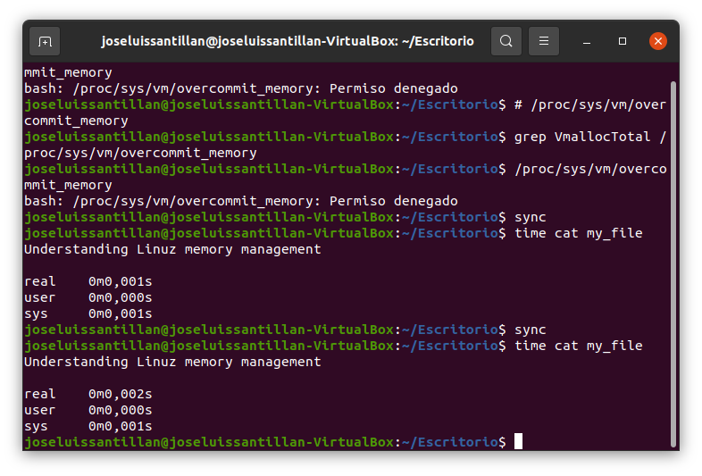

echo 3 > /proc/sys/vm/drop_caches

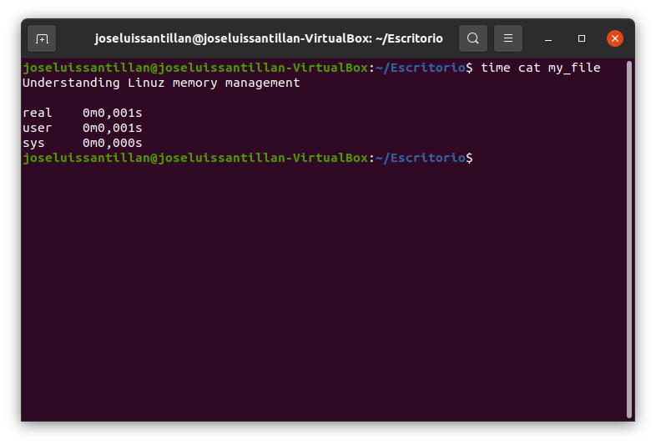

cat /proc/sys/vm/dirty_bytes
cat /proc/sys/vm/dirty_ratio
cat /proc/sys/vm/dirty_background_*
cat /proc/sys/vm/dirty_writeback_centisecs
cat /proc/sys/vm/dirty_expire_centisecs

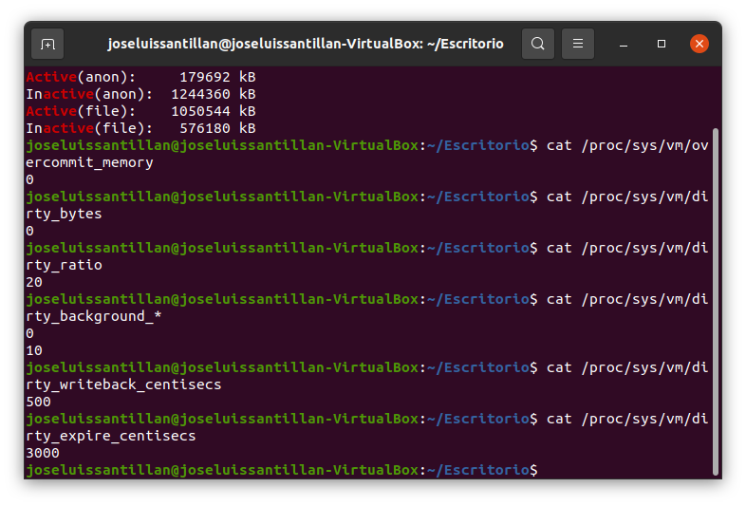

grep -i active /proc/meminfo

