Drilling and Ra/Rc

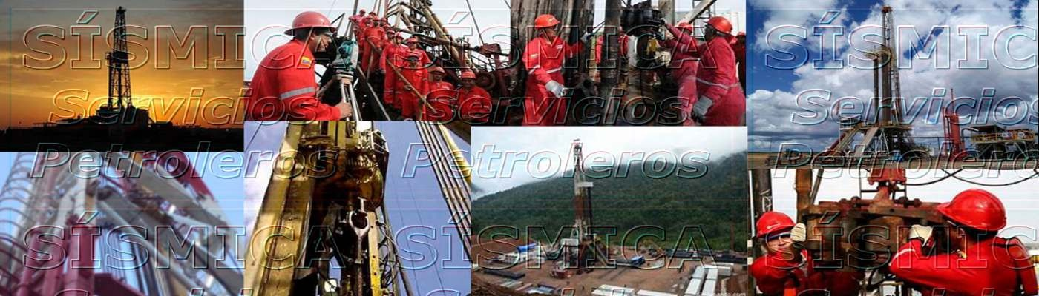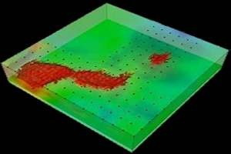

2D and 3D Seismic

We can perform 2D Seismic Data Capture and Processing, 3D Seismic Data Capture and Processing, Conventional Seismic and

Vibration Truck services.

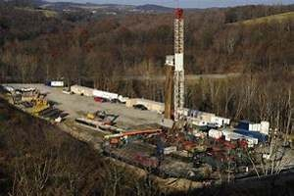

Drilling and Ra/Rc

We have at your disposal Original Drilling service of wells up to 22,000 feet of Depth Measurement and Rehabilitation and

Repair of Oil and Gas Wells in General.

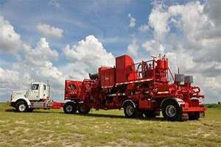

Cementation and Pumping

We provide Primary and Secondary Cementing services in Oil and Gas Wells, Well Abandonment, Fluid Displacement, Training

Integrity Tests (PIP), Grava Packaging.

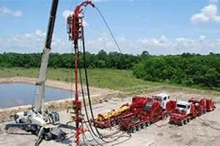

Coiled Tubing

Fishing Services, Stimulation, Isolation and Discharge Aid, Nitrogen Induction, Cementation and Canyoning, Pressure and

Temperature Records.

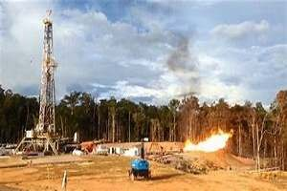

Well Testing

We test Back Pressure, Isocronal, Productivity index and Modified, Drawdown, Multirate, 2 Rates, Builtup, and Type Curve

Method.

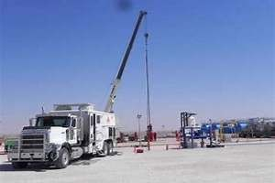

Wireline

Pipeline Check, Mechanical, Zone Change, Cleaning, Valve Redesign, BHT/BHP, Test Tool Placement, Opening and Closing of

Shirts and Fishing.

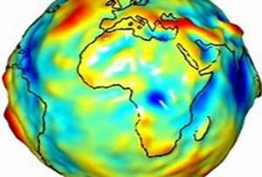

Geodesy and Topography

We provide Geodetic services, Topographic Survey, Location Rethink, Point Measurement with GNSS and DGNSS, Detecting

Buried Pipes, Opening Of Spades and Processing Geospatial Information.

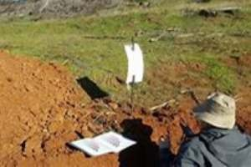

Soil Study

We provide services of Geotechnical and Soil Study, Drilling by Percussion and/or Rotation, Sampling, Physical-Chemical

Capture and Analysis, Metal Detection, Replanting and Testing for Sample Characteristics.

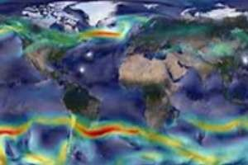

Metereology and Oceanography

We are in a position to provide services of Metereology and Oceanography, Bametries, Tracking, Environmental Base Lines, Piling, Line-Drawing and Whipping of Lake Structures.



Mission. The best service.

Providing specialized services of 2D and 3D Seismic, Coiled Tubing, Well Testing and Cleaning, Electric Guaya, Guaya Fina, Cementation and Pumping, and Drill Operation - Drilling, using equipment with Technology avant-garde, highly trained human talent, applying best practices and under quality standards, safety and in harmony with the environment, with the purpose of leveraging the production plans established by customers.

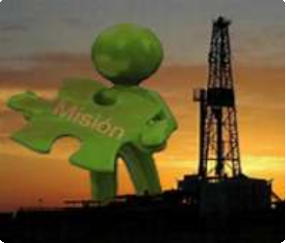

Vision. The Best Company.

To be a leading company at national and international level in the provision 2D and 3D Seismic Specialized Services, Coiled Well Testing, Guaya Electric, Guaya Fina, Cementation and Pumping, and Operation with Drill - Drilling, through the implementation of policies that allow the constant updating of technology and better rating of operational areas.

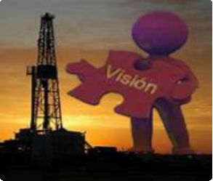

Values. Vocation of Service.

We are a team that has a high vocation of service with our Customers, we are committed to increasing equipment and machinery to improve the efficiency of our services, and increase their confidence in the organization. We respect the environment environment, diversity, freedom of thought, within established moral and legal parameters. We listen, we respect and we value the ideas and beliefs of collaborators, suppliers, government, community in general and stakeholders. We join efforts and knowledge to become increasingly

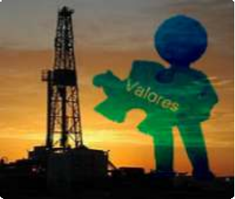

competitive and productive.



Privacy Policy Terms of Use Use of Cookies

Venezuela / RIF: J-41187461-2 / © - 2019