Lab & Activities Week 06 Agent Fundamentals

Integrantes:
José Martínez-02220131016

Institución: Universidad de Santander
Pregrado: Ingeniería de Sistemas
Docente: Jorge Galvis
17 de Septiembre 2026
Activity 1 · Warm-up Concept Quiz
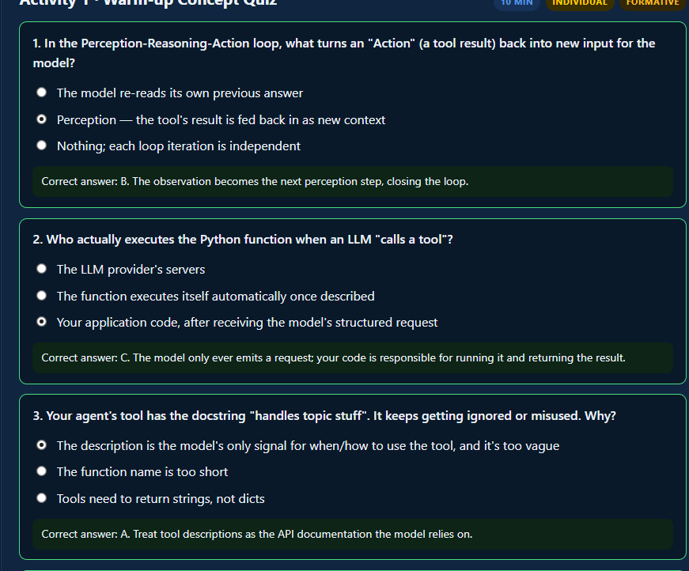
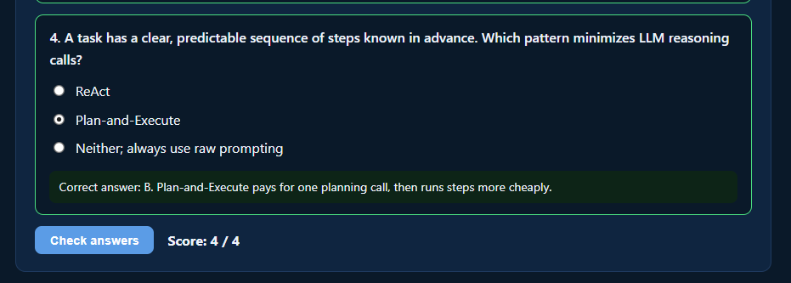
Activity 2 · Instructor-Led Live Coding
Followed the manual ReAct loop idea first (no separate content page file was in the repo, so I reconstructed it directly from the two tools in agent.py/app.py), then intentionally tried to break a tool exactly as suggested, before running both runnable apps.
Breaking a tool on purpose
First attempt: renamed the estimate_study_hours function to estimate_hours in the tools list, but left the OLD name ("estimate_study_hours") in the system instruction text -- the classic "renamed it, forgot a call site" bug the activity describes.
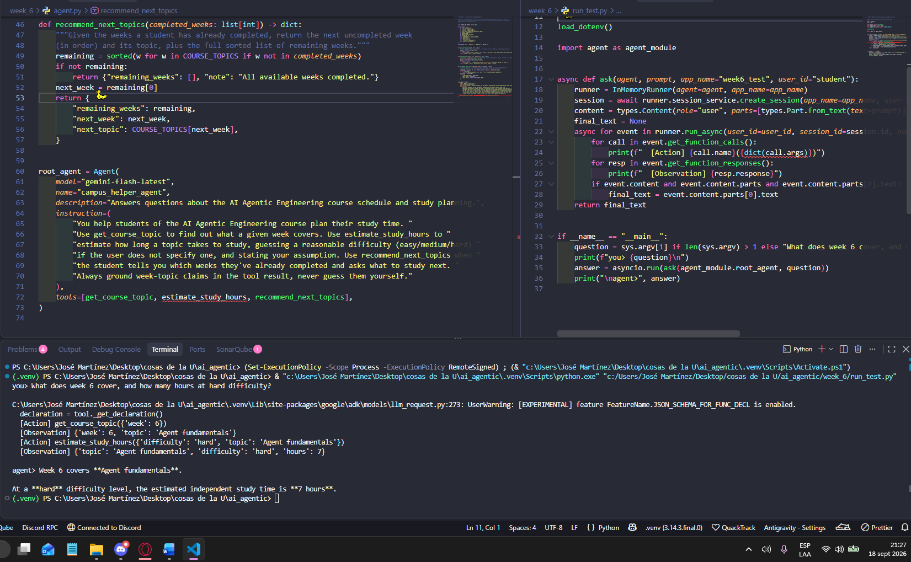
This did NOT break anything -- the model correctly called estimate_hours (the real, current tool), completely ignoring the stale name in the instruction text. ADK only ever exposes the tool's real, introspected name/schema to the model, so a rename that's inconsistent only in prose is harmless dead text, never a runtime bug.
Second attempt, a genuine break: left the tool's registered name alone, but broke its INTERNAL body instead -- one line inside estimate_study_hours references STUDY_HOURS_TABLE_RENAMED, a name that doesn't exist (the real table is still called STUDY_HOURS_TABLE). This is what "renamed it, forgot a call site" actually looks like as a real Python bug.
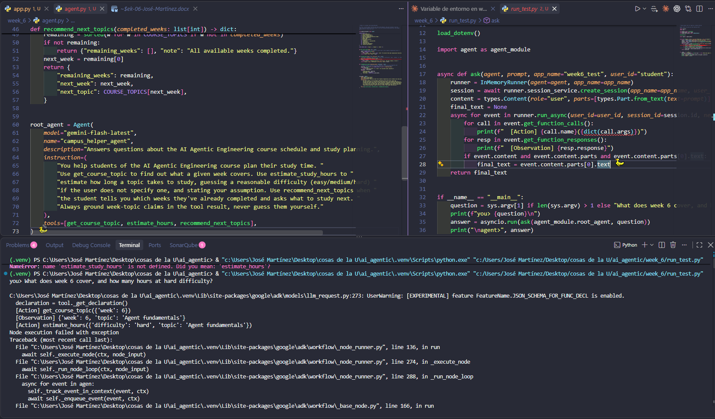
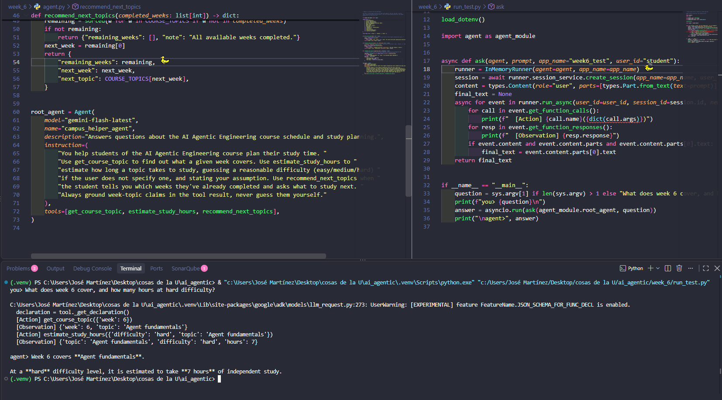
Neither framework turns an unhandled exception inside a tool into a graceful "Observation: error, please retry" -- both just crash the entire run with the raw traceback. The self-correction the activity describes only happens if the tool itself catches the exception and returns a structured error dict (e.g. {"error": "..."}) -- that translation is the tool author's job, not something either framework does automatically. Full detail in week_6/NOTES.md.
Running the two runnable apps
adk/campus_helper_agent (via InMemoryRunner, same pattern used in Weeks 2-4) and langgraph/app.py (create_react_agent), both asked "How is Corte 2 graded?"-style logistics questions, worked as expected end to end -- full traces are in Activity 4, where the same two apps are exercised with the new third tool added.

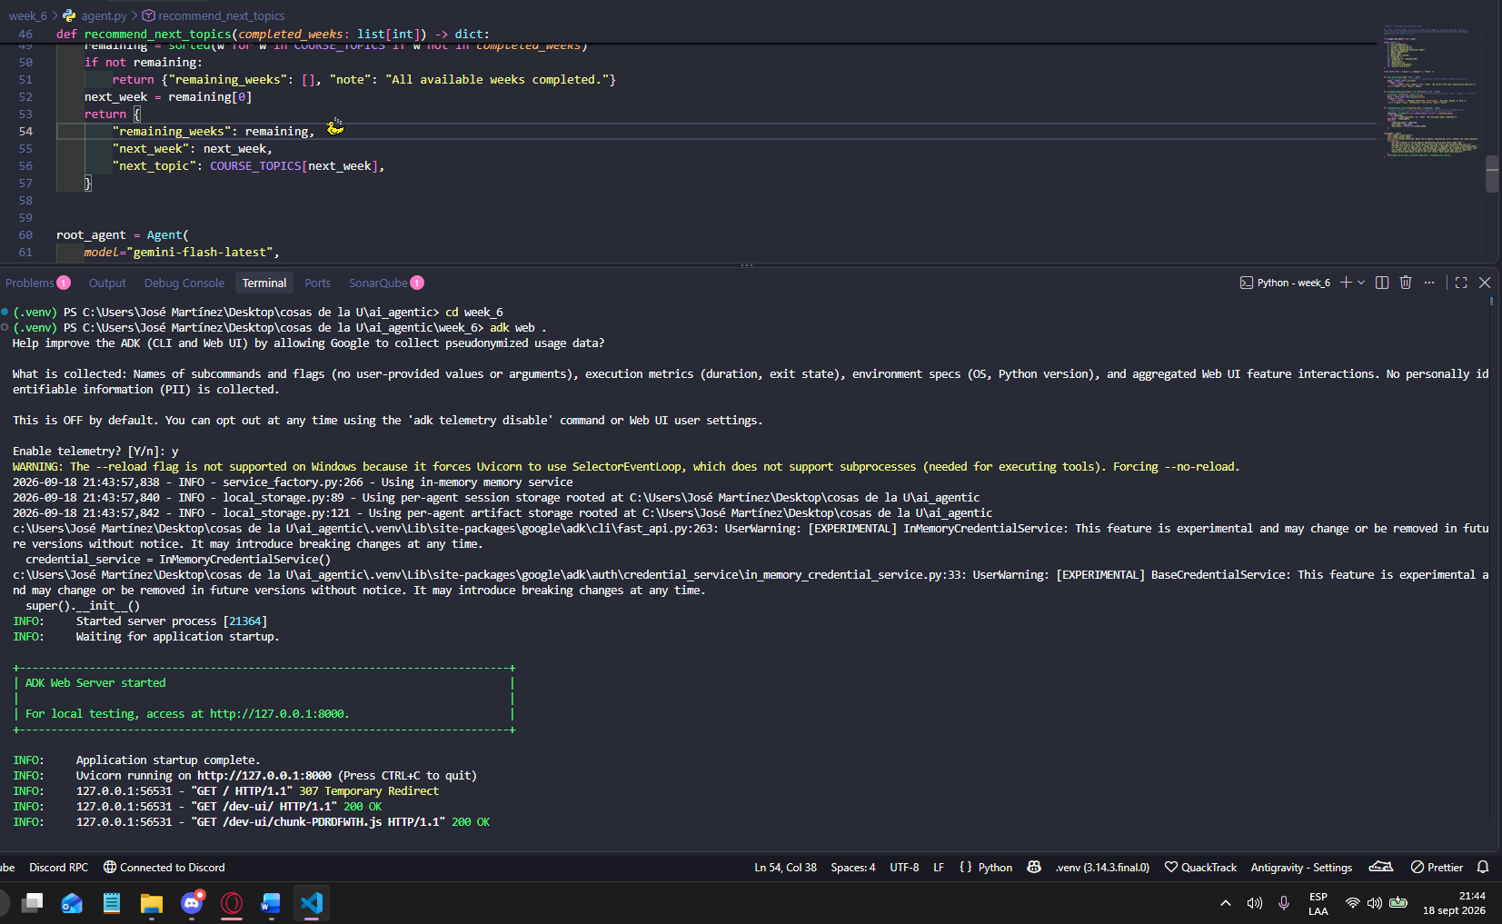
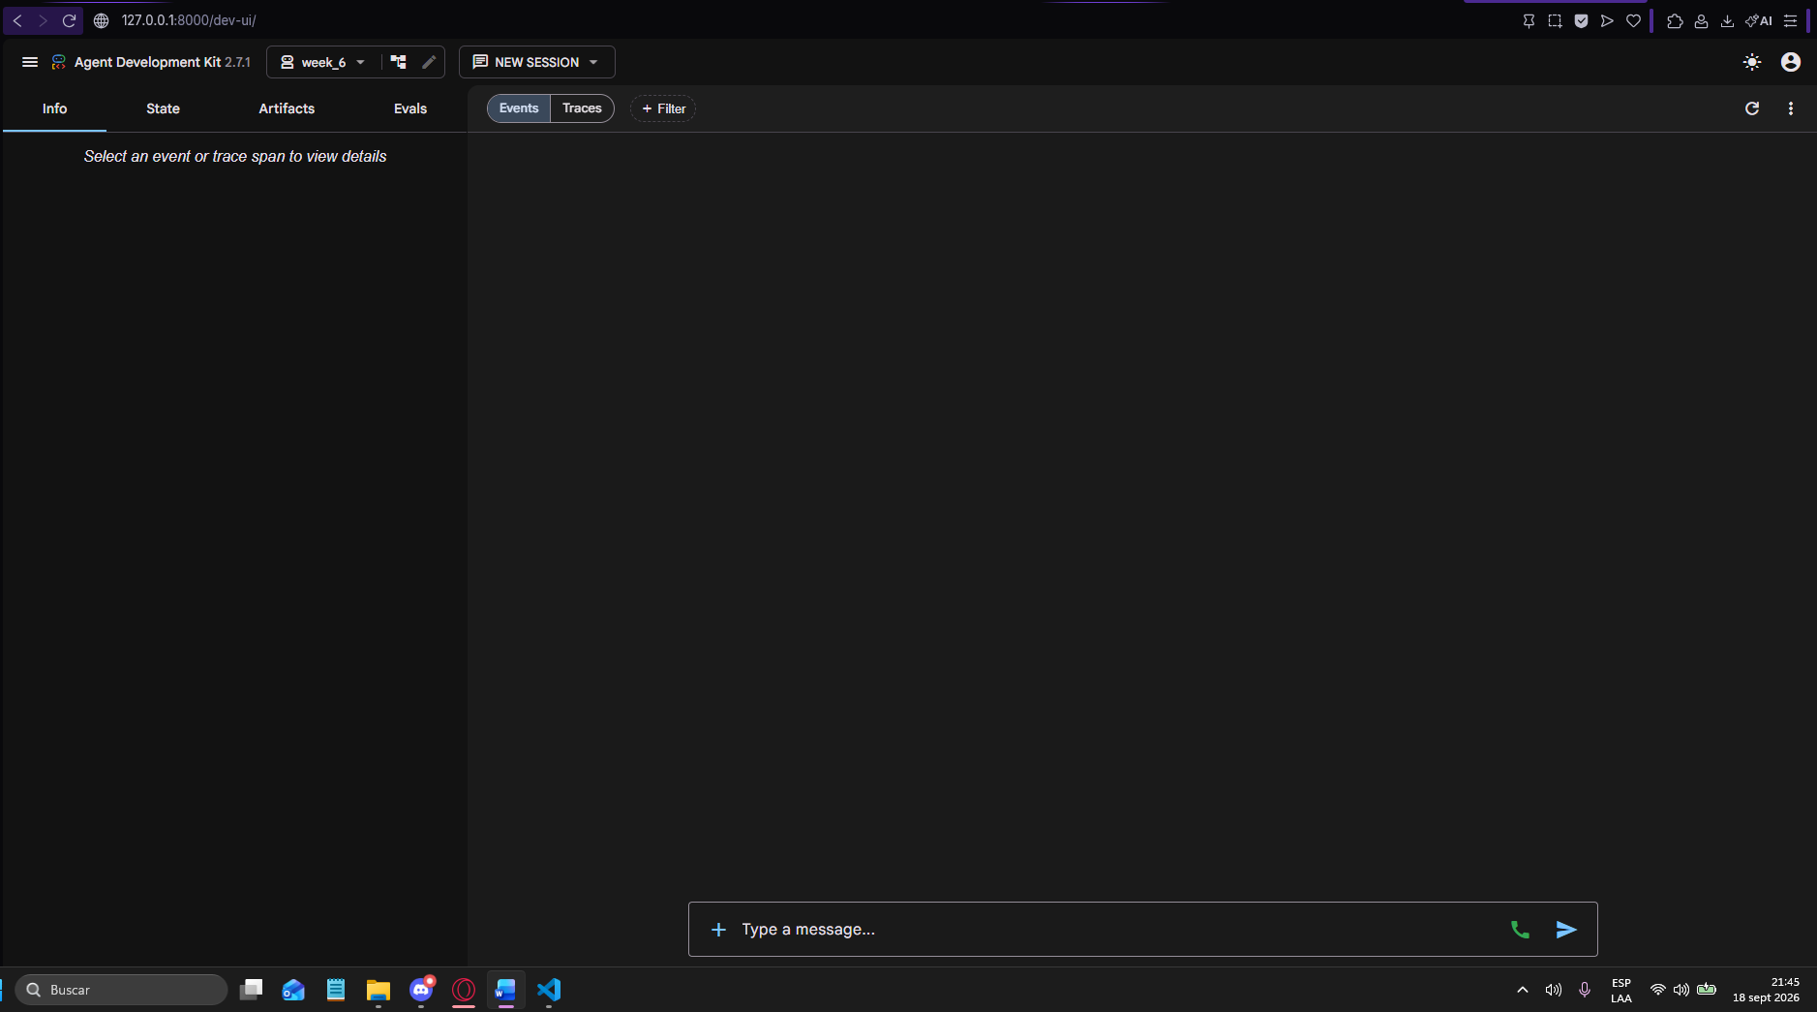
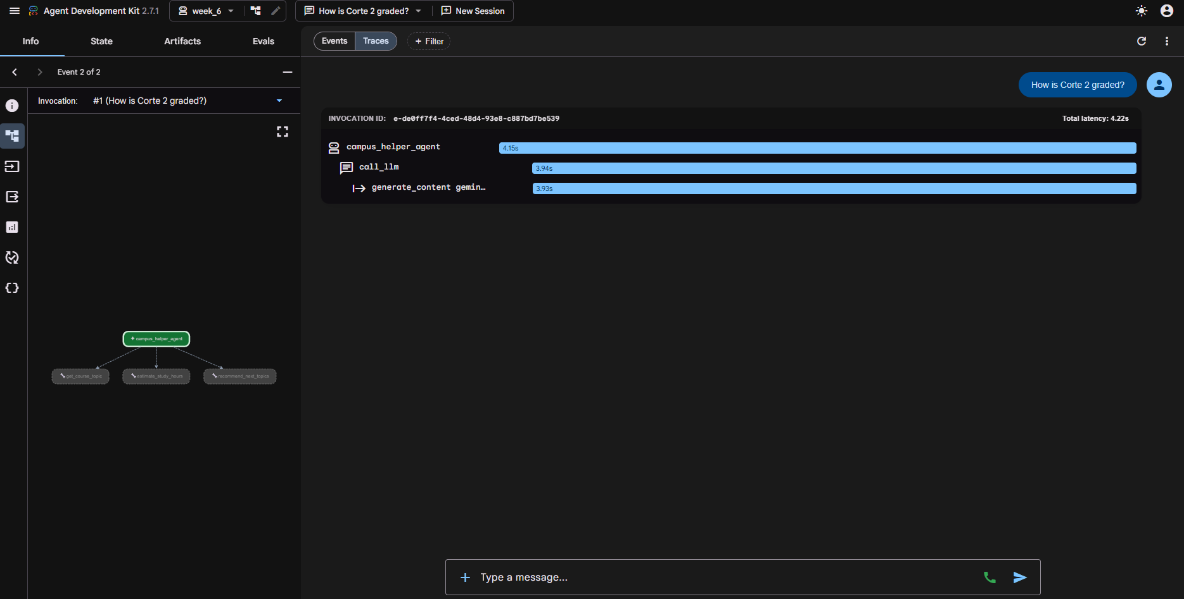
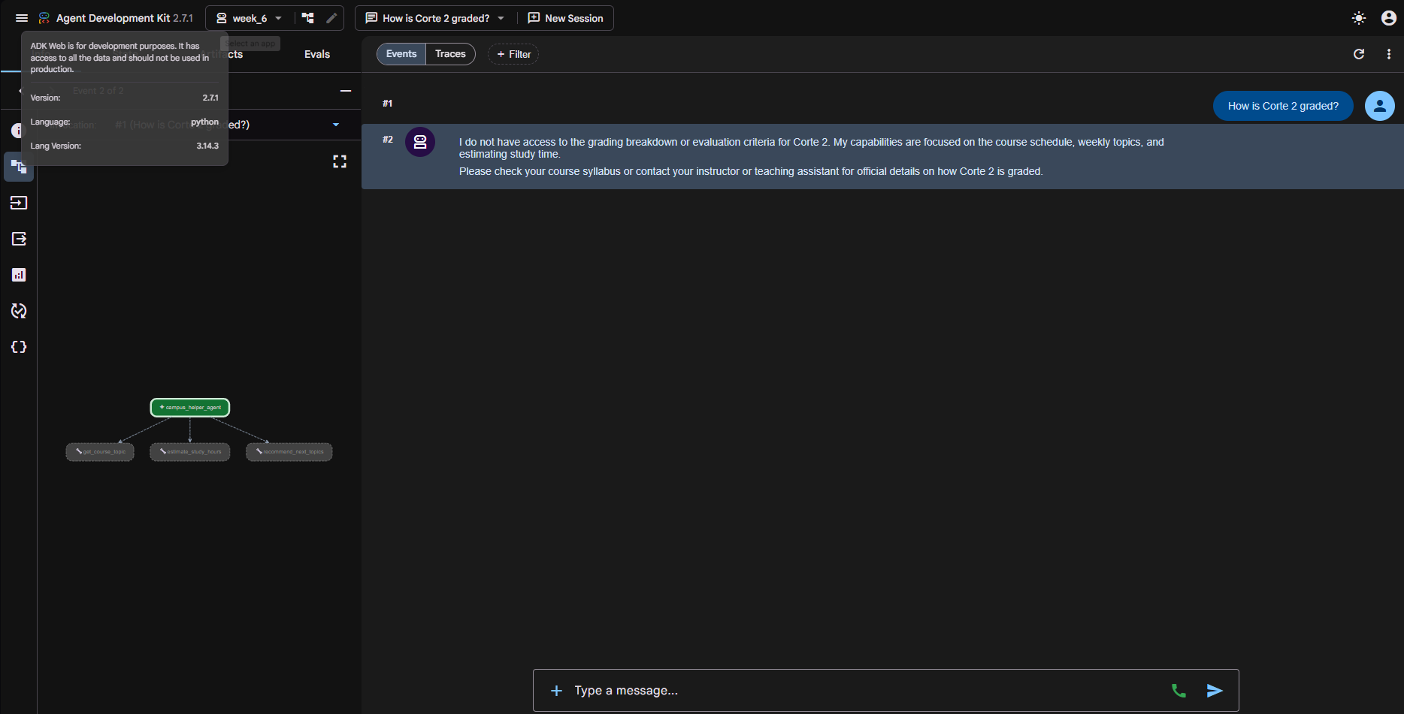
On terminal
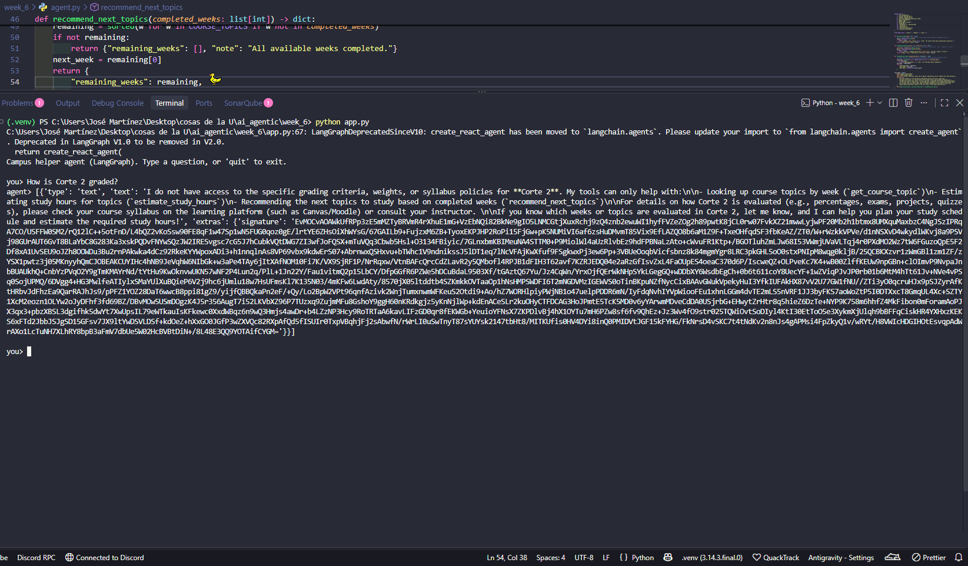
Activity 3 · Group Workshop: Trace a ReAct Run by Hand
No group was available, so I traced the scenario individually: "How many total study hours should I budget for weeks 6 through 8, and which one is hardest?" (difficulty not given).
1. Full trace
Thought: I need the topic for weeks 6, 7 and 8 before I can estimate study hours.
Action: get_course_topic(week=6)
Observation: {"week": 6, "topic": "Agent fundamentals"}
Action: get_course_topic(week=7)
Observation: {"week": 7, "topic": "Google ADK"}
Action: get_course_topic(week=8)
Observation: {"week": 8, "topic": "Multi-agent systems"}
Thought: Difficulty wasn't given. I'll assume "medium" for all three and say so.
Action: estimate_study_hours(topic="Agent fundamentals", difficulty="medium")
Observation: {"topic": "Agent fundamentals", "difficulty": "medium", "hours": 4}
Action: estimate_study_hours(topic="Google ADK", difficulty="medium")
Observation: {"topic": "Google ADK", "difficulty": "medium", "hours": 4}
Action: estimate_study_hours(topic="Multi-agent systems", difficulty="medium")
Observation: {"topic": "Multi-agent systems", "difficulty": "medium", "hours": 4}
Final answer: Assuming medium difficulty for all three (none was specified), budget
about 12 hours total (4 each) for weeks 6-8. The tools can't actually tell you which
one is "hardest" -- estimate_study_hours only returns a number for the difficulty
you hand it, so guessing the same difficulty for all three makes them tie by
construction. Answering "which is hardest" honestly would require asking the user
to rate each topic's difficulty individually, not guessing one value for all three.

2. A shortcut without losing correctness
The three get_course_topic calls are fully independent of each other (none needs another's result), so they don't have to be issued one at a time -- they can be batched into the same reasoning step. This isn't hypothetical: it's exactly what was observed empirically in Activity 4, where both ADK and LangGraph issued two independent tool calls together in a single step rather than strictly serially.
3. Where ReAct's step-by-step nature helps
If one of the three weeks were invalid (say, week 5 or week 11 -- no lecture that week), get_course_topic would come back with topic: null and a note instead of a real topic. A rigid upfront plan would have already committed to calling estimate_study_hours(topic=None, ...) before ever seeing that result. ReAct's loop lets the agent see each Observation before deciding the next Action, so it can skip estimating hours for a week that doesn't exist instead of blindly executing a fixed 6-step plan.
Activity 4 · Individual Lab: Add a Tool, Both Ways
Added recommend_next_topics(completed_weeks: list[int]) -> dict to both agent.py (ADK) and app.py (LangGraph) -- given the weeks a student already finished, it returns the next uncompleted week and its topic. Chosen because it chains naturally with estimate_study_hours (and, in one test, with get_course_topic too), which the activity requires.
def recommend_next_topics(completed_weeks: list[int]) -> dict:
"""Given the weeks a student has already completed, return the next
uncompleted week (in order) and its topic, plus the full sorted list
of remaining weeks."""
remaining = sorted(w for w in COURSE_TOPICS if w not in completed_weeks)
if not remaining:
return {"remaining_weeks": [], "note": "All available weeks completed."}
next_week = remaining[0]
return {
"remaining_weeks": remaining,
"next_week": next_week,
"next_topic": COURSE_TOPICS[next_week],
}

3 test prompts, run for real on both frameworks
Prompt 1: I've completed weeks 1 through 4. What should I study next, and how many hours should I budget if it's a hard topic?
ADK:
[Action] recommend_next_topics({'completed_weeks': [1, 2, 3, 4]})
[Observation] {'remaining_weeks': [6, 7, 8, 9, 10, 12, 13, 14, 15], 'next_week': 6, 'next_topic': 'Agent fundamentals'}
[Action] estimate_study_hours({'topic': 'Agent fundamentals', 'difficulty': 'hard'})
[Observation] {'topic': 'Agent fundamentals', 'difficulty': 'hard', 'hours': 7}
[Final] Next up is Week 6 (Agent fundamentals). At hard difficulty, budget ~7 hours.

LangGraph:
[Action] recommend_next_topics({'completed_weeks': [1, 2, 3, 4]})
[Observation] {"remaining_weeks": [6,7,8,9,10,12,13,14,15], "next_week": 6, "next_topic": "Agent fundamentals"}
[Action] estimate_study_hours({'difficulty': 'hard', 'topic': 'Agent fundamentals'})
[Observation] {"topic": "Agent fundamentals", "difficulty": "hard", "hours": 7}
[Final] Same content, wrapped in LangChain's block-list format (see NOTES.md).

Prompt 2: What does week 9 cover, and how many hours should I budget for it at medium difficulty?
ADK:
[Action] get_course_topic({'week': 9})
[Observation] {'week': 9, 'topic': 'LangGraph I'}
[Action] estimate_study_hours({'topic': 'LangGraph I', 'difficulty': 'medium'})
[Observation] {'topic': 'LangGraph I', 'difficulty': 'medium', 'hours': 4}
[Final] Week 9 covers LangGraph I. At medium difficulty, budget ~4 hours.

LangGraph:
[Action] get_course_topic({'week': 9})
[Observation] {"week": 9, "topic": "LangGraph I"}
[Action] estimate_study_hours({'difficulty': 'medium', 'topic': 'LangGraph I'})
[Observation] {"topic": "LangGraph I", "difficulty": "medium", "hours": 4}
[Final] Same content as ADK, again wrapped in the block-list format.

Prompt 3: I've completed weeks 1, 2, 3, 4, 6, and 7. What's next, what does the week after that cover, and how many hours should the next one take at easy difficulty?
ADK:
[Action] recommend_next_topics({'completed_weeks': [1, 2, 3, 4, 6, 7]})
[Observation] {'remaining_weeks': [8,9,10,12,13,14,15], 'next_week': 8, 'next_topic': 'Multi-agent systems'}
[Action] get_course_topic({'week': 9})
[Action] estimate_study_hours({'topic': 'Multi-agent systems', 'difficulty': 'easy'})
[Observation] {'week': 9, 'topic': 'LangGraph I'}
[Observation] {'topic': 'Multi-agent systems', 'difficulty': 'easy', 'hours': 2}
[Final] Next: Week 8 (Multi-agent systems). Then: Week 9 (LangGraph I). Easy-difficulty
estimate for Week 8: ~2 hours.

LangGraph:
[Action] recommend_next_topics({'completed_weeks': [1, 2, 3, 4, 6, 7]})
[Observation] {"remaining_weeks": [8,9,10,12,13,14,15], "next_week": 8, "next_topic": "Multi-agent systems"}
[Action] get_course_topic({'week': 9})
[Action] estimate_study_hours({'topic': 'Multi-agent systems', 'difficulty': 'easy'})
[Observation] {"week": 9, "topic": "LangGraph I"}
[Observation] {"topic": "Multi-agent systems", "difficulty": "easy", "hours": 2}
[Final] Same content as ADK. Note: get_course_topic and estimate_study_hours were
issued together in the same step by BOTH frameworks -- see NOTES.md.

NOTES.md — behavioral difference observed
Full write-up committed as week_6/NOTES.md. Summary: (1) ADK's final answer is a clean plain string; LangGraph/ChatGoogleGenerativeAI wraps it in a block-list structure with a 'signature' field, same wrapper difference already seen since Week 1/2 -- not agent-specific, just how that library represents any response. (2) Both frameworks parallelize independent tool calls in the same reasoning step rather than forcing one-at-a-time. (3) Both frameworks crash outright on an unhandled exception inside a tool body, instead of turning it into an error observation -- see Activity 2.

Activity 6 · Corte 2 Project: Pick Your Problem
For Corte 2, the plan is to extend Cubik-Lite into a multi-agent system (built with Google ADK or LangGraph) that keeps solving the same real problem — grounded calculus tutoring — but splits the work across specialized agents instead of one monolithic prompt. A triage ageny would first classify the student's input (theory question vs. worked exercise, and which technique it likely involves) and route it accordingly; one or more solver/specialist agents would then handle the actual step-by-step resolution for their assigned technique (substitution, integration by parts, partial fractions, etc.), pulling grounding context from the existing RAG pipeline over `data/`. This split lets each agent carry a narrower, technique-specific prompt instead of one system prompt trying to cover every case, and leaves room to add a verification role later. This will be refined once multi-agent patterns are covered in Week 8.

This description is submitting to the proyect to work on the future. This is the link of the Pull Request to merge: https://github.com/JulianGuardian/Cubik-Lite/pull/5/changes

