Lab & Activities Week 07 Google ADK

Integrantes:
José Martínez-02220131016

Institución: Universidad de Santander
Pregrado: Ingeniería Se Sistemas
Docente: Jorge Galvis
03 de Octubre 2026

Activity 1
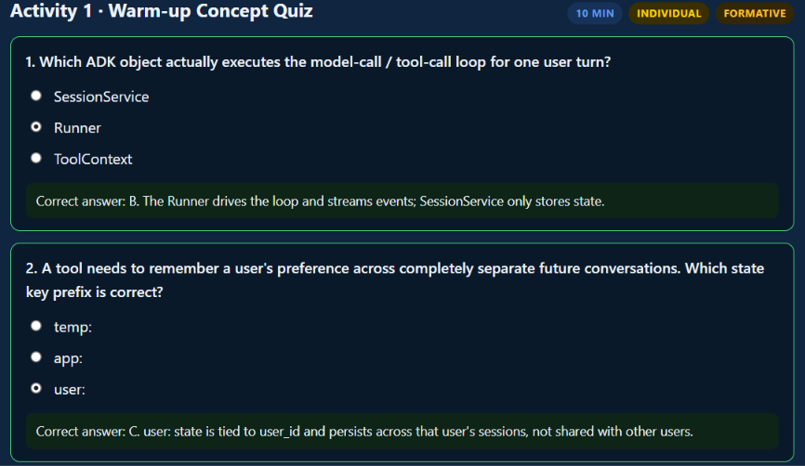
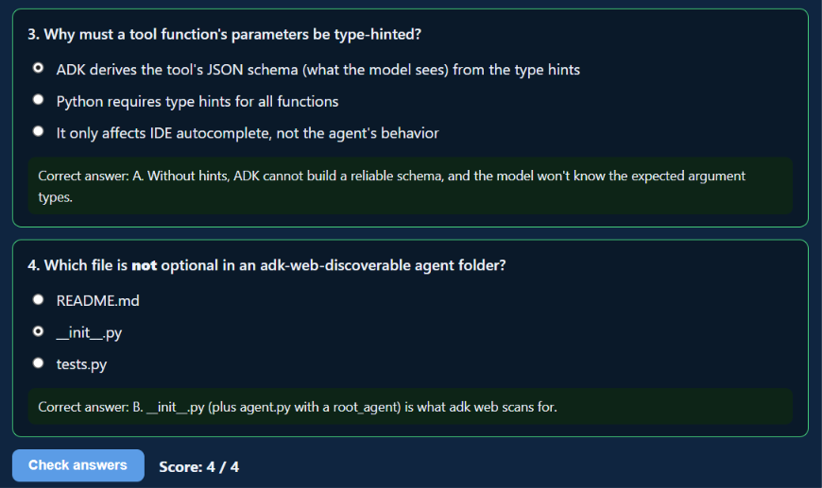

Activity 2
Built agents/week-07-google-adk/adk/study_planner_agent/ live, from an empty folder, following Section 4 of the content page: added set_preferred_pace, log_study_session, and get_study_summary one tool at a time, testing each in adk web before adding the next.
Confirmed state scoping end to end: after setting a pace and logging a session, started a brand-new session with the same user_id. user:preferred_pace carried over into the new session exactly as expected, while session_log came back empty -- matching each key's real scope lifetime.
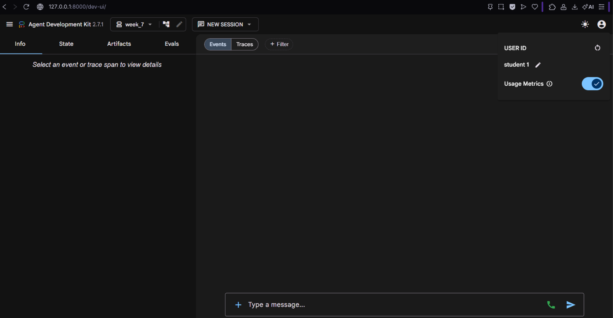
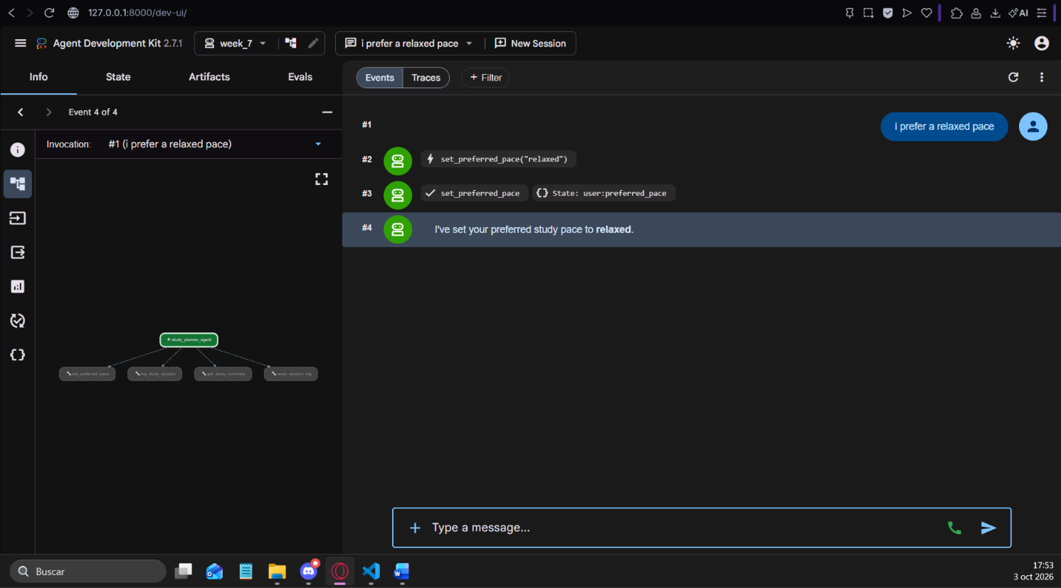
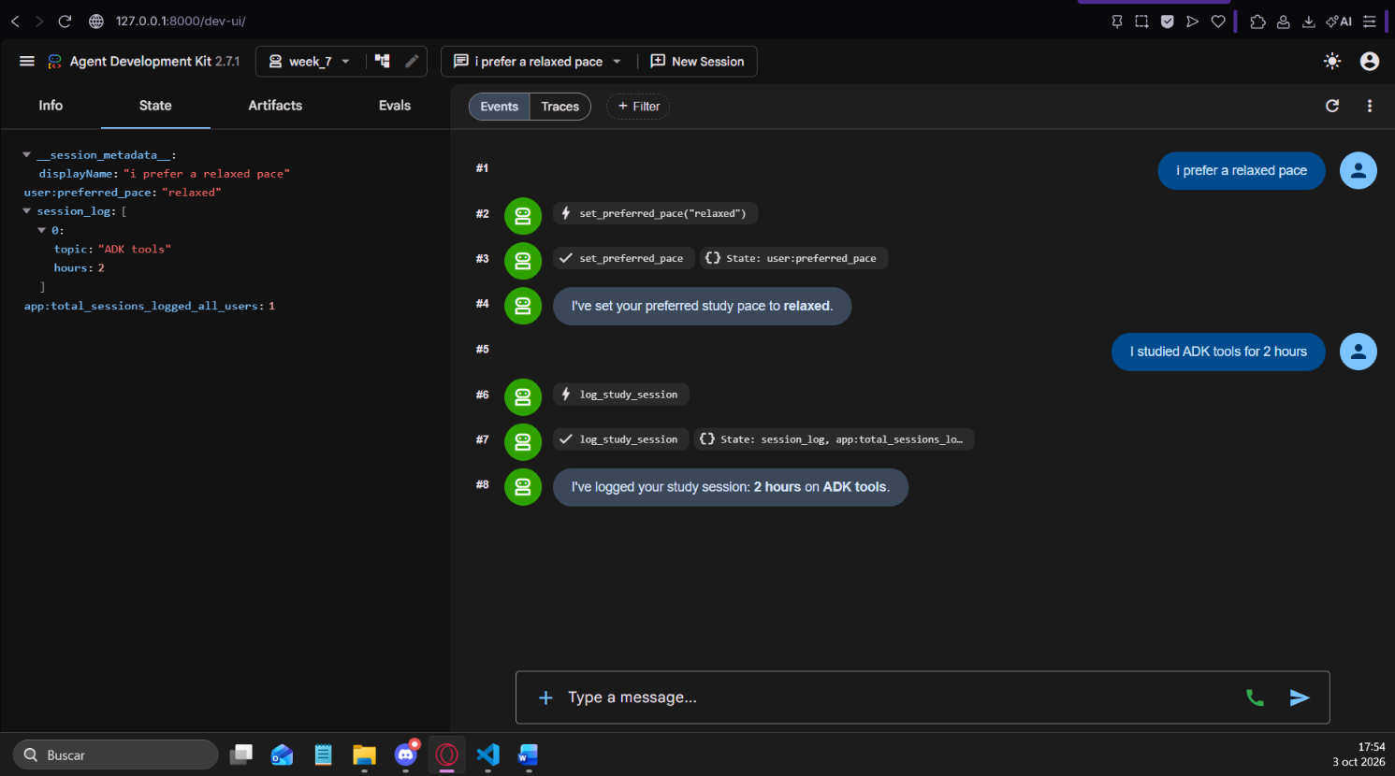
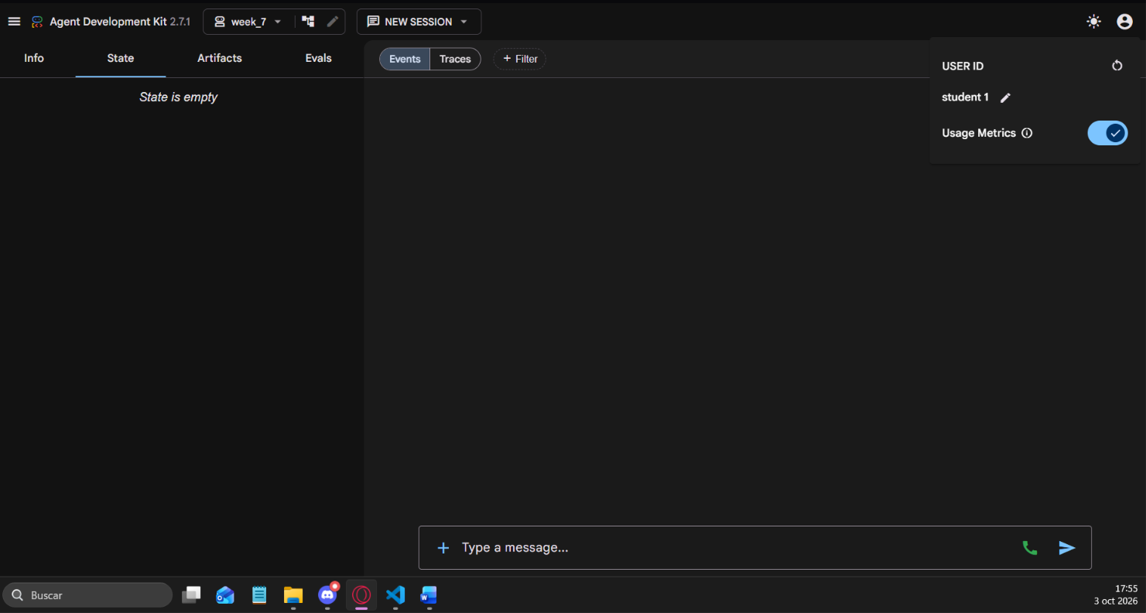
Discussed why langchain/app.py's "memory" is three plain Python dicts (user_state, app_state, session_state) instead of real scoped session state: LangChain itself has no built-in equivalent to ADK's ToolContext.state. That is an honest simplification for this stage of the course, not a framework limitation -- the real analog is LangGraph's checkpointer, covered in Week 9.

Activity 3
No group was available for this session, so the four scope-assignment cases below were worked through individually.
1. The user's preferred UI language -> user: scope. It is a personal preference tied to that user_id and must follow the user into every future session, not reset each conversation or leak to other users.
2. A raw API response a tool needs to pass to another tool call two steps later, within the same turn -> temp: scope. It only needs to exist for the rest of this one turn's tool-call chain; it should not survive into the next turn, let alone the next session.
3. The number of currently active free-tier API quota units remaining today, shared by all users -> app: scope. It is a single counter owned by the application as a whole, not by any individual user or session.
4. Which documents the user uploaded in this conversation for RAG (Week 4 recap) -> no prefix (session scope). It must survive every turn of the current conversation, which rules out temp:, but it should not follow the user into a brand-new session the way user: would.
The most debatable case is #4: temp: looks tempting because the data is conversation-scoped and not permanent, but temp: is explicitly turn-only in ADK, so a no-prefix session key is the correct match for something that must outlive a single turn but not the whole conversation history.

Activity 4
Added a fourth tool, reset_session_log(tool_context), to agents/week-07-google-adk/adk/study_planner_agent/agent.py. It clears only tool_context.state["session_log"] for the current session, leaving user:preferred_pace and the app:total_sessions_logged_all_users counter completely untouched.
The app:-scoped counter, app:total_sessions_logged_all_users, was already being incremented inside log_study_session from the live-coding build (Activity 2); get_study_summary reports it alongside the per-conversation totals.
Reproduced reset_session_log in langchain/app.py's simplified session_state dict, with an inline code comment noting it stands in for ADK's session-scoped tool_context.state["session_log"] reset; the existing app_state increment inside log_study_session is likewise commented as the stand-in for ADK's app: scope.
