Lab & Activities Week 08 multi-agent-systems

Integrantes:
José Martínez-02220131016

Institución: Universidad de Santander
Pregrado: Ingeniería Se Sistemas
Docente: Jorge Galvis
03 de Octubre 2026

Activity 1
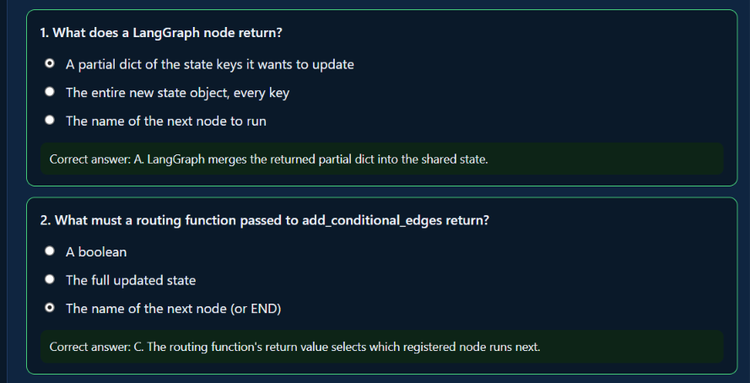
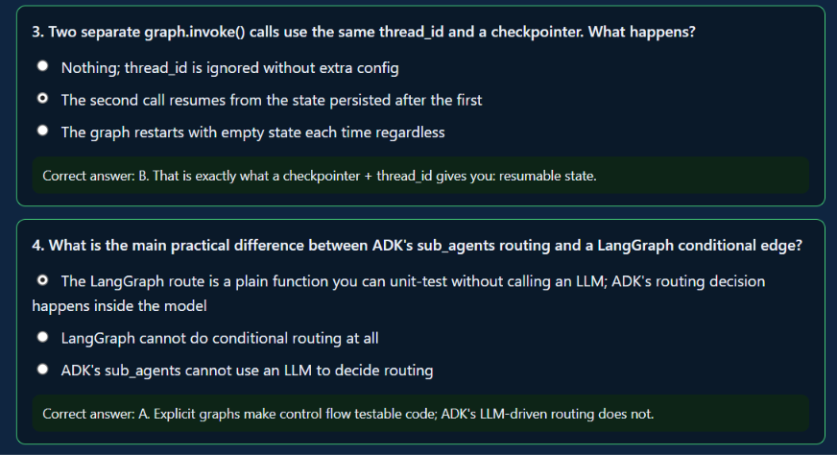

Activity 2
Ran week_9/app.py's routing StateGraph (classify -> research_node / planner_node / both_node -> respond, with an InMemorySaver checkpointer) from the terminal, sending two questions in the same session (same thread_id) and then using the CLI's /state command to print the persisted state.
Then ran week_9/agent.py's SequentialAgent (research_agent -> planner_agent, chained through output_key) with the compound question "What does week 9 cover, and how many study hours should I budget if it's hard?".
SequentialAgent's fixed order showed its limitation here: research_agent runs first and, even though it has no study-hours tool at all, answered the whole compound question anyway -- hallucinating "10 to 15 hours" out of thin air. planner_agent then ran next (because the pipeline order is fixed, not because anything routed to it) and gave the correct, tool-backed answer (7 hours), which became the pipeline's final output since it is last in sequence. The LangGraph version cannot have this failure mode: classify_node's single routing decision sends the question to exactly one of research_node/planner_node/both_node, so there is no earlier node left free to improvise an answer outside its own tool.
On "which one was easier to test without an LLM call": route_after_classify in the LangGraph graph is a plain function (state["route"] in, that same string out) that test_routing.py asserts on with zero network calls (Activity 4). ADK's SequentialAgent has no equivalent to unit-test: its only "routing" is the fixed order baked into sub_agents=[...], and whether a given step calls its tool correctly is a property of the LLM call itself, not of any testable Python function.
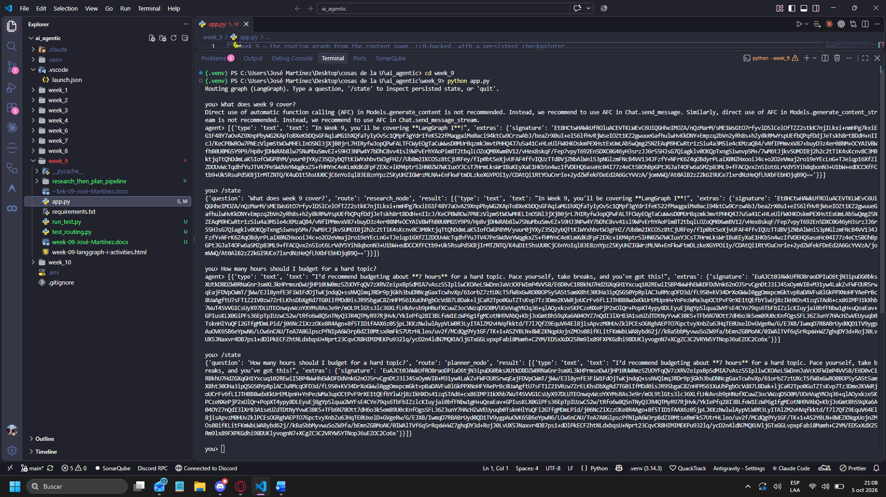
[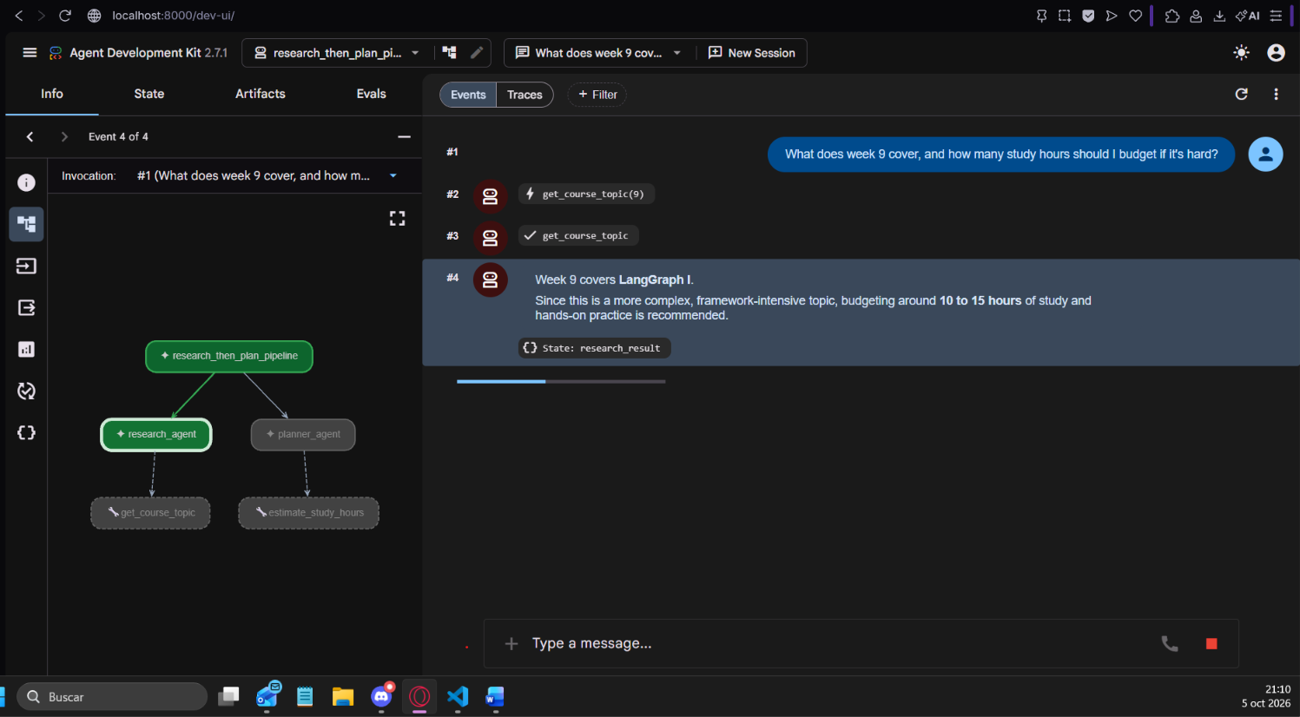
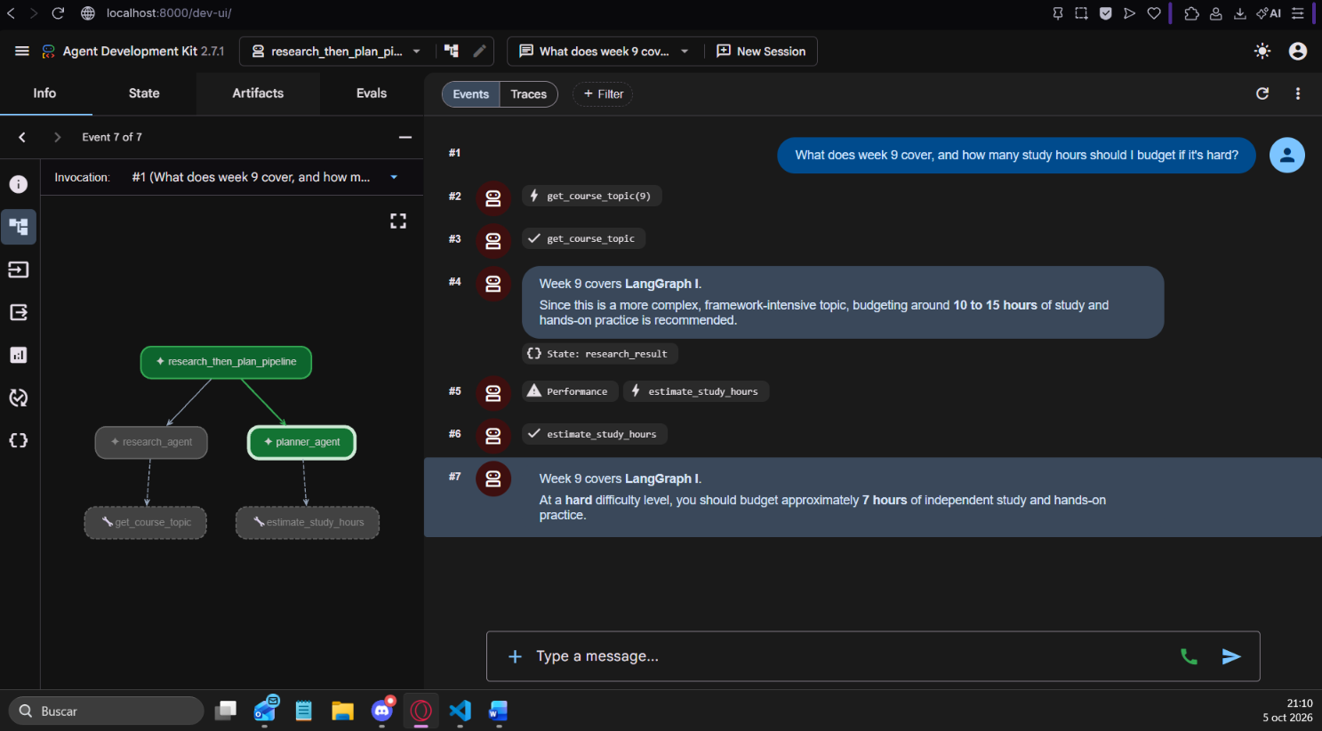

Activity 4
Added a fourth route, clarify_node, to app.py: extended RouteDecision's Literal to include "clarify_node", updated classify_node's prompt to pick it when the question is too vague for the other three, added clarify_node itself (returns a clarifying question as its result), registered it as a graph node, and wired its edge into respond exactly like the other three workers.
Moved route_after_classify out of build_graph()'s closure to module level, since it is the one piece the activity asks to unit-test without any LLM call -- it is a pure function (just forwards state["route"]), so it does not need the graph or the LLM client to exist to be tested.
test_routing.py asserts route_after_classify forwards all four branches correctly, called directly with four hand-built state dicts -- no graph build, no API key, no network call:
$ python test_routing.py
OK -- route_after_classify correctly forwards all 4 branches: ['research_node', 'planner_node', 'both_node', 'clarify_node']
Confirmed state persistence with run_test.py, run for real against the live graph (GOOGLE_API_KEY, two separate thread_ids):
Thread A, invoke 1 ("What does week 9 cover?") -> routed to research_node -> "In Week 9, you'll be diving into LangGraph I!"
Thread A, invoke 2, SAME thread_id ("How many hours should I budget for a hard topic?") -> routed to planner_node -> "I'd recommend budgeting about 7 hours for a hard topic...". graph.get_state(thread A) after each call showed the latest turn's full state (question/route/result), and graph.get_state_history(thread A) listed 10 persisted checkpoints across the two invoke() calls -- the checkpointer is genuinely writing on every step, not just at the end.
A brand-new thread_id (thread B), checked before any invoke, came back as an empty dict {} -- confirming no state leaks between threads.
Thread B, invoke 3, a deliberately vague question ("Tell me something about the course.") -> routed to the new clarify_node -> "I'd love to help! Could you let me know if you're curious about what each week covers, how many study hours to budget, or a bit of both?" -- the new branch worked end to end on the first try.
Re-checked thread A after all of thread B's activity: it still returned its own last state (the study-time turn), untouched by thread B -- confirming the two threads' state never cross.
Every result value above actually comes back from the graph as the same block-list-with-signature wrapper noted since Week 6 (ChatGoogleGenerativeAI's own representation, not a plain string) -- the plain-string versions quoted above were extracted from result[0]['text'] for readability.

