Lab & Activities Week 01 LLM Fundamentals

Integrantes:
José Martínez-02220131016

Institución: Universidad de Santander
Pregrado: Ingeniería Se Sistemas
Docente: Jorge Galvis
25 de Agosto 2026

Activity 1
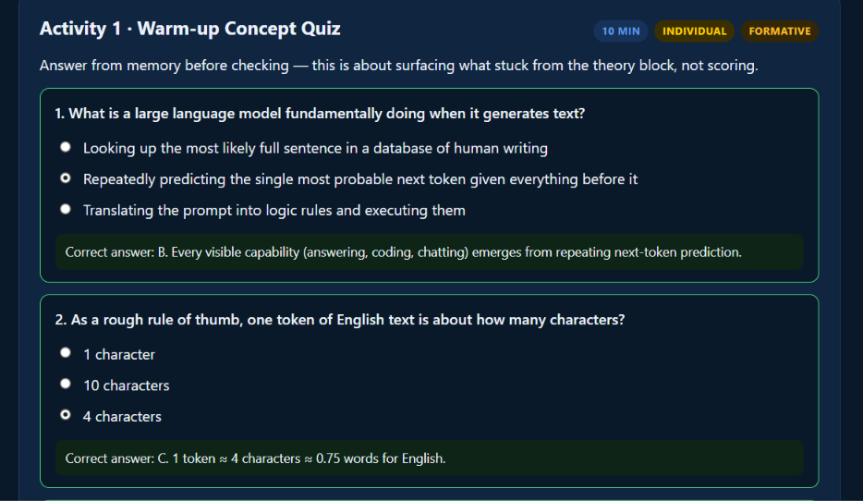
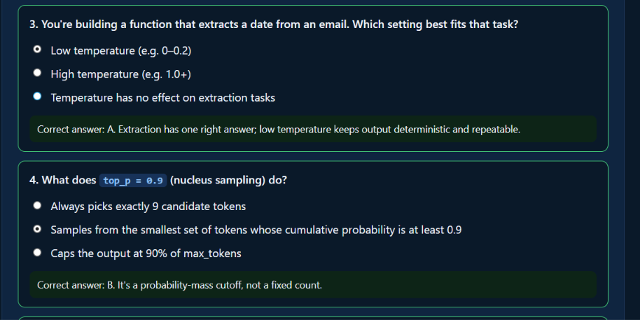
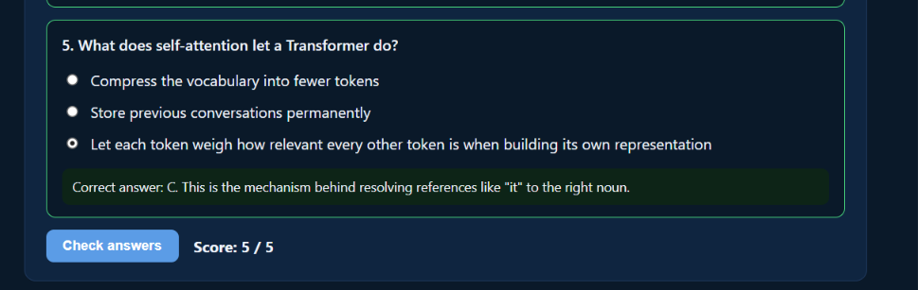

Activity 2
Follow along in week-01-llm-fundamentals.ipynb, sections 1–3:
- Confirm your .env and API key work with a single test call.
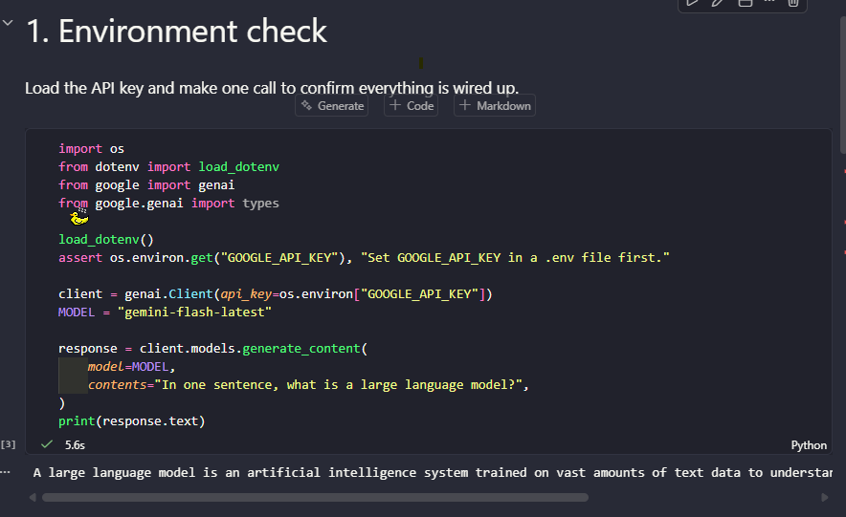
LLM Answer: “A large language model is an artificial intelligence system trained on vast amounts of text data to understand, process, and generate human-like language.”
- Run the temperature/top-p/top-k sweep together; each student calls out what they observe changing.
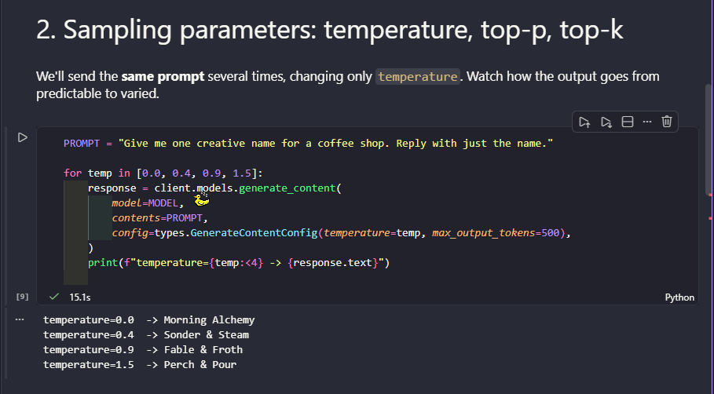
On this part of the Notebook I delete de function .strip() because they’re throw error’s also y replace the value of the max_output_tokens to 500 to get the complete answer from the LLM
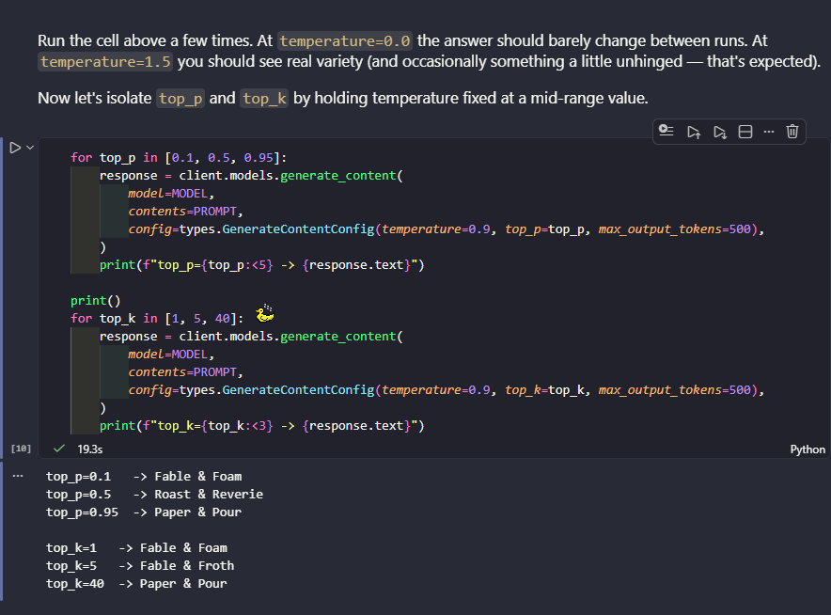
On this part I do it removing the removal of the function .strip because it was throwing error's, also put the value or the max_output_tokens to 500 to get the complete answer from the LLM. I just see how the answer start’s to get variations as the values ​​of top k and top p increased

- Run count_tokens on a few sentences of different lengths and compare against the "1 token ≈ 4 characters" rule of thumb.
For this part of the activity I add another phrase but in Spanish to see de difference between the tokenization in different languages, because the Spanish words have different tokenization heigh than the English words
The phrases was:
- "Hi!",
- "The capital of France is Paris.",
- "AI Agentic Engineering is a course about building autonomous systems with large language models, "
- "retrieval-augmented generation, and multi-agent orchestration frameworks like Google ADK and LangGraph.",
- "Una vez que hayas terminado de leer este texto, por favor, responde con un resumen en español. No olvides la puntuación y las reglas gramaticales.",
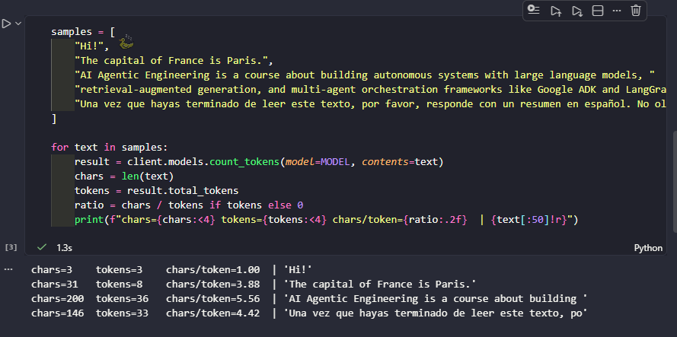
The rule holds true well in simple medium-length sentences (Paris, ratio 3.88) the ideal case where the "1 token ≈ 4 characters" heuristic originated.

It breaks down strongly in short text ("Hi!", ratio 1.00). Short texts have overhead: each short word and punctuation mark ("!") consumes its own full token; there is no "dilution" in longer text. The 4-character rule assumes average performance in long texts but fails in short messages (short system prompts, commands, etc. important in real-world apps). It reverses in long technical text (ratio 5.56, above the rule). Common English words/repeated technical vocabulary ("Agentic", "orchestration", "framework") compress well because the BPE tokenizer already treats these subwords as frequent units, more efficient than the rule predicts. Spanish comes close but falls short (4.42, not far from 4.0) accents, the letter ñ, and compound words add some cost, but not as dramatically as one might expect (modern tokenizers handle multi-language well).
The rule "1 token ≈ 4 characters" is a valid approximation only for average English in medium-length texts. It degrades at extremes (very short) and varies by language/vocabulary domain — relevant for budgeting costs/context limits in production; do not rely on a fixed rule.

Activity 3
For this activity I just generate a 3 sentences with different tempeture and top_p and mixed to get the 3 sentences in different order
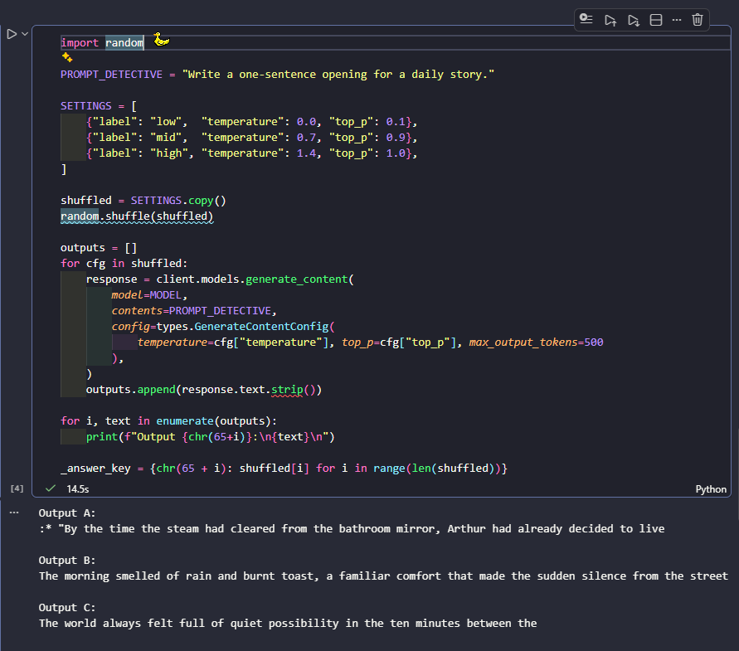
Later I just ask for an AI to construct one algorithm that throw me the phrase with the tempeture and top_p. Also this algorithm organize the dictionary and give me the answer like you see on the below image
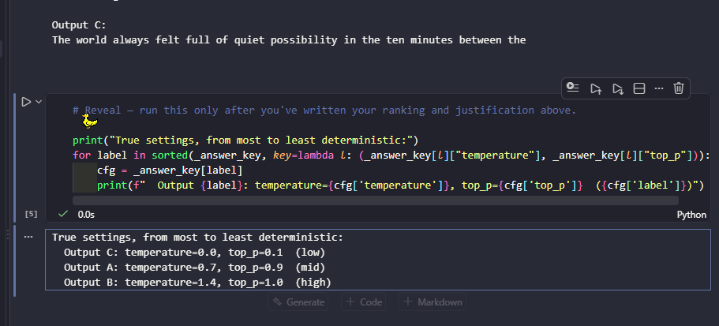
Output C (temp=0.0, top_p=0.1): Highly peaked distribution — the model almost always chooses the most probable token; sampling has very little room to vary. Generic/abstract text ("quiet possibility... between the") is a typical marker of low temperature: safe but bland.
Output A (temp=0.7, top_p=0.9): Moderately open distribution; the nucleus (top_p=0.9) allows quite a few candidates to pass, but not all. Result: coherent, with an odd touch (the stray colon at the beginning) a sign that sampling has already deviated slightly from the most probable path, but without breaking the structure.
Output B (temp=1.4, top_p=1.0): Flat distribution; top_p=1.0 doesn't clip anything; high temperature flattens the probabilities even further. More "poetic"/unexpected text (rare combination "rain and burnt toast... sudden silence"), less obvious juxtaposition a marker of almost unrestricted sampling.

Activity 4
For this part I just change the prompt because I just want kwno about physicist, the new prompt used was “Name one famous physicist and the discovery they're best known for.” Later I execute all of the 3 different forms to ask at LLM like you see on the images below
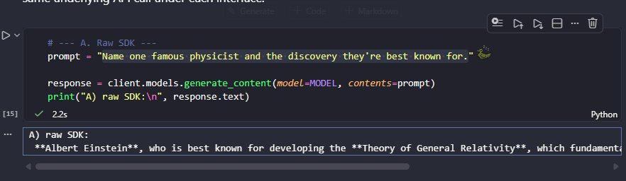
LLM Responses: “A) raw SDK:
**Albert Einstein**, who is best known for developing the **Theory of General Relativity**, which fundamentally changed our understanding of gravity, space, and time.”
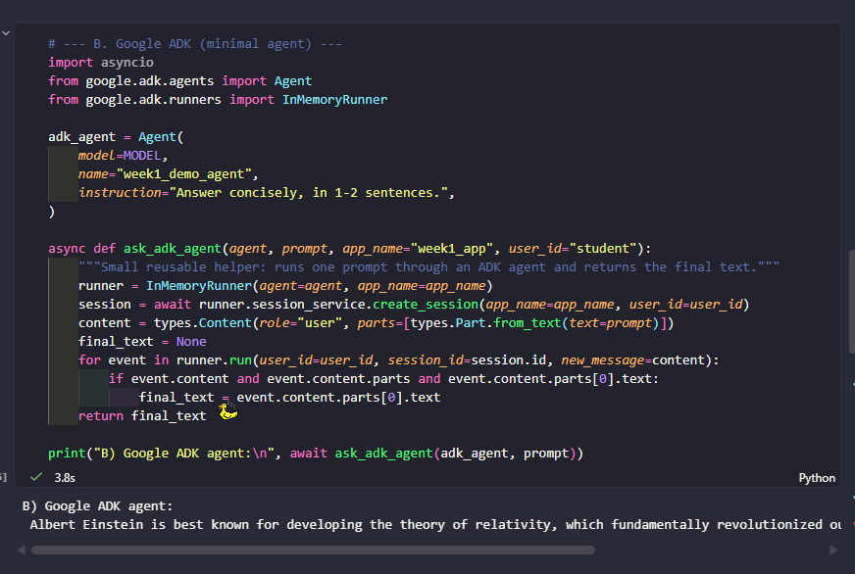
LLM Responses: “B) Google ADK agent:
Albert Einstein is best known for developing the theory of relativity, which fundamentally revolutionized our understanding of space, time, and gravity.”
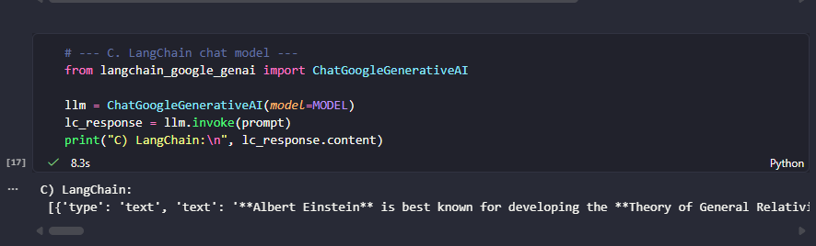
LLM Responses: “C) LangChain:
[{'type': 'text', 'text': '**Albert Einstein** is best known for developing the **Theory of General Relativity**, which revolutionized our understanding of gravity, space, and time.', 'extras': {'signature': 'ErMMCrAMARFNMg8rrfCa0y7x3oU+MFWY4YeHRU8YVjvvdBbXZr/KmH2KHPSaDWEpooo6fVSOE4N80QiuDxIrRq4ptbY……}]

A (raw SDK): returns direct plain text, response.text — the rawest form, without extra layers.
B (Google ADK): passes through the Agent with the instruction "Answer concisely, in 1-2 sentences." — this system instruction truncates and forces concise formatting, which is why it's shorter than A (which didn't have an instruction, leaving the model to add Markdown/bold/formula formatting).
C (LangChain): same model, but ChatGoogleGenerativeAI wraps the response in a block list structure ([{'type': 'text', 'text': ..., 'extras': {'signature': ...}}]) instead of a plain string — the signature is internal Gemini metadata (thought signature), not part of the actual text. The background content is equivalent to A; only the library's wrapper/format changes.

Conclusion: Same Gemini model underneath the 3, differences come from how each layer (raw SDK vs agent with instruction vs LangChain wrapper) post-processes/formats the output, not from the model itself.

I just created a github repository to upload all of the different sessions that I’m going to be working on. This is the URL: https://github.com/JoseMartInez2611/ai_agentic_class

Activity 6
Corte 1 Project Checkpoint & Independent Work
• Choose the document domain your assistant will answer questions about (e.g. your program's course catalog, a hobby's rulebook, your own class notes, a product's documentation). Pick something you have 5–20 real documents or pages for — you'll need it for chunking in Week 4.
R/ A calculus tutoring assistant that answers questions about a first-semester calculus course (limits, derivatives, and integrals). It solves exercises step by step, explaining the reasoning and the theorem/rule behind each step, and answers theoretical questions grounded in calculus lecture notes and textbook chapters via RAG, rather than relying only on the model's general knowledge.
• Write a 3–5 sentence project proposal (what it answers questions about, who it's for) and push it as PROPOSAL.md to your course GitHub repository.
R/ https://github.com/JulianGuardian/Cubik-Lite

