Lab & Activities Week 01 LLM Fundamentals

Integrantes:
José Martínez-02220131016

Institución: Universidad de Santander
Pregrado: Ingeniería Se Sistemas
Docente: Jorge Galvis
26 de Agosto 2026

Activity 1
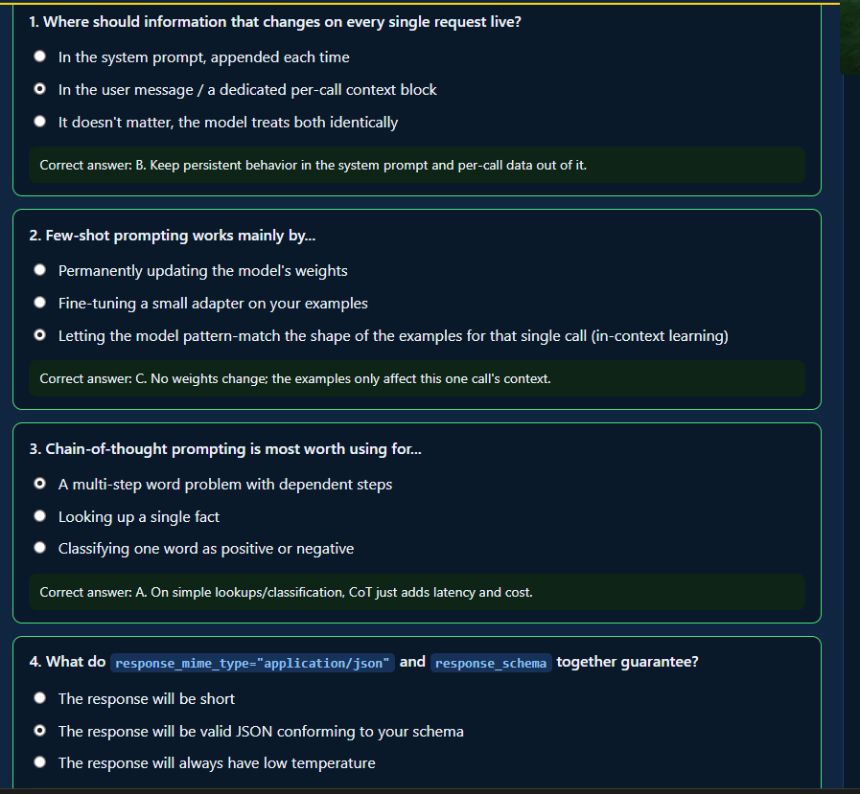
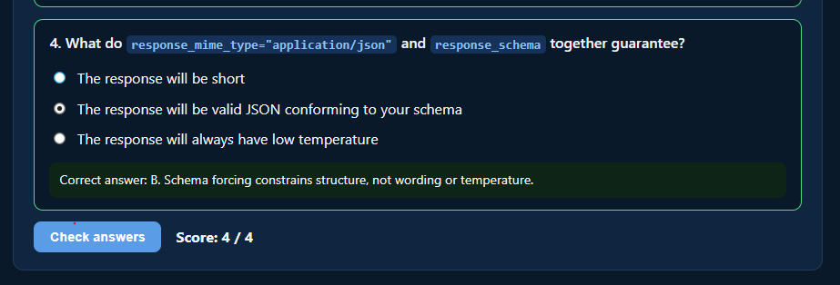

Activity 2

Activity 3

Activity 4

Activity 6
Corte 1 Project Checkpoint & Independent Work
- Draft the system prompt for your Corte 1 assistant (from your Week 1 proposal). Define its role, scope, refusal behavior, and output style.
Done on prompts/system_prompt.txt:
Role: Integral calculus tutor, explains steps and cites rules/theorems.
Scope: Definite/indefinite integrals, integration techniques (substitution, integration by parts, partial fractions, trigonometric substitution), applications (area, volume), conceptual questions, and problem generation (numerical or real-world contexts). Derivatives/limits are only included as an intermediate step, never as the main topic.
Refusal: Rejects non-calculus topics, standalone questions on derivatives/limits, and requests for "just give me the answer without explanation"—always redirects the discussion by explaining the scope.
Tone: Friendly, warm, and patient (added later upon your request).

- Decide whether any part of its output needs to be structured (JSON) — e.g. if your assistant should also return a confidence score or a source citation alongside its answer.
Decided: yes, structured JSON. Fields: answer, steps, rule, confidence (0.0–1.0), source (citation — null until RAG arrives in Week 4).
- Commit prompts/system_prompt.txt to your repo and update PROPOSAL.md with 2–3 example questions your assistant should be able to answer once RAG is added in Week 4.
prompts/system_prompt.txt created and committed. PROPOSAL.md updated with "Example Questions" section 3 example questions (integral of x·eˣ, area under sin(x) from 0 to π, why +C). Push to week2-advancement branch, pull request open to main: https://github.com/JulianGuardian/Cubik-Lite/pull/1

